QuickLinks -- Click here to rapidly navigate through this document

UNITED STATES

SECURITIES AND EXCHANGE COMMISSION

Washington, D.C. 20549

SCHEDULE 13E-3

RULE 13E-3 TRANSACTION STATEMENT

Under Section 13(e) of the Securities Exchange Act of 1934

GasLog Ltd.

(Name of the Issuer)

GasLog Ltd.

Blenheim Holdings Ltd.
Blenheim Special Investments Holding Ltd.
Olympic LNG Investments Ltd.
GEPIF III Crown Bidco L.P.
GEPIF III Crown MergerCo Limited
Global Energy & Power Infrastructure Fund III, L.P.
(Name of Persons Filing Statement)

 | Common Shares, par value $0.01 per share
 | (Title of Class of Securities)
 | G37585109
 | (CUSIP Number of Class of Securities)
GasLog Ltd. | Blenheim Holdings Ltd.
Alexandros Laios, General Counsel | Blenheim Special Investments Holding Ltd.
c/o GasLog LNG Services Ltd. | Peter G. Livanos
69 Akti Miaouli | c/o Ceres Monaco SAM
18537 Piraeus | Gildo Pastor Center
Greece | 7 rue du Gabian
+30 210 459 1000 | 98000 Monaco
 | +377 9797 0606
Olympic LNG Investments Ltd. | Global Energy & Power Infrastructure Fund III, L.P.
c/o ASOFIN Management AG | GEPIF III Crown Bidco L.P.
Heiligkreuz 2, FL-9490 Vaduz | GEPIF III Crown MergerCo Limited
Liechtenstein | One Lafayette Place
+423-237 48 03 | Greenwich, CT 06830
 | U.S.A.
 | +1 203 863 6000

(Name, Address and Telephone Number of Person Authorized to Receive

Notices and Communications on Behalf of the Person(s) Filing Statement)

 | With a copy to:
Erik R. Tavzel, Esq. | Owen Clay | Christopher R. May, Esq.
D. Scott Bennett, Esq. | Linklaters LLP | Simpson Thacher & Bartlett LLP
Andrew C. Elken, Esq. | One Silk Street | 600 Travis Street, Suite 5400
Cravath, Swaine & Moore LLP | London, EC2Y 8HQ | Houston, Texas 77002
Worldwide Plaza | United Kingdom | +1 (713) 821-5666
825 Eighth Avenue | +44 20 7456 3230
New York, New York 10019
+1 (212) 474-1000

This statement is filed in connection with (check the appropriate box):

oThe filing of solicitation materials or an information statement subject to Regulation 14A, Regulation 14C or Rule 13e-3(c) under the Securities Exchange Act of 1934.

oThe filing of a registration statement under the Securities Act of 1933.

oA tender offer.

☒None of the above.

Check the following box if the soliciting materials or information statement referred to in checking box (a) are preliminary copies: o

Check the following box if the filing is a final amendment reporting the results of the transaction: o

Calculation of Filing Fee

Transaction Valuation* Amount of Filing Fee**

$253,528,387.80 $27,659.95

- Estimated solely for purposes of calculating the filing fee pursuant to Rule 0-11(d) under the Securities Exchange Act of 1934, as amended. The transaction valuation was calculated based on the sum of (a) the aggregate cash payment for the proposed per share cash payment of $5.80 for 42,567,710 outstanding common shares of the issuer subject to the transaction, (b) the product of 642,637 common shares of the issuer subject to restricted stock unit awards that are not subject to performance-based vesting conditions multiplied by $5.80 and (c) the product of 501,444 common shares of the issuer subject to restricted stock unit awards that remain subject to performance-based vesting conditions (determined based on the achievement of applicable performance goals at target levels) multiplied by $5.80, in each case as of the date of this filing ((a), (b) and (c) together, the “Transaction Value”).

- The amount of the filing fee was calculated in accordance with Exchange Act Rule 0-11(b)(1) and the Securities and Exchange Commission Fee Rate Advisory #1 for the Fiscal Year 2021 by multiplying the Transaction Value by 0.0001091.

- Check box if any part of the fee is offset as provided by Exchange Act Rule 0-11(a)(2) and identify the filing with which the offsetting fee was previously paid. Identify the previous filing by registration statement number, or the Form or Schedule and date of its filing.

NEITHER THE SECURITIES AND EXCHANGE COMMISSION NOR ANY STATE SECURITIES COMMISSION HAS APPROVED OR DISAPPROVED OF THIS TRANSACTION, PASSED UPON THE MERITS OR FAIRNESS OF THIS TRANSACTION, OR PASSED UPON THE ADEQUACY OR ACCURACY OF THE DISCLOSURE IN THIS SCHEDULE 13E-3. ANY REPRESENTATION TO THE CONTRARY IS A CRIMINAL OFFENSE.

INTRODUCTION

This Rule 13E-3 Transaction Statement on Schedule 13E-3, together with the exhibits hereto (this “Schedule 13E-3” or this “Transaction Statement”), is being filed with the Securities and Exchange Commission (the “SEC”) pursuant to Section 13(e) of the Securities Exchange Act of 1934, as amended (together with the rules and regulations promulgated thereunder, the “Exchange Act”), by: (i) GasLog Ltd., a Bermuda exempted company (the “Company”), (ii) GEPIF

- Crown Bidco L.P., a Cayman Islands exempted limited partnership (“Parent”), (iii) GEPIF III Crown MergerCo Limited, a Bermuda exempted company and a wholly owned subsidiary of Parent (“Merger Sub”), (iv) Global Energy & Power Infrastructure Fund III, L.P., a Cayman Islands exempted limited partnership (“GEPIF III”), (v) Blenheim Holdings Ltd., a Bermuda exempted company (“Blenheim Holdings”), (vi) Blenheim Special Investments Holding Ltd., a Bermuda exempted company (“Blenheim Special Investments”), and (vii) Olympic LNG Investments Ltd., a Bermuda exempted company (“Olympic”) (each of (i) through (vii) a “Filing Person”, and collectively, the “Filing Persons”).

This Transaction Statement relates to (1) the Agreement and Plan of Merger, dated as of February 21, 2021 (as it may be amended from time to time, the “Merger Agreement”), by and among the Company, Parent and Merger Sub, (2) the related Statutory Merger Agreement contemplated by the Merger Agreement (the “Statutory Merger Agreement”), to be entered into by the Company and Merger Sub and (3) the Rollover Agreement, dated as of February 21, 2021 (the “Rollover Agreement”), by and among Parent, the Company, Blenheim Holdings, Olympic, Blenheim Special Investments, Falconera Navigation Inc., Chiara Holdings S de R.L., Maple Tree Holdings Ltd., Ash Tree SA, Acer Tree Ltd., Thatcher Investments Limited, Eleanor Investments Holdings Limited, Nelson Equity Limited and JP Jones Holdings Limited (such persons, other than Parent and the Company, the “Rolling Shareholders”). Pursuant to, and subject to the terms and conditions of, the Merger Agreement and the Statutory Merger Agreement, if each of the conditions to closing set forth in the Merger Agreement are either satisfied or, to the extent permitted, waived, Merger Sub will be merged with and into the Company (the “Merger”), with the Company as the surviving company in the merger (the “Surviving Company”).

Upon completion of the Merger, each common share of the Company, par value $0.01 per share (each, a “Company Common Share”), that is issued and outstanding at the effective time of the Merger (the “Effective Time”) (other than Company Common Shares held by (a) holders of Company Common Shares who have properly exercised appraisal rights with respect to such Company Common Shares in accordance with the Company Act 1981 of Bermuda (as amended) (the “Bermuda Companies Act”), (b) the Company or any of its wholly owned subsidiaries, (c) the Company as treasury shares or (d) the Rolling Shareholders), will be cancelled and converted into the right to receive $5.80, in cash, without interest (the “Merger Consideration”). Upon completion of the Merger, each of the Company’s 8.75% Series A Cumulative Redeemable Perpetual Preference Shares, par value $0.01 per share (each, a “Company Preference Share”) that is issued and outstanding at the Effective Time will remain issued and outstanding and convert automatically into a preference share of the Surviving Company (each, a “Surviving Company Preference Share”), and be entitled to the same dividend and other relative rights, preferences, limitations and restrictions as are now provided by the certificate of designations of the Company Preference Shares, which certificate of designations will remain at and following the completion of the Merger in full force and effect as an obligation of the Surviving Company in accordance with the Bermuda Companies Act. Following the Merger, the Rolling Shareholders will own approximately 55% of the Surviving Company’s common shares and Parent will own approximately 45% of the Surviving Company’s common shares. Following the Merger, the Surviving Company will use its reasonable best efforts to cause the Company Common Shares to be de-listed from the New York Stock Exchange and de-registered under the Exchange Act as soon as reasonably practicable following the Effective Time.

Pursuant to the Rollover Agreement, each Rolling Shareholder has agreed that (a) each Company Common Share that is issued and outstanding prior to the Effective Time and owned by it will remain outstanding and convert automatically into one duly authorized, validly issued and fully paid and nonassessable common share, par value $0.01 per share, of the Surviving Company and (b) each Company Preference Share that is issued and outstanding prior to the Effective Time and owned by it will remain outstanding and convert automatically into a Surviving Company Preference Share, and has waived any

claim to receive the Merger Consideration with respect to any Company Common Share owned by it and any rights of appraisal or rights to dissent from the Merger and the other transactions. In addition, in connection with the transactions contemplated by the Rollover Agreement and the Merger Agreement, concurrently with the closing of the Merger, each of Blenheim Holdings, Olympic and Blenheim Special Investments (the “Continuing Rolling Shareholders”), Parent and the Company have agreed to enter into a shareholder agreement (the “Shareholder Agreement”) with respect to the governance of the Surviving Company, including certain approval rights to be granted to Parent and Blenheim Holdings with respect to the conduct of the Surviving Company.

Parent expects to provide the amount of funds necessary to complete the Merger through a cash contribution from GEPIF III, pursuant to an Equity Commitment Letter, dated as of February 21, 2021 (the “Equity Commitment Letter”), between Parent and GEPIF III, under which, subject to the terms and conditions thereof, GEPIF III will provide equity financing in an aggregate amount of $247 million to Parent to complete the Merger. The obligation of GEPIF

- to fund its commitment under the Equity Commitment Letter is subject to the satisfaction in full or valid waiver of the conditions precedent to Parent’s obligations to consummate the Merger and the other transactions at the closing and the closing being required to occur under the Merger Agreement.

Concurrently with the execution and delivery of the Merger Agreement, Parent also delivered to the Company the executed guarantee of GEPIF III, dated as of February 21, 2021, in favor of the Company in respect of Parent’s obligation to pay the Parent termination fee under and in accordance with the Merger Agreement.

A special committee of the board of directors of the Company (the “Special Committee”) consisting only of independent and disinterested directors reviewed and considered the terms and conditions of the Merger Agreement, the Statutory Merger Agreement, and the transactions contemplated thereby, including the Merger. The Special Committee unanimously recommended that the board of directors of the Company (a) approve the Merger Agreement, the Statutory Merger Agreement and the transactions contemplated by the Merger Agreement, the Statutory Merger Agreement and the Rollover Agreement, including the Merger, and (b) recommend approval of the Merger, the Merger Agreement and the Statutory Merger Agreement to the holders of the Company Common Shares, other than the Company or its wholly owned subsidiaries, Parent, Merger Sub or the Rolling Shareholders and their respective affiliates (the “Public Shareholders”), and the holders of Company Preference Shares. The board of directors of the Company, acting upon the unanimous recommendation of the Special Committee, unanimously (i) determined that the Merger Agreement, the Statutory Merger Agreement and the transactions contemplated by the Merger Agreement, the Statutory Merger Agreement and the Rollover Agreement, including the Merger, are fair to, and in the best interest of, the Company, the holders of Company Common Shares and the holders of Company Preference Shares, (ii) approved the Merger Agreement, the Statutory Merger Agreement and the transactions contemplated by the Merger Agreement, the Statutory Merger Agreement and the Rollover Agreement, including the Merger, and (iii) recommended approval of the Merger, the Merger Agreement and the Statutory Merger Agreement to the Public Shareholders and the holders of Company Preference Shares.

Consummation of the Merger is subject to certain conditions, including without limitation, approval of the Merger Agreement, the Statutory Merger Agreement and the transactions contemplated thereby by the affirmative vote of (a) the holders of a majority of the voting power of the outstanding Company Common Shares and Company Preference Shares entitled to vote thereon, voting together as a single class (and with each Company Preference Share carrying a single vote), at a meeting of the Company shareholders and (b) the holders of a majority of the Company Common Shares held by the Public Shareholders and present (in person or by proxy) at a special general meeting of the Company shareholders. Pursuant to the Rollover Agreement, the Rolling Shareholders have agreed, subject to the terms and conditions therein, to vote all Company Common Shares and Company Preference Shares beneficially owned by them in favor of the approval of the Merger Agreement, the Statutory Merger Agreement and the transactions contemplated thereby, including the Merger.

The Company will make available to its shareholders a proxy statement (the “Proxy Statement,” a preliminary copy of which is attached as Exhibit (a)(1) to this Transaction Statement), relating to the special general meeting of the Company’s shareholders, at which the Company’s shareholders will consider and vote upon a proposal to approve the Merger, the Merger Agreement and the Statutory Merger Agreement. As of the date hereof, the Proxy Statement is in preliminary form and is subject to completion.

Pursuant to General Instruction F to Schedule 13E-3, the information in the Proxy Statement, including all annexes thereto, is expressly incorporated by reference herein in its entirety, and responses to each item herein are qualified in their entirety by the information contained in the Proxy Statement. The cross-references below are being supplied pursuant to General Instruction G to Schedule 13E-3 and show the location in the Proxy Statement of the information required to be included in response to the items of Schedule 13E-3.

All information concerning the Company contained in, or incorporated by reference into, this Transaction Statement and the Proxy Statement was supplied by the Company. Similarly, all information concerning each Filing Person contained in, or incorporated by reference into, this Transaction Statement and the Proxy Statement was supplied by such Filing Person. No Filing Person is responsible for the accuracy of any information supplied by any other Filing Person.

ITEM 1. SUMMARY TERM SHEET

The information set forth in the Proxy Statement under the following captions is incorporated herein by reference:

- “Summary Term Sheet”

- “Questions and Answers about the Special General Meeting and the Merger”

ITEM 2. SUBJECT COMPANY INFORMATION

- Name and Address. The information set forth in the Proxy Statement under the following captions is incorporated herein by reference:

  - “Summary Term Sheet—The Parties Involved in the Merger—The Company”

- Securities. The information set forth in the Proxy Statement under the following captions is incorporated herein by reference:

  - “Summary Term Sheet—The Parties Involved in the Merger—The Company”

  - “Summary Term Sheet—The Special General Meeting”

  - “Questions and Answers about the Special General Meeting and the Merger”

  - “The Special General Meeting—Record Date; Shareholders Entitled to Vote”

  - “Other Important Information Regarding the Company—Market Prices of the Company Common Shares and Dividends”

  - “Other Important Information Regarding the Company—Market Prices of the Company Preference Shares and Dividends”

- Trading Market and Price. The information set forth in the Proxy Statement under the following captions is incorporated herein by reference:

  - “Other Important Information Regarding the Company—Market Prices of the Company Common Shares and Dividends”

  - “Other Important Information Regarding the Company—Market Prices of the Company Preference Shares and Dividends”

- Dividends. The information set forth in the Proxy Statement under the following captions is incorporated herein by reference:

  - “Questions and Answers about the Special General Meeting and the Merger”

  - “The Merger Agreement—Conduct of Business”

  - “Other Important Information Regarding the Company—Market Prices of the Company Common Shares and Dividends”

  - “Other Important Information Regarding the Company—Market Prices of the Company Preference Shares and Dividends”

- Prior Public Offerings. The information set forth in the Proxy Statement under the following captions is incorporated herein by reference:

  - “Other Important Information Regarding the Company—Prior Public Offerings”

- Prior Stock Purchases. The information set forth in the Proxy Statement under the following captions is incorporated herein by reference:

  - “Other Important Information Regarding the Company—Prior Public Offerings”

  - “Other Important Information Regarding the Company—Certain Transactions in the Company Shares”

ITEM 3. IDENTITY AND BACKGROUND OF FILING PERSON

- Name and Address. The information set forth in the Proxy Statement under the following captions is incorporated herein by reference:

  - “Summary Term Sheet—The Parties Involved in the Merger”

  - “The Parties Involved in the Merger”

  - “Other Important Information Regarding the Company”

  - “Other Important Information Regarding the GEPIF Filing Parties”

  - “Other Important Information Regarding the Rolling Shareholders”

- Business and Background of Entities. The information set forth in the Proxy Statement under the following captions is incorporated herein by reference:

  - “Summary Term Sheet—The Parties Involved in the Merger”

  - “The Parties Involved in the Merger”

  - “Other Important Information Regarding the Company”

  - “Other Important Information Regarding the GEPIF Filing Parties”

  - “Other Important Information Regarding the Rolling Shareholders”

- Business and Background of Natural Persons. The information set forth in the Proxy Statement under the following captions is incorporated herein by reference:

  - “Other Important Information Regarding the Company—Directors and Executive Officers of the Company”

  - “Other Important Information Regarding the GEPIF Filing Parties—Directors and Executive Officers of the GEPIF Filing Parties”

  - “Other Important Information Regarding the Rolling Shareholders—Directors and Executive Officers of the Rolling Shareholders”

ITEM 4. TERMS OF THE TRANSACTION

(a)-(1) Material Terms—Tender Offers. Not applicable.

(a)-(2) Material Terms—Merger or Similar Transactions. The information set forth in the Proxy Statement under the following captions is incorporated herein by reference:

  - “Summary Term Sheet”

  - “Questions and Answers about the Special General Meeting and the Merger”

  - “The Special General Meeting”

  - “Special Factors”

  - “The Merger Agreement”

  - “The Rollover Agreement”

  - “Material U.S. Federal Income Tax Consequences of the Merger”

  - “Annex A—Merger Agreement”

  - “Annex B—Statutory Merger Agreement”

  - “Annex C—Rollover Agreement”

- Different Terms. The information set forth in the Proxy Statement under the following captions is incorporated herein by reference:

  - “Summary Term Sheet”

  - “Questions and Answers about the Special General Meeting and the Merger”

  - “Special Factors—Effects of the Merger”

  - “Special Factors—Interests of the Company’s Directors and Executive Officers in the Merger”

  - “The Merger Agreement”

  - “The Rollover Agreement”

  - “Annex A—Merger Agreement”

  - “Annex B—Statutory Merger Agreement”

  - “Annex C—Rollover Agreement”

- Appraisal Rights. The information set forth in the Proxy Statement under the following captions is incorporated herein by reference:

  - “Summary Term Sheet”

  - “Questions and Answers about the Special General Meeting and the Merger”

  - “Special Factors—Appraisal Rights”

  - “The Merger Agreement—Shares of Dissenting Holders”

  - “Appraisal Rights of Shareholders”

  - “Annex E—Copy of Section 106 of the Bermuda Companies Act”

- Provisions for Unaffiliated Security Holders. The information set forth in the Proxy Statement under the following captions is incorporated herein by reference:

  - “Provisions for Public Shareholders”

- Eligibility for Listing or Trading. Not applicable.

ITEM 5. PAST CONTACTS, TRANSACTIONS, NEGOTIATIONS AND AGREEMENTS

- Transactions. The information set forth in the Proxy Statement under the following captions is incorporated herein by reference:

  - “Other Important Information Regarding the Company—Certain Transactions in the Company Shares”

  - “Other Important Information Regarding the GEPIF Filing Parties—Past Transactions and Contracts with the Company

  - “Other Important Information Regarding the Rolling Shareholders—Past Transactions and Contracts with the Company”

(b)-(c) Significant Corporate Events; Negotiations or Contacts. The information set forth in the Proxy Statement under the following captions is incorporated herein by reference:

  - “Summary Term Sheet”

  - “Special Factors—Plans for the Company after the Merger”

  - “Special Factors—Background of the Merger”

  - “Special Factors—Reasons for the Merger”

  - “Special Factors—The GEPIF Filing Parties’ Reasons for the Merger”

  - “Special Factors—Rolling Shareholders’ Reasons for the Merger”

  - “Special Factors—Interests of the Company’s Directors and Executive Officers in the Merger”

  - “The Merger Agreement”

  - “The Rollover Agreement”

  - “Other Important Information Regarding the Company—Negotiations or Material Contacts”

  - “Other Important Information Regarding the GEPIF Filing Parties—Past Transactions and Contracts with the Company”

  - “Other Important Information Regarding the GEPIF Filing Parties—Past Transactions and Contracts with the Rolling Shareholders”

  - “Other Important Information Regarding the Rolling Shareholders—Past Transactions and Contracts with the Company”

  - “Other Important Information Regarding the Rolling Shareholders—Past Transactions and Contracts with the GEPIF Filing Parties”

  - “Annex A—Merger Agreement”

  - “Annex B—Statutory Merger Agreement”

  - “Annex C—Rollover Agreement”

- Agreements Involving the Subject Company’s Securities. The information set forth in the Proxy Statement under the following captions is incorporated herein by reference:

  - “Summary Term Sheet”

  - “The Special General Meeting”—Required Vote”

  - “Special Factors—Plans for the Company after the Merger”

  - “Special Factors—Background of the Merger”

  - “Special Factors—Financing of the Merger”

- “Special Factors—Interests of the Company’s Directors and Executive Officers in the Merger”

- “Special Factors—Delisting and Deregistration of the Company Common Shares”

- “The Merger Agreement”

- “The Rollover Agreement”

- “Other Important Information Regarding the Company—Prior Public Offerings”

- “Other Important Information Regarding the Company—Certain Transactions in the Company Shares”

- “Other Important Information Regarding the GEPIF Filing Parties—Past Transactions and Contracts with the Company”

- “Other Important Information Regarding the Rolling Shareholders—Past Transactions and Contracts with the Company”

- “Annex A—Merger Agreement”

- “Annex B—Statutory Merger Agreement”

- “Annex C—Rollover Agreement”

ITEM 6. PURPOSES OF THE TRANSACTION AND PLANS OR PROPOSALS

- Use of Securities Acquired. The information set forth in the Proxy Statement under the following captions is incorporated herein by reference:

  - “Summary Term Sheet”

  - “Questions and Answers about the Special General Meeting and the Merger”

  - “Special Factors—Effects of the Merger”

  - “Special Factors—Plans for the Company after the Merger”

  - “Special Factors—Reasons for the Merger”

  - “Special Factors—The GEPIF Filing Parties’ Reasons for the Merger”

  - “Special Factors—Rolling Shareholders’ Reasons for the Merger”

  - “Special Factors—Delisting and Deregistration of the Company Common Shares”

  - “The Merger Agreement”

  - “The Rollover Agreement”

  - “Other Important Information Regarding the Company—Market Prices of the Company Common Shares and Dividends”

  - “Annex A—Merger Agreement”

  - “Annex B—Statutory Merger Agreement”

  - “Annex C—Rollover Agreement”

(c)(1)-(8) Plans. The information set forth in the Proxy Statement under the following captions is incorporated herein by reference:

- “Summary Term Sheet”

- “Special Factors—Effects of the Merger”

- “Special Factors—Plans for the Company after the Merger”

- “Special Factors—Background of the Merger”

- “Special Factors—Reasons for the Merger”

- “Special Factors—The GEPIF Filing Parties’ Reasons for the Merger”

- “Special Factors—Rolling Shareholders’ Reasons for the Merger”

- “Special Factors—Interests of the Company’s Directors and Executive Officers in Merger”

- “Special Factors—Delisting and Deregistration of the Company Common Shares”

- “The Merger Agreement”

- “The Rollover Agreement”

- “Other Important Information Regarding the Company—Market Prices of the Company Common Shares and Dividends”

- “Annex A—Merger Agreement”

- “Annex B—Statutory Merger Agreement”

- “Annex C—Rollover Agreement”

ITEM 7. PURPOSES, ALTERNATIVES, REASONS AND EFFECTS

- Purposes. The information set forth in the Proxy Statement under the following captions is incorporated herein by reference:

  - “Summary Term Sheet”

  - “Special Factors—Background of the Merger”

  - “Special Factors—Plans for the Company after the Merger”

  - “Special Factors—Reasons for the Merger”

  - “Special Factors—The GEPIF Filing Parties’ Reasons for the Merger”

  - “Special Factors—Rolling Shareholders’ Reasons for the Merger”

- Alternatives. The information set forth in the Proxy Statement under the following captions is incorporated herein by reference:

  - “Special Factors—Effects on The Company If the Merger Is Not Completed”

  - “Special Factors—Background of the Merger”

  - “Special Factors—Reasons for the Merger

  - “Special Factors—Alternatives to the Merger”

  - “Special Factors—The GEPIF Filing Parties’ Reasons for the Merger”

  - “Special Factors—Rolling Shareholders’ Reasons for the Merger”

- Reasons. The information set forth in the Proxy Statement under the following captions is incorporated herein by reference:

  - “Summary Term Sheet”

  - “Special Factors—Effects of the Merger”

  - “Special Factors—Background of the Merger”

  - “Special Factors—Reasons for the Merger”

  - “Special Factors—Alternatives to the Merger”

  - “Special Factors—The GEPIF Filing Parties’ Reasons for the Merger”

  - “Special Factors—Position of the GEPIF Filing Parties as to Fairness of the Merger”

  - “Special Factors—Rolling Shareholders’ Reasons for the Merger”

  - “Special Factors—Position of the Rolling Shareholders as to the Fairness of the Merger”

  - “Special Factors—Opinion of Evercore—Financial Advisor to the Special Committee”

- Effects. The information set forth in the Proxy Statement under the following captions is incorporated herein by reference:

  - “Summary Term Sheet”

  - “Special Factors—Effects of the Merger”

  - “Special Factors—The Company’s Net Book Value and Net Earnings”

  - “Special Factors—Effects on the Company If the Merger Is Not Completed”

  - “Special Factors—Plans for the Company after the Merger”

  - “Special Factors—Background of the Merger”

  - “Special Factors—Reasons for the Merger”

  - “Special Factors—Interests of the Company’s Directors and Executive Officers in Merger”

  - “Special Factors—Material U.S. Federal Income Tax Consequence of the Merger”

  - “Special Factors—Material Bermuda Tax Consequences of the Merger”

  - “Special Factors—Delisting and Deregistration of the Company Common Shares”

  - “The Merger Agreement”

  - “The Rollover Agreement”

  - “Material U.S. Federal Income Tax Consequences of the Merger”

  - “Annex A—Merger Agreement”

  - “Annex B—Statutory Merger Agreement”

  - “Annex C—Rollover Agreement”

ITEM 8. FAIRNESS OF THE TRANSACTION

(a)-(b) Fairness; Factors Considered in Determining Fairness. The information set forth in the Proxy Statement under the following captions is incorporated herein by reference:

- “Summary Term Sheet”

- “Special Factors—Background of the Merger”

- “Special Factors—Reasons for the Merger”

- “Special Factors—Position of the GEPIF Filing Parties as to the Fairness of the Merger”

- “Special Factors—Position of the Rolling Shareholders as to the Fairness of the Merger”

- “Special Factors—Opinion of Evercore—Financial Advisor to the Special Committee”

- “Special Factors—Interests of the Company’s Directors and Executive Officers in the Merger”

- “Annex D—Fairness Opinion of Evercore Group L.L.C.”

- Approval of Security Holders. The information set forth in the Proxy Statement under the following captions is incorporated herein by reference:

  - “Summary Term Sheet”

  - “Questions and Answers about the Special General Meeting and the Merger”

  - “The Merger Agreement—Efforts to Obtain Required Shareholder Approvals”

  - “The Merger Agreement—Conditions to Completion of the Merger”

  - “The Special General Meeting—Required Vote”

  - “Annex A—Merger Agreement”

- Unaffiliated Representative. The information set forth in the Proxy Statement under the following captions is incorporated herein by reference:

  - “Special Factors—Background of the Merger”

  - “Special Factors—Reasons for the Merger”

  - “Special Factors—Opinion of Evercore—Financial Advisor to the Special Committee”

  - “Annex D—Fairness Opinion of Evercore Group L.L.C.”

- Approval of Directors. The information set forth in the Proxy Statement under the following captions is incorporated herein by reference:

  - “Summary Term Sheet”

  - “Questions and Answers about the Special General Meeting and the Merger”

  - “Special Factors—Background of the Merger”

  - “Special Factors—Reasons for the Merger”

- Other Offers.

  - “Summary Term Sheet”

  - “Special Factors—Background of the Merger”

  - “Special Factors—Reasons for the Merger”

  - “Other Important Information Regarding the Company—Negotiations or Material Contacts”

ITEM 9. REPORTS, OPINIONS, APPRAISALS AND NEGOTIATIONS

(a)-(b) Report, Opinion or Appraisal; Preparer and Summary of the Report, Opinion or Appraisal. The information set forth in the Proxy Statement under the following captions is incorporated herein by reference:

- “Summary Term Sheet”

- “Special Factors—Background of the Merger”

- “Special Factors—Reasons for the Merger”

- “Special Factors—Opinion of Evercore—Financial Advisor to the Special Committee”

- “Special Factors—Certain Financial Information”

- “Annex D—Fairness Opinion of Evercore Group L.L.C.”

- Availability of Documents. The information set forth in the Proxy Statement under the following captions is incorporated herein by reference:

- “Where You Can Find More Information”

The reports, opinions or appraisals referenced in this Item 9 will be made available for inspection and copying at the principal executive offices of the Company during its regular business hours by any interested the Company shareholder or his, her or its representative who has been so designated in writing.

ITEM 10. SOURCE AND AMOUNTS OF FUNDS OR OTHER CONSIDERATION

(a)-(b) Source of Funds; Conditions. The information set forth in the Proxy Statement under the following captions is incorporated herein by reference:

  - “Summary Term Sheet”

  - “Special Factors—Financing of the Merger”

  - “The Merger Agreement”

  - “Annex A—Merger Agreement”

- Expenses. The information set forth in the Proxy Statement under the following captions is incorporated herein by reference:

  - “Summary Term Sheet”

  - “Special Factors—Fees and Expenses”

  - “The Merger Agreement—Fees and Expenses”

- Borrowed Funds. Not applicable.

ITEM 11. INTEREST IN SECURITIES OF THE SUBJECT COMPANY

- Securities Ownership. The information set forth in the Proxy Statement under the following captions is incorporated herein by reference:

  - “Summary Term Sheet”

  - “Special Factors—Interests of the Company’s Directors and Executive Officers in Merger”

  - “Other Important Information Regarding the Company—Security Ownership of Company Common Shares and Company Preference Shares”

  - “Other Important Information Regarding the Company—Certain Transactions in the Company Shares—Transactions by the GEPIF Filing Parties in the Company Shares”

  - “Other Important Information Regarding the GEPIF Filing Parties—Directors and Executive Officers of the GEPIF Filing Parties”

  - “Other Important Information Regarding the Rolling Shareholders—Identity and Background of the Rolling Shareholders”

- Securities Transactions. The information set forth in the Proxy Statement under the following captions is incorporated herein by reference:

  - “Other Important Information Regarding the Company—Certain Transactions in the Company Shares”

  - “Other Important Information Regarding the Company—Certain Transactions in the Company Shares—Transactions by the GEPIF Filing Parties in the Company Shares”

  - “Other Important Information Regarding the GEPIF Filing Parties—Directors and Executive Officers of the GEPIF Filing Parties”

ITEM 12. THE SOLICITATION OR RECOMMENDATION

- Intent to Tender or Vote in a Going-Private Transaction. The information set forth in the Proxy Statement under the following captions is incorporated herein by reference:

  - “Summary Term Sheet”

  - “Questions and Answers about the Special General Meeting and the Merger”

  - “The Special General Meeting—Required Vote”

  - “The Special General Meeting—Voting by the Company’s Directors and Executive Officers”

  - “The Rollover Agreement”

  - “Annex C—Rollover Agreement”

- Recommendations of Others. The information set forth in the Proxy Statement under the following captions is incorporated herein by reference:

  - “Summary Term Sheet”

  - “The Special General Meeting—Recommendation of the Board and the Special Committee”

  - “Special Factors—Background of the Merger”

  - “Special Factors—Reasons for the Merger”

  - “Special Factors—The GEPIF Filing Parties’ Reasons for the Merger”

  - “Special Factors—Position of the GEPIF Filing Parties as to the Fairness of the Merger”

  - “Special Factors—Rolling Shareholders’ Reasons for the Merger”

  - “Special Factors—Position of Rolling Shareholders as to the Fairness of the Merger”

ITEM 13. FINANCIAL STATEMENTS

- Financial Information. The audited consolidated financial statements of the Company for the two years ended December 31, 2019 and 2020 are incorporated herein by reference to the Company’s Form 20-F for the year ended December 31, 2020, originally filed on March 5, 2021 (see page F-1 and the following pages).

The information set forth in the Proxy Statement under the following captions is incorporated herein by reference:

  - “Other Important Information Regarding the Company—Selected Historical Financial Information”

  - “Where You Can Find More Information”

- Pro Forma Information. Not applicable.

ITEM 14. PERSONS/ASSETS RETAINED, EMPLOYED, COMPENSATED OR USED

(a)-(b) Solicitations or Recommendations; Employees and Corporate Assets

- “Summary Term Sheet”

- “Questions and Answers about the Special General Meeting and the Merger”

- “The Special General Meeting—Tabulation of Votes”

- “The Special General Meeting—Solicitation of Proxies”

- “Special Factors—Effects of the Merger”

- “Special Factors—Background of the Merger”

- “Special Factors—Reasons for the Merger”

- “Special Factors—Opinion of Evercore Group L.L.C.”

- “Special Factors—Interests of the Company’s Directors and Executive Officers in Merger”

- “Special Factors—Fees and Expenses”

ITEM 15. ADDITIONAL INFORMATION

- Other Material Information. The information set forth in the Proxy Statement, including all annexes thereto, is incorporated herein by reference.

ITEM 16. EXHIBITS

The following exhibits are filed herewith:

Exhibit No. Description

(a)-(1) Preliminary Proxy Statement of the Company dated [·], 2021.

(a)-(2) Letter to the Shareholders of the Company, included in the Proxy Statement and incorporated herein by reference.

(a)-(3) Notice of Special General Meeting of Shareholders, included in the Proxy Statement and incorporated herein by reference.

(a)-(4) Form of Proxy Card, included in the Proxy Statement and incorporated herein by reference.

(a)-(5) Press Release issued by the Company, dated February 22, 2021, incorporated herein by reference to Exhibit 99.1 to the Report on Form 6-K furnished by the Company to the SEC on February 22, 2021.

- Not applicable.

(c)-(1) Fairness Opinion of Evercore Group L.L.C., dated February 21, 2021, incorporated herein by reference to Annex D to the Proxy Statement.

(c)-(2) Discussion Materials prepared by Evercore Group L.L.C. for discussion with the special committee of the board of directors of the Company, dated November 17, 2020

(c)-(3) Discussion Materials prepared by Evercore Group L.L.C. for discussion with the special committee of the board of directors of the Company, dated February 19, 2021.

(c)-(4) Discussion Materials prepared by Evercore Group L.L.C. for discussion with the special committee of the board of directors of the company, dated February 21, 2021.

(d)-(1) Agreement and Plan of Merger, dated as February 21, 2021, by and among GasLog Ltd., GEPIF III Crown Bidco L.P. and GEPIF III Crown MergerCo Limited, incorporated herein by reference to Annex A to the Proxy Statement.

(d)-(2) Statutory Merger Agreement by and among GasLog Ltd. and GEPIF III Crown MergerCo Limited, incorporated herein by reference to Annex B of the Proxy Statement.

(d)-(3) Rollover Agreement, dated as February 21, 2021, by and among GasLog Ltd., GEPIF III Crown Bidco L.P. and the Rolling Shareholders (as defined therein), incorporated herein by reference to Annex C to the Proxy Statement.

(d)-(4) Limited Guarantee, dated as of February 21, 2021, by and between Global Energy & Power Infrastructure Fund III, L.P., in favor of GasLog Ltd.

(d)-(5) Equity Commitment Letter, dated as of February 21, 2021, by and between Global Energy & Power Infrastructure Fund III, L.P. and GEPIF III Crown Bidco L.P., incorporated herein by reference to Exhibit 2 to the Schedule 13D furnished by BlackRock, Inc. to the SEC on March 3, 2021

(d)-(6) Form of Registration Rights Agreement, incorporated herein by reference to Exhibit 4.2 to Amendment No. 4 to GasLog Ltd.’s Registration Statement on Form F-1, filed with the SEC on March 16, 2012.

(d)-(7) Registration Rights Agreement, dated as of June 22, 2020, by and among GasLog Ltd. and the shareholders named therein, incorporated herein by reference to Exhibit 4.17 to GasLog Ltd.’s Annual Report on Form 20-F, filed with the SEC on March 5, 2021.

(d)-(8) Form of Subscription Agreement, incorporated herein by reference to Exhibit 10.24 to Amendment No. 4 to GasLog Ltd.’s Registration Statement on Form F-1, filed with the SEC on March 16, 2012.

Exhibit No. Description

(d)-(9) Form of Subscription Agreement, incorporated herein by reference to Exhibit 4.9 to GasLog Ltd.’s Annual Report on Form 20-F, filed with the SEC on March 27, 2014.

(d)-(10) Stock Purchase Agreement, dated June 22, 2020, between Blenheim Holdings Ltd. and GasLog Ltd., incorporated herein by reference to Exhibit 1 to Amendment No. 8 to the Schedule 13D furnished by Peter G. Livanos, Ceres Shipping Ltd. and Blenheim Holdings Ltd. to the SEC on June 30, 2020.

(d)-(11) Stock Purchase Agreement, dated June 22, 2020, between Olympic LNG Investments Ltd. and GasLog Ltd., incorporated herein by reference to Exhibit 1 to Amendment No. 1 to the Schedule 13D furnished by Olympic LNG Investments Ltd., A.S.O. Holdings S.A. and the Alexander S. Onassis Foundation to the SEC on July 2, 2020.

- Section 106 of the Bermuda Companies Act, incorporated herein by reference Annex E to the Proxy Statement

- Not applicable.

SIGNATURES

After due inquiry and to the best of my knowledge and belief, I certify that the information set forth in this statement is true, complete and correct.

Dated: March 29, 2021

GASLOG LTD.

By: /s/ PAUL A. WOGAN

Name:

Title:

Paul A. Wogan

Chief Executive Officer

BLENHEIM HOLDINGS LTD.

By: /s/ PETER G. LIVANOS

Name: Peter G. Livanos

Title: Director

BLENHEIM SPECIAL INVESTMENTS HOLDING LTD.

By: /s/ PETER G. LIVANOS

Name: Peter G. Livanos

Title: Attorney-in-fact

OLYMPIC LNG INVESTMENTS LTD.

By: /s/ A.S. PAPADIMITRIOU

Name: A.S. Papadimitriou

Title: President

By: /s/ M. GIALOURIS

Name: M. Gialouris

Title: Treasurer/Director

GEPIF III CROWN BIDCO L.P.

By: GEPIF III (GenPar), LLC, its general partner

By: /s/ JAMES BERNER

Name: | James Berner
Title: | Managing Director

GEPIF III CROWN MERGERCO LIMITED

By: /s/ JAMES BERNER

Name: James Berner

Title: Director

GLOBAL ENERGY & POWER INFRASTRUCTURE

FUND III, L.P.

By: GEPIF III (GenPar), LLC, its general partner

By: /s/ JAMES BERNER

Name: | James Berner
Title: | Managing Director

QuickLinks

INTRODUCTION

ITEM 1. SUMMARY TERM SHEET

ITEM 2. SUBJECT COMPANY INFORMATION

ITEM 3. IDENTITY AND BACKGROUND OF FILING PERSON

ITEM 4. TERMS OF THE TRANSACTION

ITEM 5. PAST CONTACTS, TRANSACTIONS, NEGOTIATIONS AND AGREEMENTS ITEM 6. PURPOSES OF THE TRANSACTION AND PLANS OR PROPOSALS ITEM 7. PURPOSES, ALTERNATIVES, REASONS AND EFFECTS

ITEM 8. FAIRNESS OF THE TRANSACTION

ITEM 9. REPORTS, OPINIONS, APPRAISALS AND NEGOTIATIONS

ITEM 10. SOURCE AND AMOUNTS OF FUNDS OR OTHER CONSIDERATION ITEM 11. INTEREST IN SECURITIES OF THE SUBJECT COMPANY ITEM 12. THE SOLICITATION OR RECOMMENDATION

ITEM 13. FINANCIAL STATEMENTS

ITEM 14. PERSONS/ASSETS RETAINED, EMPLOYED, COMPENSATED OR USED

ITEM 15. ADDITIONAL INFORMATION

ITEM 16. EXHIBITS

SIGNATURES

Use these links to rapidly review the document
TABLE OF CONTENTS
TABLE OF CONTENTS 2

TABLE OF CONTENTS 3

Exhibit (a)(1)
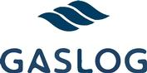

GASLOG LTD.

c/o GasLog LNG Services Ltd.

69 Akti Miaouli

18537 Piraeus

Greece

- · ], 2021

To the shareholders of GasLog Ltd.:

You are cordially invited to attend a special general meeting of the shareholders of GasLog Ltd. (referred to in the accompanying proxy statement as the “Company”) to be held on [ · ], 2021 at [ · ] Bermuda Time ([ · ] Eastern Time).

The attached notice of the special general meeting and accompanying proxy statement provide information regarding the matters to be considered and voted on at the special general meeting, including at any postponement or adjournment thereof. Attendance at the special general meeting will be limited to virtual attendance and the proceedings of the special general meeting are scheduled to be held exclusively online via live webcast. The special general meeting can only be accessed by visiting www.virtualshareholdermeeting.com/GLOG2021SM, where you will be able to attend the special general meeting, vote and submit questions online during the special general meeting. Please note that you will not be able to attend the special general meeting in person. We have chosen to adopt these arrangements for virtual attendance rather than permit in-person attendance given the current public health implications of the COVID-19 pandemic and our desire to promote the health and welfare of our shareholders.

At the special general meeting, you will be asked to consider and vote upon a proposal (referred to in the accompanying proxy statement as the “merger proposal”) to approve (a) the merger contemplated by the Agreement and Plan of Merger, dated as of February 21, 2021 (referred to in the accompanying proxy statement as the “merger agreement”), and entered into by the Company, GEPIF III Crown Bidco L.P., a Cayman Islands exempted limited partnership (referred to in the accompanying proxy statement as “Parent”), and its wholly owned subsidiary, GEPIF III Crown MergerCo Limited, a Bermuda exempted company (referred to in the accompanying proxy statement as “Merger Sub”), pursuant to which Merger Sub will merge with and into the Company (the “merger”), with the Company as the surviving company in such merger, (b) the merger agreement and (c) the statutory merger agreement contemplated by the merger agreement.

If the merger proposal receives the requisite approvals of the Company shareholders and the merger is completed, holders of common shares of the Company, par value $0.01 per share (referred to in the accompanying proxy statement as the “Company common shares”), other than the Company or any of its subsidiaries or certain existing Company shareholders, including Blenheim Holdings Ltd. (wholly owned by the Livanos family) and a wholly owned affiliate of the Onassis Foundation, which have agreed pursuant to a rollover agreement with Parent and the Company that their respective Company common shares will remain outstanding in the merger (referred to in the accompanying proxy statement as the “rolling shareholders”), will be entitled to receive $5.80 in cash, without interest and less any applicable withholding taxes (referred to in the accompanying proxy statement as the “merger consideration”), for each Company common share that they own immediately prior to the effective time of the merger unless they have properly exercised appraisal rights for such shares in accordance with the Company Act 1981 of Bermuda (as amended) (referred to in the accompanying proxy statement as the “Bermuda Companies Act”).

Further, if the merger is completed, immediately following the merger each outstanding 8.75% Series A Cumulative Redeemable Perpetual Preference Share, par value $0.01 per share, of the Company (referred to in the accompanying proxy statement as a “Company preference share”) will remain outstanding and convert automatically into a preference share in the surviving company in the merger and continue to be entitled to the same dividend and other relative rights, preferences, limitations and restrictions as currently provided by the certificate of designations for the Company preference shares.

We cannot complete the merger without receiving the affirmative vote of both (1) the holders of a majority of the voting power of the outstanding Company common shares and Company preference shares, voting together as a single class (and with each Company preference share carrying a single vote) and (2) the holders of a majority of the Company common shares held by holders other than Parent, Merger Sub or the rolling shareholders and their respective affiliates (referred to in the accompanying proxy statement as the “public shareholders”) and present (in person or by proxy) at the special general meeting.

Whether or not you are able to attend the special general meeting via the virtual meeting website, please complete, sign and date the enclosed proxy card and return it in the envelope provided or vote by telephone (at the toll-free number indicated on the proxy card) or via the internet (at the voting site indicated on the proxy card) as promptly as possible so that your shares may be represented and voted at the special general meeting (or any adjournment or postponement thereof).

A special committee of the board of directors of the Company composed solely of independent and disinterested directors (referred to in the accompanying proxy statement as the “special committee”) reviewed and considered the terms and conditions of the merger agreement, the statutory merger agreement and the transactions contemplated by the merger agreement, the statutory merger agreement and the rollover agreement, including the merger. After careful consideration and consultation with its financial advisor and legal counsel, the special committee unanimously recommended that the board of directors of the Company (a) approve the merger agreement, the statutory merger agreement and the transactions contemplated by the merger agreement, the statutory merger agreement and the rollover agreement, including the merger, and (b) recommend approval of the merger, the merger agreement and the statutory merger agreement to the public shareholders and holders of Company preference shares.

After careful consideration, the board of directors of the Company, acting upon the unanimous recommendation of the special committee, by unanimous resolution, has (a) determined that (i) the merger consideration constitutes fair value for each Company common share and (ii) the automatic conversion of each Company preference share into a preference share of the surviving company in the merger constitutes fair value for each Company preference share, in each case in accordance with the Bermuda Companies Act, (b) determined that the merger agreement, the statutory merger agreement and the transactions contemplated by the merger agreement, the statutory merger agreement and the rollover agreement, including the merger, are fair to, and in the best interests of, the Company and its shareholders and (c) approved the merger agreement, the statutory merger agreement and the transactions contemplated by the merger agreement, the statutory merger agreement and the rollover agreement, including the merger. The board of directors of the Company unanimously recommends that you vote “FOR” the merger proposal and approve the merger, the merger agreement and the statutory merger agreement.

In considering the recommendation of the special committee and the board of directors of the Company with respect to the merger, you should be aware that some of the Company’s directors or executive officers may have interests in the merger that are different from, or in addition to, the interests of the public shareholders and the holders of Company preference shares. The special committee and the board of the directors of the Company were aware of such interests and considered them in reaching their determinations regarding the merger agreement, the statutory merger agreement and the transactions contemplated by the merger agreement, the statutory merger agreement and the rollover agreement, including the merger, and issuing their recommendations.

The obligations of the Company, Parent and Merger Sub to complete the merger are subject to the satisfaction or waiver of certain conditions contained in the merger agreement. The accompanying proxy statement contains detailed information about the Company, the special general meeting, the merger agreement, the statutory merger agreement and the other transactions contemplated by the merger

agreement, the statutory merger agreement and the rollover agreement, including the merger. A copy of the merger agreement is attached as Annex A to the accompanying proxy statement. We encourage you to read the accompanying proxy statement and the merger agreement carefully and in their entirety. You may also obtain more information about the Company from documents we have filed with the Securities and Exchange Commission, which are available for free at its website www.sec.gov.

If you have any questions or need assistance voting your shares of the Company, please contact [ · ], our proxy solicitor, at [ · ].

Thank you for your consideration of this matter.

Sincerely,

Peter G. Livanos

Chairman of the Board of Directors

THE COMPANY IS A “FOREIGN PRIVATE ISSUER” WITHIN THE MEANING OF RULE 3B-4 OF THE EXCHANGE ACT OF 1934, AS AMENDED, AND, AS A RESULT, THE COMPANY IS NOT REQUIRED TO COMPLY WITH U.S. PROXY REQUIREMENTS.

NEITHER THE SECURITIES AND EXCHANGE COMMISSION NOR ANY STATE SECURITIES COMMISSION HAS APPROVED OR DISAPPROVED OF THE MERGER, PASSED UPON THE MERITS OF THE MERGER AGREEMENT, THE STATUTORY MERGER AGREEMENT, THE MERGER OR THE OTHER TRANSACTIONS CONTEMPLATED BY THE MERGER AGREEMENT, THE STATUTORY MERGER AGREEMENT OR THE ROLLOVER AGREEMENT OR DETERMINED IF THE ACCOMPANYING PROXY STATEMENT IS ACCURATE OR COMPLETE. ANY REPRESENTATION TO THE CONTRARY IS A CRIMINAL OFFENSE.

THIS PROXY STATEMENT WILL NOT BE FILED WITH ANY GOVERNMENT OR REGULATORY AUTHORITY IN BERMUDA. NEITHER THE BERMUDA MONETARY AUTHORITY NOR THE REGISTRAR OF COMPANIES IN BERMUDA ACCEPTS ANY RESPONSIBILITY FOR THE COMPANY’S FINANCIAL SOUNDNESS OR THE CORRECTNESS OF ANY OF THE STATEMENTS MADE OR OPINIONS EXPRESSED IN THIS PROXY STATEMENT.

The accompanying proxy statement is dated [ · ], 2021 and, together with the enclosed form of proxy, is first being mailed to the Company’s shareholders on or about [ · ], 2021.

GASLOG LTD.

c/o GasLog LNG Services Ltd.

69 Akti Miaouli

18537 Piraeus

Greece

 | NOTICE OF SPECIAL GENERAL MEETING OF SHAREHOLDERS
 | TO BE HELD ON [ | · | ], 2021
DATE & TIME | [ · ], 2021 at [ · ] Bermuda Time ([ | · | ] Eastern Time).
PLACE | The special general meeting of shareholders of GasLog Ltd. (the “special general meeting”) will be held exclusively
 | online via live webcast, which can be accessed by visiting www.virtualshareholdermeeting.com/GLOG2021SM (the
 | “virtual meeting website”), where you will be able to attend the special general meeting, vote and submit questions
 | online during the special general meeting.
ITEMS OF BUSINESS | Consider and vote on a proposal (the “merger proposal”) to approve (a) the Agreement and Plan of Merger (the
 | “merger agreement”), dated as of February 21, 2021, by and among GasLog Ltd., a Bermuda exempted company (the
 | “Company”), GEPIF III Crown Bidco L.P., a Cayman Islands exempted limited partnership (“Parent”), and GEPIF III
 | Crown MergerCo Limited, a Bermuda exempted company and a wholly owned subsidiary of Parent (“Merger Sub”), a
 | copy of which is included as Annex A to the proxy statement of which this notice forms a part, (b) the related statutory
 | merger agreement (the “statutory merger agreement”), by and between the Company and Merger Sub, a copy of which
 | is included as Annex B to the proxy statement, and (c) the merger of Merger Sub with and into the Company (the
 | “merger”), with the Company as the surviving company in such merger (the “surviving company”), on the terms and
 | subject to the conditions set forth in the merger agreement and the statutory merger agreement.
RECORD DATE | Holders of record of:

- the common shares, par value $0.01 per share, of the Company (the “Company common shares”); and

- 8.75% Series A Cumulative Redeemable Perpetual Preference Shares, par value $0.01 per share, of the Company (the “Company preference shares”);

in each case, at the close of business in New York City on [ · ], 2021, are entitled to notice of, to attend and to vote at the special general meeting.

VOTING BY PROXY | The board of directors of the Company is soliciting your proxy to assure that a quorum is present and that your shares
 | are represented and voted at the special general meeting. For information on submitting your proxy over the internet,
 | by telephone or by returning your proxy by mail (no extra postage is needed for the provided envelope if mailed in the
 | United States), please see the attached proxy statement and enclosed proxy card. If you later decide to vote at the
 | special general meeting via the virtual meeting website, your proxy prior to the special general meeting will be
 | revoked.
RECOMMENDATIONS | The board of directors of the Company, acting upon the unanimous recommendation of the special committee,
 | unanimously recommends that you vote “FOR” the merger proposal.
ROLLOVER AGREEMENT | Pursuant to the Rollover Agreement, dated as of February 21, 2021 (the “rollover agreement”), by and among Parent,
 | the Company and Blenheim Holdings Ltd., Olympic LNG Investments Ltd., Blenheim Special Investments
 | Holding Ltd., Falconera Navigation Inc., Chiara Holdings S. de R.L., Maple Tree Holdings Ltd., Ash Tree SA, Acer
 | Tree Ltd., Thatcher Investments Limited, Eleanor Investments Holdings Limited, Nelson Equity Limited and JP Jones
 | Holdings Limited (collectively, the “rolling shareholders”), the rolling shareholders have agreed, subject to the terms
 | and conditions set forth therein, to vote or cause to be voted any Company common shares and Company preference
 | shares beneficially owned by them in favor of approving the merger proposal. As of the date of this statement, these
 | shares held by the rolling shareholders collectively represent approximately [ · ]% of the total voting power of all
 | the Company common shares and Company preference shares, voting together as a single class (with each Company
 | preference share carrying a single vote).
REQUIRED APPROVALS | Approval of the merger proposal requires the affirmative vote in favor of both:
 | • the holders of a majority of the voting power of the outstanding Company common shares and Company preference
 | shares entitled to vote on such proposal, voting together as a single class (and with each Company preference share
 | carrying a single vote), at the special general meeting at which there must be two or more persons present in person
 | throughout such meeting and representing in person or by proxy in excess of 50% of the Company common shares
 | and Company preference shares, taken together, that are entitled to vote thereat; and
 | • the holders of a majority of the Company common shares held by the holders of the issued and outstanding
 | Company common shares, other than Parent, Merger Sub, the rolling shareholders and their respective affiliates (the
 | “public shareholders”) and present (in person or by proxy) at the special general meeting.

APPRAISAL RIGHTS

For the purposes of Section 106(2)(b)(i) of the Company Act 1981 of Bermuda (as amended) (the “Bermuda Companies Act”), the board of directors of the Company has, by unanimous resolution, determined that (a) $5.80 in cash, without interest thereon, constitutes fair value for each Company common share and (b) the automatic conversion of each Company preference share issued and outstanding immediately prior to the effective time of the merger into a preference share of the surviving company entitled to the same dividend and other relative rights, preferences, limitations and restrictions as are now provided by the certificate of designations of the Company preference shares, which certificate of designations will remain at and following the completion of the merger in full force and effect as an obligation of the surviving company in accordance with Section 109(2) of the Bermuda Companies Act constitutes fair value for each Company preference share. Pursuant to Section 106(2)(b)(ii) of the Bermuda Companies Act, any dissenting shareholder of the Company is entitled to be paid fair value for each of his shares. Moreover, in accordance with Section 106(6) any record holder of Company common shares or Company preference shares who does not vote in favor of the merger and who is not satisfied that they have been offered fair value for their shares is permitted to apply to the Supreme Court of Bermuda for an appraisal of the fair value of their shares within one month from the giving of this notice convening the special general meeting.

WHETHER OR NOT YOU PLAN TO ATTEND THE SPECIAL GENERAL MEETING VIA THE VIRTUAL MEETING WEBSITE, PLEASE VOTE OVER THE INTERNET OR BY TELEPHONE PURSUANT TO THE INSTRUCTIONS CONTAINED IN THESE MATERIALS, OR BY MAIL BY COMPLETING, DATING, SIGNING AND RETURNING A PROXY CARD AS PROMPTLY AS POSSIBLE. IF YOU ATTEND THE SPECIAL GENERAL MEETING AND WISH TO VOTE YOUR SHARES PERSONALLY VIA THE VIRTUAL MEETING WEBSITE, YOU MAY DO SO.

A shareholder who has given a proxy may revoke it at any time before it is exercised at the special general meeting by: (a) attending the special general meeting and voting via the virtual meeting website; (b) submitting a further proxy by the internet or telephone (only the last proxy appointed by each shareholder of record will be counted), provided that the shareholder does so before [ · ] Eastern Time on [ · ], 2021; (c) delivering a written notice, at the address given below, bearing a date later than that indicated on the proxy card or the date such shareholder appointed its proxy by internet or telephone, but prior to the date of the special general meeting, stating that the proxy is revoked; or (d) signing and delivering a subsequently dated proxy card prior to the vote at the special general meeting.

You should send any written notice or new proxy card to [Vote Processing, c/o Broadridge, 51 Mercedes Way, Edgewood, NY 11717, U.S.A.]

If you are a registered holder of Company common shares or Company preference shares you may request a new proxy card by calling [ · ] at [ · ], or visit http://www.proxyvote.com to submit a request online.

If your Company common shares or Company preference shares are held by a broker, bank or other nominee, you must instruct the broker, bank or other nominee how to vote your shares or obtain a proxy, executed in your favor, from that record holder giving you the right to vote the shares at the special general meeting.

The proxy statement of which this notice forms a part provides a detailed description of the merger agreement, the statutory merger agreement, the merger and the other transactions contemplated by the

merger agreement and the statutory merger agreement, including the merger. We urge you to read the proxy statement, including any documents incorporated by reference, and its annexes carefully and in their entirety. If you have any questions concerning the merger or the proxy statement, would like additional copies of the proxy statement or need help voting your Company common shares or Company preference shares, please contact the Company’s proxy solicitor: [ · ]

By Order of the Board of Directors of GasLog Ltd.

Peter G. Livanos

Chairman of the Board of Directors

Piraeus, Greece

- · ], 2021

GASLOG LTD.
c/o GasLog LNG Services Ltd.
69 Akti Miaouli
18537 Piraeus
Greece
GASLOG LTD.
PROXY STATEMENT
SPECIAL GENERAL MEETING OF SHAREHOLDERS
TABLE OF CONTENTS
SUMMARY TERM SHEET | 1
The Parties Involved in the Merger | 1
Effects of the Merger | 3
Merger Consideration | 4
Treatment of the Company Equity-Based Awards | 4
Recommendation of the Board and the Special Committee | 5
Position of the Company as to the Fairness of the Merger | 6
Position of the GEPIF Filing Parties as to the Fairness of the Merger | 6
Position of the Rolling Shareholders as to the Fairness of the Merger | 6
Opinion of Evercore Group L.L.C. | 6
Financing of the Merger | 7
Material U.S. Federal Income Tax Consequences of the Merger | 7
Third-Party Consents | 7
Expected Timing of the Merger | 7
Conditions to Completion of the Merger | 8
Restrictions on Solicitation of Takeover Proposals | 8
Changes in Board or Special Committee Recommendation | 8
Termination of the Merger Agreement | 9
Termination Fee Payable by the Company | 10
Termination Fee Payable by Parent | 10
Effect of Termination | 10
Specific Performance | 10
Appraisal Rights | 10
The Special General Meeting | 11
Interests of the Company’s Directors and Executive Officers in the Merger | 13
Market Prices of the Company Common Shares | 13
Litigation Related to the Merger | 14

QUESTIONS AND ANSWERS ABOUT THE SPECIAL GENERAL MEETING AND THE MERGER | 15
CAUTION REGARDING FORWARD-LOOKING STATEMENTS | 20
THE PARTIES INVOLVED IN THE MERGER | 22
The Company | 22
GEPIF III | 22
Parent | 22
Merger Sub | 22
The Rolling Shareholders | 23
THE SPECIAL GENERAL MEETING | 24
Date, Time and Place | 24
Purpose of the Special General Meeting | 24
Recommendation of the Board and the Special Committee | 24
Record Date; Shareholders Entitled to Vote | 25
Quorum | 25
Required Vote | 26
Abstentions and Broker Non-Votes | 26
Failure to Vote | 26
Voting by the Company’s Directors and Executive Officers | 27
Voting at the Special General Meeting | 27
Revocation of Proxies | 28
Shares Held in Name of Broker | 28
Tabulation of Votes | 28
Solicitation of Proxies | 29
Other Information | 29
SPECIAL FACTORS | 30
Effects of the Merger | 30
The Company’s Net Book Value and Net Earnings | 32
Effects on the Company if the Merger Is Not Completed | 32
Plans for the Company after the Merger | 33
Background of the Merger | 33
Reasons for the Merger | 42
Position of the Company as to the Fairness of the Merger | 50
Alternatives to the Merger | 50
The GEPIF Filing Parties’ Reasons for the Merger | 50
Position of the GEPIF Filing Parties as to the Fairness of the Merger | 51

Rolling Shareholders’ Reasons for the Merger | 53
Position of the Rolling Shareholders as to the Fairness of the Merger | 54
Opinion of Evercore—Financial Advisor to the Special Committee | 55
Certain Financial Information | 64
Interests of the Company’s Directors and Executive Officers in the Merger | 66
Financing of the Merger | 68
Regulatory Clearances and Approvals Required for the Merger | 69
Third-Party Consents | 69
Fees and Expenses | 69
Material U.S. Federal Income Tax Consequences of the Merger | 69
Material Bermuda Tax Consequences of the Merger | 70
Delisting and Deregistration of the Company Common Shares | 70
Appraisal Rights | 70
Litigation Related to the Merger | 71
THE MERGER AGREEMENT | 72
The Merger | 72
Closing; Effective Time of the Merger | 72
Effects of the Merger | 73
Exchange of Company Common Shares | 74
Lost, Stolen or Destroyed Certificates | 75
Withholding | 75
Treatment of the Company Equity-Based Awards | 75
Shares of Dissenting Holders | 75
Representations and Warranties | 76
Conduct of Business | 78
Restrictions on Solicitation of Takeover Proposals | 80
Changes in Board or Special Committee Recommendation | 81
Efforts to Obtain Required Shareholder Approvals | 83
Efforts to Complete the Merger | 84
Third-Party Consents | 84
Financing of the Merger | 85
Guarantee | 85
Other Covenants and Agreements | 85
Conditions to Completion of the Merger | 85
Termination of the Merger Agreement | 87
Termination Fees and Expense Reimbursement | 89

Fees and Expenses | 91
Amendments and Waivers | 91
Governing Law; Jurisdiction | 91
Specific Performance | 92
THE ROLLOVER AGREEMENT | 93
Rollover and Shareholder Agreement | 93
Agreement to Vote | 93
Transfer Restrictions | 94
Non-Solicitation | 94
Termination | 94
PROVISIONS FOR PUBLIC SHAREHOLDERS | 95
APPRAISAL RIGHTS OF SHAREHOLDERS | 96
OTHER IMPORTANT INFORMATION REGARDING THE COMPANY | 99
Identity and Background of the Company | 99
Directors and Executive Officers of the Company | 99
Selected Historical Financial Information | 102
Market Prices of the Company Common Shares and Dividends | 103
Market Prices of the Company Preference Shares and Dividends | 105
Security Ownership of Company Common Shares and Company Preference Shares | 106
Prior Public Offerings | 106
Certain Transactions in the Company Shares | 107
Negotiations or Material Contacts | 108
OTHER IMPORTANT INFORMATION REGARDING THE GEPIF FILING PARTIES | 109
Identity and Background of the GEPIF Filing Parties | 109
Directors and Executive Officers of the GEPIF Filing Parties | 109
Past Transactions and Contracts with the Company | 131
Past Transactions and Contracts with the Rolling Shareholders | 132
OTHER IMPORTANT INFORMATION REGARDING THE ROLLING SHAREHOLDERS | 133
Identity and Background of the Rolling Shareholders | 133
Directors and Executive Officers of the Rolling Shareholders | 134
Past Transactions and Contracts with the Company | 144
Past Transactions and Contracts with the GEPIF Filing Parties | 147
MATERIAL U.S. FEDERAL INCOME TAX CONSEQUENCES OF THE MERGER | 148
FUTURE SHAREHOLDER PROPOSALS | 152
WHERE YOU CAN FIND MORE INFORMATION | 153
Annex A—Merger Agreement | A-1

Annex B—Statutory Merger Agreement | B-1
Annex C—Rollover Agreement | C-1
Annex D—Fairness Opinion of Evercore Group L.L.C. | D-1
Annex E—Copy of Section 106 of the Bermuda Companies Act | E-1
Annex F—Form of Proxy Card | F-1


SUMMARY TERM SHEET

This summary term sheet highlights selected information contained elsewhere in this proxy statement (this “proxy statement”) and may not contain all the information that is important to you with respect to the merger (as defined below). We urge you to read carefully the remainder of this proxy statement, including the attached annexes, and the other documents to which we have referred you for a more complete understanding of the matters to be considered at the special general meeting. In addition, this proxy statement incorporates by reference important business and financial information about GasLog Ltd. You are encouraged to read all of the documents incorporated by reference into this proxy statement. For additional information on GasLog Ltd. included in documents incorporated by reference into this proxy statement, see the section entitled “Where You Can Find More Information” beginning on page 153 of this proxy statement. We have included page references in this summary to direct you to a more complete description of the topics presented below.

THE PARTIES INVOLVED IN THE MERGER

The Company (see page 22)

GasLog Ltd. (the “Company”) and its subsidiaries are primarily engaged in the ownership, operation and management of vessels in the liquefied natural gas (“LNG”) market, providing maritime services for the transportation of LNG on a worldwide basis and LNG vessel management services. The Company conducts its operations through its vessel-owning subsidiaries and through its vessel management services subsidiary.

The Company’s principal executive offices are at c/o GasLog LNG Services Ltd., 69 Akti Miaouli, 18537 Piraeus, Greece. The Company’s telephone number is +30 210 459 1000. The Company’s internet website address is http://www.gaslogltd.com. The information provided on the Company website is not part of this proxy statement and is not incorporated in this proxy statement by reference by this or any other reference to its website provided in this proxy statement.

For a description of the Company’s history, development, business and organizational structure, see the Company’s Annual Report on Form 20-F for the fiscal year ended December 31, 2020, filed on March 5, 2021, which is incorporated herein by reference. Please see the section entitled “Where You Can Find More Information” beginning on page 153 of this proxy statement for a description of how to obtain a copy of the Company’s Annual Report.

The Company’s common shares, par value $0.01 per share (the “Company common shares”), are listed and trade on the New York Stock Exchange (the “NYSE”) under the symbol “GLOG”. The Company’s 8.75% Series A Cumulative Redeemable Perpetual Preference Shares, par value $0.01 per share (the “Company preference shares”), are listed and trade on the NYSE under the symbol “GLOG PR A”.

GEPIF III (see page 22)

Global Energy & Power Infrastructure Fund III, L.P., a Cayman Islands exempted limited partnership (“GEPIF III”), is engaged in the business of making private equity and other types of investments in energy infrastructure businesses and assets.

GEPIF III’s principal executive office is located at One Lafayette Place, Greenwich, CT 06830, U.S.A. GEPIF III’s telephone number is +1 203 863 6000.

Parent (see page 22)

The principal business of GEPIF III Crown Bidco L.P., a Cayman Islands exempted limited partnership (“Parent”), is to own an interest in the Company and to make other related investments.

1


Parent’s principal executive office is located at One Lafayette Place, Greenwich, CT 06830, U.S.A. Parent’s telephone number is +1 203 863 6000.

Merger Sub (see page 22)

GEPIF III Crown MergerCo Limited, a Bermuda exempted company (“Merger Sub”), is a wholly owned subsidiary of Parent formed for the sole purpose of effecting the merger. Merger Sub has not carried out any activities to date, except for activities incidental to its incorporation and activities undertaken in connection with the transactions contemplated by the merger agreement and the statutory merger agreement.

Merger Sub’s principal executive office is located at One Lafayette Place, Greenwich, CT 06830, U.S.A. Merger Sub’s telephone number is +1 203 863 6000.

The Rolling Shareholders (see page 23)

Pursuant to the Rollover Agreement, dated as of February 21, 2021 (the “rollover agreement”), by and among Parent, the Company and Blenheim Holdings Ltd., Olympic LNG Investments Ltd., Blenheim Special Investments Holding Ltd., Falconera Navigation Inc., Chiara Holdings S. de R.L., Maple Tree Holdings Ltd., Ash Tree SA, Acer Tree Ltd., Thatcher Investments Limited, Eleanor Investments Holdings Limited, Nelson Equity Limited and JP Jones Holdings Limited (collectively, the “rolling shareholders”), the rolling shareholders have agreed, among other things, that their respective Company common shares and Company preference shares will remain outstanding and convert automatically into common shares and preference shares, respectively, of the surviving company in the merger. Following the date of the merger agreement, the rolling shareholders other than Blenheim Holdings Ltd. and Olympic LNG Investments Ltd., and certain other existing shareholders of the Company, will contribute their Company common shares and Company preference shares to Blenheim Special Investments Holding Ltd. such that immediately prior to the consummation of the merger, the rolling shareholders will consist of Blenheim Holdings Ltd., Blenheim Special Investments Holding Ltd. and Olympic LNG Investments Ltd.

Blenheim Holdings Ltd. (“Blenheim Holdings”) is a Bermuda exempted company. Blenheim Holdings is a wholly owned subsidiary of Ceres Shipping Ltd. Ceres Shipping Ltd. is the Company’s largest shareholder and owns its shareholding in the Company indirectly through Blenheim Holdings. Ceres Shipping is currently controlled by our Chairman, Peter G. Livanos. Blenheim Holdings’ principal executive office is located at c/o Ceres Monaco S.A.M., Gildo Pastor Center, 7 rue du Gabian, MC 98000, Monte Carlo, Principality of Monaco. Blenheim Holdings’ telephone number is +377 9797 0606.

Blenheim Special Investments Holding Ltd. (“Blenheim Special Investments”) is a Bermuda exempted company. Blenheim Special Investments is a wholly owned subsidiary of Blenheim Holdings. Blenheim Special Investments’ principal executive office is located at c/o Ceres Monaco S.A.M., Gildo Pastor Center, 7 rue du Gabian, MC98000, Monte Carlo, Principality of Monaco. Blenheim Special Investments’ telephone number is +377 9797 0606.

Olympic LNG Investments Ltd. (“Olympic”) is a Bermuda exempted company. Olympic’s principal executive office is located at c/o ASOFIN Management AG, Heiligkreuz 2, FL-9490 Vaduz, Liechtenstein. Olympic’s telephone number is +423-237 48 03.

THE MERGER

A copy of the Agreement and Plan of Merger, dated as of February 21, 2021 (the “merger agreement”), by and among the Company, Parent and Merger Sub, is attached as Annex A to this proxy statement. A copy of the related Statutory Merger Agreement (the “statutory merger agreement”), to be entered into by and between the Company and Merger Sub at the closing of the merger, is attached as Annex B to this proxy statement. A copy of the Rollover Agreement, dated as of February 21, 2021 (the “rollover agreement”), by and among the Company,

2


Parent and the rolling shareholders, is attached as Annex C to this proxy statement. The “transactions” refer to the transactions contemplated by the merger agreement, the statutory merger agreement and the rollover agreement, including the merger. We encourage you to read the entire merger agreement, statutory merger agreement and rollover agreement carefully because they are the principal documents governing the transactions. For more information on the merger agreement and statutory merger agreement, see the section entitled “The Merger Agreement” beginning on page 72 of this proxy statement. For more information on the rollover agreement, see the section entitled the “The Rollover Agreement” beginning on page 93 of this proxy statement.

Effects of the Merger (see page 73)

Pursuant to the terms of the merger agreement and the statutory merger agreement, at the effective time of the merger (the “effective time”), Merger Sub will be merged with and into the Company (the “merger”). As a result of the merger, the separate corporate existence of Merger Sub will cease and the Company will be the surviving company in the merger (the “surviving company”).

At the effective time:

- each Company common share that is issued and outstanding immediately prior to the effective time, other than any rollover share, any hook share, any treasury share or any dissenting common share (in each case, as defined below), will automatically be canceled and converted into the right to receive the merger consideration (as described below);

- each Company common share issued and outstanding immediately prior to the effective time and owned by, without duplication, (a) any rolling shareholder or (b) any of Bruce Blythe, Jean Haramis, Monhegetti Transport Inc., Dimitris Kolias and Stray Shipping Investments Ltd. (collectively, the “additional rolling shareholders”) (but only to the extent they have transferred any Company common shares owned by them to Blenheim Special Investments in accordance with the rollover agreement prior to the record date for the special general meeting) (each, a “rollover share”) will not represent the right to receive the merger consideration and will instead remain outstanding and convert automatically into one authorized, validly issued, fully paid and nonassessable common share, par value $0.01 per share, of the surviving company (each, a “surviving company common share”);

- each Company preference share issued and outstanding immediately prior to the effective time will remain issued and outstanding and convert automatically into a preference share of the surviving company (each, a “surviving company preference share”) entitled to the same dividend and other relative rights, preferences, limitations and restrictions as are now provided by the certificate of designations of the Company preference shares, which certificate of designations will remain at and following the completion of the merger in full force and effect as an obligation of the surviving company in accordance with the Company Act 1981 of Bermuda (the “Bermuda Companies Act”);

- each Company common share owned by any direct or indirect wholly owned subsidiary of the Company (each, a “hook share”) will not represent the right to receive the merger consideration and remain outstanding and convert automatically into one authorized, validly issued, fully paid and nonassessable surviving company common share;

- each Company common share owned by the Company as treasury shares (each, a “treasury share”) will automatically be canceled and will cease to exist and be outstanding, and no consideration will be delivered in exchange therefor;

- each Company common share for which appraisal rights have been properly exercised in accordance with the Bermuda Companies Act (each, a “dissenting common share”), will automatically be canceled (but not entitle its holder to receive the merger consideration) and be

3


converted into the right to receive the fair value of such dissenting common share as appraised by the Supreme Court of Bermuda of the Bermuda Companies Act; and

- each common share, par value $1.00 per share, of Merger Sub (each, a “Merger Sub share”), issued and outstanding immediately prior to the effective time will automatically be converted into and become a number of authorized, validly issued, fully paid and nonassessable surviving company common shares equal to (a) the number of Company common shares outstanding immediately prior to the effective time (other than hook shares and rollover shares) divided by (b) the number of Merger Sub shares issued and outstanding as of immediately prior to the effective time.

As a result of the above, holders of the Company common shares (other than the rolling shareholders or additional rolling shareholders) will no longer have any interest in, and will no longer be shareholders of, the Company or participate in any of the Company’s future earnings or growth solely by virtue of the Company common shares. Following consummation of the merger, the surviving company will use its reasonable best efforts to cause the Company common shares to be de-listed from the NYSE and de-registered under the Securities Exchange Act of 1934 and the rules and regulations promulgated thereunder (the “Exchange Act”) as soon as reasonably practicable following the effective time.

The Company preference shares, as well as the common and preference units of GasLog Partners LP (the “Partnership”) are expected to remain outstanding and continue to trade on the NYSE immediately following the completion of the merger.

Merger Consideration (see page 74)

Upon the terms and subject to the conditions of the merger agreement and the statutory merger agreement, at the effective time, holders of Company common shares (other than any rollover share, hook share, treasury share or dissenting common share) will have the right to receive $5.80 in cash, without interest (the “merger consideration”), for each Company common share that they own immediately prior to the effective time.

Treatment of the Company Equity-Based Awards (see page 75)

At the effective time:

- each option to acquire a Company common share (a “Company option”) and each stock appreciation right with respect to a Company common share granted under the Company’s 2013 Omnibus Incentive Compensation Plan (the “2013 LTIP”) (a “Company SAR”), in each case, that is outstanding immediately prior to the effective time, will automatically be canceled without any consideration given that the per-share exercise price and base price, respectively, of each such award is greater than the merger consideration;

- each restricted stock unit award with respect to a Company common share that is not subject to performance-based vesting conditions granted under the 2013 LTIP (a “Company RSU award”) that is outstanding immediately prior to the effective time, will automatically be canceled and converted into the holder’s right to receive, promptly following the effective time, an amount in cash, without interest, equal to the product of (a) the merger consideration and (b) the number of Company common shares subject to such Company RSU award; and

- each restricted stock unit award with respect to a Company common share that remains subject to performance-based vesting conditions granted under the 2013 LTIP (a “Company PSU award”) that is outstanding immediately prior to the effective time, will be canceled and converted into the holder’s right to receive, promptly following the effective time, an amount in cash, without interest, equal to the product of (a) the merger consideration and (b) the number of Company common shares subject to such Company PSU award determined based on the achievement of applicable performance goals at target levels.

4


Recommendation of the Board and the Special Committee (see page 24)

After careful consideration, a special committee of the board of directors of the Company consisting only of independent and disinterested directors (the “special committee”) unanimously:

- determined that the merger consideration constitutes fair value for each Company common share and the automatic conversion of each Company preference share into a surviving company preference share constitutes fair value for each Company preference share, in each case in accordance with the Bermuda Companies Act;

- determined that the merger agreement, the statutory merger agreement and the transactions, including the merger, are fair to, and in the best interests of, the Company, the public shareholders (as defined below) and the holders of Company preference shares; and

- recommended that the board of directors of the Company (a) approve the merger agreement, the statutory merger agreement and the transactions, including the merger, and (b) recommend approval of the merger, the merger agreement and the statutory merger agreement to the public shareholders and the holders of Company preference shares.

Certain factors considered by the special committee in reaching its decision described above can be found in the section entitled “Special Factors— Reasons for the Merger—Recommendation of the Special Committee” beginning on page 42 of this proxy statement.

The “public shareholders” refer to the holders of the issued and outstanding Company common shares, excluding Parent, Merger Sub, the rolling shareholders (including each immediate family member of any rolling shareholder and any trust or other entity (other than the Company) in which any rolling shareholder or any such immediate family member thereof holds (or in which more than one of such individuals collectively hold), beneficially or otherwise, a voting, proprietary, equity or other financial interest), the additional rolling shareholders and their respective affiliates.

After careful consideration, the board of directors of the Company, based in part on the unanimous recommendation of the special committee described above, by unanimous resolution:

- determined that the merger consideration constitutes fair value for each Company common share and the automatic conversion of each Company preference share into a surviving company preference share constitutes fair value for each Company preference share, in each case in accordance with the Bermuda Companies Act;

- determined that the merger agreement, the statutory merger agreement and the transactions, including the merger, are fair to, and in the best interests of, the Company, the public shareholders, the rolling shareholders and the holders of Company preference shares; and

- approved the merger agreement, the statutory merger agreement and the transactions, including the merger.

Certain factors considered by the board of directors of the Company in reaching its decision described above can be found in the section entitled “Special Factors—Reasons for the Merger—Recommendation of the Board of Directors of the Company” beginning on page 48 of this proxy statement.

ACCORDINGLY, THE BOARD OF DIRECTORS OF THE COMPANY UNANIMOUSLY RECOMMENDS THAT THE COMPANY SHAREHOLDERS VOTE “FOR” THE PROPOSAL (THE “MERGER PROPOSAL”) TO APPROVE THE MERGER AGREEMENT, THE STATUTORY MERGER AGREEMENT AND THE MERGER AT THE SPECIAL GENERAL MEETING.

5


Position of the Company as to the Fairness of the Merger (see page 50)

The Company believes that the merger is both procedurally and substantively fair to the public shareholders. Its belief is based upon the factors discussed under “Special Factors—Position of the Company as to the Fairness of the Merger” beginning on page 50 of this proxy statement.

Position of the GEPIF Filing Parties as to the Fairness of the Merger (see page 51)

Each of GEPIF III, Parent and Merger Sub (the “GEPIF filing parties”) believes that the merger is both procedurally and substantively fair to the public shareholders. Their belief is based upon the factors discussed under “Special Factors—Position of the GEPIF Filing Parties as to the Fairness of the Merger” beginning on page 51 of this proxy statement.

Each of the GEPIF filing parties is making the statements included in this section solely for the purpose of complying with the requirements of Rule 13e-3 and related rules under the Exchange Act. The views of the GEPIF filing parties as to the fairness of the merger are not intended to be and should not be construed as a recommendation to any Company shareholder as to how to vote on the merger proposal.

Position of the Rolling Shareholders as to the Fairness of the Merger (see page 54)

Each of the rolling shareholders believes that the merger is both procedurally and substantively fair to the public shareholders. Their belief is based upon the factors discussed under “Special Factors—Position of the Rolling Shareholders as to the Fairness of the Merger” beginning on page 54 of this proxy statement.

Each of the rolling shareholders is making the statements included in this section solely for the purpose of complying with the requirements of Rule 13e-3 and related rules under the Exchange Act. The views of the rolling shareholders as to the fairness of the merger are not intended to be and should not be construed as a recommendation to any shareholder of the Company as to how to vote on the merger proposal.

Opinion of Evercore Group L.L.C. (see page 55)

In connection with the proposed merger, Evercore delivered a written opinion, dated as of February 21, 2021, to the special committee, as to the fairness, from a financial point of view and as of the date of the opinion, of the merger consideration to be received by the public shareholders. The full text of the written opinion of Evercore, dated as of February 21, 2021, which sets forth, among other things, the procedures followed, assumptions made, matters considered and qualifications and limitations on the scope of review undertaken in rendering its opinion, is attached hereto as Annex D to this proxy statement. You are urged to read Evercore’s opinion carefully and in its entirety. Evercore’s opinion was addressed to, and provided for the information and benefit of, the special committee in connection with its evaluation of the fairness of the merger consideration, from a financial point of view, to the public shareholders, and did not address any other aspects or implications of the merger. Evercore agreed that the special committee could provide its opinion to the board of directors of the Company for the information and benefit of the board of directors of the Company in its capacity as such in connection with its evaluation of the proposed merger. Evercore’s opinion was not intended to be, and does not constitute, a recommendation to the special committee or to any other persons in respect of the merger, including as to how any shareholder of the Company should act or vote in respect of the merger. The summary of the Evercore opinion set forth herein is qualified in its entirety by reference to the full text of the opinion included as Annex D.

For a description of the opinion that the special committee received from Evercore, see the section entitled “Special Factors—Opinion of Evercore —Financial Advisor to the Special Committee” beginning on page 55 of this proxy statement.

6


Financing of the Merger (see page 68)

Parent expects to provide the amount of funds necessary to complete the merger through a cash contribution from GEPIF III, pursuant to an Equity Commitment Letter, dated as of February 21, 2021, between Parent and GEPIF III, under which, subject to the terms and conditions thereof, GEPIF III will provide equity financing in an aggregate amount of $247 million to Parent to complete the merger.

For more information on Parent’s financing arrangements for the merger, see the section entitled “Special Factors—Financing of the Merger” beginning on page 68 of this proxy statement.

Material U.S. Federal Income Tax Consequences of the Merger (see page 69)

The exchange of Company common shares for cash pursuant to the merger will be a taxable transaction for U.S. federal income tax purposes and may also be taxable under state and local and other tax laws. In general, a U.S. holder (as defined in the section entitled “Material U.S. Federal Income Tax Consequences of the Merger” beginning on page 148 of this proxy statement) who receives cash in exchange for Company common shares pursuant to the merger will recognize gain or loss for U.S. federal income tax purposes in an amount equal to the difference, if any, between (a) the amount of cash received pursuant to the merger and (b) the U.S. holder’s adjusted tax basis in such Company common shares. The receipt of cash by a non-U.S. holder (as defined in the section entitled “Material U.S. Federal Income Tax Consequences of the Merger” beginning on page 148 of this proxy statement) in exchange for Company common shares pursuant to the merger will generally not be subject to U.S. federal income tax unless such non-U.S. holder has certain connections to the United States. You should read the section entitled “Special Factors—Material U.S. Federal Income Tax Consequences of the Merger” beginning on page 69 of this proxy statement and consult your tax advisors regarding the U.S. federal income tax consequences of the merger to you in your particular circumstances, as well as tax consequences arising under the laws of any state, local or non-U.S. taxing jurisdiction.

Third-Party Consents (see page 69)

Subject to the terms and conditions of the merger agreement, the Company has agreed to use its commercially reasonable efforts to obtain certain specified third-party consents relating to certain of the Company’s existing indebtedness in connection with the consummation of the transactions, and Parent has agreed to use its commercially reasonable efforts to cooperate with the Company, in each case with respect to (a) obtaining such specified third-party consents or (b) taking such action to obviate the need for such specified third-party consents, including the replacement or refinancing of any indebtedness in a manner permitted by the merger agreement. The completion of the merger is conditioned upon such specified third-party consents being obtained. See the section entitled “Special Factors—Third-Party Consents” beginning on page 69 of this proxy statement.

Expected Timing of the Merger (see page 85)

We expect to complete the merger in the second quarter of 2021. The merger is subject to various conditions set forth in the merger agreement, however, and it is possible that factors outside the control of the Company or Parent could result in the merger being completed at a later time, or not at all. There may be a substantial amount of time between the special general meeting and the completion of the merger. We expect to complete the merger promptly following the satisfaction or, to the extent permitted, waiver of each of the conditions to the consummation of the merger. See the section entitled “The Merger Agreement—Conditions to Completion of the Merger” beginning on page 85 of this proxy statement.

7


Conditions to Completion of the Merger (see page 85)

As more fully described in this proxy statement and in the merger agreement, each party’s obligation to consummate the merger depends on a number of conditions being satisfied, including:

- the Company having obtained the affirmative vote (in person or by proxy) in favor of the approval of the merger agreement, the merger and the statutory merger agreement by both (1) the holders of a majority of the voting power of the outstanding Company common shares and Company preference shares entitled to vote thereon, voting together as a single class (and with each Company preference share carrying a single vote), and (2) the holders of a majority of the Company common shares held by the public shareholders and present (in person or by proxy) at the special general meeting;

- there not being in effect any injunction, order, judgment, ruling, decree or writ of any governmental authority enacted, promulgated, issued, entered, amended or enforced by any governmental authority of competent jurisdiction enjoining, restraining or otherwise making illegal, preventing or prohibiting the consummation of the merger;

- subject to certain qualifications, the other party having performed in all material respects all of its obligations under the merger agreement contemplated to be performed by it at or prior to the effective time of the merger; and

- subject to certain qualifications, the accuracy of representations and warranties made by the other party in the merger agreement (subject generally to a material adverse effect standard, with different standards applicable to certain representations and warranties).

Furthermore, Parent’s obligation to consummate the merger depends on a number of additional conditions being satisfied, including:

- subject to certain qualifications, the rolling shareholders having performed in all material respects certain specified obligations under the rollover agreement that are contemplated to be performed by them at or prior to the effective time of the merger;

- receipt by the Company of certain specified third-party consents relating to certain of the Company’s existing indebtedness; and

- Peter G. Livanos being employed, engaged or retained by the Company or its affiliates in substantially the same capacity as he served the Company immediately prior to the date of the merger agreement.

See the section entitled “The Merger Agreement—Conditions to Completion of the Merger” beginning on page 85 of this proxy statement.

Restrictions on Solicitation of Takeover Proposals (see page 80)

The merger agreement places certain restrictions and limitations on our ability, until the effective time or the termination of the merger agreement, to solicit or engage in discussions or negotiations with third parties regarding takeover proposals (as defined in the section entitled “The Merger Agreement—Restrictions on Solicitation of Takeover Proposals” beginning on page 80 of this proxy statement).

Changes in Board or Special Committee Recommendation (see page 81)

If the Company receives a takeover proposal prior to the receipt of the required Company shareholder approvals that did not result from any breach of the non-solicitation obligations referred to above, and the board of directors of the Company or the special committee determines in good faith after consultation with its financial advisor and outside legal counsel that such takeover proposal constitutes or would reasonably be expected to lead to a “superior proposal” (as defined in the section entitled “The

8


Merger Agreement—Changes in Board or Special Committee Recommendation” beginning on page 81 of this proxy statement), then the Company may, subject to certain conditions, participate in discussions or negotiations with the person or group making such takeover proposal.

The board of directors of the Company or the special committee may make an “adverse recommendation change” (as defined in the section entitled “The Merger Agreement—Changes in Board or Special Committee Recommendation” beginning on page 81 of this proxy statement) under certain circumstances described in the merger agreement.

Termination of the Merger Agreement (see page 87)

The merger agreement may be terminated and the transactions contemplated by the merger agreement may be abandoned at any time prior to the effective time of the merger, whether before or after receipt of the required approvals of the Company shareholders (except as otherwise expressly noted), under any of the following circumstances:

- by the mutual written consent of the Company and Parent;

- by either of the Company or Parent:

  - if the merger has not been consummated on or prior to September 30, 2021;

  - if any injunction, order, judgment, ruling, decree or writ of any governmental authority enacted, promulgated, issued, entered, amended or enforced by any governmental authority of competent jurisdiction enjoining, restraining or otherwise making illegal, preventing or prohibiting the consummation of the merger is in effect and has become final and non-appealable; or

  - if at a meeting of the Company shareholders (including any adjournments or postponements thereof) at which the vote was taken has concluded and the required approvals of the Company shareholders of the merger proposal have not been obtained (a “non-approval termination”);

- by Parent:

  - subject to applicable requirements, cure periods and materiality standards provided in the merger agreement, if the Company has breached any of its representations or warranties or failed to perform any of its obligations or agreements in the merger agreement, or if the rolling shareholders have breached certain of their obligations under the rollover agreement, which would give rise to the failure of a condition to Parent’s obligation to close the transactions; or

  - prior to obtaining the required approvals of the Company shareholders of the merger proposal, an adverse recommendation change has occurred;

- by the Company:

  - subject to applicable requirements, cure periods and materiality standards provided in the merger agreement, if Parent or Merger Sub has breached any of its representations or warranties or failed to perform any of its obligations or agreements in the merger agreement which would give rise to the failure of a condition to the Company’s obligation to close the transactions (a “Parent breach termination”);

  - prior to obtaining the required approvals of the Company shareholders of the merger proposal, in connection with entering into an acquisition agreement with respect to a superior proposal as described under the section entitled “The Merger Agreement— Changes in Board or Special Committee Recommendation” beginning on page 81 of this proxy statement, provided that the Company prior to or concurrently with such termination pays the Company termination fee as

9


described under “The Merger Agreement—Termination Fees and Expense Reimbursement” beginning on page 89 of this proxy statement; or

- if all other conditions to Parent and Merger Sub’s obligations to effect the merger have been satisfied or waived, the Company has confirmed that the conditions to its obligation to close the transactions have been satisfied and the merger is required to be consummated but Parent or Merger Sub fails to consummate the merger (“failure to close termination”).

Termination Fee Payable by the Company (see page 89)

The Company has agreed to pay to Parent a termination fee of $13 million if the merger agreement is terminated under certain circumstances. In addition, if the merger agreement is terminated pursuant to a non-approval termination, then the Company has agreed to pay to Parent or its designee all of the documented out-of-pocket fees and expenses incurred by Parent, Merger Sub or any of their affiliates in connection with the merger agreement and the transactions up to a maximum amount of $3 million. See the section entitled “The Merger Agreement—Termination Fees and Expense Reimbursement” beginning on page 89 of this proxy statement.

Termination Fee Payable by Parent (see page 89)

Parent has agreed to pay the Company a termination fee of $40 million (the “Parent termination fee”) if the merger agreement is terminated pursuant to a Parent breach termination or failure to close termination, subject to certain conditions. See the section entitled “The Merger Agreement— Termination Fees and Expense Reimbursement” beginning on page 89 of this proxy statement.

In the event that Parent fails to pay the Parent termination fee and the Company commences an action that results in a judgment against Parent for the Parent termination fee, the Parent will be required to pay the Parent termination fee, plus interest and expenses up to a maximum amount of $10 million.

Payment by Parent of the Parent termination fee in the circumstances in which such fee is payable is the sole and exclusive monetary damages remedy of the Company and its representatives against Parent, Merger Sub and their respective affiliates and representatives for any loss suffered as a result of the failure of the transactions to be consummated or for a breach or failure to perform hereunder or otherwise.

Effect of Termination (see page 87)

If the merger agreement is terminated, the merger agreement will become null and void (other than certain specified sections of the merger agreement) and there will be no liability on the part of any party to the merger agreement or their respective directors, officers and affiliates, except as liability may exist pursuant to those specified sections of the merger agreement and that no such termination will relieve any party from liability for any willful breach.

Specific Performance (see page 92)

The merger agreement provides that the parties will be entitled to an injunction, specific performance or other equitable relief to prevent breaches of the merger agreement and to enforce specifically the terms and provisions of the merger agreement.

Appraisal Rights (see page 96)

Under Bermuda law holders of Company common shares and Company preference shares have rights of appraisal pursuant to which those holders who do not vote in favor of the merger proposal and who are not satisfied that they have been offered fair value for their shares may apply to the Supreme Court of Bermuda for an appraisal of the fair value of their shares within one month of the giving of the notice of the special general meeting of the Company, provided that they otherwise fully comply with the

10


requirements of seeking appraisal under the Bermuda Companies Act (such a person, a “dissenting shareholder” and all Company common shares held by such dissenting shareholder, “dissenting shares”). Any dissenting shareholder who is dissenting with respect to Company common shares will not be paid the merger consideration for their Company common shares and will instead be entitled, in lieu of the merger consideration, to receive the fair value of such shares, as appraised by the Supreme Court of Bermuda under the Bermuda Companies Act, from the Company as the surviving company by payment within one month after such appraisal by the Supreme Court of Bermuda. Any dissenting shareholder who is dissenting with respect to Company preference shares will be entitled to retain such dissenting preference shares which will automatically convert into an equivalent number of surviving company preference shares, and, in the event that the fair value of a Company preference share as appraised by the Supreme Court of Bermuda under Section 106(6) of the Bermuda Companies Act is greater than the value of such surviving company preference shares, be entitled to receive such difference, in addition to the surviving company preference shares from the Surviving Company. If a dissenting shareholder fails to exercise, effectively withdraws or otherwise waives any right to appraisal, such dissenting shareholder (i) in the case of Company common shares, will have no other rights with respect to such Company common shares, other than the right to receive the merger consideration and (ii) in the case of Company preference shares, will have no other rights with respect to such Company preference shares other than to receive an equivalent number of surviving company preference shares. For a more complete description of the available appraisal rights, see the section entitled “Appraisal Rights of Shareholders” beginning on page 96 of this proxy statement. The full text of Section 106 of the Bermuda Companies Act is attached to this proxy statement as Annex E.

The Special General Meeting (see page 24)

The special general meeting is scheduled to be held on [ · ], 2021, with attendance permitted only online via live webcast on www.virtualshareholdermeeting.com/GLOG2021SM at [ · ] Bermuda Time ([ · ] Eastern Time). The special general meeting can be accessed by

visiting www.virtualshareholdermeeting.com/GLOG2021SM where you will be able to attend the special general meeting, vote and submit questions online during the special general meeting. Please note that you will not be able to attend the special general meeting in person. Please have your 16-digit control number to join the special general meeting. Instructions on how to attend and participate online are also posted online at www.virtualshareholdermeeting.com/GLOG2021SM. We elected to use a virtual meeting given the current public health implications of the COVID-19 pandemic and our desire to promote the health and welfare of our shareholders.

The special general meeting is being held in order to consider and vote on the merger proposal, which is further described in the sections entitled “Special Factors” and “The Merger Agreement,” beginning on pages 30 and 72, respectively, of this proxy statement.

Only holders of record of Company common shares and Company preference shares at the close of business in New York City on [ · ], the record date for the special general meeting, will be entitled to notice of, and to vote at, the special general meeting or any adjournments or postponements of the special general meeting.

At the close of business in New York City on the record date, (a) [ · ] Company common shares and 4,600,000 Company preference shares were issued and outstanding and held by [ · ] and [ · ] holders of record, respectively; and (b) the rolling shareholders, collectively, were entitled to vote 52,625,102 shares of Company common shares and 9,366 shares of Company preference shares, representing approximately [ · ]% of the total voting power of the outstanding Company common shares and Company preference shares, voting together as a single class (and with each Company preference share carrying a single vote). As of [ · ], Parent and its affiliates, collectively, were entitled to vote [ · ] shares of Company common shares and [ · ] shares of Company preference shares, representing approximately [ · ]% of the total voting power of the outstanding Company common

11

shares and Company preference shares, voting together as a single class. As of [ · ], the directors and executive officers of the Company, collectively, were entitled to vote [ · ] shares of Company common shares and [ · ] shares of Company preference shares, representing approximately [ · ]% of the total voting power of the outstanding Company common shares and Company preference shares, voting together as a single class.

Pursuant to the rollover agreement, the rolling shareholders have agreed to vote all shares of the Company held by such rolling shareholders in favor of the merger proposal at the special general meeting. The Company expects that all of the Company’s directors and executive officers will vote their shares in favor of the merger proposal; however, none of the Company’s directors and executive officers are obligated to vote in favor of the merger proposal.

The presence at the special general meeting, by attendance via the virtual meeting website or by proxy, of two or more persons present via the virtual meeting website throughout such meeting and representing by attendance via the virtual meeting website or by proxy in excess of 50% of the Company common shares and the Company preference shares, taken together, that are entitled to vote thereat will constitute a quorum. Pursuant to the terms of the merger agreement, there must be a quorum present at the special general meeting in order for the necessary shareholder approvals to be obtained. If you submit a properly executed proxy card, even if you abstain from voting, your shares will be counted for purposes of calculating whether a quorum is present at the special general meeting. Failure of a quorum to be represented at the special general meeting will necessitate an adjournment or postponement and will subject the Company to additional expense. Pursuant to the rollover agreement, each rolling shareholder has agreed to vote all shares of the Company held by such rolling shareholder in favor of the merger proposal at the special general meeting, and the representation of such shares at the special general meeting is sufficient to constitute a quorum.

Holders of record of Company common shares are entitled to one vote for each share they own at the close of business in New York City on the record date and holders of record of Company preference shares are entitled to one vote for each Company preference share they own at the close of business on the record date. Approval of the merger proposal requires the affirmative vote of both (1) the holders of a majority of the voting power of the outstanding Company common shares and Company preference shares entitled to vote on such proposal, voting together as a single class (and with each Company preference share carrying a single vote) (the “statutory approval”), and (2) the holders of a majority of the Company common shares held by the public shareholders and in attendance via the virtual meeting website or represented by proxy at the special general meeting (the “public shareholder approval”).

An abstention occurs when a shareholder attends a meeting, either via the virtual meeting website or by proxy, but abstains from voting. At the special general meeting, abstentions will be counted in determining whether a quorum is present. Because the approval of the merger proposal at the special general meeting requires two affirmative votes meeting the requisite thresholds, an abstention (including the failure of a beneficial owner of shares held in “street name” by a broker, bank or other nominee to give voting instructions to the broker, bank or other nominee) will have the effect of a vote “AGAINST” the merger proposal for purposes of the statutory approval and the public shareholder approval.

A complete failure to vote will (a) have the effect of a vote “AGAINST” the merger proposal for purposes of the statutory approval but will (b) not have the effect of a vote “FOR” or “AGAINST” the merger proposal for purposes of the public shareholder approval, but will reduce the number of public shareholders present via the virtual meeting website or represented by proxy at the special general meeting and therefore increase the relative influence of those public shareholders who are in attendance via the virtual meeting website or represented by proxy at the special general meeting.

If no instruction as to how to vote is given (including an instruction to abstain) in an executed, duly returned and not revoked proxy, the proxy will be voted “FOR” the merger proposal.

12

Interests of the Company’s Directors and Executive Officers in the Merger (see page 66)

When considering the unanimous recommendation of the board of directors of the Company that the public shareholders and holders of Company preference shares vote to approve the merger proposal, you should be aware that certain directors and executive officers may have interests in the merger that may be different from, or in addition to, those of the Company shareholders generally. These interests may present such directors and executive officers with actual or potential conflicts of interest. The board of directors of the Company and the special committee were aware of these interests during their deliberations on the merits of the merger and the board of directors of the Company was aware of these interests in deciding to recommend that the public shareholders and holders of Company preference shares vote to approve the merger proposal.

Each of the Company’s directors and executive officers (in their capacity as such, and not in their capacity as affiliates of any rolling shareholders) will be entitled to receive, for each Company common share held as of the completion of the merger, the same per-share merger consideration in the same manner as the other holders of Company common shares.

The Chairman of the board of directors of the Company and the Company’s executive officers hold outstanding Company equity-based awards granted under the 2013 LTIP. The remainder of the Company’s directors do not hold any Company equity-based awards. As more fully described below under the heading “The Merger Agreement—Treatment of the Company Equity-Based Awards” beginning on page 75 of this proxy statement, each outstanding Company option and Company SAR will be canceled for no consideration (given that the per-share exercise price and base price, respectively, of each such award is greater than the merger consideration) and each Company RSU award and Company PSU award will be canceled and converted into the right of the holder to receive an amount in cash, without interest, equal to the product of (a) the merger consideration and (b) the number of Company common shares subject to such award (with respect to a Company PSU award, determined based on the achievement of applicable performance goals at target levels).

The Company intends to grant the Chairman of the board of directors of the Company and the Company’s executive officers (a) long-term fixed cash incentive awards in lieu of the grant of annual equity-based awards in respect of fiscal year 2021, which will generally become payable on the third anniversary of the grant date, subject to continued service through such date and (b) retention bonuses, which will generally become payable on the first anniversary of the closing of the merger, subject to continued service through such date.

Following the completion of the merger, Parent and the Company intend to implement a management incentive plan for the benefit of certain of the Company’s post-closing directors, executive officers and other employees. No allocations of interests in the management incentive plan have been determined.

Following the completion of the merger, three of the Company’s current directors (Peter G. Livanos, Julian R. Metherell and Anthony S. Papadimitriou) will serve as directors of the surviving company and the officers of the Company that are in office immediately prior to the effective time will be the officers of the surviving company.

These interests are discussed in more detail in the section entitled “Special Factors—Interests of the Company’s Directors and Executive Officers in the Merger” beginning on page 66 of this proxy statement. The special committee and the board of directors of the Company were aware of the different or additional interests described herein and considered those interests along with other matters in recommending the merger agreement, the statutory merger agreement and the merger.

Market Prices of the Company Common Shares (see page 103)

The merger consideration of $5.80 per share represents a premium of approximately 17.2% over the Company common share closing share price of $4.95 on February 19, 2021, the last trading day prior to the

13


announcement that the Company had entered into the merger agreement, and a premium of approximately 22.4% based on the volume weighted average price of $4.74 per share during the 30 days ended on the same date. The closing price of Company common shares on the NYSE on [ · ], 2021, the most recent practicable date prior to the date of this proxy statement, was $[ · ] per share. You are encouraged to obtain current market prices of Company common shares and Company preference shares in connection with voting your Company common shares and Company preference shares.

Litigation Related to the Merger (see page 71)

As of the date hereof, there are no pending lawsuits challenging the merger. However, potential plaintiffs may file lawsuits challenging the merger. The outcome of any future litigation is uncertain. Such litigation, if not resolved, could prevent or delay completion of the merger and result in substantial costs to the Company, including any costs associated with the indemnification of directors and officers. One of the conditions to the closing of the merger is the absence of any judgment enacted, promulgated, issued, entered, amended or enforced by any governmental authority of competent jurisdiction that restrains or otherwise makes illegal, prevents or prohibits the consummation of the merger. Therefore, if a plaintiff were successful in obtaining an injunction prohibiting the consummation of the merger on the agreed-upon terms, then such injunction may prevent the merger from being completed, or from being completed within the expected timeframe. The defense or settlement of any lawsuit or claim that remains unresolved at the time the merger is completed may adversely affect the Company’s business, financial condition, results of operations and cash flows.

14

QUESTIONS AND ANSWERS ABOUT THE SPECIAL GENERAL MEETING AND THE MERGER

The following questions and answers address briefly some questions you may have regarding the special general meeting and the merger. These questions and answers may not address all questions that may be important to you as a Company shareholder. Please refer to the more detailed information contained elsewhere in this proxy statement, the annexes to this proxy statement and the documents referred to or incorporated by reference in this proxy statement.

- Why am I receiving this proxy statement?

- The Company, Parent and Merger Sub have entered into the merger agreement, pursuant to which, among other things, Merger Sub will merge with and into the Company, with the Company surviving as the surviving company in the merger. In order to complete the merger, both (1) the holders of a majority of the voting power of the outstanding Company common shares and Company preference shares entitled to vote thereon, voting together as a single class (and with each Company preference share carrying a single vote) and (2) the holders of a majority of the Company common shares held by public shareholders present (in person or by proxy) at the special general meeting, must vote to approve the merger agreement, the statutory merger agreement contemplated by the merger agreement and the transactions, including the merger. The Company is holding a special general meeting of Company shareholders to obtain the required approvals of Company shareholders.

At the effective time of the merger, holders of Company common shares (other than any rollover share, hook share, treasury share or dissenting common share) will be converted into the right to receive $5.80, to be paid in cash without interest and reduced by any applicable tax withholding. This document is being delivered to you as a proxy statement by which the board of directors of the Company is soliciting proxies from you, as a holder of Company common shares and/or Company preference shares, to vote on the approval of the merger agreement, the statutory merger agreement and the merger at the special general meeting or any adjournment or postponement thereof.

- When and where will the special general meeting of shareholders be held?

A: The special general meeting of shareholders of the Company will be held on [ · ], 2021 at [ · ] Bermuda Time ([ · ] Eastern Time). Shareholders can attend exclusively online via live webcast, which can be accessed by visiting www.virtualshareholdermeeting.com/GLOG2021SM, where you will be able to attend the special general meeting, vote and submit questions online during the special general meeting.

- What is the proposal that will be voted on at the special general meeting?

- You will be asked to consider and vote upon the merger proposal to approve the merger agreement, the statutory agreement and the merger.

- How do I ask questions at the special general meeting?

- The virtual meeting website allows stockholders to submit questions during the special general meeting in the question box provided at www.virtualshareholdermeeting.com/GLOG2021SM. We will respond to as many inquiries during the relevant portion of the special general meeting as time allows. We will have technicians ready to assist you with any technical difficulties that you may have in accessing the special general meeting or submitting questions. If you encounter any difficulties accessing the special general meeting during the meeting time or submitting questions, please call the technical support number that will be posted on the special general meeting log in page at www.virtualshareholdermeeting.com/GLOG2021SM.

- How does the board of directors of the Company recommend that I vote on the proposals?

- The board of directors of the Company, acting upon the unanimous recommendation of the special committee, unanimously recommends that you vote “FOR” the merger proposal. You should read the

15

section entitled “Special Factors—Reasons for the Merger” beginning on page 42 of this proxy statement.

- What will I receive as a Company shareholder when the merger occurs?

- Holders of Company common shares (other than any rollover share, hook share, treasury share or dissenting common share) will be converted into the right to receive $5.80, to be paid in cash without interest and reduced by any applicable tax withholding.

Each Company preference share will remain outstanding and automatically convert into a preference share in the surviving company and continue to be entitled to the same dividend and other relative rights, preferences, limitations and restrictions as currently provided by the certificate of designations for the Company preference shares.

You should read the section entitled “Special Factors—Effects of the Merger” beginning on page 30 of this proxy statement.

- How do the Company’s directors, executive officers and principal securityholders intend to vote?

- The Company expects that all of the Company’s directors and executive officers will vote in favor of the merger proposal; however, none of the Company’s directors and executive officers are obligated to vote in favor of the merger proposal with respect to any Company common shares or Company preference shares that they directly own.

Pursuant to the rollover agreement, each of the rolling shareholders, including entities controlled by Peter G. Livanos, the Chairman of the board of directors of the Company, and a wholly owned affiliate of the Onassis Foundation, have agreed to vote all shares of the Company held by such rolling shareholders in favor of the merger proposal at the special general meeting.

- How does the merger consideration compare to the market price of Company common shares?

- The merger consideration of $5.80 per share represents a premium of approximately 17.2% over the Company common share closing share price of $4.95 on February 19, 2021, the last trading day prior to the announcement that the Company had entered into the merger agreement, and a premium of approximately 22.4% based on the volume weighted average price of $4.74 per share during the 30 days ended on the same date. The closing price of

Company common shares on the NYSE on [ · ], 2021, the most recent practicable date prior to the date of this proxy statement, was $[ · ] per share. You are encouraged to obtain current market prices of Company common shares in connection with voting your Company common shares and Company preference shares.

- Who is entitled to attend and vote at the special general meeting?

- Holders of record of (a) the Company common shares and (b) the Company preference shares, in each case, at the close of business in New York City

on [ · ], 2021, are entitled to notice of, to attend and to vote at the special general meeting. As of the record date, there were [ · ] shares of Company common shares ([ · ] shares of which are held by the public shareholders) and [ · ] shares of Company preference shares outstanding and entitled to vote.

- What constitutes quorum for the special general meeting?

- A meeting of shareholders is duly constituted, and a quorum is present for purposes of the merger agreement (and is sufficient under the bye-laws of the Company), if there are two or more persons present in person throughout the meeting and representing in person or by proxy in excess of 50% of the Company common shares and the Company preference shares, taken together, that are entitled to vote thereat.

16

- What votes of Company shareholders are required to approve the merger proposal?

- In order to complete the merger, both (1) the holders of a majority of the voting power of the outstanding Company common shares and Company preference shares entitled to vote thereon, voting together as a single class (and with each Company preference share carrying a single vote) (the “statutory approval”) and (2) the holders of a majority of the Company common shares held by public shareholders and present (in person or by proxy) at the special general meeting (the “public shareholder approval”), must vote to approve the merger proposal.

- Do any of the Company’s directors and executive officers have any interests in the merger that may differ from, or be in addition to, my interests as a Company shareholder?

- Yes. In considering the unanimous recommendation of the board of directors of the Company to vote “FOR” the merger proposal, you should be aware that the Company’s directors and executive officers may have interests in the merger that are different from, or in addition to, those of Company shareholders more generally. For descriptions of these interests, please see the section entitled “Special Effects—Interests of the Company’s Directors and Executive Officers in the Merger” beginning on page 66 of this proxy statement.

- How are votes counted?

- Votes will be counted by the inspector of election appointed for the special general meeting, who will separately count “FOR” and “AGAINST” votes and abstentions.

Because the approval of the merger proposal at the special general meeting requires two affirmative votes meeting the requisite thresholds, an abstention will have the effect of a vote “AGAINST” the merger proposal for purposes of the statutory approval and the public shareholder approval.

A complete failure to vote will (a) have the effect of a vote “AGAINST” the merger proposal for purposes of the statutory approval but will (b) not have the effect of a vote “FOR” or “AGAINST” the merger proposal for purposes of the public shareholder approval, but will reduce the number of public shareholders present via the virtual meeting website or represented by proxy at the special general meeting and therefore increase the relative influence of those public shareholders who are in attendance via the virtual meeting website or represented by proxy at the special general meeting.

- What do I need to do now?

- After carefully reading and considering the information contained in this proxy statement, including the annexes and the other documents referred to in this proxy statement, please ensure your shares are voted at the special general meeting by submitting a proxy in one of the ways described below.

- How do I vote if I am a shareholder of record?

- You may vote by:

  - submitting your proxy by using the internet voting instructions printed on each proxy card you receive;

  - submitting your proxy by using the telephone number printed on each proxy card you receive;

  - submitting your proxy by marking, dating, signing and returning the proxy card you receive in the postage-paid envelope; or

  - appearing and voting in person (through the virtual meeting website) at the special general meeting.

Telephone and internet voting facilities for shareholders of record will be available 24 hours a day and will close at [ · ] p.m. Eastern Time on [ · ].

17

If you return your signed proxy card without indicating how you want your Company common shares or Company preference shares to be voted with regard to the merger proposal, your Company common shares or Company preference shares will be voted “FOR” such proposal. Proxy cards that are returned without a signature will not be counted as present at the special general meeting and cannot be voted.

- How do I vote if my shares are held by my brokerage firm, bank, trust or other nominee?

- If your shares are held by your broker, bank or other nominee, you will receive a form from your broker, bank or other nominee seeking instruction as to how your shares should be voted. You should contact your broker, bank or other nominee with questions about how to provide or revoke your instructions.

- What does it mean if I receive more than one proxy?

- If you hold shares in more than one account, you may receive more than one proxy or voting instruction card. To be sure that all of your shares are represented at the meeting, you must submit your proxy or voting instructions with respect to each proxy or voting instruction card you receive.

- May I change my vote after I have delivered my proxy?

- Yes. A shareholder who has given a proxy may revoke it at any time before it is exercised at the special general meeting by:

  - attending the special general meeting and voting in person (through the virtual meeting website);

  - submitting a further proxy by the internet or telephone (only the last proxy submitted by each shareholder of record will be counted), provided

that the shareholder does so before [ · ] Eastern Time on [ · ];

  - delivering a written notice, at the address given below, bearing a date later than that indicated on the proxy card or the date you voted by internet or telephone, but prior to the date of the special general meeting, stating that the proxy is revoked; or

  - signing and delivering a subsequently dated proxy card prior to the vote at the special general meeting. You should send any written notice or new proxy card to [Vote Processing], c/o [Broadridge, 51 Mercedes Way, Edgewood, NY 11717, U.S.A.]

- What happens if I sell my Company common shares before the special general meeting?

- The record date for Company shareholders entitled to vote at the special general meeting is earlier than the date of the special general meeting and the expected closing date of the merger. If you transfer your Company common shares or Company preference shares after the record date but before the special general meeting, you will, unless special arrangements are made, retain your right to vote at the special general meeting but will transfer the right to receive the merger consideration to the person to whom you transfer your shares. In addition, if you sell your shares prior to the special general meeting or prior to the effective time of the merger, you will not be eligible to exercise your appraisal rights in respect of such shares or receive the merger consideration. For a more detailed discussion of your appraisal rights and the requirements for perfecting your appraisal rights, see the section entitled “Appraisal Rights of Shareholders” beginning on page 96 of this proxy statement.

- If I hold Company common shares, will I still be paid dividends prior to the merger?

- The declaration and payment of any dividend with respect to the Company common shares is subject to the discretion of our board of directors and the requirements of Bermuda law. Under the merger agreement, the Company has agreed that, until the effective time (or termination of the merger agreement), it will not issue dividends with respect to the Company common shares other than regular quarterly cash distributions paid during the first and second quarters of 2021 that do not exceed $0.05

18

per Company common share, in each case with customary declaration, record and payment dates consistent with past practice. In addition, certain of the Company’s credit facilities impose limitations on the Company’s ability to pay dividends. Our board of directors will determine the timing and amount of all dividend payments based on various factors, including our earnings, financial condition, cash requirements and availability, restrictions in our credit facilities and the provisions of Bermuda law.

- Am I entitled to appraisal rights in connection with the merger?

- Company shareholders are entitled to appraisal rights under Section 106 of the Bermuda Companies Act so long as they follow the procedures precisely and satisfy the conditions set forth in Section 106 of the Bermuda Companies Act. For more information regarding appraisal rights, see the section entitled “Appraisal Rights of Shareholders” beginning on page 96 of this proxy statement. Failure to strictly comply with Section 106 of the Bermuda Companies Act may result in your waiver of, or inability to exercise, appraisal rights.

- Is the merger expected to be taxable to me?

- The receipt of cash in exchange for Company common shares by a U.S. holder pursuant to the merger will generally be a taxable transaction for U.S. federal income tax purposes. In general, a U.S. holder (as defined in the section of this proxy statement entitled “Material U.S. Federal Income Tax Consequences of the Merger” beginning on page 148 of this proxy statement) who receives cash in exchange for Company common shares pursuant to the merger will recognize gain or loss for U.S. federal income tax purposes in an amount equal to the difference, if any, between (a) the amount of cash received pursuant to the merger and (b) the U.S. holder’s adjusted tax basis in such Company common shares. The receipt of cash by a non-U.S. holder (as defined in the section of this proxy statement entitled “Material U.S. Federal Income Tax Consequences of the Merger” beginning on page 148 of this proxy statement) in exchange for Company common shares pursuant to the merger will generally not be subject to U.S. federal income tax unless such non-U.S. holder has certain connections to the United States. Holders of Company common shares should consult their tax advisors about the tax consequences to them of the merger in light of their particular circumstances, including the applicability and effect of any state, local, non-U.S. and other tax laws. For more information on the material U.S. federal income tax consequences of the merger, see the section of this proxy statement entitled “Material U.S. Federal Income Tax Consequences of the Merger” beginning on page 148 of this proxy statement.

- Who can answer further questions?

- For additional questions about the merger, or for assistance in submitting proxies or voting Company common shares or Company preference shares, or

for additional copies of the attached proxy statement or the enclosed proxy card, please contact [ · ], our proxy solicitor, at [ · ].

If your brokerage firm, bank, trust or other nominee holds your shares in “street name”, you should also call your brokerage firm, bank, trust or other nominee for additional information.

19

CAUTION REGARDING FORWARD-LOOKING STATEMENTS

All statements in this proxy statement, and the documents incorporated by reference or otherwise referred to in this proxy statement, that are not statements of historical fact are “forward-looking statements” within the meaning of the U.S. Private Securities Litigation Reform Act of 1995. Forward-looking statements include statements that address activities, events or developments, such as the closing of the merger, that the Company expects, projects, believes or anticipates will or may occur in the future, particularly in relation to our operations, cash flows, financial position, liquidity and cash available for dividends or distributions, plans, strategies, business prospects and changes and trends in our business and the markets in which we operate. In some cases, predictive, future-tense or forward-looking words such as “believe”, “intend”, “anticipate”, “estimate”, “project”, “forecast”, “plan”, “potential”, “may”, “should”, “could” and “expect” or the negative of these terms and similar expressions are intended to identify forward-looking statements, but are not the exclusive means of identifying such statements. In addition, we and our representatives may from time to time make other oral or written statements which are forward-looking statements, including in our periodic reports that we file with the U.S. Securities and Exchange Commission (the “SEC”), other information sent to our security holders and other written materials. We caution that these forward-looking statements represent our estimates and assumptions only as of the date of this proxy statement, the date of the documents incorporated by reference or otherwise referred to in this proxy statement, or the date on which such oral or written statements are made, as applicable, about factors that are beyond our ability to control or predict and are not intended to give any assurance as to future results. Any of these factors or a combination of these factors could materially affect future results of operations and the ultimate accuracy of the forward-looking statements. Accordingly, you should not unduly rely on any forward-looking statements.

By their nature, forward-looking statements involve risks and uncertainties because they relate to events and depend on circumstances that may or may not occur in the future. The Company cautions you that forward-looking statements are not guarantees of future performance and that the Company’s actual results of operations, financial condition and liquidity, the development of the industry in which the Company operates and the effect of acquisitions on the Company may differ materially from those made in or suggested by the forward-looking statements contained in this proxy statement. In addition, even if the Company’s results of operations, financial condition and liquidity, the development of the industry in which the Company operates and the effect of acquisitions on the Company are consistent with the forward-looking statements contained in this proxy statement, those results or developments may not be indicative of results or developments in subsequent periods. Although these expectations may change, the Company assumes no obligation to update or revise publicly any forward-looking statements whether as a result of new information, future events or otherwise. Forward-looking statements necessarily involve risks and uncertainties, many of which are outside of the Company’s control that could cause actual results to differ materially from such statements and from the Company’s historical results and experience.

Factors that may cause the Company’s actual results to differ materially from those expressed or implied by the forward-looking statements in this proxy statement include, but are not limited to the risks described under “Forward-Looking Statements” and “Item 3. Key Information—D. Risk factors” of our Annual Report on Form 20-F for the year ended December 31, 2020, which may be accessed through the SEC’s website at https://www.sec.gov/edgar. Additional factors that could cause actual results to vary from projected results related to the transactions include, but are not limited to:

- the occurrence of any event, change or other circumstance that could give rise to the termination of the merger agreement;

- the failure to receive, on a timely basis or otherwise, the required approvals by the Company shareholders with regard to the merger;

20

- the risk that a closing condition to the merger agreement may not be satisfied, including the risk that the specified third-party consents are not obtained by the Company or the possibility that the COVID-19 pandemic may hinder Parent’s ability to consummate the merger;

- the occurrence of any event, change or other circumstance that could give rise to the termination of the merger agreement or cause delays in the consummation of the merger or the failure of the merger to be completed on a timely basis or at all for any other reason;

- the risks that the Company’s business may suffer as a result of uncertainties surrounding the merger;

- the ability of the Company to retain and hire key personnel and maintain relationships with customers, suppliers and other business partners pending the consummation of the merger;

- the possibility of disruption to the Company’s business from the proposed merger, including increased costs and diversion of management time and resources;

- limitations placed on the Company’s ability to operate its business under the merger agreement;

- general economic conditions, including the possibility that the COVID-19 pandemic may adversely affect the results of operations, financial position and cash flows of the Company;

- the outcome of any legal proceedings that may be instituted against the Company or others relating to the merger agreement or the merger; and

- other financial, operational and legal risks and uncertainties detailed from time to time in the Company’s SEC reports.

Additional information about risks and uncertainties, and about the material factors or assumptions underlying such forward-looking statements, may be found under “Item 3. Key Information—D. Risk factors” of our Annual Report on Form 20-F for the year ended December 31, 2020, which may be accessed through the SEC’s website at https://www.sec.gov/edgar. The Company cautions that the foregoing list of important factors that may affect future results is not exhaustive. When relying on forward-looking statements to make decisions with respect to the merger, shareholders and others should carefully consider the foregoing factors and other uncertainties and potential events. All subsequent written and oral forward-looking statements concerning the merger or other matters attributable to the Company or any other person acting on its behalf are expressly qualified in their entirety by the cautionary statements referenced above. The forward-looking statements contained in this proxy statement speak only as of the date of this proxy statement. We undertake no obligation to update or revise any forward-looking statements contained in this proxy statement for any reason, whether as a result of new information becoming available, future events, a change in our views or expectations or otherwise, except as required by applicable law. New factors emerge from time to time, and it is not possible for us to predict all of these factors. Further, we cannot assess the impact of each such factor on our business or the extent to which any factor, or combination of factors, may cause actual results to be materially different from those contained in any forward-looking statement.

21

THE PARTIES INVOLVED IN THE MERGER

The Company

The Company and its subsidiaries are primarily engaged in the ownership, operation and management of vessels in the LNG market, providing maritime services for the transportation of LNG on a worldwide basis and LNG vessel management services. The Company conducts its operations through its vessel-owning subsidiaries and through its vessel management services subsidiary.

The Company’s principal executive offices are at c/o GasLog LNG Services Ltd., 69 Akti Miaouli, 18537 Piraeus, Greece. The Company’s telephone number is +30 210 459 1000. The Company’s internet website address is http://www.gaslogltd.com. The information provided on the Company website is not part of this proxy statement and is not incorporated in this proxy statement by reference by this or any other reference to its website provided in this proxy statement.

For a description of the Company’s history, development, business and organizational structure, see the Company’s Annual Report on Form 20-F for the fiscal year ended December 31, 2020, filed on March 5, 2021, which is incorporated herein by reference. Please see the section entitled “Where You Can Find More Information” beginning on page 153 of this proxy statement for a description of how to obtain a copy of the Company’s Annual Report.

The Company’s common shares, par value $0.01 per share (the “Company common shares”), are listed and trade on the New York Stock Exchange (the “NYSE”) under the symbol “GLOG”. The Company’s 8.75% Series A Cumulative Redeemable Perpetual Preference Shares, par value $0.01 per share (the “Company preference shares”) are listed and trade on the NYSE under the symbol “GLOG PR A”.

GEPIF III

Global Energy & Power Infrastructure Fund III, L.P., a Cayman Islands exempted limited partnership (“GEPIF III”), is engaged in the business of making private equity and other types of investments in energy infrastructure businesses and assets.

GEPIF III’s principal executive office is located at One Lafayette Place, Greenwich, CT 06830, U.S.A. GEPIF III’s telephone number is +1 203 863 6000.

Parent

The principal business of GEPIF III Crown Bidco L.P., a Cayman Islands exempted limited partnership (“Parent”), is to own an interest in the Company and to make other related investments.

Parent’s principal executive office is located at One Lafayette Place, Greenwich, CT 06830, U.S.A. Parent’s telephone number is +1 203 863 6000.

Merger Sub

GEPIF III Crown MergerCo Limited, a Bermuda exempted company (“Merger Sub”), is a wholly owned subsidiary of Parent formed for the sole purpose of effecting the merger. Merger Sub has not carried out any activities to date, except for activities incidental to its incorporation and activities undertaken in connection with the transactions contemplated by the merger agreement and the statutory merger agreement.

Merger Sub’s principal executive office is located at One Lafayette Place, Greenwich, CT 06830, U.S.A. Merger Sub’s telephone number is +1 203 863

6000.

22

The Rolling Shareholders

Pursuant to the Rollover Agreement, dated as of February 21, 2021 (the “rollover agreement”), by and among Parent, the Company and Blenheim Holdings Ltd., Olympic LNG Investments Ltd., Blenheim Special Investments Holding Ltd., Falconera Navigation Inc., Chiara Holdings S. de R.L., Maple Tree Holdings Ltd., Ash Tree SA, Acer Tree Ltd., Thatcher Investments Limited, Eleanor Investments Holdings Limited, Nelson Equity Limited and JP Jones Holdings Limited (collectively, the “rolling shareholders”), the rolling shareholders have agreed, among other things, that their respective Company common shares and Company preference shares will remain outstanding and automatically convert into common shares and preference shares, respectively, of the surviving company in the merger. Following the date of the merger agreement, (a) the rolling shareholders other than Blenheim Holdings Ltd. and Olympic LNG Investments Ltd. and (b) Bruce Blythe, Jean Haramis, Monhegetti Transport Inc., Dimitris Kolias and Stray Shipping Investments Ltd. (the “additional rolling shareholders”) will contribute their Company common shares and Company preference shares to Blenheim Special Investments Holding Ltd. such that immediately prior to the consummation of the merger, the rolling shareholders will consist of Blenheim Holdings Ltd., Blenheim Special Investments Holding Ltd. and Olympic LNG Investments Ltd.

Blenheim Holdings Ltd. (“Blenheim Holdings”) is a Bermuda exempted company. Blenheim Holdings is a wholly owned subsidiary of Ceres Shipping Ltd. Ceres Shipping Ltd. is the Company’s largest shareholder and owns its shareholding in the Company indirectly through Blenheim Holdings. Ceres Shipping is currently controlled by our Chairman, Peter G. Livanos. Blenheim Holdings’ principal executive office is located at c/o Ceres Monaco S.A.M., Gildo Pastor Center, 7 rue du Gabian, MC 98000, Monte Carlo, Principality of Monaco. Blenheim Holdings’ telephone number is +377 9797 0606.

Blenheim Special Investments Holding Ltd. (“Blenheim Special Investments”) is a Bermuda exempted company. Blenheim Special Investments is a wholly owned subsidiary of Blenheim Holdings. Blenheim Special Investments’ principal executive office is located at c/o Ceres Monaco S.A.M., Gildo Pastor Center, 7 rue du Gabian, MC 98000, Monte Carlo, Principality of Monaco. Blenheim Special Investments’ telephone number is +377 9797 0606.

Olympic LNG Investments Ltd. (“Olympic”) is a Bermuda exempted company. Olympic’s principal executive office is located at c/o ASOFIN Management AG, Heiligkreuz 2, FL-9490 Vaduz, Liechtenstein. Olympic’s telephone number is +423-237 48 03.

23

THE SPECIAL GENERAL MEETING

This proxy statement is being provided to the shareholders of the Company as part of a solicitation of proxies by the board of directors of the Company for use at the special general meeting to be held at the time specified below, and at any properly convened meeting following an adjournment or postponement thereof. This proxy statement provides shareholders of the Company with the information they need to know to be able to vote or instruct their vote to be cast at the special general meeting or any adjournment or postponement thereof.

Date, Time and Place

The special general meeting is scheduled to be held exclusively online via live webcast on [ · ], 2021 at [ · ] Bermuda Time ([ · ] Eastern Time). The special general meeting can be accessed by visiting www.virtualshareholdermeeting.com/GLOG2021SM, where you will be able to attend the special general meeting, vote and submit your questions during the special general meeting. We encourage you to allow ample time for online check-in, which will open at [ · ] Bermuda Time ([ · ] Eastern Time). Please note that you will not be able to attend the special general meeting in person. We elected to adopt these arrangements given the current public health implications of the COVID-19 pandemic and our desire to promote the health and welfare of our shareholders.

We intend to mail the notice of the special general meeting, this proxy statement and a proxy card to our shareholders of record on or about [ · ].

Purpose of the Special General Meeting

At the special general meeting, the holders of the Company common shares and Company preference shares will be asked to consider and vote on a proposal to approve the merger proposal, which is further described in the sections entitled “Special Factors” and “The Merger Agreement,” beginning on pages 30 and 72, respectively, of this proxy statement.

If the Company shareholders fail to approve the merger proposal, the merger will not occur. For more information on the required approvals by the Company shareholders, see the section entitled “—Required Vote” beginning on page 26 of this proxy statement.

Recommendation of the Board and the Special Committee

After careful consideration and consultation with its financial advisor and legal counsel, the special committee unanimously determined that the merger consideration constitutes fair value for each Company common share and the automatic conversion of each Company preference share into a surviving company preference share constitutes fair value for each Company preference share, each in accordance with the Bermuda Companies Act. The special committee also unanimously (a) approved the merger agreement, the statutory merger agreement and the transactions, including the merger and (b) determined that the merger agreement, the statutory merger agreement and the transactions contemplated by the merger agreement, the statutory merger agreement and the rollover agreement (collectively, the “transactions”), including the merger, are fair to, and in the best interests of, the Company, the public shareholders (as defined below) and the holders of Company preference shares. The special committee, therefore, recommended that the board of directors of the Company

- approve each of the merger agreement and the statutory merger agreement, and the transactions, including the merger, and (ii) recommend approval of the merger, the merger agreement and the statutory merger agreement to the public shareholders and the holders of Company preference shares. Certain factors considered by the special committee in reaching its decisions described above can be found in the section entitled “Special Factors—Reasons for the Merger— Recommendation of the Special Committee” beginning on page 42 of this proxy statement.

After careful consideration, the board of directors of the Company, acting upon the recommendation of the special committee, by unanimous resolution, has determined that the merger consideration

24

constitutes fair value for each Company common share and the automatic conversion of each Company preference share into a surviving company preference share constitutes fair value for each Company preference share, each in accordance with the Bermuda Companies Act. The board of directors of the Company also (a) approved the merger agreement, the statutory merger agreement and the transactions, including the merger and (b) determined that the merger agreement, the statutory merger agreement and the transactions, including the merger, are fair to, and in the best interests of, the Company, the public shareholders, the rolling shareholders and the holders of Company preference shares. Certain factors considered by the board of directors of the Company in reaching its decision to approve the merger agreement, the statutory merger agreement and the transactions, including the merger, can be found in the section entitled “Special Factors—Reasons for the Merger—Recommendation of the Board of Directors of the Company” beginning on page 48 of this proxy statement.

For purposes of this proxy statement, “public shareholders” refer to the holders of the issued and outstanding Company common shares, excluding Parent, Merger Sub, the rolling shareholders (including each immediate family member of any rolling shareholder and any trust or other entity (other than the Company) in which any rolling shareholder or any such immediate family member thereof holds (or in which more than one of such individuals collectively hold), beneficially or otherwise, a voting, proprietary, equity or other financial interest), the additional rolling shareholders and their respective affiliates.

The board of directors of the Company recommends that the public shareholders and the holders of Company preference shares vote “FOR” the proposal (the “merger proposal”) to approve the merger agreement, the statutory merger agreement and the merger.

Record Date; Shareholders Entitled to Vote

Only holders of record of Company common shares and Company preference shares at the close of business on [ · ], the record date for the special general meeting, will be entitled to notice of, to attend, and to vote at, the special general meeting (or any postponements or adjournments thereof). At the close of business on the record date, [ · ] Company common shares and [ · ] Company preference shares were issued and outstanding and held by [ · ] holders of record. Holders of record of Company common shares are entitled to one vote for each Company common share they own at the close of business in New York City on the record date and holders of record of Company preference shares are entitled to one vote for each Company preference share they own at the close of business on the record date.

Quorum

Shareholders may not take action at the special general meeting unless there is a quorum present at the meeting pursuant to the bye-laws of the Company.

A meeting of shareholders is duly constituted, and a quorum is present for purposes of the merger agreement (and is sufficient under the bye-laws of the Company), if there are two or more persons present in person throughout the meeting and representing in person or by proxy in excess of 50% of the Company common shares and the Company preference shares, taken together, that are entitled to vote thereat.

Pursuant to the rollover agreement, the rolling shareholders have agreed, subject to the terms and conditions therein, to vote all Company common shares and Company preference shares beneficially owned by them in favor of the merger proposal at the special general meeting, and the representation of such shares at the special general meeting is sufficient to constitute a quorum. Broker non-votes (as described below) will be included in the calculation of the number of shares considered to be present at the meeting for quorum purposes. Abstentions will be included in the calculation of the number of shares considered to be present at the meeting for quorum purposes.

25

Required Vote

Under the merger agreement, approval of the merger proposal requires the affirmative vote of (a) the holders of a majority of the voting power of the outstanding Company common shares and Company preference shares entitled to vote on such proposal, voting together as a single class (and with each Company preference share carrying a single vote) (the “statutory approval”), and (b) the holders of a majority of the Company common shares held by the public shareholders and present via the virtual meeting website or represented by proxy at the special general meeting (the “public shareholder approval”), in each case “FOR” the merger proposal at the special general meeting.

Pursuant to the rollover agreement, the rolling shareholders have agreed, subject to the terms and conditions therein, to vote all Company common shares and Company preference shares beneficially owned by them in favor of the merger proposal at the special general meeting. These shares held by the rolling shareholders collectively represent, as of the date of this proxy statement, approximately [ · ]% of the total voting power of all the Company common shares and Company preference shares, voting together as a single class (with each Company preference share carrying a single vote). While the affirmative vote of the rolling shareholders “FOR” the merger proposal will be sufficient for the statutory approval, the merger proposal will not be approved at the special general meeting unless the public shareholder approval is also obtained.

Abstentions and Broker Non-Votes

An abstention occurs when a shareholder withholds such shareholder’s vote by checking the “ABSTAIN” box on the proxy card, or similarly elects to abstain via the virtual meeting website or telephone voting. At the special general meeting, abstentions will be counted in determining whether a quorum is present but will not be considered votes on any proposal brought before the special general meeting.

Because the approval of the merger proposal at the special general meeting requires two affirmative votes meeting the requisite thresholds, an abstention will have the effect of a vote “AGAINST” the merger proposal for purposes of the statutory approval and the public shareholder approval.

Broker non-votes are shares held by brokers and other record holders that are present or represented by proxy at the special general meeting, but with respect to which the broker or other record holder is not instructed by the beneficial owner of such shares how to vote on a particular proposal and the broker does not have discretionary voting power on such proposal. Based on current NYSE rules, because brokers and other record holders do not have discretionary voting authority with respect to the merger proposal, if a beneficial owner of Company common shares or Company preference shares held in “street name” does not give voting instructions to the broker or other holder of record, then those shares will not be voted at the special general meeting. Because the approval of the merger proposal at the special general meeting requires two affirmative votes meeting the requisite thresholds, a failure to instruct your broker, bank or other nominee to vote your shares with respect to any proposal will have the effect of a vote “AGAINST” the merger proposal.

If no instruction as to how to vote is given (including an instruction to abstain) in an executed, duly returned and not revoked proxy, the proxy will be voted “FOR” the merger proposal.

Failure to Vote

If you are a registered shareholder and you do not sign and return your proxy card or vote over the internet, by telephone or by attendance via the virtual meeting website, your shares will not be voted at the special general meeting and will not be counted for purposes of determining whether a quorum exists. Proxy cards that are returned without a signature will not be counted as present at the special general meeting and cannot be voted.

26

If you are the record owner of your shares and you fail to vote, (a) it will have the effect of a vote “AGAINST” the merger proposal for purposes of the statutory approval and (b) it will not have the effect of a vote “FOR” or “AGAINST” the merger proposal for purposes of the public shareholder approval, but will reduce the number of public shareholders present via the virtual meeting website or represented by proxy at the special general meeting and therefore increase the relative influence of those public shareholders present via the virtual meeting website or represented by proxy at the special general meeting.

Voting by the Company’s Directors and Executive Officers

As of [ · ], directors and executive officers of the Company, collectively, were entitled to vote [ · ] shares of Company common shares and [ · ] shares of Company preference shares, representing approximately [ · ]% of the total voting power of the outstanding Company common shares and Company preference shares, voting together as a single class. The Company expects that all of the Company’s directors and executive officers will vote their shares in favor of the merger proposal, for the reasons set forth in the section entitled “Special Factors—Reasons for the Merger” beginning on page 42 of this proxy statement. None of the Company’s directors and executive officers is obligated to vote in favor of the merger proposal.

Voting at the Special General Meeting

To participate in the special general meeting, visit www.virtualshareholdermeeting.com/GLOG2021SM and enter the 16-digit control number included on your proxy card or on the instructions that accompanied your proxy materials.

If we experience technical difficulties during the special general meeting (e.g., a temporary or prolonged power outage), we will determine whether the meeting can be promptly reconvened (if the technical difficulty is temporary) or whether the meeting will need to be reconvened on a later day (if the technical difficulty is more prolonged). In any situation, we will promptly notify shareholders of the decision via www.virtualshareholdermeeting.com/GLOG2021SM. If you encounter technical difficulties accessing our meeting or asking questions during the special general meeting, a support line will be available on the login page of the meeting website.

Please note that if your Company common shares or Company preference shares are held by a broker, bank or other nominee, and you wish to attend and vote at the special general meeting, you must obtain a proxy, executed in your favor, from your broker, bank or other nominee giving you the right to attend and vote your shares at the special general meeting.

You may also authorize the persons named as proxies on the proxy card to vote your Company common shares or Company preference shares by

- signing, dating, completing and returning the proxy card by mail; (b) by completing and submitting your proxy over the internet; or (c) by submitting your proxy via telephone. The Company encourages you to submit your proxy over the internet as the Company believes this is the most cost-effective method for voting at the special general meeting. We also recommend that you submit your proxy as soon as possible, even if you are planning to attend the special general meeting, so that the vote count will not be delayed. The internet provides a convenient, cost-effective alternative to returning your proxy card by mail or submitting a proxy by telephone. If you submit a proxy via the internet, you may incur costs associated with electronic access, such as usage charges from internet access providers. If you choose to submit your proxy over the internet, there is no need for you to mail back your proxy card.

If you are a shareholder of record, there are three ways to vote by proxy:

- By Internet—You can vote over the internet at www.virtualshareholdermeeting.com/GLOG2021SM by following the instructions in the notice of the special general meeting and the proxy card. You will

27

need to enter your control number, which is a 16-digit number located in a box on your proxy card that is included with your proxy materials.

We encourage you to vote by internet.

- By Telephone—You may vote and submit your proxy by calling toll-free [1-800-690-6903] and providing your control number, which is a 16-digit number located in a box on your proxy card that is included with your proxy materials.

- By Mail—You can vote by mail by marking, dating, signing and returning the proxy card in the postage-paid envelope.

Telephone and internet voting facilities for shareholders of record will be available 24 hours a day and will close at [ · ] p.m. Eastern Time on [ · ].

If you return your signed proxy card without indicating how you want your Company common shares or Company preference shares to be voted with regard to the merger proposal, your Company common shares or Company preference shares will be voted “FOR” such proposal. Proxy cards that are returned without a signature will not be counted as present at the special general meeting and cannot be voted.

If your shares are held by your broker, bank or other nominee, you will receive a form from your broker, bank or other nominee seeking instruction as to how your shares should be voted. You should contact your broker, bank or other nominee with questions about how to provide or revoke your instructions.

If you hold shares in more than one account, you may receive more than one proxy or voting instruction card. To be sure that all of your shares are represented at the meeting, you must submit your proxy or voting instructions with respect to each proxy or voting instruction card you receive.

Revocation of Proxies

A shareholder who has given a proxy may revoke it at any time before it is exercised at the special general meeting by:

- attending the special general meeting and voting in person (through the virtual meeting website);

- submitting a further proxy by the internet or telephone (only the last proxy submitted by each shareholder of record will be counted), provided

that the shareholder does so before [ · ] Eastern Time on [ · ];

- delivering a written notice, at the address given below, bearing a date later than that indicated on the proxy card or the date you voted by internet or telephone, but prior to the date of the special general meeting, stating that the proxy is revoked; or

- signing and delivering a subsequently dated proxy card prior to the vote at the special general meeting. You should send any written notice or new proxy card to [Vote Processing], c/o [Broadridge, 51 Mercedes Way, Edgewood, NY 11717, U.S.A.].

Shares Held in Name of Broker

If your shares are held by your broker, bank or other nominee, often referred to as held in “street name,” you will receive a form from your broker, bank or other nominee seeking instruction as to how your shares should be voted. You should contact your broker, bank or other nominee with questions about how to provide or revoke your instructions.

Tabulation of Votes

The Company has retained Broadridge Financial Solutions as an independent tabulator to receive and tabulate the proxies.

28

Solicitation of Proxies

The Company will pay the cost of soliciting proxies for the special general meeting. The Company may solicit by mail, telephone, personal contact and electronic means and arrangements are made with brokerage houses and other custodians, nominees and fiduciaries to send this proxy statement to beneficial owners, but no additional compensation will be paid to them. The Company has engaged [ · ] to assist in the solicitation of proxies for the meeting and the Company estimates that it will pay [ · ] a fee of approximately $[ · ], plus out-of-pocket expenses not to exceed $[ · ], for these services. In addition, the Company may reimburse brokerage firms and other persons representing beneficial owners of the Company common shares or the Company preference shares for their reasonable expenses in forwarding solicitation materials to such beneficial owners.

Other Information

You should not send documents representing Company common shares or Company preference shares with the proxy card. If the merger is completed, the paying agent for the merger will send you a letter of transmittal and instructions for exchanging your Company common shares for the merger consideration.

29

SPECIAL FACTORS

The discussion of the merger in this proxy statement is qualified in its entirety by reference to the merger agreement, a copy of which is attached to this proxy statement as Annex A and incorporated by reference into this proxy statement, the statutory merger agreement, a copy of which is attached as Annex B to this proxy statement, and the rollover agreement, a copy of which is attached as Annex C to this proxy statement. You should read the merger agreement, the statutory merger agreement and the rollover agreement carefully as they are the legal documents that govern the transactions.

Effects of the Merger

Pursuant to the terms of the merger agreement and the statutory merger agreement, at the effective time of the merger (the “effective time”), Merger Sub will be merged with and into the Company (the “merger”). As a result of the merger, the separate corporate existence of Merger Sub will cease and the Company will be the surviving company of the merger (the “surviving company”).

At the effective time:

- each Company common share that is issued and outstanding immediately prior to the effective time, other than any rollover share, any hook share, any treasury share or any dissenting common share (in each case, as defined below), will automatically be canceled and converted into the right to receive the merger consideration (as described below);

- each Company common share issued and outstanding immediately prior to the effective time and owned by, without duplication, (a) any rolling shareholder or (b) any additional rolling shareholder (but only to the extent they have transferred any Company common shares owned by them to Blenheim Special Investments in accordance with the rollover agreement prior to the record date for the special general meeting) (each, a “rollover share”) will not represent the right to receive the merger consideration and will instead remain outstanding and automatically convert into one authorized, validly issued, fully paid and nonassessable common share, par value $0.01 per share, of the surviving company (each, a “surviving company common share”);

- each Company preference share issued and outstanding immediately prior to the effective time will remain issued and outstanding and automatically convert into a preference share of the surviving company (each, a “surviving company preference share”) entitled to the same dividend and other relative rights, preferences, limitations and restrictions as are now provided by the certificate of designations of the Company preference shares, which certificate of designations will remain at and following the completion of the merger in full force and effect as an obligation of the surviving company in accordance with the Company Act 1981 of Bermuda (as amended) (the “Bermuda Companies Act”);

- each Company common share owned by any direct or indirect wholly owned subsidiary of the Company (each, a “hook share”) will not represent the right to receive the merger consideration and will remain outstanding and automatically convert into one authorized, validly issued, fully paid and nonassessable surviving company common share;

- each Company common share owned by the Company as treasury shares (each, a “treasury share”) will automatically be canceled and will cease to exist and be outstanding, and no consideration will be delivered in exchange therefor;

- each Company common share for which appraisal rights have been properly exercised in accordance with the Bermuda Companies Act (each, a “dissenting common share”) will automatically be canceled (but not entitle its holder to receive the merger consideration) and be converted into the right to receive the fair value of such dissenting common share as appraised by the Supreme Court of Bermuda of the Bermuda Companies Act; and

30

- each common share, par value $1.00 per share, of Merger Sub (each, a “Merger Sub share”), issued and outstanding immediately prior to the effective time will automatically be converted into and become a number of authorized, validly issued, fully paid and nonassessable surviving company common shares equal to (a) the number of Company common shares outstanding immediately prior to the effective time (other than hook shares and rollover shares) divided by (b) the number of Merger Sub shares issued and outstanding as of immediately prior to the effective time.

Promptly after completion of the merger, the Company common shares will be delisted from the NYSE. The Company preference shares, as well as the common and preference units of GasLog Partners LP (the “Partnership”) are expected to remain outstanding and continue to trade on the NYSE immediately following the completion of the merger.

With respect to Company equity-based awards, upon consummation of the merger:

- each option to acquire a Company common share (a “Company option”) and each stock appreciation right with respect to a Company common share granted under the Company’s 2013 Omnibus Incentive Compensation Plan (the “2013 LTIP”) (a “Company SAR”), in each case, that is outstanding immediately prior to the effective time, will automatically be canceled without any consideration given that the per-share exercise price and base price, as applicable, of each such award is greater than the merger consideration;

- each restricted stock unit award with respect to a Company common share that is not subject to performance-based vesting conditions granted under the 2013 LTIP (a “Company RSU award”) that is outstanding immediately prior to the effective time will automatically be canceled and converted into the right to receive an amount in cash, without interest, equal to the product of (a) the merger consideration and (b) the number of Company common shares subject to such Company RSU award; and

- each restricted stock unit award with respect to a Company common share that remains subject to performance-based vesting conditions granted under the 2013 LTIP (a “Company PSU award”) that is outstanding immediately prior to the effective time, will automatically be canceled and converted into the right to receive an amount in cash, without interest, equal to the product of (a) the merger consideration and (b) the number of Company common shares subject to such Company PSU award determined based on the achievement of applicable performance goals at target levels.

The memorandum of association of the surviving company will be the memorandum of association of the Company as in effect immediately prior to the effective time, as set forth in Annex A to the statutory merger agreement and the bye-laws of the surviving company will be in the form of such document set forth in Exhibit B to the merger agreement and Annex B to the statutory merger agreement, in each case until changed or amended as provided therein or the shareholder agreement (as defined below) or pursuant to applicable law.

From and after the effective time, the parties to the merger agreement have agreed to take all such actions necessary such that, immediately following the effective time, Peter G. Livanos, Julian R. Metherell, Anthony S. Papadimitriou, James Berner and Eduard Ruijs become the sole directors of the surviving company, and each such director will hold his office until the earlier of his resignation or removal or until his successor is elected and qualified, in each case in accordance with the surviving company’s organizational documents or the shareholder agreement. The officers of the Company in office immediately prior to the effective time will be the officers of the surviving company until the earlier of their resignation or removal or until their respective successors are elected or appointed and qualified, in each case in accordance with the surviving company’s organizational documents or the shareholder agreement.

31

Certain factors considered by the special committee and the board of directors of the Company, including the potential benefits and detriments of the transactions to the Company and the public shareholders, in connection with their respective evaluations of the merger can be found in the section entitled “— Reasons for the Merger” beginning on page 42 of this proxy statement.

The Company’s Net Book Value and Net Earnings

The table below sets out each of the rolling shareholders’, Parent’s and Merger Sub’s interests in the Company’s net book value and net earnings attributable to holders of Company common shares before and after the proposed merger, based on the historical net book value of the Company as of December 31, 2020 and the net income attributable to the Company for the year ended December 31, 2020.

 | Ownership Prior to the Merger |  |  |  |  |  |  |  | Ownership After the Merger
 | Net Book Value |  |  |  | Earnings |  |  |  | Net Book Value |  |  |  | Earnings
 | $(millions) |  | % |  | $(millions) |  | % |  | $(millions) |  | % |  | $(millions) |  | %
Blenheim Holdings | [·] |  | [·] |  | [·] |  | [·] |  | [·] |  | [·] |  | [·] |  | [·]
Blenheim Special Investments | [·] |  | [·] |  | [·] |  | [·] |  | [·] |  | [·] |  | [·] |  | [·]
Olympic | [·] |  | [·] |  | [·] |  | [·] |  | [·] |  | [·] |  | [·] |  | [·]
GEPIF III | — |  | — |  | — |  | — |  | [·] |  | [·] |  | [·] |  | [·]
Parent | — |  | — |  | — |  | — |  | [·] |  | [·] |  | [·] |  | [·]
Merger Sub | — |  | — |  | — |  | — |  | — |  | — |  | — |  | —

Effects on the Company if the Merger Is Not Completed

If the merger agreement and the statutory merger agreement are not approved pursuant to the required approvals of the Company shareholders or if the merger is not completed for any other reason, the public shareholders will not receive any payment for their Company common shares in connection with the merger. Instead, the Company will remain a stand-alone public company and Company common shares will continue to be listed and traded on the NYSE. In addition, if the merger is not completed, the Company shareholders will continue to be subject to the same risks and opportunities to which they are currently subject, including, without limitation, risks related to the industry in which the Company operates, market volatility and adverse economic conditions.

Furthermore, if the merger is not completed, and depending on the circumstances that would have caused the merger not to be completed, it is likely that the price of Company common shares will decline significantly. If that were to occur, it is uncertain when, if ever, the price of Company common shares would return to the price at which it trades as of the date of this proxy statement.

Accordingly, if the merger is not completed, there can be no assurance as to the effect of these risks and opportunities on the future value of your Company common shares. If the merger agreement and statutory merger agreement are not approved pursuant to the required approvals of the Company shareholders or if the merger is not completed for any other reason, there can be no assurance that any other transaction acceptable to the Company will be offered or that the Company’s business, prospects or results of operation will not be adversely impacted.

In addition, the Company has agreed to pay to Parent a termination fee of $13 million if the merger agreement is terminated under certain circumstances. If the merger agreement is terminated pursuant to a non-approval termination, then the Company has also agreed to pay to Parent or its designee all of the documented out-of-pocket fees and expenses incurred by Parent, Merger Sub or any of their affiliates in connection with the merger agreement and the transactions up to a maximum amount of $3 million. See the section entitled “The Merger Agreement—Termination Fees and Expense Reimbursement” beginning on page 89 of this proxy statement.

32

Plans for the Company after the Merger

The Company, the rolling shareholders and Parent anticipate that the Company’s operations will, after the effective time of the merger, be conducted substantially as they are currently being conducted, except that the Company common shares will cease to be publicly traded and the Company, certain of the rolling shareholders and Parent will enter into a shareholder agreement with respect to the governance of the surviving company, including certain approval rights to be granted to Parent and Blenheim Holdings with respect to the conduct of the surviving company, the form of which is attached as Exhibit B to the rollover agreement (the “shareholder agreement”).

Other than as described in this proxy statement and transactions already under consideration by the Company, there are no present plans or proposals that relate to or would result in an extraordinary corporate transaction involving the Company’s corporate structure or business, such as a merger, reorganization, liquidation, relocation of any material operations, or purchase, sale or transfer of a material amount of assets of the Company or any of its subsidiaries. However, the Company, the rolling shareholders and Parent will continue to evaluate the Company’s entire business and operations from time to time. At this time, however, no actual agreement or understanding as to the particulars of any abovementioned plans has been determined or agreed upon.

Subsequent to the completion of the merger, the anticipated deregistration of the Company common shares and delisting of the Company common shares from the NYSE, the Company may experience positive effects on profitability as a result of cost savings and increased access to growth capital.

The Company preference shares, as well as the common and preference units of GasLog Partners LP (the “Partnership”) are expected to remain outstanding and continue to trade on the NYSE immediately following the completion of the merger.

Background of the Merger

The following chronology summarizes the key meetings and events that led to the signing of the merger agreement. The following chronology does not purport to catalogue every conversation among the board of directors of the Company, the special committee or Parent, or the representatives of each company, their respective advisors or any other persons.

The board of directors of the Company regularly evaluates the Company’s historical performance, future growth prospects and long-term strategic plan and considers various strategic opportunities available to the Company as well as ways to enhance shareholder value and the Company’s performance and prospects, including in light of the business, competitive, regulatory, financing and economic environment and developments in the Company’s industry. These reviews have included discussions as to whether the Company should continue to execute on its strategy as a stand-alone company, pursue various acquisitions, seek to improve its capital structure, pursue equity investments or a take-private transaction or pursue a sale of the entire company or certain of its assets. As part of these reviews, the board of directors of the Company has considered from time to time what would offer the best avenue to enhance shareholder value along with the potential benefits and risks of any potential alternative.

From time to time over the past several years, representatives of the Company and representatives of BlackRock’s Global Energy & Power Infrastructure team (“GEPIF”) and certain of its affiliates discussed various potential commercial transactions, including potential preferred equity investments by GEPIF in the Company or the Partnership and possible joint ventures involving new lines of business, none of which were ultimately pursued by the Company or GEPIF, as acceptable terms on which to proceed with such potential transactions could not be mutually agreed.

On November 5, 2020, the board of directors of the Company received an unsolicited non-binding indication of interest from GEPIF proposing the potential acquisition by GEPIF of the outstanding Company common shares not owned by certain existing shareholders of the Company, including Blenheim

33

Holdings, at a preliminary valuation representing a 20-30% premium to the volume weighted average share price of the Company common shares over the 30 days prior to November 3, 2020 (the “GEPIF Initial Proposal”), which equated to a proposed purchase price range of approximately $3.18 - $3.45 per share at that time.

On November 6, 2020, the board of directors of the Company convened a video conference meeting to discuss the GEPIF Initial Proposal. The board of directors of the Company determined to further discuss the GEPIF Initial Proposal in greater detail at the regularly scheduled meeting of the board of directors of the Company on November 9, 2020.

At the regularly scheduled meeting of the board of directors of the Company on November 9, 2020, the board of directors of the Company determined that it was consistent with its fiduciary responsibilities to further investigate the GEPIF Initial Proposal and authorized the creation of a special committee of the board of directors of the Company, consisting of Donald J. Kintzer and Kristin H. Holth, each of whom was determined by the board of directors of the Company to be independent and disinterested for purposes of reviewing the terms of the GEPIF Initial Proposal and other potential transactions (the “special committee”). The board of directors of the Company authorized the special committee to lead the review, evaluation and negotiation of any potential transaction with GEPIF, as well as any other strategic alternative, including a sale of all or substantially all of the assets or outstanding shares of the Company to, or merger with, a third party, that the special committee may determine in its sole discretion to consider, as well as the possibility that the Company remain a standalone public company, and, if appropriate, to make a recommendation to the board of directors of the Company regarding any potential transaction. The board of directors of the Company delegated to the special committee the full power and authority of the board of directors of the Company, to the fullest extent permitted by the Company’s bye-laws and Bermuda law, to propose, review, evaluate and negotiate any potential transaction and to make any such recommendations to the board of directors of the Company and to the Company’s shareholders regarding any potential transaction as the special committee determined in its sole discretion to be advisable, or to reject in its sole discretion any potential transaction and to terminate discussions with GEPIF and any other parties proposing a potential transaction. The board of directors of the Company resolved that it would not approve or implement any potential transaction or submit any such potential transaction for the approval of the Company’s shareholders, unless the special committee had, in its sole discretion, provided a prior recommendation in favor of such potential transaction and such recommendation shall not have been revoked or withdrawn. The special committee was authorized and empowered to engage any such advisors, consultants and agents, including legal counsel and financial advisors, as the special committee deemed in its sole discretion to be necessary or appropriate in connection with fulfilling its duties as delegated by the board of directors of the Company. The formation of the special committee, together with its mandate and authority, were each ratified by the board of directors of the Company pursuant to a unanimous written consent signed by each of the members of the board of directors of the Company on November 18, 2020 and were deemed to be effective from November 9, 2020.

Also on November 9, 2020, the special committee held a video conference meeting with representatives of Cravath, Swaine & Moore LLP (“Cravath”) and management to discuss the process for engaging with GEPIF and other third parties with respect to a potential transaction and the potential engagement of a financial advisor in connection therewith. Pursuant to the authority granted to the special committee by the board of directors of the Company with respect to the engagement of advisors, the special committee engaged Cravath as its legal counsel based, in part, on Cravath’s credentials and its experience in transactions in the LNG and shipping industries.

On November 12, 2020, the special committee held a video conference meeting with Peter G. Livanos and Anthony Papadimitriou, each in their capacity as representatives of Blenheim Holdings and Olympic, respectively, to discuss the GEPIF Initial Proposal. During this meeting, Messrs. Livanos and Papadimitriou notified the special committee that Blenheim Holdings and Olympic would only support a potential transaction in which both Blenheim Holdings and Olympic would retain their existing combined

34

majority ownership stake in the Company. Further, Messrs. Livanos and Papadimitriou noted that Blenheim Holdings and Olympic would only consider supporting a potential transaction in which the counterparty shared the Company’s values, particularly with respect to safety and environmental matters, and was aligned on the Company’s long-term strategic direction.

Also on November 12, 2020, the special committee held a video conference meeting with representatives of Cravath and management to discuss its meeting with Messrs. Livanos and Papadimitriou, the engagement of a financial advisor in advance of formulating a response to the GEPIF Initial Proposal and the possibility of reaching out to other potential counterparties. During such meeting, the special committee discussed potentially engaging Evercore Group L.L.C. (“Evercore”) as its financial advisor based, in part, on Evercore’s credentials and its experience in transactions in the LNG and shipping industries.

On November 13, 2020, the special committee held a video conference meeting with representatives of Cravath, management and Evercore to discuss Evercore’s experience, credentials and industry relationships (including with GEPIF) and the potential engagement of Evercore as the special committee’s financial advisor. Later that day, the special committee verbally engaged Evercore as its financial advisor, with such engagement being formalized in a written engagement letter dated December 14, 2020. Also on November 13, 2020, the special committee met with, and subsequently engaged, Appleby (Bermuda) Limited (“Appleby”) as Bermuda legal counsel to the special committee based, in part, on Appleby’s credentials and its expertise in public company transactions under Bermuda law.

On November 17, 2020, the special committee held a video conference meeting with representatives of Cravath, management and Evercore to further discuss the GEPIF Initial Proposal and potential next steps. Representatives of Evercore reviewed with the special committee its preliminary analyses of the Company’s valuation, based largely on publicly available information, and noted that it would further refine its analyses based on management’s financial projections for the Company. The special committee and representatives of Cravath and Evercore then discussed the process for responding to GEPIF and approaching other potential counterparties to gauge their interest in a potential transaction. At the conclusion of the discussion, the special committee instructed Cravath to provide to GEPIF a draft non-disclosure agreement to facilitate further discussions and directed Evercore to instruct GEPIF that the GEPIF Initial Proposal was not acceptable to the special committee and that GEPIF would need to significantly increase its offer. The special committee determined to finalize its decision regarding outreach to other potential counterparties after Evercore had provided the special committee with additional information regarding the universe of potential counterparties.

Later that day on November 17, 2020, representatives of Cravath sent a draft non-disclosure agreement to representatives of GEPIF, and Evercore communicated with representatives of GEPIF in accordance with the special committee’s direction.

On November 18, 2020, the special committee, together with representatives of Cravath, Evercore and management, held a video conference meeting with Mr. Livanos, in his capacity as representative of Blenheim Holdings, to discuss Mr. Livanos’ views regarding any potential transaction. Representatives of Cravath explained to Mr. Livanos that it would be useful for the special committee and its advisors to understand the types of potential transactions that Blenheim Holdings and Olympic would be willing to support as majority shareholders, including their willingness to sell all or a portion of their common shares in a potential transaction, and any governance-related matters that Blenheim Holdings and Olympic considered to be key to their determination on whether to support a potential transaction if Blenheim Holdings and Olympic were to retain a majority, or significant minority, ownership stake in the Company. Mr. Livanos noted that neither Blenheim Holdings and Olympic intended to sell any of their common shares in a potential transaction or to give up their combined controlling interest in the Company, and that while both Blenheim Holdings and Olympic were not necessarily determined to pursue any potential transaction, they were open to considering any potential transaction with a long-term partner—whether

35

GEPIF or another party—that was in the best interests of the Company’s current shareholders and so long as Blenheim Holdings and Olympic retained majority control of the Company post-closing. Mr. Livanos confirmed that Blenheim Holdings and Olympic understood and supported that the special committee would pursue the process in the manner deemed appropriate by the special committee.

On November 19, 2020, the special committee held a video conference meeting with representatives of Cravath, Evercore and management to discuss Evercore’s discussions with GEPIF following the prior special committee meeting on November 17, 2020. Representatives of Evercore noted that it had relayed the message to GEPIF that the Initial GEPIF Proposal was insufficient and that GEPIF would need to provide a substantially improved price within the following two weeks in order for the special committee to engage in further discussions with GEPIF regarding a potential transaction. Evercore also noted that GEPIF had indicated that it may take as long as six weeks for GEPIF to provide an improved bid, and that it would need to receive a management presentation with respect to the Company in order for GEPIF to be able to confirm whether it would be able to increase its bid.

On November 20, 2020, the special committee, together with representatives of Cravath, Evercore and management, held a video conference meeting with Messrs. Livanos and Papadimitriou, each in their capacity as representatives of Blenheim Holdings and Olympic, respectively, to solicit their views regarding the ongoing process for the special committee’s evaluation of a potential transaction, including the relevant potential benefits and risks of pursuing a potential transaction with GEPIF or another party at this time. Following such discussion, the special committee convened a separate meeting of the special committee, at which representatives of Cravath were present, and determined to continue its evaluation of a potential transaction.

Later that day on November 20, 2020, the special committee held a video conference meeting with representatives of Cravath, Evercore and management to discuss next steps with respect to the special committee’s evaluation of a potential transaction. At the conclusion of the discussion, the special committee directed Evercore to contact representatives of GEPIF to reiterate the need for GEPIF to provide an improved bid, including further details with respect to proposed post-closing governance matters, as soon as possible, and to start scheduling a management presentation. The special committee also further discussed with Evercore and Cravath the plan for contacting other potential counterparties to gauge their interest in a potential transaction.

Between November 17, 2020 and November 24, 2020, representatives of Cravath and GEPIF negotiated the terms of the draft non-disclosure agreement.

On November 24, 2020, the Company and GEPIF entered into a non-disclosure agreement with respect to a potential transaction.

On November 25, 2020, the special committee and representatives of Cravath, Evercore and management discussed a non-binding five-slide PowerPoint presentation sent by representatives of Party A to the Company’s Chief Executive Officer and Chief Financial Officer earlier that month. Such presentation described the terms of a proposed joint venture in which a newly formed entity—to be owned 49% by Blenheim Holdings and Olympic and 51% by Party A— would acquire the entire Company for no premium to the $2.38 closing stock price of Company common shares as of November 2, 2020. Such proposal was based on a number of assumptions and was subject to completion of due diligence and mutual agreement on definitive terms. The special committee determined that, notwithstanding the nature of the economic and governance terms set forth in Party A’s initial proposal, Party A would be considered as a potential counterparty in the special committee’s process.

Also on November 25, 2020, representatives of Cravath and representatives of Simpson Thacher & Bartlett LLP (“Simpson”), legal counsel to GEPIF, discussed the potential transaction, including the expectation that a condition to the potential transaction would be obtaining a “majority of the minority” approval by the public shareholders of the Company receiving cash consideration.

36

On December 1, 2020, management of the Company and Mr. Livanos, in his capacity as the Chairman of the board of directors of the Company, participated in a management presentation with representatives of GEPIF, with members of the special committee and representatives of Cravath and Evercore in attendance.

On December 3, 2020, the special committee held a video conference meeting with representatives of Cravath, Evercore and management to discuss the management presentation for GEPIF that was held on December 1, 2020 and the process for outreach to other potential counterparties with respect to a potential transaction.

On December 8, 2020, the special committee received a revised non-binding indication of interest from GEPIF at a valuation of $4.10 per Company common share (the “GEPIF Dec. 8th Proposal”), which also included a term sheet containing GEPIF’s proposed post-closing governance terms. Later that day on December 8, 2020, the special committee held a video conference meeting with representatives of Cravath, Evercore and management to discuss the GEPIF Dec. 8th Proposal and next steps with regards to the ongoing process regarding a potential transaction.

On December 10, 2020, the special committee, together with representatives of Cravath and management, held a video conference meeting with Messrs. Livanos and Papadimitriou, each in their capacity as representatives of Blenheim Holdings and Olympic, respectively, to discuss the proposed governance terms in the GEPIF Dec. 8th Proposal.

On December 10, 2020, the special committee held a video conference meeting with representatives of Cravath, Evercore and management to discuss the meeting with Messrs. Livanos and Papadimitriou, each in their capacity as representatives of Blenheim Holdings and Olympic, respectively, the status of due diligence preparations and the outreach to other potential counterparties. Following such discussion, the special committee directed Evercore to reach out to Party A and six other potential counterparties (Parties B, C, D, E, F and G) to gauge their interest in a potential transaction and to offer a draft non-disclosure agreement to facilitate the sharing of additional information. The list of counterparties for the initial outreach was determined based in part on Evercore’s views on the parties who were active investors in the infrastructure sector that would be the most likely to be interested in making a minority investment of the contemplated size in the Company, and balanced against the risks to the Company’s business of potential public leaks.

From December 11, 2020 through December 15, 2020, representatives of Evercore had discussions with representatives of Parties A, B, C, D, E, F and G to gauge their interest in a potential transaction and to offer a draft non-disclosure agreement to facilitate the sharing of additional information. Parties C, D, E, F and G declined to participate in the process.

On December 14, 2020, Messrs. Livanos and Papadimitriou, each in their capacity as representatives of Blenheim Holdings and Olympic, respectively, held a video conference meeting with representatives of GEPIF to discuss GEPIF’s proposed governance terms as set forth in the GEPIF Dec. 8th Proposal, with representatives of the Company, Cravath and Simpson in attendance.

Also on December 14, 2020, representatives of Cravath had a discussion with Simpson regarding next steps for GEPIF’s evaluation of a potential transaction.

Also on December 14, 2020, the Company made a virtual dataroom for the potential transaction available to GEPIF and its representatives, containing information and documents relating to GEPIF’s due diligence requests. Between December 14, 2020 and the signing of the merger agreement on February 21, 2021, GEPIF and its representatives submitted further confirmatory due diligence requests and engaged in numerous discussions with the Company and its representatives relating thereto, and the Company continued to make additional responsive information and documents available to facilitate GEPIF’s due diligence exercise.

37

On December 15, 2020, the special committee held a video conference meeting with representatives of Cravath, Evercore and management to discuss Evercore’s outreach to potential counterparties.

On December 17, 2020, the special committee held a series of video conference meetings with representatives of Cravath, Evercore and management to discuss Evercore’s outreach to potential counterparties, outreach to additional potential counterparties and the continued engagement with GEPIF with respect to a potential transaction. Following such discussions and in light of the number of the potential counterparties included in the initial outreach that declined to participate in the process, the special committee directed Evercore to contact Party H and Party I, who were identified by Evercore as active investors in the infrastructure sector, to gauge their interest in pursuing a potential transaction and to offer a draft non-disclosure agreement to facilitate the sharing of additional information, which Evercore did.

The Company and Party B entered into a non-disclosure agreement on December 21, 2020, following which Party B received access to the virtual dataroom, including the due diligence materials.

On December 22, 2020, the special committee held a video conference meeting with representatives of Cravath, Evercore and management to discuss the ongoing engagement with GEPIF and the outreach to potential counterparties with respect to a potential transaction. Following such discussion, the special committee directed Evercore to reach out to Party J, to gauge its interest in a potential transaction and to offer a draft non-disclosure agreement to facilitate the sharing of additional information, which Evercore did. Party J declined to participate in the process.

On December 23, 2020, GEPIF submitted a revised term sheet with respect to proposed governance arrangements for the Company following the consummation of the potential transaction, which reflected changes from the proposed terms attached to the GEPIF Dec. 8th Proposal.

On December 28, 2020, management of the Company and Mr. Livanos, in his capacity as the Chairman of the board of directors of the Company, participated in a management presentation with representatives of Party B, with representatives of Cravath in attendance.

On January 1, 2021, the Company and Party H entered into a non-disclosure agreement with respect to a potential transaction, following which Party H received access to the virtual dataroom, including the due diligence materials.

On January 4, 2021, the same auction draft of the merger agreement was posted to the virtual dataroom for each of the potential counterparties that had signed a non-disclosure agreement to date, which consisted of GEPIF, Party B and Party H.

Also on January 4, 2021, Evercore sent a process letter to Party B and Party H requesting a preliminary non-binding bid letter on or before January 14,

2021.

Also on January 4, 2021, representatives of Party A sent an indication of interest letter to Evercore setting forth a preliminary non-binding proposal to acquire the publicly traded Company common shares not held by Blenheim Holdings or Olympic at a valuation of $4.15-$4.30 per share, which represented an approximate 12%-16% premium to the closing price on the most recent trading day at that time.

On January 6, 2021, the Company and Party I entered into a non-disclosure agreement with respect to a potential transaction, and Party I subsequently received the process letter previously sent to Party B and Party H on January 4, 2021 and Party I received access to the virtual dataroom, including the due diligence materials and the auction draft of the merger agreement.

On January 8, 2021, Messrs. Livanos and Papadimitriou, each in their capacity as representatives of Blenheim Holdings and Olympic, respectively, participated in a video conference meeting with representatives of Party B with respect to proposed governance arrangements for the Company following the consummation of the potential transaction.

38

Also on January 8, 2021, the same auction draft of the rollover agreement and the same auction draft of the shareholders agreement were each posted to the virtual dataroom for each of the potential counterparties that had signed a non-disclosure agreement to date, which consisted of GEPIF, Party B, Party H and Party I.

On January 11, 2021, the Company and Party A entered into a non-disclosure agreement with respect to a potential transaction, and Party A subsequently received the process letter previously sent to Party B, Party H and Party I, and Party A received access to the virtual dataroom, including the due diligence materials and the auction drafts of the merger agreement, rollover agreement and shareholders agreement.

Between January 11, 2021 and February 3, 2021, the date on which Party A notified Evercore that it would no longer be participating in the process with respect to the potential transaction, Party A and its representatives submitted further confirmatory due diligence requests and engaged in numerous discussions with the Company and its representatives relating thereto, and the Company continued to make additional responsive information and documents available to facilitate Party A’s due diligence exercise.

On January 13, 2021, management of the Company and Mr. Livanos, in his capacity as the Chairman of the board of directors of the Company, participated in a management presentation with representatives of Party A.

On January 14, 2021, representatives of Party A indicated to representatives of Evercore that Party A was not yet ready to submit a bid, but expected to do so in the coming days; representatives of Party B indicated to representatives of Evercore that Party B would not be submitting a bid, in part because Party B did not expect to be able to bid materially in excess of $4.00 per share, which was substantially lower than the then-current trading price of the Company common shares; representatives of Party H indicated to representatives of Evercore that Party H would not be submitting a bid; and representatives of Party I indicated to representatives of Evercore that Party I would not be submitting a bid. Each of Party H and Party I indicated that it would not be submitting a bid due to alternative investment opportunities that each such party was pursuing at the time.

On January 16, 2021, Messrs. Livanos and Papadimitriou, each in their capacity as representatives of Blenheim Holdings and Olympic, respectively, participated in a video conference meeting with representatives of Party A with respect to proposed governance arrangements for the Company following the completion of a potential transaction.

On January 17, 2021, Evercore, on behalf of the special committee, received a non-binding preliminary proposal from Party A regarding the potential acquisition by Party A of the public shareholders’ interests (assumed by Party A to represent approximately 42% of the outstanding Company common shares) at a valuation of $6.25—$6.75 per share, which represented an approximate 6%-15% premium to the closing price on the most recent trading day at that time.

On January 20, 2021, the special committee, representatives of Cravath, Evercore and management and Messrs. Livanos and Papadimitriou, each in their capacity as representatives of Blenheim Holdings and Olympic, respectively, participated in a video conference meeting with representatives of GEPIF during which representatives of Evercore notified GEPIF that the special committee had engaged with other potential counterparties and that GEPIF would need to significantly increase the price reflected in the GEPIF Dec. 8th Proposal for the special committee to consider recommending a potential transaction with GEPIF. GEPIF indicated that it was continuing to complete its due diligence and, subject to receiving internal approvals, expected to submit an improved offer by the end of January.

On January 22, 2021 and January 25, 2021, Evercore sent a process letter to Party A and GEPIF, respectively, requesting that each such party submit a definitive proposal with respect to a potential

39

transaction on or before February 8, 2021 and full markups of auction drafts of the merger agreement, rollover agreement and shareholders agreement on or before February 1, 2021.

On January 26, 2021, Mr. Livanos, in his capacity as representative of Blenheim Holdings, participated in a video conference meeting with representatives of Party A regarding Party A’s interest in pursuing a potential transaction, including potential governance arrangements for the Company following the completion of a potential transaction, with representatives of Cravath and Evercore in attendance.

On January 26, 2021, the auction draft of Annex A to the shareholders agreement setting forth certain minority investor approval rights was posted to the virtual dataroom for GEPIF and Party A.

On January 29, 2021, Party A submitted a markup of Annex A to the shareholders agreement, and on February 1, 2021, submitted markups of the merger agreement, the rollover agreement and the shareholders agreement.

Also on February 1, 2021, GEPIF submitted markups of the merger agreement, the rollover agreement and the shareholders agreement (including Annex A thereto).

On February 3, 2021, the special committee held a video conference meeting with representatives of Cravath, Evercore and management to discuss the markups of the transaction agreements received from each of GEPIF and Party A. Messrs. Livanos and Papadimitriou, each in his capacity as representatives of Blenheim Holdings and Olympic, respectively, attended the beginning of the meeting to provide their views with respect to the markups of the shareholders agreement (including Annex A thereof) submitted by each of GEPIF and Party A. In particular, Messrs. Livanos and Papadimitriou expressed their views that neither markup from GEPIF or Party A contemplated a post-closing governance structure that would be acceptable to Blenheim Holdings or Olympic, and reiterated their position that neither Blenheim Holdings nor Olympic would support any transaction in which the counterparty would not be a long-term minority investor in the Company with general operational control remaining with the majority shareholders. Messrs. Livanos and Papadimitriou requested that the special committee and its advisors relay the same message to each of GEPIF and Party A that Blenheim Holdings and Olympic would only support a transaction in which the post-closing governance arrangements more closely resembled the framework contemplated by the auction draft of the shareholders agreement (including Annex A thereof). Following the departure of Messrs. Livanos and Papadimitriou from the meeting, the special committee discussed with representatives of Cravath, Evercore and management that in light of the fact that there could be no actionable transaction without the support of Blenheim Holdings and Olympic, it would be appropriate for the special committee to deliver the same message to both GEPIF and Party A with respect to the foregoing, and directed each of Cravath and Evercore to do so.

Later that day on February 3, 2021, representatives of Cravath participated in separate telephonic meetings with each of Simpson, on behalf of GEPIF, and outside legal counsel to Party A, on behalf of Party A, and representatives of Evercore participated in separate telephonic meetings with representatives of each of GEPIF and Party A, to relay the same message to each party. Representatives of GEPIF indicated that GEPIF was not seeking operational control of the Company and they expected to be able to reach a mutually acceptable agreement with respect to post-closing governance. Representatives of Party A indicated that Party A would need to be actively involved in operation of the Company and expected equality of participation in governance matters. Following such telephonic meetings, later that evening on February 3, 2021, representatives of Party A notified Evercore that Party A would no longer be participating in the process for a potential transaction, and Evercore notified members of the special committee, Cravath and management.

On February 8, 2021, the special committee received a definitive proposal from GEPIF at a valuation of $5.75 per Company common share (the “GEPIF Feb. 8th Proposal”), which included a draft exclusivity agreement and a request for 30 days of exclusivity.

40

On February 9, 2021, the special committee held a video conference meeting with representatives of Cravath, Evercore and management to discuss the GEPIF Feb. 8th Proposal.

Later that day on February 9, 2021, representatives of Evercore communicated with representatives of GEPIF and, at the special committee’s direction, indicated that the special committee would consider granting two weeks of exclusivity if GEPIF increased its bid to $5.85 per Company common share. Subsequently on that day, representatives of GEPIF indicated that GEPIF would increase its bid to $5.80 per Company common share in exchange for grant of exclusivity until February 28, 2021.

On February 10, 2021, the special committee held a video conference meeting with representatives of Cravath, Evercore and management to discuss Evercore’s communications with GEPIF from the previous day. Following such discussion, the special committee determined to grant exclusivity to GEPIF through February 28, 2021 at its proposal of $5.80 per Company common share.

Later that day on February 10, 2021, Cravath and Simpson exchanged drafts of the exclusivity agreement and the Company and GEPIF entered into the exclusivity agreement. Following the execution of the exclusivity agreement, Cravath sent revised drafts of the merger agreement, rollover agreement and shareholders agreement (including Annex A thereto) to Simpson. Following such time and until the signing of the merger agreement and rollover agreement on February 21, 2021, representatives of Cravath and representatives of Linklaters LLP (“Linklaters”), counsel to Blenheim Holdings, participated in discussions with representatives of Simpson with respect thereto, including on February 10, 14 and 18, and exchanged multiple drafts of each of the merger agreement, the rollover agreement and the shareholders agreement (including Annex A thereto).

Between February 11, 2021 and until the signing of the merger agreement and rollover agreement on February 21, 2021, members of the special committee and representatives of management, Cravath, Linklaters, Simpson, Blenheim Holdings, Olympic and GEPIF participated in a number of video conference meetings to discuss, among other things, the transaction agreements, post-closing governance arrangements, due diligence matters, the implementation of a post-closing management equity incentive plan and the replacement of the Company’s existing annual incentive plan and other matters relating to the announcement of the transaction.

On February 16, 2021, the Company entered into a non-disclosure agreement with Shareholder A, an existing shareholder of the Company holding approximately 2% of the outstanding Company common shares, to facilitate discussions with respect to the possible participation by Shareholder A as a rolling shareholder in the potential transaction with GEPIF. Shareholder A was identified by Blenheim Holdings and Olympic as potentially being interested in participating in the transaction as a rolling shareholder, and GEPIF was willing to consider such participation by Shareholder A. Shareholder A ultimately decided not to participate as a rolling shareholder, and therefore Company common shares held by Shareholder A will be treated in the same manner as all other public shareholders and converted into the right to receive $5.80 in cash.

On February 18, 2021, the special committee held a video conference meeting with representatives of Cravath at which representatives of Cravath provided an overview of the current status of negotiations with GEPIF and the state of each of the transaction agreements, as well as an overview of the fiduciary duties of the members of the special committee with respect to a potential transaction.

On February 19, 2021, the special committee held a video conference meeting with representatives of Cravath, Evercore and management at which representatives of Cravath presented an overview of the key terms of the potential transaction with GEPIF based on the current state of the transaction agreements and representatives of Evercore provided an overview of its preliminary financial analyses. Later that day on February 19, 2021, the board of directors of the Company held a video conference meeting with representatives of Cravath, Evercore and management at which Cravath and Evercore presented the same materials from the earlier meeting of the special committee.

41

On February 20, 2021, the special committee held a video conference meeting with representatives of Cravath and Evercore to discuss Evercore’s preliminary financial analyses that had been presented to the special committee on the previous day. Representatives of Cravath also provided an overview of developments in the transaction agreements since the previous day.

On February 21, 2021, the special committee held a video conference meeting with representatives of Cravath, Evercore and management at which representatives of Cravath reviewed the proposed final terms of the transaction agreements with GEPIF, copies of which had been provided to the special committee. Representatives of Evercore also provided its final financial analyses with respect to the transaction and delivered its oral opinion that, as of such date, the consideration to be received by the public shareholders in the transaction was fair, from a financial point of view, to the public shareholders, which was subsequently confirmed by the delivery of a written opinion dated February 21, 2021. Following a discussion, the special committee unanimously

- determined that the merger consideration constitutes fair value for each Company common share and the automatic conversion of each Company preference share into a surviving company preference share constitutes fair value for each Company preference share, in each case in accordance with the Bermuda Companies Act, (b) determined that the merger agreement, the statutory merger agreement and the transactions, including the merger, are fair to, and in the best interests of, the Company, the public shareholders and the holders of Company preference shares and (c) recommended that the board of directors of the Company (i) approve each of the merger agreement and the statutory merger agreement and the transactions, including the merger, and (ii) subject to Section 5.02 of the merger agreement, recommend approval of the merger, the merger agreement and the statutory merger agreement to the public shareholders and the holders of Company preference shares.

Following the conclusion of the special committee meeting, the board of directors of the Company held a video conference meeting with representatives of Cravath, Evercore and management at which the special committee delivered its recommendation to the board of directors of the Company. Following a discussion, the board of directors of the Company, acting upon the recommendation of the special committee, unanimously (a) determined that the merger consideration constitutes fair value for each Company common share and the automatic conversion of each Company preference share into a surviving company preference share constitutes fair value for each Company preference share, in each case in accordance with the Bermuda Companies Act,

- determined that the merger agreement, the statutory merger agreement and the transactions, including the merger, are fair to, and in the best interests of the Company, the public shareholders, the rolling shareholders and the holders of Company preference shares, (c) approved the merger agreement, the statutory merger agreement and the transactions, including the merger, and (d) resolved, subject to Section 5.02 of the merger agreement, to recommend approval of the merger, the merger agreement and the statutory agreement to the public shareholders and the holders of Company preference shares.

Later on February 21, 2021, the Company, Parent and Merger Sub entered into the merger agreement, and the rolling shareholders party thereto, the Company and Parent entered into the rollover agreement.

On the morning of February 22, 2021, the Company publicly announced the transactions.

Reasons for the Merger

Recommendation of the Special Committee

As described in the section entitled “—Background of the Merger” beginning on page 33 of this proxy statement, the board of directors of the Company duly formed a special committee of the board of directors of the Company, consisting of Donald J. Kintzer and Kristin H. Holth, each of whom was determined by the board of directors of the Company to be independent and disinterested for purposes of reviewing the terms of the GEPIF Initial Proposal and other potential transactions. The board of directors of the Company authorized the special committee to lead the review, evaluation and negotiation of any

42

potential transaction with GEPIF, as well as any other strategic alternative, including a sale of all or substantially all of the assets or outstanding shares of the Company to, or merger with, a third party, that the special committee may determine in its sole discretion to consider, as well as the possibility that the Company remains a standalone public company, and, if appropriate, to make a recommendation to the board of directors regarding any potential transaction. The board of directors of the Company delegated to the special committee the full power and authority of the board of directors of the Company, to the fullest extent permitted by the Company’s bye-laws and Bermuda law, to propose, review, evaluate and negotiate any potential transaction and to make any such recommendations to the board of directors of the Company and to the Company’s shareholders regarding any potential transaction as the special committee determined in its sole discretion to be advisable, or to reject in its sole discretion any potential transaction and to terminate discussions with GEPIF and any other parties proposing a potential transaction. The special committee was authorized and empowered to engage any such advisors, consultants and agents, including legal counsel and financial advisors, as the special committee deemed in its sole discretion to be necessary or appropriate in connection with fulfilling its duties as delegated by the board of directors of the Company.

The special committee, acting with the advice and assistance of Evercore Group L.L.C. (“Evercore”), its independent financial advisor, and Cravath, Swaine & Moore LLP (“Cravath”) and Appleby (Bermuda) Limited (“Appleby”), its independent legal counsel, evaluated and negotiated the merger, including the terms and conditions of the merger agreement and the statutory merger agreement, and at the meeting of the special committee on February 21, 2021, after careful consideration, unanimously:

- determined that the merger consideration constitutes fair value for each Company common share and the automatic conversion of each Company preference share into a surviving company preference share constitutes fair value for each Company preference share, in each case in accordance with the Bermuda Companies Act;

- determined that the merger agreement, the statutory merger agreement and the transactions, including the merger, on the terms and subject to the conditions set forth in the merger agreement, are fair to, and in the best interests of, the Company, the public shareholders and the holders of Company preference shares; and

- recommended that the board of directors of the Company (a) approve the merger agreement, the statutory merger agreement and the transactions, including the merger, and (b) recommend approval of the merger, the merger agreement and the statutory merger agreement to the public shareholders and the holders of Company preference shares.

The special committee consulted with its independent financial and legal advisors and considered many factors in making its determination and approvals, and the related recommendation to the board of directors of the Company. The special committee considered the following material factors to be generally positive or favorable in making its determination and approvals, and the related recommendation to the board of directors of the Company (which are not listed in any relative order of importance):

- Premium to Trading Price. The special committee considered the current and historical market prices of Company common shares, including the fact that the merger consideration of $5.80 in cash constituted a premium of:

  - approximately 17.2% based on the trading price of $4.95 per share at market close on February 19, 2021, the last trading day before the announcement of the execution of the merger agreement; and

  - approximately 22.4% based on the volume weighted average price of $4.74 per share during the 30 days ended February 19, 2021, the last trading day before the announcement of the execution of the merger agreement.

43

- Financial Condition and Prospects. Certain factors related to the Company’s business, financial condition and results of operations, and the Company’s prospects, including:

  - the special committee’s understanding of the business, operations, financial condition, earnings and prospects of the Company, including the strategy and prospects (as well as the risks involved in achieving these prospects) of the Company continuing as a standalone publicly traded entity;

  - the nature of the Company’s industry and economic and market conditions, both on a historical and a prospective basis;

  - the Company’s potential near- and long-term performance;

  - the potential risks to the Company of continuing to have publicly traded common shares, including the risks of market volatility;

  - certain compliance costs and obligations imposed on the Company as a result of having publicly traded common shares; and

  - the management forecasts prepared by the Company’s management for, or otherwise made available to, the special committee.

- Cost of Capital. The special committee considered the fact that the Company may require additional capital in the future to refinance existing indebtedness, fund acquisitions and growth capital expenditures or for other purposes and the state of the public equity markets makes it difficult to obtain equity or debt financing on favorable terms, or at all, and that the Company’s leveraged balance sheet could negatively impact the Company’s liquidity position going forward and negatively impact the ability of the Company to refinance existing indebtedness or secure new financing on favorable terms, or at all, all of which may have a negative impact on the trading price of the Company common shares.

- Certain Value of Merger Consideration. The special committee considered the fact that the merger consideration consists solely of cash, which provides certainty of value and immediate liquidity to the public shareholders, while eliminating long-term business and execution risk for the public shareholders.

- Extensive Negotiations with GEPIF. The special committee had been engaged in discussions with GEPIF regarding the merger proposal since the special committee’s formation by the board of directors of the Company on November 9, 2020, following the Company’s receipt of the GEPIF Initial Proposal on November 5, 2020. As a result of extensive negotiations, the special committee, in consultation with its financial and legal advisors, was able to secure improved terms and conditions in the merger agreement and the statutory merger agreement, including an approximately 68-82% increase to the per share merger consideration payable to holders of Company common shares compared to the preliminary non-binding range set forth in the GEPIF Initial Proposal. See the section entitled “—Background of the Merger” beginning on page 33 of this proxy statement for more information.

- Process Conducted by the Special Committee. The special committee consists solely of independent and disinterested directors. As described above, the board of directors of the Company delegated to the special committee the full power and authority of the board of directors of the Company to consider and negotiate the merger or any alternative transaction, or no transaction. The special committee, together with its financial and legal advisors, conducted an extensive process to consider the transactions and alternatives thereto, including engaging with other potential counterparties, as discussed in more detail in the section entitled “—Background of the Merger” beginning on page 33 of this proxy statement, and each member of the special committee was actively engaged in

44

the process on a regular basis. The special committee recognized that they had no obligation to recommend the approval of the merger or any other alternative transaction.

- Retention of Independent Counsel. The special committee retained Cravath and Appleby as its independent legal counsel to assist the special committee in its evaluation of the merger and the other transactions and alternatives thereto.

- Retention of Independent Financial Advisor; Fairness Opinion. The special committee retained Evercore as its independent financial advisor to assist the special committee in its evaluation of the merger and the other transactions and alternatives thereto. On February 21, 2021, Evercore rendered to the special committee its oral opinion, subsequently confirmed in writing, that, as of that date, and based upon and subject to the factors, procedures, assumptions, qualifications and limitations set forth in its opinion, the merger consideration to be paid to the public shareholders is fair, from a financial point of view, to the public shareholders. For more information, see the sections entitled “—Opinion of Evercore—Financial Advisor to the Special Committee” beginning on page 55 of this proxy statement.

- Best Transaction Reasonably Available. The special committee believes that the merger represents the best transaction reasonably available for the public shareholders in light of the foregoing factors as well as, among other things, the fact that (a) the special committee engaged with a number of other potential counterparties to explore alternative transactions and (b) the special committee believes that the merger consideration was the highest price that could be obtained from GEPIF, that the terms of the merger agreement and the statutory merger agreement were the most favorable terms GEPIF would be willing to agree to and that further negotiations would have created a risk of causing GEPIF to abandon the merger altogether or materially delay the entry into a definitive agreement for the transactions.

- Public Shareholder Approvals. The special committee considered the fact that the merger is conditioned upon, among other things, the approval of the merger proposal by the affirmative vote of the holders of a majority of the Company common shares held by the public shareholders present (in person or in proxy) at the meeting of the Company shareholders called to approve the merger proposal, sometimes referred to as a “majority of the minority” condition.

- Availability of Appraisal Rights. The special committee considered the availability of appraisal rights to shareholders of Company common shares and Company preference shares who do not vote in favor of the merger proposal, which rights provide eligible shareholders with the opportunity to have a Bermuda court appraise the fair value of their shares in accordance with the provisions set forth in the Bermuda Companies Act. For more information, see below under the heading “Appraisal Rights”.

- Terms of the Merger Agreement. The terms and conditions of the merger agreement, including the parties’ respective representations, warranties and covenants, the conditions to their respective obligations to complete the transactions contemplated thereby and their ability to terminate the agreement. The special committee considered the following in connection with its evaluation of the merger agreement:

  - the merger agreement includes provisions allowing the board of directors of the Company or the special committee to withdraw or change their recommendation in favor of the merger in certain circumstances where the board of directors of the Company or the special committee determines in good faith, after consultation with, and taking into account the advice of, its financial advisor and outside legal counsel, that the failure to take such action would be inconsistent with the directors’ fiduciary duties under applicable law, as described in further detail in the section entitled “The Merger Agreement—Changes in Board of Special Committee Recommendation” beginning on page 81 of this proxy statement;

45

- the Company’s ability, subject to compliance with the terms and conditions of the merger agreement, to participate in discussions or negotiations with any person or group making a takeover proposal prior to the receipt of the required Company shareholder approvals so long as such takeover proposal did not result from any breach of the non-solicitation obligations in the merger agreement and the special committee determines in good faith after consultation with its financial advisor and outside legal counsel that such takeover proposal constitutes or would reasonably be expected to lead to a “superior proposal” (as defined in the section entitled “The Merger Agreement —Changes in Board or Special Committee Recommendation” beginning on page 81 of this proxy statement), and to terminate the merger agreement prior to the receipt of the required Company shareholder approvals in order to accept a takeover proposal that is a “superior proposal”;

- the fact that the consummation of the merger is not conditioned upon financing and the delivery by Parent of a fully executed equity commitment letter from GEPIF III in the amount of $247 million;

- the probability that the ability of the Company and Parent to consummate the merger is increased by the commitment by the rolling shareholders to vote their Company common shares and Company preference shares in favor of the merger proposal;

- the termination fee of $40 million payable to the Company by Parent (the obligations of which are guaranteed by GEPIF III) upon the termination of the merger agreement by the Company under certain circumstances, as described in further detail in “The Merger Agreement—Termination Fees and Expense Reimbursement” beginning on page 89 of this proxy statement; and

- the other terms and conditions of the merger agreement, as discussed in the section entitled “The Merger Agreement” beginning on page 72 of this proxy statement, which the special committee, after consulting with its independent legal counsel, considered to be reasonable.

The special committee also considered certain countervailing factors and risks to the Company and the public shareholders relating to the merger agreement, the statutory merger agreement and the transactions, including the following (which are not listed in any relative order of importance):

- Potential Failure to Consummate the Merger. The merger and the other transactions may not be completed for a variety of reasons, including the failure of one or more closing conditions to be satisfied, such as the failure of the Company to obtain certain specified third-party consents relating to certain of its existing indebtedness. If the merger and other transactions are not completed, the Company may experience negative consequences, including the potential reduction to the trading price of the Company common shares and erosion of employee or customer confidence in the Company, and the possibility that, under certain circumstances in which the merger agreement is terminated, the Company may be required to pay a termination fee of $13 million, as more fully described in the section entitled “The Merger Agreement—Termination Fees and Expense Reimbursement” beginning on page 89 of this proxy statement;

- Effect of the Merger on Company Shareholders. The fact that the public shareholders will have no ongoing equity participation in the Company following the merger, and that the public shareholders would forego the opportunity to participate in the potential future earnings or growth of the Company, if any, and the possibility that, at some future time, the rolling shareholders or Parent could sell some or all of the surviving company or its securities, businesses or assets to one or more purchasers at a valuation higher than available in the merger, and that the public shareholders would not be able to participate in or benefit from such a sale;

- Higher Historical Trading Prices. The fact that the trading price of the Company common shares had at times during the 52-week period preceding the date of the merger agreement been higher than

46

the merger consideration (with the 52-week high during that period being $6.50 per share on January 15, 2021), although the special committee noted that such historical prices were by their nature not reflective of the most recently available information with respect to the financial condition and prospects of the Company or current industry or market conditions;

- Interests of Directors and Executive Officers. Some directors and executive officers of the Company, although not the members of the special committee, may have potential interests in the merger that are different from, or in addition to, the interests of the public shareholders. For more information, see the section entitled “—Interests of the Company’s Directors and Executive Officers in the Merger” beginning on page 66 of this proxy statement;

- Diversion of Management. The substantial time and effort of management necessary to complete the merger could result in diverting time and attention from, and could have a detrimental impact on, the Company’s business;

- Interim Operating Covenants. The merger agreement restricts the conduct of the Company’s business prior to the completion of the merger, generally requiring the Company to conduct its business only in the ordinary course and subject to specific limitations, which may (but are not likely to) delay or prevent the Company from undertaking business opportunities that may arise pending completion of the merger;

- Expenses; Litigation. The risk of incurring substantial expenses related to the merger, including in connection with any litigation that may arise in the future; and

- Taxable Transaction. The merger will be a taxable transaction to holders of Company common shares for U.S. federal income tax purposes and may also be taxable under state and local and other tax laws. For more information, see the section entitled “Material U.S. Federal Income Tax Consequences of the Merger” beginning on page 148 of this proxy statement.

The preceding list of factors is not intended to be exhaustive but includes material factors that the special committee considered in evaluating the merger agreement, the statutory merger agreement and the transactions, including the merger. In view of the complexity and wide variety of factors in connection with the special committee’s evaluation of the merger agreement, the statutory merger agreement and the transactions, including the merger, the members of the special committee did not find it practical to quantify, rank or otherwise assign relative weights to the different factors in reaching their decision. In addition, in considering the factors described above, individual members of the special committee may have given different weight to different factors. The special committee did not undertake to make any specific determination as to whether any factor, or any particular aspect of any factor, supported or did not support their ultimate determinations. The special committee based its recommendation on the totality of the information analyzed and presented to the special committee.

The special committee did not consider the Company’s net book value as an important factor in determining the fairness of the merger consideration to the public shareholders. The special committee believes that net book value, as an accounting concept based on historical costs, is not a material indicator of the Company’s value as a going concern as it does not take into account the future prospects of the Company, market conditions, trends in the industry or the business risks in that industry, but rather is indicative of historical costs and therefore not a relevant measure in the determination as to the fairness of the merger consideration to the public shareholders.

The special committee did not find it practicable to, and did not, appraise the assets of the Company to determine the liquidation value per Company common share for the public shareholders because (a) the special committee believed that liquidation sales generally result in proceeds that are substantially less than in sales of a stake in a going concern; (b) it believed that it was impracticable to determine a liquidation value given the significant execution risk involved in any liquidation; (c) it considered the Company to be a viable going concern; and (d) the Company will continue to operate its business following

47

the merger. The special committee did not seek to establish a pre-merger going concern value for the Company common shares to determine the fairness of the merger consideration to the public shareholders because following the merger the Company will have a different capital structure. However, to the extent that the pre-merger going concern value was reflected in the NYSE closing price of $4.95 per Company common share on February 19, 2021, the last trading day before the Company announced the merger agreement and the statutory merger agreement, the merger consideration of $5.80 per Company common share represents a premium to the going concern value of the Company.

The special committee did not consider the purchase price paid in the transactions described under “Other Important Information Regarding the Company —Certain Transactions in the Company Shares” beginning on page 107 of this proxy statement as an important factor in determining the fairness of the merger consideration to the public shareholders. The special committee believes that the prices paid in such historical transactions were by their nature not reflective of the most recently available information with respect to the financial condition and prospects of the Company and current industry and market conditions.

The special committee is not aware of any firm offer for a merger or asset sale of the Company or a purchase of the Company’s securities that would enable the holder to exercise control of the subject company having been made during the past two years.

It should be noted that this explanation of the reasoning of the special committee and certain information presented in this section is forward-looking in nature and should be read in light of the factors set forth below in the section entitled “Caution Regarding Forward-Looking Statements” beginning on page 20 of this proxy statement.

Recommendation of the Board of Directors of the Company

On February 21, 2021, based in part on the unanimous recommendation of the special committee, as well as on the basis of the other factors described above (including, among other factors, the financial analyses reviewed and discussed with the special committee with its financial advisor and provided to the board of directors of the Company by the special committee for the information and benefit of the board of directors of the Company in its capacity as such in connection with its evaluation of the merger), the board of directors of the Company by unanimous resolution:

- determined that the merger consideration constitutes fair value for each Company common share and the automatic conversion of each Company preference share into a surviving company preference share constitutes fair value for each Company preference share, in each case in accordance with the Bermuda Companies Act;

- determined that the merger agreement, the statutory merger agreement and the transactions, including the merger, on the terms and subject to the conditions set forth in the merger agreement, are fair to, and in the best interests of, the Company, the public shareholders, the rolling shareholders and the holders of Company preference shares;

- approved the merger agreement, the statutory merger agreement and the transactions, including the merger; and

- recommended approval of the merger, the merger agreement and the statutory merger agreement to the public shareholders and the holders of Company preference shares.

In evaluating the merger agreement and the statutory merger agreement and the transactions contemplated thereby, and in the course of making these determinations, the board of directors of the Company expressly adopted the special committee’s analyses and conclusions described above. Without limiting the foregoing, the board of directors of the Company considered a number of factors, including

48

the following material factors and benefits of the merger (which are not listed in any relative order of importance):

- the independence and experience of the special committee and the factors relating to procedural safeguards of the special committee process;

- the unanimous recommendation of the special committee; and

- the factors considered by the special committee, including the benefits, risks and potentially negative factors relating to the merger and other transactions contemplated by the merger agreement and the statutory merger agreement.

The preceding list of factors is not intended to be exhaustive but includes material factors that the board of directors of the Company considered in evaluating the merger agreement, the statutory merger agreement and the transactions, including the merger. In view of the complexity and wide variety of factors in connection with the board of directors’ evaluation of the merger agreement, the statutory merger agreement and the transactions, including the merger, the members of the board of directors of the Company did not find it practical to quantify, rank or otherwise assign relative weights to the different factors in reaching their decision. In addition, in considering the factors described above, individual members of the board of directors of the Company may have given different weight to different factors. The board of directors of the Company did not undertake to make any specific determination as to whether any factor, or any particular aspect of any factor, supported or did not support their ultimate determinations. The board of directors of the Company based its recommendation on the totality of the information presented, including discussions with the special committee.

The board of directors of the Company did not consider the Company’s net book value as an important factor in determining the fairness of the merger consideration to the public shareholders. The board of directors of the Company believes that net book value, as an accounting concept based on historical costs, is not a material indicator of the Company’s value as a going concern as it does not take into account the future prospects of the Company, market conditions, trends in the industry or the business risks in that industry, but rather is indicative of historical costs and therefore not a relevant measure in the determination as to the fairness of the merger consideration to the public shareholders.

The board of directors of the Company did not find it practicable to, and did not, appraise the assets of the Company to determine the liquidation value per Company common share for the public shareholders because (a) the board of directors of the Company believed that liquidation sales generally result in proceeds that are substantially less than in sales of a stake in a going concern; (b) it believed that it was impracticable to determine a liquidation value given the significant execution risk involved in any liquidation; (c) it considered the Company to be a viable going concern; and (d) the Company will continue to operate its business following the merger. The board of directors of the Company did not seek to establish a pre-merger going concern value for the Company common shares to determine the fairness of the merger consideration to the public shareholders because following the merger the Company will have a different capital structure. However, to the extent that the pre-merger going concern value was reflected in the NYSE closing price of $4.95 per Company common share on February 19, 2021, the last trading day before the Company announced the merger agreement and the statutory merger agreement, the merger consideration of $5.80 per Company common share represents a premium to the going concern value of the Company.

The board of directors of the Company did not consider the purchase price paid in the transactions described under “Other Important Information Regarding the Company—Certain Transactions in the Company Shares” beginning on page 107 of this proxy statement as an important factor in determining the fairness of the merger consideration to the public shareholders. The board of directors of the Company believes that the prices paid in such historical transactions were by their nature not reflective of the most

49

recently available information with respect to the financial condition and prospects of the Company and current industry and market conditions.

The board of directors of the Company is not aware of any firm offer for a merger or asset sale of the Company or a purchase of the Company’s securities that would enable the holder to exercise control of the subject company having been made during the past two years.

It should be noted that this explanation of the reasoning of the board of directors of the Company and certain information presented in this section is forward-looking in nature and should be read in light of the factors set forth below in the section entitled “Caution Regarding Forward-Looking Statements” beginning on page 20 of this proxy statement.

Position of the Company as to the Fairness of the Merger

The Company believes that the interests of the public shareholders were represented by the special committee, which negotiated the terms and conditions of the merger agreement and the statutory merger agreement with the assistance of its independent legal and financial advisors. The special committee was delegated by the board of directors of the Company the full power and authority of the board of directors of the Company, to the fullest extent permitted by the Company’s bye-laws and Bermuda law, to propose, review, evaluate and negotiate any potential transaction and to make any such recommendations to the board of directors of the Company and to the Company’s shareholders regarding any potential transaction as the special committee determined in its sole discretion to be advisable, or to reject in its sole discretion any potential transaction and to terminate discussions with GEPIF and any other parties proposing a potential transaction. The special committee was authorized and empowered to engage any such advisors, consultants and agents, including legal counsel and financial advisors, as the special committee deemed in its sole discretion to be necessary or appropriate in connection with fulfilling its duties as delegated by the board of directors of the Company. Based on their knowledge and analysis of available information relating to the Company, discussions with the Company’s senior management regarding the Company and its business, the factors considered by, and findings of, the special committee and the board of directors of the Company discussed in this section entitled “—Reasons for the Merger”, the Company believes that the merger is both substantively and procedurally fair to the public shareholders.

Alternatives to the Merger

As noted above, in response to the proposal from GEPIF, the special committee considered potential strategic alternatives, including a potential sale of the Company, with the assistance of the Company’s senior management and advisors. The special committee considered the risks and potential likelihood of achieving greater value for the Company’s public shareholders by pursuing strategic alternatives to the merger, including continuing as a stand-alone public company, relative to the benefits of the merger. For more information on the process behind the special committee’s determination, see the sections entitled “— Background of the Merger” and “—Reasons for the Merger” beginning on page 33 and 42, respectively, of this proxy statement.

The GEPIF Filing Parties’ Reasons for the Merger

Under the SEC’s rules governing “going-private” transactions, including Rule 13e-3 under the Exchange Act, each of the GEPIF filing parties may be deemed an “affiliate” of the Company and, if deemed an “affiliate” of the Company, would be required because of its affiliate status to disclose among other things its purpose for the merger, its reasons for structuring the transaction as proposed and any alternative structure that it considered, and its reasons for pursuing the merger at this time. Each of the GEPIF filing parties is making the statements included in this part of the proxy statement solely for the purpose of complying with the requirements of Rule 13e-3 and other rules under the Exchange Act. None of the GEPIF filing parties are making any recommendation to any Company shareholder as to how that shareholder should vote on the merger proposal, and the GEPIF filing parties’ views as described in this part of the proxy statement should not be so construed as such a recommendation.

50

For the GEPIF filing parties, the purpose of the merger is to enable Parent to acquire each Company common share that is issued and outstanding immediately prior to the effective time, other than any rollover share, any hook share, any treasury share or any dissenting common share.

The GEPIF filing parties determined that structuring the transaction as a merger in the way as set forth in the merger agreement, the statutory merger agreement and the rollover agreement was efficient and appropriate because (a) it will enable Parent to acquire each Company common share that is issued and outstanding immediately prior to the effective time, other than any rollover share, any hook share, any treasury share or any dissenting common share, (b) it will allow holders of Company common shares (other than any rollover share, any hook share, any treasury share or any dissenting common share) to immediately realize the value of their investment in the Company through their receipt of the $5.80 per Company common share merger consideration and

- it is consistent with recent precedent transactions involving NYSE-listed companies incorporated under Bermuda law. Because the transaction structure is consistent with the objectives of the GEPIF filing parties and with market practice, the GEPIF filing parties did not pursue or propose an alternative transaction structure.

In making this determination, the GEPIF filing parties evaluated both the long-term strategy with respect to the Company and its separate public listing and recent developments with respect to the Company. The GEPIF filing parties have undertaken to pursue the merger at this time for the reasons described above.

Although the GEPIF filing parties believe that there will be certain opportunities associated with their investment in the Company if the merger is completed, the GEPIF filing parties realize that there are also substantial risks (including the risks and uncertainties relating to the prospects of the Company) and that such opportunities may never be fully realized.

Position of the GEPIF Filing Parties as to the Fairness of the Merger

Under the SEC’s rules governing “going-private” transactions, including Rule 13e-3 under the Exchange Act, each of the GEPIF filing parties is an “affiliate” of the Company and is required because of its affiliate status to disclose among other things its purpose for the merger, its reasons for structuring the transaction as proposed and any alternative structure that it considered, and its reasons for pursuing the merger at this time. Each of the GEPIF filing parties is making the statements included in this part of the proxy statement solely for the purpose of complying with the requirements of Rule 13e-3 and other rules under the Exchange Act. None of the GEPIF filing parties are making any recommendation to any Company shareholder as to how that shareholder should vote on the merger proposal, and the GEPIF filing parties’ views as described in this part of the proxy statement should not be so construed as such a recommendation.

The GEPIF filing parties believe that the interests of the public shareholders were represented by the special committee, which negotiated the terms and conditions of the merger agreement and the statutory merger agreement with the assistance of its independent legal and financial advisors. Each of the GEPIF filing parties attempted to negotiate a transaction that would be most favorable to the GEPIF filing parties, and not to the public shareholders and, accordingly, did not negotiate the merger agreement with a goal of obtaining terms that were substantively or procedurally fair to the public shareholders. None of the GEPIF filing parties or their respective affiliates participated in the deliberations of the special committee regarding, nor received any advice from the special committee’s independent legal or financial advisors as to, the fairness of the merger to the public shareholders.

Furthermore, none of the GEPIF filing parties or their respective affiliates undertook a formal evaluation of the fairness of the merger to the public shareholders. No financial advisor provided the GEPIF filing parties or any of their respective affiliates with any analysis or opinion with respect to the fairness of the merger consideration to the public shareholders. The GEPIF filing parties did not receive any independent reports, opinions or appraisals from any third party that is materially related to the

51

merger in connection with the merger consideration or the fairness of the merger consideration offered to the public shareholders or the fairness of the merger to the Company or its affiliates or to the public shareholders, and thus did not consider any such reports, opinions or appraisals in determining the substantive and procedural fairness of the merger consideration to the public shareholders.

Based on their knowledge and analysis of available information relating to the Company, discussions with the Company’s senior management regarding the Company and its business, the factors considered by, and findings of, the special committee and the board of directors of the Company discussed in the section entitled “—Reasons for the Merger”, beginning on page 42 of this proxy statement, and the following factors, which are considered material and not listed in any relative order of importance, the GEPIF filing parties believe that the merger is both substantively and procedurally fair to the public shareholders:

- pursuant to the merger agreement and the statutory merger agreement, the public shareholders will receive the merger consideration of $5.80 per Company common share, which represents a premium of approximately 17.2% based on the trading price of $4.95 per share at market close on February 19, 2021, the last trading day before the announcement of the execution of the merger agreement and a premium of approximately 22.4% based on the volume weighted average price of $4.74 per share during the 30 days ended February 19, 2021, the last trading day before the announcement of the execution of the merger agreement;

- the merger consideration is payable to the public shareholders entirely in cash which provides certainty of value and immediate liquidity to the shareholders of Company common shares;

- notwithstanding that the opinion of Evercore was delivered to the special committee only and none of the GEPIF filing parties or any of their respective affiliates was entitled to rely or relied upon any such opinion, the fact that the special committee received an opinion from Evercore, to the effect that, as of the date of the opinion, and based upon and subject to the procedures followed, assumptions made, matters considered and qualifications and limitations on the review undertaken by Evercore set forth in the written opinion, the merger consideration was fair, from a financial point of view, to the public shareholders;

- the special committee was established and given authority to, among other things, review, evaluate and negotiate the terms of the merger and to recommend to the board of directors of the Company what action should be taken by the Company, including not to engage in the merger;

- the special committee consists solely of directors independent and disinterested directors who are unaffiliated with the GEPIF filing parties or any member of management of the Company and none of the members of the special committee is or was an employee of the Company or any of its subsidiaries or affiliates;

- none of the GEPIF filing parties or their respective affiliates participated in the deliberative process of, or the conclusions reached by, the special committee or the negotiating positions of the special committee;

- the special committee retained and was advised by its independent legal counsel and financial advisor who are experienced in advising committees such as the special committee in similar transactions;

- the special committee and the board of directors of the Company, acting upon the unanimous recommendation of the special committee, determined that the merger agreement and the statutory merger agreement and the transactions therein, including the merger, are fair to and in the best interests of the public shareholders;

52

- the availability of appraisal rights to Company shareholders who do not vote in favor of the merger proposal provides eligible shareholders with the opportunity to have a Bermuda court appraise the fair value of their shares; and

- the merger agreement requires Parent to pay a reverse termination fee of $40,000,000 as set forth in the merger agreement, if the merger agreement is terminated under certain circumstances, which termination fee is guaranteed by GEPIF III.

The GEPIF filing parties did not consider the Company’s net book value as an important factor in determining the fairness of the merger consideration to the public shareholders. The GEPIF filing parties believe that net book value, as an accounting concept based on historical costs, is not a material indicator of the Company’s value as a going concern as it does not take into account the future prospects of the Company, market conditions, trends in the industry or the business risks in that industry, but rather is indicative of historical costs and therefore not a relevant measure in the determination as to the fairness of the merger consideration to the public shareholders.

The GEPIF filing parties did not find it practicable to, and did not, appraise the assets of the Company to determine the liquidation value per Company common share for the public shareholders because (a) the GEPIF filing parties believed that liquidation sales generally result in proceeds that are substantially less than in sales of a going concern, (b) they believed that it was impracticable to determine a liquidation value given the significant execution risk involved in any liquidation, (c) they considered the Company to be a viable going concern and (d) the Company will continue to operate its business following the merger.

The GEPIF filing parties are not aware of any firm offer for a merger or asset sale of the Company having been made during the past two years.

The foregoing discussion of the information and factors considered by the GEPIF filing parties in connection with the fairness of the merger is not intended to be exhaustive, but the GEPIF filing parties believe that it includes all material factors considered by each of them. None of the GEPIF filing parties found it practicable to, and they did not, quantify or otherwise attach relative weights to the foregoing factors in reaching their conclusion as to the fairness of the merger. Rather, the fairness determinations were made by the GEPIF filing parties after considering all the factors as a whole. The sequence in which the factors described above are presented is not intended to reflect their relative importance. The GEPIF filing parties believe that these factors provide a reasonable basis upon which to form its belief that the merger is fair to the public shareholders. This belief should not, however, be construed as a recommendation to any Company shareholder to vote in favor of the merger proposal. As noted above, the GEPIF filing parties are not making any recommendation as to how the Company shareholders should vote their Company common shares or Company preference shares on the merger proposal.

Rolling Shareholders’ Reasons for the Merger

Under the SEC’s rules governing “going-private” transactions, including Rule 13e-3 under the Exchange Act, each rolling shareholder is an “affiliate” of the Company and is required because of its affiliate status to disclose among other things its purpose for the merger, its reasons for structuring the transaction as proposed and any alternative structure that it considered, and its reasons for pursuing the merger at this time. Each rolling shareholder is making the statements included in this part of the proxy statement solely for the purpose of complying with the requirements of Rule 13e-3 and other rules under the Exchange Act. No rolling shareholder is making any recommendation to any Company shareholder as to how that shareholder should vote on the merger proposal, and the rolling shareholders’ views as described in this part of the proxy statement should not be so construed as such a recommendation.

53

For the rolling shareholders, the purpose of the merger is to enable to rolling shareholders to maintain their existing ownership in the Company while facilitating the acquisition by Parent of all of the Company common shares held by the public shareholders.

The rolling shareholders determined that structuring the transaction as a merger in the way as set forth in the merger agreement, the statutory merger agreement and the rollover agreement was efficient and appropriate because (a) it will enable the Company common shares held by the rolling shareholders to remain outstanding at and following the merger, (b) it will allow Parent to acquire all of the outstanding Company common shares held by the public shareholders and (c) it will allow the public shareholders to immediately realize the value of their investment in the Company through their receipt of the merger consideration. Because the transaction structure is consistent with the objectives of the rolling shareholders, the rolling shareholders did not pursue or propose an alternative transaction structure.

In making this determination, the rolling shareholders evaluated the Company’s long-term strategy as a standalone public company and recent developments and trading performance with respect to the Company and the Company common shares.

Position of the Rolling Shareholders as to the Fairness of the Merger

Under the SEC’s rules governing “going-private” transactions, including Rule 13e-3 under the Exchange Act, each rolling shareholder may be deemed an “affiliate” of the Company and, if deemed an “affiliate” of the Company, would be required because of its affiliate status to disclose among other things its purpose for the merger, its reasons for structuring the transaction as proposed and any alternative structure that it considered, and its reasons for pursuing the merger at this time. Each rolling shareholder is making the statements included in this part of the proxy statement solely for the purpose of complying with the requirements of Rule 13e-3 and other rules under the Exchange Act. No rolling shareholder is making any recommendation to any Company shareholder as to how that shareholder should vote on the merger proposal, and the rolling shareholders’ views as described in this part of the proxy statement should not be so construed as such a recommendation.

The rolling shareholders believe that the interests of the public shareholders were represented by the special committee, which negotiated the terms and conditions of the merger agreement and the statutory merger agreement with the assistance of its independent legal and financial advisors. The rolling shareholders did not participate in the negotiations of the merger agreement. None of the rolling shareholders, in their capacity as such, participated in the deliberations of the special committee regarding, nor received any advice from the special committee’s independent legal or financial advisors as to, the fairness of the merger to the public shareholders.

Furthermore, none of the rolling shareholders, in their capacity as such, undertook a formal evaluation of the fairness of the merger to the public shareholders. No financial advisor provided the rolling shareholders, in their capacity as such, with any analysis or opinion with respect to the fairness of the merger consideration to the public shareholders. The rolling shareholders did not receive any independent reports, opinions or appraisals from any third party that is materially related to the merger in connection with the merger consideration or the fairness of the merger consideration offered to the public shareholders or the fairness of the merger to the Company or to the public shareholders, and thus did not consider any such reports, opinions or appraisals in determining the substantive and procedural fairness of the merger consideration to the public shareholders.

Based on their knowledge and analysis of available information relating to the Company, discussions with the Company’s senior management regarding the Company and its business, the factors considered by, and findings of, the special committee and the board of directors of the Company discussed in the section entitled “—Reasons for the Merger” beginning on page 42 of this proxy statement, the rolling shareholders believe that the merger is both substantively and procedurally fair to the public shareholders.

54

Opinion of Evercore—Financial Advisor to the Special Committee

The special committee retained Evercore to act as financial advisor to the special committee in connection with evaluating the merger. On February 21, 2021, at a meeting of the special committee and at the request of the special committee, Evercore rendered its oral opinion to the special committee that, as of February 21, 2021, and based upon and subject to the factors, procedures, assumptions, qualifications and limitations set forth in its opinion, the merger consideration to be received by the public shareholders is fair, from a financial point of view, to the public shareholders. Evercore subsequently confirmed its oral opinion on February 21, 2021, in a written opinion executed on February 21, 2021.

The full text of the written opinion of Evercore, dated as of February 21, 2021, which sets forth, among other things, the procedures followed, assumptions made, matters considered and qualifications and limitations on the scope of review undertaken in rendering its opinion, is attached hereto as Annex D to this proxy statement. You are urged to read Evercore’s opinion carefully and in its entirety. Evercore consented to the reference to its opinion and to the inclusion of its opinion in this proxy statement, in each case, in accordance with the terms of Evercore’s written opinion dated February 21, 2021. Evercore’s opinion was addressed to, and provided for the information and benefit of, the special committee in connection with its evaluation of the fairness of the merger consideration, from a financial point of view, to the public shareholders, and did not address any other aspects or implications of the merger. Evercore agreed that the special committee could provide its opinion to the board of directors of the Company for the information and benefit of the board of directors of the Company in its capacity as such in connection with its evaluation of the proposed merger. Evercore’s opinion does not constitute a recommendation to the special committee or to any other persons in respect of the merger, including as to how any Company shareholder should act or vote in respect of the merger. The summary of the Evercore opinion set forth herein is qualified in its entirety by reference to the full text of the opinion included as Annex D.

In connection with rendering its opinion and performing its related financial analysis, Evercore, among other things:

- reviewed certain publicly-available historical business and financial information relating to the Company that Evercore deemed relevant, including as set forth in the Annual Report on Form 20-F for the year ended December 31, 2019, the Quarterly Report on Form 6-K for the quarter ended September 30, 2020, and certain Current Reports on Form 6-K, in each case as filed with or furnished to the SEC by the Company;

- reviewed certain publicly-available historical business and financial information relating to the Partnership that Evercore deemed relevant, including as set forth in the Annual Report on Form 20-F for the year ended December 31, 2019, the Quarterly Report on Form 6-K for the quarter ended September 30, 2020, and certain Current Reports on Form 6-K, in each case as filed with or furnished to the SEC by the Partnership;

- reviewed publicly-available research analyst price targets and estimates for the Company’s future financial performance on a standalone basis;

- reviewed certain internal projected financial and operating data relating to the Company and the Partnership prepared and furnished to Evercore by management of the Company and the Partnership, respectively, as approved for Evercore’s use by the Company (collectively, the “management forecasts”) (for more information on the management forecasts, see the section entitled “—Certain Financial Information” beginning on page 64 of this proxy statement);

- discussed with management of the Company and the Partnership, respectively, their assessment of the past and current operations of the Company and the Partnership, the current financial condition and prospects of the Company and the Partnership and the management forecasts;

55

- reviewed the reported prices and the historical trading activity of the Company common shares and the common units of the Partnership;

- compared the financial performance of the Company and the Partnership and their stock market trading multiples with those of certain other publicly traded companies and partnerships that Evercore deemed relevant;

- compared the financial performance of the Company and the Partnership and the valuation multiples relating to the merger with the financial terms, to the extent publicly available, of certain other transactions that Evercore deemed relevant;

- performed discounted cash flow analyses for the Company and the Partnership based on the management forecasts and other data provided by management of the Company and the Partnership, respectively;

- performed a price to net asset value analysis for the Company and the Partnership based on the management forecasts and other data provided by management of the Company and the Partnership, respectively;

- reviewed the financial terms and conditions of the merger agreement; and

- performed such other analyses and examinations and considered such other factors that Evercore deemed appropriate for the purposes of providing the opinion included as Annex D.

For purposes of Evercore’s analysis and opinion, Evercore assumed and relied upon the accuracy and completeness of the financial and other information publicly available, and all of the information supplied or otherwise made available to, discussed with, or reviewed by Evercore, without any independent verification of such information (and Evercore did not assume responsibility or liability for any independent verification of such information), and further relied upon the assurances of the management of the Company and the Partnership that they were not aware of any facts or circumstances that would make such information inaccurate or misleading. With respect to the management forecasts, Evercore assumed with the Company’s consent that they had been reasonably prepared on bases reflecting the best currently available estimates and good faith judgments of management of the Company and the Partnership as to the future financial performance of the Company and the Partnership and the other matters covered thereby. Evercore expressed no view as to the management forecasts or the assumptions on which they were based.

For purposes of Evercore’s analysis and opinion, Evercore assumed, in all respects material to Evercore’s analysis, that the final executed merger agreement would not differ from the merger agreement reviewed by Evercore, that the representations and warranties of each party contained in the merger agreement were true and correct, that each party would perform all of the covenants and agreements required to be performed by it under the merger agreement and that all conditions to the consummation of the merger would be satisfied without waiver or modification thereof. Evercore further assumed, in all respects material to Evercore’s analysis, that all governmental, regulatory or other consents, approvals or releases necessary for the consummation of the merger would be obtained without any delay, limitation, restriction or condition that would have an adverse effect on the Company or the consummation of the merger or reduce the contemplated benefits to the Company’s public shareholders of the merger.

Evercore did not conduct a physical inspection of the properties or facilities of the Company or the Partnership and did not make or assume any responsibility for making any independent valuation or appraisal of the assets or liabilities (including any contingent, derivative or other off-balance sheet assets and liabilities) of the Company or the Partnership, nor was Evercore furnished with any such valuations or appraisals, nor did Evercore evaluate the solvency or fair value of the Company or the Partnership under any state or federal laws relating to bankruptcy, insolvency or similar matters. Evercore’s opinion was necessarily based upon information made available to Evercore as of the date of the opinion and financial,

56

economic, market and other conditions as they existed and as could be evaluated on the date of its opinion. Subsequent developments may affect Evercore’s opinion and Evercore does not have any obligation to update, revise or reaffirm its opinion.

Evercore was not asked to pass upon, and expressed no opinion with respect to, any matter other than the fairness to the public shareholders, from a financial point of view, of the merger consideration to be received by the public shareholders. Evercore did not express any view on, and Evercore’s opinion did not address, the fairness of the proposed transaction to, or any consideration received in connection therewith by, the holders of any other class of securities, creditors or other constituencies of the Company, nor as to the fairness of the amount or nature of any compensation to be paid or payable to any of the officers, directors or employees of the Company, or any class of such persons, whether relative to the merger consideration or otherwise. Evercore was not asked to, nor did Evercore express any view on, and Evercore’s opinion did not address, any other term or aspect of the merger agreement or the merger, including, without limitation, the structure or form of the merger, or any term or aspect of any other agreement or instrument contemplated by the merger agreement or entered into or amended in connection with the merger agreement. Evercore’s opinion did not address the relative merits of the merger as compared to other business or financial strategies that might be available to the Company, nor did it address the underlying business decision of the Company to engage in the merger. Evercore’s opinion did not constitute a recommendation to the special committee or to any other persons in respect of the merger, including as to how any holder of Company common shares should vote or act in respect of the merger. Evercore did not express any opinion as to the prices at which the Company common shares will trade at any time, as to the potential effects of volatility in the credit, financial and stock markets on the Company or the merger or as to the impact of the merger on the solvency or viability of the Company or the ability of the Company to pay its obligations when they come due. Evercore is not a legal, regulatory, accounting or tax expert and assumed the accuracy and completeness of assessments by the Company and its advisors with respect to legal, regulatory, accounting and tax matters.

Set forth below is a summary of the material financial analyses performed by Evercore and reviewed with the special committee on February 21, 2021, in connection with the rendering of Evercore’s opinion to the special committee. Each analysis was provided to the special committee. In connection with arriving at its opinion, Evercore considered all of its analyses as a whole, and the order of the analyses described and the results of these analyses do not represent any relative importance or particular weight given to these analyses by Evercore. Except as otherwise noted, the following quantitative information, to the extent that it is based on market data, is based on market data that existed on February 21, 2021, and is not necessarily indicative of current market conditions.

Analysis of the Company Public Shares

Assumptions with Respect to the Company

Evercore performed a series of analyses to derive indicative valuation ranges for the Company common shares. Evercore performed its analyses utilizing the management forecasts prepared and furnished by management and at the request of the special committee. A summary of the management forecasts is available in the section entitled “—Certain Financial Information” beginning on page 64 of this proxy statement.

Discounted Cash Flow Analysis—Perpetuity Growth and EBITDA Exit Multiple Methodology

Evercore performed a discounted cash flow analysis of the Company to derive ranges of implied values per share of the Company common shares utilizing the management forecasts based on discounted cash flow analyses of the Company’s directly-held assets and the implied value of the general partner units, common units and class B units of the Partnership owned by the Company based on discounted cash flow analysis of the general partner units, common units and class B units of the Partnership.

57

Evercore performed a discounted cash flow analysis of the implied value of the general partner units, common units and class B units of the Partnership owned by the Company by estimating the present value of the unlevered free cash flows that the Partnership was forecasted to generate during the years 2021 through 2025 based on the management forecasts, set forth in the section entitled “—Certain Financial Information” under Partnership Management Forecasts as “Partnership Unlevered Free Cash Flow”. Evercore calculated terminal values for the Partnership by applying a range of estimated EBITDA exit multiples of 8.5x to 9.5x and a range of perpetuity growth rates of 1.75% to 2.25%, to a terminal year estimate of the unlevered free cash flows that the Partnership was forecasted to generate based on the management forecasts. The terminal year estimate of the Partnership’s unlevered free cash flow in the perpetuity growth methodology was further reduced by a capital expenditures reserve of approximately $111.9 million. The unlevered free cash flows and the terminal values in each case were then discounted to present value as of January 1, 2021, using a range of discount rates of 8.5% to 9.5%, based on the Partnership’s weighted average cost of capital (“WACC”), as estimated by Evercore based on the capital asset pricing model (“CAPM”) and the Partnership’s LNG shipping peers to derive a range of implied enterprise values for the Partnership. Based on this range of implied enterprise values, after adjusting for debt and cash as of January 1, 2021 and the liquidation value of the Partnership’s preferred equity as of January 1, 2021, and based on the outstanding number of general partner, common and class B units of the Partnership and the number of the Partnership units owned by the Company as of January 1, 2021, the discounted cash flow analysis utilizing the EBITDA exit multiple methodology to calculate terminal value resulted in an implied equity value range of $130.9 million to $208.2 million of the general partner units, common units and class B units of the Partnership owned by the Company, and the discounted cash flow analysis utilizing the perpetuity growth rate methodology to calculate terminal value resulted in an implied equity value range of $21.2 million to $121.3 million of the general partner units, common units and class B units owned by the Company.

For the discounted cash flow analysis of the Company’s directly-held assets, Evercore calculated ranges of implied enterprise value of the Company’s directly-held assets by estimating the present value of the unlevered free cash flows the Company’s directly-held assets were forecasted to generate during the years 2021 through 2025 based on the management forecasts, set forth in the section entitled “—Certain Financial Information” under Company Management Forecasts as “Company Directly-Held Asset Unlevered Free Cash Flow”. Evercore calculated terminal values for the Company by applying a range of estimated EBITDA exit multiples of 8.5x to 9.5x and a range of perpetuity growth rates of 1.75% to 2.25%, to a terminal year estimate of the unlevered free cash flows that the Company’s directly-held assets were forecasted to generate based on the management forecasts. The terminal year estimate of the Company’s unlevered free cash flow in the perpetuity growth methodology was further reduced by a capital expenditures reserve of approximately $152.7 million. The unlevered free cash flows and the terminal values of the Company’s directly-held assets, in each case were then discounted to present value as of January 1, 2021, using a range of discount rates of 8.0% to 9.0%, based on the Company’s WACC, as estimated by Evercore based on the CAPM and the Company’s LNG shipping peers to derive a range of implied enterprise values for the Company’s directly-held assets. Evercore then added the implied values of the general partner units, common units and Class B units of the Partnership owned by the Company, derived from the discounted cash flow analysis of the Partnership, to the implied enterprise value ranges based on the discounted cash flow analysis of the Company’s directly-held assets to derive ranges of the Company’s total enterprise value. Based on this range of implied enterprise values, after adjusting for debt and cash as of January 1, 2021 and the liquidation value of the Company’s preferred equity as of January 1, 2021, and based on the number of Company common shares outstanding as of January 1, 2021, the discounted cash flow analysis utilizing the EBITDA exit multiple methodology to calculate terminal value resulted in a range of implied equity value per share of Company common shares of $3.68 to $8.22, and the discounted cash flow analysis utilizing the perpetuity growth rate methodology to calculate terminal value resulted in a range of implied equity value per share of Company common shares of $1.25 to $8.76.

58

Discounted Cash Flow—Useful Life Methodology

Evercore performed a “sum-of-parts” discounted cash flow analysis of the implied value of the general partner units, common units and Class B units of the Partnership owned by the Company by estimating the present value of the unlevered free cash flows that the Partnership’s vessels were forecasted to generate over their estimated 30-year useful lives, based on the management forecasts and other information provided by Company management, and utilizing certain assumptions as directed by Company management. The management forecasts were extended to 30 years from five years assuming no inflation for day rates earned by each vessel beginning in 2025, 1.5% inflation for direct operating expenses beginning in 2025, 1.5% inflation for general and administrative expenses beginning in 2025 and 1.0% inflation for dry docking expenses and other capital expenditures beginning in 2025. The unlevered free cash flows were then discounted to present value as of January 1, 2021, using a range of discount rates of 8.0% to 9.0%, based on the WACC as estimated by Evercore based on the CAPM and the LNG shipping peers of the Partnership to derive a range of implied enterprise values for the Partnership. Based on this range of implied enterprise values, after adjusting for debt and cash as of January 1, 2021 and the liquidation value of the Partnership’s preferred equity as of January 1, 2021, and based on the outstanding number of general partner, common and class B units of the Partnership and the number of the Partnership units owned by the Company as of January 1, 2021, Evercore calculated an implied equity value range of the general partner units, common units and class B units of the Partnership owned by the Company.

For the “sum-of-parts” discounted cash flow analysis of the Company’s directly-held assets, Evercore calculated a range of implied enterprise value of the Company’s directly-held assets by estimating the present value of the unlevered free cash flows that the Company’s vessels were forecasted to generate over their estimated 30-year useful lives, based on the management forecasts and other information provided by Company management, and utilizing certain assumptions as directed by Company management. The management forecasts were extended to 30 years from five years assuming no inflation for day rates earned by each vessel beginning in 2025, 1.5% inflation for direct operating expenses beginning in 2025, 1.5% inflation for general and administrative expenses beginning in 2025 and 1.0% inflation for dry docking expenses and other capital expenditures beginning in 2025. The unlevered free cash flows were then discounted to present value as of January 1, 2021, using a range of discount rates of 8.0% to 9.0%, based on the WACC as estimated by Evercore based on the CAPM and the LNG shipping peers of the Company to derive a range of implied enterprise values for the Company. Evercore then added the implied values of the general partner units, common units and Class B units of the Partnership owned by the Company, derived from the discounted cash flow analysis of the Partnership, to the implied enterprise value ranges based on the discounted cash flow analysis of the Company’s directly-held assets to derive ranges of the Company’s total enterprise value. Based on this range of implied enterprise values, after adjusting for debt and cash as of January 1, 2021 and the liquidation value of the Company’s preferred equity as of January 1, 2021, and based on the number of Company common shares outstanding as of January 1, 2021, the discounted cash flow analysis utilizing the useful life methodology resulted in a range of implied equity value per share of Company common shares of $3.91 to $6.85.

Peer Group Trading Analysis

Evercore performed a peer group trading analysis of the Company by reviewing and comparing the market values and trading multiples of the following LNG shipping companies and master limited partnership (“MLPs”) that Evercore deemed to have certain characteristics that are similar to those of the

59

Company and the Partnership, including size, business operations, services offered, nature of business and customers, and financial performance:

 |  | Company Peer Group |  |  | Partnership Peer Group
 | LNG Shipping Companies |  |  | LNG Shipping Companies
• |  | Flex LNG | • |  | Flex LNG
• |  | Hoegh LNG | • |  | Hoegh LNG
LNG Shipping MLPs |  |  | LNG Shipping MLPs
• Dynagas LNG Partners LP |  |  | • Dynagas LNG Partners LP
• |  | GasLog Partners LP | • Hoegh LNG Partners LP
• Hoegh LNG Partners LP |  |  | • Teekay LNG Partners LP
• Teekay LNG Partners LP

Although each peer group was compared to the Company and Partnership for purposes of this analysis, no company or MLP used in the peer group analysis is identical or directly comparable to the Company or the Partnership. In order to calculate peer group trading multiples, Evercore relied on publicly available filings with the SEC and equity research analyst estimates.

For each of the peer group companies and MLPs, Evercore calculated the following trading multiples:

- Enterprise Value/2021 EBITDA, which is defined as enterprise value divided by estimated EBITDA for the calendar year 2021;

- Enterprise Value/2022 EBITDA, which is defined as enterprise value divided by estimated EBITDA for the calendar year 2022; and

- Price / Net Asset Value, which is defined as equity value divided by the estimated net asset value.

The mean and median trading multiples for each peer group of the Company and the Partnership are set forth below. The table also includes relevant multiple ranges selected by Evercore based on the resulting range of multiples and certain other considerations related to the specific characteristics of the Company and the Partnership based on Evercore’s experience and professional judgement.

 |  |  |  |  |  |  |  |  |  |  |  | MLPs (Excluding the
Benchmark |  |  | C-Corps |  |  |  | MLPs |  |  |  |  |  | Partnership)
 |  |  | Mean |  | Median |  | Mean |  |  | Median |  | Mean |  |  |  | Median
 | Enterprise Value/2021 EBITDA |  | 8.4x |  | 8.4x |  | 9.1x |  |  | 9.0x |  |  | 9.3x |  |  | 9.4x
 | Enterprise Value/2022 EBITDA |  | 9.6x |  | 9.6x |  | 9.6x |  |  | 9.6x |  |  | 9.7x |  |  | 10.0x
 | Price / Net Asset Value |  | 0.74x |  | 0.74x |  | 0.99x |  |  | 1.04x |  | 1.06x |  |  |  | 1.08x
 |  |  |  |  |  |  |  |  |  | Company |  |  |  |  | Partnership
Benchmark |  |  |  |  |  |  |  |  | Reference Range |  |  |  |  | Reference Range
 | Enterprise Value/2021 EBITDA |  |  |  |  |  |  |  |  | 8.5x - 10.0x |  |  |  | 8.5x - 10.0x
 | Enterprise Value/2022 EBITDA |  |  |  |  |  |  |  |  | 8.5x - 10.0x |  |  |  | 8.5x - 10.0x
 | Price / Appraisal Net Asset Value |  |  |  |  |  |  |  | 0.65x - 1.05x |  |  |  |  | 0.65x - 1.05x
 | Price / Research Analyst Net Asset Value |  |  |  |  |  |  |  | 0.75x - 1.05x |  |  |  |  | 0.75x - 1.05x

Evercore calculated the implied value of the general partner units, common units and class B units of the Partnership owned by the Company by applying the selected multiples to the Partnership’s EBITDA for each of 2021 and 2022 based on the management forecasts. Based on this range of implied enterprise values, after adjusting for debt and cash as of January 1, 2021 and the liquidation value of the Partnership’s preferred equity as of January 1, 2021, and based on the outstanding number of general partner, common and class B units of the Partnership and the number of the Partnership units owned by the Company as of

60

January 1, 2021, Evercore derived an implied equity value range of $49.0 million to $157.2 million of the general partner units, common units and class B units owned by the Company based on 2021 EBITDA and a value range of $81.1 million to $194.9 million based on 2022 EBITDA, respectively.

Evercore calculated the implied value of the Company’s directly-held assets by applying the selected multiples to the Company’s deconsolidated EBITDA for each of 2021 and 2022 based on the management forecasts, excluding the Company’s share of the net income of the Partnership. Evercore then added the implied values of the general partner units, common units and class B units of the Partnership owned by the Company, derived from the peer group trading analysis of the Partnership, to the implied enterprise value ranges based on the peer group trading analysis of the Company’s directly-held assets to derive ranges of the Company’s total enterprise value. Based on this range of implied enterprise values, after adjusting for debt and cash as of January 1, 2021 and the liquidation value of the Company’s preferred equity as of January 1, 2021, and based on the number of Company common shares outstanding as of January 1, 2021, Evercore derived a range of value per share of Company common shares of $2.07 to $8.32 based on 2021 deconsolidated EBITDA and $5.56 to $12.43 based on 2022 deconsolidated EBITDA.

For the peer group trading analysis based on net asset value, Evercore calculated the total implied net asset value of the Company, including the Company’s ownership interest in Partnership, based on (a) an average of appraisals received from Fearnleys and Braemar ACM as of December 2020 and

- an average of reported net asset value from equity research analysts, and applied such average values to the selected multiples to derive an implied equity value range. Evercore then divided the ranges of the implied equity value by the number of Company common shares outstanding as of January 1, 2021, to derive a range of value per share of the Company common shares of $2.92 to $8.32.

Precedent M&A Transaction Analysis

Evercore reviewed selected transactions that Evercore deemed to have certain characteristics similar to those of the Company and Partnership, including transactions involving LNG shipping vessels and companies.

Evercore reviewed transactions involving LNG shipping announced since January 2018 and selected nine transactions involving assets that Evercore deemed to have certain characteristics that are similar to those of the Partnership and Company’s directly-held assets, including size, business operations, services offered, nature of business and customers, and financial performance, although Evercore noted that none of the selected transactions or the selected companies or partnerships that participated in the selected transactions were directly comparable to the Partnership and Company’s directly-held assets.

Date
Announced |  | Acquiror / Target
1/13/21 |  | New Fortress Energy Inc. / Hygo Energy Transition Ltd.
1/13/21 |  | New Fortress Energy Inc. / Golar LNG Partners, LP
10/1/19 |  | Brookfield Business Partners L.P. / Teekay Offshore Partners L.P.
8/9/19 |  | SPII Holdings Inc. / DryShips Inc.
5/27/19 |  | Star Bulk Carriers Corp. / 11 Dry Bulk Vessels (Delphin Shipping LLC)
11/27/18 |  | DSS Holdings L.P. / Capital Product Partners L.P.
10/29/18 |  | Poseidon Containers / Global Ship Lease, Inc.
4/20/18 |  | Star Bulk Carriers Corp. / 16 Dry bulk Vessels (Augustea Atlantica SpA & York Capital Management)
3/14/18 |  | Seaspan Corporation / 89.0% of Greater China Intermodal Investments LLC

The mean and median multiples for each of the relevant transactions are set forth below. The table also includes relevant multiple ranges selected by Evercore based on the resulting range of multiples and

61

certain other considerations related to the specific characteristics of the Company and the Partnership and based on Evercore’s experience and professional judgement.

Benchmark |  |  |  | Mean |  |  |  | Median
 | Enterprise Value/EBITDA |  |  | 7.9x |  |  |  | 8.0x
 |  |  | Company |  |  |  | Partnership
Benchmark |  |  | Reference Range Reference Range
 | Enterprise | Value/2021 Run-Rate EBITDA | 7.5x - 9.5x |  |  |  | 7.0x - 9.0x

Evercore calculated the implied value of the general partner units, common units and class B units of the Partnership owned by the Company by applying the selected multiple range to the 2021 run-rate EBITDA generated by the Partnership, calculated for purposes of Evercore’s analysis as annualized July to December 2021 EBITDA. Based on this range of implied enterprise values, after adjusting for debt and cash as of January 1, 2021, and the liquidation value of the Partnership’s preferred equity as of January 1, 2021, and based on the outstanding number of general partner, common and class B units of the Partnership and the number of the Partnership’s units owned by the Company as of January 1, 2021, Evercore derived an implied equity value range of negative $67.2 million to $74.7 million of the general partner units, common units and class B units owned by the Company.

Evercore calculated the implied value of the Company’s directly-held assets by applying the selected multiple range to the 2021 run-rate EBITDA generated by the Company, calculated for purposes of Evercore’s analysis as annualized July to December 2021 EBITDA. Evercore then added the implied values of the general partner units, common units and class B units of the Partnership owned by the Company (but assuming a value of $0 million for the low end of the range), derived from the precedent M&A transactions analysis of the Partnership, to the implied enterprise value ranges based on the precedent M&A transactions analysis of the Company’s directly-held assets to derive ranges of the Company’s total enterprise value. Based on this range of implied enterprise values, after adjusting for expected undiscounted remaining new-build capital expenditures, debt and cash as of January 1, 2021 and the liquidation value of the Company’s preferred equity as of January 1, 2021, and based on the number of Company common shares outstanding as of January 1, 2021, Evercore derived a range of value per share of Company common shares of $0.00 to $3.47.

Other Presentations by Evercore

In addition to the presentation made to the special committee on February 21, 2021, the date on which Evercore delivered its opinion, as described above, Evercore made other written and oral presentations to the special committee on November 17, 2020 and February 19, 2021, which are referred to as the preliminary Evercore presentations. Copies of the preliminary Evercore presentations provided to the special committee by Evercore have been attached as exhibits to the Schedule 13E-3 related to the merger. These written presentations and the written opinion will be available for any interested shareholder of the Company to inspect and copy at the Company’s executive offices during regular business hours.

None of the preliminary Evercore presentations, alone or together, constitutes an opinion of Evercore with respect to the merger consideration.

The November 17, 2020 materials included (a) an executive summary; (b) an overview of the Company’s current market situation; (c) a review of the management forecasts; and (d) a preliminary valuation of the Company common shares.

The February 19, 2021 materials included (a) an executive summary; (b) a review of GEPIF’s proposal; (c) a review of the marketing process for the transaction; (d) an overview of the Company’s

62

current market situation; (e) a preliminary review of the management forecasts; and (f) a preliminary valuation of the Company common shares.

Each of the analyses performed in these preliminary Evercore presentations was subject to further updating and subject to the final analyses presented to the special committee on February 21, 2021, by Evercore. Each of these analyses was necessarily based on financial, economic, monetary, market, regulatory and other conditions and circumstances as they existed and as could be evaluated by Evercore as of the dates on which Evercore performed such analyses. Accordingly, the results of the financial analyses may have differed due to changes in those conditions and other information, and not all of the written and oral presentations contained all of the financial analyses included in the February 21, 2021 presentation.

General

In connection with the review of the transaction, Evercore performed a variety of financial and comparative analyses for purposes of rendering its opinion to the special committee. The preparation of a fairness opinion is a complex process and is not necessarily susceptible to partial analysis or summary description. Selecting portions of the analyses or of the summary described above, without considering the analyses as a whole, could create an incomplete view of the processes underlying Evercore’s opinion. In arriving at its fairness determination, Evercore considered the results of all the analyses and did not draw, in isolation, conclusions from or with regard to any one analysis or factor considered by it for purposes of its opinion. Rather, Evercore made its determination as to fairness on the basis of its experience and professional judgment after considering the results of all the analyses. In addition, Evercore may have given various analyses and factors more or less weight than other analyses and factors, and may have deemed various assumptions more or less probable than other assumptions. As a result, the ranges of valuations resulting from any particular analysis or combination of analyses described above should not be taken to be the view of Evercore with respect to the merger consideration. No company or partnership used in the above analyses as a comparison is directly comparable to the Company or the Partnership and no precedent transaction used is directly comparable to the assets of the Company or the Partnership. Furthermore, Evercore’s analyses involve complex considerations and judgments concerning financial and operating characteristics and other factors that could affect the acquisition, public trading or other values of the corporations, MLPs or transactions used, including judgments and assumptions with regard to industry performance, general business, economic, market and financial conditions and other matters, many of which are beyond the control of the Company and its advisors.

Evercore prepared these analyses solely for the information and benefit of the special committee and for the purpose of providing an opinion to the special committee as to whether the merger consideration to be received by the public shareholders is fair, from a financial point of view, to the public shareholders. These analyses do not purport to be appraisals or to necessarily reflect the prices at which the business or securities actually may be sold. Any estimates contained in these analyses are not necessarily indicative of actual future results, which may be significantly more or less favorable than those suggested by such estimates. Accordingly, estimates used in, and the results derived from, Evercore’s analyses are inherently subject to substantial uncertainty, and Evercore assumes no responsibility if future results are materially different from those forecasted in such estimates. The issuance of the opinion was approved by an opinion committee of Evercore.

Except as described above, the special committee imposed no other instruction or limitation on Evercore with respect to the investigations made or the procedures followed by Evercore in rendering its opinion. The terms and conditions of the merger agreement and the related terms and conditions of the transaction were determined through arm’s-length negotiations between the special committee and GEPIF. Evercore did not recommend any specific consideration to the special committee or recommend that any specific consideration constituted the only appropriate consideration in the merger. Evercore’s opinion was only one of many factors considered by the special committee in its evaluation of the merger

63

and should not be viewed as determinative of the views of the special committee with respect to the merger or the merger consideration.

Under the terms of Evercore’s engagement letter with the Company and the special committee, the Company has agreed to pay Evercore a fee of $1,000,000 upon rendering its opinion and a net transaction fee of $1,750,000 upon consummation of the merger inclusive of crediting the fee upon rendering an opinion against the fee payable upon consummation of the merger. Evercore also received a fee of $250,000 upon execution of its engagement letter with the Company and the special committee. In addition, the Company has agreed to reimburse Evercore for its reasonable out-of-pocket expenses (including legal fees, expenses and disbursements) incurred in connection with its engagement and to indemnify Evercore and any of its members, officers, advisors, representatives, employees, agents, affiliates or controlling persons, if any, against certain liabilities and expenses arising out of its engagement, or to contribute to payments which any of such persons might be required to make with respect to such liabilities.

Since January 2018, Evercore has provided financial advisory services to (a) the special committee with respect to the Company’s $36 million private placement for which Evercore received $250,000 of aggregate fees and reimbursement of expenses; (b) the conflicts committee of the board of directors of the Partnership with respect to two transactions between the Company and the Partnership, for which Evercore received $780,000 of aggregate fees and reimbursement of expenses; and (c) GEPIF and its affiliates with respect to fewer than 10 transactions, for which Evercore received less than $50 million of aggregate fees and reimbursement of expenses.

Evercore and its affiliates engage in a wide range of activities for their own accounts and the accounts of customers, including corporate finance, mergers and acquisitions, equity sales, trading and research, private equity, placement agent, asset management and related activities. In connection with these businesses or otherwise, Evercore and its affiliates and/or their respective employees, as well as investment funds in which any of them may have a financial interest, may at any time, directly or indirectly, hold long or short positions and may trade or otherwise effect transactions for their own accounts or the accounts of customers, in debt or equity securities, senior loans and/or derivative products relating to the Company, the Partnership, GEPIF and its affiliates, the parties to the merger and/or any of their respective affiliates or persons that are competitors, customers or suppliers of the Company, the Partnership or GEPIF and its affiliates.

Certain Financial Information

The Company does not, as a matter of course, publicly disclose detailed financial projections as to future performance, earnings or other results given, among other reasons, the uncertainty, unpredictability and subjectivity of the underlying assumptions and estimates. These and other factors make it difficult to accurately forecast the Company’s performance. However, as further described in the section entitled “—Background of the Merger” beginning on page 33 of this proxy statement, Company management has historically prepared and periodically updated financial projections for use in discussions and reviews with the board of directors of the Company of the Company’s strategic plan. The special committee reviewed financial projections for the Company and the Partnership for fiscal years 2020 through 2025 (the “management forecasts”) in November 2020 following receipt of the GEPIF Initial Proposal and the management forecasts were made available to the special committee and its advisors in connection with their evaluation of the merger.

This summary of the management forecasts is included solely to provide information on the financial projections that were made available to the special committee and the special committee’s advisors in connection with their evaluation of the merger. The management forecasts may differ materially from published analyst estimates and forecasts and the inclusion of the management forecasts should not be regarded as an indication that the Company, the special committee or the special committee’s advisors or

64

any other person considered, or now considers, the management forecasts to be a reliable prediction of future results. By including the management forecasts, neither the Company nor any other person (or their respective representatives) has made or is making any representation to any person regarding the information included in the management forecasts or the ultimate performance of the Company compared to the management forecasts. Accordingly, the Company has not made any representation to Parent or Merger Sub, in the merger agreement and the statutory merger agreement or otherwise, concerning the management forecasts.

The management forecasts are subjective in many respects. Although presented with numerical specificity, the management forecasts reflect and are based on numerous varying assumptions and estimates with respect to industry performance, general business, economic, political, market and financial conditions, competitive uncertainties, and other matters, all of which are difficult to predict and beyond the Company’s control. The management forecasts also reflect assumptions as to certain business matters that are subject to change and are beyond the Company’s control, and accordingly these assumptions and the management forecasts are inherently uncertain. The management forecasts are forward-looking statements that should be read with caution, and there can be no assurance that the projected results will be realized or that actual results will not be higher or lower than projected (see the section entitled “Caution Regarding Forward-Looking Statements” beginning on page 20 of this proxy statement and the risks described under “Forward-Looking Statements” and “Item 3. Key Information—D. Risk factors” of the Company’s Annual Report on Form 20-F for the year ended December 31, 2020, which may be accessed through the SEC’s website at https://www.sec.gov/edgar, for more information). In addition, since the management forecasts cover multiple years, such information by its nature becomes less reliable with each successive year. The management forecasts were not prepared with a view toward public disclosure or toward complying with IFRS and the Company’s independent registered public accounting firm has not examined or compiled any of the financial projections, expressed any conclusion or provided any form of assurance with respect to the financial projections and, accordingly, assumes no responsibility for them. The management forecasts incorporate certain financial measures, such as EBITDA and unlevered free cash flow, which are not IFRS measures. The Company’s calculations of these financial measures may differ from others in its industry and are not necessarily comparable with information presented under similar captions used by other companies.

The management forecasts were prepared by the Company’s management in good faith based on management’s reasonable best estimates and assumptions (subject to the limitations discussed in the descriptions below) with respect to the Company’s future financial performance at the time they were prepared and speak only as of that time. The management forecasts do not take into account any circumstances or events occurring after the date they were prepared, and the Company does not intend to update or otherwise revise the management forecasts, or the specific portions presented, to reflect circumstances existing after the date when they were made or to reflect the occurrence of future events, even in the event that any or all of the assumptions are shown to be in error. For the foregoing reasons, as well as the bases and assumptions on which the management forecasts were compiled, the inclusion of specific portions of the management forecasts in this proxy statement should not be regarded as an indication that such forecasts are an accurate prediction of future events, and they should not be relied on as such. The management forecasts are not included in this proxy statement in order to induce any Company shareholder to vote in favor of the merger proposal and are presented solely to give Company shareholders access to the information that was made available to the special committee and its advisors. For the reasons described above, Company shareholders are cautioned not to place undue, if any, reliance on the management forecasts. The Company has not made any representation in the merger agreement concerning the management forecasts.

Set forth below is a summary of the management forecasts that the special committee and its advisors considered in their evaluation of the merger.

65

Company Management Forecasts

 |  |  |  |  | For the Years Ending December 31,
 |  |  | 2021E |  |  | 2022E |  |  | 2023E |  |  | 2024E |  |  | 2025E
Revenue |  | $ | 440.1 |  | $ | 483.0 |  | $ | 480.7 |  | $ | 483.3 |  | $ | 477.2
Deconsolidated EBITDA⁽¹⁾ |  | $ | 343.1 |  | $ | 382.7 |  | $ | 381.9 |  | $ | 384.0 |  | $ | 375.5
Income from the Partnership |  | $ | 13.7 |  | $ | 17.6 |  | $ | 21.7 |  | $ | 23.0 |  | $ | 22.9
Directly-Held Asset Deconsolidated EBITDA⁽²⁾ |  | $ | 329.4 |  | $ | 365.2 |  | $ | 360.2 |  | $ | 361.0 |  | $ | 352.6
Capital Expenditures |  | $ | 507.3 |  | $ | 5.6 |  | $ | 13.8 |  | $ | 13.1 |  | $ | 28.0
Company Unlevered Free Cash Flow⁽³⁾ |  | $ | (171.8) |  | $ | 372.1 |  | $ | 350.3 |  | $ | 351.8 |  | $ | 327.8
Company Directly-Held Asset Unlevered Free Cash Flow⁽⁴⁾ |  | $ | (172.4) |  | $ | 371.5 |  | $ | 349.6 |  | $ | 351.1 |  | $ | 327.1

- Deconsolidated EBITDA calculated as revenue, plus the Partnership management fee, plus income from the Partnership, minus direct operating expenses, minus general and administrative expenses.

- Directly-Held Asset Deconsolidated EBITDA calculated as Deconsolidated EBITDA, minus income from the Partnership.

- Company Unlevered Free Cash Flow calculated as Deconsolidated EBITDA, minus difference in the Partnership distributions compared to net income from the Partnership, minus changes in working capital, minus capital expenditures, plus other immaterial adjustments.

- Company Directly-Held Asset Unlevered Free Cash Flow calculated as Directly-Held Asset Deconsolidated EBITDA, minus changes in working capital, minus capital expenditures, plus other immaterial adjustments.

Partnership Management Forecasts

 |  |  |  |  | For the Years Ending December 31,
 |  |  | 2021E |  |  | 2022E |  |  | 2023E |  |  | 2024E |  |  | 2025E
Revenue |  | $ | 291.0 |  | $ | 303.6 |  | $ | 313.7 |  | $ | 314.9 |  | $ | 311.2
Partnership EBITDA⁽¹⁾ |  | $ | 199.7 |  | $ | 210.1 |  | $ | 218.7 |  | $ | 219.1 |  | $ | 214.2
Capital Expenditures |  | $ | 28.8 |  | $ | 14.3 |  | $ | 17.1 |  | $ | 8.7 |  | $ | 16.8
Partnership Unlevered Free Cash Flow⁽²⁾ |  | $ | 156.8 |  | $ | 196.9 |  | $ | 202.0 |  | $ | 210.6 |  | $ | 197.7

- Partnership EBITDA calculated as revenue, minus direct operating expenses, minus general and administrative expenses.

- Partnership Unlevered Free Cash Flow calculated as Partnership EBITDA, minus changes in working capital, minus capital expenditures, plus other immaterial adjustments.

Interests of the Company’s Directors and Executive Officers in the Merger

When considering the unanimous recommendation of the board of directors of the Company that the public shareholders and the holders of Company preference shares approve the merger agreement, the statutory merger agreement and the merger, you should be aware that certain directors and executive officers may have interests in the merger that may be different from, or in addition to, those of the Company shareholders generally. These interests may present such directors and executive officers with actual or potential conflicts of interest. The board of directors of the Company and the special committee were aware of these interests during their deliberations on the merits of the merger and, in the case of the board of directors of the Company, in deciding to recommend that the Company shareholders and the holders of Company preference shares vote to approve the merger agreement and statutory merger agreement and to approve the merger.

Set forth below are descriptions of the interests of the Company’s directors and executive officers, including interests in equity or Company equity-based awards and other compensation and benefit arrangements.

66

Treatment of the Company Common Shares held by the Company’s Directors and Executive Officers

Each of the Company’s directors and the Company’s executive officers (in their capacity as such, and not in their capacity as affiliates of any rolling shareholders) will be entitled to receive, for each share of Company common shares held by such director or executive officer as of the completion of the merger, the same per-share merger consideration in the same manner as the other holders of Company common shares. As of [ · ], the Company’s directors and executive officers held as a group [ · ] Company common shares and [ · ] company preference shares.

Treatment of Company Equity-Based Awards held by the Company’s Directors and Executive Officers

The Chairman of the board of directors of the Company and the Company’s executive officers hold outstanding Company equity-based awards under the Company’s 2013 Omnibus Incentive Compensation Plan (the “2013 LTIP”). As more fully described below under the heading “The Merger Agreement— Treatment of the Company Equity-Based Awards” beginning on page 75 of this proxy statement, each outstanding option to acquire a Company common share (a “Company option”) and each stock appreciation right with respect to a Company common share granted under the 2013 LTIP (a “Company SAR”) will be canceled for no consideration (given that the per-share exercise price and base price, respectively, of each such award is greater than the merger consideration) and each restricted stock unit award with respect to a Company common share that is not subject to performance-based vesting conditions granted under the 2013 LTIP (a “Company RSU award”) and each restricted stock unit award with respect to a Company common share that remains subject to performance-based vesting conditions granted under the 2013 LTIP (a “Company PSU award”) will be canceled and converted into the right of the holder to receive an amount in cash, without interest, equal to the product of (a) the merger consideration and (b) the number of Company common shares subject to such award (with respect to a Company PSU award, determined based on the achievement of applicable performance goals at target levels). The estimated aggregate value (based on the merger consideration) of Company RSU awards and Company PSU awards (based on achievement of applicable performance goals at target levels) held by the Chairman of the board of directors of the Company and the Company’s executive officers as of [ · ], 2021 is [ · ].

Long-Term Incentive Awards

- In lieu of annual equity-based awards in respect of fiscal year 2021, the Company intends to grant long-term fixed cash incentive awards to participants in the 2013 LTIP, including the Chairman of the board of directors of the Company and the Company’s executive officers, with values equal to the target long-term incentive opportunities then in effect for such participants (the “2021 cash LTI awards”). Each 2021 cash LTI award will become payable upon the third anniversary of the grant date, subject to continued service through such date; provided that in the event of the participant’s termination of employment (a) due to a qualifying retirement, such award will remain outstanding and continue to vest through the third anniversary of the grant date, (b) due to death or disability, such award will immediately vest and (c) by the Company without “cause” or by the participant for “good reason” (each, as defined under the 2013 LTIP), such award will continue to vest through December 31 of the year following the year of such termination. The aggregate amount of the 2021 cash LTI awards to be granted to the Chairman of the board of directors of the Company and the Company’s executive officers is approximately $1,990,000.

- In lieu of annual Partnership equity based awards in respect of fiscal year 2021, the Partnership intends to grant the Company’s CFO a long-term fixed cash incentive award in the amount of $80,000, which will be subject to substantially similar vesting conditions as the 2021 cash LTI awards referenced immediately above.

67

Retention Bonus Arrangements

- The Company intends to grant to the Chairman of the board of directors of the Company and each employee holding canceled Company options or Company SARs, including the Company’s executive officers, a retention bonus. Each retention bonus will become payable upon the first anniversary of the closing of the merger, subject to the individual’s continued service through such date; provided that, in the event that the individual’s employment is terminated due to death, disability or by the Company without “cause” (as defined under the 2013 LTIP), in each case, following the closing of the merger, such retention bonus will become payable upon such termination. The aggregate amount of the retention bonuses to be granted to the Chairman of the board of directors of the Company and the Company’s executive officers is approximately $1,414.000.

Post-Closing Management Incentive Plan

Following the completion of the merger, Parent and the Company intend to implement a management incentive plan on the terms set forth in a memorandum of understanding agreed to by Parent, the Company and Peter G. Livanos, as the managers’ representative, in connection with the signing of the merger agreement. The memorandum of understanding provides for the establishment of a pool of equity of Parent for employees, directors and other key service providers of the Company and its subsidiaries, including the ability of such persons to participate in up to 15% of the excess proceeds received by GEPIF III or its affiliates upon the occurrence of certain events where certain specified return hurdles are met. Certain of the Company’s post-closing directors and executive officers are expected to participate in such plan, however, no determinations have been made with respect to the value of awards to be granted under such plan to any particular individuals.

Executive Officer Severance Protections

The employment agreements for the Company’s executive officers generally stipulate that severance pay will be regulated by applicable law, and that each executive officer must be given six months’ notice of termination, or for the Company’s CEO, payment in lieu thereof. The CEO and COO are additionally entitled to repatriation benefits.

Role in the Surviving Company

Peter G. Livanos, Julian R. Metherell and Anthony S. Papadimitriou are currently members of the board of directors of the Company. From and after the effective time, the parties to the merger agreement have agreed to take all such actions necessary such that, immediately following the effective time, Peter G. Livanos, Julian R. Metherell, Anthony S. Papadimitriou, James Berner and Eduard Ruijs become the sole directors of the surviving company, and each such director will hold his office until the earlier of his resignation or removal or until his successor is elected and qualified, in each case in accordance with the surviving company’s organizational documents or the shareholder agreement.

The officers of the Company in office immediately prior to the effective time will be the officers of the surviving company until the earlier of their resignation or removal or until their respective successors are elected or appointed and qualified, in each case in accordance with the surviving company’s organizational documents or the shareholder agreement.

Financing of the Merger

The parties estimate that the total amount of funds necessary to pay the aggregate cash consideration to the public shareholders in the merger is approximately $247 million, assuming no exercise of dissenters’ rights by shareholders of the Company. Parent expects to provide the amount of funds necessary to complete the merger and the related transactions through a cash contribution from GEPIF III pursuant to an Equity Commitment Letter, dated as of February 21, 2021, between Parent and GEPIF III, under which, subject to the terms and conditions thereof, GEPIF III will provide equity financing in an aggregate amount of $247 million to Parent to complete the merger.

For more information on Parent’s financing arrangements for the merger, see the sections entitled “The Merger Agreement—Financing of the Merger” beginning on page 85 of this proxy statement.

68

Regulatory Clearances and Approvals Required for the Merger

Under the terms of the merger agreement, each of the Company, Merger Sub and Parent agrees to use their respective reasonable best efforts (except where the merger agreement specifies a different standard) to take, or cause to be taken, all actions and to do, or cause to be done, and assist and cooperate with the other parties in doing, all things necessary, proper or advisable to cause the conditions to closing of the merger to be satisfied and to consummate the transactions contemplated by the merger agreement as promptly as reasonably practicable, including preparing and filing promptly practicable with any government authority or other third party all documentation to effect all necessary filings and obtaining any specified regulatory approvals and third-party consents. The completion of the merger is not conditioned upon any regulatory approvals having been obtained but is conditioned on certain specified third-party consents relating to certain of the Company’s existing indebtedness being obtained.

The Company does not believe that any material federal or state regulatory approvals, filings or notices are required in connection with effecting the merger other than the approvals, filings or notices required under federal securities laws, and the filing with the Registrar of Companies in Bermuda to register the merger pursuant to the Bermuda Companies Act with respect to the merger and the notification to the Bermuda Monetary Authority regarding the merger, delisting and change in the ultimate beneficial ownership of the Company.

Third-Party Consents

Subject to the terms and conditions of the merger agreement, the Company has agreed to use its commercially reasonable efforts to obtain certain specified third-party consents relating to certain of the Company’s existing indebtedness in connection with the consummation of the transactions, and Parent has agreed to use its commercially reasonable efforts to cooperate with the Company, in each case with respect to (a) obtaining such specified third-party consents or

- taking such action to obviate the need for such specified third-party consents, including the replacement or refinancing of any indebtedness in a manner permitted by the merger agreement. The completion of the merger is conditioned upon certain specified third-party consents being obtained.

Fees and Expenses

Except as described in the section entitled “The Merger Agreement—Termination Fees and Expense Reimbursement” beginning on page 89 of this proxy statement, whether or not the merger is completed, all fees and expenses incurred in connection with the merger will be paid by the party to the merger agreement incurring those fees and expenses. The Company will pay the costs of printing and mailing this proxy statement and any related solicitation expenses. Total fees and expenses incurred or to be incurred by the Company in connection with the merger are estimated at this time not to exceed the following:

Description |  |  |  | Amount
 | Financial advisory fees and expenses |  | $ |  | [·]
 | Legal fees and expenses |  | $ |  | [·]
 | Printing and mailing costs |  | $ |  | [·]
 | Solicitation expenses |  | $ |  | [·]
 | Total |  | $ |  | [·]

Material U.S. Federal Income Tax Consequences of the Merger

The exchange of Company common shares for cash pursuant to the merger will be a taxable transaction for U.S. federal income tax purposes and may also be taxable under state and local and other tax laws. In general, a U.S. holder (as defined in the section of this proxy statement entitled “Material U.S. Federal Income Tax Consequences of the Merger” beginning on page 148) who receives cash in exchange

69

for Company common shares pursuant to the merger will recognize gain or loss for U.S. federal income tax purposes in an amount equal to the difference, if any, between (a) the amount of cash received pursuant to the merger and (b) the U.S. holder’s adjusted tax basis in such Company common shares. The receipt of cash by a non-U.S. holder (as defined in the section of this proxy statement entitled “Material U.S. Federal Income Tax Consequences of the Merger” beginning on page 148) in exchange for Company common shares pursuant to the merger will generally not be subject to U.S. federal income tax unless such non-U.S. holder has certain connections to the United States. You should read the section entitled “Material U.S. Federal Income Tax Consequences of the Merger” beginning on page 148 of this proxy statement and consult your tax advisors regarding the U.S. federal income tax consequences of the merger to you in your particular circumstances, as well as tax consequences arising under the laws of any state, local or non-U.S. taxing jurisdiction.

Material Bermuda Tax Consequences of the Merger

At the present time, there is no Bermuda income or profits tax, withholding tax, capital gains tax, capital transfer tax, estate duty or inheritance tax payable by the Company or by its shareholders in respect of the Company common shares. As a result, other than for persons ordinarily resident in Bermuda, there are no current Bermuda taxation implications resulting from the merger or the transactions contemplated by the merger agreement and the statutory merger agreement.

The Company has obtained an assurance from the Minister of Finance of Bermuda under the Exempted Undertakings Tax Protection Act 1966 of Bermuda, as amended, that, in the event that any legislation is enacted in Bermuda imposing any tax computed on profits or income or computed on any capital asset, gain or appreciation or any tax in the nature of estate duty or inheritance tax, such tax will not, until March 31, 2035, be applicable to the Company or to any of the Company’s operations or to the Company’s shares, debentures or other obligations except in so far as such tax applies to persons ordinarily resident in Bermuda or is payable by the Company in respect of real property owned or leased by the Company in Bermuda. Given the limited duration of the Minister of Finance’s assurance, the Company can give no assurance that it will not be subject to any Bermuda tax after March 31, 2035. Consequently, other than for persons ordinarily resident in Bermuda, there are no current Bermuda taxation implications for holders of Company common shares resulting from the merger or the transactions contemplated by the merger agreement and the statutory merger agreement.

Delisting and Deregistration of the Company Common Shares

The surviving company has agreed to use its reasonable best efforts to cause the Company common shares to be de-listed from the New York Stock Exchange and de-registered under the Exchange Act as soon as reasonably practicable following the effective time.

Appraisal Rights

Under Bermuda law holders of Company common shares or Company preference shares have rights of appraisal pursuant to which those holders of Company common shares or Company preference shares who do not vote in favor of the merger proposal and who are not satisfied that they have been offered fair value for their shares may apply to the Supreme Court of Bermuda for an appraisal of the fair value of their shares within one month of the giving of the notice of the special general meeting of the Company and otherwise fully comply with the requirements seeking appraisal under the Bermuda Companies Act (such a person, a “dissenting shareholder”, all Company common shares held by such dissenting shareholder, the “dissenting common shares” and all Company preference shares held by such dissenting shareholder, “dissenting preference shares”). Any dissenting shareholder with dissenting common shares will not be paid the merger consideration with respect to their dissenting common shares and will instead be entitled, in lieu of the merger consideration, to receive the fair value of such shares, as appraised by the Supreme Court of Bermuda under the Bermuda Companies Act, from the surviving company by payment

70

within one month after such appraisal by the Supreme Court of Bermuda. Any dissenting shareholder with dissenting preference shares will, unless otherwise required by applicable law, be entitled to retain such dissenting preference shares which will convert automatically into an equivalent number of surviving company preference shares, and such dissenting shareholder will, in the event that the fair value of a dissenting preference share as appraised by the Supreme Court of Bermuda under Section 106(6) of the Bermuda Companies Act is greater than the value of such surviving company preference shares, be entitled to receive such difference (the “additional amount”), in addition to the surviving company preference shares from the surviving company.

If a dissenting shareholder fails to perfect, effectively withdraws or otherwise waives any right to appraisal (an “appraisal withdrawal”), then (a) in the case of dissenting common shares, such dissenting shareholder will have no other rights with respect to such dissenting common shares, other than the right to receive the merger consideration and (b) in the case of dissenting preference shares, such dissenting shareholder will have no other rights with respect to such dissenting preference shares other than to retain such dissenting preference shares which will convert automatically into an equivalent number of surviving company preference shares.

For a more complete description of the available appraisal rights, see the section entitled “Appraisal Rights of Shareholders” beginning on page 96 of this proxy statement. The full text of Section 106 of the Bermuda Companies Act is attached to this proxy statement as Annex E.

Under the merger agreement, the Company has agreed to give Parent (i) prompt written notice of (A) any demands for appraisal of dissenting common shares or dissenting preference shares or appraisal withdrawals and any other written instruments, notices, petitions or other communications received by the Company or its representatives in connection with the foregoing and (B) to the extent the Company has knowledge thereof, any applications to the Supreme Court of Bermuda for appraisal of the fair value of the dissenting common shares or dissenting preference shares and (ii) to the extent permitted by applicable law, the opportunity to participate with the Company in any settlement negotiations and proceedings with respect to any demands for appraisal under the Bermuda Companies Act. The Company will not, without the prior written consent of Parent, voluntarily make any payment with respect to, offer to settle, or settle any such demands or applications, or waive any failure to timely deliver a written demand for appraisal or to timely take any other action to exercise appraisal rights in accordance with the Bermuda Companies Act. Payment of any additional amount payable to holders of dissenting common shares or dissenting preference shares will be the obligation of the surviving company.

Litigation Related to the Merger

As of the date of this proxy statement, there are no pending lawsuits challenging the merger. However, potential plaintiffs may file lawsuits challenging the merger. The outcome of any future litigation is uncertain. Such litigation, if not resolved, could prevent or delay completion of the merger and result in substantial costs to the Company, including any costs associated with the indemnification of directors and officers. One of the conditions to the closing of the merger is the absence of any provision of any applicable law restraining, enjoining, prohibiting or otherwise making illegal the consummation of the merger or any of the other transactions contemplated by the merger agreement. Therefore, if a plaintiff were successful in obtaining an injunction prohibiting the consummation of the merger on the agreed-upon terms, then such injunction may prevent the merger from being completed, or from being completed within the expected timeframe. The defense or settlement of any lawsuit or claim that remains unresolved at the time the merger is completed may adversely affect the Company’s business, financial condition, results of operations and cash flows.

71

THE MERGER AGREEMENT

The following is a summary of the material terms and conditions of the merger agreement. This summary does not purport to be complete and may not contain all of the information about the merger agreement that is important to you. This summary is qualified in its entirety by reference to the complete text of the merger agreement, a copy of which is attached to this proxy statement as Annex A, and which is incorporated by reference into this proxy statement. We encourage you to read the merger agreement carefully and in its entirety because it is the legal document that governs the merger.

Explanatory Note Regarding the Merger Agreement

The following summary is included in this proxy statement only to provide you with information regarding the terms and conditions of the merger agreement, and not to provide any factual information about the Company or its subsidiaries or affiliates. Accordingly, the following summary is not intended to modify or supplement any factual disclosures about the Company in its public reports filed with the SEC. In particular, the merger agreement and the related summary are not intended to be, and should not be relied upon as, disclosures regarding any facts and circumstances relating to the company or any of its subsidiaries or affiliates. The merger agreement contains representations and warranties by the Company, Parent and Merger Sub which were made only for purposes of that agreement and as of specified dates. The representations, warranties and covenants in the merger agreement were made solely for the benefit of the parties to the merger agreement; may be subject to limitations agreed upon by the contracting parties, including being qualified by the disclosure schedules to the merger agreement; were made for the purposes of allocating contractual risk between the parties to the merger agreement instead of establishing these matters as facts; and may apply contractual standards of materiality or material adverse effect that generally differ from those applicable to investors. In addition, information concerning the subject matter of the representations, warranties and covenants may change after the date of the merger agreement, which subsequent information may or may not be fully reflected in the Company’s public disclosures.

Additional information about the Company may be found elsewhere in this proxy statement and the Company’s other public filings. See the section entitled “Where You Can Find More Information,” beginning on page 153 of this proxy statement.

The Merger

Upon the terms and subject to the conditions set forth in the merger agreement and the statutory merger agreement, and pursuant to Section 104H of the Bermuda Companies Act, at the effective time of the merger, Merger Sub will be merged with and into the Company. As a result of the merger, the separate corporate existence of Merger Sub will cease and the Company will be the surviving company of the merger.

Closing; Effective Time of the Merger

Unless another place, time or date is mutually agreed by the Company and Parent, the closing of the merger will take place on the third business day following the satisfaction of, or, to the extent permitted, waiver by the party or parties entitled to the benefits thereof of, the closing conditions set forth in the merger agreement and described in the section entitled “—Conditions to Completion of the Merger” beginning on page 85 of this proxy statement (other than conditions that by their nature are to be satisfied at the closing, but subject to the satisfaction or, to the extent permissible, waiver of each of those conditions at the closing); provided, however, that if on the date on which the required Company shareholder approvals are obtained there are any closing conditions that have not been satisfied or waived at least 12 business days prior to such date (other than those conditions that by their nature are to be satisfied at the closing), then the closing will occur on the 12th business day following the first date on which all such other conditions are satisfied or waived (other than those conditions that by their nature are to be satisfied at the closing, but subject to the satisfaction or (to the extent permitted) waiver of each of

72

those conditions at such time). Parent and Merger Sub have agreed to use commercially reasonable efforts to minimize or eliminate any such delay described in the proviso in the preceding sentence, including by accessing any credit facilities of GEPIF III, if any, that have sufficient available capacity to borrow the aggregate merger consideration.

The merger will become effective upon the issuance of the certificate of merger by the Registrar of Companies in Bermuda at the time and date shown on the certificate of merger. The parties have agreed that they will request that the Registrar of Companies in Bermuda provide in the certificate of merger that the effective time of the merger will be 10:00 a.m., Bermuda time (or such other time mutually agreed by the Company and Parent), on the closing date of the merger.

Effects of the Merger

The memorandum of association of the surviving company will be the memorandum of association of the Company as in effect immediately prior to the effective time, as set forth in Annex A to the statutory merger agreement, and the bye-laws of the surviving company will be in the form of such document set forth in Exhibit B to the merger agreement and Annex B to the statutory merger agreement, in each case until changed or amended as provided therein or the shareholder agreement or pursuant to applicable law.

From and after the effective time, the parties to the merger agreement have agreed to take all such actions necessary such that, immediately following the effective time, Peter G. Livanos, Julian R. Metherell, Anthony S. Papadimitriou, James Berner and Eduard Ruijs become the sole directors of the surviving company, and each such director will hold his office until the earlier of his resignation or removal or until his successor is elected and qualified, in each case in accordance with the surviving company’s organizational documents or the shareholder agreement. The officers of the Company in office immediately prior to the effective time will be the officers of the surviving company until the earlier of their resignation or removal or until their respective successors are elected or appointed and qualified, in each case in accordance with the surviving company’s organizational documents or the shareholder agreement.

At the effective time:

- each Company common share that is issued and outstanding immediately prior to the effective time, other than any rollover share, any hook share, any treasury share or any dissenting common share (in each case, as defined below), will automatically be canceled and converted into the right to receive the merger consideration (as described below);

- each Company common share issued and outstanding immediately prior to the effective time and owned by, without duplication, (a) any rolling shareholder or (b) any of Bruce Blythe, Jean Haramis, Monhegetti Transport Inc., Dimitris Kolias and Stray Shipping Investments Ltd. (collectively, the “additional rolling shareholders”) (but only to the extent they have transferred any Company common shares owned by them to Blenheim Special Investments in accordance with the rollover agreement prior to the record date for the special general meeting) (each, a “rollover share”) will not represent the right to receive the merger consideration and will instead remain outstanding and convert automatically into one authorized, validly issued, fully paid and nonassessable common share, par value $0.01 per share, of the surviving company (each, a “surviving company common share”);

- each Company preference share issued and outstanding immediately prior to the effective time will remain issued and outstanding and convert automatically into a preference share of the surviving company (each, a “surviving company preference share”) entitled to the same dividend and other relative rights, preferences, limitations and restrictions as are now provided by the certificate of designations of the Company preference shares, which certificate of designations will remain at and following the completion of the merger in full force and effect as an obligation of the surviving

73

company in accordance with the Company Act 1981 of Bermuda (as amended) (the “Bermuda Companies Act”);

- each Company common share owned by any direct or indirect wholly owned subsidiary of the Company (each, a “hook share”) will not represent the right to receive the merger consideration and remain outstanding and convert automatically into one authorized, validly issued, fully paid and nonassessable surviving company common share;

- each Company common share owned by the Company as treasury shares (each, a “treasury share”) will automatically be canceled and will cease to exist and be outstanding, and no consideration will be delivered in exchange therefor;

- each Company common share for which appraisal rights have been properly exercised in accordance with the Bermuda Companies Act (each, a “dissenting common share”), will automatically be canceled (but not entitle its holder to receive the merger consideration) and be converted into the right to receive the fair value of such dissenting common share as appraised by the Supreme Court of Bermuda of the Bermuda Companies Act; and

- each common share, par value $1.00 per share, of Merger Sub (each, a “Merger Sub share”), issued and outstanding immediately prior to the effective time will automatically be converted into and become a number of authorized, validly issued, fully paid and nonassessable surviving company common shares equal to (a) the number of Company common shares outstanding immediately prior to the effective time (other than hook shares and rollover shares) divided by (b) the number of Merger Sub shares issued and outstanding as of immediately prior to the effective time.

Merger Consideration

Upon the terms and subject to the conditions of the merger agreement and the statutory merger agreement, at the effective time, holders of Company common shares (other than any rollover share, hook share, treasury share or dissenting common share) will have the right to receive $5.80 in cash, without interest (the “merger consideration”), for each Company common share that they own immediately prior to the effective time.

Exchange of Company Common Shares

Not less than ten business days prior to the anticipated closing date of the merger, Parent will designate a bank or trust company reasonably acceptable to the Company to act as agent (the “paying agent”) for the payment and delivery of the aggregate merger consideration payable to holders of Company common shares. At or prior to the effective time, Parent or Merger Sub will deposit or cause to be deposited with the paying agent an amount in cash sufficient to pay the aggregate merger consideration.

If you hold your Company common shares in certificated form, as soon as practicable after the effective time of the merger (but in no event later than three business days thereafter), the surviving company or Parent will cause the paying agent to mail to you, as the holder of record, a letter of transmittal and instructions setting forth the procedures by which you may receive the merger consideration you are entitled to.

Upon the completion of the applicable procedures set forth in the letter of transmittal and the surrender by a holder of share certificates, and without any action by any holder of record of Company common shares that are uncertificated and represented by book-entry (“book-entry shares”), the paying agent will deliver to you cash in an amount equal to the number of Company common shares owned by you multiplied by the merger consideration, and such certificates or book-entry shares will forthwith be canceled. Until satisfaction of the procedures set forth by the paying agent, each Company common share certificate or book-entry share will be deemed after the effective time to represent only the right to receive the merger consideration. No interest will be paid or will accrue on the cash payable with respect to such Company common share.

74

Lost, Stolen or Destroyed Certificates

If you have lost your Company common share certificate, or if it has been stolen or destroyed, you will have to provide an affidavit of that fact and, if required by the surviving company or Parent, post a bond in such reasonable amount as the surviving company or Parent may direct, as indemnity against any claim that may be made against it with respect to such share certificate. Upon the posting of such bond, the surviving company will cause the paying agent to pay you the applicable merger consideration in exchange for such lost, stolen or destroyed share certificate.

Withholding

Merger Sub, the surviving company and the paying agent (without duplication) will be entitled to deduct and withhold from the merger consideration any amounts required to be deducted and withheld with respect to any applicable withholding taxes.

Treatment of the Company Equity-Based Awards

At the effective time:

- each option to acquire a Company common share (a “Company option”) and each stock appreciation right with respect to a Company common share granted under the Company’s 2013 Omnibus Incentive Compensation Plan (the “2013 LTIP”) (a “Company SAR”), in each case, that is outstanding immediately prior to the effective time, will automatically be canceled without any consideration given that the per-share exercise price and base price, respectively, of each such award is greater than the merger consideration.

- each restricted stock unit award with respect to a Company common share that is not subject to performance-based vesting conditions granted under the 2013 LTIP (a “Company RSU award”) that is outstanding immediately prior to the effective time, will automatically be canceled and converted into the holder’s right to receive, promptly following the effective time, an amount in cash, without interest, equal to the product of

(a) the merger consideration and (b) the number of Company common shares subject to such Company RSU award.

- each restricted stock unit award with respect to a Company common share that remains subject to performance-based vesting conditions granted under the 2013 LTIP (a “Company PSU award”) that is outstanding immediately prior to the effective time, will be canceled and converted into the holder’s right to receive, promptly following the effective time, an amount in cash, without interest, equal to the product of (a) the merger consideration and (b) the number of Company common shares subject to such Company PSU award determined based on the achievement of applicable performance goals at target levels.

Shares of Dissenting Holders

Company common shares issued and outstanding immediately prior to effective time of the merger and held by a shareholder who does not vote in favor of the merger, who complies with all of the provisions of the Bermuda Companies Act concerning the right of holders of Company common shares to require appraisal of their Company common shares pursuant to the Bermuda Companies Act and who does not fail to perfect, effectively withdraw or otherwise waive any right to appraisal, will automatically be canceled (but will not entitled their holders to receive the merger consideration) and converted into the right to receive the fair value of such Company common shares as appraised by the Supreme Court of Bermuda under Section 106(6) of the Bermuda Companies Act, as further described in the section entitled “Appraisal Rights of Shareholders” beginning on page 96 of this proxy statement.

Company preference shares issued and outstanding immediately prior to the effective time of the merger and held by a shareholder who does not vote in favor of the merger, who complies with all of the

75

provisions of the Bermuda Companies Act concerning the rights of holders of the Company preference shares to require appraisal of their Company preference shares pursuant to the Bermuda Companies Act and who does not fail to perfect, effectively withdraw or otherwise waive any right to appraisal, will be entitled to retain such dissenting preference shares which will automatically convert into an equivalent number of surviving company preference shares and, in the event that the fair value of a Company preference share as appraised by the Supreme Court of Bermuda under Section 106(6) of the Bermuda Companies Act is greater than the value of a surviving company preference share, will be entitled to receive such difference, in addition to a surviving company preference share, as further described in the section entitled “Appraisal Rights of Shareholders” beginning on page 96 of this proxy statement.

Representations and Warranties

In the merger agreement, the Company has made customary representations and warranties to Parent and Merger Sub, which are qualified by information set forth in a confidential disclosure letter of the Company provided to Parent and Merger Sub in connection with the execution of the merger agreement and certain disclosures in the SEC filings of the Company and the Partnership since January 1, 2019 and publicly available prior to the date of the merger agreement, including representations and warranties relating to, among other things:

- organization, standing and corporate power;

- capitalization;

- ownership of subsidiaries;

- authority; special committee recommendation and board approval;

- absence of conflicts with, or violations of, organizational documents, contracts and applicable law;

- required Company shareholder approvals;

- governmental approvals;

- SEC filings, financial statements, undisclosed liabilities and internal controls;

- conduct of the business since January 1, 2021;

- absence of any material adverse effect since September 30, 2020;

- absence of certain legal proceedings;

- compliance with applicable laws and permits;

- anti-corruption, sanctions and anti-money laundering matters;

- tax matters;

- employee benefits matters;

- labor matters;

- environmental matters;

- intellectual property matters;

- absence of any anti-takeover statutes applying to the merger;

- material contracts;

- insurance policies;

- opinion of the special committee’s financial advisor;

76

- brokers’ fees payable in connection with the transactions;

- vessels and maritime matters;

- title to properties and assets;

- the Partnership;

- joint venture agreements; and

- significant customers.

Many of the representations and warranties in the merger agreement made by the Company are qualified as to “materiality” or “material adverse effect”. For purposes of the merger agreement, a “material adverse effect” means, with respect to the Company and its subsidiaries, any fact, circumstance, effect, change, event or development that, individually or in the aggregate, with all other facts, circumstances, effects, changes, events or developments, (a) would prevent or materially delay, interfere with, hinder or impair the consummation by the Company of any of the transactions, including the merger, in accordance with the terms of the merger agreement; or (b) has had or would reasonably be expected to have a material adverse effect on the business, properties, assets, liabilities, financial condition or results of operations of the Company and its subsidiaries, taken as a whole. However, for purposes of clause (b) of the immediately preceding sentence, no fact, circumstance, effect, change, event or development resulting from or arising out of any of the following, individually or in the aggregate, will constitute or be taken into account in determining whether a “material adverse effect” has occurred, is continuing or would reasonably be expected to occur, except in the case of clauses (i), (ii), (vi), (vii), (viii) and (ix) below, to the extent that such fact, circumstance, effect, change, event or development has a disproportionate adverse effect on the Company and its subsidiaries, taken as a whole, compared to other companies in the industries in which the Company and its subsidiaries operate, in which case the incremental disproportionate impact may be taken into account in determining whether there has been, or would be, a “material adverse effect”:

- any change or condition affecting any industry in which the Company or any of its subsidiaries operates, including the shipping, marine shipping, LNG, LNG shipping and oil and gas industries (including, in each case, any changes in the operations thereof);

- any economic, legislative or political condition, including any government shutdown or the results of any election, or any securities, credit, financial or other capital markets condition, in each case in the United States, in any foreign jurisdiction or in any specific geographical area, including changes in interest or exchange rates, monetary policy or inflation;

- any failure in and of itself by the Company or any of its subsidiaries to meet any internal or public projection, budget, forecast, estimate or prediction in respect of revenues, earnings or other financial or operating metrics for any period (it being understood that the underlying facts or occurrences giving rise to or contributing to such failure may be deemed to constitute, or be taken into account in determining whether there has or will be, a “material adverse effect” to the extent such underlying facts or occurrences are not otherwise excluded from being taken into account);

- the announcement, execution or delivery of the merger agreement or the pendency of the merger (other than for purposes of the representations and warranties made by the Company relating to non-contravention of applicable law and orders and the Company’s organizational documents and contracts, including the condition to closing relating to the accuracy of such representations and warranties), including (A) any action taken by the Company or any of its subsidiaries that is consented to in writing by Parent or Merger Sub, (B) any shareholder litigation arising out of or related to the merger agreement, (C) any adverse change in supplier, employee, financing source, shareholder, regulatory, partner or similar relationships resulting therefrom or (D) any change

77

that arises out of or relates to the identity of Parent or any of its affiliates as the acquirer of the Company;

- any change in and of itself in the market price, credit rating or trading volume of shares of Company common shares on the NYSE or any change affecting the ratings or the ratings outlook for the Company or any of its subsidiaries (it being understood that the underlying facts or occurrences giving rise to or contributing to such failure may be deemed to constitute, or be taken into account in determining whether there has or will be, a “material adverse effect” to the extent such underlying facts or occurrences are not otherwise excluded from being taken into account);

- any change in applicable law, regulation or IFRS (or authoritative interpretation thereof);

- social unrest, riots, protests, geopolitical conditions, the outbreak or escalation of hostilities, any act of war, cyberattack, sabotage or terrorism, or any escalation or worsening of any such act of war, cyberattack, sabotage or terrorism threatened or underway as of the date of the merger agreement (except that any damage or destruction of any vessels of the Company and its subsidiaries may be deemed to constitute, or be taken into account in determining whether there has or will be, a “material adverse effect” to the extent that losses resulting therefrom are not covered by insurance);

- the occurrence or worsening of any pandemic, epidemic, public health emergency or disease outbreak (including COVID-19); or

- any hurricane, strong winds, ice event, fire, tornado, tsunami, flood, earthquake or other natural or manmade disaster or severe weather-related event, circumstance or development (except that any damage or destruction of any vessels of the Company and its subsidiaries may be deemed to constitute, or be taken into account in determining whether there has or will be, a “material adverse effect” to the extent that losses resulting therefrom are not covered by insurance).

Conduct of Business

The merger agreement provides that, during the period from the date of the merger agreement until the effective time (or, if earlier, until the valid termination of the merger agreement) (the “pre-closing period”), except (a) as set forth in the confidential disclosure letter of the Company provided to Parent and Merger Sub in connection with the execution of the merger agreement, (b) as required by applicable law or judgment, (c) as expressly required by the merger agreement or (d) as expressly consented to in writing by Parent (which consent will not be unreasonably withheld, conditioned or delayed), the Company will, and will cause each of its subsidiaries to, use commercially reasonable efforts to:

- carry on its business in all material respects in the ordinary course of business; and

- preserve intact in all material respects the business organizations, existing relations with key customers, suppliers and other persons with whom the Company or its subsidiaries have significant business relationships and the goodwill and reputation of its businesses.

The merger agreement also contains specific covenants pursuant to which the Company has agreed not to, and cause each of its subsidiaries not to, take certain actions during the pre-closing period (subject to the same exceptions listed above and certain additional exceptions specified in the merger agreement), including, among other things:

- issue, sell, transfer, pledge, dispose of, grant or authorize the issuance, sale, transfer, pledge, disposition or grant of, any shares of its capital stock or other equity or voting interests, or any securities or rights convertible into, exchangeable or exercisable for, or evidencing the right to subscribe for, any shares of its capital stock or other equity or voting interests, or any rights, warrants or options to purchase any shares of its capital stock or other equity or voting interests;

78

- redeem, purchase or otherwise acquire, directly or indirectly, any outstanding Company common shares or other equity or voting interests of the Company or any rights, warrants or options to acquire any Company common shares or other equity or voting interests of the Company or its subsidiaries;

- establish a record date for, declare, set aside for payment or pay any dividend on, or make any other distribution in respect of, any Company common shares or other equity or voting interests of, or other securities or obligations convertible (whether currently convertible or convertible only after the passage of time or the occurrence of specific events) into or exchangeable for any equity interests of the Company or any of its subsidiaries;

- split, combine, subdivide or reclassify any Company common shares or other equity or voting interests of the Company, the Partnership or any non-wholly owned subsidiaries of the Company or the Partnership;

- amend organizational documents of the Company or amend in any material respect the comparable organizational documents of any of the subsidiaries of the Company in a manner that would reasonably be expected to prevent or to impede, interfere with, hinder or delay in any material respect the consummation of the transactions;

- adopt a plan or agreement of complete or partial liquidation or dissolution, merger, amalgamation, consolidation, restructuring, recapitalization or other reorganization of the Company or any of its subsidiaries;

- fail to file any reports, returns, declarations, claims for refunds, statements or other information supplied or required to be supplied to a governmental authority relating to taxes or any amendment thereof or schedule or attachment thereto (or attachment thereof) where such failure itself would preclude the Company from claiming any available exclusion from gross income under Section 883 of the U.S. Internal Revenue Code of 1986 (the “Code”) for all income described in Section 883(a)(1) of the Code;

- take any action which, if taken following the closing, would require the consent of Parent pursuant to Annex A of the shareholder agreement; or

- authorize any of, or commit or agree, in writing or otherwise, to take any of, the foregoing actions.

Notwithstanding the foregoing, nothing in the merger agreement is intended to give Parent, directly or indirectly, the right to control or direct the Company’s or its subsidiaries’ operations prior to the effective time.

Further, notwithstanding anything to the contrary in the merger agreement, the Company may, and may permit or cause any subsidiary to, take actions as may be reasonably necessary with respect to (a) any operational or maritime emergencies and (b) the actual or anticipated effects of COVID-19 or any quarantine, “shelter in place”, “stay at home”, workforce reduction, social distancing, shut down, closure, sequester, safety or similar law, injunction, order, judgment, ruling, decree or writ of any governmental authority, guideline or recommendation promulgated by any relevant industry group or any governmental authority (each, a “COVID-19 measure”); provided, in each case, that the Company will promptly notify Parent and Merger Sub of any such emergency situation or COVID-19 measure to the extent it involves any immediate and material threat to the health or safety of natural persons, property, vessels or the environment and any actions taken in response thereto.

The Company’s obligation to cause the Partnership and its subsidiaries to take or omit to take any action will be deemed to be performed in full so long as the Company directs, and takes all reasonable actions in its power to cause, the Partnership and its subsidiaries to take or omit to take any such actions, and the foregoing will not require the Company to cause any director of the Partnership to take any actions

79

that would reasonably be expected to violate his or her fiduciary duties under the organizational documents of the Partnership or applicable law.

Restrictions on Solicitation of Takeover Proposals

The Company has agreed that it will and will cause each of its subsidiaries and its and their officers, employees and directors to, and will use its reasonable best efforts to cause its other representatives to, immediately cease any discussions or negotiations with any persons that may have been ongoing with respect to a “takeover proposal” (as defined below).

The Company has also agreed that it will and will cause each of its subsidiaries and its and their officers, employees and directors to, and will use its reasonable best efforts to cause its other representatives to, during the pre-closing period, not, directly or indirectly:

- solicit, initiate or knowingly encourage or knowingly facilitate the making of a takeover proposal;

- engage in or otherwise participate in any discussions or negotiations regarding, or furnish to any other person any non-public information or access to its properties or assets for the purpose of encouraging or facilitating, a takeover proposal; or

- enter into any letter of intent, memorandum of understanding, agreement in principle, merger agreement, acquisition agreement, amalgamation agreement or other similar agreement relating to any takeover proposal (other than any acceptable confidentiality agreement permitted to be entered into under the terms of the merger agreement) (each, a “Company acquisition agreement”).

The Company has also agreed that:

- it will promptly request that each person (other than Parent, Merger Sub and their representatives) that has, on or prior to the date of the merger agreement, executed a confidentiality agreement in connection with its consideration of a takeover proposal to promptly return or destroy all confidential information furnished to such person by or on behalf of the Company or any of its subsidiaries or representatives on or prior to the date of the merger agreement and terminate access to all data rooms furnished in connection therewith; and

- neither it nor any of its subsidiaries will terminate, waive, amend, release or modify any provision of any existing standstill or similar agreement to which it or one of its subsidiaries is a party, except that prior to obtaining the required approvals of the Company shareholders, if after consultation with, and taking into account the advice of, outside legal counsel, the board of directors of the Company or the special committee determines that the failure to take such action would be inconsistent with the directors’ fiduciary duties under applicable law, the Company may waive any such standstill provision solely to the extent necessary to permit a person to make, on a confidential basis, to the board of directors of the Company, a takeover proposal, or to permit any discussions or negotiations permitted by the merger agreement.

Notwithstanding the above restrictions, if at any time prior to obtaining the required approvals of the Company shareholders, the Company receives a takeover proposal that did not result from any breach of such restrictions, then:

- the Company and its representatives may contact and engage in discussions with such person or group of persons making the takeover proposal or its or their representatives to clarify the terms and conditions thereof or to request that any takeover proposal made orally be made in writing; and

- if the board of directors of the Company or the special committee determines in good faith after consultation with, and taking into account the advice of, its financial advisor and outside legal

80

counsel, that such takeover proposal constitutes or would reasonably be expected to lead to a “superior proposal” (as defined below), then the

Company and its representatives may:

  - enter into a confidentiality agreement in accordance with the terms of the merger agreement with the third party making the takeover proposal and furnish pursuant thereto information (including non-public information) with respect to the Company and its subsidiaries to such third party and its representatives and financing sources (and the Company further agreed that it will promptly provide to Parent any non-public information concerning the Company or any of its subsidiaries that is provided to any third party given such access that was not previously provided to Parent or its representatives); and

  - engage in or otherwise participate in discussions or negotiations with the third party making such takeover proposal and its or their representatives and financing sources, including to solicit the making of a revised takeover proposal.

- The Company must promptly (and in any event within 24 hours) notify Parent in the event it receives a takeover proposal and disclose to Parent the material terms and conditions of such takeover proposal (and copies of any written takeover proposal, including proposed agreements) and the identity of the person or group making such takeover proposal, and keep parent reasonably informed on a prompt and timely basis of any material developments with respect to any such takeover proposal.

Changes in Board or Special Committee Recommendation

Except as described below, the Company has agreed that neither its board of directors, the special committee nor any other committee thereof will:

- withhold or withdraw (or modify in a manner adverse to Parent), or publicly propose to withhold or withdraw (or modify in a manner adverse to Parent), the recommendation that the Company shareholders approve the merger proposal;

- recommend, approve or adopt, or publicly propose to recommend, approve or adopt, any takeover proposal; or

- fail to include its recommendation that the Company shareholders approve the merger proposal in this proxy statement.

Any of the actions by the Company described in the immediately preceding paragraph are referred to in this proxy statement as an “adverse recommendation change”.

The Company has also agreed that it will not, and will not cause or permit its subsidiaries to, execute or enter into any Company acquisition agreement.

For purposes of the merger agreement, “takeover proposal” means any inquiry, proposal (whether or not in writing) or offer from any person or group (other than Parent and its subsidiaries) relating to, in a single transaction or series of related transactions, any direct or indirect:

- acquisition that if consummated would result in any person or group owning 20% or more of the assets (based on the fair market value thereof, as determined in good faith by the board of directors of the Company, the special committee or any other committee thereof), revenues or net income of the Company and its subsidiaries, taken as a whole;

- acquisition of 20% or more of the outstanding Company common shares;

- tender offer or exchange offer that if consummated would result in any person or group having beneficial ownership of 20% or more of the outstanding Company common shares; or

81

- merger, amalgamation, consolidation, share exchange, scheme of arrangement, business combination or similar transaction pursuant to which any person or group (or the shareholders of any person) would acquire 20% of more of the aggregate voting power of the Company or the surviving entity;

other than, in each case:

- the transactions contemplated by the merger agreement; or

- any transaction or series of related transactions resulting from the acquisition of Company common shares by one or more of the rolling shareholders solely from the transfer or other disposition of Company common shares by another rolling shareholder as expressly contemplated by the rollover agreement.

However, prior to the time the required approvals of the Company shareholders are obtained, the board of directors of the Company or the special committee may, if the board or the special committee determines in good faith, after consultation with, and taking into account the advice of, its financial advisor and outside legal counsel, that failure to take such action would be inconsistent with the directors’ fiduciary duties under applicable law:

- make an adverse recommendation change in response to an “intervening event” (as defined below), so long as the Company:

  - delivers to Parent a written notice advising Parent that the Company intends to take such action and specifying the reasons therefor and a reasonably detailed description of the underlying facts giving rise thereto; and

  - during a four business day period following the delivery of such notice, if requested by Parent, engages in good faith negotiations with Parent and its representatives regarding any changes to the terms of the merger agreement so that such intervening event would cease to warrant an adverse recommendation change; or

- if a “superior proposal” (as defined below) is received by the Company that did not result from, any breach of its non-solicitation obligations, as described under the section entitled “—Restrictions on Solicitations of Takeover Proposals”, make an adverse recommendation change or terminate the merger agreement to enter into an acquisition agreement with respect to such superior proposal, so long as the Company:

  - delivers to Parent a written notice advising Parent that the Company intends to take such action and specifying the reasons therefor and a reasonably detailed description of the underlying facts giving rise thereto, including (a) the material terms and conditions of such takeover proposal and the identity of the person or group of persons making such takeover proposal and (b) a copy of the most current version of the Company acquisition agreement (if any) with respect to such superior proposal;

  - during a four business day period following the delivery of such notice, if requested by Parent, engages in good faith negotiations with Parent and its representatives regarding any changes to the terms of the merger agreement so that such takeover proposal ceases to constitute a superior proposal; and

  - after the expiration of such four business day period, the board of directors of the Company or the special committee determines in good faith (after consultation with its outside legal counsel and financial advisor) that such takeover proposal continues to constitute a superior proposal (it being understood and agreed that any change in the financial terms or any other material amendment to the terms and conditions of such superior proposal will require a new notice and a new two business day period for further engagement with Parent).

82

For purposes of the merger agreement:

- “intervening event” means any event, change, effect, condition, development, fact or circumstance with respect to the Company and its subsidiaries or their respective businesses that (a) is neither known by, nor reasonably foreseeable (with respect to magnitude or material consequences) by the board of directors of the Company or the special committee as of the date of the merger agreement and (b) does not relate to any takeover proposal; provided that none of the foregoing will constitute an intervening event: (i) the Company or any of its subsidiaries meeting or exceeding any internal or public projection, budget, forecast, estimate or prediction in respect of revenues, earnings or other financial or operating metrics for any period (it being understood that the underlying facts or occurrences may be considered an intervening event to the extent otherwise satisfying the terms of this definition) and (ii) any change in and of itself in the market price, credit rating or trading volume of Company common shares on the NYSE or any change affecting the ratings or the ratings outlook for the Company or any of its subsidiaries (it being understood that the underlying facts or occurrences giving rise to such change may be considered an intervening event to the extent otherwise satisfying the terms of this definition); and

- “superior proposal” means any bona fide written takeover proposal that the board of directors of the Company, the special committee or any other committee thereof has determined in its good faith judgment, after consultation with, and taking into account the advice of, its financial advisor and outside legal counsel, and taking into account all relevant legal, regulatory, financial and other aspects, including the risk and timing of consummation of such proposal and any changes to the terms of the merger agreement committed to by Parent in response to such superior proposal, would be more favorable to the public shareholders than the merger; provided that for purposes of the definition of “superior proposal”, (a) the reference to 20% in clause (a) of the definition of takeover proposal will be deemed to be a reference to 50%, (b) the references to “20% or more of the outstanding Company common shares” in clauses (b) and (c) of the definition of takeover proposal will be deemed to be references to “no less than all of the outstanding Company common shares not owned by the rolling shareholders and their affiliates” and (c) the reference to “20% or more of the aggregate voting power” in clause (d) of the definition of takeover proposal will be deemed to be a reference to “no less than the percentage of the aggregate voting power of the outstanding Company common shares not owned by the rolling shareholders and their affiliates prior to such transaction”.

Efforts to Obtain Required Shareholder Approvals

As soon as reasonably practicable after the SEC confirms that it has no further comments on the Rule 13E-3 transaction statement on Schedule 13E-3 relating to the adoption of the merger agreement by the Company shareholders and this proxy statement, the Company has agreed to take all necessary actions in accordance with applicable law, the organizational documents of the Company and the rules of the NYSE to call, give notice of, convene and hold a meeting of its shareholders for the purpose of obtaining the required approvals of Company shareholders, consisting of the affirmative vote (in person or by proxy) of:

- the holders of a majority of the outstanding Company common shares and Company preference shares entitled to vote thereon, voting together as a single class (and with each Company preference share carrying a single vote), at a meeting of the Company shareholders at which there are two or more persons present in person throughout such meeting and representing in person or by proxy in excess of 50% of the Company common shares and Company preference shares, taken together, that are entitled to vote thereat; and

- the holders of a majority of the Company common shares held by the public shareholders and present (in person or in proxy) at a meeting of the Company shareholders;

83

in each case, in favor of the approval of the merger agreement, the merger and the statutory merger agreement.

Subject to terms of the merger agreement, the Company has agreed to use its reasonable best efforts to obtain the required approvals from the holders of outstanding Company common shares and Company preference shares, and to keep Parent and its representatives reasonably apprised following the mailing of this proxy statement and prior to the date of the special general meeting as to the aggregate tally of proxies received by the Company with respect to the required approvals of such Company shareholders.

Efforts to Complete the Merger

Subject to the terms of the merger agreement, each of the Company, Parent and Merger Sub have agreed to cooperate with the other parties to the merger agreement and use (and to cause their respective subsidiaries to use) their respective reasonable best efforts (unless another standard of performance is expressly provided for in the merger agreement) to promptly:

- take, or cause to be taken, all actions, and do, or cause to be done, and assist and cooperate with the other parties hereto in doing, all things necessary, proper or advisable to cause the conditions to closing applicable to such party to be satisfied as promptly as reasonably practicable and to consummate and make effective, in the most expeditious manner reasonably practicable, the transactions contemplated by the merger agreement, including:

- taking all such actions contemplated by the terms of the statutory merger agreement;

- otherwise preparing and filing promptly and fully all documentation to effect all necessary filings, notices, petitions, statements, registrations, submissions of information, applications and other documents; and

- executing and delivering any additional instruments necessary to consummate the transactions contemplated by the merger agreement;

- obtain all consents from any governmental authority or third-party necessary, proper or advisable to consummate the transactions contemplated by the merger agreement, including any such consents required under applicable antitrust laws,

- take all steps that are necessary, proper or advisable to avoid any actions by any governmental authorities with respect to the merger agreement or the transactions contemplated thereby; and

- defend or contest in good faith any action by any third party (excluding any governmental authority), whether judicial or administrative, challenging the merger agreement or that could otherwise prevent or impede, interfere with, hinder or delay in any material respect the consummation of the transactions contemplated by the merger agreement.

Third-Party Consents

The Company has also agreed to use its commercially reasonable efforts to obtain certain specified third-party consents with respect to certain of its existing indebtedness in connection with the consummation of the transactions contemplated by the merger agreement, and Parent has agreed to use its commercially reasonable efforts to cooperate with the Company, in each case with respect to:

- obtaining such specified third-party consents; or

- taking such action to obviate the need for such specified third-party consents, including the replacement or refinancing of any indebtedness in a manner permitted by the merger agreement.

The parties further agreed that no party to the merger agreement would be required to pay (and the Company and its subsidiaries have agreed not to pay or agree to pay any amounts in excess of a specified amount without the prior written consent of Parent (such consent not to be unreasonably withheld, conditioned or delayed)) any fee, penalty or other consideration to any third-party for any such specified third-party consents or for any other consent or approval required for the consummation of the transactions contemplated by the merger agreement.

84

Financing of the Merger

Parent has delivered to the Company a true and complete copy of a fully executed equity commitment letter, dated as of the date of the merger agreement from GEPIF III to Parent that provides for an equity investment in Parent, subject to the terms and conditions therein, in the aggregate amount of $247 million. The obligation of GEPIF III to fund its commitment under the equity commitment letter is subject to the satisfaction in full or valid waiver of the conditions precedent to Parent’s obligations to consummate the merger and the other transactions at the closing and the closing being required to occur under the merger agreement.

Guarantee

Concurrently with the execution and delivery of the merger agreement, Parent also delivered to the Company the executed guarantee of GEPIF III, dated as of February 21, 2021, in favor of the Company in respect of Parent’s obligation to pay the Parent termination fee under and in accordance with the merger agreement, as described in section “—Termination Fees and Expense Reimbursement” of this proxy statement.

Other Covenants and Agreements

The merger agreement contains certain other covenants and agreements, including covenants relating to, among other things:

- cooperation between the Company, on the one hand, and Parent and Merger Sub, on the other hand, in the preparation of the Schedule 13E-3 and this proxy statement;

- consultation between the Company, on the one hand, and Parent and Merger Sub, on the other hand, in connection with public statements with respect to the transactions contemplated by the merger agreement;

- confidentiality and access by Parent to certain information regarding the Company;

- each party notifying the other party of any litigation commenced, or to the knowledge of such party, threatened, relating to the merger agreement, the statutory merger agreement or the transactions contemplated by the merger agreement, and giving the other party the opportunity to participate in the defense and settlement of any such litigation;

- Parent, in its capacity as the sole shareholder of Merger Sub, approving the merger agreement, the statutory merger agreement and the transactions contemplated by the merger agreement; and

- the surviving company using reasonable best efforts to cause the Company common shares to be de-listed from the NYSE and de-registered under the Exchange Act as soon as reasonably practicable following the effective time.

Conditions to Completion of the Merger

We expect to complete the merger in the second quarter of 2021. The respective obligations of the Company, Parent and Merger Sub to effect the merger are subject to the satisfaction (or written waiver by the Company and Parent, if permissible under applicable law) at or prior to the closing of the following conditions:

- the Company having obtained the affirmative vote (in person or by proxy) in favor of the approval of the merger agreement, the merger and the statutory merger agreement by (a) the holders of a majority of the voting power of the outstanding Company common shares and Company preference shares entitled to vote thereon, voting together as a single class (and with each Company preference share carrying a single vote), at a meeting of the Company shareholders at which there are two or

85

more persons present in person throughout such meeting and representing in person or by proxy in excess of 50% of the Company common shares and Company preference shares, taken together, that are entitled to vote thereat and (b) the holders of a majority of the Company common shares held by the public shareholders and present (in person or by proxy) at the special general meeting; and

- there not being in effect any injunction, order, judgment, ruling, decree or writ of any governmental authority enacted, promulgated, issued, entered, amended or enforced by any governmental authority of competent jurisdiction enjoining, restraining or otherwise making illegal, preventing or prohibiting the consummation of the merger.

In addition, the obligations of Parent and Merger Sub to consummate the merger are also subject to the satisfaction (or written waiver by Parent, if permissible under applicable law) at or prior to the closing of the merger of the following conditions:

- (a) the representations and warranties of the Company with respect to (i) the absence of any material adverse effect since September 30, 2020,

  - the requisite approval of the Company shareholders to consummate the merger and (iii) the absence of a Surrender Election (as such term is defined in the Seventh Amended and Restated Agreement of Limited Partnership of the Partnership, dated as of August 5, 2020) with respect to the Partnership must be true and correct in all respects as of the closing date (except to the extent made as of an earlier date, in which case as of such date); (b) the representations and warranties of the Company with respect to (i) the number of Company common shares issued and outstanding and issuable in respect of outstanding Company equity-based awards, (ii) the absence of any other shares of capital stock or rights to receive shares of capital stock of the Company and (iii) the ownership of Company common shares by the rolling shareholders and the additional rolling shareholders must be true and correct in all but de minimis respects as of the closing date (except to the extent made as of an earlier date, in which case as of such date); (c) the representations and warranties of the Company with respect to (i) organization and standing;

  - other capitalization matters; (iii) corporate authority and board and special committee approvals; (iv) absence of any anti-takeover statutes applying to the merger; (v) opinion of the special committee’s financial advisor; (vi) the absence of undisclosed brokers’ fees in connection with the transactions contemplated by the merger agreement and (vii) ownership by the Company of Partnership units must be true and correct in all material respects as of the closing date (except to the extent made as of an earlier date, in which case as of such date); and (d) all other representations and warranties of the Company must be true and correct (disregarding all qualifications or limitations as to “materiality”, “material adverse effect” and words of similar import) as of the closing date (except to the extent made as of an earlier date, in which case as of such date), except, where the failure of such representations and warranties to be true and correct would not, individually or in the aggregate, reasonably be expected to have a material adverse effect;

- the Company must have performed or complied in all material respects with the obligations and agreements required to be performed or complied by with it under the merger agreement at or prior to the effective time of the merger;

- Parent must have received certificates signed on behalf of the Company by an executive officer of the Company to the effect that the conditions described in the two immediately preceding bullets have been satisfied;

- the rolling shareholders must have performed or complied in all material respects with certain of its obligations and agreements required to be performed by it under the rollover agreement, including with respect to the rollover of its Company common shares and Company preference shares in the merger, the voting of its Company common shares and Company preference shares in favor of the merger proposal, the entry into the shareholder agreement and transfer and non-solicitation

86

restrictions (the “specified rollover obligations”), as described in further detail in the section entitled “Rollover Agreement” of this proxy statement beginning on page 93;

- Peter G. Livanos must be employed, engaged or retained by the Company or its affiliates in substantially the same capacity as he served the Company immediately prior to the date of the merger agreement; and

- the Company must have received and delivered to Parent and Merger Sub all specified third-party consents, and all such third-party consents will remain in full force and effect.

Furthermore, the obligations of the Company to consummate the merger are also subject to the satisfaction (or written waiver by the Company, if permissible under applicable law) at or prior to the closing of the following conditions:

- (a) the representations and warranties of Parent and Merger Sub with respect to organization and standing, corporate authority, approvals and absence of broker and the absence of undisclosed brokers’ fees in connection with the transactions contemplated by the merger agreement must be true and correct in all material respects as of the closing date (except to the extent made as of an earlier date, in which case as of such date) and (b) all other representations and warranties of Parent and Merger Sub must be true and correct (disregarding all qualifications or limitations as to “materiality” or “material adverse effect” and words of similar import) as of the closing date (except to the extent made as of an earlier date, in which case as of such date), except, where the failure of such representations and warranties to be true and correct would not, individually or in the aggregate, reasonably be expected to prevent or materially delay, interfere with, hinder or impair the consummation by Parent or Merger Sub or any of the transactions in accordance with the merger agreement;

- Parent and Merger Sub must have performed or complied in all material respects with the obligations and agreements required to be performed or complied by with them under the merger agreement at or prior to the effective time of the merger; and

- the Company must have received certificates signed on behalf of Parent and Merger Sub by an executive officer of Parent to the effect that the conditions described in the two immediately preceding bullets have been satisfied.

Termination of the Merger Agreement

The merger agreement may be terminated and the transactions contemplated by the merger agreement may be abandoned at any time prior to the effective time of the merger, whether before or after receipt of the required approvals of the Company shareholders (except as otherwise expressly noted), under any of the following circumstances:

- by the mutual written consent of the Company and Parent;

- by either of the Company or Parent:

  - if the merger has not have been consummated on or prior to September 30, 2021 (the “outside date”), except that the right to terminate the merger agreement pursuant to the provision described in this bullet will not available to any party if the breach by such party of its representations and warranties or the failure by such party to perform any of its obligations under the merger agreement or to act in good faith or use reasonable best efforts to consummate the transactions has been a principal cause of or resulted in the failure of the merger to be consummated on or before such date (an “outside date termination”);

  - if any injunction, order, judgment, ruling, decree or writ of any governmental authority enacted, promulgated, issued, entered, amended or enforced by any governmental authority of

87

competent jurisdiction enjoining, restraining or otherwise making illegal, preventing or prohibiting the consummation of the merger is in effect and has become final and non-appealable, except that the party seeking to terminate the merger agreement pursuant to the provision described in this bullet must have performed in all material respects its obligations under the merger agreement, acted in good faith and used reasonable best efforts to prevent the entry of and to remove such injunction, order, judgment, ruling, decree or writ in accordance with its obligations under the merger agreement;

  - if at a meeting of the Company shareholders (including any adjournments or postponements thereof) the required approvals of the Company shareholders of the merger proposal have not been obtained (a “non-approval termination”);

- by Parent:

  - if the Company has breached any of its representations or warranties or failed to perform any of its obligations or agreements in the merger agreement, or if the rolling shareholders have breached any of the specified rollover obligations, which breach or failure to perform (a) would give rise to the failure of certain conditions to the obligations of Parent and Merger Sub to effect the merger described under “—Conditions to Completion of the Merger” beginning on page 85 of this proxy statement and (b) is not reasonably capable of being cured prior to the outside date, or if reasonably capable of being cured, has not been cured within 30 calendar days following receipt by the Company of written notice thereof stating Parent’s intention to terminate the merger agreement pursuant to the provision described in this bullet and the basis for such termination, except that Parent may not terminate the merger agreement under this provision if it is then in material breach of any of its representations, warranties, obligations or agreements under the merger agreement (a “Company breach termination”); or

  - prior to obtaining the required approvals of the Company shareholders of the merger proposal, (a) an adverse recommendation change has occurred, (b) following the commencement of a tender offer or exchange offer that constitutes a takeover proposal, the Company has not published, sent or given to Company shareholders, within a 10-business day period after such tender offer or exchange offer is first made, a statement recommending that Company shareholders reject such tender offer or exchange offer and affirming the recommendation of the board of directors of the merger proposal, or (c) the board of directors of the Company, the special committee or any other committee thereof has resolved to effect or publicly announced an intention to effect any of the foregoing (an “adverse recommendation termination”);

- by the Company:

  - if Parent or Merger Sub has breached any of its representations or warranties or failed to perform any of its obligations or agreements in the merger agreement, which breach or failure to perform (a) would give rise to the failure of certain conditions to the obligations of the Company to effect the merger described under “—Conditions to Completion of the Merger” beginning on page 85 of this proxy statement and (b) is not reasonably capable of being cured prior to the outside date, or if reasonably capable of being cured, has not been cured within 30 calendar days following receipt by Parent of written notice thereof stating the Company’s intention to terminate the merger agreement pursuant to the provision described in this bullet and the basis for such termination, except that the Company may not terminate the merger agreement under this provision if it is then in material breach of any of its representations, warranties, obligations or agreements under the merger agreement (a “Parent breach termination”);

88

- prior to obtaining the required approvals of the Company shareholders of the merger proposal, in connection with entering into a Company acquisition agreement with respect to a superior proposal as described under “—Changes in Board or Special Committee Recommendation” beginning on page 81 of this proxy statement; provided that the Company prior to or concurrently with such termination pays the Company termination fee as described under “—Termination Fees and Expense Reimbursement” beginning on page 89 of this proxy statement (a “superior proposal termination”); or

- if all other conditions to the Parent and Merger Sub’s obligations to effect the merger have been satisfied (other than those conditions that by their nature are to be satisfied by actions taken at the closing so long as such conditions would be satisfied as of the date of termination) and the merger is required to be consummated but Parent or Merger Sub fail to consummate the merger after the receipt by Parent of notice thereof (“failure to close termination”).

Termination Fees and Expense Reimbursement

In the event of the termination of the merger agreement in accordance with its terms by a party, written notice of such termination will be given to the other party specifying the provision thereof pursuant to which such termination is made, and the merger agreement will forthwith become null and void (other than certain sections that survive termination of the merger agreement, including those relating to the termination fees and expense reimbursement, the guarantee and confidentiality) without liability on the part of any party or its directors, officers and affiliates, other than, as liability may exist pursuant to the provisions that will survive the termination of the merger agreement. In addition, no termination will relieve any party to the merger agreement from liability for any willful breach.

The Company will be obligated to pay Parent a termination fee of $13 million (the “Company termination fee”):

- within two business days following the termination of the merger agreement (a) by Parent in connection with an adverse recommendation termination or (b) by Parent or the Company in connection with an outside date termination or non-approval termination at a time at which the merger agreement was terminable by Parent in connection with an adverse recommendation termination, in each case as described under “— Termination of the Merger Agreement” beginning on page 87 of this proxy statement;

- simultaneously with the termination of the merger agreement by the Company in connection with a superior proposal termination as described under “—Termination of the Merger Agreement” beginning on page 87 of this proxy statement; or

- within two business days after the earlier of entry into a Company acquisition agreement or consummation of any triggering takeover proposal (as defined below) if each of the following occurs:

  - the merger agreement is terminated by the Company or Parent in connection with (a) an outside date termination, (b) a non-approval termination or (c) a Company breach termination;

  - at any time after the date of the merger agreement but prior to, (a) in the case of clause (a) of the immediately preceding bullet, the date of such termination, (b) in the case of clause (b) of the immediately preceding bullet, the date of the meeting of the Company shareholders at which the required approvals of the Company shareholders for the merger proposal were not obtained and (c) in the case of clause (c) of the immediately preceding bullet, the occurrence the breach giving rise to the right of such termination, a bona fide triggering takeover proposal has been made or proposed (and, in the case of a non-approval termination, such triggering takeover proposal must have been publicly made or proposed and not withdrawn at least three

89

business days prior to the meeting of Company shareholders called to approve the merger proposal);

- at the time of such termination, the Company was not entitled to terminate the merger agreement in connection with a failure to close termination, as described under “—Termination of the Merger Agreement” beginning on page 87 of this proxy statement, and neither Parent nor Merger Sub was then in material breach of its representations, warranties, covenants or obligations under the merger agreement; and

- within nine months of the date of the merger agreement is terminated, the Company consummations a triggering takeover proposal or consummates a Company acquisition agreement with respect to a triggering takeover proposal.

For purposes of the merger agreement, a “triggering takeover proposal” means any inquiry, proposal (whether or not in writing) or offer from any person or group (other than Parent and its subsidiaries) relating to, in a single transaction or series of related transactions, any direct or indirect:

- acquisition that if consummated would result in any person or group owning 50% or more of the assets, revenues or net income of the Company and its subsidiaries, taken as a whole;

- acquisition of Company common shares representing 40% or more of the outstanding common shares or acquisition of not less than all of the outstanding Company common shares not owned by the rolling shareholders, any employee of the Company or any of their respective affiliates;

- tender offer or exchange offer that if consummated would result in any person or group having beneficial ownership of Company common shares representing 40% or more of the outstanding Company common shares or not less than all of the outstanding Company common shares not owned by the rolling shareholders, any employee of the Company or any of their respective affiliates;

- merger, amalgamation, consolidation, share exchange, scheme of arrangement, business combination, recapitalization, liquidation, dissolution or similar transaction involving the Company pursuant to which such person or group (or the shareholders of any person) would acquire, directly or indirectly, 40% or more of the aggregate voting power of the Company or of the surviving entity in a merger or amalgamation involving the Company or the resulting direct or indirect parent of the Company or such surviving entity, or not less than the percentage of the aggregate voting power of all of the outstanding Company common shares not owned by the rolling shareholders, any employee of the Company or their respective affiliates prior to such transaction of the aggregate voting power of the Company or of the surviving entity in a merger or amalgamation involving the Company or the resulting direct or indirect parent of the Company or such surviving entity; or

- any similar transaction that would have constituted a triggering takeover proposal but for the parties structuring the transaction with the primary purpose of such structure being to avoid the payment of the Company termination fee;

in each case of clauses (a) through (c), other than the transactions contemplated by the merger agreement.

In addition, the Company will be obligated to pay to Parent all of the documented out-of-pocket fees and expenses incurred by Parent, Merger Sub or any of their affiliates in connection with the merger agreement and the transactions contemplated by the merger agreement in an amount not to exceed $3 million within two business days following the termination of the merger agreement by the Company or Parent pursuant to a non-approval termination described in “— Termination of the Merger Agreement” beginning on page 87 of this proxy statement.

90

Furthermore, Parent will be obligated to pay the Company a termination fee of $40 million (the “Parent termination fee”), within two business days after such termination, upon:

- the termination of the merger agreement by the Company in connection with a Parent breach termination (so long as at the time of such termination there is no state of facts or circumstances that would reasonably be expected to cause the failure of certain conditions to the obligations of Parent and Merger Sub to effect the merger described under “—Conditions to Completion of the Merger” beginning on page 85 of this proxy statement, other than those resulting from a breach of the merger agreement by Parent or Merger Sub); or

- the termination by the Company in connection with a failure to close termination or the termination by either party pursuant to an outside date termination at a time when the merger agreement is terminable by the Company in connection with a failure to close termination, in each case as described under “—Conditions to Completion of the Merger” beginning on page 85 of this proxy statement.

In the event that Parent fails to pay the Parent termination fee when due and, in order to obtain such payment, the Company commences an action that results in a judgment against Parent for the Parent termination fee, the Parent will be required to pay the Parent termination fee, plus interest on the Parent termination fee from the date of termination of the merger agreement at a rate per annum equal to the prime rate as published in the Wall Street Journal, in effect on the date of termination of the merger agreement, plus the amount of any reasonable fees, costs and expenses incurred by the Company and its affiliates in connection therewith, up to a maximum amount of $10 million.

Payment by Parent of the Parent termination fee in the circumstances in which such fee is payable is the sole and exclusive monetary damages remedy of the Company and its representatives against Parent, Merger Sub and their respective affiliates and representatives for any loss suffered as a result of the failure of the transactions to be consummated or for a breach or failure to perform hereunder or otherwise.

Fees and Expenses

Except as set forth in the section “—Termination Fees and Expense Reimbursement” beginning on page 89 of this proxy statement, all fees and expenses incurred in connection with the merger agreement and the transactions contemplated by the merger agreement will be paid by the party incurring or required to incur such fees or expenses.

Amendments and Waivers

At any time prior to the effective time of the merger agreement, the merger agreement may be amended, modified or supplemented in any and all respects, whether before or after receipt of the required approvals of the Company shareholders of the merger proposal, only by written agreement of the parties thereto, except that following receipt of the required approvals of the Company shareholders of the merger proposal, the parties will not amend or change the provisions of the merger agreement which by applicable law would require further approval by the Company shareholders without such approval.

Governing Law; Jurisdiction

The merger agreement is governed by, and construed in accordance with, the laws of the state of Delaware, regardless of the laws that might otherwise govern under any applicable conflict of laws principles, except to the extent the provisions of the laws of Bermuda are mandatorily applicable to the statutory merger agreement and the merger.

The parties have agreed to submit to the jurisdiction and venue of the Bermuda courts in any actions and proceedings arising out of or relating to the merger agreement or the transactions contemplated by the merger agreement.

91

Specific Performance

The parties recognized and agreed in the merger agreement that irreparable damage for which monetary relief, even if available, would not be an adequate remedy, would occur in the event that any provision of the merger agreement is not performed in accordance with its specific terms or is otherwise breached. Accordingly, each of the parties to the merger agreement agreed that, in addition to all other remedies to which it may be entitled, each of the parties to the merger agreement is entitled to an injunction or injunctions, specific performance or other equitable relief to prevent breaches of the merger agreement and to enforce specifically the terms and provisions thereof without the necessity of posting a bond or other security in connection therewith. The parties agreed not to assert that a remedy of specific enforcement is unenforceable, invalid, contrary to law or inequitable for any reason, and not to assert that a remedy of monetary damages would provide an adequate remedy.

92

THE ROLLOVER AGREEMENT

The following is a summary of the material terms and conditions of the rollover agreement. This summary does not purport to be complete and may not contain all of the information about the rollover agreement that is important to you. This summary is qualified in its entirety by reference to the complete text of the rollover agreement, a copy of which is attached to this proxy statement as Annex C, and which is incorporated by reference into this proxy statement. We encourage you to read the rollover agreement carefully and in its entirety before making any decisions regarding the merger.

Rollover and Shareholder Agreement

Pursuant to the rollover agreement, each rolling shareholder has agreed that (a) each Company common share that is issued and outstanding prior to the effective time of the merger and owned by it will remain outstanding and convert automatically into one duly authorized, validly issued and fully paid and nonassessable surviving company common share and (b) each Company preference share that is issued and outstanding prior to the effective time of the merger and owned by it will remain outstanding and convert automatically into a surviving company preference share, and has waived any claim to receive the merger consideration with respect to any Company common share owned by it and any rights of appraisal or rights to dissent from the merger and the other transactions.

In addition, in connection with the transactions contemplated by the rollover agreement and the merger agreement, concurrently with the closing of the merger, each of Blenheim Holdings, Olympic and Blenheim Special Investments (the “continuing rolling shareholders”), Parent and the Company have agreed to enter into a shareholder agreement with respect to the governance of the surviving company, including certain approval rights to be granted to Parent and Blenheim Holdings with respect to the conduct of the surviving company, the form of which is attached as Exhibit B to the rollover agreement. Pursuant to the shareholder agreement and following the consummation of the merger, the continuing rolling shareholders will appoint the majority of the surviving company’s board of directors in accordance with the shareholder agreement. In addition, Peter G. Livanos, following the consummation of the merger, will hold a proxy to vote the Company common shares of the rolling shareholders under the terms of the shareholder agreement and, as a result of such proxy, will control more than a majority of the shares in the voting stock of the surviving company and will control the right to appoint a majority of the board of the surviving company.

Agreement to Vote

Pursuant to the rollover agreement, each rolling shareholder has agreed that it will, at any meeting of the Company shareholders called to approve the merger proposal:

- when such meeting of Company shareholders is held, appear at such meeting or otherwise cause its shares to be counted as present thereat for purposes of establishing a quorum;

- vote or cause to be voted at any such meeting its shares in favor of approving the merger agreement, the statutory merger agreement, the merger and any other actions contemplated by the merger agreement or the statutory merger agreement in respect of which Company shareholder approval is requested or required and for any other matters necessary or reasonably requested by the Company for consummation of the merger and the other transactions contemplated by the merger agreement;

- vote or cause to be voted at any such meeting its shares in favor of any proposal to adjourn or postpone any such meeting to a later date if there are not sufficient votes to approve the merger proposal;

- vote or caused to be voted at any such meeting its shares against any takeover proposal or any other proposal made in opposition to, in competition with, or inconsistent with the merger proposal; and

93

- vote or caused to be voted at any such meeting its shares against any other action or agreement that would (a) result in a breach of any representation, warranty, covenant or other obligation or agreement of the Company under the merger agreement, (b) result in the conditions to the consummation of the merger agreement not being fulfilled or (c) impede, frustrate, interfere with, delay, postpone or adversely affect the merger and the other transactions contemplated by the merger agreement.

Transfer Restrictions

Other than as provided below, each rolling shareholder has also agreed to certain restrictions on the transfer of its shares prior to obtaining shareholder approval of the merger. Each rolling shareholder has agreed not to, directly or indirectly, transfer, pledge, assign, exchange, encumber or otherwise dispose of, or enter into any contract, option or other arrangement or understanding with respect to the sale, transfer, pledge, assignment, exchange, encumbrance or other disposition of any of the Company common shares or Company preference shares owned by it, deposit any such shares into a voting trust or similar arrangement, or acquire beneficial or record ownership of additional Company equity securities.

Notwithstanding the foregoing, prior to the record date for the meeting of the Company shareholders called to approve the merger proposal, certain rolling shareholders and the additional rolling shareholders may transfer the Company common shares and Company preference shares owned by it to Blenheim Special Investments, and Blenheim Special Investments may acquire such shares.

Non-Solicitation

Additionally, each rolling shareholder has agreed, subject to certain exceptions, that it will not, and will cause its officers, employees and directors not to, and use its reasonable best efforts to cause its other representatives and affiliates not to, directly or indirectly:

- solicit, initiate or knowingly encourage and knowingly facilitate the making of a takeover proposal;

- engage in or otherwise participate in any discussions or negotiations regarding, or furnish to any other person any non-public information or access to its properties or assets for the purposes of encouraging or facilitating, a takeover proposal; or

- enter into any Company acquisition agreement.

Notwithstanding the foregoing or any other provision of the rollover agreement, the rolling shareholders, their affiliates and their respective representatives are permitted to furnish information to, and engage and participate in discussions or negotiations with, a person making a takeover proposal to the same extent that the Company is permitted to do so under the terms of the merger agreement.

Termination

The rollover agreement terminates automatically upon the earliest of:

- the effective time of the merger;

- the termination of the merger agreement in accordance with its terms;

- with respect to any rolling shareholder, the entry without the prior written consent of such rolling shareholder into any amendment or modification to the merger agreement that results in (a) each Company common share owned by it immediately prior to the effective time of the merger not remaining outstanding and converting automatically into one duly authorized, validly issued, fully paid and nonassessable surviving company common share immediately following the effective time of the merger or (b) increasing the total number of surviving company common shares that will be outstanding immediately following the effective time; and

- with respect to any rolling shareholder, the mutual written agreement of such rolling shareholder, the Company and Parent.

94

PROVISIONS FOR PUBLIC SHAREHOLDERS

No provision has been made (a) to grant the public shareholders access to the corporate files of the Company, any other party to the merger or any of their respective affiliates, or (b) to obtain counsel or appraisal services at the expense of the Company, or any other such party or affiliate.

95

APPRAISAL RIGHTS OF SHAREHOLDERS

Under Bermuda law, in the event of a merger of a Bermuda company with another Bermuda company or foreign corporation, any shareholder of the Bermuda company is entitled to receive fair value for its shares. For purposes of Section 106(2)(b)(i) of the Bermuda Companies Act, the board of directors of the Company considers the fair value for each Company common share to be $5.80, without interest, and the fair value for each Company preference share to be the automatic conversion of each Company preference share into a surviving company preference share.

Any of the Company shareholders who is not satisfied that it has been offered fair value for its Company common shares or its Company preference shares and whose shares are not voted in favor of the merger proposal may exercise its appraisal rights under the Bermuda Companies Act to have the fair value of its shares appraised by the Supreme Court of Bermuda. Persons owning beneficial interests in Company common shares or Company preference shares but who are not shareholders of record should note that only persons who are shareholders of record are entitled to make an application for appraisal. Any holder of Company common shares or Company preference shares intending to exercise appraisal rights must file its application for appraisal of the fair value of its shares with the Supreme Court of Bermuda within one month after the date the notice convening the special general meeting to approve the merger has been given. The notice delivered with this proxy statement constitutes this notice. There are no statutory rules and limited decisions of the Supreme Court of Bermuda prescribing in detail the operation of the provisions of the Bermuda Companies Act governing appraisal rights that are set forth in Section 106 of the Bermuda Companies Act or the process of appraisal by the Supreme Court of Bermuda; the Supreme Court of Bermuda retains considerable discretion as to the precise methodology that it would adopt when determining the fair value of shares in an appraisal application under the Bermuda Companies Act.

If a the Company shareholder votes in favor of the merger proposal at the special general meeting, such shareholder will have no right to apply to the Supreme Court of Bermuda to appraise the fair value of its Company common shares or Company preference shares, and instead, if the merger is consummated, and as discussed in the section of this proxy statement titled “The Merger Agreement—Effects of the Merger” on page 73, each Company common share held by such shareholder will be canceled and converted into the right to receive the merger consideration and each Company preference share held by such shareholder will be automatically converted into a surviving company preference share. Voting against the merger, or not voting, will not in itself satisfy the requirements under the Bermuda Companies Act for a shareholder to exercise such shareholder’s right to apply for appraisal of the fair value of its shares.

A FAILURE OF A DISSENTING SHAREHOLDER TO AFFIRMATIVELY VOTE AGAINST THE MERGER PROPOSAL WILL NOT CONSTITUTE A WAIVER OF ITS RIGHT TO HAVE THE FAIR VALUE OF ITS COMMON SHARES APPRAISED, PROVIDED THAT SUCH SHAREHOLDER DOES NOT VOTE IN FAVOR OF THE MERGER PROPOSAL.

In any case where a registered holder of Company common shares has made an appraisal application, in respect of the Company common shares held by such dissenting shareholder, and the merger has been made effective under Bermuda law before the Supreme Court of Bermuda’s appraisal of the fair value of such dissenting shares, such dissenting shareholder will be paid by the surviving company within one month of the Supreme Court of Bermuda’s appraisal, an amount equal to the value of the dissenting shares appraised by the Supreme Court of Bermuda.

In the case where a registered holder of Company preference shares has made an appraisal application, in respect of the Company preference shares held by such dissenting shareholder, and the merger has been made effective under Bermuda law before the Supreme Court of Bermuda’s appraisal of the fair value of such dissenting shares and in the event that the fair value of the Company preference shares as appraised by the Supreme Court of Bermuda under Section 106(6) of the Bermuda Companies Act is greater than the value of such surviving company preference shares, such dissenting shareholder will be paid by the surviving company within one month of the Supreme Court of Bermuda’s appraisal, such

96

difference, in addition to retaining the dissenting preference shares which will convert automatically into an equivalent number of surviving company preference shares from the surviving company.

In any case where the value of the dissenting shares held by a dissenting shareholder is appraised by the Supreme Court of Bermuda before the merger has been made effective under Bermuda law, then the Company will be required to pay the dissenting shareholder within one month of the Supreme Court of Bermuda’s appraisal an amount equal to the value of the dissenting shares appraised by the Supreme Court of Bermuda, unless the merger is terminated under the terms of the merger agreement, in which case no payment will be made. However, it is anticipated that, subject to having obtained the requisite shareholder approval at the special general meeting of the Company, the merger would have proceeded prior to the appraisal by the Supreme Court of Bermuda.

A shareholder that has exercised appraisal rights has no right of appeal from an appraisal made by the Supreme Court of Bermuda. The responsibility for apportioning the costs of any application to the Supreme Court of Bermuda under Section 106 of the Bermuda Companies Act will be in the discretion of the Supreme Court of Bermuda.

The relevant portion of Section 106 of the Bermuda Companies Act in relation to appraisal rights is as follows:

- “(6) Any shareholder who did not vote in favor of the amalgamation or merger and who is not satisfied that he has been offered fair value for his shares may within one month of the giving of the notice referred to in subsection (2) apply to the Court to appraise the fair value of his shares.

- (6A) Subject to subsection (6B), within one month of the Court appraising the fair value of any shares under subsection (6) the company will be entitled either—(a) to pay to the dissenting shareholder an amount equal to the value of his shares as appraised by the Court; or (b) to terminate the amalgamation or merger in accordance with subsection (7).

- (6B) Where the Court has appraised any shares under subsection (6) and the amalgamation or merger has proceeded prior to the appraisal then, within one month of the Court appraising the value of the shares, if the amount paid to the dissenting shareholder for his shares is less than that appraised by the Court, the amalgamated or surviving company will pay to such shareholder the difference between the amount paid to him and the value appraised by the Court.

- (6C) No appeal will lie from an appraisal by the Court under this section.

- (6D) The costs of any application to the Court under this section will be in the discretion of the Court.

- (7) An amalgamation agreement or merger agreement may provide that at any time before the issue of a certificate of amalgamation or merger the agreement may be terminated by the directors of an amalgamating or merging company, notwithstanding approval of the agreement by the shareholders of all or any of the amalgamating or merging companies.”

SHAREHOLDERS WHO HOLD THEIR SHARES IN BANK OR BROKERAGE ACCOUNTS OR OTHER NOMINEE FORMS, AND WHO WISH TO EXERCISE APPRAISAL RIGHTS, SHOULD CONSULT WITH THEIR BANKS, BROKERAGE FIRMS AND OTHER NOMINEES, AS APPLICABLE, TO DETERMINE THE APPROPRIATE PROCEDURES FOR THE BANK, BROKERAGE FIRM OR OTHER NOMINEE HOLDER TO MAKE A DEMAND FOR APPRAISAL OF THOSE COMPANY COMMON SHARES. A PERSON HAVING A BENEFICIAL INTEREST IN SHARES HELD OF RECORD IN THE NAME OF ANOTHER PERSON, SUCH AS A BANK, BROKERAGE FIRM AND OTHER NOMINEE MUST ACT PROMPTLY TO CAUSE THE RECORD HOLDER TO FOLLOW PROPERLY AND IN A TIMELY MANNER THE STEPS NECESSARY TO PERFECT APPRAISAL RIGHTS.

97

A shareholder who elects to exercise appraisal rights under Section 106(6) of the Bermuda Companies Act should, in addition to making an application to the Supreme Court of Bermuda, mail or deliver a written demand to:

GasLog Ltd.

c/o GasLog LNG Services Ltd.

69 Akti Miaouli, 18537

Piraeus, Greece

Attention: General Counsel

98

OTHER IMPORTANT INFORMATION REGARDING THE COMPANY

Identity and Background of the Company

Under the SEC rules governing “going private” transactions, the Company may be deemed the “subject company” in the “going private” transaction. The Company and its subsidiaries are primarily engaged in the ownership, operation and management of vessels in the LNG market, providing maritime services for the transportation of LNG on a worldwide basis and LNG vessel management services. The Company conducts its operations through its vessel owning subsidiaries and through its vessel management services subsidiary. The Company is a Bermuda exempted company. The Company’s principal executive office is located at c/o GasLog LNG Services Ltd., 69 Akti Miaouli, 18537 Piraeus, Greece. The Company’s telephone number is +30 210 459 1000. The Company common shares are listed and trade on the New York Stock Exchange (the “NYSE”) under the symbol “GLOG”. The Company preference shares are listed and trade on the NYSE under the symbol “GLOG PR A”.

Directors and Executive Officers of the Company

The names and material occupations, positions, offices or employment during the past five years of the Company’s directors and executive officers are set forth below. During the past five years, none of the Company nor any of the Company’s directors or executive officers have been (i) convicted in a criminal proceeding (excluding traffic violations and similar misdemeanors) or (ii) party to any judicial or administrative proceeding (excluding matters that were dismissed without sanction or settlement) that resulted in a judgment, decree or final order enjoining such person from future violations of, or prohibiting activities subject to, federal or state securities laws, or a finding of any violation of federal or state securities laws. Unless otherwise indicated, the address for the Company and each of the Company’s listed directors and executive officers is c/o GasLog LNG Services Ltd., 69 Akti Miaouli, 18537 Piraeus, Greece, and the phone number for the Company and each of the Company’s listed directors and executive officers is +30 210 459 1000.

 |  |  |  |  |  |  | Name/Address of
 |  |  | Address of |  |  |  | Principal
 |  |  | Principal |  | Country of |  | Employer and
Director/Officer |  |  | Office/Business |  | Citizenship |  | Occupation
Directors
Peter G. Livanos |  | c/o Ceres Monaco SAM |  |  | Greece and United Kingdom | GasLog Ltd., Chairman
 |  | Gildo Pastor Centre, 7, rue
 |  | du Gabian, 98000 Monaco
 |  |  |  |  |  | Ceres Shipping Ltd.,
 |  |  |  |  |  | Chairman, Chief Executive
 |  |  |  |  |  | Officer and sole
 |  |  |  |  |  | shareholder, Clarendon
 |  |  |  |  |  | House 2 Church Street,
 |  |  |  |  |  | HM11 Hamilton, Bermuda
Paul A. Wogan |  | c/o GasLog LNG Services |  |  | United Kingdom | GasLog Ltd., Chief
 |  | Ltd., |  |  |  | Executive Officer
 |  | 69 Akti Miaouli 18537
 |  | Piraeus, Greece

Principal

Business of
Employer

International owner, operator and manager of LNG carriers.

Holding Company that has interests in international operators, owners and managers of LNG carriers and Dry Bulk carriers

See above

Material

Occupations or
Positions During
Past Five Years

GasLog Ltd., Chairman (2003 - current)

Ceres Shipping Ltd., Chairman (2010 - current), Chief Executive Officer (2017 - current) and sole shareholder (December 2001 - current)

GasLog Ltd., Chief Executive Officer (2013 - current) and Director (2015 - current)

99

 |  |  |  |  |  |  | Name/Address of |  |  |  | Material
 |  |  | Address of |  |  |  | Principal |  | Principal |  | Occupations or
 |  |  | Principal |  | Country of |  | Employer and |  | Business of |  | Positions During
Director/Officer |  |  | Office/Business |  | Citizenship |  | Occupation |  | Employer |  | Past Five Years
 |  |  |  |  |  |  | GasLog Partners, LP, Chief |  | International owner, |  | GasLog Partners, LP, Chief
 |  |  |  |  |  | Executive Officer, c/o |  |  | operator and manager of |  | Executive Officer and
 |  |  |  |  |  | GasLog LNG Services Ltd., |  |  | LNG carriers |  | Director (2020 - current)
 |  |  |  |  |  | 69 Akti Miaouli 18537
 |  |  |  |  |  | Piraeus, Greece
Bruce L. Blythe |  | Minera Mews London |  |  | U.S.A. and United Kingdom | GasLog Ltd., Director |  |  | See above |  | GasLog Ltd., Director (2011
 |  | SW1W 9JD, United |  |  |  |  |  |  |  |  | - current)
 |  | Kingdom |  |  |  |  |  |  |  |  | Ceres Shipping Ltd., Vice-
 |  |  |  |  |  |  |  |  |  |  | Chairman (2010 - current)
 |  |  |  |  |  |  |  |  |  |  | Ford Motor Company,
 |  |  |  |  |  |  |  |  |  |  | Advisor to Chairman (1993-
 |  |  |  |  |  |  |  |  |  | 2019)
Kristin H. Holth |  | Tyveholmen |  |  | Norway | N/A |  |  | Advisory Services including |  | GasLog Ltd., Director (2020
 |  | kontorfellesskap AS |  |  |  |  |  |  | Non-Executive Director |  | —current)
 |  | Tjuvholmen Alle 19, 7. floor |  |  |  |  |  |  | Positions
 |  | N-0252 Oslo |  |  |  |  |  |  |  |  | The Drilling Company of
 |  |  |  |  |  |  |  |  |  |  | 1972 A/S, Director (2020 -
 |  |  |  |  |  |  |  |  |  |  | current)
 |  |  |  |  |  |  |  |  |  |  | Maersk Tankers A/S,
 |  |  |  |  |  |  |  |  |  |  | Director (2021 - current)
 |  |  |  |  |  |  |  |  |  |  | Hitec Vision AS, Director
 |  |  |  |  |  |  |  |  |  |  | (2020 - current)
 |  |  |  |  |  |  |  |  |  |  | Moelven Industrier, A.S.A,
 |  |  |  |  |  |  |  |  |  |  | Director, (2020 - current)
 |  |  |  |  |  |  |  |  |  |  | Asset Buyout Partner A.S.,
 |  |  |  |  |  |  |  |  |  |  | Director (2020 - current)
 |  |  |  |  |  |  |  |  |  |  | DNB Bank ASA, Executive
 |  |  |  |  |  |  |  |  |  |  | Vice President and Global
 |  |  |  |  |  |  |  |  |  |  | Head of Ocean Industries
 |  |  |  |  |  |  |  |  |  |  | (2017 - 2020) and Global
 |  |  |  |  |  |  |  |  |  |  | Head of Shipping,
 |  |  |  |  |  |  |  |  |  |  | Offshore & Logistics
 |  |  |  |  |  |  |  |  |  | (2013 - 2017)

100

 |  |  |  |  |  |  | Name/Address of |  |  |  | Material
 |  |  | Address of |  |  |  | Principal |  | Principal |  | Occupations or
 |  |  | Principal |  | Country of |  | Employer and |  | Business of |  | Positions During
Director/Officer |  |  | Office/Business |  | Citizenship |  | Occupation |  | Employer |  | Past Five Years
Donald J. Kintzer |  | 1 Tappan Lane, Orinda, CA, |  |  | U.S.A. | N/A |  |  | N/A |  | GasLog Ltd., Director (2014
 |  | 94563-1310, USA |  |  |  |  |  |  |  |  | - current)
 |  |  |  |  |  |  |  |  |  |  | GasLog Partners LP,
 |  |  |  |  |  |  |  |  |  |  | Director (2014 - 2015)
 |  |  |  |  |  |  |  |  |  |  | California Bank of
 |  |  |  |  |  |  |  |  |  |  | Commerce, Director (2013 -
 |  |  |  |  |  |  |  |  |  |  | current)
 |  |  |  |  |  |  |  |  |  |  | Lawrence Livermore
 |  |  |  |  |  |  |  |  |  |  | National Security LLC,
 |  |  |  |  |  |  |  |  |  |  | Governor, (2012—current)
 |  |  |  |  |  |  |  |  |  |  | Los Alamos National
 |  |  |  |  |  |  |  |  |  |  | Security, LLC, Director
 |  |  |  |  |  |  |  |  |  | (2021 - 2018)
Julian R. Metherell |  | 81 Kings Road, London, |  |  | United Kingdom | MW&L Capital, 81 Kings |  |  | Investment |  | GasLog Ltd., Vice-
 |  | SW3 4NX, United Kingdom |  |  |  | Road, London, SW3 4NX, |  |  |  |  | Chairman and Director
 |  |  |  |  |  | United Kingdom |  |  |  |  | ((2011 - current)
 |  |  |  |  |  |  |  |  |  |  | GasLog Partners LP,
 |  |  |  |  |  |  |  |  |  |  | Director (2020 - current)
 |  |  |  |  |  |  |  |  |  |  | MW&L Capital, Director
 |  |  |  |  |  |  |  |  |  |  | (2017 - current)
Anthony S. Papadimitriou |  | 367 Syngrou Av. Paleo |  |  | Greece | ASOFIN Management S.A., |  |  | Consulting company |  | Alexander S. Onassis
 |  | Faliro 17564 Athens Greece |  |  |  | Director, 8 Zephyrou Str. |  |  |  |  | Foundation, President and
 |  |  |  |  |  | Paleo Faliro 17564 Athens |  |  |  |  | Treasurer (2005 - current),
 |  |  |  |  |  | Greece |  |  |  |  | and Board Member (1988—
 |  |  |  |  |  |  |  |  |  |  | current)
 |  |  |  |  |  |  |  |  |  |  | GasLog Ltd., Director (2011
 |  |  |  |  |  |  |  |  |  |  | - current)
 |  |  |  |  |  |  |  |  |  |  | GasLog Partners LP,
 |  |  |  |  |  |  |  |  |  |  | Director (2015 - January
 |  |  |  |  |  |  |  |  |  | 2019)
 |  |  |  |  |  |  |  |  |  |  | A.S. Papadimitriou and
 |  |  |  |  |  |  |  |  |  |  | Partners Law Firm,
 |  |  |  |  |  |  |  |  |  |  | Founding Partner (2005 -
 |  |  |  |  |  |  |  |  |  |  | current), Domboli 14, 11636
 |  |  |  |  |  |  |  |  |  |  | Athens

101

 |  |  |  |  |  |  | Name/Address of |  |  |  | Material
 |  |  | Address of |  |  |  | Principal |  | Principal |  | Occupations or
 |  |  | Principal |  | Country of |  | Employer and |  | Business of |  | Positions During
Director/Officer |  |  | Office/Business |  | Citizenship |  | Occupation |  | Employer |  | Past Five Years
Officers
Paul A. Wogan, Chief |  | See above |  |  | See above | See above |  |  | See above |  | See above
Executive Officer
Achilleas Tasioulas, Chief |  | c/o GasLog LNG Services |  |  | Greece | GasLog Ltd., Chief |  |  | See above |  | GasLog Ltd.,
Financial Officer |  | Ltd., |  |  |  | Financial Officer |  |  |  |  | Chief Financial Officer
 |  | 69 Akti Miaouli 18537 |  |  |  |  |  |  |  |  | (2020 - current); Deputy
 |  | Piraeus, Greece |  |  |  |  |  |  |  |  | CFO (2019-2020);
 |  |  |  |  |  |  |  |  |  |  | Chief Risk Officer, Financial
 |  |  |  |  |  |  |  |  |  |  | Controller and Head of Tax
 |  |  |  |  |  |  |  |  |  |  | (2017 - 2019); Financial
 |  |  |  |  |  |  |  |  |  |  | Controller (2014 - 2017)
 |  |  |  |  |  | GasLog Partners, LP, Chief |  |  | See above |  | GasLog Partners LP, Chief
 |  |  |  |  |  | Financial Officer, c/o |  |  |  |  | Financial Officer (2020 -
 |  |  |  |  |  | GasLog LNG Services Ltd., |  |  |  |  | current)
 |  |  |  |  |  | 69 Akti Miaouli 18537
 |  |  |  |  |  | Piraeus, Greece
Paolo Enoizi, Chief |  | c/o GasLog LNG Services |  |  | Italy | GasLog Ltd., Chief |  |  | See above |  | GasLog Ltd., Chief
Operating Officer |  | Ltd., |  |  |  | Operating Officer |  |  |  |  | Operating Officer (2019 -
 |  | 69 Akti Miaouli 18537 |  |  |  |  |  |  |  |  | current)
 |  | Piraeus, Greece |  |  |  |  |  |  |  |  | Stolt Tankers BV, Managing
 |  |  |  |  |  |  |  |  |  |  | Director (2015- 2019)
 |  |  |  |  |  | GasLog Partners, LP, Chief |  |  | See above |  | GasLog Partners LP, Chief
 |  |  |  |  |  | Operating Officer, c/o |  |  |  |  | Operating Officer (2019 -
 |  |  |  |  |  | GasLog LNG Services Ltd., |  |  |  |  | current)
 |  |  |  |  |  | 69 Akti Miaouli 18537
 |  |  |  |  |  | Piraeus, Greece

Selected Historical Financial Information

The SEC allows us to “incorporate by reference” information into this proxy statement. This means that we can disclose important information by referring to another document filed separately with the SEC. The information incorporated by reference is considered to be part of this proxy statement. This proxy statement and the information that we later file with the SEC may update and supersede the information incorporated by reference. The audited consolidated financial statements of the Company for the two years ended December 31, 2020 and 2019 are incorporated herein by reference to the Company’s Form 20-F for the year ended December 31, 2020, originally filed on March 5, 2021 (see page F-1 and the following pages).

The Company’s historical results do not necessarily indicate results expected for any future periods. The audited consolidated financial statements should be read in conjunction with, and are qualified in their entirety by reference to, the related notes and “Item 5. Operating and Financial Review and Prospects” in the Company’s annual report on Form 20-F for the year ended December 31, 2020, which

102

are also incorporated into this proxy statement by reference. See “Where You Can Find More Information” beginning on page 153 of this proxy statement for a description of how to obtain a copy of such Annual Report. The net book value per Company common share as of [ · ], 2021 was $[ · ] based on [ · ] issued and outstanding Company common shares as of that date.

Market Prices of the Company Common Shares and Dividends

The Company common shares are listed on the NYSE under the symbol “GLOG”. At the close of business in New York City on [ · ], 2021, there were

- · ] holders of record of Company common shares. A number of the Company shareholders have their shares in street name; therefore, the Company believes that there are substantially more beneficial owners of Company common shares.

The following table sets forth on a per share basis the low and high intra-day prices of the Company common shares as reported in published financial sources for each quarter during the past two years.

 |  |  |  |  | High |  |  | Low
 | Fiscal Year 2021
 | First Quarter (through [ | ], 2021) | $ |  | [·] | $ |  | [·]
 | Fiscal Year 2020
 | Fourth Quarter |  | $ |  | 4.09 | $ |  | 2.23
 | Third Quarter |  | $ |  | 3.67 | $ |  | 2.53
 | Second Quarter |  | $ |  | 5.47 | $ |  | 2.55
 | First Quarter |  | $ |  | 10.02 | $ |  | 2.67
 | Fiscal Year 2019
 | Fourth Quarter |  | $ |  | 14.86 | $ |  | 8.68
 | Third Quarter |  | $ |  | 15.16 | $ |  | 11.21
 | Second Quarter |  | $ |  | 17.80 | $ |  | 12.94
 | First Quarter |  | $ |  | 18.97 | $ |  | 15.85
 |  |  | 103

We paid our first cash dividend since becoming a public company in March 2012 on December 17, 2012 in an amount of $0.11 per share. We have subsequently paid dividends to holders of our common shares as follows:

 |  |  |  |  | Dividend
Date |  |  |  | per Share
 | March 25, 2013 |  | $ |  | 0.11
 | June 11, 2013 |  | $ |  | 0.11
 | September 13, 2013 |  | $ |  | 0.11
 | December 9, 2013 |  | $ |  | 0.12
 | March 25, 2014 |  | $ |  | 0.12
 | June 11, 2014 |  | $ |  | 0.12
 | September 8, 2014 |  | $ |  | 0.12
 | December 5, 2014 |  | $ |  | 0.14
 | March 13, 2015 |  | $ |  | 0.14
 | May 21, 2015 |  | $ |  | 0.14
 | August 20, 2015 |  | $ |  | 0.14
 | November 19, 2015 |  | $ |  | 0.14
 | March 17, 2016 |  | $ |  | 0.14
 | May 26, 2016 |  | $ |  | 0.14
 | August 25, 2016 |  | $ |  | 0.14
 | November 24, 2016 |  | $ |  | 0.14
 | March 16, 2017 |  | $ |  | 0.14
 | May 25, 2017 |  | $ |  | 0.14
 | August 24, 2017 |  | $ |  | 0.14
 | November 22, 2017 |  | $ |  | 0.14
 | March 15, 2018 |  | $ |  | 0.14
 | May 24, 2018 |  | $ |  | 0.15
 | August 23, 2018 |  | $ |  | 0.15
 | November 21, 2018 |  | $ |  | 0.15
 | December 17, 2018 |  | $ |  | 0.40
 | March 14, 2019 |  | $ |  | 0.15
 | May 23, 2019 |  | $ |  | 0.15
 | August 22, 2019 |  | $ |  | 0.15
 | November 21, 2019 |  | $ |  | 0.15
 | December 31, 2019 |  | $ |  | 0.38
 | March 12, 2020 |  | $ |  | 0.15
 | May 28, 2020 |  | $ |  | 0.05
 | August 27, 2020 |  | $ |  | 0.05
 | November 30, 2020 |  | $ |  | 0.05

The declaration and payment of any dividend with respect to the Company common shares is subject to the discretion of our board of directors and the requirements of Bermuda law. Under the merger agreement, the Company has agreed that, until the effective time (or, if earlier, until the valid termination of the merger agreement), it will not issue dividends with respect to the Company common shares other than regular quarterly cash distributions paid during the first and second quarters of 2021 that do not exceed $0.05 per Company common share, in each case with customary declaration, record and payment dates consistent with past practice and the corresponding dividend equivalent in respect of each Company RSU award or Company PSU award. In addition, certain of the Company’s credit facilities impose limitations on the Company’s ability to pay dividends. Our board of directors will determine the timing and amount of all dividend payments based on various factors, including our earnings, financial condition, cash requirements and availability, restrictions in our credit facilities and the provisions of Bermuda law.

104

Accordingly, we cannot guarantee that we will be able to pay quarterly dividends. Additionally, following consummation of the merger, the Company, the rolling shareholders and Parent may make material changes to the Company’s dividend rate or policy.

The closing price of Company common shares on the NYSE on [ · ], 2021, the most recent practicable date prior to the date of this proxy statement, was $[ · ] per share. As of [ · ], 2021, there were [ · ] Company common shares outstanding. You are encouraged to obtain current market prices of Company common shares in connection with voting your Company common shares and Company preference shares.

Market Prices of the Company Preference Shares and Dividends

The Company preference shares are listed on the NYSE under the symbol “GLOG PR”. At the close of business in New York City on [ · ], 2021, there were [ · ] holders of record of Company preference shares. A number of the Company shareholders have their shares in street name; therefore, the Company believes that there are substantially more beneficial owners of Company preference shares.

The following table sets forth on a per share basis the low and high intra-day prices of the Company preference shares as reported in published financial sources for each quarter during the past two years.

 |  |  |  | High |  |  | Low
Fiscal Year 2021
First Quarter (through [ | ], 2021) | $ |  | [·] | $ |  | [·]
Fiscal Year 2020
Fourth Quarter |  | $ |  | 24.69 | $ |  | 17.73
Third Quarter |  | $ |  | 21.60 | $ |  | 18.19
Second Quarter |  | $ |  | 22.60 | $ |  | 13.52
First Quarter |  | $ |  | 26.07 | $ |  | 13.55
Fiscal Year 2019
Fourth Quarter |  | $ |  | 26.97 | $ |  | 25.27
Third Quarter |  | $ |  | 27.97 | $ |  | 26.45
Second Quarter |  | $ |  | 27.14 | $ |  | 26.10
First Quarter |  | $ |  | 27.07 | $ |  | 25.20

Dividends on Company preference shares are payable quarterly on each of January 1, April 1, July 1 and October 1, or the next succeeding business day, as and if declared by our board of directors out of legally available funds for such purpose. The dividend rate for the Company preference shares is 8.75% per annum per $25.00 of liquidation preference per share (equal to $2.18750 per annum per share). The dividend rates are not subject to adjustment. We paid dividends to holders of the Company preference shares of $0.546875 per share on January 2, 2019, April 1, 2019, July 1, 2019, October 1, 2019, January 2, 2020, April 1, 2020, July 1, 2020, October 1, 2020 and January 4, 2021. The Company preference shares dividend payment obligations impact our future liquidity needs.

The closing price of Company preference shares on the NYSE on [ · ], 2021, the most recent practicable date prior to the date of this proxy statement, was $[ · ] per share. As of [ · ], 2021, there were [ · ] Company preference shares outstanding. You are encouraged to obtain current market prices of Company preference shares in connection with voting your Company common shares and Company preference shares.

105

Security Ownership of Company Common Shares and Company Preference Shares

The following table sets forth certain information regarding the beneficial ownership of the outstanding Company common shares and Company preference shares as of [ · ].

 |  |  |  |  | SHARES BENEFICIALLY OWNED
 |  |  |  |  |  |  |  |  |  |  | PERCENTAGE
 |  |  |  |  |  |  |  |  |  |  | OF TOTAL
 |  |  | COMMON |  |  |  | PREFERENCE |  |  |  | VOTING
NAME OF BENEFICIAL OWNER |  |  | SHARES |  | % |  | SHARES |  | % |  | POWER⁽¹⁾
Directors and Officers of the Company
Peter G. Livanos⁽²⁾ |  |  | 39,419,544 |  | [·]% |  | 9,366 |  | [·]% |  | [·]%
Paul A. Wogan |  |  | 115,827 |  | [·]% |  | — |  | [·]% |  | [·]%
Bruce L. Blythe |  |  | 1,200,000 |  | [·]% |  | — |  | [·]% |  | [·]%
Paolo Enoizi |  |  | 2,750 |  | [·]% |  | — |  | [·]% |  | [·]%
Donald J. Kintzer |  |  | 25,000 |  | [·]% |  | 3,000 |  | [·]% |  | [·]%
Julian R. Metherell |  |  | 7,142 |  | [·]% |  | — |  | [·]% |  | [·]%
Anthony S. Papadimitriou |  |  | 15,750 |  | [·]% |  | — |  | [·]% |  | [·]%
All directors and officers as a group |  |  | 40,788,013 |  | [·]% |  | 12,366 |  | [·]% |  | [·]%
Other 5.0% Beneficial Owners
Alexander S. Onassis Foundation⁽³⁾ |  |  | 11,164,904 |  | [·]% |  | — |  | — |  | —

- Percentage of total voting power represents voting power with respect to all of the Company common shares and Company preference shares, voting together as a single class (with each Company common share and Company preference share carrying a single vote).

- By virtue of Company common shares held (a) directly, (b) indirectly through Blenheim Holdings Ltd., in which Mr. Livanos has a majority ownership interest, (c) indirectly through several entities whose share capital is owned by Mr. Livanos and (d) by several entities of which Mr. Livanos and/or members of his family are beneficiaries and for which Mr. Livanos serves as an officer and/or a board member. Mr. Livanos disclaims beneficial ownership of the shares held by the entities referenced in (d). Mr. Livanos can effectively control the Company through direct and indirect ownership interests. Mr. Livanos’ ownership interest changed in connection with the purchase by Blenheim Holdings of certain outstanding manager shares in January 2012, a transfer by Blenheim Holdings of 657,090 shares to one of its minority shareholders in March 2014 in exchange for such shareholder’s interest in Blenheim Holdings, and the vesting of 30,527 Restricted Stock Units in April 2017.

- By virtue of Company common shares held indirectly through its wholly owned subsidiary, Olympic LNG Investments Ltd. A portion of the shares were acquired from the Company in a private placement in January 2014. The Alexander S. Onassis Public Benefit Foundation is the sole beneficiary of the assets and income of the Onassis Foundation, and as a result may be deemed to have indirect beneficial ownership of the shares.

- Less than 1.0%.

Prior Public Offerings

On April 4, 2012, we completed our initial public offering, or “IPO”, and the Company common shares began trading on the NYSE on March 30, 2012 under the ticker symbol “GLOG”. On January 22, 2014, the Company completed a follow on public offering of 10,925,000 Company common shares (including 1,425,000 Company common shares in relation to the over allotment option exercised in full by the underwriters) and a concurrent private placement of 2,317,460 Company common shares at the public offering price to certain of its directors and officers and one of its major shareholders. The offering and private placement resulted in net proceeds of $199.0 million which were used to partially finance the acquisition of the first three ships acquired from Methane Services Limited, a subsidiary of Shell (“MSL”), in 2014. On April 16, 2014, the Company completed a second follow on public offering of 4,887,500 Company common shares (including 637,500 Company common shares in relation to the over allotment option exercised in full by the underwriters). The offering resulted in net proceeds of $109.9 million which were used to partially finance the acquisition of the additional three ships acquired from MSL in 2014.

106

On April 7, 2015, the Company completed a public offering of 4,600,000 Company preference shares, par value $0.01 per share, liquidation preference $25.00 per share and priced at $25.00 per share, including 600,000 shares issued upon the exercise in full by the underwriters of their option to purchase additional Company preference shares. The net proceeds from the offering after deducting underwriting discounts, commissions and other offering expenses were $110.7 million to be used for general corporate purposes. The Company preference shares are listed on the NYSE under the symbol “GLOG PR A”.

On June 29, 2020, the Company completed the sale of 14,400,000 Company common shares at a price of $2.50 per share for total gross proceeds of $36.0 million through a private placement of unregistered Company common shares (“the Private Placement”). The net proceeds were used for general corporate purposes. Approximately 75% of shares issued in the Private Placement were purchased by the Company’s directors and affiliates, including 6,500,000 Company common shares purchased by Blenheim Holdings Ltd., wholly owned by the Livanos family, and 4,000,000 Company common shares purchased by a wholly owned affiliate of the Onassis Foundation.

Certain Transactions in the Company Shares

Transactions During the Past 60 Days

Except as described elsewhere in this proxy statement, other than the merger agreement and the agreements entered into in connection with the merger agreement, there have been no transactions in the Company common shares or Company preference shares during the past 60 days by any of the Company, the GEPIF filing parties, the rolling shareholders or their directors or officers, respectively, or any associate or majority-owned subsidiary of the foregoing.

Transactions by the Company and the Rolling Shareholders During the Past Two Years

On November 28, 2018, the Company announced that its board of directors had approved a share repurchase program of up to $50 million of the Company’s common shares covering the period from January 1, 2019 to December 31, 2021. Under the terms of the repurchase program, the Company may repurchase common shares from time to time, at the Company’s discretion, on the open market or in privately negotiated transactions. Any repurchases are subject to market conditions, applicable legal requirements and other considerations. The Company is not obligated under the repurchase program to repurchase any specific dollar amount or number of common shares, and the repurchase program may be modified, suspended or discontinued at any time or never utilized. Any Company common shares repurchased by the Company under the program will be held in treasury. 536,030 Company common shares had been repurchased by the Company between January 1, 2019 and December 31, 2020.

107

Set forth below are all purchases of our common shares by us and the rolling shareholders for the past two years:

 |  |  |  | Total
 |  |  |  | Number of
 |  |  |  | Company |  |  |  |  | Average
 |  |  |  | Common Shares |  | Range of |  |  | Price Paid
Period |  |  |  | Purchased |  | Prices Paid |  |  | per Share ($)
 | March 2019⁽¹⁾ |  |  | 212,111 |  | $17.52 to $17.85 | $ |  | 17.69
 | May 2019⁽²⁾ |  |  | 6,500 | $15.00 |  | $ |  | 15.00
 | June 2019⁽²⁾ |  |  | 41,988 | $13.17 - $13.95 |  | $ |  | 13.69
 | August 2019⁽²⁾ |  |  | 78,012 | $13.40 |  | $ |  | 13.40
 | November 2019⁽³⁾ |  |  | 185,945 | $8.94 - $11.02 |  | $ |  | 10.35
 | February 2020⁽²⁾ |  |  | 8,000 | $5.50 |  | $ |  | 5.50
 | March 2020⁽⁴⁾ |  |  | 323,919 |  | $6.06 to $6.22 | $ |  | 6.16
 | June 2020⁽⁵⁾ |  |  | 10,500,000 | $2.50 |  | $ |  | 2.50
 | September 2020⁽²⁾ |  |  | 100,000 | $2.74 |  | $ |  | 2.74
 | Total |  |  | 11,456,475

- Company common shares repurchased under the authorized share repurchase program of up to $50.0 million covering the period from January 1, 2019 to December 31, 2021.

- Entities controlled by Peter Livanos, for his own benefit and the benefit of his immediate family members, acquired these shares in open-market transactions.

- Entities controlled by Peter Livanos, for his own benefit and the benefit of his immediate family members, and Olympic LNG Investments Ltd. acquired these shares in open-market transactions.

- Company common shares repurchased under the authorized share repurchase program of up to $50.0 million covering the period from January 1, 2019 to December 31, 2021.

- Entities controlled by Peter Livanos, for his own benefit and the benefit of his immediate family members, and Olympic LNG Investments Ltd. acquired these shares in a private placement.

Transactions by the GEPIF Filing Parties in the Company Shares

During the past two years, none of the GEPIF filing parties have purchased or acquired any Company common shares or Company preference shares.

As of March 2, 2021, BlackRock, Inc., through its subsidiaries, is the beneficial owner of an aggregate of 457,372 Company common shares, representing approximately 0.48% of the aggregate amount of Company common shares issued and outstanding as of February 21, 2021. None of the GEPIF filing parties hold any Company common shares or Company preference shares. One or more of BlackRock, Inc. and its subsidiaries (the “BlackRock Entities”) may directly or indirectly beneficially own 10% or more of the equity securities of other entities. The BlackRock Entities generally do not have unfettered access to information about associates in which they have a minority position. Each such BlackRock Entity has disclosed, to the extent known after reasonable inquiry, the beneficial ownership of the securities of the Company by each such BlackRock Entity’s associates as required under Item 1008 of Regulation M-A.

Negotiations or Material Contacts

From time to time during the past two years, the Company has engaged in discussions with respect to strategic alternatives but has never pursued a potential transaction similar to this one until the receipt of the initial indication of interest from GEPIF, as discussed in more detail in the section entitled “Special Factors—Background of the Merger” beginning on page 33 of this proxy statement.

108

OTHER IMPORTANT INFORMATION REGARDING THE GEPIF FILING PARTIES Identity and Background of the GEPIF Filing Parties

Under the SEC rules governing “going private” transactions, the GEPIF filing parties (as defined below) may each be deemed “affiliates” (as defined under Rule 13e-3 of the Exchange Act) of the Company engaged in the “going private” transaction. The GEPIF filing parties own no shares of Company common shares as of [ · ].

The “GEPIF filing parties” means:

- Global Energy & Power Infrastructure Fund III, L.P., a Cayman Islands exempted limited partnership (“GEPIF III”). GEPIF III is engaged in the business of making private equity and other types of investments in energy infrastructure businesses and assets. GEPIF III’s principal executive office is located at One Lafayette Place, Greenwich, CT 06830, U.S.A. GEPIF III’s telephone number is +1 203 863 6000. See the section entitled “The Parties Involved in the Merger—GEPIF III” beginning on page 22 of this proxy statement.

  - GEPIF III Crown Bidco L.P., a Cayman Islands exempted limited partnership (“Parent”). The principal business of Parent is to own an interest in the Company and to make other related investments. Parent’s principal executive office is located at One Lafayette Place, Greenwich, CT 06830, U.S.A. Parent’s telephone number is +1 203 863 6000. See the section entitled “The Parties Involved in the Merger—GEPIF III” beginning on page 22 of this proxy statement.

  - GEPIF III Crown MergerCo Limited, a Bermuda exempted company (“Merger Sub”). Merger Sub is a wholly owned subsidiary of Parent formed for the sole purpose of effecting the merger. Merger Sub has not carried out any activities to date, except for activities incidental to its incorporation and activities undertaken in connection with the transactions contemplated by the merger agreement and the statutory merger agreement. Merger Sub’s principal executive office is located at One Lafayette Place, Greenwich, CT 06830, U.S.A. Merger Sub’s telephone number is +1 203 863 6000. See the section entitled “The Parties Involved in the Merger—Merger Sub” beginning on page 22 of this proxy statement.

Directors and Executive Officers of the GEPIF Filing Parties

GEPIF III and Parent

GEPIF III is a Cayman Islands exempted limited partnership principally engaged in the business of making private equity and other types of investments in energy infrastructure businesses and assets.

Parent is a Cayman Islands exempted limited partnership whose principal business is to own an interest in the Company and to make other related investments.

The address for GEPIF III and Parent is One Lafayette Place, Greenwich, CT 06830, U.S.A., and the phone number for GEPIF III and Parent is +1 203 863 6000.

GEPIF III (GenPar), LLC (“GEPIF III (GenPar)”) is the general partner of GEPIF III and Parent. GEPIF III (GenPar) is a Delaware limited liability company, the principal business of which is acting as general partner of GEPIF III and related funds and Parent.

BlackRock Infrastructure Master Carry, L.P.—GEPIF III Series (“GEPIF III Master Carry”) is the sole member of GEPIF III (GenPar). GEPIF III Master Carry is a Delaware series limited partnership, the principal business of which is to offer a range of investment solutions from fundamental and quantitative active management to indexing strategies designed to gain broad exposure to the world’s capital markets.

BlackRock Financial Management, Inc. (“BFM”) is the general partner of GEPIF III Master Carry. BFM is a Delaware corporation, the principal business of which is to offer a range of investment solutions

109

from fundamental and quantitative active management to indexing strategies designed to gain broad exposure to the world’s capital markets.

BlackRock Holdco 2 Inc. (“Holdco 2”) is a Delaware corporation and the sole stockholder of BFM.

BlackRock, Inc. (“BlackRock”) is the sole stockholder of Holdco 2. BlackRock is a Delaware corporation that, through its subsidiaries, provides diversified investment management directly and indirectly through various investment products to institutions, intermediaries and individual investors. Investment management services primarily consist of the management of equity, fixed income, multi-asset class, alternative investment and cash management products. BlackRock, through its subsidiaries, offers its investment products in a variety of accounts, including open-end and closed-end mutual funds, iShares® exchange-traded funds, collective investment trusts and separate accounts. In addition, BlackRock, through its subsidiaries, provides market risk management, financial markets advisory and enterprise investment system services to a broad base of clients. Financial markets advisory services include valuation services relating to illiquid securities, dispositions and workout assignments (including long-term portfolio liquidation assignments), risk management and strategic planning and execution.

The business address for each of GEPIF III (GenPar), GEPIF III Master Carry, BFM, Holdco 2 and BlackRock is 55 East 52nd Street, New York, NY 10055 and the phone number for GEPIF III (GenPar), GEPIF III Master Carry, BFM, Holdco 2 and BlackRock and each of BlackRock’s listed directors and executive officers is +1 212 810 5300.

The names and material occupations, positions, offices or employment during the past five years of BlackRock’s directors and executive officers are set forth below. Except as set forth below, during the past five years, none of BFM, Holdco 2 or BlackRock nor any of BFM’s, Holdco 2’s or BlackRock’s directors or executive officers have been (i) convicted in a criminal proceeding (excluding traffic violations and similar misdemeanors) or (ii) party to any judicial or administrative proceeding (excluding matters that were dismissed without sanction or settlement) that resulted in a judgment, decree or final order enjoining such person from future violations of, or prohibiting activities subject to, federal or state securities laws, or a finding of any violation of federal or state securities laws.

On January 17, 2017, BlackRock reached an agreement with the SEC, resolving a matter regarding a provision in an old version of BlackRock’s form employee separation agreement that the SEC found violated the Dodd Frank Act’s whistleblower provisions. In the settlement with the SEC, BlackRock agreed to pay a $340,000 penalty and consented to the entry of an Administrative Order containing a finding that BlackRock violated Rule 21F-17 under the Securities Exchange Act of 1934 and ordering BlackRock to cease and desist from committing or causing any violations and any future violations of Rule 21F-17.

110

 |  |  |  |  |  |  |  |  | Material
 |  |  |  |  | Name/Address of |  | Principal |  | Occupations or
 |  |  | Country of |  | Principal Employer and |  | Business of |  | Positions During
 | Director/Officer |  | Citizenship |  | Occupation |  | Employer |  | Past Five Years
 | Executive Officers
 | Laurence D. Fink |  | U.S.A. |  | BlackRock, Inc. |  | Investment |  | Mr. Fink is founder,
 |  |  |  |  | 55 East 52nd Street New York, |  | Management |  | Chairman and Chief
 |  |  |  |  | NY 10055; Chairman and Chief |  |  |  | Executive Officer of
 |  |  |  |  | Executive Officer |  |  |  | BlackRock. He also leads
 |  |  |  |  |  |  |  |  | the firm’s Global Executive
 |  |  |  |  |  |  |  |  | Committee. He is
 |  |  |  |  |  |  |  |  | responsible for senior
 |  |  |  |  |  |  |  |  | leadership development and
 |  |  |  |  |  |  |  |  | succession planning,
 |  |  |  |  |  |  |  |  | defining and reinforcing
 |  |  |  |  |  |  |  |  | BlackRock’s vision and
 |  |  |  |  |  |  |  |  | culture, and engaging
 |  |  |  |  |  |  |  |  | relationships with key
 |  |  |  |  |  |  |  |  | strategic clients, industry
 |  |  |  |  |  |  |  |  | leaders, regulators and
 |  |  |  |  |  |  |  |  | policy makers. Mr. Fink co-
 |  |  |  |  |  |  |  |  | founded BlackRock in
 |  |  |  |  |  |  |  |  | 1988, and under his
 |  |  |  |  |  |  |  |  | leadership, the firm has
 |  |  |  |  |  |  |  |  | grown into a global leader
 |  |  |  |  |  |  |  |  | in investment management,
 |  |  |  |  |  |  |  |  | risk management and
 |  |  |  |  |  |  |  |  | advisory services for
 |  |  |  |  |  |  |  |  | institutional and retail
 |  |  |  |  |  |  |  |  | clients.
 |  |  |  | 111

 |  |  |  |  |  |  |  |  | Material
 |  |  |  |  | Name/Address of |  | Principal |  | Occupations or
 |  |  | Country of |  | Principal Employer and |  | Business of |  | Positions During
 | Director/Officer |  | Citizenship |  | Occupation |  | Employer |  | Past Five Years
 | Robert S. Kapito |  | U.S.A. |  | BlackRock, Inc. |  | Investment |  | Mr. Kapito has been
 |  |  |  |  | 55 East 52nd Street New York, |  | Management |  | President of BlackRock
 |  |  |  |  | NY 10055; President |  |  |  | since 2007 and is a member
 |  |  |  |  |  |  |  |  | of BlackRock’s Global
 |  |  |  |  |  |  |  |  | Executive Committee and
 |  |  |  |  |  |  |  |  | Chairman of the Global
 |  |  |  |  |  |  |  |  | Operating Committee. He
 |  |  |  |  |  |  |  |  | also serves as a member of
 |  |  |  |  |  |  |  |  | the board of directors of
 |  |  |  |  |  |  |  |  | iShares, Inc. Mr. Kapito co-
 |  |  |  |  |  |  |  |  | founded BlackRock in
 |  |  |  |  |  |  |  |  | 1988. He is responsible for
 |  |  |  |  |  |  |  |  | the day-to-day oversight of
 |  |  |  |  |  |  |  |  | BlackRock’s key operating
 |  |  |  |  |  |  |  |  | units including Investment
 |  |  |  |  |  |  |  |  | Strategies, Client
 |  |  |  |  |  |  |  |  | Businesses, Technology &
 |  |  |  |  |  |  |  |  | Operations and Risk &
 |  |  |  |  |  |  |  |  | Quantitative Analysis. Prior
 |  |  |  |  |  |  |  |  | to 2007, Mr. Kapito served
 |  |  |  |  |  |  |  |  | as Vice Chairman of
 |  |  |  |  |  |  |  |  | BlackRock and Head of
 |  |  |  |  |  |  |  |  | BlackRock’s Portfolio
 |  |  |  |  |  |  |  |  | Management Group.
 |  |  |  | 112

 |  |  |  |  |  |  |  |  | Material
 |  |  |  |  | Name/Address of |  | Principal |  | Occupations or
 |  |  | Country of |  | Principal Employer and |  | Business of |  | Positions During
 | Director/Officer |  | Citizenship |  | Occupation |  | Employer |  | Past Five Years
 | Gary S. Shedlin |  | U.S.A. |  | BlackRock, Inc. |  | Investment |  | Senior Managing Director,
 |  |  |  |  | 55 East 52nd Street New York, |  | Management |  | has been Chief Financial
 |  |  |  |  | NY 10055; Senior Managing |  |  |  | Officer of BlackRock since
 |  |  |  |  | Director and Chief Financial Officer |  |  |  | 2013. Prior to joining
 |  |  |  |  |  |  |  |  | BlackRock, Mr. Shedlin
 |  |  |  |  |  |  |  |  | was Vice Chairman,
 |  |  |  |  |  |  |  |  | Investment Banking and a
 |  |  |  |  |  |  |  |  | Managing Director in the
 |  |  |  |  |  |  |  |  | Financial Institutions
 |  |  |  |  |  |  |  |  | Group at Morgan Stanley
 |  |  |  |  |  |  |  |  | from 2010 to 2013. Prior to
 |  |  |  |  |  |  |  |  | that, Mr. Shedlin worked at
 |  |  |  |  |  |  |  |  | Citigroup from 2004 to
 |  |  |  |  |  |  |  |  | 2010, where he most
 |  |  |  |  |  |  |  |  | recently served as
 |  |  |  |  |  |  |  |  | Chairman of the Financial
 |  |  |  |  |  |  |  |  | Institutions Group.
 |  |  |  |  |  |  |  |  | Previously, Mr. Shedlin
 |  |  |  |  |  |  |  |  | served as the Co-Head of
 |  |  |  |  |  |  |  |  | the Financial Institutions
 |  |  |  |  |  |  |  |  | Group at Lazard Ltd.
 | Robert L. Goldstein |  | U.S.A. |  | BlackRock, Inc. |  | Investment |  | Senior Managing Director,
 |  |  |  |  | 55 East 52nd Street New York, |  | Management |  | has been Chief Operating
 |  |  |  |  | NY 10055; Senior Managing |  |  |  | Officer since 2014 and has
 |  |  |  |  | Director, Chief Operating Officer & |  |  |  | been the Head of
 |  |  |  |  | Head of BlackRock Solutions |  |  |  | BlackRock Solutions,
 |  |  |  |  |  |  |  |  | which leverages the
 |  |  |  |  |  |  |  |  | Company’s unique risk
 |  |  |  |  |  |  |  |  | analytics capabilities and
 |  |  |  |  |  |  |  |  | capital markets insights to
 |  |  |  |  |  |  |  |  | deliver unbiased advice and
 |  |  |  |  |  |  |  |  | expertise to other
 |  |  |  |  |  |  |  |  | institutions, since 2009. He
 |  |  |  |  |  |  |  |  | led BlackRock’s
 |  |  |  |  |  |  |  |  | Institutional Client
 |  |  |  |  |  |  |  |  | Business from 2012 to
 |  |  |  |  |  |  |  |  | 2014. Mr. Goldstein has
 |  |  |  |  |  |  |  |  | spent his entire career at
 |  |  |  |  |  |  |  |  | BlackRock, beginning in
 |  |  |  |  |  |  |  |  | 1994 as an analyst in the
 |  |  |  |  |  |  |  |  | Company’s Portfolio
 |  |  |  |  |  |  |  |  | Analytics Group.
 |  |  |  | 113

 |  |  |  |  |  |  |  |  | Material
 |  |  |  |  | Name/Address of |  | Principal |  | Occupations or
 |  |  | Country of |  | Principal Employer and |  | Business of |  | Positions During
 | Director/Officer |  | Citizenship |  | Occupation |  | Employer |  | Past Five Years
 | J. Richard | Kushel | U.S.A. |  | BlackRock, Inc. |  | Investment |  | Senior Managing Director,
 |  |  |  |  | 55 East 52nd Street New York, |  | Management |  | has been Head of Multi-
 |  |  |  |  | NY 10055; Senior Managing Director |  |  |  | Asset Strategies and Global
 |  |  |  |  | and Head of the Portfolio Management |  |  |  | Fixed Income since 2018.
 |  |  |  |  | Group |  |  |  | Mr. Kushel was Chief
 |  |  |  |  |  |  |  |  | Product Officer and Head
 |  |  |  |  |  |  |  |  | of Strategic Product
 |  |  |  |  |  |  |  |  | Management from 2014 to
 |  |  |  |  |  |  |  |  | 2016, Deputy Chief
 |  |  |  |  |  |  |  |  | Operating Officer of
 |  |  |  |  |  |  |  |  | BlackRock from 2012 to
 |  |  |  |  |  |  |  |  | 2014, Head of the Portfolio
 |  |  |  |  |  |  |  |  | Management Group of
 |  |  |  |  |  |  |  |  | BlackRock from 2010 to
 |  |  |  |  |  |  |  |  | 2012 and Chairman of
 |  |  |  |  |  |  |  |  | BlackRock’s International
 |  |  |  |  |  |  |  |  | platform from 2009 to
 |  |  |  |  |  |  |  |  | 2010. Mr. Kushel has been
 |  |  |  |  |  |  |  |  | with BlackRock since
 |  |  |  |  |  |  |  |  | 1991.
 | Rachel Lord |  | United |  | BlackRock, Inc. Drapers Gardens |  | Investment |  | Senior Managing Director,
 |  |  | Kingdom |  | 12 Throgmorton Avenue London |  | Management |  | has been Head of EMEA
 |  |  |  |  | EC2N 2DL United Kingdom; Senior |  |  |  | since 2017. Ms. Lord also
 |  |  |  |  | Managing Director and Head of |  |  |  | chairs the EMEA Executive
 |  |  |  |  | Europe, Middle East and Africa |  |  |  | Committee and is the
 |  |  |  |  |  |  |  |  | Global Executive Sponsor
 |  |  |  |  |  |  |  |  | of the Women’s Initiative
 |  |  |  |  |  |  |  |  | Network. From 2013 to
 |  |  |  |  |  |  |  |  | 2017, she was EMEA Head
 |  |  |  |  |  |  |  |  | of iShares and Head of
 |  |  |  |  |  |  |  |  | Global Clients, ETF and
 |  |  |  |  |  |  |  |  | Index Investments.
 |  |  |  |  |  |  |  |  | Ms. Lord joined BlackRock
 |  |  |  |  |  |  |  |  | in November 2013 from
 |  |  |  |  |  |  |  |  | Citigroup where she was
 |  |  |  |  |  |  |  |  | the Global Head of
 |  |  |  |  |  |  |  |  | Corporate Equity
 |  |  |  |  |  |  |  |  | Derivatives.
 |  |  |  | 114

 |  |  |  |  |  |  |  |  | Material
 |  |  |  |  | Name/Address of |  | Principal |  | Occupations or
 |  |  | Country of |  | Principal Employer and |  | Business of |  | Positions During
 | Director/Officer |  | Citizenship |  | Occupation |  | Employer |  | Past Five Years
 | Mark S. McCombe |  | U.S.A. |  | BlackRock, Inc. |  | Investment |  | Senior Managing Director,
 |  |  |  |  | 55 East 52nd Street New York, |  | Management |  | has been Chief Client
 |  |  |  |  | NY 10055; Senior Managing |  |  |  | Officer since 2019.
 |  |  |  |  | Director and Chief Client Officer |  |  |  | Previously, he served as
 |  |  |  |  |  |  |  |  | Head of Americas from
 |  |  |  |  |  |  |  |  | 2017 to 2019, Global Head
 |  |  |  |  |  |  |  |  | and Chairman of
 |  |  |  |  |  |  |  |  | BlackRock Alternative
 |  |  |  |  |  |  |  |  | Investors from 2015 to
 |  |  |  |  |  |  |  |  | 2017, Global Head of
 |  |  |  |  |  |  |  |  | BlackRock’s Institutional
 |  |  |  |  |  |  |  |  | Client Business from 2014
 |  |  |  |  |  |  |  |  | to 2016 and Head of
 |  |  |  |  |  |  |  |  | BlackRock’s Asia Pacific
 |  |  |  |  |  |  |  |  | region from 2012 to 2014.
 |  |  |  |  |  |  |  |  | Before joining BlackRock,
 |  |  |  |  |  |  |  |  | Mr. McCombe served as
 |  |  |  |  |  |  |  |  | Chief Executive Officer in
 |  |  |  |  |  |  |  |  | Hong Kong for HSBC from
 |  |  |  |  |  |  |  |  | 2010 to 2012.
 | Christopher J. Meade |  | U.S.A. |  | BlackRock, Inc. |  | Investment |  | Senior Managing Director,
 |  |  |  |  | 55 East 52nd Street New York, |  | Management |  | has been Chief Legal
 |  |  |  |  | NY 10055; Senior Managing |  |  |  | Officer of BlackRock since
 |  |  |  |  | Director, Chief Legal Officer and |  |  |  | 2016 and General Counsel
 |  |  |  |  | General Counsel |  |  |  | since 2015. Before joining
 |  |  |  |  |  |  |  |  | BlackRock in 2015,
 |  |  |  |  |  |  |  |  | Mr. Meade was the General
 |  |  |  |  |  |  |  |  | Counsel of the U.S.
 |  |  |  |  |  |  |  |  | Department of the Treasury.
 |  |  |  |  |  |  |  |  | Previously, he was a
 |  |  |  |  |  |  |  |  | partner with the law firm of
 |  |  |  |  |  |  |  |  | Wilmer Cutler Pickering
 |  |  |  |  |  |  |  |  | Hale and Dorr. Earlier in
 |  |  |  |  |  |  |  |  | his career, Mr. Meade
 |  |  |  |  |  |  |  |  | served as a law clerk to
 |  |  |  |  |  |  |  |  | Justice John Paul Stevens
 |  |  |  |  |  |  |  |  | on the U.S. Supreme Court
 |  |  |  |  |  |  |  |  | and Judge Harry T.
 |  |  |  |  |  |  |  |  | Edwards of the U.S. Court
 |  |  |  |  |  |  |  |  | of Appeals for the D.C.
 |  |  |  |  |  |  |  |  | Circuit.
 |  |  |  | 115

 |  |  |  |  |  |  |  |  | Material
 |  |  |  |  | Name/Address of |  | Principal |  | Occupations or
 |  |  | Country of |  | Principal Employer and |  | Business of |  | Positions During
 | Director/Officer |  | Citizenship |  | Occupation |  | Employer |  | Past Five Years
 | Manish Mehta |  | U.S.A. |  | BlackRock, Inc. 400 Howard Street |  | Investment |  | Senior Managing Director,
 |  |  |  |  | San Francisco, CA 94105; Senior |  | Management |  | has been Global Head of
 |  |  |  |  | Managing Director, Global Head of |  |  |  | Human Resources since
 |  |  |  |  | Human Resources |  |  |  | 2019. Prior to this,
 |  |  |  |  |  |  |  |  | Mr. Mehta was Global
 |  |  |  |  |  |  |  |  | Head of Markets &
 |  |  |  |  |  |  |  |  | Investments for ETF and
 |  |  |  |  |  |  |  |  | Index Investments from
 |  |  |  |  |  |  |  |  | 2016 to 2019, Head of
 |  |  |  |  |  |  |  |  | Product & Markets for
 |  |  |  |  |  |  |  |  | iShares from 2015 to 2016
 |  |  |  |  |  |  |  |  | and Chief Operating
 |  |  |  |  |  |  |  |  | Officer for iShares from
 |  |  |  |  |  |  |  |  | 2011 to 2015. Mr. Mehta
 |  |  |  |  |  |  |  |  | joined BlackRock in 2009
 |  |  |  |  |  |  |  |  | as part of the acquisition of
 |  |  |  |  |  |  |  |  | Barclays Global Investors,
 |  |  |  |  |  |  |  |  | where he was Head of
 |  |  |  |  |  |  |  |  | Strategy and Corporate
 |  |  |  |  |  |  |  |  | Development and Chief of
 |  |  |  |  |  |  |  |  | Staff to the CEO.
 | Mark Wiedman |  | U.S.A. |  | BlackRock, Inc. |  | Investment |  | Senior Managing Director,
 |  |  |  |  | 55 East 52nd Street New York, |  | Management |  | has been Head of
 |  |  |  |  | NY 10055; Senior Managing |  |  |  | International and of
 |  |  |  |  | Director, Head of International and |  |  |  | Corporate Strategy since
 |  |  |  |  | of Corporate Strategy |  |  |  | 2019. From 2011 to 2019,
 |  |  |  |  |  |  |  |  | Mr. Wiedman served as
 |  |  |  |  |  |  |  |  | Global Head of iShares and
 |  |  |  |  |  |  |  |  | Index Investments.
 |  |  |  |  |  |  |  |  | Mr. Wiedman joined
 |  |  |  |  |  |  |  |  | BlackRock in 2004 to help
 |  |  |  |  |  |  |  |  | start what became the
 |  |  |  |  |  |  |  |  | Financial Markets Advisory
 |  |  |  |  |  |  |  |  | Group. Prior to joining
 |  |  |  |  |  |  |  |  | BlackRock, he was Senior
 |  |  |  |  |  |  |  |  | Advisor to the Under
 |  |  |  |  |  |  |  |  | Secretary for Domestic
 |  |  |  |  |  |  |  |  | Finance at the U.S.
 |  |  |  |  |  |  |  |  | Treasury and a
 |  |  |  |  |  |  |  |  | management consultant at
 |  |  |  |  |  |  |  |  | McKinsey & Company.
 | Directors
 | Laurence D. Fink |  | See above |  | See above |  | See above |  | See above
 | Robert S. Kapito |  | See above |  | See above |  | See above |  | See above
 |  |  |  | 116

 |  |  |  |  |  |  |  |  | Material
 |  |  |  |  | Name/Address of |  | Principal |  | Occupations or
 |  |  | Country of |  | Principal Employer and |  | Business of |  | Positions During
 | Director/Officer |  | Citizenship |  | Occupation |  | Employer |  | Past Five Years
 | Bader M. Alsaad |  | Kuwait |  | BlackRock, Inc. |  | Investment |  | Mr. Alsaad has served as a
 |  |  |  |  | 55 East 52nd Street New York, |  | Management |  | member of the board of
 |  |  |  |  | NY 10055; Kuwait Investment |  |  |  | directors of the Kuwait
 |  |  |  |  | Authority—Former Managing |  |  |  | Investment Authority
 |  |  |  |  | Director |  |  |  | (KIA) since 2003. He was
 |  |  |  |  |  |  |  |  | Managing Director of the
 |  |  |  |  |  |  |  |  | KIA from December 2003
 |  |  |  |  |  |  |  |  | until April 2017. Prior to
 |  |  |  |  |  |  |  |  | his appointment at KIA,
 |  |  |  |  |  |  |  |  | Mr. Alsaad served as the
 |  |  |  |  |  |  |  |  | Chief Executive Officer of
 |  |  |  |  |  |  |  |  | one of the leading
 |  |  |  |  |  |  |  |  | investment companies in
 |  |  |  |  |  |  |  |  | Kuwait, The Kuwait
 |  |  |  |  |  |  |  |  | Financial Center.
 |  |  |  |  |  |  |  |  | Mr. Alsaad is currently a
 |  |  |  |  |  |  |  |  | member of the Global
 |  |  |  |  |  |  |  |  | Advisory Council of Bank
 |  |  |  |  |  |  |  |  | of America, a member of
 |  |  |  |  |  |  |  |  | the board of directors of the
 |  |  |  |  |  |  |  |  | Kuwait Fund for Economic
 |  |  |  |  |  |  |  |  | Development and a
 |  |  |  |  |  |  |  |  | member of the supervisory
 |  |  |  |  |  |  |  |  | board of Daimler AG. He
 |  |  |  |  |  |  |  |  | also served as the Chairman
 |  |  |  |  |  |  |  |  | and Deputy Chairman of
 |  |  |  |  |  |  |  |  | the International Forum of
 |  |  |  |  |  |  |  |  | Sovereign Wealth Funds
 |  |  |  |  |  |  |  |  | from its inception in 2009
 |  |  |  |  |  |  |  |  | until October 2015.
 |  |  |  |  |  |  |  |  | Other Public Company
 |  |  |  |  |  |  |  |  | Directorships
 |  |  |  |  |  |  |  |  | Daimler AG (2017 -
 |  |  |  |  |  |  |  |  | present)
 |  |  |  | 117

 |  |  |  |  |  |  |  |  | Material
 |  |  |  |  | Name/Address of |  | Principal |  | Occupations or
 |  |  | Country of |  | Principal Employer and |  | Business of |  | Positions During
 | Director/Officer |  | Citizenship |  | Occupation |  | Employer |  | Past Five Years
 | Mathis Cabiallavetta |  | Switzerland |  | BlackRock, Inc. |  | Investment |  | Mr. Cabiallavetta served as
 |  |  |  |  | 55 East 52nd Street New York, |  | Management |  | a member of the board of
 |  |  |  |  | NY 10055; UBS—Former Chairman |  |  |  | directors of Swiss
 |  |  |  |  |  |  |  |  | Reinsurance Company Ltd.
 |  |  |  |  |  |  |  |  | (Swiss Re) from 2008 to
 |  |  |  |  |  |  |  |  | 2016 and as the Vice
 |  |  |  |  |  |  |  |  | Chairman of its board
 |  |  |  |  |  |  |  |  | between 2009 and 2015.
 |  |  |  |  |  |  |  |  | Mr. Cabiallavetta retired as
 |  |  |  |  |  |  |  |  | Vice Chairman, Office of
 |  |  |  |  |  |  |  |  | the Chief Executive Officer
 |  |  |  |  |  |  |  |  | of Marsh & McLennan
 |  |  |  |  |  |  |  |  | Companies, Inc. and as
 |  |  |  |  |  |  |  |  | Chairman of Marsh &
 |  |  |  |  |  |  |  |  | McLennan Companies
 |  |  |  |  |  |  |  |  | International in 2008. Prior
 |  |  |  |  |  |  |  |  | to joining Marsh &
 |  |  |  |  |  |  |  |  | McLennan Companies, Inc.
 |  |  |  |  |  |  |  |  | in 1999, Mr. Cabiallavetta
 |  |  |  |  |  |  |  |  | was Chairman of the board
 |  |  |  |  |  |  |  |  | of directors of Union Bank
 |  |  |  |  |  |  |  |  | of Switzerland (UBS A.G.).
 |  |  |  |  |  |  |  |  | Other Public Company
 |  |  |  |  |  |  |  |  | Directorships
 |  |  |  |  |  |  |  |  | Swiss Re Ltd.
 |  |  |  |  |  |  |  |  | (2008 - 2016) (Vice
 |  |  |  |  |  |  |  |  | Chairman from
 |  |  |  |  |  |  |  | 2009 - 2015)
 |  |  |  | 118

 |  |  |  |  |  |  |  |  | Material
 |  |  |  |  | Name/Address of |  | Principal |  | Occupations or
 |  |  | Country of |  | Principal Employer and |  | Business of |  | Positions During
 | Director/Officer |  | Citizenship |  | Occupation |  | Employer |  | Past Five Years
 | Pamela Daley |  | U.S.A. |  | BlackRock, Inc. |  | Investment |  | Ms. Daley retired from
 |  |  |  |  | 55 East 52nd Street New York, |  | Management |  | General Electric Company
 |  |  |  |  | NY 10055; General Electric |  |  |  | (GE) in January 2014,
 |  |  |  |  | Company—Former Senior Vice |  |  |  | having most recently
 |  |  |  |  | President of Corporate Business |  |  |  | served as a Senior Advisor
 |  |  |  |  | Development |  |  |  | to its Chairman from April
 |  |  |  |  |  |  |  |  | 2013 to January 2014. Prior
 |  |  |  |  |  |  |  |  | to this role, Ms. Daley
 |  |  |  |  |  |  |  |  | served as GE’s Senior Vice
 |  |  |  |  |  |  |  |  | President of Corporate
 |  |  |  |  |  |  |  |  | Business Development
 |  |  |  |  |  |  |  |  | from 2004 to 2013 and as
 |  |  |  |  |  |  |  |  | Vice President and Senior
 |  |  |  |  |  |  |  |  | Counsel for Transactions
 |  |  |  |  |  |  |  |  | from 1991 to 2004. As
 |  |  |  |  |  |  |  |  | Senior Vice President,
 |  |  |  |  |  |  |  |  | Ms. Daley was responsible
 |  |  |  |  |  |  |  |  | for GE’s mergers,
 |  |  |  |  |  |  |  |  | acquisitions and divestiture
 |  |  |  |  |  |  |  |  | activities worldwide.
 |  |  |  |  |  |  |  |  | Previously, Ms. Daley was
 |  |  |  |  |  |  |  |  | a Partner of Morgan,
 |  |  |  |  |  |  |  |  | Lewis & Bockius, a large
 |  |  |  |  |  |  |  |  | U.S. law firm, where she
 |  |  |  |  |  |  |  |  | specialized in domestic and
 |  |  |  |  |  |  |  |  | cross-border tax-oriented
 |  |  |  |  |  |  |  |  | financings and commercial
 |  |  |  |  |  |  |  |  | transactions.
 |  |  |  |  |  |  |  |  | Other Public Company
 |  |  |  |  |  |  |  |  | Directorships
 |  |  |  |  |  |  |  |  | BP p.l.c. (2018 - present)
 |  |  |  |  |  |  |  |  | SecureWorks Corp. (2016 -
 |  |  |  |  |  |  |  |  | present) Patheon N.V.
 |  |  |  |  |  |  |  |  | (2016 - 2017)
 |  |  |  |  |  |  |  |  | BG Group p.l.c.
 |  |  |  |  |  |  |  |  | (2014 - 2016)
 |  |  |  | 119

 |  |  |  |  |  |  |  |  | Material
 |  |  |  |  | Name/Address of |  | Principal |  | Occupations or
 |  |  | Country of |  | Principal Employer and |  | Business of |  | Positions During
 | Director/Officer |  | Citizenship |  | Occupation |  | Employer |  | Past Five Years
 | Jessica Einhorn |  | U.S.A. |  | BlackRock, Inc. |  | Investment |  | Ms. Einhorn served as
 |  |  |  |  | 55 East 52nd Street New York, |  | Management |  | Dean of the Paul H. Nitze
 |  |  |  |  | NY 10055; Paul H. Nitze School of |  |  |  | School of Advanced
 |  |  |  |  | Advanced International Studies at |  |  |  | International Studies at The
 |  |  |  |  | Johns Hopkins University—Former |  |  |  | Johns Hopkins University
 |  |  |  |  | Dean |  |  |  | from 2002 until June 2012.
 |  |  |  |  |  |  |  |  | Prior to becoming Dean,
 |  |  |  |  |  |  |  |  | she was a consultant at
 |  |  |  |  |  |  |  |  | Clark & Weinstock, a
 |  |  |  |  |  |  |  |  | strategic consulting firm.
 |  |  |  |  |  |  |  |  | Ms. Einhorn also spent
 |  |  |  |  |  |  |  |  | nearly 20 years at the
 |  |  |  |  |  |  |  |  | World Bank, concluding as
 |  |  |  |  |  |  |  |  | a Managing Director in
 |  |  |  |  |  |  |  |  | 1998. Between 1998 and
 |  |  |  |  |  |  |  |  | 1999, Ms. Einhorn was a
 |  |  |  |  |  |  |  |  | Visiting Fellow at the
 |  |  |  |  |  |  |  |  | International Monetary
 |  |  |  |  |  |  |  |  | Fund. Prior to joining the
 |  |  |  |  |  |  |  |  | World Bank in 1978, she
 |  |  |  |  |  |  |  |  | held positions at the U.S.
 |  |  |  |  |  |  |  |  | Treasury, the U.S. State
 |  |  |  |  |  |  |  |  | Department and the
 |  |  |  |  |  |  |  |  | International Development
 |  |  |  |  |  |  |  |  | Cooperation Agency of the
 |  |  |  |  |  |  |  |  | United States. Ms. Einhorn
 |  |  |  |  |  |  |  |  | currently serves as a
 |  |  |  |  |  |  |  |  | Director of the National
 |  |  |  |  |  |  |  |  | Bureau of Economic
 |  |  |  |  |  |  |  |  | Research and was formerly
 |  |  |  |  |  |  |  |  | a Director of the Peterson
 |  |  |  |  |  |  |  |  | Institute for International
 |  |  |  |  |  |  |  |  | Economics. As of July
 |  |  |  |  |  |  |  |  | 2012, Ms. Einhorn is
 |  |  |  |  |  |  |  |  | resident at The Rock Creek
 |  |  |  |  |  |  |  |  | Group in Washington, D.C.,
 |  |  |  |  |  |  |  |  | where she is a Senior
 |  |  |  |  |  |  |  |  | Advisor and longstanding
 |  |  |  |  |  |  |  |  | member of The Rock Creek
 |  |  |  |  |  |  |  |  | Group Advisory Board.
 |  |  |  |  |  |  |  |  | Other Public Company
 |  |  |  |  |  |  |  |  | Directorships
 |  |  |  |  |  |  |  |  | Time Warner, Inc. (2005 -
 |  |  |  |  |  |  |  |  | June 2018)
 |  |  |  | 120

 |  |  |  |  |  |  |  |  | Material
 |  |  |  |  | Name/Address of |  | Principal |  | Occupations or
 |  |  | Country of |  | Principal Employer and |  | Business of |  | Positions During
 | Director/Officer |  | Citizenship |  | Occupation |  | Employer |  | Past Five Years
 | William E. | Ford | U.S.A. |  | General Atlantic Park Avenue Plaza |  | Private |  | Mr. Ford has served as the
 |  |  |  |  | 55 East 52nd Street, 33rd Fl New |  | Equity |  | Chief Executive Officer of
 |  |  |  |  | York, NY 10055; General Atlantic— |  | Investments |  | General Atlantic since
 |  |  |  |  | Chief Executive Officer |  |  |  | 2007. Mr. Ford is actively
 |  |  |  |  |  |  |  |  | involved with a number of
 |  |  |  |  |  |  |  |  | educational and not-for-
 |  |  |  |  |  |  |  |  | profit organizations and
 |  |  |  |  |  |  |  |  | also serves on the
 |  |  |  |  |  |  |  |  | Executive Committee of
 |  |  |  |  |  |  |  |  | the Partnership for New
 |  |  |  |  |  |  |  |  | York City, the board of
 |  |  |  |  |  |  |  |  | directors of the National
 |  |  |  |  |  |  |  |  | Committee on United
 |  |  |  |  |  |  |  |  | States-China Relations and
 |  |  |  |  |  |  |  |  | is a member of The Council
 |  |  |  |  |  |  |  |  | on Foreign Relations. He is
 |  |  |  |  |  |  |  |  | also a member of the
 |  |  |  |  |  |  |  |  | Steering Committee for the
 |  |  |  |  |  |  |  |  | CEO Action for Diversity
 |  |  |  |  |  |  |  |  | and Inclusion initiative.
 |  |  |  |  |  |  |  |  | Mr. Ford has formerly
 |  |  |  |  |  |  |  |  | served on the boards of
 |  |  |  |  |  |  |  |  | First Republic Bank, NYSE
 |  |  |  |  |  |  |  |  | Euronext, E*Trade,
 |  |  |  |  |  |  |  |  | Priceline, NYMEX
 |  |  |  |  |  |  |  |  | Holdings and
 |  |  |  |  |  |  |  |  | Computershare.
 |  |  |  |  |  |  |  |  | Other Public Company
 |  |  |  |  |  |  |  |  | Directorships
 |  |  |  |  |  |  |  |  | IHS Markit Ltd. (2016 -
 |  |  |  |  |  |  |  |  | present)
 |  |  |  |  |  |  |  |  | Axel Springer (2016 - April
 |  |  |  |  |  |  |  |  | 2018)
 |  |  |  | 121

 |  |  |  |  |  |  |  |  | Material
 |  |  |  |  | Name/Address of |  | Principal |  | Occupations or
 |  |  | Country of |  | Principal Employer and |  | Business of |  | Positions During
 | Director/Officer |  | Citizenship |  | Occupation |  | Employer |  | Past Five Years
 | Fabrizio Freda |  | Italy & |  | Estée Lauder Companies |  | Manufacturers and |  | Mr. Freda has served as
 |  |  | U.S.A. |  | 767 Fifth Avenue, 40th Fl New |  | marketers of skin |  | President, Chief Executive
 |  |  |  |  | York, NY 10153; The Estée |  | care, makeup, |  | Officer and as a member of
 |  |  |  |  | Lauder Companies Inc.— |  | fragrance and hair |  | the board of directors of
 |  |  |  |  | President and Chief Executive |  | care products |  | The Estée Lauder
 |  |  |  |  | Officer |  |  |  | Companies Inc. (Estée
 |  |  |  |  |  |  |  |  | Lauder) since 2009.
 |  |  |  |  |  |  |  |  | Mr. Freda previously
 |  |  |  |  |  |  |  |  | served as Estée Lauder’s
 |  |  |  |  |  |  |  |  | President and Chief
 |  |  |  |  |  |  |  |  | Operating Officer from
 |  |  |  |  |  |  |  |  | March 2008 to July 2009.
 |  |  |  |  |  |  |  |  | Estée Lauder is a global
 |  |  |  |  |  |  |  |  | leader in beauty with more
 |  |  |  |  |  |  |  |  | than 25 brands and over
 |  |  |  |  |  |  |  |  | 40,000 employees
 |  |  |  |  |  |  |  |  | worldwide. Prior to joining
 |  |  |  |  |  |  |  |  | Estée Lauder, Mr. Freda
 |  |  |  |  |  |  |  |  | held various senior
 |  |  |  |  |  |  |  |  | positions at Procter &
 |  |  |  |  |  |  |  |  | Gamble Company over the
 |  |  |  |  |  |  |  |  | span of 20 years. From
 |  |  |  |  |  |  |  |  | 1986 to 1988, Mr. Freda
 |  |  |  |  |  |  |  |  | directed marketing and
 |  |  |  |  |  |  |  |  | strategic planning for Gucci
 |  |  |  |  |  |  |  |  | SpA.
 |  |  |  |  |  |  |  |  | Other Public Company
 |  |  |  |  |  |  |  |  | Directorships
 |  |  |  |  |  |  |  |  | The Estée Lauder
 |  |  |  |  |  |  |  |  | Companies Inc. (2009 -
 |  |  |  |  |  |  |  |  | present)
 |  |  |  |  | 122

 |  |  |  |  |  |  |  |  | Material
 |  |  |  |  | Name/Address of |  | Principal |  | Occupations or
 |  |  | Country of |  | Principal Employer and |  | Business of |  | Positions During
 | Director/Officer |  | Citizenship |  | Occupation |  | Employer |  | Past Five Years
 | Murry S. Gerber |  | U.S.A. |  | BlackRock, Inc. |  | Investment |  | Mr. Gerber served as
 |  |  |  |  | 55 East 52nd Street New York, |  | Management |  | Executive Chairman of
 |  |  |  |  | NY 10055; EQT Corporation— |  |  |  | EQT Corporation, an
 |  |  |  |  | Former Executive Chairman, |  |  |  | integrated energy
 |  |  |  |  | Chairman, President and CEO |  |  |  | production company, from
 |  |  |  |  |  |  |  |  | 2010 until May 2011, as its
 |  |  |  |  |  |  |  |  | Chairman from 2000 to
 |  |  |  |  |  |  |  |  | 2010, as its President from
 |  |  |  |  |  |  |  |  | 1998 to 2007 and as its
 |  |  |  |  |  |  |  |  | Chief Executive Officer
 |  |  |  |  |  |  |  |  | from 1998 to 2000. Prior to
 |  |  |  |  |  |  |  |  | joining EQT Corporation,
 |  |  |  |  |  |  |  |  | Mr. Gerber served as the
 |  |  |  |  |  |  |  |  | CEO of Coral Energy (now
 |  |  |  |  |  |  |  |  | Shell Trading North
 |  |  |  |  |  |  |  |  | America) from 1995 to
 |  |  |  |  |  |  |  |  | 1998. He is also a member
 |  |  |  |  |  |  |  |  | of the board of trustees of
 |  |  |  |  |  |  |  |  | the Pittsburgh Cultural
 |  |  |  |  |  |  |  |  | Trust. Mr. Gerber currently
 |  |  |  |  |  |  |  |  | serves as BlackRock’s Lead
 |  |  |  |  |  |  |  |  | Independent Director.
 |  |  |  |  |  |  |  |  | Other Public Company
 |  |  |  |  |  |  |  |  | Directorships
 |  |  |  |  |  |  |  |  | U.S. Steel Corporation
 |  |  |  |  |  |  |  |  | (2012 - present)
 |  |  |  |  |  |  |  |  | Halliburton Company
 |  |  |  |  |  |  |  |  | (2012 - present)
 |  |  |  | 123

 |  |  |  |  |  |  |  |  | Material
 |  |  |  |  | Name/Address of |  | Principal |  | Occupations or
 |  |  | Country of |  | Principal Employer and |  | Business of |  | Positions During
 | Director/Officer |  | Citizenship |  | Occupation |  | Employer |  | Past Five Years
 | Margaret L. | Johnson | U.S.A. |  | Magic Leap, Inc. 7500 W. Sunrise |  | Augmented |  | Ms. Johnson has been an
 |  |  |  |  | Blvd. Plantation, FL 33322; Magic |  | Reality |  | Executive Vice President of
 |  |  |  |  | Leap Inc.—Chief Executive Officer |  | Technology |  | Business Development at
 |  |  |  |  |  |  |  |  | Microsoft Corporation
 |  |  |  |  |  |  |  |  | since September 2014. She
 |  |  |  |  |  |  |  |  | is responsible for driving
 |  |  |  |  |  |  |  |  | strategic business deals and
 |  |  |  |  |  |  |  |  | partnerships across various
 |  |  |  |  |  |  |  |  | industries. Ms. Johnson
 |  |  |  |  |  |  |  |  | joined Microsoft from
 |  |  |  |  |  |  |  |  | Qualcomm Incorporated,
 |  |  |  |  |  |  |  |  | where she served in various
 |  |  |  |  |  |  |  |  | leadership positions across
 |  |  |  |  |  |  |  |  | engineering, sales,
 |  |  |  |  |  |  |  |  | marketing and business
 |  |  |  |  |  |  |  |  | development. She most
 |  |  |  |  |  |  |  |  | recently served as
 |  |  |  |  |  |  |  |  | Executive Vice President of
 |  |  |  |  |  |  |  |  | Qualcomm
 |  |  |  |  |  |  |  |  | Technologies, Inc. and
 |  |  |  |  |  |  |  |  | President of Global Market
 |  |  |  |  |  |  |  |  | Development. Ms. Johnson
 |  |  |  |  |  |  |  |  | is an Advisor to
 |  |  |  |  |  |  |  |  | Huntington’s Disease
 |  |  |  |  |  |  |  |  | Society of America, San
 |  |  |  |  |  |  |  |  | Diego Chapter.
 |  |  |  |  |  |  |  |  | Other Public Company
 |  |  |  |  |  |  |  |  | Directorships
 |  |  |  |  |  |  |  |  | Live Nation Entertainment
 |  |  |  |  |  |  |  |  | (2013 - June 2018)
 |  |  |  | 124

 |  |  |  |  |  |  |  |  | Material
 |  |  |  |  | Name/Address of |  | Principal |  | Occupations or
 |  |  | Country of |  | Principal Employer and |  | Business of |  | Positions During
 | Director/Officer |  | Citizenship |  | Occupation |  | Employer |  | Past Five Years
 | Cheryl D. Mills |  | U.S.A. |  | BlackIvy Group LLC 2300 N Street |  | Logistics and |  | Ms. Mills is Founder and
 |  |  |  |  | NW Suite 630 Washington DC |  | Infrastructure |  | Chief Executive Officer of
 |  |  |  |  | 20037; BlackIvy Group LLC—Chief |  | Solutions |  | the BlackIvy Group, a
 |  |  |  |  | Executive Officer |  |  |  | private holding company
 |  |  |  |  |  |  |  |  | that grows and builds
 |  |  |  |  |  |  |  |  | businesses in Sub-Saharan
 |  |  |  |  |  |  |  |  | Africa. Previously, she
 |  |  |  |  |  |  |  |  | served as Chief of Staff
 |  |  |  |  |  |  |  |  | to former Secretary of State
 |  |  |  |  |  |  |  |  | Hillary Clinton and
 |  |  |  |  |  |  |  |  | Counselor to the U.S.
 |  |  |  |  |  |  |  |  | Department of State from
 |  |  |  |  |  |  |  |  | 2009 to 2013. Ms. Mills
 |  |  |  |  |  |  |  |  | was with New York
 |  |  |  |  |  |  |  |  | University from 2002 to
 |  |  |  |  |  |  |  |  | 2009, where she served as
 |  |  |  |  |  |  |  |  | Senior Vice President for
 |  |  |  |  |  |  |  |  | Administration and
 |  |  |  |  |  |  |  |  | Operations, General
 |  |  |  |  |  |  |  |  | Counsel and as Secretary of
 |  |  |  |  |  |  |  |  | the Board of Trustees. She
 |  |  |  |  |  |  |  |  | also served as Deputy
 |  |  |  |  |  |  |  |  | Counsel to President
 |  |  |  |  |  |  |  |  | Clinton and as the White
 |  |  |  |  |  |  |  |  | House Associate Counsel.
 |  |  |  |  |  |  |  |  | Ms. Mills previously served
 |  |  |  |  |  |  |  |  | on the boards of Cendant
 |  |  |  |  |  |  |  |  | Corporation (now Avis
 |  |  |  |  |  |  |  |  | Budget Group, Inc.), a
 |  |  |  |  |  |  |  |  | consumer real estate and
 |  |  |  |  |  |  |  |  | travel conglomerate, and
 |  |  |  |  |  |  |  |  | Orion Power, an
 |  |  |  |  |  |  |  |  | independent electric power
 |  |  |  |  |  |  |  |  | generating company.
 |  |  |  | 125

 |  |  |  |  |  |  |  |  | Material
 |  |  |  |  | Name/Address of |  | Principal |  | Occupations or
 |  |  | Country of |  | Principal Employer and |  | Business of |  | Positions During
 | Director/Officer |  | Citizenship |  | Occupation |  | Employer |  | Past Five Years
 | Gordon M. | Nixon | Canada |  | BlackRock, Inc. |  | Investment |  | Mr. Nixon served as
 |  |  |  |  | 55 East 52nd Street New York, |  | Management |  | President, Chief Executive
 |  |  |  |  | NY 10055; Royal Bank of Canada— |  |  |  | Officer and a member of
 |  |  |  |  | Former President, CEO and Board |  |  |  | the board of directors of
 |  |  |  |  | Member |  |  |  | Royal Bank of Canada
 |  |  |  |  |  |  |  |  | (RBC) from 2001 to 2014.
 |  |  |  |  |  |  |  |  | He first joined
 |  |  |  |  |  |  |  |  | RBC Dominion
 |  |  |  |  |  |  |  |  | Securities Inc. in 1979,
 |  |  |  |  |  |  |  |  | where he held a number of
 |  |  |  |  |  |  |  |  | operating positions and
 |  |  |  |  |  |  |  |  | from December 1999 to
 |  |  |  |  |  |  |  |  | April 2001 was Chief
 |  |  |  |  |  |  |  |  | Executive Officer of RBC
 |  |  |  |  |  |  |  |  | Capital Markets (the
 |  |  |  |  |  |  |  |  | successor company to
 |  |  |  |  |  |  |  |  | RBC Dominion
 |  |  |  |  |  |  |  |  | Securities Inc.). Mr. Nixon
 |  |  |  |  |  |  |  |  | has served on the board of
 |  |  |  |  |  |  |  |  | directors of BCE Inc. since
 |  |  |  |  |  |  |  |  | 2014 and was named
 |  |  |  |  |  |  |  |  | Chairman of the board
 |  |  |  |  |  |  |  |  | upon his re-election in
 |  |  |  |  |  |  |  |  | April 2016. He is also on
 |  |  |  |  |  |  |  |  | the advisory board of
 |  |  |  |  |  |  |  |  | Kingsett Capital.
 |  |  |  |  |  |  |  |  | Other Public Company
 |  |  |  |  |  |  |  |  | Directorships
 |  |  |  |  |  |  |  |  | BCE Inc. (2014 - present)
 |  |  |  |  |  |  |  |  | George Weston Limited
 |  |  |  |  |  |  |  |  | (2014 - present)
 |  |  |  | 126

 |  |  |  |  |  |  |  |  | Material
 |  |  |  |  | Name/Address of |  | Principal |  | Occupations or
 |  |  | Country of |  | Principal Employer and |  | Business of |  | Positions During
 | Director/Officer |  | Citizenship |  | Occupation |  | Employer |  | Past Five Years
 | Charles H. | Robbins | U.S.A. |  | Cisco Systems, Inc. 170 West Tasman |  | Technology |  | Mr. Robbins serves as the
 |  |  |  |  | Drive San Jose, CA 95134; Cisco |  | Services |  | Chairman and Chief
 |  |  |  |  | Systems, Inc.—Chief Executive Officer |  | and |  | Executive Officer of Cisco
 |  |  |  |  | and Board Member |  | Products |  | Systems, Inc. (Cisco). Prior
 |  |  |  |  |  |  |  |  | to assuming this role in
 |  |  |  |  |  |  |  |  | July 2015, he was Senior
 |  |  |  |  |  |  |  |  | Vice President of Cisco’s
 |  |  |  |  |  |  |  |  | Worldwide Field
 |  |  |  |  |  |  |  |  | Operations and led its
 |  |  |  |  |  |  |  |  | Worldwide Sales and
 |  |  |  |  |  |  |  |  | Partner Organization where
 |  |  |  |  |  |  |  |  | he helped drive and execute
 |  |  |  |  |  |  |  |  | many of Cisco’s investment
 |  |  |  |  |  |  |  |  | areas and strategy shifts.
 |  |  |  |  |  |  |  |  | He serves as Chairman of
 |  |  |  |  |  |  |  |  | the U.S.- Japan Business
 |  |  |  |  |  |  |  |  | Council, Chair of the IT
 |  |  |  |  |  |  |  |  | Governors Steering
 |  |  |  |  |  |  |  |  | Committee for the World
 |  |  |  |  |  |  |  |  | Economic Forum and is a
 |  |  |  |  |  |  |  |  | member of the International
 |  |  |  |  |  |  |  |  | Business Council for the
 |  |  |  |  |  |  |  |  | World Economic Forum
 |  |  |  |  |  |  |  |  | and the Business
 |  |  |  |  |  |  |  |  | Roundtable. Mr. Robbins is
 |  |  |  |  |  |  |  |  | also on the board of
 |  |  |  |  |  |  |  |  | directors for the Business
 |  |  |  |  |  |  |  |  | Roundtable and is a Trustee
 |  |  |  |  |  |  |  |  | for the Ford Foundation.
 |  |  |  |  |  |  |  |  | Other Public Company
 |  |  |  |  |  |  |  |  | Directorships
 |  |  |  |  |  |  |  |  | Cisco Systems, Inc. (2015 -
 |  |  |  |  |  |  |  |  | present)
 |  |  |  |  |  |  |  |  | (Chairman from 2017 -
 |  |  |  |  |  |  |  |  | present)
 |  |  |  | 127

 |  |  |  | Name/Address of
 |  | Country of |  | Principal Employer and
Director/Officer |  | Citizenship |  | Occupation
Marco Antonio Slim |  | Mexico |  | Grupo Financiero Inbursa Av. Paseo de
Domit |  |  |  | las Palmas, #736 Floor 1 Colonia Lomas
 |  |  |  | de Chapultepec C.P. 11000, México D.F.;
 |  |  |  | Grupo Financiero Inbursa, S.A.B. de C.V.
 |  |  |  | —Chairman

128

Principal |  | Material
Business |  | Occupations or
of |  | Positions During
Employer |  | Past Five Years
Banking |  | Mr. Slim has been
and |  | Chairman of the board of
Finance |  | directors of Grupo
 |  | Financiero Inbursa, S.A.B.
 |  | de C.V. since 1997 and
 |  | previously served as its
 |  | Chief Executive Officer
 |  | from 1997 until April 2012.
 |  | Mr. Slim is also a member
 |  | of the board of directors of
 |  | Grupo Carso, S.A.B. de
 |  | C.V. and Chairman of
 |  | The Carlos Slim Health
 |  | Institute and of Impulsora
 |  | del Desarrollo y el Empleo
 |  | en América Latina, S.A.B.
 |  | de C.V. (IDEAL), an
 |  | infrastructure company.
 |  | Mr. Slim was a member of
 |  | the board of directors of
 |  | Teléfonos de México,
 |  | S.A.B. de C.V. from 1995
 |  | until April 2014.
 |  | Other Public Company
 |  | Directorships
 |  | Grupo Carso, S.A.B. de
 |  | C.V. (1991 - present)
 |  | Grupo Financiero
 |  | Inbursa, S.A.B. de C.V.
 |  | (Chairman from 1997 -
 |  | present)
 |  | Impulsora del Desarrollo y
 |  | el Empleo en América
 |  | Latina, S.A.B. de C.V.
 |  | (Chairman from 2012 -
 |  | present)

 |  |  |  |  |  |  |  |  | Material
 |  |  |  |  | Name/Address of |  | Principal |  | Occupations or
 |  |  | Country of |  | Principal Employer and |  | Business of |  | Positions During
 | Director/Officer |  | Citizenship |  | Occupation |  | Employer |  | Past Five Years
 | Susan L. Wagner |  | U.S.A. |  | BlackRock, Inc. |  | Investment |  | Ms. Wagner retired as Vice
 |  |  |  |  | 55 East 52nd Street New York, |  | Management |  | Chairman of BlackRock
 |  |  |  |  | NY 10055; BlackRock—Former Vice |  |  |  | after serving in that role
 |  |  |  |  | Chairman |  |  |  | from 2006 to 2012.
 |  |  |  |  |  |  |  |  | Ms. Wagner also served as
 |  |  |  |  |  |  |  |  | a member of BlackRock’s
 |  |  |  |  |  |  |  |  | Global Executive
 |  |  |  |  |  |  |  |  | Committee and Global
 |  |  |  |  |  |  |  |  | Operating Committee.
 |  |  |  |  |  |  |  |  | Ms. Wagner previously
 |  |  |  |  |  |  |  |  | served as BlackRock’s
 |  |  |  |  |  |  |  |  | Chief Operating Officer
 |  |  |  |  |  |  |  |  | and as Head of Corporate
 |  |  |  |  |  |  |  |  | Strategy. She serves as a
 |  |  |  |  |  |  |  |  | member of the board of
 |  |  |  |  |  |  |  |  | trustees of Wellesley
 |  |  |  |  |  |  |  |  | College. Ms. Wagner also
 |  |  |  |  |  |  |  |  | currently serves as a
 |  |  |  |  |  |  |  |  | director of Color Genomics
 |  |  |  |  |  |  |  |  | (privately-held).
 |  |  |  |  |  |  |  |  | Other Public Company
 |  |  |  |  |  |  |  |  | Directorships
 |  |  |  |  |  |  |  |  | Apple Inc. (2014 - present)
 |  |  |  |  |  |  |  |  | Swiss Re Ltd. (2014 -
 |  |  |  |  |  |  |  |  | present)
 |  |  |  | 129

 |  |  |  |  |  |  |  | Material
 |  |  |  | Name/Address of |  | Principal |  | Occupations or
 |  | Country of |  | Principal Employer and |  | Business of |  | Positions During
Director/Officer |  | Citizenship |  | Occupation |  | Employer |  | Past Five Years
Mark Wilson |  | New |  | BlackRock, Inc. |  | Investment |  | Mr. Wilson served as the
 |  | Zealand |  | 55 East 52nd Street New York, |  | Management |  | Chief Executive Officer of
 |  |  |  | NY 10055; Aviva plc—Former CEO |  |  |  | Aviva plc (Aviva), a
 |  |  |  |  |  |  |  | multinational insurance
 |  |  |  |  |  |  |  | company headquartered in
 |  |  |  |  |  |  |  | the UK, from January 2013
 |  |  |  |  |  |  |  | to October 2018. Prior to
 |  |  |  |  |  |  |  | joining Aviva, Mr. Wilson
 |  |  |  |  |  |  |  | worked in Asia for
 |  |  |  |  |  |  |  | 14 years, including as Chief
 |  |  |  |  |  |  |  | Executive Officer of AIA
 |  |  |  |  |  |  |  | Group Limited, a leading
 |  |  |  |  |  |  |  | pan-Asian company.
 |  |  |  |  |  |  |  | Mr. Wilson is recognized
 |  |  |  |  |  |  |  | for his leadership on
 |  |  |  |  |  |  |  | sustainability issues and is
 |  |  |  |  |  |  |  | a member of the UN
 |  |  |  |  |  |  |  | Business and Sustainable
 |  |  |  |  |  |  |  | Development Commission.
 |  |  |  |  |  |  |  | Other Public Company
 |  |  |  |  |  |  |  | Directorships
 |  |  |  |  |  |  |  | Aviva plc (2013 - October
 |  |  |  |  |  |  | 2018)

As of March 2, 2021, BlackRock, Inc., through its subsidiaries, is the beneficial owner of an aggregate of 457,372 Company common shares, representing approximately 0.48% of the aggregate amount of Company common shares issued and outstanding as of February 21, 2021. None of the GEPIF filing parties hold any Company common shares or Company preference shares. One or more of BlackRock, Inc. and its subsidiaries (the “BlackRock Entities”) may directly or indirectly beneficially own 10% or more of the equity securities of other entities. The BlackRock Entities generally do not have unfettered access to information about associates in which they have a minority position. Each such BlackRock Entity has disclosed, to the extent known after reasonable inquiry, the beneficial ownership of the securities of the Company by each such BlackRock Entity’s associates as required under Item 1008 of Regulation M-A.

Merger Sub

The names and material occupations, positions, offices or employment during the past five years of Merger Sub’s directors and executive officers are set forth below. During the past five years, none of Merger Sub nor any of Merger Sub’s directors or executive officers have been (i) convicted in a criminal proceeding (excluding traffic violations and similar misdemeanors) or (ii) party to any judicial or administrative proceeding (excluding matters that were dismissed without sanction or settlement) that resulted in a judgment, decree or final order enjoining such person from future violations of, or prohibiting activities subject to, federal or state securities laws, or a finding of any violation of federal or state securities laws. The address for Merger Sub is One Lafayette Place, Greenwich, CT 06830, U.S.A., and the phone number for Merger Sub and each of Merger Sub’s listed directors and executive officers is +1 203 863 6000.

130

 |  |  |  | Name/Address |  |  |  | Material
 |  |  |  | of Principal |  | Principal |  | Occupations or
 |  | Country of |  | Employer and |  | Business of |  | Positions During
Director/Officer/Control Person |  | Citizenship |  | Occupation |  | Employer |  | Past Five Years
James Berner |  | U.S.A. |  | BlackRock, Inc. |  | Investment |  | Mr. Berner, Managing Director, is a
 |  |  |  | 55 East 52nd Street |  | Management |  | Senior Investment Professional
 |  |  |  | New York, NY 10055 |  |  |  | dedicated to the Global Energy &
 |  |  |  |  |  |  |  | Power Infrastructure Fund (GEPIF)
 |  |  |  |  |  |  |  | team at BlackRock, investing in the
 |  |  |  |  |  |  |  | power, midstream, utility and other
 |  |  |  |  |  |  |  | areas in the energy sector across
 |  |  |  |  |  |  |  | three funds. Prior to joining
 |  |  |  |  |  |  |  | BlackRock in 2017, Mr. Berner
 |  |  |  |  |  |  |  | was a Managing Director on the
 |  |  |  |  |  |  |  | Energy Infrastructure team at First
 |  |  |  |  |  |  |  | Reserve where he executed over
 |  |  |  |  |  |  |  | $700 million of equity investments.
 |  |  |  |  |  |  |  | Prior to joining First Reserve in
 |  |  |  |  |  |  |  | 2011, Mr. Berner was a Managing
 |  |  |  |  |  |  |  | Director at General Electric Capital
 |  |  |  |  |  |  |  | Corporation in the Energy
 |  |  |  |  |  |  |  | Financial Services division focused
 |  |  |  |  |  |  |  | on energy investing and lending,
 |  |  |  |  |  |  |  | and worked in the USA, UK and
 |  |  |  |  |  |  |  | Singapore. Prior to General
 |  |  |  |  |  |  |  | Electric Capital Corporation, he
 |  |  |  |  |  |  |  | was a Vice President, Project and
 |  |  |  |  |  |  |  | Structured Finance, at Deutsche
 |  |  |  |  |  |  |  | Bank Securities Inc. focused on US
 |  |  |  |  |  |  |  | and Latin American project finance
 |  |  |  |  |  |  |  | and advisory.

Past Transactions and Contracts with the Company

Other than the transactions described above or the arrangements in connection with the merger discussed elsewhere in this proxy statement, during the past two years (i) there were no negotiations, transactions or material contacts between the Company and its affiliates, on the one hand, and the GEPIF filing parties, on the other hand, concerning any merger, consolidation, acquisition, tender offer for or other acquisition of any class of the Company’s securities; election of the Company’s directors or sale or other transfer of a material amount of assets of the Company; (ii) the Company and its affiliates did not enter into any other transaction with an aggregate value exceeding 1% of our consolidated revenues with the GEPIF filing parties, (iii) none of the Company’s executive officers, directors or affiliates that is a natural person entered into any transaction during the past two years with an aggregate value (in respect of such transaction or series of similar transactions with that person) exceeding $60,000 with the GEPIF filing parties and (iv) there were no agreements, arrangements, or understanding, between the GEPIF filing parties and any other person with respect to any Company common shares or Company preference shares.

131

Past Transactions and Contracts with the Rolling Shareholders

Other than the arrangements in connection with the merger discussed elsewhere in this proxy statement, during the past two years there were no negotiations, transactions or material contracts between any of the GEPIF filing parties, on the one hand, and any of the rolling shareholders, on the other hand.

132

OTHER IMPORTANT INFORMATION REGARDING THE ROLLING SHAREHOLDERS

Identity and Background of the Rolling Shareholders

Under the SEC rules governing “going private” transactions, the rolling shareholders and their affiliates may each be deemed each “affiliates” (as defined under Rule 13e-3 of the Exchange Act) of the Company engaged in the “going private” transaction.

Blenheim Holdings Ltd. (“Blenheim Holdings”) is a Bermuda exempted company incorporated in Bermuda on May 25, 2011, with registration number 45429. The principal business of Blenheim Holdings is acting as an investment holding company. Blenheim Holdings’ principal executive office is located at c/o Ceres Monaco S.A.M., Gildo Pastor Center, 7 rue du Gabian, MC 98000, Monte Carlo, Principality of Monaco. Blenheim Holdings’ telephone number is +377 9797 0606. As of the date of this proxy statement, Blenheim Holdings holds 30,800,000 Company common shares.

Blenheim Special Investments Holding Ltd. (“Blenheim Special Investments”) is a Bermuda exempted company incorporated in Bermuda on November 8, 2017, with registration number 53039. The principal business of Blenheim Special Investments is acting as a segregated accounts company. Blenheim Special Investments is a wholly owned subsidiary of Blenheim Holdings. Blenheim Special Investments’ principal executive office is located at c/o Ceres Monaco S.A.M., Gildo Pastor Center, 7 rue du Gabian, MC 98000, Monte Carlo, Principality of Monaco. Blenheim Special Investments’ telephone number is +377 9797 0606. In accordance with the Rollover Agreement, as of the date of this proxy statement, Blenheim Special Investments will hold 10,660,198 Company common shares and 9,366 Company preference shares.

Olympic LNG Investments Ltd. (“Olympic”) is a Bermuda exempted company. The principal business of Olympic is acting as an investment company. Olympic’s registered address is Conyers Corporate Services (Bermuda) Limited, Clarendon House, 2 Church Street, Hamilton, HM11, Bermuda and its agency office and principal executive office is located at c/o ASOFIN Management AG, Heiligkreuz 2, FL-9490 Vaduz, Liechtenstein. Olympic’s telephone number is +423-237 48 03. As of the date of this proxy statement, Olympic holds 11,164,904 Company common shares.

133

Directors and Executive Officers of the Rolling Shareholders

Blenheim Entities

The names and material occupations, positions, offices or employment during the past five years of Blenheim Holdings’ directors and executive officers are set forth below. During the past five years, none of Blenheim Holdings nor any of Blenheim Holdings’ directors or executive officers have been

- convicted in a criminal proceeding (excluding traffic violations and similar misdemeanors) or (ii) party to any judicial or administrative proceeding (excluding matters that were dismissed without sanction or settlement) that resulted in a judgment, decree or final order enjoining such person from future violations of, or prohibiting activities subject to, federal or state securities laws, or a finding of any violation of federal or state securities laws. The address for Blenheim Holdings is c/o Ceres Monaco S.A.M., Gildo Pastor Center, 7 rue du Gabian, MC 98000, Monte Carlo, Principality of Monaco, and the phone number for Blenheim Holdings is +377 9797 0606.

 |  |  | Address of
 |  |  | Principal |  |  |  |  |  |  |  | Material
 |  |  | Office/ |  | Country of |  | Name/Address of |  |  |  | Occupations or
 |  |  | Business or |  | Citizenship / |  | Principal |  | Principal |  | Positions
 |  |  | Residence |  | Jurisdiction of |  | Employer and |  | Business of |  | During Past
 | Director/Officer |  | Address |  | Incorporation |  | Occupation |  | Employer |  | Five Years
 | Directors
 | Peter G. Livanos |  | c/o Ceres Monaco |  | Greece and United |  | GasLog Ltd., |  | International |  | GasLog Ltd.,
 |  |  | SAM Gildo Pastor |  | Kingdom |  | Chairman |  | owner, operator |  | Chairman (2003 -
 |  |  | Centre, 7, rue du |  |  |  |  |  | and manager of |  | current)
 |  |  | Gabian, 98000 |  |  |  |  |  | LNG carriers.
 |  |  | Monaco
 |  |  |  |  |  |  | Ceres |  | Holding Company |  | Ceres
 |  |  |  |  |  |  | Shipping Ltd., |  | that has interests |  | Shipping Ltd.,
 |  |  |  |  |  |  | Chairman, Chief |  | in international |  | Chairman (2010 -
 |  |  |  |  |  |  | Executive Officer |  | operators, owners |  | current), Chief
 |  |  |  |  |  |  | and sole |  | and managers of |  | Executive Officer
 |  |  |  |  |  |  | shareholder, |  | LNG carriers and |  | (2017 - current)
 |  |  |  |  |  |  | Clarendon House |  | Dry Bulk carriers |  | and sole
 |  |  |  |  |  |  | 2 Church Street, |  |  |  | shareholder
 |  |  |  |  |  |  | HM11 Hamilton, |  |  |  | (December 2001 -
 |  |  |  |  |  |  | Bermuda |  |  |  | current)
 | Ilias A. Iliopoulos |  | Le Continental |  | Greece |  | Ceres |  | Family Office |  | DryLog Ltd.,
 |  |  | Place des Moulins |  |  |  | Monaco S.A.M., |  |  |  | Director (2017 -
 |  |  | MC 98000, |  |  |  | Managing |  |  |  | current)
 |  |  | Monaco |  |  |  | Director, Gildo |  |  |  | Ceres Shipping
 |  |  |  |  |  |  | Pastor Center 7
 |  |  |  |  |  |  | rue du Gabian |  |  |  | Ltd., Director
 |  |  |  |  |  |  | 98000, Monaco |  |  |  | (2017 - current)
 | Stanislao Faina |  | c/o C Transport |  | Italy |  | C Transport |  | International |  | C Transport
 |  |  | Maritime S.A.M. |  |  |  | Maritime S.A.M., |  | operator and |  | Maritime S.A.M.,
 |  |  | Gildo Pastor |  |  |  | Legal and |  | manager of dry |  | Legal and
 |  |  | Center 7 Rue du |  |  |  | Corporate, Gildo |  | bulk carriers |  | Corporate (2004 -
 |  |  | Gabian Monte |  |  |  | Pastor Center 7 |  |  |  | current)
 |  |  | Carlo MC 98000, |  |  |  | rue du Gabian
 |  |  | Monaco |  |  |  | 98000, Monaco
 |  |  |  | 134

 |  | Address of
 |  | Principal |  |  |  |  |  |  |  | Material
 |  | Office/ |  | Country of |  | Name/Address of |  |  |  | Occupations or
 |  | Business or |  | Citizenship / |  | Principal |  | Principal |  | Positions
 |  | Residence |  | Jurisdiction of |  | Employer and |  | Business of |  | During Past
Director/Officer |  | Address |  | Incorporation |  | Occupation |  | Employer |  | Five Years
Officers
Peter G. |  | See above |  | See above |  | See above |  | See above |  | See above
Livanos,Chief
Executive Officer
Athanasios |  | 6, Parthenonos |  | Greece |  | DryLog |  | Holding Company |  | DryLog Ltd.,
Thanopoulos,Chief |  | Street Paleo Faliro |  |  |  | Services Ltd., |  | that has interests |  | Chief Financial
Financial Officer |  | Athens 17562, |  |  |  | General Manager, |  | in international |  | Officer (2014 -
 |  | Greece |  |  |  | Branch Office in |  | operators, owners |  | current) and Chief
 |  |  |  |  |  | Greece, 69 Akti |  | and managers of |  | Executive Officer
 |  |  |  |  |  | Miaouli Street |  | dry bulk vessels |  | (2017 - current),
 |  |  |  |  |  | 18537 Piraeus |  |  |  | c/o Ceres
 |  |  |  |  |  | Greece |  |  |  | Monaco S.A.M.,
 |  |  |  |  |  |  |  |  |  | Gildo Pastor
 |  |  |  |  |  |  |  |  |  | Center 7 rue du
 |  |  |  |  |  |  |  |  |  | Gabian 98000,
 |  |  |  |  |  |  |  |  |  | Monaco
 |  |  |  |  |  |  |  |  |  | Blenheim
 |  |  |  |  |  |  |  |  |  | Holdings Ltd.,
 |  |  |  |  |  |  |  |  |  | Chief Financial
 |  |  |  |  |  |  |  |  |  | Officer (2017 -
 |  |  |  |  |  |  |  |  |  | current)
Konstantinos |  | 13, Terpsihoris |  | Greece |  | DryLog |  | International |  | DryLog
Andreou,Chief |  | Street Paleo Faliro |  |  |  | Services Ltd., |  | operator of dry |  | Services Ltd.,
Compliance |  | Athens 17562, |  |  |  | Legal Counsel, |  | bulk carrier |  | Legal Counsel
Officer / Assistant |  | Greece |  |  |  | Branch Office in |  | vessels |  | (2019 - current)
Secretary |  |  |  |  |  | Greece 69 Akti
 |  |  |  |  |  | Miaouli Street
 |  |  |  |  |  | 18537 Piraeus,
 |  |  |  |  |  | Greece
Conyers |  | Clarendon House |  | Bermuda |  | N/A |  | Resident |  | N/A
Corporate |  | 2 Church Street |  |  |  |  |  | representatives
Services |  | Hamilton, HM 11
(Bermuda) |  | Bermuda
Limited,
Secretary

The names and material occupations, positions, offices or employment during the past five years of Blenheim Special Investments’ directors and executive officers are set forth below. During the past five years, none of Blenheim Special Investments nor any of Blenheim Special Investments’ directors or executive officers have been (i) convicted in a criminal proceeding (excluding traffic violations and similar misdemeanors) or (ii) party to any judicial or administrative proceeding (excluding matters that were dismissed without sanction or settlement) that resulted in a judgment, decree or final order enjoining such person from future violations of, or prohibiting activities subject to, federal or state securities laws, or a finding of any violation of federal or state securities laws. The address for Blenheim Special Investments is

135

c/o Ceres Monaco S.A.M., Gildo Pastor Center, 7 rue du Gabian, MC 98000, Monte Carlo, Principality of Monaco, and the phone number for Blenheim Special Investments is +377 9797 0606.

 |  | Address of
 |  | Principal |  |  |  |  |  |  |  | Material
 |  | Office/ |  | Country of |  | Name/Address of |  |  |  | Occupations or
 |  | Business or |  | Citizenship / |  | Principal |  | Principal |  | Positions
 |  | Residence |  | Jurisdiction of |  | Employer and |  | Business of |  | During Past
Director/Officer |  | Address |  | Incorporation |  | Occupation |  | Employer |  | Five Years
Directors
Athanasios |  | See above |  | See above |  | See above |  | See above |  | See above
Thanopoulos
Ilias A. Iliopoulos |  | Le Continental |  | Greece |  | Ceres |  | Family Office |  | DryLog Ltd.,
 |  | Place des Moulins |  |  |  | Monaco S.A.M., |  |  |  | Director (2017 to
 |  | MC 98000, |  |  |  | Managing |  |  |  | current)
 |  | Monaco |  |  |  | Director, Gildo
 |  |  |  |  |  | Pastor Center 7 |  |  |  | Ceres
 |  |  |  |  |  | rue du Gabian |  |  |  | Shipping Ltd.,
 |  |  |  |  |  | 98000, Monaco |  |  |  | Director (2017 -
 |  |  |  |  |  |  |  |  |  | current)
Jean Haramis |  | Le Continental |  | Switzerland |  | Ceres |  | Family Office |  | DryLog Ltd.,
 |  | Place des Moulins |  |  |  | Monaco S.A.M., |  |  |  | Director, (2006 -
 |  | MC 98000, |  |  |  | Managing |  |  |  | current) and
 |  | Monaco |  |  |  | Director, Gildo |  |  |  | Managing
 |  |  |  |  |  | Pastor Center 7 |  |  |  | Director and
 |  |  |  |  |  | rue du Gabian |  |  |  | Deputy Chairman
 |  |  |  |  |  | 98000, Monaco |  |  |  | (2017 - current)
 |  |  |  |  |  |  |  |  |  | Ceres
 |  |  |  |  |  |  |  |  |  | Shipping Ltd.,
 |  |  |  |  |  |  |  |  |  | Director, (2010 -
 |  |  |  |  |  |  |  |  |  | current)
Officers
Konstantinos |  | See above |  | See above |  | See above |  | See above |  | See above
Andreou,Chief
Compliance
Officer / Assistant
Secretary
Conyers |  | See above |  | See above |  | See above |  | See above |  | See above
Corporate
Services
(Bermuda)
Limited,
Secretary

Peter G. Livanos beneficially owns 100% of the share capital of Ceres Shipping Ltd. (“Ceres Shipping”). Ceres Shipping does not directly own any Company common shares. Ceres Shipping beneficially owns a majority of the share capital of Blenheim Holdings. Ceres Shipping is an exempted company incorporated in Bermuda on December 31, 2001, with registration number 31517 and the principal business of Ceres Shipping is acting as a holding company that has interests in international operators, owners and managers of LNG carriers and dry bulk carrier vessels. The names and material occupations, positions, offices or employment during the past five years of Ceres Shipping’s directors and executive officers are set forth below. During the past five years, none of Ceres Shipping nor any of Ceres Shipping’s directors or executive officers have been (i) convicted in a criminal proceeding (excluding traffic violations and similar misdemeanors) or (ii) party to any judicial or administrative proceeding (excluding matters that were dismissed without sanction or settlement) that resulted in a judgment, decree or final order enjoining such person from future violations of, or prohibiting activities subject to, federal or state securities laws, or a finding of any violation of federal or state securities laws. The address for Ceres

136

Shipping is c/o Ceres Monaco S.A.M., Gildo Pastor Center, 7 rue du Gabian, MC 98000, Monte Carlo, Principality of Monaco, and the phone number for Ceres Shipping is +377 9797 0606.

 |  | Address of
 |  | Principal |  |  |  |  |  |  |  | Material
 |  | Office/ |  | Country of |  | Name/Address of |  |  |  | Occupations or
 |  | Business or |  | Citizenship / |  | Principal |  | Principal |  | Positions
 |  | Residence |  | Jurisdiction of |  | Employer and |  | Business of |  | During Past
Director/Officer |  | Address |  | Incorporation |  | Occupation |  | Employer |  | Five Years
Directors
Peter G. Livanos |  | See above |  | See above |  | See above |  | See above |  | See above
Bruce L. Blythe |  | Minera Mews |  | U.S.A. and United |  | GasLog Ltd., |  | International |  | GasLog Ltd.,
 |  | London |  | Kingdom |  | Director |  | owner, operator |  | Director (2012 -
 |  | SW1W 9JD, |  |  |  |  |  | and manager of |  | current)
 |  | United Kingdom |  |  |  |  |  | LNG carriers. |  | Ceres
 |  |  |  |  |  |  |  |  |  | Shipping Ltd.,
 |  |  |  |  |  |  |  |  |  | Director (2012 -
 |  |  |  |  |  |  |  |  |  | current)
Ilias A. Iliopoulos |  | See above |  | See above |  | See above |  | See above |  | See above
Jean Haramis |  | See above |  | See above |  | See above |  | See above |  | See above
Officers
Peter G. |  | See above |  | See above |  | See above |  | See above |  | See above
Livanos,Chairman
/ Chief Executive
Officer
Bruce L. |  | See above |  | See above |  | See above |  | See above |  | See above
Blythe,Vice
Chairman
Athanasios |  | See above |  | See above |  | See above |  | See above |  | See above
Thanopoulos,Chief
Financial Officer
Konstantinos |  | See above |  | See above |  | See above |  | See above |  | See above
Andreou,Chief
Compliance
Officer / Assistant
Secretary
Conyers |  | See above |  | See above |  | See above |  | See above |  | See above
Corporate
Services
(Bermuda)
Limited,
Secretary

Olympic

The names and material occupations, positions, offices or employment during the past five years of Olympic’s directors and executive officers are set forth below. During the past five years, none of Olympic nor any of Olympic’s directors or executive officers have been (i) convicted in a criminal proceeding (excluding traffic violations and similar misdemeanors) or (ii) party to any judicial or administrative proceeding (excluding matters that were dismissed without sanction or settlement) that resulted in a judgment, decree or final order enjoining such person from future violations of, or prohibiting activities subject to, federal or state securities laws, or a finding of any violation of federal or state securities laws.

137

The address for Olympic is c/o ASOFIN Management AG, Heiligkreuz 2, FL-9490 Vaduz, Liechtenstein, and the phone number for Olympic is +423-237 48 03.

 |  | Address of
 |  | Principal |  |  |  | Name/Address of |  |  |  | Material
 |  | Office/ |  | Country of |  | Principal |  |  |  | Occupations or
 |  | Business or |  | Citizenship / |  | Employer and |  | Principal |  | Positions
 |  | Residence |  | Jurisdiction of |  | Principal |  | Business of |  | During Past
Director/Officer |  | Address |  | Incorporation |  | Occupation |  | Employer |  | Five Years
Directors
Prof. |  | c/o Center for |  | Greece |  | Center for |  | University |  | Center for
Constantinos |  | Shipping, Trade |  |  |  | Shipping, Trade |  |  |  | Shipping, Trade
Grammenos |  | and Finance CASS |  |  |  | and Finance CASS |  |  |  | and Finance CASS
 |  | BUSINESS |  |  |  | BUSINESS |  |  |  | BUSINESS
 |  | SCHOOL CITY |  |  |  | SCHOOL CITY |  |  |  | SCHOOL CITY
 |  | UNIVERSITY |  |  |  | UNIVERSITY |  |  |  | UNIVERSITY
 |  | LONDON 106 |  |  |  | LONDON, |  |  |  | LONDON,
 |  | Bunhill Row |  |  |  | Professor, 106 |  |  |  | Professor (1984 -
 |  | London |  |  |  | Bunhill Row |  |  |  | current)
 |  | EC1Y 8TZ, U.K. |  |  |  | London |  |  |  | Alexander S.
 |  |  |  |  |  | EC1Y 8TZ, U.K.
 |  |  |  |  |  |  |  |  |  | Onassis
 |  |  |  |  |  |  |  |  |  | Foundation, Board
 |  |  |  |  |  |  |  |  |  | Member (1995 -
 |  |  |  |  |  |  |  |  |  | current)
Stefanos |  | 27, Artemisiou |  | Greece |  | N/A |  | Self-Employed |  | Alexander S.
Tamvakis |  | Str, GR15234 |  |  |  |  |  |  |  | Onassis
 |  | Chalandri, Athens, |  |  |  |  |  |  |  | Foundation, Non-
 |  | Greece |  |  |  |  |  |  |  | executive Member
 |  |  |  |  |  |  |  |  |  | (2003 - current)
Edward Rance |  | Clarendon House |  | UK |  | Conyers Corporate |  | Law Firm |  | Conyers Corporate
 |  | 2 Church Street |  |  |  | Services |  |  |  | Services
 |  | Hamilton, HM 11, |  |  |  | (Bermuda) |  |  |  | (Bermuda)
 |  | Bermuda |  |  |  | Limited, Lawyer, |  |  |  | Limited, Lawyer
 |  |  |  |  |  | Clarendon House |  |  |  | (2016 - current)
 |  |  |  |  |  | 2 Church Street
 |  |  |  |  |  | Hamilton, HM 11, |  |  |  | Olympic LNG
 |  |  |  |  |  | Bermuda |  |  |  | Investments Ltd.,
 |  |  |  |  |  |  |  |  |  | Director (2017 -
 |  |  |  |  |  |  |  |  |  | current)
Michail Gialouris |  | 8 Zephyrou Str. |  | Greece |  | ASOFIN |  | Consulting |  | GasLog
 |  | Paleo Faliro 17564 |  |  |  | Management S.A., |  | company |  | Partners LP,
 |  | Athens Greece |  |  |  | Managing |  |  |  | Director (February
 |  |  |  |  |  | Director, 8 |  |  |  | 2019 - August
 |  |  |  |  |  | Zephyrou Str. |  |  | 2020)
 |  |  |  |  |  | Paleo Faliro 17564 |  |  |  | ASOFIN
 |  |  |  |  |  | Athens Greece
 |  |  |  |  |  |  |  |  |  | Management S.A.,
 |  |  |  |  |  |  |  |  |  | President and
 |  |  |  |  |  |  |  |  |  | Managing
 |  |  |  |  |  |  |  |  |  | Director (2009 -
 |  |  |  |  |  |  |  |  |  | current)
 |  |  |  |  |  |  |  |  |  | Board Member
 |  |  |  |  |  |  |  |  |  | and Officer in a
 |  |  |  |  |  |  |  |  |  | number of Onassis
 |  |  |  |  |  |  |  |  |  | Foundation
 |  |  |  |  |  |  |  |  |  | companies (2009 -
 |  |  |  |  |  |  |  |  |  | current)

138

 | Address of
 | Principal |  | Name/Address of |  | Material
 | Office/ | Country of | Principal |  | Occupations or
 | Business or | Citizenship / | Employer and | Principal | Positions
 | Residence | Jurisdiction of | Principal | Business of | During Past
Director/Officer | Address | Incorporation | Occupation | Employer | Five Years

Officers

Anthony S.

Papadimitriou¹,
President

Marianna

Moschou,Vice

President

367 Syngrou Av. | Greece | ASOFIN | Consulting | Alexander S.
Paleo Faliro 17564 |  | Management S.A., | company | Onassis
Athens Greece |  | Director, 8 |  | Foundation,
 |  | Zephyrou Str. |  | President and
 |  | Paleo Faliro 17564 |  | Treasurer (2005 -
 |  | Athens Greece |  | current), and
 |  |  |  | Board Member
 |  |  |  | (1988 - current)
 |  |  |  | GasLog Ltd.,
 |  |  |  | Director (2011 -
 |  |  |  | current)
 |  |  |  | GasLog
 |  |  |  | Partners LP,
 |  |  |  | Director (2015 -
 |  |  |  | January 2019)
 |  |  |  | A.S.
 |  |  |  | Papadimitriou and
 |  |  |  | Partners Law
 |  |  |  | Firm, Founding
 |  |  |  | Partner (2005 -
 |  |  |  | current), Domboli
 |  |  |  | 14, 11636 Athens
8 Zephyrou Str. | Greece | Alexander S. | Foundation | Alexander S.
Paleo Faliro 17564 |  | Onassis |  | Onassis
Athens Greece |  | Foundation, |  | Foundation,
 |  | Secretary and |  | Secretary and
 |  | Director, |  | Board Member
 |  | Heiligkreuz 2 FL- |  | (2005 - current)
 |  | 9490 Vaduz
 |  | Liechtenstein |  | ELEPAP-
 |  |  |  | Organisation for
 |  |  |  | the Rehabilitation
 |  |  |  | of Disabled
 |  |  |  | Children,
 |  |  |  | President (2010 -
 |  |  |  | current) and Board
 |  |  |  | Member (2001 -
 |  |  |  | current), Kononos
 |  |  |  | 16, 11634 Athens

Michail | See above | See above | See above | See above | See above
Gialouris²,
Treasurer
Conyers | Clarendon House | Bermuda | N/A | Local agent | N/A
Corporate | 2 Church Street
Services | Hamilton,
(Bermuda) | HM 11, Bermuda
Limited,
Secretary

- As of March 18, 2021, Anthony S. Papadimitriou beneficially owns 15,750 Company common shares.

- As of March 18, 2021, Michail Gialouris beneficially owns 400 Company common shares.

139

A.S.O. Maritima S.A. (“Maritima”) owns 100% of Olympic LNG Investments Ltd. Maritima is a corporation (Société Anonyme), incorporated in Panama. Maritima does not directly own any Company common shares. Maritima is a holding company and the principal business of the Maritima is acting as a shipping holding company. The names and material occupations, positions, offices or employment during the past five years of Maritima’s directors and executive officers are set forth below. During the past five years, none of Maritima nor any of Maritima’s directors or executive officers have been (i) convicted in a criminal proceeding (excluding traffic violations and similar misdemeanors) or (ii) party to any judicial or administrative proceeding (excluding matters that were dismissed without sanction or settlement) that resulted in a judgment, decree or final order enjoining such person from future violations of, or prohibiting activities subject to, federal or state securities laws, or a finding of any violation of federal or state securities laws. The address for Maritima is Calle Aquillino de la Guardia 8 Panama 1, Republic of Panama, and the phone number for Maritima is +30 210 9498311.

 |  | Address of
 |  | Principal |  |  |  | Name/Address of |  |  |  | Material
 |  | Office/ |  |  |  | Principal |  |  |  | Occupations or
 |  | Business or |  | Country of |  | Employer and |  | Principal |  | Positions
 |  | Residence |  | Incorporation / |  | Principal |  | Business of |  | During Past
Director/Officer |  | Address |  | Citizenship |  | Occupation |  | Employer |  | Five Years
Directors
Anthony S. |  | See above |  | See above |  | See above |  | See above |  | See above
Papadimitriou
Georgios |  | 8 Zephyrou Str. P. |  | Greece |  | Olympic Shipping |  | Ship management |  | Olympic Shipping
Karageorgiou³ |  | Faliro 17564 |  |  |  | and |  | company |  | and
 |  | Athens Greece |  |  |  | Management S.A. |  |  |  | Management S.A.,
 |  |  |  |  |  | (Branch in |  |  |  | President,
 |  |  |  |  |  | Greece), |  |  |  | Director and Chief
 |  |  |  |  |  | President/Director, |  |  |  | Executive Officer
 |  |  |  |  |  | 8 Zephyrou Str. P. |  |  |  | (January 2017 -
 |  |  |  |  |  | Faliro 17564 |  |  |  | current)
 |  |  |  |  |  | Athens Greece |  |  |  | Board Member
 |  |  |  |  |  |  |  |  |  | and Officer in a
 |  |  |  |  |  |  |  |  |  | number of Onassis
 |  |  |  |  |  |  |  |  |  | Foundation
 |  |  |  |  |  |  |  |  |  | companies (2016 -
 |  |  |  |  |  |  |  |  |  | current)
Michail Gialouris |  | See above |  | See above |  | See above |  | See above |  | See above
Spyridon |  | Heiligkreuz 2, |  | Greece |  | ASOFIN |  | Consulting |  | ASOFIN
Floratos |  | Vaduz, 9490, |  |  |  | Management AG, |  | company |  | Management AG,
 |  | Liechtenstein |  |  |  | Portfolio |  |  |  | Portfolio Manager
 |  |  |  |  |  | Manager, |  |  |  | (2016 - current)
 |  |  |  |  |  | Heiligkreuz 2,
 |  |  |  |  |  | Vaduz, 9490, |  |  |  | Board Member
 |  |  |  |  |  | Liechtenstein |  |  |  | and Officer in a
 |  |  |  |  |  |  |  |  |  | number of Onassis
 |  |  |  |  |  |  |  |  |  | Foundation
 |  |  |  |  |  |  |  |  |  | companies (2021 -
 |  |  |  |  |  |  |  |  |  | current)

- As of March 18, 2021, Georgios Karageorgiou beneficially owns 19,000 Company common shares.

140

 |  | Address of
 |  | Principal |  |  |  | Name/Address of |  |  |  | Material
 |  | Office/ |  |  |  | Principal |  |  |  | Occupations or
 |  | Business or |  | Country of |  | Employer and |  | Principal |  | Positions
 |  | Residence |  | Incorporation / |  | Principal |  | Business of |  | During Past
Director/Officer |  | Address |  | Citizenship |  | Occupation |  | Employer |  | Five Years
Officers
Anthony S. |  | See above |  | See above |  | See above |  | See above |  | See above
Papadimitriou,
President
Georgios |  | See above |  | See above |  | See above |  | See above |  | See above
Karageorgiou,
Vice President
and Chief
Executive Officer
Michail |  | See above |  | See above |  | See above |  | See above |  | See above
Gialouris,
Secretary
Spyridon |  | See above |  | See above |  | See above |  | See above |  | See above
Floratos,
Treasurer

The Alexander S. Onassis Foundation (the “Foundation”) owns 100% of Maritima. The Foundation is a Foundation established in Liechtenstein. The Foundation does not directly own any Company common shares. The Foundation is a business foundation and the principal business of the Foundation is to manage its assets and properties. The names and material occupations, positions, offices or employment during the past five years of the Foundation’s directors and executive officers are set forth below. During the past five years, none of the Foundation nor any of the Foundation’s directors or executive officers have been (i) convicted in a criminal proceeding (excluding traffic violations and similar misdemeanors) or (ii) party to any judicial or administrative proceeding (excluding matters that were dismissed without sanction or settlement) that resulted in a judgment, decree or final order enjoining such person from future violations of, or prohibiting activities subject to, federal or state securities laws, or a finding of any violation of federal or state securities laws. The address for the Foundation is Heiligkreuz 6 Vaduz, Lichtenstein, and the phone number for the Foundation is +423- 235 02 24.

 |  | Address of
 |  | Principal |  |  |  | Name/Address of |  |  |  | Material
 |  | Office/ |  |  |  | Principal |  |  |  | Occupations or
 |  | Business or |  | Country of |  | Employer and |  | Principal |  | Positions
 |  | Residence |  | Incorporation / |  | Principal |  | Business of |  | During Past
Director/Officer |  | Address |  | Citizenship |  | Occupation |  | Employer |  | Five Years
Directors
Anthony S. |  | See above |  | See above |  | See above |  | See above |  | See above
Papadimitriou
Marianna |  | See above |  | See above |  | See above |  | See above |  | See above
Moschou
Prof. |  | See above |  | See above |  | See above |  | See above |  | See above
Constantinos
Grammenos
Michael Sotirhos |  | 545 Smith Ridge |  | U.S.A. |  | The Blackstone |  | Investment and |  | The Institutional
 |  | Road New |  |  |  | Group, Senior |  | advisory firm |  | Client Solutions
 |  | Canaan, |  |  |  | Managing |  |  |  | Group at
 |  | Connecticut 06840 |  |  |  | Director, 345 Park |  |  |  | Blackstone, Senior
 |  | USA |  |  |  | Avenue NY, NY |  |  |  | Managing
 |  |  |  |  |  | 10154 USA |  |  |  | Director (2010 -
 |  |  |  |  |  |  |  |  |  | current)
 |  |  |  |  |  |  |  |  |  | Alexander S.
 |  |  |  |  |  |  |  |  |  | Onassis
 |  |  |  |  |  |  |  |  |  | Foundation, Board
 |  |  |  |  |  |  |  |  |  | Member (2010 -
 |  |  |  |  |  |  |  |  |  | current)

141

 |  |  | Address of
 |  |  | Principal |  |  |  |  | Name/Address of |  |  |  | Material
 |  |  | Office/ |  |  |  |  | Principal |  |  |  | Occupations or
 |  |  | Business or |  | Country of |  |  | Employer and |  | Principal |  | Positions
 |  |  | Residence |  | Incorporation / |  |  | Principal |  | Business of |  | During Past
 | Director/Officer |  | Address |  | Citizenship |  |  | Occupation |  | Employer |  | Five Years
 | Dennis Houston |  | 15 North Fazio |  | U.S.A. |  |  | Retired |  | N/A |  | GasLog Ltd.,
 |  |  | Way The |  |  |  |  |  |  |  |  | Director, (June
 |  |  | Woodlands, TX |  |  |  |  |  |  |  |  | 2013 - May 2020)
 |  |  | 77389 USA |  |  |  |  |  |  |  |  | Alexander S.
 |  |  |  |  |  |  |  |  |  |  |  | Onassis
 |  |  |  |  |  |  |  |  |  |  |  | Foundation, Vice
 |  |  |  |  |  |  |  |  |  |  |  | President and
 |  |  |  |  |  |  |  |  |  |  |  | Board Member
 |  |  |  |  |  |  |  |  |  |  |  | (2014 - current)
 |  |  |  |  |  |  |  |  |  |  |  | Argus Media
 |  |  |  |  |  |  |  |  |  |  |  | Limited, Board
 |  |  |  |  |  |  |  |  |  |  |  | Member (February
 |  |  |  |  |  |  |  |  |  |  |  | 2011 - current),
 |  |  |  |  |  |  |  |  |  |  |  | Lacon House, 84
 |  |  |  |  |  |  |  |  |  |  |  | Theobald’s Road,
 |  |  |  |  |  |  |  |  |  |  |  | London WC1X
 |  |  |  |  |  |  |  |  |  |  |  | BNL
 |  |  |  |  |  |  |  |  |  |  |  | Suncor,
 |  |  |  |  |  |  |  |  |  |  |  | Independent
 |  |  |  |  |  |  |  |  |  |  |  | Board Member,
 |  |  |  |  |  |  |  |  |  |  |  | (May 2018 -
 |  |  |  |  |  |  |  |  |  |  |  | current), 150
 |  |  |  |  |  |  |  |  |  |  |  | 6th Avenue SW,
 |  |  |  |  |  |  |  |  |  |  |  | Calgary Alberta,
 |  |  |  |  |  |  |  |  |  |  |  | Canada T2P 3E3
 |  |  |  |  |  |  |  |  |  |  |  | American Bureau
 |  |  |  |  |  |  |  |  |  |  |  | of Shipping,
 |  |  |  |  |  |  |  |  |  |  |  | Independent
 |  |  |  |  |  |  |  |  |  |  |  | Board Member
 |  |  |  |  |  |  |  |  |  |  |  | (May 2011 -
 |  |  |  |  |  |  |  |  |  |  |  | current), 1701
 |  |  |  |  |  |  |  |  |  |  |  | City Plaza Drive,
 |  |  |  |  |  |  |  |  |  |  |  | Spring Texas
 |  |  |  |  |  |  |  |  |  |  |  | 77389, USA
 |  |  |  |  |  |  |  |  |  |  |  | Alexander S.
 |  |  |  |  |  |  |  |  |  |  |  | Onassis
 |  |  |  |  |  |  |  |  |  |  |  | Foundation, Board
 |  |  |  |  |  |  |  |  |  |  |  | Member (2014 -
 |  |  |  |  |  |  |  |  |  |  |  | current)
 |  |  |  |  |  | 142

 |  | Address of
 |  | Principal |  |  |  | Name/Address of |  |  |  | Material
 |  | Office/ |  |  |  | Principal |  |  |  | Occupations or
 |  | Business or |  | Country of |  | Employer and |  | Principal |  | Positions
 |  | Residence |  | Incorporation / |  | Principal |  | Business of |  | During Past
Director/Officer |  | Address |  | Citizenship |  | Occupation |  | Employer |  | Five Years
Nikolaos |  | SME Remedium |  | Greece |  | SME Remedium |  | N/A |  | SME Remedium
Karamouzis |  | Cap, 10 rue |  |  |  | Cap, 10 rue |  |  |  | Cap, Executive
 |  | Antoine Jans, L- |  |  |  | Antoine Jans, L- |  |  |  | Chairman (June
 |  | 1820 |  |  | 1820 |  |  |  |  | 2019 - current),
 |  | Luxembourg, |  |  |  | Luxembourg, |  |  |  | Koari 3, 10564,
 |  | Grand Duchy of |  |  |  | Grand Duchy of |  |  |  | Athens, Greece
 |  | Luxembourg |  |  |  | Luxembourg |  |  |  | Alexander S.
 |  |  |  |  |  |  |  |  |  | Onassis
 |  |  |  |  |  |  |  |  |  | Foundation, Board
 |  |  |  |  |  |  |  |  |  | Member (July
 |  |  |  |  |  |  |  |  |  | 2017 - current)
 |  |  |  |  |  |  |  |  |  | Grant Thornton,
 |  |  |  |  |  |  |  |  |  | Greece, Non
 |  |  |  |  |  |  |  |  |  | Executive
 |  |  |  |  |  |  |  |  |  | Chairman (May
 |  |  |  |  |  |  |  |  |  | 2019 - current),
 |  |  |  |  |  |  |  |  |  | Zefyrou 56, 17564
 |  |  |  |  |  |  |  |  |  | Pal. Faliron,
 |  |  |  |  |  |  |  |  |  | Athens, Greece
 |  |  |  |  |  |  |  |  |  | Eurobank
 |  |  |  |  |  |  |  |  |  | Cyprus Ltd.,
 |  |  |  |  |  |  |  |  |  | Board Member
 |  |  |  |  |  |  |  |  |  | (2015 - current)
 |  |  |  |  |  |  |  |  |  | and Vice President
 |  |  |  |  |  |  |  |  |  | (2018 - current),
 |  |  |  |  |  |  |  |  |  | 28, Spyrou
 |  |  |  |  |  |  |  |  |  | Kyprianou
 |  |  |  |  |  |  |  |  |  | Avenue, 1075
 |  |  |  |  |  |  |  |  |  | Nicosia, Cyprus
 |  |  |  |  |  |  |  |  |  | Eurobank Private
 |  |  |  |  |  |  |  |  |  | Bank
 |  |  |  |  |  |  |  |  |  | Luxembourg,
 |  |  |  |  |  |  |  |  |  | Board Member
 |  |  |  |  |  |  |  |  |  | (April 2019 -
 |  |  |  |  |  |  |  |  |  | current), 534, rue
 |  |  |  |  |  |  |  |  |  | de Neudorf, L-
 |  |  |  |  |  |  |  |  | 2220,
 |  |  |  |  |  |  |  |  |  | Luxembourg
 |  |  |  |  |  |  |  |  |  | diaNeosis
 |  |  |  |  |  |  |  |  |  | Research and
 |  |  |  |  |  |  |  |  |  | Policy Institute,
 |  |  |  |  |  |  |  |  |  | Advisory, Board
 |  |  |  |  |  |  |  |  |  | Member (2016 -
 |  |  |  |  |  |  |  |  |  | current), Granikou
 |  |  |  |  |  |  |  |  | 7, 15125,
 |  |  |  |  |  |  |  |  |  | Maroussi, Greece
 |  |  |  |  |  |  |  |  |  | Quest Holdings,
 |  |  |  |  |  |  |  |  |  | Board Member,
 |  |  |  |  |  |  |  |  |  | (2019 - current),
 |  |  |  |  |  |  |  |  |  | Filikis Eterias
 |  |  |  |  |  |  |  |  |  | Square 19-20,
 |  |  |  |  |  |  |  |  |  | 10673, Athens,
 |  |  |  |  |  |  |  |  |  | Greece Stanton

143

 |  | Address of
 |  | Principal |  |  |  | Name/Address of |  |  |  | Material
 |  | Office/ |  |  |  | Principal |  |  |  | Occupations or
 |  | Business or |  | Country of |  | Employer and |  | Principal |  | Positions
 |  | Residence |  | Incorporation / |  | Principal |  | Business of |  | During Past
Director/Officer |  | Address |  | Citizenship |  | Occupation |  | Employer |  | Five Years
 |  |  |  |  |  |  |  |  |  | Chase, Advisory
 |  |  |  |  |  |  |  |  |  | Committee
 |  |  |  |  |  |  |  |  |  | Member, (2019 -
 |  |  |  |  |  |  |  |  |  | current), Mykalis
 |  |  |  |  |  |  |  |  | 10, 15124
 |  |  |  |  |  |  |  |  |  | Maroussi, Greece
 |  |  |  |  |  |  |  |  |  | Hellenic
 |  |  |  |  |  |  |  |  |  | Foundation for
 |  |  |  |  |  |  |  |  |  | European and
 |  |  |  |  |  |  |  |  |  | Foreign Policy—
 |  |  |  |  |  |  |  |  |  | ELIAMEP,
 |  |  |  |  |  |  |  |  |  | Advisory Board
 |  |  |  |  |  |  |  |  |  | Member, (2020 -
 |  |  |  |  |  |  |  |  |  | current), Vass.
 |  |  |  |  |  |  |  |  |  | Sofias Avenue 49,
 |  |  |  |  |  |  |  |  |  | 10676 Athens,
 |  |  |  |  |  |  |  |  |  | Greece
 |  |  |  |  |  |  |  |  |  | Eurobank
 |  |  |  |  |  |  |  |  |  | Ergasias S.A.,
 |  |  |  |  |  |  |  |  |  | Chairman and
 |  |  |  |  |  |  |  |  |  | Member of the
 |  |  |  |  |  |  |  |  |  | Board (January
 |  |  |  |  |  |  |  |  |  | 2015 - March
 |  |  |  |  |  |  |  |  |  | 2019), 8 Othonos
 |  |  |  |  |  |  |  |  |  | Street, Athens 105
 |  |  |  |  |  |  |  |  |  | 57, Greece
Officers
Anthony S. |  | See above |  | See above |  | See above |  | See above |  | See above
Papadimitriou,
President/Treasurer
Marianna |  | See above |  | See above |  | See above |  | See above |  | See above
Moschou, Secretary
Dennis Houston, |  | See above |  | See above |  | See above |  | See above |  | See above
Vice President

Past Transactions and Contracts with the Company

Restrictive Covenant Agreement

On April 4, 2012, Peter G. Livanos and Blenheim Holdings entered into a Restrictive Covenant Agreement with us, pursuant to which Mr. Livanos is prohibited from directly or indirectly owning, operating or managing LNG vessels, other than pursuant to his involvement with us. The restrictions will terminate in the event that Mr. Livanos ceases to beneficially own at least 20.0% of our issued and outstanding share capital.

144

Notwithstanding these restrictions, Mr. Livanos is permitted to engage in the following activities:

- passive ownership (a) of minority interests in any business that is not primarily engaged in owning, operating or managing LNG vessels or

(b) constituting less than 5.0% of any publicly listed company; and

- non-passive participation in a business that acquires an interest in the ownership, operation or management of LNG vessels, provided that as promptly as reasonably practicable either (A) the business enters into an agreement to dispose of such competitive activity and such disposition is completed within a reasonable time, or (B) Mr. Livanos’ participation in such business is changed so as to satisfy the exception for passive ownership of minority interests in a business that is not primarily engaged in a competitive activity.

The restrictions described above do not apply to transactions by independent fund managers not acting under the direction or control of Mr. Livanos or Blenheim Holdings.

As noted above, Mr. Livanos and Blenheim Holdings are permitted under the terms of the restrictive covenant agreement to dispose of our common shares in the following circumstances:

- pursuant to any transfer by Blenheim Holdings to its shareholders (including any division of the ownership interests in Blenheim Holdings or Mr. Livanos), provided that the transferee or transferees agree to be bound by the share transfer restrictions of the restrictive covenant agreement;

- pursuant to any private sale to a strategic investor in the Company, provided that the strategic investor agrees to be bound by the share transfer restrictions of the restrictive covenant agreement;

- in connection with any sale or transfer that would result in a change in control of the Company, provided that such change in control has been approved by our board of directors; and

- in transactions relating to shares acquired following the effective date of the restrictive covenant agreement.

For purposes of the restrictive covenant agreement, a “change of control” means Mr. Livanos and Blenheim Holdings cease to beneficially own, in the aggregate, at least 38.0% of the issued and outstanding share capital of the Company. The share transfer restrictions described above will terminate as to any person that ceases to beneficially own, or does not beneficially own, at least 20.0% of our issued and outstanding share capital.

Registration Rights Agreement

On April 4, 2012, we entered into a registration rights agreement with Blenheim Holdings, Peter G. Livanos and Olympic, pursuant to which we granted such shareholders and their transferees the right, under certain circumstances and subject to certain restrictions, including restrictions included in the lock-up agreements to which they will be a party, to require us to register under the Securities Act of 1933, as amended, our common shares held by those persons. Under the registration rights agreement, certain of our shareholders and their transferees have the right to request us to register the sale of shares held by them on their behalf and may require us to make available shelf registration statements permitting sales of shares into the market from time to time over an extended period. While these demand registration rights are subject to certain timing and other restrictions, there is no limit on the number of times a shareholder may exercise such rights. In addition, those persons have the ability to exercise certain piggyback registration rights in connection with registered offerings initiated by us. In March 2014, in response to a Demand Registration Request (as defined in the registration rights agreement), the Company filed a Registration Statement on Form F-3 registering the common shares entitled to registration rights in addition to other common shares held by the Company’s directors and officers. In connection with the transactions, Blenheim Holdings, Peter G. Livanos and Olympic have agreed in the rollover agreement to

145

take all actions necessary to cause the termination of the registration rights agreement concurrently with, and effective as of, the closing of the transactions.

On June 22, 2020, we entered into a registration rights agreement with certain of our shareholders, including Olympic, pursuant to which we agreed to file and maintain a registration statement under the Securities Act of 1933, as amended, with respect to the resale of the common shares held by those persons. In July 2020, the Company filed a Registration Statement on Form F-3 registering the common shares entitled to registration rights.

Subscription Agreements

On March 29, 2012, we entered into subscription agreements with certain of our directors and officers for a concurrent private placement of 261,670 Company common shares at a price of $14.00 per share.

On January 16, 2014, we entered into subscription agreements with certain of our directors and officers and affiliates, including Blenheim Holdings and Olympic, for a concurrent private placement of 2,317,460 Company common shares at a price of $15.75 per share.

On June 22, 2020, we entered into share purchase agreements with certain of our directors and affiliates, including Blenheim Holdings and Olympic, amongst others, for a private placement of 14,400,000 Company common shares at a price of $2.50 per share. Approximately 75% of shares issued in the Private Placement were purchased by the Company’s directors and affiliates, including 6,500,000 common shares purchased by Blenheim Holdings Ltd. and 4,000,000 common shares purchased by Olympic.

Indemnification Agreements

We have entered into indemnification agreements with our directors and officers, including Peter G. Livanos and Anthony S. Papadimitriou, which provide, among other things, that we will indemnify our directors and officers, under the circumstances and to the extent provided for therein, for expenses, damages, judgments, fines, settlements and fees that they may be required to pay in actions or proceedings to which they are or may be made a party by reason of such person’s position as a director, officer, employee or other agent of the Company, subject to, and to the maximum extent permitted by, applicable law.

Office Space and Related Arrangements

Through our subsidiary GasLog LNG Services, we lease our office space in Piraeus, Greece from an entity controlled by the Livanos family, Nea Dimitra Ktimatiki Kai Emporiki S.A. The lease agreement is filed with the Greek authorities, and has been entered into on market rates.

GasLog LNG Services has also entered into an agreement with Seres S.A., an entity controlled by the Livanos family, for the latter to provide catering services to the staff based in our Piraeus office. Amounts paid pursuant to the agreement are generally less than €10 per person per day, but are slightly higher on special occasions. In addition, GasLog LNG Services has entered into an agreement with Seres S.A. for the latter to provide telephone and documentation services for our staff based in Piraeus. Amounts paid pursuant to the agreement are less than €100,000 per year.

Consulting Services Agreements

The Company entered into a consulting agreement with Unisea Maritime Ltd. (“Unisea”), an entity controlled by the Livanos family, in consideration of the consulting services performed by Unisea in respect of the sale and leaseback transaction for the vessel Methane Julia Louise. Under the terms of the consulting agreement, the Company agreed to pay a brokerage commission fee equal to 0.25% of the agreed charter rates under the sale and leaseback transaction plus reasonable expenses (in line with the

146

Company’s policies). The brokerage commission fee was paid in advance for the full 20-year period of the bareboat charter, discounted to the date of the agreement at an annual discount rate of 7.5%.

The Company entered into a consulting agreement for the services of an employee of Ceres Monaco S.A.M., an entity controlled by the Livanos family, for consultancy services in connection with the acquisition of the Company’s shareholding in Gastrade and the ongoing work on the development of the Alexandroupolis FSRU project. The Company agreed to pay a fixed fee for work carried out between May 1, 2016 and December 31, 2017 in the sum of $100,000 and an ongoing consultancy arrangement fee of $12,000 per month for a minimum of 12 days per month, which was terminated on December 31, 2020.

In December 2020, the Company and the Partnership reached agreement with Ceres Shipping, an entity controlled by the Livanos family, to pay a fee of US$1.0M to Ceres Shipping in consideration of the provision of services provided by employees of Ceres Shipping in support of the refinancing of all the Company and the Partnership bank debt maturities due in 2021. The US$1.0M fee was paid 60% by the Company and 40% by the Partnership.

In February 2021, GasLog agreed with Ceres Shipping that if GasLog proceeds with the refinancing of the 8.875% Senior Notes due 2022, Ceres Shipping will receive a fee equal to 10% of the total fees paid by the Company to investment banks in the refinancing process. The fee payable to Ceres Shipping will be in consideration of the provision of services provided by employees of Ceres Shipping in support of the refinancing.

Other than the transactions described above or the arrangements in connection with the merger discussed elsewhere in this proxy statement, during the past two years (i) there were no negotiations, transactions or material contacts between the Company and its affiliates, on the one hand, and any of the rolling shareholders, on the other hand, concerning any merger, consolidation, acquisition, tender offer for or other acquisition of any class of the Company’s securities; election of the Company’s directors or sale or other transfer of a material amount of assets of the Company; (ii) the Company and its affiliates did not enter into any other transaction with an aggregate value exceeding 1% of our consolidated revenues with any rolling shareholder, and (iii) none of the Company’s executive officers, directors or affiliates that is a natural person entered into any transaction during the past two years with an aggregate value (in respect of such transaction or series of similar transactions with that person) exceeding $60,000 with any rolling shareholder.

Past Transactions and Contracts with the GEPIF Filing Parties

Other than the arrangements in connection with the merger discussed elsewhere in this proxy statement, during the past two years there were no negotiations, transactions or material contracts between any of the GEPIF filing parties, on the one hand, and any of the rolling shareholders, on the other hand.

147

MATERIAL U.S. FEDERAL INCOME TAX CONSEQUENCES OF THE MERGER

The following are material U.S. federal income tax consequences of the merger to holders of Company common shares whose common shares are converted into the right to receive cash pursuant to the merger. This discussion applies only to persons that hold their Company common shares as capital assets for U.S. federal income tax purposes (generally, property held for investment). This discussion does not describe all of the tax consequences that may be relevant to an owner of Company common shares in light of its particular circumstances, including alternative minimum tax or Medicare contribution tax considerations, or to persons subject to special rules, such as:

- Brokers in securities, commodities or foreign currencies;

- Banks and other financial institutions;

- Insurance companies;

- Mutual funds;

- Controlled foreign corporations;

- Passive foreign investment companies;

- Former citizens or residents of the United States;

- Dealers or traders in securities that use a mark-to-market method of tax accounting;

- Persons holding Company common shares as part of a straddle or integrated transaction;

- Holders who own or have owned (directly, indirectly or constructively) 5% or more (by vote or value) of the Company common shares

- U.S. holders whose functional currency is not the U.S. dollar;

- Partnerships or other entities classified as partnerships for U.S. federal income tax purposes or investors in such entities;

- Persons that acquired Company common shares through the exercise of employee stock options or otherwise as compensation;

- Regulated investment companies;

- Real estate investment trusts;

- Tax-exempt entities, “individual retirement accounts” or “Roth IRAs”;

- Holders of Company common shares not exchanging such shares for cash pursuant to the merger; or

- Holders of Company preference shares.

If an entity that is classified as a partnership for U.S. federal income tax purposes holds Company common shares, the U.S. federal income tax treatment of a partner will generally depend on the status of the partner and the activities of the partnership. Partnerships holding Company common shares and partners in such partnerships should consult their tax advisors as to the particular U.S. federal income tax consequences of the merger to them.

This discussion is based on the Code, administrative pronouncements, judicial decisions and final and temporary Treasury regulations, all as of the date hereof, any of which is subject to change, possibly with retroactive effect. Tax considerations under state, local and non-U.S. laws are not addressed.

148

Tax Consequences to U.S. Holders

For purposes of this discussion, the term “U.S. holder” means a beneficial owner of Company common shares that is:

- A citizen or resident of the United States;

- A corporation, or other entity taxable as a corporation for U.S. federal income tax purposes, created or organized in or under the laws of the United States, any state thereof or the District of Columbia;

- A trust if (i) a court within the United States is able to exercise primary supervision over the trust’s administration and one or more U.S. persons are authorized to control all substantial decisions of the trust or (ii) it has a valid election in effect under applicable U.S. Treasury regulations to be treated as a U.S. person; or

- An estate the income of which is subject to U.S. federal income taxation regardless of its source.

The exchange of Company common shares for cash pursuant to the merger will be a taxable transaction for U.S. federal income tax purposes. In general, a U.S. holder whose Company common shares are converted into the right to receive cash will recognize capital gain or loss for U.S. federal income tax purposes in an amount equal to the difference, if any, between the amount of cash received with respect to such shares and the U.S. holder’s adjusted tax basis in such shares. A U.S. holder’s adjusted tax basis generally will equal the price the U.S. holder paid for such shares. Subject to the discussion below concerning the PFIC rules, such gain or loss generally will be treated as long-term capital gain or loss if the U.S. holder’s holding period in the Company common shares exceeds one year at the time of disposition. Any such gain or loss recognized by U.S. holders generally will be treated as U.S.-source gain or loss. Long-term capital gains of non-corporate U.S. holders generally are subject to U.S. federal income tax at preferential rates. The deductibility of capital losses is subject to limitations.

If a U.S. holder acquired different blocks of Company common shares at different times or at different prices, the U.S. holder generally must determine its adjusted tax basis and holding period separately with respect to each block of Company common shares.

Passive Foreign Investment Company

If it were determined that the Company is or has been a passive foreign investment company within the meaning of the Code (referred to in this proxy statement as a “PFIC”), a U.S. holder of Company common shares generally would be required (i) to pay a special addition to tax on certain distributions and gains on the sale or other disposition of such shares and (ii) to pay tax on any gain from the sale or other disposition of such shares at ordinary income (rather than capital gains) rates in addition to paying the special addition to tax on this gain.

In general, a non-U.S. corporation will be a PFIC during a given year if (i) 75% or more of its gross income constitutes “passive income” or (ii) 50% or more of its assets produce (or are held for the production of) passive income. For purposes of the PFIC determination, a non-U.S. corporation is generally treated as owning a proportionate share of the assets and income of any other corporation in which it owns, directly or indirectly, more than 25% (by value) of the corporation’s shares. Passive income generally includes interest, dividends, annuities and other investment income.

The Company is not currently classified as a PFIC for U.S. federal income tax purposes, but this conclusion is a factual determination made annually and, thus, is subject to change. The PFIC rules are complex, and each U.S. holder should consult its own tax advisor regarding the classification of the Company as a PFIC and the effect of the PFIC rules on such U.S. holder.

149

Information Reporting and Backup Withholding

Payments made to a U.S. holder in exchange for the Company shares pursuant to the merger generally will be subject to information reporting and may be subject to backup withholding (at a rate of 24%). To avoid backup withholding, each U.S. holder should timely complete and return an IRS Form W-9, certifying that such U.S. holder is a U.S. person, the taxpayer identification number provided is correct and such U.S. holder is not subject to backup withholding. Certain exempt holders generally are not subject to backup withholding. Backup withholding is not an additional tax. The amount of any backup withholding from a payment to a U.S. holder will be allowed as a credit against the U.S. holder’s U.S. federal income tax liability and may entitle the U.S. holder to a refund if the required information is timely furnished to the IRS.

Tax Consequences to Non-U.S. Holders

For purposes of this discussion, a “non-U.S. holder” is a beneficial owner of Company common shares that is neither a U.S. holder nor an entity or arrangement classified as a partnership for U.S. federal income tax purposes.

A non-U.S. holder generally will not be subject to U.S. federal income tax on any gain realized on the receipt of cash in exchange for Company common shares pursuant to the merger unless:

- the gain is effectively connected with the non-U.S. holder’s conduct of a trade or business within the United States (and, if required by an applicable income tax treaty, such gain is attributable to a permanent establishment maintained by the non-U.S. holder in the United States); or

- the non-U.S. holder is a nonresident alien individual present in the United States for 183 days or more during the taxable year of the disposition of Company common shares pursuant to the merger, and certain other requirements are met.

Gain described in the first bullet point above generally will be subject to U.S. federal income tax on a net income basis at the regular graduated U.S. federal income tax rates, generally in the same manner as if such non-U.S. holder were a U.S. holder. A non-U.S. holder that is a corporation also may be subject to a branch profits tax at a rate of 30%, or lower rate specified in an applicable income tax treaty, on such effectively connected gain, as adjusted for certain items.

Gain described in the second bullet point above generally will be subject to U.S. federal income tax at a rate of 30% (or such lower rate as may be specified under an applicable income tax treaty), which may be offset by U.S.-source capital losses of the non-U.S. holder (even though the individual is not considered a resident of the United States), provided the non-U.S. holder has timely filed U.S. federal income tax returns with respect to such losses.

Non-U.S. holders should consult their tax advisors regarding potentially applicable income tax treaties that may provide for different rules.

Information Reporting and Backup Withholding

In general, a non-U.S. holder will not be subject to U.S. federal backup withholding or information reporting with respect to cash received by the non-U.S. holder in exchange for Company common shares pursuant to the merger, if the non-U.S. holder (i) certifies under penalty of perjury that it is not a United States person (by providing a properly executed IRS Form W-8BEN, IRS Form W-8BEN-E or other applicable IRS Form W-8) and the payor does not have actual knowledge or reason to know that the holder is a “United States person” as defined under the Code or (ii) such holder otherwise establishes an exemption from backup withholding. Backup withholding is not an additional tax. The amount of any backup withholding from a payment to a non-U.S. holder will be allowed as a credit against the non-U.S.

150

holder’s U.S. federal income tax liability and may entitle the non-U.S. holder to a refund if the required information is timely furnished to the IRS.

You are urged to consult your tax advisor with respect to the application of U.S. federal income tax laws to your particular circumstances as well as any tax consequences arising under the U.S. federal estate or gift tax rules, or under the laws of any state, local or non-U.S. tax laws.

151

FUTURE SHAREHOLDER PROPOSALS

If the merger is completed, the Company will have no public shareholders, and there will be no public participation in any future annual general meetings of shareholders of the Company.

152

WHERE YOU CAN FIND MORE INFORMATION

We are subject to the reporting requirements of the Exchange Act applicable to foreign private issuers and we file or furnish our annual and current reports and other information with the SEC. You may read and copy these reports and other information at the SEC’s Public Reference Room at 100 F Street NE, Washington, D.C. 20549 at prescribed rates. Information on the operation of the Public Reference Room may be obtained by calling the SEC at 1-800-SEC-0330. The information we file or furnish is also available free of charge on the SEC’s website at http://www.sec.gov.

You also may obtain free copies of the documents we file with the SEC by going to the “Investors” section of our website at http:// www.gaslogltd.com. Our website address is provided as an inactive textual reference only. The information provided on our website is not part of this proxy statement, and therefore is not incorporated by reference.

Because the merger is a “going-private” transaction, the GEPIF filing parties, the Company and certain affiliates of the Company have filed with the SEC a Transaction Statement on Schedule 13E-3 with respect to the merger. The Schedule 13E-3, including any amendments and exhibits filed or incorporated by reference therein, is available for inspection as set forth above. The Schedule 13E-3 will be amended to report promptly any material changes in the information set forth in the most recent Schedule 13E-3 filed with the SEC.

Statements contained in this proxy statement regarding the contents of any contract or other document, are not necessarily complete and each such statement is qualified in its entirety by reference to that contract or other document attached as an exhibit hereto. The SEC allows us to “incorporate by reference” information into this proxy statement. This means that we can disclose important information by referring to another document filed separately with the SEC. The information incorporated by reference is considered to be part of this proxy statement. This proxy statement and the information that we later file with the SEC may update and supersede the information incorporated by reference. Similarly, the information that we later file with the SEC may update and supersede the information in this proxy statement. Our annual report on Form 20-F filed with the SEC on March 5, 2021 is incorporated herein by reference. To the extent that any of the periodic reports incorporated by reference in this proxy statement contain references to the safe harbor provisions of the Private Securities Litigation Reform Act of 1995 with respect to forward-looking statements, we note that these safe harbor provisions do not apply to any forward-looking statements we make in connection with the going private transaction described in this proxy statement.

We undertake to provide without charge to each person to whom a copy of this proxy statement has been delivered, upon request, by first-class mail or other equally prompt means, within one business day of receipt of the request, a copy of any or all of the documents incorporated by reference into this proxy statement, other than the exhibits to these documents, unless the exhibits are specifically incorporated by reference into the information that this proxy statement incorporates.

Requests for copies of our filings should be directed to Investor Relations at GasLog Ltd., c/o GasLog LNG Services Ltd., 69 Akti Miaouli, 18537 Piraeus, Greece, +1 212-223-0643.

THIS PROXY STATEMENT DOES NOT CONSTITUTE THE SOLICITATION OF A PROXY IN ANY JURISDICTION TO OR FROM ANY PERSON TO WHOM OR FROM WHOM IT IS UNLAWFUL TO MAKE SUCH PROXY SOLICITATION IN THAT JURISDICTION. YOU SHOULD RELY ONLY ON THE INFORMATION CONTAINED OR INCORPORATED BY REFERENCE IN THIS PROXY STATEMENT TO VOTE YOUR SHARES AT THE SPECIAL GENERAL MEETING. WE HAVE NOT AUTHORIZED ANYONE TO PROVIDE YOU WITH INFORMATION THAT IS DIFFERENT FROM WHAT IS CONTAINED OR INCORPORATED BY REFERENCE IN THIS PROXY STATEMENT.

THIS PROXY STATEMENT IS DATED [ · ]. YOU SHOULD NOT ASSUME THAT THE INFORMATION CONTAINED IN THIS PROXY STATEMENT IS ACCURATE AS OF ANY DATE OTHER THAN THAT DATE, AND THE MAILING OF THIS PROXY STATEMENT TO SHAREHOLDERS DOES NOT CREATE ANY IMPLICATION TO THE CONTRARY.

153

Annex A

Execution Version

AGREEMENT AND PLAN OF MERGER

By and Among

GasLog Ltd.,

GEPIF III Crown Bidco L.P.

and

GEPIF III Crown MergerCo Limited

Dated as of February 21, 2021

 |  |  |  |  |  |  |  |  |  |  |  |  |  |  |  |  |  |  |  |  |  |  |  |  |  | TABLE OF CONTENTS
 |  |  |  |  |  |  |  |  |  |  |  |  |  |  |  |  |  |  |  |  |  |  |  |  |  |  |  |  |  | ARTICLE I |  |  |  |  |  |  |  |  |  | Page
 |  |  |  |  |  |  |  |  |  |  |  |  |  |  |  |  |  |  |  |  |  |  |  |  |  |  |  |  |  | The Merger
SECTION 1.01. | Merger |  |  |  |  |  |  |  |  |  |  |  |  |  |  |  |  |  |  |  |  |  |  |  |  |  |  |  |  |  |  |  |  |  |  |  |  |  |  | 2
SECTION 1.02. Merger Effective Time |  |  |  |  |  |  |  |  |  |  |  |  |  |  |  |  |  |  |  |  |  |  |  |  |  |  |  |  |  |  |  |  |  |  |  |  |  |  |  | 2
SECTION 1.03. | Effects of Merger |  |  |  |  |  |  |  |  |  |  |  |  |  |  |  |  |  |  |  |  |  |  |  |  |  |  |  |  |  |  |  |  |  |  |  |  |  |  | 2
SECTION 1.04. Memorandum of Association and Bye-Laws of the Surviving Company |  |  |  |  |  |  |  |  |  |  |  |  |  |  |  |  |  |  |  |  |  |  |  |  |  |  |  |  |  |  |  |  |  |  |  |  |  |  |  | 2
SECTION 1.05. Board of Directors and Officers of Surviving Company |  |  |  |  |  |  |  |  |  |  |  |  |  |  |  |  |  |  |  |  |  |  |  |  |  |  |  |  |  |  |  |  |  |  |  |  |  |  |  | 3
SECTION 1.06. | Closing |  |  |  |  |  |  |  |  |  |  |  |  |  |  |  |  |  |  |  |  |  |  |  |  |  |  |  |  |  |  |  |  |  |  |  |  |  |  | 3
 |  |  |  |  |  |  |  |  |  |  |  |  |  |  |  |  |  |  |  |  |  |  |  |  |  |  |  |  | ARTICLE II
 |  |  | Effect on the Share Capital of the Constituent Entities; Payment of Consideration
SECTION 2.01. Effect of Merger on the Share Capital of Merger Sub and the Company |  |  |  |  |  |  |  |  |  |  |  |  |  |  |  |  |  |  |  |  |  |  |  |  |  |  |  |  |  |  |  |  |  |  |  |  |  |  |  | 4
SECTION 2.02. | Exchange Fund |  |  |  |  |  |  |  |  |  |  |  |  |  |  |  |  |  |  |  |  |  |  |  |  |  |  |  |  |  |  |  |  |  |  |  |  |  |  | 5
SECTION 2.03. | Company Awards |  |  |  |  |  |  |  |  |  |  |  |  |  |  |  |  |  |  |  |  |  |  |  |  |  |  |  |  |  |  |  |  |  |  |  |  |  |  | 7
SECTION 2.04. Shares of Dissenting Holders |  |  |  |  |  |  |  |  |  |  |  |  |  |  |  |  |  |  |  |  |  |  |  |  |  |  |  |  |  |  |  |  |  |  |  |  |  |  |  | 7
SECTION 2.05. | Adjustments |  |  |  |  |  |  |  |  |  |  |  |  |  |  |  |  |  |  |  |  |  |  |  |  |  |  |  |  |  |  |  |  |  |  |  |  |  |  | 8
 |  |  |  |  |  |  |  |  |  |  |  |  |  |  |  |  |  |  |  |  |  |  |  |  |  |  |  | ARTICLE III
 |  |  |  |  |  |  |  |  |  |  |  |  |  |  |  |  |  | Representations and Warranties of the Company
SECTION 3.01. | Organization; Standing |  |  |  |  |  |  |  |  |  |  |  |  |  |  |  |  |  |  |  |  |  |  |  |  |  |  |  |  |  |  |  |  |  |  |  |  |  |  | 9
SECTION 3.02. | Capitalization |  |  |  |  |  |  |  |  |  |  |  |  |  |  |  |  |  |  |  |  |  |  |  |  |  |  |  |  |  |  |  |  |  |  |  |  |  |  | 9
SECTION 3.03. Authority; Noncontravention; Voting Requirements |  |  |  |  |  |  |  |  |  |  |  |  |  |  |  |  |  |  |  |  |  |  |  |  |  |  |  |  |  |  |  |  |  |  |  |  |  |  |  | 11
SECTION 3.04. | Governmental Approvals |  |  |  |  |  |  |  |  |  |  |  |  |  |  |  |  |  |  |  |  |  |  |  |  |  |  |  |  |  |  |  |  |  |  |  |  |  |  | 12
SECTION 3.05. Company SEC Documents; Undisclosed Liabilities |  |  |  |  |  |  |  |  |  |  |  |  |  |  |  |  |  |  |  |  |  |  |  |  |  |  |  |  |  |  |  |  |  |  |  |  |  |  |  | 13
SECTION 3.06. Absence of Certain Changes |  |  |  |  |  |  |  |  |  |  |  |  |  |  |  |  |  |  |  |  |  |  |  |  |  |  |  |  |  |  |  |  |  |  |  |  |  |  |  | 15
SECTION 3.07. | Legal Proceedings |  |  |  |  |  |  |  |  |  |  |  |  |  |  |  |  |  |  |  |  |  |  |  |  |  |  |  |  |  |  |  |  |  |  |  |  |  |  | 15
SECTION 3.08. Compliance with Laws; Permits |  |  |  |  |  |  |  |  |  |  |  |  |  |  |  |  |  |  |  |  |  |  |  |  |  |  |  |  |  |  |  |  |  |  |  |  |  |  |  | 15
SECTION 3.09. Anti-Corruption; Sanctions; Anti-Money Laundering. |  |  |  |  |  |  |  |  |  |  |  |  |  |  |  |  |  |  |  |  |  |  |  |  |  |  |  |  |  |  |  |  |  |  |  |  |  |  |  | 16
SECTION 3.10. | Tax Matters |  |  |  |  |  |  |  |  |  |  |  |  |  |  |  |  |  |  |  |  |  |  |  |  |  |  |  |  |  |  |  |  |  |  |  |  |  |  | 16
SECTION 3.11. | Employee Benefits |  |  |  |  |  |  |  |  |  |  |  |  |  |  |  |  |  |  |  |  |  |  |  |  |  |  |  |  |  |  |  |  |  |  |  |  |  |  | 18
SECTION 3.12. | Labor Matters |  |  |  |  |  |  |  |  |  |  |  |  |  |  |  |  |  |  |  |  |  |  |  |  |  |  |  |  |  |  |  |  |  |  |  |  |  |  | 19
SECTION 3.13. | Environmental Matters |  |  |  |  |  |  |  |  |  |  |  |  |  |  |  |  |  |  |  |  |  |  |  |  |  |  |  |  |  |  |  |  |  |  |  |  |  |  | 19
SECTION 3.14. | Intellectual Property |  |  |  |  |  |  |  |  |  |  |  |  |  |  |  |  |  |  |  |  |  |  |  |  |  |  |  |  |  |  |  |  |  |  |  |  |  |  | 20
SECTION 3.15. | Anti-Takeover Provisions |  |  |  |  |  |  |  |  |  |  |  |  |  |  |  |  |  |  |  |  |  |  |  |  |  |  |  |  |  |  |  |  |  |  |  |  |  |  | 20
SECTION 3.16. | Contracts |  |  |  |  |  |  |  |  |  |  |  |  |  |  |  |  |  |  |  |  |  |  |  |  |  |  |  |  |  |  |  |  |  |  |  |  |  |  | 21
SECTION 3.17. | Insurance |  |  |  |  |  |  |  |  |  |  |  |  |  |  |  |  |  |  |  |  |  |  |  |  |  |  |  |  |  |  |  |  |  |  |  |  |  |  | 23
SECTION 3.18. Opinion of Financial Advisor |  |  |  |  |  |  |  |  |  |  |  |  |  |  |  |  |  |  |  |  |  |  |  |  |  |  |  |  |  |  |  |  |  |  |  |  |  |  |  | 23
SECTION 3.19. Brokers and Other Advisors |  |  |  |  |  |  |  |  |  |  |  |  |  |  |  |  |  |  |  |  |  |  |  |  |  |  |  |  |  |  |  |  |  |  |  |  |  |  |  | 23
SECTION 3.20. Vessels; Maritime Matters. |  |  |  |  |  |  |  |  |  |  |  |  |  |  |  |  |  |  |  |  |  |  |  |  |  |  |  |  |  |  |  |  |  |  |  |  |  |  |  | 23
SECTION 3.21. Title to Properties and Assets |  |  |  |  |  |  |  |  |  |  |  |  |  |  |  |  |  |  |  |  |  |  |  |  |  |  |  |  |  |  |  |  |  |  |  |  |  |  |  | 24
SECTION 3.22. | The Partnership |  |  |  |  |  |  |  |  |  |  |  |  |  |  |  |  |  |  |  |  |  |  |  |  |  |  |  |  |  |  |  |  |  |  |  |  |  |  | 24
SECTION 3.23. Joint Venture Agreements |  |  |  |  |  |  |  |  |  |  |  |  |  |  |  |  |  |  |  |  |  |  |  |  |  |  |  |  |  |  |  |  |  |  |  |  |  |  |  | 26
SECTION 3.24. | Customers |  |  |  |  |  |  |  |  |  |  |  |  |  |  |  |  |  |  |  |  |  |  |  |  |  |  |  |  |  |  |  |  |  |  |  |  |  |  | 26
SECTION 3.25. No Other Representations or Warranties |  |  |  |  |  |  |  |  |  |  |  |  |  |  |  |  |  |  |  |  |  |  |  |  |  |  |  |  |  |  |  |  |  |  |  |  |  |  |  | 27

i

 |  |  |  |  |  |  |  |  |  |  |  |  |  |  |  |  |  |  |  |  |  |  |  |  |  |  |  |  |  |  |  |  |  |  |  |  |  |  | Page
 |  |  |  |  |  |  |  |  |  |  |  |  |  |  |  |  |  |  |  |  |  |  |  | ARTICLE IV
 |  |  |  |  |  |  |  | Representations and Warranties of Parent and Merger Sub
SECTION 4.01. |  | Organization; Standing |  |  |  |  |  |  |  |  |  |  |  |  |  |  |  |  |  |  |  |  |  |  |  |  |  |  |  |  |  |  |  |  |  |  |  |  | 27
SECTION 4.02. |  | Authority; Noncontravention |  |  |  |  |  |  |  |  |  |  |  |  |  |  |  |  |  |  |  |  |  |  |  |  |  |  |  |  |  |  |  |  |  |  |  |  | 28
SECTION 4.03. |  | Governmental Approvals |  |  |  |  |  |  |  |  |  |  |  |  |  |  |  |  |  |  |  |  |  |  |  |  |  |  |  |  |  |  |  |  |  |  |  |  | 28
SECTION 4.04. Ownership and Operations of Merger Sub |  |  |  |  |  |  |  |  |  |  |  |  |  |  |  |  |  |  |  |  |  |  |  |  |  |  |  |  |  |  |  |  |  |  |  |  |  |  | 29
SECTION 4.05. |  | Financing |  |  |  |  |  |  |  |  |  |  |  |  |  |  |  |  |  |  |  |  |  |  |  |  |  |  |  |  |  |  |  |  |  |  |  |  | 29
SECTION 4.06. |  | Guarantee |  |  |  |  |  |  |  |  |  |  |  |  |  |  |  |  |  |  |  |  |  |  |  |  |  |  |  |  |  |  |  |  |  |  |  |  | 30
SECTION 4.07. |  | Certain Arrangements |  |  |  |  |  |  |  |  |  |  |  |  |  |  |  |  |  |  |  |  |  |  |  |  |  |  |  |  |  |  |  |  |  |  |  |  | 30
SECTION 4.08. Brokers and Other Advisors |  |  |  |  |  |  |  |  |  |  |  |  |  |  |  |  |  |  |  |  |  |  |  |  |  |  |  |  |  |  |  |  |  |  |  |  |  |  | 30
SECTION 4.09. No Other Representations or Warranties |  |  |  |  |  |  |  |  |  |  |  |  |  |  |  |  |  |  |  |  |  |  |  |  |  |  |  |  |  |  |  |  |  |  |  |  |  |  | 30
SECTION 4.10. |  | Non-Reliance on Company Estimates, Projections, Forecasts, Forward-Looking Statements and
 |  |  |  | Business Plans |  |  |  |  |  |  |  |  |  |  |  |  |  |  |  |  |  |  |  |  |  |  |  |  |  |  |  |  |  |  |  |  |  |  | 31
SECTION 4.11. |  | Information Supplied |  |  |  |  |  |  |  |  |  |  |  |  |  |  |  |  |  |  |  |  |  |  |  |  |  |  |  |  |  |  |  |  |  |  |  |  | 31
SECTION 4.12. |  | Legal Proceedings |  |  |  |  |  |  |  |  |  |  |  |  |  |  |  |  |  |  |  |  |  |  |  |  |  |  |  |  |  |  |  |  |  |  |  |  | 31
SECTION 4.13. Ownership of Common Shares |  |  |  |  |  |  |  |  |  |  |  |  |  |  |  |  |  |  |  |  |  |  |  |  |  |  |  |  |  |  |  |  |  |  |  |  |  |  | 31
 |  |  |  |  |  |  |  |  |  |  |  |  |  |  |  |  |  |  |  |  |  |  |  | ARTICLE V
 |  |  |  |  |  |  |  |  |  |  |  |  |  |  | Additional Covenants and Agreements
SECTION 5.01. Conduct of Business |  |  |  |  |  |  |  |  |  |  |  |  |  |  |  |  |  |  |  |  |  |  |  |  |  |  |  |  |  |  |  |  |  |  |  |  |  |  | 32
SECTION 5.02. No Solicitation by the Company; Change in Recommendation |  |  |  |  |  |  |  |  |  |  |  |  |  |  |  |  |  |  |  |  |  |  |  |  |  |  |  |  |  |  |  |  |  |  |  |  |  |  | 34
SECTION 5.03. Preparation of Schedule 13E-3 |  |  |  |  |  |  |  |  |  |  |  |  |  |  |  |  |  |  |  |  |  |  |  |  |  |  |  |  |  |  |  |  |  |  |  |  |  |  | 38
SECTION 5.04. Company Shareholders Meeting |  |  |  |  |  |  |  |  |  |  |  |  |  |  |  |  |  |  |  |  |  |  |  |  |  |  |  |  |  |  |  |  |  |  |  |  |  |  | 39
SECTION 5.05. Reasonable Best Efforts |  |  |  |  |  |  |  |  |  |  |  |  |  |  |  |  |  |  |  |  |  |  |  |  |  |  |  |  |  |  |  |  |  |  |  |  |  |  | 40
SECTION 5.06. |  | Transfer Taxes |  |  |  |  |  |  |  |  |  |  |  |  |  |  |  |  |  |  |  |  |  |  |  |  |  |  |  |  |  |  |  |  |  |  |  |  | 41
SECTION 5.07. |  | Public Announcements |  |  |  |  |  |  |  |  |  |  |  |  |  |  |  |  |  |  |  |  |  |  |  |  |  |  |  |  |  |  |  |  |  |  |  |  | 41
SECTION 5.08. Access to Information; Confidentiality |  |  |  |  |  |  |  |  |  |  |  |  |  |  |  |  |  |  |  |  |  |  |  |  |  |  |  |  |  |  |  |  |  |  |  |  |  |  | 41
SECTION 5.09. |  | Equity Financing |  |  |  |  |  |  |  |  |  |  |  |  |  |  |  |  |  |  |  |  |  |  |  |  |  |  |  |  |  |  |  |  |  |  |  |  | 42
SECTION 5.10. Notification of Certain Matters; Litigation |  |  |  |  |  |  |  |  |  |  |  |  |  |  |  |  |  |  |  |  |  |  |  |  |  |  |  |  |  |  |  |  |  |  |  |  |  |  | 42
SECTION 5.11. Merger Sub Shareholder Approval |  |  |  |  |  |  |  |  |  |  |  |  |  |  |  |  |  |  |  |  |  |  |  |  |  |  |  |  |  |  |  |  |  |  |  |  |  |  | 43
SECTION 5.12. Stock Exchange De-listing |  |  |  |  |  |  |  |  |  |  |  |  |  |  |  |  |  |  |  |  |  |  |  |  |  |  |  |  |  |  |  |  |  |  |  |  |  |  | 43
 |  |  |  |  |  |  |  |  |  |  |  |  |  |  |  |  |  |  |  |  |  |  |  | ARTICLE VI
 |  |  |  |  |  |  |  |  |  |  |  |  |  |  |  |  |  |  |  |  | Conditions Precedent
SECTION 6.01. Conditions to Each Party’s Obligation to Effect the Merger |  |  |  |  |  |  |  |  |  |  |  |  |  |  |  |  |  |  |  |  |  |  |  |  |  |  |  |  |  |  |  |  |  |  |  |  |  |  | 43
SECTION 6.02. Conditions to Obligations of Parent and Merger Sub |  |  |  |  |  |  |  |  |  |  |  |  |  |  |  |  |  |  |  |  |  |  |  |  |  |  |  |  |  |  |  |  |  |  |  |  |  |  | 43
SECTION 6.03. Conditions to Obligations of the Company |  |  |  |  |  |  |  |  |  |  |  |  |  |  |  |  |  |  |  |  |  |  |  |  |  |  |  |  |  |  |  |  |  |  |  |  |  |  | 44
SECTION 6.04. Frustration of Closing Conditions |  |  |  |  |  |  |  |  |  |  |  |  |  |  |  |  |  |  |  |  |  |  |  |  |  |  |  |  |  |  |  |  |  |  |  |  |  |  | 44
 |  |  |  |  |  |  |  |  |  |  |  |  |  |  |  |  |  |  |  |  |  |  | ARTICLE VII
 |  |  |  |  |  |  |  |  |  |  |  |  |  |  |  |  |  |  |  |  |  |  |  | Termination
SECTION 7.01. |  | Termination |  |  |  |  |  |  |  |  |  |  |  |  |  |  |  |  |  |  |  |  |  |  |  |  |  |  |  |  |  |  |  |  |  |  |  |  | 45
SECTION 7.02. Effect of Termination |  |  |  |  |  |  |  |  |  |  |  |  |  |  |  |  |  |  |  |  |  |  |  |  |  |  |  |  |  |  |  |  |  |  |  |  |  |  | 46
SECTION 7.03. Termination Fees and Expense Reimbursement |  |  |  |  |  |  |  |  |  |  |  |  |  |  |  |  |  |  |  |  |  |  |  |  |  |  |  |  |  |  |  |  |  |  |  |  |  |  | 46

ii

 |  |  |  |  |  |  |  |  |  |  |  |  |  |  |  |  |  | Page
 |  |  |  |  |  |  |  |  |  |  |  | ARTICLE VIII
 |  |  |  |  |  |  |  |  |  |  |  |  | Miscellaneous
SECTION 8.01. | No Survival of Representations, Warranties and Covenants |  |  |  |  |  |  |  |  |  |  |  |  |  |  |  |  | 49
SECTION 8.02. | Amendment or Supplement |  |  |  |  |  |  |  |  |  |  |  |  |  |  |  |  | 49
SECTION 8.03. | Extension of Time, Waiver, Etc |  |  |  |  |  |  |  |  |  |  |  |  |  |  |  |  | 49
SECTION 8.04. | Assignment |  |  |  |  |  |  |  |  |  |  |  |  |  |  |  |  | 49
SECTION 8.05. | Counterparts |  |  |  |  |  |  |  |  |  |  |  |  |  |  |  |  | 50
SECTION 8.06. | Entire Agreement; No Third-Party Beneficiaries |  |  |  |  |  |  |  |  |  |  |  |  |  |  |  |  | 50
SECTION 8.07. | Governing Law; Jurisdiction |  |  |  |  |  |  |  |  |  |  |  |  |  |  |  |  | 50
SECTION 8.08. | Specific Enforcement |  |  |  |  |  |  |  |  |  |  |  |  |  |  |  |  | 50
SECTION 8.09. | WAIVER OF JURY TRIAL |  |  |  |  |  |  |  |  |  |  |  |  |  |  |  |  | 51
SECTION 8.10. | Notices |  |  |  |  |  |  |  |  |  |  |  |  |  |  |  |  | 51
SECTION 8.11. | Severability |  |  |  |  |  |  |  |  |  |  |  |  |  |  |  |  | 52
SECTION 8.12. | Definitions |  |  |  |  |  |  |  |  |  |  |  |  |  |  |  |  | 53
SECTION 8.13. | Fees and Expenses |  |  |  |  |  |  |  |  |  |  |  |  |  |  |  |  | 61
SECTION 8.14. | Interpretation |  |  |  |  |  |  |  |  |  |  |  |  |  |  |  |  | 61
SECTION 8.15. | No Recourse |  |  |  |  |  |  |  |  |  |  |  |  |  |  |  |  | 62
Exhibit A | Statutory Merger Agreement
Exhibit B | Surviving Company Bye-Laws
Exhibit C | Surviving Company Board

iii

This AGREEMENT AND PLAN OF MERGER (this “Agreement”) dated as of February 21, 2021, among GasLog Ltd., a Bermuda exempted company (the “Company”), GEPIF III Crown Bidco L.P., a Cayman Islands exempted limited partnership (“Parent”), and GEPIF III Crown MergerCo Limited, a Bermuda exempted company and a wholly owned Subsidiary of Parent (“Merger Sub”). Capitalized terms used but not defined elsewhere in this Agreement shall have the meanings set forth in Section 8.12.

WHEREAS the parties hereto intend that, on the terms and subject to the conditions set forth in this Agreement and the Statutory Merger Agreement and in accordance with the Bermuda Companies Act, Merger Sub will merge with and into the Company, with the Company surviving such merger (the “Merger”);

WHEREAS the Board of Directors of the Company (the “Company Board”) (a) established a special committee of the Company Board consisting only of independent and disinterested directors of the Company (the “Special Committee”) to, among other things, review, evaluate and negotiate this Agreement and the Transactions and (b) resolved not to approve or implement any transaction of the type contemplated by this Agreement without the prior recommendation of the Special Committee;

WHEREAS the Special Committee has unanimously (a) determined that (i) the Merger Consideration constitutes fair value for each common share, par value $0.01 per share, of the Company (each, a “Common Share”) and (ii) the conversion of each share of the Company’s 8.75% Series A Cumulative Redeemable Perpetual Preference Shares, par value $0.01 per share (the “Preference Shares”) into a Surviving Company Preference Share constitutes fair value for each such Preference Share, in each case, in accordance with the Bermuda Companies Act, (b) determined that this Agreement, the Statutory Merger Agreement and the Transactions, including the Merger, on the terms and subject to the conditions set forth herein, are fair to, and in the best interests of, the Company, the Public Shareholders and the holders of Preference Shares and (c) recommended that the Company Board (i) approve this Agreement, the Statutory Merger Agreement and the Transactions, including the Merger, and (ii) subject to Section 5.02, recommend approval of the Merger, this Agreement and the Statutory Merger Agreement to the Public Shareholders and the holders of Preference Shares (this clause (c), the “Special Committee Recommendation”);

WHEREAS the Company Board, acting upon the Special Committee Recommendation, has unanimously (a) determined that (i) the Merger Consideration constitutes fair value for each Common Share and (ii) the conversion of each Preference Share into a Surviving Company Preference Share constitutes fair value for each Preference Share, in each case, in accordance with the Bermuda Companies Act, (b) determined that this Agreement, the Statutory Merger Agreement and the Transactions, including the Merger, on the terms and subject to the conditions set forth herein, are fair to, and in the best interests of, the Company, the Public Shareholders, the Rolling Shareholders and the holders of Preference Shares, (c) approved this Agreement, the Statutory Merger Agreement and the Transactions, including the Merger, and (d) resolved, subject to Section 5.02, to recommend approval of the Merger, this Agreement and the Statutory Merger Agreement to the Public Shareholders and the holders of Preference Shares (this clause (d), the “Company Board Recommendation”);

WHEREAS the general partner of Parent (the “Parent GP”) has, and the Board of Directors of Merger Sub (the “Merger Sub Board”) has unanimously,

- determined that this Agreement and the Transactions, including the Merger, on the terms and subject to the conditions set forth herein, are fair to, and in the best interest of, Parent and Merger Sub and (b) adopted resolutions that have approved and declared advisable this Agreement, the Statutory Merger Agreement and the Transactions;

WHEREAS as promptly as practicable following the execution of this Agreement, Parent will execute and deliver, in accordance with Section 106 of the Bermuda Companies Act and in its capacity as the sole shareholder of Merger Sub, a written consent approving the Merger, this Agreement and the Statutory Merger Agreement (the “Merger Sub Shareholder Approval”);

WHEREAS concurrently with the execution and delivery of this Agreement, and as a condition and inducement to the Company’s willingness to enter into this Agreement, Global Energy & Power Infrastructure Fund III, L.P., a Cayman Islands exempted limited partnership (the “Guarantor”), is

entering into the Guarantee with respect to the obligations of Parent to pay the Parent Termination Fee and any amounts required pursuant to Section 7.03(e), subject to the limitations set forth therein;

WHEREAS concurrently with the execution and delivery of this Agreement, and as a condition and inducement to the willingness of Parent and Merger Sub to enter into this Agreement, Blenheim Holdings Ltd., Olympic LNG Investments Ltd., Blenheim Special Investments Holding Ltd., Falconera Navigation Inc., Chiara Holdings Inc., Maple Tree Holdings Ltd., Ash Tree SA, Acer Tree SA, Thatcher Investments Limited, Eleanor Investments Holdings, Nelson Equity Limited and JP Jones Holdings Limited (collectively, the “Rolling Shareholders”) are entering into a share rollover agreement (as may be amended or modified in accordance with its terms, the “Rollover Agreement”), pursuant to which the Rolling Shareholders will agree, subject to the terms and conditions set forth therein (a) that their Common Shares and Preference Shares will remain outstanding as Surviving Company Shares and Surviving Company Preference Shares, respectively, immediately following, and otherwise not be affected by, the Merger and (b) to vote or cause to be voted any Common Shares and Preference Shares beneficially owned by them in favor of adopting this Agreement and any other actions contemplated hereby in respect of which approval of the Company’s shareholders is requested; and

WHEREAS the Company, Parent and Merger Sub desire to make certain representations, warranties, covenants and agreements in connection with the Merger and also to prescribe various conditions to the Merger.

NOW, THEREFORE, in consideration of the foregoing, the parties hereto agree as follows:

ARTICLE I

The Merger

SECTION 1.01. Merger. On the terms and subject to the conditions set forth in this Agreement and the Statutory Merger Agreement, and pursuant to and in accordance with Section 104H of the Companies Act 1981 of Bermuda (the “Bermuda Companies Act”), at the Effective Time, Merger Sub shall be merged with and into the Company, the separate corporate existence of Merger Sub shall thereupon cease, and the Company shall be the surviving company in the Merger (such surviving company, the “Surviving Company”).

SECTION 1.02. Merger Effective Time. On the terms and subject to the conditions set forth in this Agreement and the Statutory Merger Agreement, the Company, Parent and Merger Sub will (a) on the Closing Date, execute and deliver the Statutory Merger Agreement, (b) on or prior to the Closing Date, cause an application for registration of the Surviving Company (the “Merger Application”) to be executed and delivered to the Registrar of Companies in Bermuda (the “Registrar”) as provided under Section 108 of the Bermuda Companies Act and to be accompanied by the documents required by Section 108(2) of the Bermuda Companies Act and (c) cause to be included in the Merger Application a request that the Registrar issue the certificate of merger with respect to the Merger (the “Certificate of Merger”) on the Closing Date at the time of day mutually agreed upon by the Company and Parent and set forth in the Merger Application. The Merger shall become effective upon the issuance of the Certificate of Merger by the Registrar at the time and date shown on the Certificate of Merger. The Company, Parent and Merger Sub agree that they will request that the Registrar provide in the Certificate of Merger that the effective time of the Merger shall be 10:00 a.m., Bermuda time (or such other time mutually agreed upon by the Company and Parent) on the Closing Date (such time, the “Effective Time”).

SECTION 1.03. |  | Effects of Merger. From and after the Effective Time, the Merger shall have the effects set forth in this Agreement, the Statutory
Merger Agreement and Section 109(2) of the Bermuda Companies Act.
SECTION 1.04. | Memorandum of Association and Bye-Laws of the Surviving Company. At the Effective Time, (a) the memorandum of association

of the Company as in effect immediately prior to the

2

Effective Time, as set forth in Annex A to the Statutory Merger Agreement shall be the memorandum of association of the Surviving Company and (b) the bye-laws of the Surviving Company shall be in the form of such document set forth in Annex B to the Statutory Merger Agreement and Exhibit B to this Agreement (collectively, the “Surviving Company Organizational Documents”). Such Surviving Company Organizational Documents shall thereafter be the memorandum of association and bye-laws of the Surviving Company until changed or amended as provided therein or the Shareholder Agreement or pursuant to applicable Law.

SECTION 1.05. Board of Directors and Officers of Surviving Company. The directors of the Company in office immediately prior to the Effective Time shall be the directors of the Surviving Company; provided that any such directors who are not set forth in Exhibit C shall as promptly as practicable following the date of this Agreement provide resignations from the board of the Surviving Company that are contingent upon the Closing occurring and that are effective as of immediately after the Effective Time. The parties hereto shall take all such actions necessary such that, immediately following the Effective Time, the persons set forth in Exhibit C shall become the sole directors of the Surviving Company. Each such director shall hold his or her office until the earlier of his or her resignation or removal or until his or her successor is elected and qualified, as the case may be, in each case in accordance with the Surviving Company Organizational Documents or the Shareholder Agreement. The officers of the Company in office immediately prior to the Effective Time shall be the officers of the Surviving Company until the earlier of their resignation or removal or until their respective successors are elected or appointed and qualified, as the case may be, in each case in accordance with the Surviving Company Organizational Documents or the Shareholder Agreement.

SECTION 1.06. Closing. The closing (the “Closing”) of the Merger shall take place either (a) remotely by telephone and electronic communication or

- physically at the offices of Appleby (Bermuda) Limited, Canon’s Court, 22 Victoria Street, Hamilton, Bermuda, in each case at 10:00 a.m., Bermuda time, on a date to be specified by the Company and Parent, which date shall be on the third business day following the satisfaction or (to the extent permitted herein and by applicable Law) waiver by the party or parties entitled to the benefits thereof of the conditions set forth in Article VI (other than those conditions that by their nature are to be satisfied at the Closing, but subject to the satisfaction or (to the extent permitted herein and by applicable Law) waiver of those conditions at such time), or at such other place, time and date as shall be agreed to in writing by the Company and Parent; provided, however, that if on the date on which the Required Shareholder Approvals have been obtained there are any conditions set forth in Article VI that have not been satisfied or waived at least twelve business days prior to such date (other than those conditions that by their nature are to be satisfied at the Closing), the Closing shall occur on the 12th business day following the first date on which all such other conditions are satisfied or waived (other than those conditions that by their nature are to be satisfied at the Closing, but subject to the satisfaction or (to the extent permitted herein and by applicable Law) waiver of those conditions at such time), or such other place, time and date as shall be agreed to in writing by the Company and Parent; provided, further, that Parent and Merger Sub shall use commercially reasonable efforts to minimize or eliminate any such delay, including by accessing any credit facilities of the Guarantor, if any, that have sufficient available capacity to borrow the Merger Consideration. The date on which the Closing occurs is referred to in this Agreement as the “Closing Date”.

3

ARTICLE II

Effect on the Share Capital of the Constituent Entities;

Payment of Consideration

SECTION 2.01. Effect of Merger on the Share Capital of Merger Sub and the Company. At the Effective Time, by virtue of the occurrence of the

Merger, and without any action on the part of the Company, Parent, Merger Sub or any holder of any equity thereof:

- Share Capital of Merger Sub. Each common share, par value $1.00 per share, of Merger Sub (each, a “Merger Sub Share”) issued and outstanding immediately prior to the Effective Time shall automatically be converted into and become a number of authorized, validly issued, fully paid and nonassessable common shares, par value $0.01 per share, of the Surviving Company (the “Surviving Company Shares”) equal to (i) the number of Common Shares outstanding immediately prior to the Effective Time (other than Hook Shares and Rollover Shares) divided by (ii) the number of Merger Sub Shares issued and outstanding as of immediately prior to the Effective Time.

      - Cancelation of Treasury Shares; Treatment of Shares Held by Company Subsidiaries. All Common Shares that are owned by the Company as treasury shares shall automatically be canceled and shall cease to exist and be outstanding and no consideration shall be delivered in exchange therefor. Each Common Share issued and outstanding immediately prior to the Effective Time and owned by any direct or indirect wholly owned Subsidiary of the Company (each, a “Hook Share”) shall not represent the right to receive the Merger Consideration and shall instead remain outstanding as one authorized, validly issued, fully paid and nonassessable Surviving Company Share.

  - Treatment of Rollover Shares. In accordance with the Rollover Agreement, each Common Share issued and outstanding immediately prior to the Effective Time and owned by, without duplication, (i) any Rolling Shareholder or (ii) any of Bruce Blythe, Jean Haramis, Monhegetti Transport Inc., Dimitris Kolias and Stray Shipping Investments (the “Additional Rolling Shareholders”, it being understood in order for Common Shares owned by Additional Rolling Shareholders to qualify as Rollover Shares, such Additional Rolling Shareholders shall transfer each Common Share that is intended to be a Rollover Share in accordance with the Rollover Agreement to the Rolling Shareholder contemplated by the Rollover Agreement prior to the record date for the Company Shareholders Meeting) (each, a “Rollover Share” and collectively, the “Rollover Shares”) shall not represent the right to receive the Merger Consideration and shall remain outstanding as one authorized, validly issued, fully paid and nonassessable Surviving Company Share.

    - Conversion of Common Shares. Subject to Sections 2.01(b), 2.01(c) and 2.04, each Common Share that is issued and outstanding immediately prior to the Effective Time, other than (x) any Rollover Share or (y) any Hook Share, shall automatically be canceled and converted into and shall thereafter represent the right to receive an amount in cash equal to $5.80, without interest (the “Merger Consideration”). Subject to Section 2.04, as of the Effective Time, all such Common Shares shall no longer be issued and outstanding and shall automatically be canceled and shall cease to exist, and each holder of (i) a certificate that immediately prior to the Effective Time evidenced any such Common Shares (each, a “Certificate”) or (ii) any such Common Shares that were uncertificated and represented by book-entry immediately prior to the Effective Time (each, a “Book-Entry Share”) shall cease to have any rights with respect thereto, except the right to receive the Merger Consideration (less any applicable withholding Taxes) pertaining to the Common Shares represented by such Certificate or Book-Entry Share, as applicable, to be paid in consideration therefor, in accordance with Section 2.02(b) and the right to receive dividends and other distributions in accordance with this Article II, in each case without interest. For the avoidance of doubt, the term “Certificate” shall not be deemed to include any certificate evidencing any Rollover Shares or Hook Shares and the term “Book-Entry Share” shall not be deemed to include any Rollover Shares or Hook Shares that are represented by book-entry.

4

- Preference Shares. Subject to Section 2.04, each Preference Share issued and outstanding immediately prior to the Effective Time shall remain issued and outstanding as a preference share of the Surviving Company (the “Surviving Company Preference Shares”) and shall be entitled to the same dividend and other relative rights, preferences, limitations and restrictions as are now provided by the certificate of designations of such Preference Shares, which certificate of designations shall remain at and following the Effective Time in full force and effect as an obligation of the Surviving Company in accordance with Section 109(2) of the Bermuda Companies Act.

SECTION 2.02. Exchange Fund.

  - Paying Agent. Not less than ten business days prior to the anticipated Closing Date, Parent shall designate a bank or trust company reasonably acceptable to the Company to act as agent (the “Paying Agent”) for the payment and delivery of the aggregate Merger Consideration in accordance with this Article II (such aggregate Merger Consideration to be calculated assuming there shall be no Dissenting Shares) and, in connection therewith, Parent and the Company shall enter into an agreement with the Paying Agent at or prior to the Closing Date in a form reasonably acceptable to Parent and the Company. At or prior to the Effective Time, Parent or Merger Sub shall deposit or cause to be deposited with the Paying Agent an amount in cash sufficient to pay the aggregate Merger Consideration (the “Exchange Fund”). Pending its disbursement in accordance with this Section 2.02, the Exchange Fund shall be invested by the Paying Agent as directed by Parent in (i) short-term direct obligations of the United States of America, (ii) short-term obligations for which the full faith and credit of the United States of America is pledged to provide for the payment of principal and interest, (iii) short-term commercial paper rated the highest quality by either Moody’s Investors Service, Inc. or Standard and Poor’s Ratings Services or (iv) certificates of deposit, bank repurchase agreements or banker’s acceptances of commercial banks with capital exceeding $5 billion. Any and all interest earned on the funds in the Exchange Fund shall be paid by the Paying Agent to Parent. No investment losses resulting from investment of the funds deposited with the Paying Agent shall diminish the rights of any former holder of Common Shares to receive the Merger Consideration in accordance with this Article II. Except as directed by Parent, the Exchange Fund shall not be used for any purpose other than the payment to holders of Common Shares of the Merger Consideration or payment to the Surviving Company as contemplated in this Section 2.02.

- Letter of Transmittal; Exchange of Common Shares. As soon as practicable after the Effective Time (but in no event later than three business days after the Effective Time), the Surviving Company or Parent shall cause the Paying Agent to mail to each holder of record of a Certificate a form of letter of transmittal (which (i) shall specify that delivery of a Certificate shall be effected, and risk of loss and title to such Certificate shall pass, only upon delivery of such Certificate to the Paying Agent and (ii) shall be in such form and have such other customary provisions as the Surviving Company may specify, subject to Parent’s consent (such consent not to be unreasonably withheld, conditioned or delayed)), together with instructions thereto, setting forth, inter alia, the procedures by which holders of Certificates may receive the Merger Consideration and any dividends or other distributions to which they are entitled pursuant to this Article II. Upon the completion of such applicable procedures by a holder and the surrender of such holder’s Certificates, and without any action by any holder of record of Book-Entry Shares, the Paying Agent shall deliver to such holder (other than any holder of Common Shares representing Dissenting Shares), (A) in the case of Book-Entry Shares, a notice of the effectiveness of the Merger and (B) cash in an amount (subject to Section 2.02(g)) equal to the number of Common Shares represented by such Certificate or Book-Entry Shares immediately prior to the Effective Time multiplied by the Merger Consideration to which such holder is entitled under this Article II, and such Certificates or Book-Entry Shares shall forthwith be canceled. If payment of the Merger Consideration is to be made to a Person other than the Person in whose name a Certificate surrendered is registered, it shall be a condition of payment that (x) the Certificate so surrendered shall be properly endorsed or shall otherwise be in proper form for transfer and (y) the Person requesting such payment shall have established to the reasonable satisfaction of the Surviving Company and Parent that any transfer and other Taxes required by reason of

5

the payment of the Merger Consideration to a Person other than the registered holder either has been paid or is not applicable. Until satisfaction of the applicable procedures contemplated by this Section 2.02 and subject to Section 2.04, each Certificate or Book-Entry Share shall be deemed at any time after the Effective Time to represent only the right to receive the Merger Consideration and any dividends or other distributions pertaining to Common Shares formerly represented by such Certificate or Book-Entry Share as contemplated by this Article II. No interest shall be paid or shall accrue on the Merger Consideration payable with respect to Common Shares pursuant to this Article II.

  - Lost, Stolen or Destroyed Certificates. If any Certificate shall have been lost, stolen or destroyed, upon the making of an affidavit of that fact by the Person claiming such Certificate to be lost, stolen or destroyed and, if required by the Surviving Company or Parent, the posting by such Person of a bond, in such reasonable amount as the Surviving Company or Parent may direct, as indemnity against any claim that may be made against it with respect to such Certificate, the Surviving Company shall cause the Paying Agent to pay, in exchange for such lost, stolen or destroyed Certificate, the applicable Merger Consideration as contemplated by this Article II.

  - Termination of Exchange Fund. At any time, the Surviving Company shall be entitled to require the Paying Agent to deliver to it any portion of the Exchange Fund (including any interest received with respect thereto) that had been delivered to the Paying Agent and which has not been disbursed to former holders of Common Shares, and thereafter such former holders shall be entitled to look only to the Surviving Company for, and the Surviving Company shall remain liable for, payment of their claims of the Merger Consideration and any dividends or other distributions pertaining to their former Common Shares that such former holders have the right to receive pursuant to the provisions of this Article II. Any amounts remaining unclaimed by such holders at such time at which such amounts would otherwise escheat to or become property of any Governmental Authority shall become, to the extent permitted by applicable Law, the property of the Surviving Company or its designee, free and clear of all claims or interest of any Person previously entitled thereto.

  - No Liability. Notwithstanding any provision of this Agreement to the contrary, none of the parties hereto, the Surviving Company or the Paying Agent shall be liable to any Person for Merger Consideration delivered to a public official pursuant to any applicable state, federal or other abandoned property, escheat or similar Law.

    - Transfer Books; No Further Ownership Rights in Common Shares. The Merger Consideration paid in respect of each Common Share upon surrender of Certificates or Book-Entry Shares in accordance with the terms of this Article II shall be deemed to have been paid in full satisfaction of all rights pertaining to such Common Shares previously represented by such Certificates or Book-Entry Shares, subject, however, to (i) Section 2.04 and (ii) the Surviving Company’s obligation to pay any dividends or make any other distributions with a record date prior to the Effective Time that may have been declared by the Company on Common Shares not in violation of the terms of this Agreement or prior to the date of this Agreement and which remain unpaid at the Effective Time. At the Effective Time, the share transfer books of the Company shall be closed and thereafter there shall be no further registration of transfers on the share transfer books of the Surviving Company of Common Shares that were issued and outstanding immediately prior to the Effective Time (other than with respect to any Common Shares that remain outstanding pursuant to Section 2.01(b) or Section 2.01(c)). From and after the Effective Time, the holders of Common Shares formerly represented by Certificates or Book-Entry Shares immediately prior to the Effective Time shall cease to have any rights with respect to such underlying Common Shares, except as otherwise provided for herein or by applicable Law. Subject to the last sentence of Section 2.02(d), if, at any time after the Effective Time, Certificates or Book-Entry Shares are presented to the Surviving Company for any reason, they shall be canceled and exchanged as provided in this Article II.

- Withholding Taxes. Merger Sub, the Surviving Company and the Paying Agent (without duplication) shall be entitled to deduct and withhold from the consideration otherwise payable pursuant to

6

this Agreement such amounts as are required to be deducted and withheld with respect to the making of such payment under the U.S. Internal Revenue Code of 1986 (the “Code”), or under any provision of other applicable Tax Law. To the extent amounts are so withheld and paid over to the appropriate Governmental Authority, the withheld amounts shall be treated for all purposes of this Agreement as having been paid to the Person in respect of which such deduction and withholding was made.

SECTION 2.03. Company Awards.

- At the Effective Time, by virtue of the occurrence of the Merger, and without any action on the part of the Company, Parent, Merger Sub or the holder thereof, each Company Option and each Company SAR, in each case, that is outstanding immediately prior to the Effective Time shall automatically be canceled and converted into and shall thereafter represent the right to receive an amount in cash, without interest, equal to the product of (i) the total number of shares of Common Shares subject to such Company Option or Company SAR multiplied by (ii) the excess, if any, of the Merger Consideration over the exercise price per share or base price per share, as applicable, of such Company Option or Company SAR; provided that, if the exercise price per share or base price per share, as applicable, of such Company Option or Company SAR is equal to or greater than the Merger Consideration, then such Company Option or Company SAR shall automatically be canceled for no consideration.

- At the Effective Time, by virtue of the occurrence of the Merger, and without any action on the part of the Company, Parent, Merger Sub or the holder thereof, each Company RSU Award that is outstanding immediately prior to the Effective Time shall automatically be canceled and converted into the right to receive an amount in cash, without interest, equal to the product of (i) the Merger Consideration and (ii) the number of Common Shares subject to such Company RSU Award.

- At the Effective Time, by virtue of the occurrence of the Merger, and without any action on the part of the Company, Parent, Merger Sub or the holder thereof, each Company PSU Award that is outstanding immediately prior to the Effective Time shall automatically be canceled and converted into the right to receive an amount in cash, without interest, equal to the product of (i) the Merger Consideration and (ii) the number of Common Shares subject to such Company PSU Award determined based on the achievement of applicable performance goals at target levels.

  - Promptly following the Effective Time (but in any event, no later than the end of the first regular payroll cycle commencing following the Effective Time), the Surviving Company shall pay to the holders of Company Awards, through its payroll systems, any amounts due, less applicable Tax withholdings, pursuant to this Section 2.03.

SECTION 2.04. Shares of Dissenting Holders.

- Notwithstanding anything in this Agreement to the contrary, at the Effective Time, all Dissenting Shares shall automatically be canceled (but shall not entitle their holders to receive the Merger Consideration) and, without any further action on the part of the Company, Merger Sub or the holder of such Dissenting Share, automatically be converted into the right to receive the fair value of such Dissenting Share as appraised by the Supreme Court of Bermuda under Section 106(6) of the Bermuda Companies Act (the “Appraised Fair Value”) from, subject to Section 2.04(e), the Surviving Company by payment to the holder of the Dissenting Shares made within one month after such Appraised Fair Value is finally determined pursuant to such statutory appraisal procedure.

- Notwithstanding anything in this Agreement to the contrary, at the Effective Time, all holders of Dissenting Preference Shares shall, unless otherwise required by applicable Law, be entitled to retain such Dissenting Preference Shares, and any holder of Dissenting Preference Shares shall, in the event that the fair value of a Dissenting Preference Share as appraised by the Supreme Court of Bermuda under Section 106(6) of the Bermuda Companies Act is greater than the value of such Surviving Company Preference Shares, be entitled to receive such difference (the “Additional Amount”), in addition to the Surviving Company Preference Shares from the Surviving Company.

7

- In the event that a holder of Dissenting Shares or Dissenting Preference Shares fails to perfect, effectively withdraws or otherwise waives any right to appraisal (each, an “Appraisal Withdrawal”), then (i) in the case of Dissenting Shares, such holder shall have no other rights with respect to such Dissenting Shares, other than the right to receive the Merger Consideration as contemplated by Section 2.01 and (ii) in the case of Dissenting Preference Shares, such holder shall have no other rights with respect to such Dissenting Preference Shares other than to receive an equivalent number of Surviving Company Preference Shares.

  - The Company shall give Parent (i) prompt written notice of (A) any demands for appraisal of Dissenting Shares or Dissenting Preference Shares or Appraisal Withdrawals and any other written instruments, notices, petitions or other communications received by the Company or its Representatives in connection with the foregoing and (B) to the extent the Company has Knowledge thereof, any applications to the Supreme Court of Bermuda for appraisal of the fair value of the Dissenting Shares or Dissenting Preference Shares and (ii) to the extent permitted by applicable Law, the opportunity to participate with the Company in any settlement negotiations and proceedings with respect to any demands for appraisal under the Bermuda Companies Act. The Company shall not, without the prior written consent of Parent, voluntarily make any payment with respect to, offer to settle, or settle any such demands or applications, or waive any failure to timely deliver a written demand for appraisal or to timely take any other action to exercise appraisal rights in accordance with the Bermuda Companies Act. Payment of any Additional Amount payable to holders of Dissenting Shares or Dissenting Preference Shares shall be the obligation of the Surviving Company.

    - The Exchange Fund shall be available to fund payments of the Appraised Fair Value up to the amount of the Merger Consideration to holders of Dissenting Shares.

SECTION 2.05. Adjustments. Notwithstanding any provision of this Article II to the contrary, if between the date of this Agreement and the Effective Time the issued and outstanding Common Shares shall have been changed into a different number of Common Shares or a different class by reason of the occurrence or record date of any stock dividend, subdivision, reclassification, recapitalization, split, combination, exchange of shares or similar transaction, the Merger Consideration shall be appropriately adjusted to reflect such stock dividend, subdivision, reclassification, recapitalization, split, combination, exchange of shares or similar transaction.

ARTICLE III

Representations and Warranties of the Company

The Company represents and warrants to Parent and Merger Sub that, except as (A) set forth in the disclosure letter delivered by the Company to Parent and Merger Sub on the date of this Agreement (the “Company Disclosure Letter”) (it being understood that any information, item or matter set forth on one section or subsection of the Company Disclosure Letter shall be deemed disclosed with respect to, and shall be deemed to apply to and qualify, the section or subsection of this Agreement to which it corresponds in number and each other section or subsection of this Agreement to the extent that it is reasonably apparent on the face of such disclosure that such information, item or matter is relevant to such other section or subsection), (B) disclosed in any report, schedule, form, statement or other document (including exhibits) filed with, or furnished to, the SEC on or after January 1, 2019 and prior to the date of this Agreement by the Company and publicly available prior to the date of this Agreement (the “Filed Company SEC Documents”) or (C) disclosed in any report, schedule, form, statement or other document (including exhibits) filed with, or furnished to, the SEC on or after January 1, 2019 and prior to the date of this Agreement by the Partnership and publicly available prior to the date of this Agreement (the “Filed Partnership SEC Documents” and, together with the Filed Company SEC Documents, the “Filed SEC Documents”), other than, in the case of clauses (B) and (C), disclosure contained in any such Filed SEC Documents under the headings “Risk Factors” or “Cautionary Statements About Forward Looking

8

Statements” or similar headings, or disclosure of any risks generally faced by participants in the industries in which the Company and the Partnership, as applicable, operates, in each case without disclosure of specific facts and circumstances (it being understood that clause (B) and clause (C) shall not be applicable to the representations and warranties set forth in Section 3.02, Section 3.03 and Section 3.06(b)):

SECTION 3.01. Organization; Standing.

- The Company is an exempted company duly organized, existing and in good standing under the Laws of Bermuda. The Company has all requisite power and authority necessary to carry on its business as it is now being conducted and to own, lease and operate its assets and properties, except as would not, individually or in the aggregate, reasonably be expected to have a Material Adverse Effect. The Company is duly licensed or qualified to do business and is in good standing (where such concept is recognized under applicable Law) in each jurisdiction in which the nature of the business conducted by it or the character or location of the properties and assets owned or leased by it makes such licensing or qualification necessary, except where the failure to be so licensed, qualified or in good standing would not, individually or in the aggregate, reasonably be expected to have a Material Adverse Effect. A true and complete copy of each of the Company Organizational Documents is included in the Filed Company SEC Documents. The Company is not in violation of the Company Organizational Documents and no Subsidiary of the Company is in violation of any of its organizational documents.

  - Each of the Company’s Subsidiaries is duly incorporated or organized, existing and in good standing (where such concept is recognized under applicable Law) under the Laws of the jurisdiction of its incorporation or organization, except where the failure to be so incorporated or organized, existing and in good standing would not, individually or in the aggregate, reasonably be expected to have a Material Adverse Effect. Each of the Company’s Subsidiaries is duly licensed or qualified to do business and is in good standing (where such concept is recognized under applicable Law) in each jurisdiction in which the nature of the business conducted by such Subsidiary or the character or location of the properties and assets owned or leased by such Subsidiary makes such licensing or qualification necessary, except where the failure to be so licensed, qualified or in good standing would not, individually or in the aggregate, reasonably be expected to have a Material Adverse Effect. A true and complete copy of the organizational documents of each of the Company’s Subsidiaries (other than the Partnership) has been made available to Parent prior to the date hereof. A true and complete copy of each of the organizational documents of the Partnership is included in the Filed Partnership SEC Documents.

SECTION 3.02. Capitalization.

  - The authorized share capital of the Company consists of 500,000,000 shares with a par value of $0.01 per share. At the close of business on February 17, 2021 (the “Capitalization Date”), (i) 95,393,126 Common Shares were issued and outstanding, (ii) 4,600,000 Preference Shares were issued and outstanding, (iii) 200,314 Common Shares were held by the Company as treasury shares or held by its Subsidiaries, (iv) 1,989,947 Common Shares were issuable in the aggregate in respect of outstanding Company Options, with a weighted average exercise price of $13.49, (v) 462,531 Common Shares were issuable in respect of outstanding Company SARs, (vi) 642,637 Common Shares were issuable in respect of outstanding Company RSU Awards and

- 501,444 Common Shares were issuable in respect of outstanding Company PSU Awards (assuming attainment of all applicable performance goals at target levels for payout and in settlement in Common Shares). Since the Capitalization Date through the date of this Agreement, other than in connection with the settlement or exercise, as applicable, of Company Awards that were outstanding on the Capitalization Date and included in the preceding sentence, neither the Company nor any of its Subsidiaries has issued any Company Securities.

9

  - Except as set forth in, or as contemplated by the last sentence of, Section 3.02(a), as of the date of this Agreement, there were (i) no outstanding shares of capital stock of, or other equity or voting interests in, the Company, (ii) no outstanding securities of the Company convertible into or exchangeable for shares of capital stock of, or other equity or voting interests in, the Company, (iii) no outstanding subscriptions, options, warrants, calls, phantom equity rights or other commitments or agreements to acquire from the Company, or that obligate the Company to issue, any capital stock of or other equity or voting interests in, or any securities convertible into or exchangeable for shares of capital stock of, or other equity or voting interests in, the Company (collectively, “Company Rights”, and the items in clauses (i), (ii) and (iii) being referred to collectively as “Company Securities”) and (iv) no other obligations by the Company or any of its Subsidiaries to make any payments based on the price or value of any Company Securities or dividends paid thereon. Other than in connection with the Company Awards, there are no outstanding agreements or instruments of any kind that obligate the Company or any of its Subsidiaries to repurchase, redeem or otherwise acquire any Company Securities (or obligate the Company to grant, extend or enter into any such agreements relating to any Company Securities) or that grant any preemptive rights, subscription rights, anti-dilutive rights, rights of first refusal or similar rights with respect to any Company Securities. Except as described in this Section 3.02(b), no direct or indirect Subsidiary of the Company owns any Common Shares. None of the Company or any Subsidiary of the Company is a party to any shareholders’ agreement, voting trust agreement, registration rights agreement or other similar agreement or understanding relating to any Company Securities or any other agreement relating to the disposition or voting with respect to any Company Securities. Except as set forth in Section 3.02(b) of the Company Disclosure Letter, no holder of Company Securities has any right to have such Company Securities registered by the Company. All issued and outstanding Common Shares and Preference Shares have been authorized and validly issued and are fully paid, nonassessable and free of preemptive rights. The Common Shares and Preference Shares are the only issued and outstanding classes of equity securities of the Company registered under the Exchange Act.

    - Section 3.02(c) of the Company Disclosure Letter sets forth, as of the date of this Agreement, the name and jurisdiction of incorporation or organization of each Subsidiary of the Company, and the percentage of the outstanding equity interests of each such Subsidiary owned by the Company and each of the other Subsidiaries of the Company. All of the issued and outstanding share capital or shares of capital stock of, or other equity or voting interests in, each Subsidiary of the Company (other than the Partnership and its Subsidiaries) are owned, directly or indirectly, beneficially and of record, by the Company, free and clear of all Liens, except for Permitted Liens, and transfer restrictions, other than transfer restrictions of general applicability, as may be provided under the Securities Act of 1933 and the rules and regulations promulgated thereunder (collectively, the “Securities Act”) or other applicable securities Laws. Each issued and outstanding share capital or share of capital stock of, or other equity or voting interests in, each Subsidiary of the Company that is held, directly or indirectly, by the Company, is duly authorized, validly issued, fully paid, nonassessable and free of preemptive rights, and there are no subscription rights, options, warrants, anti-dilutive rights, rights of first refusal or similar rights, calls, contracts or other commitments that obligate the Company or any Subsidiary of the Company to issue (other than to the Company or any Subsidiary of the Company) any share capital or shares of capital stock or other equity or voting interests of any Subsidiary of the Company, including any right of conversion or exchange under any outstanding security, instrument or agreement, any agreements granting any preemptive rights, subscription rights, anti-dilutive rights, rights of first refusal or similar rights (to Persons other than the Company or any Subsidiary of the Company) with respect to any securities of any Subsidiary of the Company.

- All grants of Company Awards were validly issued and properly approved by the Company Board (or a committee thereof) in accordance with the applicable Company Share Plan and applicable Law, including the applicable requirements of the New York Stock Exchange. The Company has provided Parent with a complete and correct list, as of the date of this Agreement, of (i) each outstanding Company Option and Company SAR including the date of grant, exercise price, vesting schedule and number of

10

shares of Common Shares subject thereto and (ii) each Company RSU Award and Company PSU Award, including the date of grant, vesting schedule and number of Common Shares thereof (assuming achievement of the target level of performance at the end of the applicable performance period).

- Section 3.02(e) of the Company Disclosure Letter sets forth, as of the date hereof, any joint venture, partnership or other similar arrangement or other entity in which the Company has an equity interest (other than a Subsidiary of the Company) (each a “Joint Venture Entity” and collectively the “Joint Venture Entities”), including for each Joint Venture Entity, (i) the name and jurisdiction of formation of such Joint Venture Entity and (ii) the percentage ownership interests of such Joint Venture Entity held directly or indirectly by the Company. All of the shares of capital stock of, or other equity or voting interests in a Joint Venture Entity that is owned, directly or indirectly, beneficially and of record, by the Company or its Subsidiaries, are owned by the Company or its Subsidiaries, as applicable, free and clear of all Liens, other than Permitted Liens, and transfer restrictions other than transfer restrictions of general applicability as may be provided under the Securities Act or other applicable securities Laws.

    - Section 3.02(f) of the Company Disclosure Letter sets forth, as of the date of this Agreement, a true, complete and correct list of each Rolling Shareholder and Additional Rolling Shareholder and the amount of Rollover Shares held by each such Rolling Shareholder and each such Additional Rolling Shareholder.

  - Section 3.02(g) of the Company Disclosure Letter contains a true, correct and complete list of all indebtedness for borrowed money of the Company and its Subsidiaries and identifies for each item of indebtedness, the outstanding principal and the accrued but unpaid interest thereunder as of the date of this Agreement.

SECTION 3.03. Authority; Noncontravention; Voting Requirements.

  - The Company has all necessary power and authority to execute and deliver this Agreement and the Statutory Merger Agreement, to perform its obligations hereunder and, subject to obtaining the Required Shareholder Approvals, to consummate the Transactions. The execution, delivery and performance by the Company of this Agreement and the Statutory Merger Agreement, and the consummation by the Company of the Transactions, have been unanimously authorized and approved by the Company Board (acting upon the Special Committee Recommendation), and, except for obtaining the Required Shareholder Approvals and Governmental Approvals, executing and delivering the Statutory Merger Agreement and filing the Merger Application with the Registrar pursuant to the Bermuda Companies Act, no other action on the part of the Company is necessary to authorize the execution, delivery and performance by the Company of this Agreement and the Statutory Merger Agreement and the consummation by the Company of the Transactions. This Agreement has been duly and validly executed and delivered by the Company and, assuming due authorization, execution and delivery hereof by the other parties hereto, constitutes a legal, valid and binding obligation of the Company, enforceable against the Company in accordance with its terms, except that such enforceability (i) may be limited by bankruptcy, insolvency, fraudulent transfer, reorganization, moratorium, rehabilitation, conservatorship, liquidation, receivership and other similar Laws, now or hereafter in effect, of general application affecting or relating to the enforcement of creditors’ rights generally and (ii) is subject to general principles of equity, whether considered in a proceeding at law or in equity (collectively, the “Bankruptcy and Equity Exception”).

- The Special Committee, at a meeting duly called and held, has unanimously (i) determined that (A) the Merger Consideration constitutes fair value for each Common Share and (B) the conversion of each Preference Share into a Surviving Company Preference Share constitutes fair value for each Preference Share, in each case, in accordance with the Bermuda Companies Act, (ii) determined that this Agreement, the Statutory Merger Agreement and the Transactions, including the Merger, on the terms and subject to the conditions set forth herein, are fair to, and in the best interests of, the Company, the Public Shareholders and the holders of Preference Shares and (iii) made, subject to Section 5.02, the

11

Special Committee Recommendation, and, as of the date of this Agreement, such Special Committee Recommendation has not been subsequently rescinded, modified or withdrawn in any way.

      - The Company Board (upon the unanimous recommendation of the Special Committee) has unanimously (i) determined that (A) the Merger Consideration constitutes fair value for each Common Share and (B) the conversion of each Preference Share into a Surviving Company Preference Share constitutes fair value for each Preference Share, in each case, in accordance with the Bermuda Companies Act, (ii) determined that this Agreement, the Statutory Merger Agreement and the Transactions, including the Merger, on the terms and subject to the conditions set forth herein, are fair to, and in the best interests of, the Company, the Public Shareholders, the Rolling Shareholders and the holders of Preference Shares, (iii) approved this Agreement, the Statutory Merger Agreement and the Transactions and (iv) resolved, subject to Section 5.02, to make the Company Board Recommendation, and, as of the date of this Agreement, such resolutions have not been subsequently rescinded, modified or withdrawn in any way.

  - Neither the execution and delivery of this Agreement by the Company, nor the consummation by the Company of the Transactions, nor performance or compliance by the Company with any of the terms or provisions hereof, will (i) subject to the receipt of the Required Shareholder Approvals, conflict with or violate any provision of (A) the Company Organizational Documents or (B) the similar organizational documents of any of the Company’s Subsidiaries or

- assuming that the Governmental Approvals and the Required Shareholder Approvals are obtained, the filings referred to in Section 3.04 are made and any waiting periods thereunder have terminated or expired, in each case prior to the Effective Time, (w) violate any Law or Judgment applicable to the Company or any of its Subsidiaries, (x) violate or constitute a default under (with or without notice or lapse of time or both) any of the terms, conditions or provisions of any Contract to which the Company or its Subsidiaries, as applicable, are bound or give rise to any right to terminate, cancel, amend, modify or accelerate the Company’s or, if applicable, any of its Subsidiaries’, rights or obligations under any such Contract, (y) give rise to any right of first refusal, preemptive right, tag-along right, transfer right or other similar right of any other party to a Contract to which the Company or any of its Subsidiaries is bound or (z) result in the creation of any Lien (other than Permitted Liens) on any properties or assets of the Company or any of its Subsidiaries, except, in the case of clauses (i)(B) and (ii), as would not, individually or in the aggregate, reasonably be expected to have a Material Adverse Effect.

    - The affirmative vote (in person or by proxy) of (i) the holders of a majority of the voting power of the outstanding Common Shares and Preference Shares entitled to vote thereon, voting together as a single class (and with each Preference Share carrying a single vote), at a Company Shareholders Meeting at which there are two or more Persons present in person throughout such meeting and representing in person or by proxy in excess of 50% of the Common Shares and the Preference Shares, taken together, that are entitled to vote thereat and (ii) the holders of a majority of the Common Shares held by the Public Shareholders and present (in person or by proxy) at the Company Shareholders Meeting (clauses (i) and (ii), the “Required Shareholder Approvals”), in each case, in favor of the approval of this Agreement, the Merger and the Statutory Merger Agreement are the only votes or approvals of the holders of any class or series of share capital or capital stock of the Company or any of its Subsidiaries that are necessary to approve this Agreement, the Statutory Merger Agreement and the Merger.

SECTION 3.04. Governmental Approvals. Except for (a) compliance with the applicable requirements of the Securities Exchange Act of 1934 and the rules and regulations promulgated thereunder (collectively, the “Exchange Act”), including the filing with the Securities and Exchange Commission (the “SEC”) of the Schedule 13E-3 (including the Proxy Statement therein), (b) compliance with the rules and regulations of the New York Stock Exchange, (c) the filing of the Merger Application with the Registrar pursuant to the Bermuda Companies Act, (d) Consents, filings, declarations or registrations as are required to be made or obtained under any applicable Antitrust Laws, (e) a notification submitted to the Bermuda Monetary Authority pursuant to the Exchange Control Act 1972 regarding the change of ownership of the Company following the Effective Time and (f) compliance with any applicable

12

state securities or blue sky laws (collectively, the “Governmental Approvals”), no Consent of, or filing, declaration or registration with, any Governmental Authority is necessary for the execution and delivery of this Agreement by the Company, the performance by the Company of its obligations hereunder and the consummation by the Company of the Transactions, other than such other Consents, filings, declarations or registrations that, if not obtained, made or given, would not, individually or in the aggregate, reasonably be expected to be material to the Company and its Subsidiaries, taken as a whole.

SECTION 3.05. Company SEC Documents; Undisclosed Liabilities; Internal Controls.

  - The Company has timely filed with the SEC all reports, schedules, forms, statements and other documents required to be filed by the Company as a “foreign private issuer” (as defined in Rule 405 of Regulation C under the Securities Act and Rule 3b-4 under the Exchange Act) with the SEC pursuant to the Securities Act or the Exchange Act since January 1, 2019 (collectively, the “Company SEC Documents”). As of their respective effective dates (in the case of Company SEC Documents that are registration statements filed pursuant to the requirements of the Securities Act) or their respective SEC filing dates or, if amended or supplemented prior to the date hereof, the date of the filing of such amendment or supplement, with respect to the portions that are amended or supplemented (in the case of all other Company SEC Documents), the Company SEC Documents complied as to form in all material respects with the requirements of the Securities Act or the Exchange Act, as the case may be, applicable to such Company SEC Documents, and none of the Company SEC Documents as of such respective dates (or, if amended or supplemented prior to the date of this Agreement, the date of the filing of such amendment or supplement, with respect to the disclosures that are amended or supplemented) contained any untrue statement of a material fact or omitted to state a material fact necessary in order to make the statements therein, in light of the circumstances under which they were made, not misleading. As of the date of this Agreement, there are no outstanding written comments from the SEC with respect to the Company SEC Documents.

- The Company’s 2019 Form 20-F contains the following financial statements: the Company’s audited consolidated (i) statements of financial position as of December 31, 2018 and 2019, (ii) statements of profit or loss for the years ended December 31, 2017, 2018 and 2019, (iii) statements of comprehensive income or loss for the years ended December 31, 2017, 2018 and 2019, (iv) statements of changes in equity for the years ended December 31, 2017, 2018 and 2019 and (v) statements of cash flows for the years ended December 31, 2017, 2018 and 2019. The Report of Foreign Private Issuer on Form 6-K filed with the SEC on November 10, 2020 contains the Company’s unaudited condensed consolidated (i) statements of financial position as of December 31, 2019 and September 30, 2020, (ii) statements of profits or loss for the three and nine months ended September 30, 2019 and 2020, (iii) statements of comprehensive income or loss for the three and nine months ended September 30, 2019 and 2020, (iv) statements of changes in equity for the nine months ended September 30, 2019 and 2020 and (v) statements of cash flows for the nine months ended September 30, 2019 and 2020. The financial statements referenced in the prior two sentences (including all related notes or schedules thereto) are referred to as the “Company Financial Statements.” The Company Financial Statements present fairly in all material respects the consolidated financial position of the Company and its consolidated Subsidiaries as of the dates shown and the consolidated results of operations and cash flows for the periods shown (subject, in the case of unaudited financial statements, to normal year-end adjustments, none of which has been or would be, individually or in the aggregate, reasonably be expected to be material to the Company or its consolidated Subsidiaries, taken as a whole), and such Company Financial Statements have been prepared in all material respects in accordance with the International Financial Reporting Standards as issued by the International Accounting Standards Board (“IFRS”) (except, in the case of unaudited financial statements, as permitted by the SEC rules and regulations) applied on a consistent basis during the periods involved (except as may be indicated in the notes thereto). Since the latest Company Financial Statements, there have been no material changes in the accounting policies of the Company (including any change in depreciation or amortization policies or rates, or policies with respect to reserves for uncollectable accounts receivable or excess or obsolete inventory) and no revaluation of the Company’s assets.

13

- Neither the Company nor any of its Subsidiaries has any liabilities of any nature (whether accrued, absolute, contingent or otherwise) that would be required under IFRS, as in effect on the date of this Agreement, to be reflected on a consolidated balance sheet of the Company (including the notes thereto) except liabilities (i) reflected or reserved against in the balance sheet (or the notes thereto) of the Company and its consolidated Subsidiaries as of December 31, 2019, included in the Company SEC Documents, (ii) incurred after December 31, 2019, in the ordinary course of business, (iii) as contemplated by this Agreement or otherwise incurred in connection with the Transactions or (iv) as would not, individually or in the aggregate, reasonably be expected to have a Material Adverse Effect.

  - The Company is in compliance in all material respects with the provisions of the Sarbanes-Oxley Act of 2002 and the rules and regulations of the SEC promulgated thereunder (the “Sarbanes-Oxley Act”) that are applicable to the Company. With respect to each Company SEC Document on Form 20-F, each of the principal executive officer and the principal financial officer of the Company has made all certifications required by Rule 13a-14 or 15d-14 under the Exchange Act and Sections 302 or 906 of the Sarbanes-Oxley Act with respect to such Company SEC Documents. The Company is in compliance in all material respects with the applicable listing and corporate governance rules and regulations of the New York Stock Exchange.

    - The information supplied or to be supplied by or on behalf of the Company for inclusion in the Schedule 13E-3 (including any amendment or supplement thereto, the Proxy Statement included therein and any document incorporated by reference therein) shall not, on the date the Schedule 13E-3 is filed with the SEC, the date the Proxy Statement (including any amendment or supplement thereto) is first mailed to shareholders of the Company or at the time of the Company Shareholders Meeting, contain any untrue statement of a material fact or omit to state any material fact required to be stated therein or necessary in order to make the statements therein, in light of the circumstances under which they are made, not misleading. Notwithstanding the foregoing, the Company makes no representation or warranty with respect to statements made or incorporated by reference therein based on information supplied by or on behalf of Parent or Merger Sub or any Affiliates thereof for inclusion or incorporation by reference in the Schedule 13E-3.

- The Company maintains books and records that fairly reflect, in all material respects, the assets and liabilities of the Company and the Company maintains a proper and effective system of accounting controls designed to provide reasonable assurances that (i) transactions are executed in accordance with management’s general or specific authorizations; (ii) transactions are recorded as necessary to permit preparation of the consolidated financial statements of the Company in conformity with IFRS and to maintain asset accountability; (iii) access to assets is permitted only in accordance with management’s general or specific authorization; and (iv) the reporting of assets is compared with existing assets at reasonable intervals, and appropriate action is taken with respect to any differences.

    - Since January 1, 2019, neither the Company nor any director, officer or accountant (to the extent communicated to the Company) thereof, has received any material complaint, allegation, assertion or claim, whether written or oral, that (i) the Company has engaged in illegal or fraudulent accounting practices, (ii) there are any significant deficiencies or material weaknesses in the design or operation of the internal controls of the Company which have materially and adversely affected the ability of the Company to record, process, summarize and report financial data or (iii) there is any fraud, whether or not material, involving management or other employees that was reported to the Company Board or management of the Company.

  - Neither the Company nor any of its Subsidiaries is a party to, or has any commitment to become a party to, any joint venture, off-balance sheet partnership or any similar Contract (including any Contract or arrangement relating to any transaction or relationship between or among the Company and any of its Subsidiaries, on the one hand, and any unconsolidated Affiliate, including any structured finance, special purpose or limited purpose entity or Person, on the other hand, or any “off-balance sheet arrangements” (as defined in Item 303(a) of Regulation S-K of the SEC)), where the purpose of such Contract is to avoid

14

disclosure of any material transaction involving, or material liabilities of, the Company in the Company’s published financial statements or any Company SEC Documents.

- The minute books of the Company are accurate and complete in all material respects, except for minutes which are in draft form and are being finalized in accordance with the Company’s customary practice, and contain records of all corporate action taken by the Company’s shareholders, the Company Board and committees of the Company Board, respectively, since January 1, 2019 and no material corporate action has been taken since such date for which minutes have not been prepared and are not contained in such minute books, other than as may be set forth in minutes which are in draft form and are being finalized in accordance with the Company’s customary practice. A true and complete copy of such minute books have been made available to Parent, other than those records which involve documents or information relating to the evaluation or negotiation of this Agreement or the Transactions or any similar transaction.

SECTION 3.06. Absence of Certain Changes. (a) From September 30, 2020 through the date of this Agreement except for (i) the execution, delivery and performance of this Agreement and the discussions, negotiations and transactions related thereto and to any transaction of the type contemplated by this Agreement and (ii) the announced review of the Partnership’s business and strategic alternatives, and any discussions, negotiations and transactions related thereto, the business of the Company and its Subsidiaries has been carried on and conducted in all material respects in the ordinary course of business (other than commercially reasonable actions taken by the Company and its Subsidiaries outside of the ordinary course of business in response to actual or anticipated changes or developments resulting from COVID-19 or any COVID-19 Measures), (b) since September 30, 2020, there has not been any Material Adverse Effect and (c) from January 1, 2021 through the date of this Agreement, neither the Company nor any of its Subsidiaries has taken any action or failed to take any action that would have required the prior consent of Parent under Section 5.01(b) had the restrictions thereunder been in effect since January 1, 2021.

SECTION 3.07. Legal Proceedings. Except as would not, individually or in the aggregate, reasonably be expected to have a Material Adverse Effect, there is no (a) pending or, to the Knowledge of the Company, threatened in writing, legal or administrative proceeding, suit, arbitration or action or, to the Knowledge of the Company, investigation against the Company or any of its Subsidiaries or (b) outstanding injunction, order, judgment, ruling, decree or writ of any Governmental Authority (a “Judgment”) imposed upon the Company or any of its Subsidiaries or any director or officer of the Company or any of its Subsidiaries (in their capacity as such) or, to the Knowledge of the Company, any other Person for whom the Company or any of its Subsidiaries may be liable as an indemnifying party or otherwise, in each case, by or before any Governmental Authority.

SECTION 3.08. Compliance with Laws; Permits.

  - The Company and each of its Subsidiaries are, and have been since January 1, 2019, (i) in compliance with all federal, national, provincial, state, local or multinational laws, statutes, common laws, ordinances, codes, rules and regulations (collectively, “Laws”), Judgments and Permits, in each case, applicable to the Company or any of its Subsidiaries, except as would not, individually or in the aggregate, reasonably be expected to have a Material Adverse Effect and (ii) have not received from any Governmental Authority any written or, to the Knowledge of the Company, oral, notice or communication of any noncompliance with any such Laws, except for any such noncompliance that would not, individually or in the aggregate, reasonably be expected to have a Material Adverse Effect.

- The Company, each of its Subsidiaries and, to the Knowledge of the Company, each of the Joint Venture Entities, hold all valid licenses, franchises, permits, certificates, approvals, authorizations and registrations from Governmental Authorities necessary for the lawful conduct of their respective businesses as each such business is currently conducted, including in relation to the operation of any Vessels (collectively, “Permits”), except (x) for those Permits that are the responsibility of the

15

counterparties to obtain pursuant to the forms of any charter agreements or (y) where the failure to hold the same would not, individually or in the aggregate, reasonably be expected to have a Material Adverse Effect. The operation of the business of the Company and each of its Subsidiaries as currently conducted is not, and has not been since January 1, 2019, in violation of, nor are the Company or any of its Subsidiaries in default or violation under, any Permits and, to the Knowledge of the Company, no event has occurred which, with notice or the lapse of time or both, would constitute a default or violation of any terms, condition or provision of any Permit, except where such default or violation of such Permit would not, individually or in the aggregate, reasonably be expected to have a Material Adverse Effect. All such Permits are in full force and effect, except where the failure to be in full force and effect would not, individually or in the aggregate, reasonably be expected to have a Material Adverse Effect.

SECTION 3.09. Anti-Corruption; Sanctions; Anti-Money Laundering.

- To the Knowledge of the Company, neither the Company nor any of its Subsidiaries are in violation, or since January 1, 2016 have been in violation, of any Anti-Bribery Laws, except, in each case, as would not, individually or in the aggregate, reasonably be expected to be material to the Company and its Subsidiaries, taken as a whole. Without limiting the foregoing, neither the Company nor any of its Subsidiaries, their respective directors or officers, nor, to the Knowledge of the Company, any of their respective employees or agents, acting on behalf of the Company or any of its Subsidiaries, has made or caused to be made any Payments, (i) to or for the use or benefit of any Government Official, (ii) to any other Person either for an advance or reimbursement, if it knows or has reason to know that any part of such Payment will be directly or indirectly given or paid by such other Person, or will reimburse such other Person for Payments previously made, to any Government Official or (iii) to any other Person, to obtain or keep business or to secure some other improper advantage, in violation of Anti-Bribery Laws, except, in each case, as would not, individually or in the aggregate, reasonably be expected to be material to the Company and its Subsidiaries, taken as a whole. The Company has policies, procedures and controls that are reasonably designed to provide reasonable assurances that violations of Anti-Bribery Laws will be prevented, detected and deterred.

- Neither the Company nor any of its Subsidiaries, nor any of their respective officers or directors, nor, to the Knowledge of the Company, any of their respective employees or agents, or other Persons acting on behalf of any of them, is the subject or target of any sanctions or trade embargoes imposed, enforced or administered by the Office of Foreign Assets Control of the United States Treasury Department, the U.S. Department of State, and the U.S. Department of Commerce, the United Nations Security Council, the European Union, and the United Kingdom (collectively, “Economic Sanctions”), and does not make any sales to or engage in business activities with or for the benefit of any Persons or jurisdictions that are the subject or target of any Economic Sanctions that would cause any Person to be in violation of any Economic Sanctions. None of the Company or any of its Subsidiaries has taken any action that would, or would reasonably be expected to, constitute a material violation of any Economic Sanctions.

- No legal or administrative proceeding, suit, arbitration or action or, to the Knowledge of the Company, investigation, by or before any Governmental Authority involving the Company or any of its Subsidiaries with respect to Money Laundering Laws, Anti-Bribery Laws or Economic Sanctions is pending or, to the Knowledge of the Company, threatened.

SECTION 3.10. Tax Matters. Except as would not, individually or in the aggregate, reasonably be expected to have a Material Adverse Effect:

- The Company and each of its Subsidiaries has prepared (or caused to be prepared) and timely filed (taking into account valid extensions of time within which to file) all Tax Returns required to be filed by any of them. All such filed Tax Returns (taking into account all amendments thereto) are true, complete and accurate, and all Taxes owed by the Company and each of its Subsidiaries that are due have been timely and fully paid (whether or not showed to be due on a Tax Return), other than any such Taxes that are being contested in good faith or have been adequately reserved against in accordance with IFRS.

16

            - As of the date of this Agreement, the Company has not received written notice of any pending or, to the Knowledge of the Company, threatened audits, examinations, investigations, claims or other proceedings in respect of any Taxes of the Company or any of its Subsidiaries. No deficiency with respect to a material amount of Taxes has been proposed, asserted or assessed in writing against the Company or any of its Subsidiaries. Neither the Company nor any of its Subsidiaries has been informed in writing by any jurisdiction that the Company or any of its Subsidiaries currently does not file Tax Returns in that that the jurisdiction believes that the Company or any of its Subsidiaries was required to file any Tax Return in such jurisdiction.

        - The Company and each of its Subsidiaries has timely and properly withheld and paid all material Taxes required to have been withheld and paid in connection with amounts paid or owing to any employee, creditor, shareholder, independent contractor or other third-party.

      - The Company and each of its Subsidiaries has collected all material sales and use Taxes required to be collected, and has remitted, or will remit on a timely basis, such amounts to the appropriate Governmental Authorities, or has been furnished properly completed exemption certificates.

  - There are no Liens for Taxes on any of the assets of the Company or any of its Subsidiaries other than Permitted Liens.

            - Neither the Company nor any of its Subsidiaries has been a “controlled corporation” or a “distributing corporation” in any distribution occurring during the two-year period ending on the date of this Agreement that was purported or intended to be governed by Section 355 of the Code (or any similar provision of applicable Law).

          - Neither the Company nor any of its Subsidiaries has waived any statute of limitations in respect of Taxes or agreed to any extension of time with respect to an assessment or deficiency for Taxes, which waiver or agreement, as applicable, remains in effect (other than pursuant to extensions of time to file Tax Returns obtained in the ordinary course).

    - Neither the Company nor any of its Subsidiaries has any liability for Taxes of another Person (other than the Company or any of its current or former Subsidiaries) under U.S. Treasury Regulation Section 1.1502-6 (or any similar provision of applicable Law), as a transferee or successor or by contract (other than any contract that does not relate principally to Taxes).

        - To the Knowledge of the Company, the Company will not be required to include amounts in income, or exclude items of deduction, in a taxable period (or portion thereof) beginning after the Closing Date as a result of (i) a change in or incorrect method of accounting occurring prior to the Closing,

- an installment sale or open transaction arising in a taxable period (or portion thereof) ending on or before the Closing Date, (iii) a prepaid amount received, or paid, prior to the Closing or (iv) a “closing agreement” as described in Section 7121 of the Code (or any corresponding or similar provision of state or local income Tax Law) executed on or prior to the Closing Date.

    - Neither the Company nor any of its Subsidiaries is a party to or is bound by any Tax sharing, allocation or indemnification agreement or arrangement other than (i) such an agreement or arrangement exclusively between or among the Company and its Subsidiaries or (ii) customary Tax indemnification provisions in Contracts the primary purpose of which does not relate to Taxes.

  - Neither the Company nor any of its Subsidiaries has participated in any “listed transaction” within the meaning of U.S. Treasury Regulation Section 1.6011-4(b)(2).

- The Company and each of its Subsidiaries is in compliance in all material respects with all applicable transfer pricing laws and regulations, including the execution and maintenance of contemporaneous documentation substantiating the transfer pricing practices and methodology and conducting intercompany transactions at arm’s length.

17

- The Company is not a “controlled foreign corporation” within the meaning of Section 957(a) of the Code. Neither the Company nor the Partnership is a “passive foreign investment company” within the meaning of Section 1297 of the Code.

- The Company has, for the Tax year beginning January 1, 2018 through the Tax year beginning January 1, 2020, been eligible to claim an exclusion from gross income under Section 883 of the Code for all income described in Section 883(a)(1) of the Code and the Company has complied in all material respects with the provisions of Section 883 of the Code and the Treasury Regulations issued thereunder for such applicable years.

SECTION 3.11. Employee Benefits.

    - Section 3.11(a) of the Company Disclosure Letter sets forth a true and complete list of each material Company Plan as of the date of this Agreement and specifies whether any such Company Plan is a Foreign Plan. With respect to each material Company Plan, the Company has made available to Parent true and complete copies (to the extent applicable) of (i) the plan document, including any amendments thereto, other than any document that the Company or any of its Subsidiaries is prohibited from making available to Parent as the result of applicable Law relating to the safeguarding of data privacy; provided that the Company shall take all steps reasonably necessary that would allow for the delivery of such documents (which may include, without limitation, anonymizing personally identifiable information); (ii) any current related trust agreements or insurance contracts, actuarial reports or financial statements; (iii) the most recent annual report or similar compliance documents required to be filed with any Governmental Authority with respect to such Company Plan; and (iv) any document issued by a Governmental Authority relating to any material compliance issues or the satisfaction of law necessary to obtain favorable tax treatment.

    - Each Company Plan has been administered in compliance with its terms and applicable Laws, other than instances of noncompliance that would not, individually or in the aggregate, reasonably be expected to have a Material Adverse Effect. As of the date hereof, there is no material pending or, to the Knowledge of the Company, threatened Action relating to the Company Plans, other than routine claims for benefits.

  - Each Company Pension Plan that, as of the date of this Agreement, is intended to be “qualified” within the meaning of Section 401(a) of the Code has received a favorable determination letter from the IRS or is entitled to rely upon a favorable opinion issued by the IRS, and, to the Knowledge of the Company, there are no existing circumstances or any events that have occurred that could reasonably be expected to cause the loss of any such qualification status of any such Company Pension Plan, except where such loss of qualification status would not, individually or in the aggregate, reasonably be expected to have a Material Adverse Effect.

      - (i) Each Foreign Plan and related trust, if any, complies in all material respects with and has been administered in material compliance with (A) the Laws of the applicable foreign country and (B) their terms and the terms of any collective bargaining, collective labor or works council agreements and

- except as would not, individually or in the aggregate, reasonably be expected to have a Material Adverse Effect, (A) each Foreign Plan which, under the Laws of the applicable foreign country, is required to be registered or approved by any Governmental Authority, has been so registered or approved and

(B) each Foreign Plan intended to qualify for special tax treatment meets all the requirements for such treatment. Except as would not be material to the business of the Company and its Subsidiaries, taken as a whole, all Foreign Plans required to be funded and/or book-reserved are funded and/or book reserved, as appropriate, based upon reasonable actuarial assumptions.

    - Neither the Company nor its ERISA Affiliates has ever maintained or contributed to a plan subject to Title IV of ERISA or Section 412 of the Code, including any “single employer” defined benefit plan or any “multiemployer plan” (each, as defined in Section 4001 of ERISA). “ERISA Affiliate” means

18

any employer (whether or not incorporated) that would be treated together with the Company or any of its Subsidiaries as a single employer within the meaning of Section 414 of the Code.

  - Except (i) as required under applicable Law, (ii) for matters that would not, individually or in the aggregate, reasonably be expected to have a Material Adverse Effect or (iii) where the costs are borne solely by the participant (or his or her dependents or beneficiaries), no Company Plan provides health, medical, dental or life insurance benefits following retirement or other termination of employment.

- Except as set forth on Section 3.11(g) of the Company Disclosure Letter, neither the execution and delivery of this Agreement, shareholder or other approval of this Agreement, nor the consummation of the Transactions may, either alone or in combination with another event, (i) entitle any employee, director, officer or independent contractor of the Company or any of its Subsidiaries to severance pay or any material increase in severance pay, (ii) accelerate the time of payment or vesting, or materially increase the amount of compensation or other amounts due to any director, officer or employee of the Company or any of its Subsidiaries (whether by virtue of any termination, severance, change of control or similar benefit or otherwise), (iii) cause the Company to transfer or set aside any assets to fund any benefits under any Company Plan, (iv) limit or restrict the right to amend, terminate or transfer the assets of any Company Plan on or following the Effective Time, (v) require a “gross-up,” indemnification for, or payment to any individual for, any taxes imposed under Section 409A or Section 4999 of the Code or any other tax or (vi) result in the payment of any amount that could, individually or in combination with any other such payment, constitute an “excess parachute payment” as defined in Section 280G(b)(1) of the Code.

SECTION 3.12. Labor Matters. Except as would not, individually or in the aggregate, reasonably be expected to have a Material Adverse Effect, as of the date of this Agreement, (a) neither the Company nor any of its Subsidiaries is a party to any collective bargaining agreement or other agreement with a labor union, works council or similar organization, (b) to the Knowledge of the Company, there are no activities or proceedings of any labor organization to organize any employees of the Company or any of its Subsidiaries pending or threatened against the Company or any of its Subsidiaries and no demand for recognition as the exclusive bargaining representative of any such employees has been made by or on behalf of any labor or similar organization, (c) no approvals of any works council, labor union or similar organization are required under applicable Law or collective bargaining agreement in connection with the execution or delivery of this Agreement or any of the other Transaction Agreements, or the consummation of the Transactions, (d) there is no pending or, to the Knowledge of the Company, threatened strike, lockout, slowdown or work stoppage by or with respect to the employees of the Company or any of its Subsidiaries, (e) there is no unfair labor practice, labor dispute (other than routine individual grievances) or labor arbitration proceeding pending or, to the Knowledge of the Company, threatened against the Company or any of its Subsidiaries and (f) each of the Company and its Subsidiaries is in compliance with all applicable Laws regarding labor and unfair labor practices, employment and employment practices, and terms and conditions of employment.

SECTION 3.13. Environmental Matters. Except as would not, individually or in the aggregate, reasonably be expected to have a Material Adverse Effect, (a) the Company and each of its Subsidiaries is, and has been since January 1, 2019, in compliance with all applicable Laws relating to pollution or the protection of the environment or natural resources or imposing liability or standards of conduct concerning the use, handling, storage or management of any hazardous or toxic materials (“Environmental Laws”), and neither the Company nor any of its Subsidiaries has received any written notice of violation, claim, settlement or order since January 1, 2019 alleging that the Company or any of its Subsidiaries is in violation of or has any liability under any Environmental Law, (b) the Company and each of its Subsidiaries possesses and is, and has been since January 1, 2019, in compliance with all Permits required under Environmental Laws for the operation of their respective businesses as currently conducted (“Environmental Permits”), (c) there has been no known or threatened Release of any Hazardous Materials for which the Company or any of its Subsidiaries would reasonably be expected to be liable,

19

- there are no Liens or Actions under or pursuant to any Environmental Law or Environmental Permit that are pending or, to the Knowledge of the Company, threatened against the Company or any of its Subsidiaries, (e) neither the Company nor any of its Subsidiaries is subject to any Judgment imposed by any Governmental Authority under which there are outstanding obligations on the part of the Company or its Subsidiaries arising under Environmental Laws and

- the Company has delivered or otherwise made available for inspection to Parent and its Representatives prior to the date of this Agreement true, complete and correct copies of any written environmental reports, audits, and site assessments completed since January 1, 2019 in the possession of the Company or any of its Subsidiaries pertaining to (i) any unresolved liabilities under Environmental Law, (ii) any Release of Hazardous Materials by the Company or any of its Subsidiaries or at any property currently or formerly owned, operated or leased by the Company or any of its Subsidiaries, or (iii) the Company’s or any of its Subsidiaries’ compliance with applicable Environmental Laws.

SECTION 3.14. Intellectual Property.

- The Company does not own any material Intellectual Property. Except as would not, individually or in the aggregate, reasonably be expected to have a Material Adverse Effect, the Company and its Subsidiaries own, possess or have sufficient rights to use all Intellectual Property necessary to the conduct of the business of the Company and its Subsidiaries as currently conducted; provided that nothing in this Section 3.14(a) shall be interpreted or construed as a representation or warranty with respect to whether there is any infringement of any Intellectual Property, which is the subject of Section 3.14(c). All Intellectual Property that is owned by the Company or any of its Subsidiaries that is registered or issued is subsisting and, to the Knowledge of the Company, valid and enforceable, and there are no pending legal or administrative proceedings, suits, arbitrations or actions involving the Company or any of its Subsidiaries in which the validity or enforceability of any such Intellectual Property is being challenged or contested.

    - Except as would not, individually or in the aggregate, reasonably be expected to have a Material Adverse Effect, no claims are pending or, to the Knowledge of the Company, threatened in writing (i) challenging the ownership, enforceability, scope, validity or use by the Company or any of its Subsidiaries of any Intellectual Property owned by the Company or any of its Subsidiaries or (ii) alleging that the Company or any of its Subsidiaries is violating, misappropriating or infringing the Intellectual Property rights of any Person.

        - Except as would not, individually or in the aggregate, reasonably be expected to have a Material Adverse Effect, (i) to the Knowledge of the Company, no Person is misappropriating, violating or infringing the rights of the Company or any of its Subsidiaries with respect to any Intellectual Property owned by the Company or a Subsidiary of the Company and (ii) to the Knowledge of the Company, the operation of the business of the Company and its Subsidiaries as currently conducted does not violate, misappropriate or infringe the Intellectual Property rights of any other Person.

      - Except as would not, individually or in the aggregate, reasonably be expected to have a Material Adverse Effect, the Company and each of its Subsidiaries is, and has been since January 1, 2019, in compliance with all of the Company’s publicly posted privacy policies and all applicable Laws relating to data protection or the privacy, security, collection, use and disclosure of “personally identifiable information”.

  - The Company and its Subsidiaries have taken commercially reasonable steps to maintain and protect the integrity and operation of their information technology systems, computers, middleware, servers, workstations, routers, hubs, switches, data communications lines and all other information technology equipment and, except as would not, individually or in the aggregate, reasonably be expected to have a Material Adverse Effect, since January 1, 2019, there has been no unauthorized access to or use or breach of any such systems or equipment (or any software, information or data stored thereon).

SECTION 3.15. Anti-Takeover Provisions. |  |  | Except for the provisions of Section 106(6) of the Bermuda Companies Act concerning the right of
holders of Common Shares to require appraisal of their
 |  |  | 20

Common Shares and the right of holders of Preference Shares to require appraisal of their Preference Shares pursuant to the Bermuda Companies Act, no “fair price”, “moratorium”, “control share acquisition” or other similar anti-takeover statute or similar statute or regulation (each, a “Takeover Law”) applies to the Company with respect to this Agreement or the Merger.

SECTION 3.16. Contracts.

- Except for (A) this Agreement and (B) each Contract filed as an exhibit to the Filed SEC Documents, Section 3.16(a) of the Company Disclosure Letter sets forth a list of all Material Contracts as of the date of this Agreement. For purposes of this Agreement, “Material Contract” means any Contract to which the Company or any of its Subsidiaries is a party or by which the Company, any of its Subsidiaries or any of their respective properties or assets is bound (other than Company Plans), whether or not scheduled and including any such Contract entered into after the date hereof that:

  - is required to be filed as an exhibit to the Company’s Annual Report on Form 20-F pursuant to Instruction 4 under “Instructions as to Exhibits” of Form 20-F;

  - relates to the formation or management of any joint venture, partnership or other similar arrangement that is material to the business of the Company and its Subsidiaries, taken as a whole, including any Joint Venture Entity, but excluding any partnership that is wholly owned by the Company or any of its wholly owned Subsidiaries;

- under which the Company or any of its Subsidiaries has directly or indirectly incurred or guaranteed or assumed indebtedness for borrowed money of another Person (other than any wholly owned Subsidiary of the Company), in each case having an outstanding or committed amount in excess of $2 million individually or $10 million in the aggregate;

    - has been entered into since January 1, 2019, and involves the acquisition from another Person or disposition to another Person of capital stock or other equity interests of another Person or of a business or any assets (other than, in each case, any Vessels), in each case, for aggregate consideration under such Contract in excess of $5 million (excluding, for the avoidance of doubt, acquisitions or dispositions of supplies, equipment, products, properties or other assets in the ordinary course of business or dispositions of supplies, equipment, products, properties or other assets that are obsolete, worn out, surplus or no longer used or useful in the conduct of business of the Company or any of its Subsidiaries, other than, in each case, any Vessels);

- contains provisions that prohibit the Company or any of its Affiliates during any period of time from competing or engaging in any line of business or prevent the Company or any Affiliate of the Company from entering any territory, market or field or freely engaging in business anywhere in the world, in each case, other than Contracts that can be terminated (including such restrictive provisions) by the Company or any of its Subsidiaries on less than 60 days’ notice without payment by the Company or any Subsidiary of the Company of any material penalty;

  - (A) is between the Company or any of its Subsidiaries, on the one hand, and any director, officer or employee of the Company or any of its Subsidiaries or any Person beneficially owning 10% or more of the outstanding Common Shares, on the other hand or (B) is required to be disclosed pursuant to Item 7.B. of Form 20-F;

- is a ship-sales, memorandum of agreement, bareboat charter or other vessel acquisition or construction Contract entered into since January 1, 2018 for (A) vessels contracted to be constructed, under construction or newly constructed for, but not yet delivered to, the Company or any of its Subsidiaries (“Newbuildings”) or (B) second hand vessels, in each case contracted for by the Company or any of its Subsidiaries;

- has otherwise been entered into since January 1, 2018 with respect to Newbuildings of the Company or any of its Subsidiaries and the financing thereof, including performance guarantees, counter guarantees, refund guarantees, supervision agreements and plan verification services agreements;

21

        - contains any “most favored nations,” exclusivity or similar right or undertaking in favor of any party other than the Company and its Subsidiaries with respect to any material goods or services purchased or sold by the Company or its Subsidiaries and that would bind Parent or any of its Subsidiaries following the Closing Date;

      - is with any third-party which provides operating and maintenance, asset management or other similar project-level services to the Company or any of its Subsidiaries, that involved payments by the Company or any of its Subsidiaries during either of the years ended December 31, 2019 or December 31, 2020 in excess of $5 million in the aggregate for each such year;

      - is any lease, sublease or similar Contract with any Person under which the Company or any of its Subsidiaries is a lessor or sublessor of, or makes available for use to any Person, any interests in real property;

  - would reasonably be expected to provide for the payment by the Company of more than $5 million for the year ending December 31, 2021 that is not terminable at will by the Company or any of its Subsidiaries (or by Parent and the Surviving Company following the Closing Date) on less than 60 days’ notice without payment by the Company or any Subsidiary of the Company of any penalty;

  - is any material settlement or compromise of any Action relating to the Company or any of its Subsidiaries that would materially and adversely impact the business currently being conducted by the Company or any of its Subsidiaries at or following the Closing Date;

- is any currency, interest rate or other hedge, swap or other derivative Contract;

- is a revenue-generating Contract with a Significant Customer;

- is a pool arrangement or management agreement with respect to any Vessel;

- requires capital expenditures in excess of $2 million individually or $15 million in the aggregate;

- is a collective bargaining agreement or other agreement with a labor union, works council or similar organization;

    - is a Contract with a third-party for the charter of any Vessel with a term of greater than 6 months (taking into account any extension options), other than those Contracts disclosed pursuant to clause (xv) above; or

  - is a material Contract for which the primary purpose is a license or grant of other rights in or to use Intellectual Property that is material to the business of the Company and its Subsidiaries.

- True and complete copies of each Material Contract (including any amendments thereto) entered into prior to the date of this Agreement have been made available to Parent and Merger Sub. Each Material Contract is valid and binding on the Company or its Subsidiaries to the extent such Person is a party thereto, as applicable, and to the Knowledge of the Company, each other party thereto, and is in full force and effect and is enforceable against the Company or its Subsidiaries, as applicable, in accordance with its terms, except where the failure to be valid, binding or in full force and effect would not, individually or in the aggregate, reasonably be expected to have a Material Adverse Effect, or except insofar as such enforceability may be limited by the Bankruptcy and Equity Exception. Except as would not, individually or in the aggregate, reasonably be expected to have a Material Adverse Effect, (i) the Company and each of its Subsidiaries, as applicable, and, to the Knowledge of the Company, any other party thereto, has performed all obligations required to be performed by it under each Material Contract and is not in breach of or default under such Material Contract, (ii) to the Knowledge of the Company, neither the Company nor any of its Subsidiaries has received notice of the existence of any event or condition which constitutes, or, after notice or lapse of time or both, will constitute, a default on the part of the Company or any of its Subsidiaries under any Material Contract and (iii) to the Knowledge of the Company, there are no events or conditions which constitute, or, after notice or lapse of time or both, will constitute a default on the part of any counterparty under such Material Contract. From January 1, 2020 to

22

the date of this Agreement, neither the Company nor any of its Subsidiaries have received written notice or, to the Knowledge of the Company, any other notice, from any other party to any Material Contract that it intends to (A) terminate such Material Contract or (B) seek to change, materially and adversely, the terms and conditions of such Material Contract.

SECTION 3.17. Insurance. Except as would not, individually or in the aggregate, reasonably be expected to have a Material Adverse Effect, the Company and its Subsidiaries own or hold policies of insurance with financially sound and reputable insurers, or are self-insured, in amounts providing reasonably adequate coverage against all risks customarily insured against by companies in similar lines of business as the Company and its Subsidiaries. All such insurance policies are in full force and effect except for any expiration thereof in accordance with the terms thereof, no written notice of cancelation or modification has been received other than in connection with ordinary renewals, all premiums due have been paid in full, no insurance claim has been disputed or denied by the applicable insurer, and there is no existing default or event which, with the giving of notice or lapse of time or both, would constitute a material breach or a material default by any insured thereunder. The Company and its Subsidiaries have no reason to believe that they will not be able to

- renew their existing insurance coverage as and when such policies expire or (b) obtain comparable coverage from similar institutions as may be necessary or appropriate to conduct their business as now conducted.

SECTION 3.18. Opinion of Financial Advisor. The Special Committee has received the opinion of Evercore Group L.L.C. (“Evercore”), dated as of the date of this Agreement, to the effect that, as of such date, and based upon and subject to the various assumptions, qualifications and limitations set forth therein, the Merger Consideration to be received by the Public Shareholders in the Merger is fair, from a financial point of view, to the Public Shareholders. The Special Committee has provided such opinion to the Board for the information and benefit of the Board in its capacity as such in connection with its evaluation of the Merger. It is agreed and understood that such opinion is for the benefit of the Special Committee and the Board and may not be relied on by Parent or Merger Sub for any purpose. The Company shall provide to Parent, solely for informational purposes, a copy of such written opinion promptly following the execution of this Agreement.

SECTION 3.19. Brokers and Other Advisors. Except for Evercore, the fees (the aggregate amount of which have been disclosed to Parent or its legal counsel on or prior to the date hereof) and expenses of which will be paid by the Company, no broker, investment banker, financial advisor or other Person is entitled to any broker’s, finder’s, financial advisor’s or other similar fee or commission, or the reimbursement of expenses in connection therewith, in connection with the Transactions based upon arrangements made by or on behalf of the Company or any of its Subsidiaries.

SECTION 3.20. Vessels; Maritime Matters.

  - Section 3.20 of the Company Disclosure Letter contains a true, complete and accurate list, as of the date of this Agreement, (i) all vessels wholly owned by the Company or any of its Subsidiaries (the “Wholly Owned Vessels”), (ii) all vessels chartered-in by the Company or any of its Subsidiaries pursuant to charter arrangements (the “Leased Vessels”) or (iii) any other vessels in which the Company or any of its Subsidiaries have an ownership interest (together with the Wholly Owned Vessels and the Leased Vessels, the “Vessels”), including the name, registered owner, capacity (dwt), gross tonnage, year built, classification society, official number, flag state, charterer (and whether such charterer is currently operating in the spot or time charter market) and manager (commercial or technical) of each Vessel.

- Except as would not, individually or in the aggregate, reasonably be expected to be material to the Company and its Subsidiaries, taken as a whole, each Vessel is (i) seaworthy, (ii) has been class maintained without any outstanding conditions or recommendations that have not been complied with under the terms thereof, (iii) operated in compliance with all applicable Maritime Guidelines and Laws, (iv) has all national and international operating and trading certificates, each of which is valid, that are required for the operation of such Vessel in the trades and geographic areas in which it is operated,

23

- properly registered in the name of the legal owner under and pursuant to the flag and law of each Vessel’s applicable country of flagship, and, to the Knowledge of the Company, all fees due and payable in connection with such registration have been paid and (vi) is supplied with spare parts at levels consistent with operational needs as reasonably determined by the Company or its Subsidiaries. Except as would not, individually or in the aggregate, reasonably be expected to have a Material Adverse Effect, each of the Company and its Subsidiaries are qualified to own and operate its Wholly Owned Vessels under applicable Laws, including the Laws of each Wholly Owned Vessel’s flag state.

    - Each Vessel is classed by a classification society that is a member of the International Association of Classification Societies and possesses class and trading certificates that are free from overdue conditions or recommendations affecting class and that are valid through the date of this Agreement and, to the Knowledge of the Company, no event has occurred and no outstanding condition exists that would cause such Vessel’s class to be suspended or withdrawn.

    - No Vessel (i) is under arrest or otherwise detained or (ii) other than in the ordinary course of business, is in possession of any Person (other than such Vessel’s master and crew).

  - To the Knowledge of the Company, no blacklisting or boycotting of any type exists in respect of any Vessel.

  - There are no outstanding options or other rights to purchase any Vessel.

  - With respect to each of the Wholly Owned Vessels, either the Company or one of its Subsidiaries, as applicable, is the sole owner of each such Vessel and has good title to such Vessel free and clear of all Liens other than Permitted Liens.

SECTION 3.21. Title to Properties and Assets. Except as would not, individually or in the aggregate, reasonably be expected to have a Material Adverse Effect, the Company and its Subsidiaries have good and valid title to, or, if applicable, valid leasehold interests in, or valid license or right to use, all of the Company’s and its Subsidiaries’ properties and assets (other than, in each case, Vessels, which are the subject of Section 3.20), in each case as such property or asset is currently being used.

SECTION 3.22. The Partnership.

- As of the date hereof, the Company owns, directly or indirectly, (i) all of the general partner interest in the Partnership, (ii) 14,791,602 common units of the Partnership and (iii) 2,075,000 Class B units of the Partnership (collectively, the “Partnership Units”). All of such Partnership Units, and all of the outstanding share capital or shares of capital stock of, or other equity or voting interests in the Subsidiaries of the Partnership that are owned by the Partnership, are owned, directly or indirectly, beneficially and of record, by the Company, free and clear of all Liens, except for Permitted Liens, and transfer restrictions, other than transfer restrictions of general applicability, as may be provided under the Securities Act or other applicable securities Laws.

- The Partnership has timely filed with the SEC all reports, schedules, forms, statements and other documents required to be filed by the Partnership as a “foreign private issuer” (as defined in Rule 405 of Regulation C under the Securities Act and Rule 3b-4 under the Exchange Act) with the SEC pursuant to the Securities Act or the Exchange Act since January 1, 2019 (collectively, the “Partnership SEC Documents”). As of their respective effective dates (in the case of Partnership SEC Documents that are registration statements filed pursuant to the requirements of the Securities Act) or their respective SEC filing dates or, if amended or supplemented prior to the date hereof, the date of the filing of such amendment or supplement, with respect to the portions that are amended or supplemented (in the case of all other Partnership SEC Documents), the Partnership SEC Documents complied as to form in all material respects with the requirements of the Securities Act or the Exchange Act, as the case may be, applicable to such Partnership SEC Documents, and none of the Partnership SEC Documents as of such respective dates (or, if amended or supplemented prior to the date of this Agreement, the date of the filing of such amendment or supplement, with respect to the disclosures that are amended or supplemented)

24

contained any untrue statement of a material fact or omitted to state a material fact necessary in order to make the statements therein, in light of the circumstances under which they were made, not misleading. As of the date of this Agreement, there are no outstanding written comments from the SEC with respect to the Partnership SEC Documents.

      - The Partnership’s 2019 Form 20-F contains the following financial statements: the Partnership’s audited consolidated (i) statements of financial position as of January 1 and December 31, 2018 and December 31, 2019, (ii) statements of profit or loss and total comprehensive income or loss for the years ended December 31, 2017, 2018 and 2019, (iii) statements of changes in owners’/partners’ equity for the years ended December 31, 2017, 2018 and 2019 and

- statements of cash flows for the years ended December 31, 2017, 2018 and 2019. The Report of Foreign Private Issuer on Form 6-K filed with the SEC on November 10, 2020 contains the Partnership’s unaudited condensed consolidated (i) statements of financial position as of December 31, 2019 and September 30, 2020, (ii) statements of profits or loss and total comprehensive income for the three and nine months ended September 30, 2019 and 2020,

- statements of changes in owners’/partners’ equity for the nine months ended September 30, 2019 and 2020 and (iv) statements of cash flows for the nine months ended September 30, 2019 and 2020. The financial statements referenced in the prior two sentences (including all related notes or schedules thereto) are referred to as the “Partnership Financial Statements.” The Partnership Financial Statements present fairly in all material respects the consolidated financial position of the Partnership and its consolidated Subsidiaries as of the dates shown and the consolidated results of operations and cash flows for the periods shown (subject, in the case of unaudited financial statements, to normal year-end adjustments, none of which has been or would be, individually or in the aggregate, reasonably be expected to be material to the Partnership and its consolidated Subsidiaries, taken as a whole), and such Partnership Financial Statements have been prepared in all material respects in accordance with IFRS (except, in the case of unaudited financial statements, as permitted by the SEC rules and regulations) applied on a consistent basis during the periods involved (except as may be indicated in the notes thereto). Since the latest Partnership Financial Statements, there have been no material changes in the accounting policies of the Partnership (including any change in depreciation or amortization policies or rates, or policies with respect to reserves for uncollectable accounts receivable or excess or obsolete inventory) and no revaluation of the Partnership’s assets.

    - The Partnership is in compliance in all material respects with the provisions of the Sarbanes-Oxley Act that are applicable to the Partnership. With respect to each Partnership SEC Document on Form 20-F, each of the principal executive officer and the principal financial officer of the Partnership has made all certifications required by Rule 13a-14 or 15d-14 under the Exchange Act and Sections 302 or 906 of the Sarbanes-Oxley Act with respect to such Partnership SEC Documents.

  - The Partnership maintains books and records that fairly reflect in all material respects the assets and liabilities of the Partnership and the Partnership maintains a proper and effective system of accounting controls designed to provide reasonable assurances that (i) transactions are executed in accordance with management’s general or specific authorizations; (ii) transactions are recorded as necessary to permit preparation of the consolidated financial statements of the Partnership in conformity with IFRS and to maintain asset accountability; (iii) access to assets is permitted only in accordance with management’s general or specific authorization; and (iv) the reporting of assets is compared with existing assets at reasonable intervals, and appropriate action is taken with respect to any differences.

    - Since January 1, 2019, neither the Partnership nor any director, officer or accountant (to the extent communicated to the Partnership) thereof, has received any material complaint, allegation, assertion or claim, whether written or oral, that (i) the Partnership has engaged in illegal or fraudulent accounting practices, (ii) there are any significant deficiencies or material weaknesses in the design or operation of the internal controls of the Partnership which have materially and adversely affected the ability of the Partnership to record, process, summarize and report financial data or (iii) there is any fraud,

25

whether or not material, involving management or other employees that was reported to the Partnership Board or management of the Partnership.

  - Neither the Partnership nor any of its Subsidiaries is a party to, or has any commitment to become a party to, any joint venture, off-balance sheet partnership or any similar Contract (including any Contract or arrangement relating to any transaction or relationship between or among the Partnership and any of its Subsidiaries, on the one hand, and any unconsolidated Affiliate, including any structured finance, special purpose or limited purpose entity or Person, on the other hand, or any “off-balance sheet arrangements” (as defined in Item 303(a) of Regulation S-K of the SEC)), where the purpose of such Contract is to avoid disclosure of any material transaction involving, or material liabilities of, the Partnership in the Partnership’s published financial statements or any Partnership SEC Documents.

- The Company has not made or caused the general partner of the Partnership to make a “Surrender Election” (as such term is defined in the Seventh Amended and Restated Agreement of Limited Partnership, dated as of August 5, 2020, as it may be further amended, restated, modified or supplemented).

- The minute books of the Partnership are accurate and complete in all material respects, except for minutes which are in draft form and are being finalized in accordance with the Partnership’s customary practice, and contain records of all partnership action taken by the Partnership’s unitholders, the Partnership Board, and committees of the Partnership Board, respectively, since January 1, 2019 and no material partnership action of the Partnership’s unitholders, Partnership Board or committee of the Partnership Board has been taken since such date for which minutes have not been prepared and are not contained in such minute books, other than as may be set forth in minutes which are in draft form and are being finalized in accordance with the Partnership’s customary practice. A true and complete copy of such minute books have been made available to Parent, other than those records which involve documents or information relating to the evaluation or negotiation of this Agreement or the Transactions or any similar transaction.

SECTION 3.23. Joint Venture Agreements. As of the date of this Agreement, to the Knowledge of the Company, (a) each agreement pursuant to which any Joint Venture Entity is a party (the “Joint Venture Contracts”) is valid and binding on the applicable Joint Venture Entity and each other party thereto, and is in full force and effect, (b) the applicable Joint Venture Entity, and any other party thereto, has performed all material obligations required to be performed by it under each Joint Venture Contract, (c) none of the Joint Venture Entities has received written notice of the existence of any event or condition which constitutes, or, after notice or lapse of time or both, will constitute, a default on the part of such Joint Venture Entity under any Joint Venture Contract, except where such default would not reasonably be expected to have, individually or in the aggregate, a Material Adverse Effect and (d) there are no events or conditions which constitute, or, after notice or lapse of time or both, will constitute, a default on the part of any counterparty under such Joint Venture Contract, except as would not reasonably be expected to have, individually or in the aggregate, a Material Adverse Effect, (e) no Joint Venture Entity to a Joint Venture Contract is, insolvent or the subject of a rehabilitation, liquidation, conservatorship, receivership, bankruptcy or similar proceeding and (f) there are no disputes under any Joint Venture Contract, except as would not reasonably be expected to have, individually or in the aggregate, a Material Adverse Effect.

SECTION 3.24. Customers. Section 3.24 of the Company Disclosure Letter sets forth a true and complete list of each customer who was one of the ten largest sources of revenue for the Company and its Subsidiaries during the fiscal year ended December 31, 2020, based on amounts paid or payable (each, a “Significant Customer”). From January 1, 2020 until the date of this Agreement, neither the Company nor any of its Subsidiaries have received written notice or, to the Knowledge of the Company, any other notice, from any Significant Customer that it intends to (a) terminate its relationship with the Company or its Subsidiaries or (b) seek to change, materially and adversely, the terms and conditions of the time charter or time charters under which it charters any Vessel or Vessels from the Company or its Subsidiaries.

26

SECTION 3.25. No Other Representations or Warranties.

- Except for the representations and warranties expressly made by the Company in this Article III, neither the Company nor any of its Subsidiaries, nor any other Person, has made or is making any other express or implied representation or warranty with respect to the Company or any of its Subsidiaries or Joint Venture Entities or their respective businesses, operations, assets, liabilities, condition (financial or otherwise) or prospects, notwithstanding the delivery or disclosure to Parent, Merger Sub or any of their respective Representatives or Affiliates of any documentation, forecasts or other information with respect to any one or more of the foregoing, and each of Parent and Merger Sub acknowledge the foregoing. In particular, and without limiting the generality of the foregoing, except for the representations and warranties expressly made by the Company in this Article III, neither the Company nor any other Person makes or has made any express or implied representation or warranty to Parent, Merger Sub or any of their respective Representatives or Affiliates with respect to (i) any financial projection, forecast, estimate, budget or prospective information relating to the Company, any of its Subsidiaries or Joint Venture Entities or their respective businesses or (ii) any oral, written or other information presented or provided to Parent, Merger Sub or any of their respective Representatives or Affiliates in the course of their due diligence investigation of the Company and its Subsidiaries, the negotiation of this Agreement or the course of the Transactions.

  - Notwithstanding anything to the contrary contained in this Agreement, the Company acknowledges and agrees that neither Parent nor Merger Sub, nor any Affiliate or Representative of either of them, has made or is making any representation or warranty relating to Parent, any of its Subsidiaries or Merger Sub, whatsoever, express or implied, beyond those expressly given by Parent and Merger Sub in Article IV, including any implied representation or warranty as to the accuracy or completeness of any information regarding Parent and its Subsidiaries furnished or made available to the Company or any of its Representatives and that the Company has not relied on any such other representation or warranty not set forth in Article IV.

ARTICLE IV

Representations and Warranties of Parent and Merger Sub

Parent and Merger Sub jointly and severally represent and warrant to the Company that, except as set forth in the disclosure letter delivered by Parent to the Company on the date of this Agreement (the “Parent Disclosure Letter”) (it being understood that any information, item or matter set forth on one section or subsection of the Parent Disclosure Letter shall be deemed disclosed with respect to, and shall be deemed to apply to and qualify, the section or subsection of this Agreement to which it corresponds in number and each other section or subsection of this Agreement to the extent that it is reasonably apparent on the face of such disclosure that such information, item or matter is relevant to such other section or subsection):

SECTION 4.01. Organization; Standing. Parent is an exempted limited partnership duly organized, validly existing and in good standing under the Laws of the Cayman Islands and Merger Sub is an exempted company organized, existing and in good standing under the Laws of Bermuda. Each of Parent and Merger Sub has all requisite power and authority necessary to carry on its business as it is now being conducted, except as would not, individually or in the aggregate, reasonably be expected to have a Parent Material Adverse Effect. Each of Parent and Merger Sub is licensed or qualified to do business and is in good standing (where such concept is recognized under applicable Law) in each jurisdiction in which the nature of the business conducted by it or the character or location of the properties and assets owned or leased by it makes such licensing or qualification necessary, except where the failure to be so licensed, qualified or in good standing would not, individually or in the aggregate, reasonably be expected to have a Parent Material Adverse Effect.

27

SECTION 4.02. Authority; Noncontravention.

  - Each of Parent and Merger Sub has all necessary power and authority to execute and deliver this Agreement and the Statutory Merger Agreement and to perform its obligations hereunder and, subject to obtaining the Merger Sub Shareholder Approval, to consummate the Transactions. The execution, delivery and performance by Parent and Merger Sub of this Agreement and the Statutory Merger Agreement, and the consummation by Parent and Merger Sub of the Transactions, have been unanimously authorized and approved by each of the Parent GP and the Merger Sub Board, as applicable, and, except for executing and delivering the Statutory Merger Agreement, filing the Merger Application with the Registrar pursuant to the Bermuda Companies Act and obtaining the Merger Sub Shareholder Approval (which approval shall be provided by the written consent of Parent as promptly as practicable following the execution of this Agreement) and Governmental Approvals, no other action (including any shareholder vote or other action) on the part of Parent or Merger Sub is necessary to authorize the execution, delivery and performance by Parent and Merger Sub of this Agreement and the Statutory Merger Agreement and the consummation by Parent and Merger Sub of the Transactions. This Agreement has been duly and validly executed and delivered by Parent and Merger Sub and, assuming due authorization, execution and delivery hereof by the Company, constitutes a legal, valid and binding obligation of each of Parent and Merger Sub, enforceable against each of them in accordance with its terms, except that such enforceability may be limited by and is subject to the Bankruptcy and Equity Exception.

      - The Parent GP has, and the Merger Sub Board has unanimously, (i) determined that this Agreement, the Statutory Merger Agreement and the Transactions, including the Merger, on the terms and subject to the conditions set forth herein, are fair to, and in the best interest of, Parent and Merger Sub and

- adopted resolutions that have approved and declared advisable this Agreement, the Statutory Merger Agreement and the Transactions, and, as of the date of this Agreement, such resolutions have not been subsequently rescinded, modified or withdrawn in any way.

  - Neither the execution and delivery of this Agreement by Parent and Merger Sub, nor the consummation by Parent or Merger Sub of the Transactions, nor performance or compliance by Parent or Merger Sub with any of the terms or provisions hereof, will (i) conflict with or violate any provision of the certificates or articles of incorporation, memorandum of association, bye-laws or other comparable charter or organizational documents of (A) Parent or Merger Sub or (B) any of Parent’s other Subsidiaries or (ii) assuming that the Governmental Approvals and, in the case of Merger Sub, the Merger Sub Shareholder Approval are obtained, the filings referred to in Section 4.03 are made and any waiting periods thereunder have terminated or expired, in each case prior to the Effective Time, (w) violate any Law applicable to Parent or Merger Sub, (x) violate or constitute a default under (with or without notice of lapse of time or both) any of the terms, conditions or provisions of any Contract to which Parent or any of its Subsidiaries, as applicable, are bound or give rise to any right to terminate, cancel, amend, modify or accelerate Parent’s or, if applicable, any of its Subsidiaries’, rights or obligations under any such Contract, (y) give rise to any right of first refusal, preemptive right, tag-along right, transfer right or other similar right of any other party to a Contract to which Parent or any of its Subsidiaries is bound or (z) result in the creation of any Lien on any properties or assets of Parent or any of its Subsidiaries, except, in the case of clauses (i)(B) and (ii), as would not, individually or in the aggregate, reasonably be expected to have a Parent Material Adverse Effect.

    - The Merger Sub Shareholder Approval (which approval shall be provided by the written consent of Parent as contemplated by Section 5.11) is the only vote or approval of the holders of any class or series of shares of Merger Sub that is necessary to approve this Agreement, the Statutory Merger Agreement and the Merger.

SECTION 4.03. Governmental Approvals. Except for (a) compliance with the applicable requirements of the Exchange Act, including the filing with the SEC of the Schedule 13E-3 (including the Proxy Statement therein), (b) compliance with the rules and regulations of the New York Stock Exchange,

28

- the filing of the Merger Application with the Registrar pursuant to the Bermuda Companies Act, (d) Consents, filings, declarations or registrations as are required to be made or obtained under applicable Antitrust Laws and (e) compliance with any applicable state securities or blue sky laws, no Consent of, or filing, declaration or registration with, any Governmental Authority is necessary for the execution and delivery of this Agreement by Parent and Merger Sub, the performance by Parent and Merger Sub of their obligations hereunder and the consummation by Parent and Merger Sub of the Transactions, other than such other Consents, filings, declarations or registrations that, if not obtained, made or given, would not, individually or in the aggregate, reasonably be expected to have a Parent Material Adverse Effect.

SECTION 4.04. Ownership and Operations of Merger Sub. Parent owns beneficially and of record all of the issued and outstanding shares of Merger Sub, free and clear of all Liens. Merger Sub was formed solely for the purpose of engaging in the Transactions, has no assets, liabilities or obligations of any nature other than those incidental to its formation and those in furtherance of the Transactions, and prior to the Effective Time, will not have engaged in any business activities other than those relating to the Transactions.

SECTION 4.05. Financing.

- Parent has delivered to the Company a true and complete copy of a fully executed equity commitment letter dated as of the date hereof, together with all schedules, exhibits, annexes and term sheets attached thereto (the “Equity Commitment Letter”), from the Guarantor to Parent and Merger Sub providing for an equity investment in Parent, subject to the terms and conditions therein, in the aggregate amount set forth therein (the “Equity Financing”). As of the date of this Agreement, the Equity Commitment Letter in the form delivered to the Company has not been amended or modified, no such amendment or modification is contemplated and none of the obligations and commitments contained in such Equity Commitment Letter have been withdrawn, terminated or rescinded in any respect and no such withdrawal, termination or rescission is contemplated. Assuming the Equity Financing is funded in accordance with the Equity Commitment Letter and the accuracy of the representations and warranties set forth in Section 3.02(a) and compliance by the Company with Section 5.01(b)(i), the net proceeds contemplated by the Equity Commitment Letter will in the aggregate be sufficient for Parent and Merger Sub to pay the aggregate Merger Consideration and any other amount required to be paid by Parent or Merger Sub in connection with the consummation of the Transactions.

  - The Equity Commitment Letter is in full force and effect and is the legal, valid, binding and enforceable obligation of Parent and each of the other parties thereto, except as enforcement may be limited by and subject to the Bankruptcy and Equity Exception. As of the date of this Agreement, no event has occurred which, with or without notice, lapse of time or both, would or would reasonably be expected to constitute a default or breach on the part of any party to the Equity Commitment Letter or otherwise result in any portion of the Equity Financing contemplated hereby being unavailable or delayed. As of the date of this Agreement, and assuming the satisfaction of (i) the conditions set forth in Article VI and the performance by the Company of its obligations under this Agreement and (ii) the conditions precedent or other contingencies related to the obligations of the Guarantor to fund the full amount of the Equity Financing set forth in the Equity Commitment Letter, Parent does not have any reason to believe that any party to the Equity Commitment Letter will be unable to satisfy on a timely basis any term or condition of the Equity Commitment Letter required to be satisfied by it, that the conditions to the Equity Financing in the Equity Commitment Letter will not otherwise be satisfied or that the full amount of the Equity Financing will not be available on the Closing Date. The only conditions precedent or other contingencies related to the obligations of the Guarantor to fund the full amount of the Equity Financing are those expressly set forth in the Equity Commitment Letter. As of the date of this Agreement, there are no side letters or other Contracts, arrangements or understandings (whether oral or written and whether or not legally binding) or commitments to enter into side letters or other Contracts, arrangements or understandings (whether oral or written and whether or not legally binding) to which Parent or any of its Affiliates is a party related to the Equity Financing other than as expressly contained in the Equity

29

Commitment Letter and delivered to the Company prior to the date of this Agreement. For the avoidance of doubt, in no event shall the receipt or availability of any funds or financing by or to Parent or any Affiliate of Parent be a condition to any of Parent’s or Merger Sub’s obligations hereunder.

SECTION 4.06. Guarantee. Concurrently with the execution and delivery of this Agreement, Parent has delivered to the Company the executed guarantee of the Guarantor, dated as of the date of this Agreement, in favor of the Company in respect of Parent’s obligation to pay the Parent Termination Fee in accordance with the terms of this Agreement (the “Guarantee”). The Guarantee is (a) a legal, valid and binding obligation of the Guarantor, (b) enforceable against the Guarantor in accordance with its terms, subject to the Bankruptcy and Equity Exception and (c) in full force and effect. As of the date of this Agreement, no event has occurred which, with or without notice, lapse of time or both, would or would reasonably be expected to constitute a default or breach on the part of the Guarantor under the Guarantee.

SECTION 4.07. Certain Arrangements. Other than the Equity Commitment Letter, the Guarantee, the Rollover Agreement and the Shareholder Agreement, as of the date of this Agreement, there are no Contracts or other arrangements or understandings (whether oral or written) or commitments to enter into Contracts or other arrangements or understandings (whether oral or written) (a) between Parent, Merger Sub, the Guarantor or any of their respective Affiliates, on the one hand, and any member of the Company’s management, the Company Board or any shareholder of the Company, on the other hand, that relate in any way to the Company or any of its Subsidiaries or the Transactions or (b) pursuant to which any shareholder of the Company would be entitled to receive consideration of a different amount or nature than the Merger Consideration or pursuant to which any shareholder of the Company agrees to vote to approve the Merger and this Agreement or agrees to vote against any Superior Proposal.

SECTION 4.08. Brokers and Other Advisors. No broker, investment banker, financial advisor or other Person is entitled to any broker’s, finder’s, financial advisor’s or other similar fee or commission, or the reimbursement of expenses in connection therewith, in connection with the Transactions based upon arrangements made by or on behalf of Parent or any of its Subsidiaries, except for Persons, if any, whose fees and expenses will be paid by Parent.

SECTION 4.09. No Other Representations or Warranties.

- Parent and Merger Sub each acknowledges that it and its Representatives have received access to such books and records, facilities, equipment, Contracts and other assets of the Company which it and its Representatives have desired or requested to review, and that it and its Representatives have had full opportunity to meet with the management of the Company and to discuss the business and assets of the Company. Except for the representations and warranties expressly set forth in Article III, Parent and Merger Sub hereby agree and acknowledge that (a) neither the Company nor any of its Subsidiaries, nor any other Person, has made or is making, and Parent and Merger Sub are not relying on, any other express or implied representation or warranty with respect to the Company or any of its Subsidiaries or the Joint Venture Entities or their respective businesses, operations, assets, liabilities, condition (financial or otherwise) or prospects, including with respect to any information made available to Parent, Merger Sub or any of their respective Representatives or Affiliates or any information developed by Parent, Merger Sub or any of their respective Representatives or Affiliates based thereon and (b) neither the Company nor any of its Subsidiaries, nor any other Person, will have or be subject to any liability to Parent or Merger Sub resulting from the delivery, dissemination or any other distribution to Parent, Merger Sub or any of their respective Representatives or Affiliates, or the use by Parent, Merger Sub or any of their respective Representatives or Affiliates, of any information made available to Parent, Merger Sub or any of their respective Representatives or Affiliates, including in any “data rooms” or management presentations, in anticipation or contemplation of any of the Transactions. Parent and Merger Sub hereby acknowledge (each for itself and on behalf of its Affiliates and Representatives) that it has conducted, to its satisfaction, its own independent investigation of the business, operations, assets and financial condition of the

30

Company and its Subsidiaries and the Joint Venture Entities and, in making its determination to proceed with the Transactions, each of Parent, Merger Sub and their respective Affiliates and Representatives have relied on the results of their own independent investigation and have not relied on any express or implied representations or warranties regarding the Company, its Subsidiaries or the Joint Venture Entities other than those expressly set forth in Article III.

- Except for the representations and warranties expressly made by Parent and Merger Sub in this Article IV, neither Parent, Merger Sub nor any other Person makes any other express or implied representation or warranty with respect to Parent or Merger Sub or their respective businesses, operations, assets, liabilities, condition (financial or otherwise) or prospects, notwithstanding the delivery or disclosure to the Company or any of its Representatives of any documentation, forecasts or other information with respect to any one or more of the foregoing, and the Company acknowledges the foregoing.

SECTION 4.10. Non-Reliance on Company Estimates, Projections, Forecasts, Forward-Looking Statements and Business Plans. In connection with the due diligence investigation of the Company by Parent and Merger Sub, Parent and Merger Sub have received and may continue to receive from the Company certain estimates, projections, forecasts and other forward-looking information, as well as certain business and strategic plan information, regarding the Company and its Subsidiaries and the Joint Venture Entities and their respective businesses and operations. Parent and Merger Sub hereby acknowledge that (a) there are uncertainties inherent in attempting to make such estimates, projections, forecasts and other forward-looking statements, as well as in such business and strategic plans, (b) Parent and Merger Sub are making their own evaluation of the adequacy and accuracy of all estimates, projections, forecasts and other forward-looking information, as well as such business plans, so furnished to them (including the reasonableness of the assumptions underlying such estimates, projections, forward-looking information or business plans), and (c) Parent and Merger Sub have not relied on such information and will have no claim against the Company or any of its Subsidiaries, or any of their respective Representatives, with respect thereto or any rights hereunder with respect thereto, except in respect of the representations and warranties expressly set forth in Article III or for fraud.

SECTION 4.11. Information Supplied. The information supplied or to be supplied by or on behalf of Parent or Merger Sub in writing expressly for inclusion in the Schedule 13E-3 (including any amendment or supplement thereto, the Proxy Statement included therein and any document incorporated by reference therein) shall not, on the date the Schedule 13E-3 is filed with the SEC, the date the Proxy Statement (including any amendment or supplement thereto) is first mailed to shareholders of the Company or at the time of the Company Shareholders Meeting, contain any untrue statement of a material fact or omit to state any material fact required to be stated therein or necessary in order to make the statements therein, in light of the circumstances under which they are made, not misleading. Notwithstanding the foregoing, Parent and Merger Sub make no representation or warranty with respect to statements made or incorporated by reference therein based on information supplied by or on behalf of the Company or any Affiliates thereof for inclusion or incorporation by reference in the Schedule 13E-3.

SECTION 4.12. Legal Proceedings. Except as would not, individually or in the aggregate, reasonably be expected to have a Parent Material Adverse Effect, as of the date of this Agreement, there is no (a) pending or, to the Knowledge of Parent and Merger Sub, threatened in writing, legal or administrative proceeding, suit, arbitration or action or, to the Knowledge of Parent and Merger Sub, investigation against Parent or any of its Subsidiaries or (b) outstanding Judgment imposed upon Parent or any of its Subsidiaries or any director or officer of Parent or any of its Subsidiaries (in their capacity as such) or, to the Knowledge of Parent, any other Person for whom Parent or any of its Subsidiaries may be liable as an indemnifying party or otherwise, in each case, by or before any Governmental Authority.

SECTION 4.13. Ownership of Common Shares. Except as set forth in Section 4.13 of the Parent Disclosure Letter, as of the date of this Agreement, none of Parent, Merger Sub or any of their Affiliates beneficially owns (within the meaning of Section 13 of the Exchange Act) or is a party to any Contract,

31

other arrangement or understanding (whether written or oral) (other than this Agreement and the Rollover Agreement) for the purpose of acquiring, holding, voting or disposing of any Common Shares.

ARTICLE V

Additional Covenants and Agreements

SECTION 5.01. Conduct of Business. (a) Except as required by applicable Law, or Judgment, as expressly required by this Agreement or as described in Section 5.01 of the Company Disclosure Letter, during the period from the date of this Agreement until the Effective Time (or such earlier date on which this Agreement is validly terminated pursuant to Section 7.01), unless Parent otherwise expressly consents in writing (such consent not to be unreasonably withheld, conditioned or delayed), the Company shall, and shall cause each of its Subsidiaries to, use its and their commercially reasonable efforts to (i) carry on its business in all material respects in the ordinary course of business and (ii) to the extent consistent with the foregoing, preserve intact in all material respects, its and each of its Subsidiaries’ business organizations, existing relations with key customers, suppliers and other Persons with whom the Company or its Subsidiaries have significant business relationships and the goodwill and reputation of the Company’s and its Subsidiaries’ respective businesses.

- Except as required by applicable Law or Judgment, as expressly required by this Agreement or as described in Section 5.01 of the Company Disclosure Letter, during the period from the date of this Agreement until the Effective Time (or such earlier date on which this Agreement is validly terminated pursuant to Section 7.01), unless Parent otherwise expressly consents in writing (such consent not to be unreasonably withheld, conditioned or delayed), the Company shall not, and shall cause each of its Subsidiaries not to:

  - issue, sell, transfer, pledge, dispose of, grant or authorize the issuance, sale, transfer, pledge, disposition or grant of, any shares of its capital stock or other equity or voting interests, or any securities or rights convertible into, exchangeable or exercisable for, or evidencing the right to subscribe for, any shares of its capital stock or other equity or voting interests, or any rights, warrants or options to purchase any shares of its capital stock or other equity or voting interests; provided that the Company may issue Common Shares or other securities as required pursuant to the vesting, settlement or exercise of Company Awards or other equity awards or Company Rights outstanding on the date of this Agreement in accordance with the terms of the applicable Company Award, other equity award or Company Right in effect on the date of this Agreement; provided, further, that (I) the Subsidiaries (other than the Partnership and its Subsidiaries) of the Company may make any such sales, issuances, transfers, pledges, dispositions or grants to the Company or a direct or indirect wholly owned Subsidiary of the Company and (II) the Subsidiaries of the Partnership may make any such sales, issuances, transfers, pledges, dispositions or grants to the Partnership or a direct or indirect wholly owned Subsidiary of the Partnership;

      - redeem, purchase or otherwise acquire, directly or indirectly, any outstanding Common Shares or other equity or voting interests of the Company or any rights, warrants or options to acquire any Common Shares or other equity or voting interests of the Company or its Subsidiaries, except (x) pursuant to the Company Awards outstanding on the date of this Agreement in accordance with the terms of the applicable Company Award or (y) in connection with the satisfaction of Tax withholding obligations with respect to Company Awards or exercise through net settlement of any Company Option or Company SAR;

    - establish a record date for, declare, set aside for payment or pay any dividend on, or make any other distribution in respect of, any Common Shares or other equity or voting interests of, or other securities or obligations convertible (whether currently convertible or convertible only after the passage of time or the occurrence of specific events) into or exchangeable for any equity interests of the Company or any of its Subsidiaries, in each case, other than (A) with respect to the Company,

32

regular quarterly cash distributions paid during the first and second quarters of 2021 not to exceed $0.05 per Common Share in each case with customary declaration, record and payment dates consistent with past practice and corresponding dividend equivalent in respect of each Company RSU Award or Company PSU Award, (B) with respect to Preference Shares, in accordance with their terms, (C) with respect to the Partnership, regular quarterly cash distributions not to exceed $0.01 per unit in each case consistent with customary declaration, record and payment dates consistent with past practice and or with respect to preference units of the Partnership in accordance with their terms, (D) dividends or distributions from wholly owned Subsidiaries of the Partnership to other wholly owned Subsidiaries of the Partnership or to the Partnership and (E) dividends or distributions from wholly owned Subsidiaries of the Company to other wholly owned Subsidiaries of the Company or to the Company;

- split, combine, subdivide or reclassify any Common Shares or other equity or voting interests of the Company, the Partnership or any non-wholly owned Subsidiaries of the Company or the Partnership;

- (A) amend the Company Organizational Documents or (B) amend in any material respect the comparable organizational documents of any of the Subsidiaries of the Company in a manner that would reasonably be expected to prevent or to impede, interfere with, hinder or delay in any material respect the consummation of the Transactions;

    - adopt a plan or agreement of complete or partial liquidation or dissolution, merger, amalgamation, consolidation, restructuring, recapitalization or other reorganization of the Company or any of its Subsidiaries (other than dormant Subsidiaries or, with respect to any merger, amalgamation or consolidation, other than among the Company and any wholly owned Subsidiary of the Company or among wholly owned Subsidiaries of the Company);

  - fail to file any Tax Return (or attachment thereof) where such failure itself would preclude the Company from claiming any available exclusion from gross income under Section 883 of the Code for all income described in Section 883(a)(1) of the Code; provided that the Company is legally able to claim such exclusion and has in its possession all documentation and certifications necessary to substantiate such exemption pursuant to Section 883 of the Code and the Treasury Regulations thereunder;

      - take any action which, if taken following the Closing, would require the consent of Parent pursuant to Annex A of the Shareholder Agreement; or

    - authorize any of, or commit or agree, in writing or otherwise, to take any of, the foregoing actions.

- Neither Parent nor Merger Sub shall knowingly take or permit any of their respective Affiliates to take any action that could reasonably be expected to prevent or to impede, interfere with, hinder or delay in any material respect the consummation of the Transactions.

- Nothing contained in this Agreement is intended to give Parent, directly or indirectly, the right to control or direct the Company’s or its Subsidiaries’ operations prior to the Effective Time, and nothing contained in this Agreement is intended to give the Company, directly or indirectly, the right to control or direct Parent’s or its Subsidiaries’ operations. Prior to the Effective Time, each of Parent and the Company shall exercise, consistent with the terms and conditions of this Agreement, complete control and supervision over its and its Subsidiaries’ respective operations.

  - Notwithstanding anything to the contrary herein, the Company may, and may permit or cause any Subsidiary to, take actions as may be reasonably necessary with respect to (i) any operational or maritime emergencies (including any piracy, marine disasters, accidents involving a Vessel, hurricanes, strong winds, ice event, fire, tornado, tsunami, flood, earthquake or other natural or manmade disaster or severe

33

weather-related event, circumstance or development), equipment failures or an immediate and material threat to the health or safety of natural Persons, property, Vessels or the environment and (ii) the actual or anticipated effects of COVID-19 or any COVID-19 Measure; provided, in each case, that the Company shall promptly notify Parent and Merger Sub of any such emergency situation or COVID-19 Measure to the extent it involves any immediate and material threat to the health or safety of natural Persons, property, Vessels or the environment and any actions taken in response thereto.

- Notwithstanding anything to the contrary herein, the Company’s obligation to cause the Partnership and its Subsidiaries to take or omit to take any action pursuant to this Section 5.01 shall be deemed to be performed in full so long as the Company directs, and takes all reasonable actions in its power to cause, the Partnership and its Subsidiaries to take or omit to take any such actions; provided that the foregoing shall not require the Company to cause any director of the Partnership to take any actions that would reasonably be expected to violate his or her fiduciary duties under the organizational documents of the Partnership or applicable Law.

SECTION 5.02. No Solicitation by the Company; Change in Recommendation.

  - Except as permitted by this Section 5.02, the Company shall and shall cause each of its Subsidiaries and its and their officers, employees and directors to, and shall use its reasonable best efforts to cause its other Representatives to, (i) immediately cease any discussions or negotiations with any Persons that may be ongoing with respect to a Takeover Proposal and (ii) from the date hereof until the Effective Time (or, if earlier, the valid termination of this Agreement in accordance with Article VII), not, directly or indirectly, (A) solicit, initiate or knowingly encourage or knowingly facilitate the making of a Takeover Proposal, (B) engage in or otherwise participate in any discussions or negotiations regarding, or furnish to any other Person any non-public information or access to its properties or assets for the purpose of encouraging or facilitating, a Takeover Proposal or (C) enter into any Company Acquisition Agreement. The Company will promptly request that each Person (other than Parent, Merger Sub and their Representatives) that has, on or prior to the date hereof, executed a confidentiality agreement in connection with its consideration of a Takeover Proposal to promptly return or destroy all confidential information furnished to such Person by or on behalf of the Company or any of its Subsidiaries or Representatives on or prior to the date hereof and shall terminate access to all data rooms furnished in connection therewith. The Company agrees that neither it nor any of its Subsidiaries shall terminate, waive, amend, release or modify any provision of any existing standstill or similar agreement to which it or one of its Subsidiaries is a party, except that prior to obtaining the Required Shareholder Approvals, if after consultation with, and taking into account the advice of, outside legal counsel, the Company Board or the Special Committee determines that the failure to take such action would be inconsistent with the directors’ fiduciary duties under applicable Law, the Company may waive any such standstill provision solely to the extent necessary to permit a Person to make, on a confidential basis, to the Company Board, a Takeover Proposal, or to permit any discussions or negotiations permitted by Section 5.02(b).

    - Notwithstanding anything contained in Section 5.02(a) or any other provision of this Agreement to the contrary, if at any time prior to obtaining the Required Shareholder Approvals the Company receives a Takeover Proposal, which Takeover Proposal did not result from any breach of this Section 5.02, then

- the Company and its Representatives may contact and engage in discussions with such Person or group of Persons making the Takeover Proposal or its or their Representatives to clarify the terms and conditions thereof or to request that any Takeover Proposal made orally be made in writing and (ii) if the Company Board or the Special Committee determines in good faith after consultation with, and taking into account the advice of, its financial advisor and outside legal counsel that such Takeover Proposal constitutes or would reasonably be expected to lead to a Superior Proposal, then the Company and its Representatives may (x) enter into an Acceptable Confidentiality Agreement with the Person or group of Persons making the Takeover Proposal and furnish pursuant thereto information (including non-public information) with respect to the Company and its Subsidiaries to the Person or group of Persons who has made such Takeover Proposal and its or their respective Representatives and financing sources; provided

34

that the Company shall promptly provide to Parent any non-public information concerning the Company or any of its Subsidiaries that is provided to any Person or group of Persons given such access that was not previously provided to Parent or its Representatives and (y) engage in or otherwise participate in discussions or negotiations with the Person or group of Persons making such Takeover Proposal and its or their Representatives and financing sources, including to solicit the making of a revised Takeover Proposal.

  - The Company shall promptly (and in any event within 24 hours) notify Parent in the event that the Company or any of its Subsidiaries or its or their Representatives receives a Takeover Proposal and shall disclose to Parent the material terms and conditions of any such Takeover Proposal and copies of any written Takeover Proposal, including proposed agreements, and the identity of the Person or group of Persons making such Takeover Proposal, and the Company shall, upon the request of Parent, keep Parent reasonably informed on a prompt and timely basis of any material developments with respect to any such Takeover Proposal (including any material changes thereto) and provide to Parent on a prompt and timely basis (and in any event within 48 hours) after receipt or delivery thereof copies of all material correspondence and other written materials sent or provided to the Company or any of its Subsidiaries from any Person or group of Persons describing any of the material terms or conditions of any Takeover Proposal. The Company agrees that it and its Subsidiaries will not enter into any confidentiality agreement with any Person subsequent to the date of this Agreement that prohibits the Company from providing any information to Parent in accordance with this Section 5.02(c). For the avoidance of doubt, all information provided to Parent pursuant to this Section 5.02 will be subject to the terms of the Confidentiality Agreement.

  - Neither the Company Board, the Special Committee nor any other committee of the Company Board shall (i)(A) withhold or withdraw (or modify in a manner adverse to Parent), or publicly propose to withhold or withdraw (or modify in a manner adverse to Parent), the Company Board Recommendation,

- recommend, approve or adopt, or publicly propose to recommend, approve or adopt, any Takeover Proposal or (C) fail to include the Company Board Recommendation in the Proxy Statement (any action described in this clause (i) being referred to as an “Adverse Recommendation Change”) or (ii) authorize, cause or permit the Company or any of its Subsidiaries to execute or enter into any letter of intent, memorandum of understanding, agreement in principle, merger agreement, acquisition agreement, amalgamation agreement or other similar agreement relating to any Takeover Proposal, other than any Acceptable Confidentiality Agreement pursuant to Section 5.02(b) (each, a “Company Acquisition Agreement”). Notwithstanding the foregoing or any other provision of this Agreement to the contrary, prior to the time the Required Shareholder Approvals are obtained, the Company Board or the Special Committee may, if the Company Board or the Special Committee has determined in good faith, after consultation with, and taking into account the advice of, its financial advisor and outside legal counsel, that failure to take such action would be inconsistent with the directors’ fiduciary duties under applicable Law, (I) make an Adverse Recommendation Change in response to an Intervening Event or (II) if a Superior Proposal is received by the Company that did not result from, any breach of this Section 5.02, make an Adverse Recommendation Change or cause the Company to terminate this Agreement pursuant to Section 7.01(d)(ii) and enter into a Company Acquisition Agreement with respect to such Superior Proposal; provided that the Company shall not be permitted to take any action set forth in clause (I) unless the Company (x) delivers to Parent a written notice (a “Company Notice”) advising Parent that the Company intends to take such action and specifying the reasons therefor and a reasonably detailed description of the underlying facts giving rise thereto and (y) during the period from the delivery of the Company Notice until 5:00 p.m. Bermuda time, on the fourth business day following the day on which the Company delivered the Company Notice (it being understood that for purposes of calculating such four business days, the first business day will be the first business day after the date of such delivery), if requested by Parent, the Company will and will cause its Representatives to, engage in good faith negotiations with Parent and its Representatives regarding any changes to the terms of this Agreement so that such Intervening Event would cease to warrant an Adverse Recommendation Change; provided, further, that the Company shall not be permitted to take any action set forth in clause (II) unless the

35

Company (x) delivers to Parent a Company Notice, including (1) the material terms and conditions of such Takeover Proposal and the identity of the Person or group of Persons making such Takeover Proposal and (2) a copy of the most current version of the Company Acquisition Agreement (if any) with respect to such Superior Proposal, (y) during the period from the delivery of the Company Notice until 5:00 p.m. Bermuda time, on the fourth business day following the day on which the Company delivered the Company Notice (it being understood that for purposes of calculating such four business days, the first business day will be the first business day after the date of such delivery) (the “Notice Period”), if requested by Parent, the Company will and will cause its Representatives to, engage in good faith negotiations with Parent and its Representatives regarding any changes to the terms of this Agreement so that such Takeover Proposal ceases to constitute a Superior Proposal and (z) after the expiration of the Notice Period, the Company Board or the Special Committee determines in good faith (after consultation with its outside legal counsel and financial advisor) that such Takeover Proposal continues to constitute a Superior Proposal (it being understood and agreed that any change in the financial terms or any other material amendment to the terms and conditions of such Superior Proposal will require a new Company Notice and a new two business day Notice Period (it being understood that any such two business day period will be calculated in the same manner as the initial four business day period and no such new Company Notice shall reduce the initial four business day period)). In determining whether to terminate this Agreement pursuant to Section 7.01(d)(ii) and enter into a Company Acquisition Agreement with respect to such Superior Proposal, the Company Board or the Special Committee will take into account any changes to the terms of this Agreement committed to in writing by Parent by 5:00 p.m., Bermuda time, on the last business day of the applicable Notice Period in response to a Company Notice.

  - Nothing contained in this Section 5.02 or elsewhere in this Agreement shall prohibit the Company, the Company Board, the Special Committee or any other committee of the Company Board from (i) taking and disclosing to shareholders of the Company a position or communication contemplated by Rule 14e-2(a), Rule 14d-9 or Item 1012(a) of Regulation M-A promulgated under the Exchange Act or (ii) making any disclosure or communication to shareholders of the Company that the Company Board, the Special Committee or any other committee of the Company Board determines in good faith, after consultation with, and taking into account the advice of, its outside legal counsel, is required by the directors’ fiduciary duties or applicable Law (provided that none of the Company, the Company Board, the Special Committee or any other committee of the Company Board may recommend a Takeover Proposal unless expressly permitted by this Section 5.02; and provided, further, that any such disclosure that has the substantive effect of withdrawing or adversely modifying the Company Board Recommendation and any such disclosure that relates to a Takeover Proposal shall in each case be deemed to be an Adverse Recommendation Change (it being understood that any “stop, look or listen” communication pursuant to Rule 14d-9(f) shall not, in and of itself, be deemed to be an Adverse Recommendation Change)).

- As used in this Agreement, “Acceptable Confidentiality Agreement” shall mean (i) any confidentiality agreement entered into by the Company from and after the date of this Agreement that contains confidentiality provisions that are not materially less favorable in the aggregate to the Company than those contained in the Confidentiality Agreement and which does not restrict the Company from providing the access, information or data required to be provided to Parent pursuant to this Agreement, including this Section 5.02, or (ii) any confidentiality agreement entered into prior to the date of this Agreement, except that if any such confidentiality agreement would restrict the Company from providing the access, information or data required to be provided to Parent pursuant to this Agreement, including this Section 5.02, no such confidentiality agreement shall constitute an Acceptable Confidentiality Agreement unless and until it has been amended to remove any such restrictions.

  - As used in this Agreement, “Intervening Event” means any event, change, effect, condition, development, fact or circumstance with respect to the Company and its Subsidiaries or their respective businesses that (i) is neither known by, nor reasonably foreseeable (with respect to magnitude or material consequences) by the Company Board or the Special Committee as of the date of this Agreement and

36

- does not relate to any Takeover Proposal; provided, that none of the foregoing shall constitute an Intervening Event: (A) the Company or any of its Subsidiaries meeting or exceeding any internal or public projection, budget, forecast, estimate or prediction in respect of revenues, earnings or other financial or operating metrics for any period (it being understood that the underlying facts or occurrences may be considered an Intervening Event to the extent otherwise satisfying the terms of this definition) and (B) any change in and of itself in the market price, credit rating or trading volume of shares of Common Shares on the New York Stock Exchange or any change affecting the ratings or the ratings outlook for the Company or any of its Subsidiaries (it being understood that the underlying facts or occurrences giving rise to such change may be considered an Intervening Event to the extent otherwise satisfying the terms of this definition).

  - As used in this Agreement, “Takeover Proposal” shall mean any inquiry, proposal (whether or not in writing) or offer from any Person or group (other than Parent and its Subsidiaries) relating to, in a single transaction or series of related transactions, any direct or indirect (i) acquisition that if consummated would result in any Person or group owning 20% or more of the assets (based on the fair market value thereof, as determined in good faith by the Company Board, the Special Committee or any other committee of the Company Board), revenues or net income of the Company and its Subsidiaries, taken as a whole,

- acquisition of Common Shares representing 20% or more of the outstanding Common Shares, (iii) tender offer or exchange offer that if consummated would result in any Person or group having beneficial ownership of Common Shares representing 20% or more of the outstanding Common Shares or (iv) merger, amalgamation, consolidation, share exchange, scheme of arrangement, business combination, recapitalization, liquidation, dissolution or similar transaction involving the Company pursuant to which such Person or group (or the shareholders of any Person) would acquire, directly or indirectly, 20% or more of the aggregate voting power of the Company or of the surviving entity in a merger or amalgamation involving the Company or the resulting direct or indirect parent of the Company or such surviving entity, in each case, other than (A) the Transactions or (B) any such transaction or series of related transactions resulting from the acquisition of Common Shares by one or more of the Rolling Shareholders solely from the transfer or other disposition of Common Shares by another Rolling Shareholder as expressly contemplated by the Rollover Agreement.

  - As used in this Agreement, “Superior Proposal” shall mean any bona fide written Takeover Proposal that the Company Board, the Special Committee or any other committee of the Company Board has determined in its good faith judgment, after consultation with, and taking into account the advice of, its financial advisor and outside legal counsel, and taking into account all relevant (in the view of the Company Board, the Special Committee or such other committee of the Company Board) legal, regulatory, financial and other aspects, including the risk and timing of consummation of such proposal and any changes to the terms of this Agreement committed to by Parent in response to such Superior Proposal, would be more favorable to the Public Shareholders than the Merger; provided that for purposes of the definition of “Superior Proposal”, (A) the reference to 20% in clause (i) of the definition of Takeover Proposal shall be deemed to be a reference to 50%, (B) the references to “20% or more of the outstanding Common Shares” in clauses (ii) and (iii) of the definition of Takeover Proposal shall be deemed to be references to “no less than all of the outstanding Common Shares not owned by the Rolling Shareholders and their Affiliates” and (C) the reference to “20% or more of the aggregate voting power” in clause (iv) of the definition of Takeover Proposal shall be deemed to be a reference to “no less than the percentage of the aggregate voting power of the outstanding Common Shares not owned by the Rolling Shareholders and their Affiliates prior to such transaction”.

  - As used in this Section 5.02, “group” has the meaning ascribed to it in Rule 13d-5 promulgated under the Exchange Act.

37

SECTION 5.03. Preparation of Schedule 13E-3.

    - As promptly as reasonably practicable after the execution of this Agreement, the Company, Parent and Merger Sub shall, and shall cause their respective Affiliates (as applicable) to, jointly prepare and the Company shall and shall cause its Affiliates (as applicable) to file, and, to the extent the SEC or its staff indicates that it is required, Parent and Merger Sub shall, and shall cause their respective Affiliates (as applicable) to, file with the SEC the Rule 13E-3 transaction statement on Schedule 13E-3 relating to the adoption of this Agreement by the shareholders of the Company (including all exhibits and any amendments or supplements thereto, the “Schedule 13E-3”), including a proxy statement relating to the approval and adoption of this Agreement, the Statutory Merger Agreement and the Transactions, including the Merger, by the shareholders of the Company (including all exhibits and any amendments or supplements thereto, the “Proxy Statement”).

  - Each of the Company, Parent and Merger Sub shall use its reasonable best efforts so that the Schedule 13E-3 will comply as to form in all material respects with the requirements of the Exchange Act and the rules and regulations promulgated thereunder. Each of the Company, Parent and Merger Sub shall use its reasonable best efforts to respond (with the assistance of, and after consultation with, each other as provided by this Section 5.03(b)) promptly to any comments of the SEC with respect to the Schedule 13E-3 and to resolve comments from the SEC. Each of the Company, Parent and Merger Sub shall furnish all information concerning such party or its Affiliates (as applicable) to the others as may be reasonably requested in connection with the preparation, filing and distribution of the Schedule 13E-3 and the resolution of comments with respect thereto from the SEC. Each of the Company, Parent and Merger Sub shall promptly notify the other parties hereto upon the receipt of any comments from the SEC or its staff or any request from the SEC or its staff for amendments or supplements to the Schedule 13E-3 and shall provide such other parties with copies of all correspondence between it and its Representatives, on the one hand, and the SEC and its staff, on the other hand. Prior to filing the Schedule 13E-3 or mailing the Proxy Statement (or in each case, any amendment or supplement thereto) or responding to any comments of the SEC with respect thereto, the Company (i) shall provide Parent and Merger Sub with a reasonable period of time to review and comment on such document or response and (ii) shall consider in good faith all additions, deletions or changes reasonably proposed by Parent in good faith.

- If at any time prior to the Company Shareholders Meeting, any event, circumstance or information relating to Parent, Merger Sub or the Company, or their respective Affiliates, officers or directors, should be discovered that should be set forth in an amendment or a supplement to the Proxy Statement or the Schedule 13E-3 so that such document would not include any misstatement of a material fact or omit to state any material fact required to be stated therein or necessary in order to make the statements therein, in light of the circumstances under which they are made, not misleading, the party discovering such event, circumstance or information shall promptly inform the other parties and an appropriate amendment or supplement describing such event or circumstance shall be promptly filed with the SEC and disseminated to the shareholders of the Company to the extent required by Law; provided that, prior to such filing, the Company and Parent, as the case may be, shall consult with each other with respect to such amendment or supplement and shall afford the other party hereto and its Representatives a reasonable opportunity to comment thereon.

- The Company shall cause the Proxy Statement and Schedule 13E-3 to be mailed to shareholders of the Company as of the record date established for the Company Shareholders Meeting promptly as practicable after the date on which the SEC confirms that it has no further comments on the Schedule 13E-3.

- Each of Parent, Merger Sub and the Company agrees, as to itself and its respective Affiliates or Representatives, that none of the information supplied or to be supplied by Parent, Merger Sub or the Company, as applicable, expressly for inclusion or incorporation by reference in the Proxy Statement, the Schedule 13E-3 or any other documents filed or to be filed with the SEC in connection with the

38

Transactions, will, as of the time such documents (or any amendment thereof or supplement thereto) are mailed to the Company’s shareholders and at the time of the Company Shareholders Meeting, contain any untrue statement of a material fact, or omit to state any material fact required to be stated therein or necessary in order to make the statements therein, in light of the circumstances under which they were made, not misleading; provided, however, that no representation, warranty, covenant or agreement is made by Parent, Merger Sub or the Company with respect to information supplied by the other party for inclusion or incorporation by reference in the Proxy Statement or the Schedule 13E-3, as applicable. Each of Parent, Merger Sub and the Company further agrees that all documents that such party is responsible for filing with the SEC in connection with the Merger will comply as to form and substance in all material respects with the applicable requirements of the Securities Act, the Exchange Act and any other applicable Laws and that all information supplied by such party for inclusion or incorporation by reference in such document will not contain any untrue statement of a material fact, or omit to state any material fact required to be stated therein or necessary in order to make the statements therein, in light of the circumstances under which they were made, not misleading.

- Subject to Section 5.02, the Company Board shall make the Company Board Recommendation and shall include such recommendation in the Proxy Statement. For the avoidance of doubt, nothing in this Section 5.03 shall limit or preclude the ability of the Company Board or the Special Committee to effect an Adverse Recommendation Change pursuant to and in accordance with Section 5.02. In connection with any disclosure regarding an Adverse Recommendation Change, the Company shall not be required to provide Parent or Merger Sub (i) the opportunity to review or comment on (or include comments proposed by Parent or Merger Sub in) the Proxy Statement or any amendment or supplement thereto, (ii) any comments thereon or requests related thereto from, or any other filing or correspondence with, the SEC or any other Governmental Authority, in each case with respect to such disclosure, or (iii) any notification with respect to any of the foregoing.

SECTION 5.04. Company Shareholders Meeting. As soon as reasonably practicable after the SEC confirms that it has no further comments on the Schedule 13E-3, the Company shall take all necessary actions in accordance with applicable Law, the Company Organizational Documents and the rules of the New York Stock Exchange to call, give notice of, convene and hold a meeting of its shareholders (including any adjournment, recess, reconvening or postponement thereof, the “Company Shareholders Meeting”) for the purpose of obtaining the Required Shareholder Approvals (it being understood that, unless this Agreement is terminated in accordance with its terms, the requirement to hold the Company Shareholders Meeting shall not be affected by any Adverse Recommendation Change). Subject to Section 5.02, the Company shall use its reasonable best efforts to obtain the Required Shareholder Approvals. Notwithstanding anything to the contrary contained in this Agreement, the Company may adjourn, recess, reconvene or postpone the Company Shareholders Meeting if, after consultation with Parent, the Company reasonably believes that (i) such adjournment, recess, reconvening or postponement is necessary to ensure that any required supplement or amendment to the Proxy Statement or Schedule 13E-3 (as determined after consultation with its outside counsel) is provided to the Company’s shareholders within a reasonable amount of time in advance of the Company Shareholders Meeting, (ii) as of the time for which the Company Shareholders Meeting is originally scheduled (as set forth in the Proxy Statement), (A) there will be an insufficient number of Common Shares or Preference Shares present (either in person or by proxy) to constitute a quorum necessary to conduct the business of the Company Shareholders Meeting or

- there will be an insufficient number of proxies to obtain the Required Shareholder Approvals or (iii) such adjournment, recess, reconvening or postponement is required by applicable Law or a court or other Governmental Authority of competent jurisdiction in connection with any Actions in connection with this Agreement or the Transactions or has been requested by the SEC or its staff; provided, that, in the case of clause (ii) above, the Company Shareholders Meeting shall not be adjourned, recessed or postponed to a date that is more than 30 days after the date on which the Company Shareholders Meeting was originally scheduled without the prior written consent of Parent (not to be unreasonably withheld, conditioned or delayed). The Company shall keep Parent and its Representatives reasonably apprised

39

following the mailing of the Proxy Statement and prior to the date of the Company Shareholders Meeting (and any reconvening thereof) as to the aggregate tally of proxies received by the Company with respect to the Required Shareholder Approvals and whether such proxies have been voted affirmatively or negatively with respect to each of the proposals to be presented at the Company Shareholders Meeting.

SECTION 5.05. Reasonable Best Efforts.

  - Subject to and upon the terms and conditions of this Agreement, each of the parties hereto shall cooperate with the other parties hereto and use (and shall cause their respective Subsidiaries to use) their respective reasonable best efforts (unless, with respect to any action, another standard of performance is expressly provided for herein) to promptly (i) take, or cause to be taken, all actions, and do, or cause to be done, and assist and cooperate with the other parties hereto in doing, all things necessary, proper or advisable to cause the conditions to Closing set forth in Article VI applicable to such party to be satisfied as promptly as reasonably practicable and to consummate and make effective, in the most expeditious manner reasonably practicable, the Transactions, including

- taking all such actions contemplated by the terms of the Statutory Merger Agreement, (B) otherwise preparing and filing promptly and fully all documentation to effect all necessary filings, notices, petitions, statements, registrations, submissions of information, applications and other documents and

- executing and delivering any additional instruments necessary to consummate the Transactions, (ii) obtain all Consents from any Governmental Authority or third-party necessary, proper or advisable to consummate the Transactions, including any such Consents required under applicable Antitrust Laws, (iii) take all steps that are necessary, proper or advisable to avoid any Actions by any Governmental Authorities with respect to this Agreement or the Transactions and (iv) defend or contest in good faith any Action by any third- party (excluding any Governmental Authority), whether judicial or administrative, challenging this Agreement or that could otherwise prevent or impede, interfere with, hinder or delay in any material respect the consummation of the Transactions. Notwithstanding anything in this Agreement to the contrary, nothing in this Section 5.05 or elsewhere in this Agreement shall require Parent or Merger Sub to take or agree to take any action with respect to any of its Affiliates (including any Person in which any of its Affiliates has any debt or equity investment and any affiliated or commonly advised investment fund) or any direct or indirect portfolio companies (as such term is understood in the private equity industry) thereof.

    - Subject to and upon the terms and conditions of this Agreement, the Company and Parent shall each use its reasonable best efforts to (i) take all action necessary to ensure that no Takeover Law is or becomes applicable to any of the Transactions or this Agreement and refrain from taking any actions that would cause the applicability of such Laws and (ii) if the restrictions of any Takeover Law become applicable to any of the Transactions, take all action necessary to ensure that the Transactions may be consummated as promptly as practicable on the terms contemplated by this Agreement and otherwise lawfully minimize the effect of such Takeover Law on the Transactions.

  - Notwithstanding anything to the contrary herein, the Company shall use its commercially reasonable efforts to obtain the third-party Consents listed on Section 5.05(c)(i) of the Company Disclosure Letter (the “Required Third-Party Consents”) in connection with the consummation of the Transactions, and Parent shall use its commercially reasonable efforts to cooperate with the Company with respect to (i) obtaining such Required Third-Party Consents or (ii) taking such action to obviate the need for such Required Third-Party Consents, including the replacement or refinancing of any indebtedness in a manner permitted by Section 5.01(b) (and in the event any such action has resulted in the obviation of any Consent requirement with respect to any Required Third-Party Consent, such Required Third-Party Consent shall no longer be deemed to be a Required Third-Party Consent for purposes of this Section 5.05(c) and Section 6.02(d)); provided that no party hereto shall be required to pay (and the Company and its Subsidiaries shall not pay or agree to pay any amounts in excess of the amount set forth in Section 5.05(c)(ii) of the Company Disclosure Letter with respect to any individual Required Third-Party Consent without the prior written consent of Parent (such consent not to be unreasonably withheld, conditioned or delayed)) any fee, penalty or other consideration to any third-party for any such Required

40

Third-Party Consents or for any other Consent or approval required for the consummation of the transactions contemplated by this Agreement under any Contract. Notwithstanding the foregoing, each party hereto acknowledges and agrees that its respective obligations to effect the Transaction is not subject to any condition or contingency with respect to the receipt of any third-party Consents, except to the extent expressly set forth in Sections 6.02(a) or 6.02(d).

SECTION 5.06. Transfer Taxes. Except as provided in Section 2.02(b), all share transfer, real estate transfer, documentary, stamp, recording and other similar Taxes (including interest, penalties and additions to any such Taxes) (“Transfer Taxes”) incurred in connection with the Transactions and imposed on Parent, Merger Sub, the Company or its Subsidiaries shall be paid by the Company, and, prior to the Effective Time, the parties hereto shall cooperate with each other in preparing, executing and filing any applicable Tax Returns with respect to such Transfer Taxes.

SECTION 5.07. Public Announcements. Parent and Merger Sub, on the one hand, and the Company, on the other hand, shall consult with each other before issuing, and give each other the reasonable opportunity to review and comment upon, any press release or other public statements with respect to the Transactions, and shall not (and shall not cause or permit their respective Subsidiaries or Representatives to) issue any such press release or make any such public statement prior to such consultation, except as may be required by applicable Law, Judgment, court process or the rules and regulations of any national securities exchange or national securities quotation system and except for any matters referred to in Section 5.02 or to the extent related to any actual or contemplated litigation between or among the parties hereto; provided, that the foregoing shall not apply with respect to any press release or other public statement made regarding an Adverse Recommendation Change or a Takeover Proposal following an Adverse Recommendation Change. The parties hereto agree that the initial press release to be issued with respect to the Transactions following execution of this Agreement shall be in the form heretofore agreed to by the parties hereto. Notwithstanding the foregoing, Parent and the Company may make any oral or written public announcements, releases or statements without complying with the foregoing requirements if the substance of such announcements, releases or statements, was publicly disclosed and previously subject to the foregoing requirements.

SECTION 5.08. Access to Information; Confidentiality. Subject to applicable Law and any applicable Judgment, between the date of this Agreement and the earlier of the Effective Time and the valid termination of this Agreement pursuant to Section 7.01, upon reasonable notice, the Company shall (a) afford to Parent and Parent’s Representatives reasonable access during normal business hours to the Company’s officers, employees, agents, properties, books, Contracts and records (other than any of the foregoing that relate to the negotiation and execution of this Agreement or, except as expressly provided in Section 5.02, to any Takeover Proposal) and (b) furnish to Parent and Parent’s Representatives such information concerning its business, personnel, assets, liabilities and properties as Parent may reasonably request, in the case of each of the foregoing clauses (a) and (b), solely for the purpose of facilitating the consummation of the Transactions; provided that Parent and its Representatives shall conduct any such activities in such a manner as not to interfere unreasonably with the business or operations of the Company; provided further, however, that the Company shall not be obligated to provide such access or information if the Company determines, in its reasonable judgment, that doing so could (i) violate any confidentiality restrictions with its customers, (ii) result in the disclosure of trade secrets or competitively sensitive information to any competitor of the Company or any of its Subsidiaries, (iii) violate applicable Law, an applicable Judgment or a Contract or obligation of confidentiality owing to a third-party, (iv) waive the protection of an attorney-client privilege, attorney work product protection or other legal privilege, (v) be adverse to the interests of the Company or any of its Subsidiaries in any pending or threatened Action against Parent or any of its Affiliates, (vi) expose the Company to risk of liability for disclosure of sensitive or personal information or (vii) involve documents or information relating to the evaluation or negotiation of this Agreement, the Transactions or, subject to Section 5.02, a Takeover Proposal or Superior Proposal. Without limiting the foregoing, in the event that the Company does not

41

provide access or information in reliance on the immediately preceding sentence, it shall provide notice to Parent that it is withholding such access or information and the basis for such withholding and shall use its reasonable best efforts to make appropriate substitute arrangements under circumstances in which any of the potential harms described in clauses (i) through (vi) above would not apply or, to the extent such arrangements are not feasible, to communicate, to the extent feasible, the applicable information in a way that would not result in any of the potential harms described in clauses (i) through

- above. All requests for information made pursuant to this Section 5.08 shall be directed to the Person designated by the Company. Until the Effective Time, all information provided by the Company and its Representatives in connection with this Agreement, including pursuant to this Section 5.08, will be subject to the terms of the non-disclosure agreement dated as of November 24, 2020, by and between the Company and BlackRock Alternatives Management LLC (as may in the future be amended from time to time, the “Confidentiality Agreement”).

SECTION 5.09. Equity Financing.

  - Subject to the terms and conditions of this Agreement, each of Parent and Merger Sub will not, without the prior written consent of the Company in its sole discretion, effect or permit any amendment or modification to be made to, or any waiver of any provision or remedy pursuant to, the Equity Commitment Letter if such amendment, modification or waiver would, or would reasonably be expected to, (i) reduce the aggregate amount of the Equity Financing, (ii) impose new or additional conditions or other terms or otherwise expand, amend or modify any of the conditions to the receipt of the Equity Financing or any other terms to the Equity Financing in a manner that would reasonably be expected to (A) delay or prevent the Closing Date or (B) make the timely funding of the Equity Financing, or the satisfaction of the conditions to obtaining the Equity Financing, less likely to occur in any respect or
- adversely impact the ability of Parent, Merger Sub or the Company, as applicable, to enforce its rights against the Guarantor under the Equity Commitment Letter.

  - Subject to the terms and conditions set forth herein, prior to the Effective Time, Parent and Merger Sub shall each use its respective reasonable best efforts to take, or cause to be taken, all actions and to do, or cause to be done, all things necessary, proper and advisable to consummate and obtain the Equity Financing on the terms and conditions described in the Equity Commitment Letter, including using its reasonable best efforts to (i) maintain in effect the Equity Commitment Letter, (ii) satisfy on a timely basis all conditions to funding that are applicable to Parent and Merger Sub in the Equity Commitment Letter that are within its control, (iii) consummate the Equity Financing at or prior to the Closing, (iv) comply with its obligations pursuant to the Equity Commitment Letter and (v) enforce its rights pursuant to the Equity Commitment Letter. Nothing in this Agreement shall require, and in no event shall the reasonable best efforts of Parent and Merger Sub be deemed or construed to require, either Parent or Merger Sub to seek the Equity Financing from any source other than the Guarantor, or in excess of that contemplated by, the Equity Commitment Letter. Parent and Merger Sub shall give the Company prompt notice of, and keep the Company informed on a current basis and in reasonable detail of, (i) any actual or potential breach, default, termination or repudiation by any party to the Equity Commitment Letter of which Parent or Merger Sub becomes aware, including the receipt of any written notice or communication with respect thereto and (ii) the occurrence of an event or development that could reasonably be expected to adversely impact the ability of Parent or Merger Sub to obtain all or a portion of the Equity Financing at or prior to the Closing.

SECTION 5.10. Notification of Certain Matters; Litigation. During the period from the date of this Agreement through the earlier of the Effective Time and the valid termination of this Agreement, Parent shall give prompt notice to the Company, and the Company shall give prompt notice to Parent, of any Actions commenced or, to such party’s Knowledge, threatened against such party which relates to this Agreement, the Statutory Merger Agreement or the Transactions, and such party shall keep the other parties hereto reasonably informed regarding any such Action. Subject to applicable Law and the provisions of Section 5.01(b)(viii), each party hereto shall give the other parties hereto the opportunity to

42

participate, at such other party’s sole cost and expense, in the defense and settlement of any litigation against the first party or its directors relating to this Agreement, the Statutory Merger Agreement or the Transactions, and no such settlement shall be agreed to without such other party’s prior written consent (such consent not to be unreasonably withheld, conditioned or delayed).

SECTION 5.11. Merger Sub Shareholder Approval. As promptly as practicable following the execution of this Agreement, Parent shall execute and deliver, in accordance with Section 106 of the Bermuda Companies Act and in its capacity as the sole shareholder of Merger Sub, the Merger Sub Shareholder Approval, to the extent that such has not already been executed.

SECTION 5.12. Stock Exchange De-listing. The Surviving Company shall use its reasonable best efforts to cause the Common Shares to be de-listed from the New York Stock Exchange and de-registered under the Exchange Act as soon as reasonably practicable following the Effective Time.

ARTICLE VI

Conditions Precedent

SECTION 6.01. Conditions to Each Party’s Obligation to Effect the Merger. The respective obligations of the Company, Parent and Merger Sub to effect the Merger shall be subject to the satisfaction (or written waiver by the Company and Parent, if permissible under applicable Law) at or prior to the Closing of the following conditions:

- Required Shareholder Approvals. The Required Shareholder Approvals shall have been obtained in accordance with applicable Law and the Company Organizational Documents.

  - No Restraints. No Judgment enacted, promulgated, issued, entered, amended or enforced by any Governmental Authority of competent jurisdiction (collectively, “Restraints”) shall be in effect enjoining, restraining or otherwise making illegal, preventing or prohibiting the consummation of the Merger.

SECTION 6.02. Conditions to Obligations of Parent and Merger Sub. The obligations of Parent and Merger Sub to effect the Merger are further subject to the satisfaction (or written waiver by Parent, if permissible under applicable Law) at or prior to the Closing of the following conditions:

  - Representations and Warranties. The representations and warranties of the Company (i) set forth in Sections 3.03(e), 3.06(b) and 3.22(h) shall be true and correct in all respects as of the Closing Date with the same effect as though made on and as of such date, (ii) set forth in Section 3.02(a), the first sentence of Section 3.02(b) and Section 3.02(f) shall be true and correct in all but de minimis respects as of the Closing Date as though made on and as of such date (except to the extent expressly made as of an earlier date, in which case as of such earlier date), (iii) set forth in Sections 3.01, 3.02 (other than 3.02(a), the first sentence of 3.02(b) and 3.02(f)), 3.03(a), 3.03(b), 3.03(c), 3.15, 3.18, 3.19 and 3.22(a) shall be true and correct in all material respects as of the Closing Date with the same effect as though made on and as of such date (except to the extent expressly made as of an earlier date, in which case as of such earlier date), and (iv) set forth in the Sections of Article III other than those Sections specifically identified in clauses (i), (ii) or (iii) of this Section 6.02(a) shall be true and correct (disregarding all qualifications or limitations as to “materiality”, “Material Adverse Effect” and words of similar import set forth therein) as of the Closing Date with the same effect as though made on and as of such date (except to the extent expressly made as of an earlier date, in which case as of such earlier date), except, in the case of this clause (iv), where the failure to be true and correct would not, individually or in the aggregate, reasonably be expected to have a Material Adverse Effect. Parent shall have received a certificate signed on behalf of the Company by an executive officer of the Company to such effect.

- Performance of Obligations and Agreements of the Company and the Rolling Shareholders. The Company shall have performed or complied in all material respects with the obligations and

43

agreements required to be performed or complied with by it under this Agreement at or prior to the Effective Time, and Parent shall have received a certificate signed on behalf of the Company by an executive officer of the Company to such effect. Each Rolling Shareholder shall have performed or complied in all material respects with the obligations and agreements required to be performed or complied with by it under Article II, Section 5.01, Section 5.02, Section 5.03 and Section 5.07 of the Rollover Agreement (collectively, the “Specified Rollover Obligations”) at or prior to the Effective Time.

  - Key Man Retention. The Person set forth in Section 6.02(c) of the Company Disclosure Letter shall be employed, engaged or retained by the Company or its Affiliates in substantially the same capacity as such Person served the Company immediately prior to the date of this Agreement.

- Required Third-Party Consents. The Company shall have received and delivered to Parent and Merger Sub all Required Third-Party Consents, and all such Required Third-Party Consents shall remain in full force and effect.

SECTION 6.03. Conditions to Obligations of the Company. The obligations of the Company to effect the Merger are further subject to the satisfaction (or written waiver by the Company, if permissible under applicable Law) at or prior to the Closing of the following conditions:

  - Representations and Warranties. The representations and warranties of Parent and Merger Sub (i) set forth in Sections 4.01, 4.02(a), 4.02(b), 4.02(d) and 4.08 shall be true and correct in all material respects as of the Closing Date with the same effect as though made on and as of such date (except to the extent expressly made as of an earlier date, in which case as of such date) and (ii) set forth in the Sections of Article IV other than those Sections specifically identified in clause (i) of this Section 6.03(a) shall be true and correct (disregarding all qualifications or limitations as to “materiality”, “Parent Material Adverse Effect” and words of similar import set forth therein) as of the Closing Date with the same effect as though made on and as of such date (except to the extent expressly made as of an earlier date, in which case as of such date), except, in the case of this clause (ii), where the failure to be true and correct would not, individually or in the aggregate, reasonably be expected to have a Parent Material Adverse Effect. The Company shall have received a certificate signed on behalf of Parent and Merger Sub by an executive officer of Parent to such effect.

- Performance of Obligations and Agreements of Parent and Merger Sub. Parent and Merger Sub shall have performed or complied in all material respects with the obligations and agreements required to be performed or complied with by them under this Agreement at or prior to the Effective Time, and the Company shall have received a certificate signed on behalf of Parent and Merger Sub by an executive officer of Parent to such effect.

SECTION 6.04. Frustration of Closing Conditions. The Company may not rely on the failure of any condition set forth in Section 6.01 or Section 6.03 to be satisfied if the failure of the Company to perform in all material respects any of its obligations under this Agreement, including to use its reasonable best efforts to consummate the Transactions, as required by and subject to the terms of this Agreement, was the primary cause of or primarily resulted in the failure of such condition to be satisfied. Neither Parent nor Merger Sub may rely on the failure of any condition set forth in Section 6.01 or Section 6.02 to be satisfied if the failure of Parent or Merger Sub to perform in all material respects any of its obligations under this Agreement, including to use its reasonable best efforts to consummate the Transactions as required by and subject to the terms and conditions of this Agreement, was the primary cause of or primarily resulted in the failure of such condition to be satisfied.

44

ARTICLE VII

Termination

SECTION 7.01. Termination. This Agreement may be terminated and the Transactions abandoned at any time prior to the Effective Time, whether before or after receipt of the Required Shareholder Approvals (except as otherwise expressly noted):

- by the mutual written consent of the Company and Parent;

- by either of the Company or Parent:

  - if the Merger shall not have been consummated on or prior to September 30, 2021 (as such date may be extended pursuant to Section 8.08, the “Outside Date”); provided that the right to terminate this Agreement under this Section 7.01(b)(i) shall (x) not be available to any party if the breach by such party of its representations and warranties set forth in this Agreement or the failure of such party to perform any of its obligations under this Agreement, its failure to act in good faith or its failure to use its reasonable best efforts to consummate the Transactions, including to the extent required by and subject to Section 5.05, has been a principal cause of or resulted in the failure of the Merger to be consummated on or prior to such date (it being understood that Parent and Merger Sub shall be deemed a single party for purposes of the foregoing proviso) and (y) be subject to the proviso set forth in Section 7.01(d)(iii);

    - if any Restraint having the effect set forth in Section 6.01(b) shall be in effect and shall have become final and nonappealable; provided, that the party seeking to terminate this Agreement pursuant to this Section 7.01(b)(ii) shall have performed in all material respects its obligations under this Agreement, acted in good faith and used reasonable best efforts to prevent the entry of and to remove such Restraint in accordance with its obligations under this Agreement; or

        - if the Company Shareholders Meeting (including any adjournments or postponements thereof) at which the vote was taken shall have concluded and the Required Shareholder Approvals shall not have been obtained;

- by Parent:

    - if the Company shall have breached any of its representations or warranties or failed to perform any of its obligations or agreements set forth in this Agreement or any of the Rolling Shareholders have breached any of the Specified Rollover Obligations, which breach or failure to perform

  - would give rise to the failure of a condition set forth in Section 6.02(a) or 6.02(b) and (B) is not reasonably capable of being cured prior to the Outside Date or, if reasonably capable of being cured prior to the Outside Date, has not been cured within 30 calendar days following receipt by the Company of written notice of such breach or failure to perform from Parent stating Parent’s intention to terminate this Agreement pursuant to this Section 7.01(c)(i) and the basis for such termination (or in any event has not been cured by the Outside Date); provided that Parent shall not have the right to terminate this Agreement pursuant to this Section 7.01(c)(i) if Parent or Merger Sub is then in material breach of any of its representations, warranties, obligations or agreements hereunder; or

      - prior to receipt of the Required Shareholder Approvals, (A) if an Adverse Recommendation Change shall have occurred, (B) following the commencement of a tender offer or exchange offer that constitutes a Takeover Proposal, the Company shall not have published, sent or given to its shareholders, pursuant to Rule 14e-2 under the Exchange Act within the ten business day period (as specified in Rule 14e-2 under the Exchange Act) after such tender offer or exchange offer is first published, sent or given, or subsequently amended in any material respect, a statement recommending that shareholders reject such tender offer or exchange offer and affirming the Company Board Recommendation, or (C) the Company Board, the Special Committee or any other committee of the

45

Company Board shall have resolved to effect or publicly announced an intention to effect any of the foregoing; or

- by the Company:

    - if Parent or Merger Sub shall have breached any of its representations or warranties or failed to perform any of its obligations or agreements set forth in this Agreement, which breach or failure to perform (A) would give rise to the failure of a condition set forth in Section 6.03(a) or 6.03(b) and (B) is not reasonably capable of being cured prior to the Outside Date, or if reasonably capable of being cured prior to the Outside Date, has not been cured within 30 calendar days following receipt by Parent or Merger Sub of written notice of such breach or failure to perform from the Company stating the Company’s intention to terminate this Agreement pursuant to this Section 7.01(d)(i) and the basis for such termination (or in any event has not been cured by the Outside Date); provided that the Company shall not have the right to terminate this Agreement pursuant to this Section 7.01(d)(i) if the Company is then in material breach of any of its representations, warranties, obligations or agreements hereunder;

    - prior to receipt of the Required Shareholder Approvals, in connection with entering into a Company Acquisition Agreement in accordance with clause (II) of the second sentence of Section 5.02(d); provided that prior to or concurrently with such termination the Company pays or causes to be paid the Company Termination Fee, so long as Parent has provided the Company with wire instructions for such payment; or

  - if (A) the conditions set forth in Section 6.01 and Section 6.02 have been satisfied or waived (other than those conditions that by their nature are to be satisfied by actions taken at the Closing so long as such conditions would be satisfied if the Closing Date were the date of termination of this Agreement), (B) the Company has confirmed by notice to Parent that all conditions set forth in Section 6.03 have been satisfied (other than those conditions that by their nature are to be satisfied by actions taken at the Closing so long as such conditions would be satisfied if the Closing Date were the date of such notice) or that it is willing to waive any unsatisfied conditions of Section 6.03, (C) the Merger is required to be consummated pursuant to Section 1.06 and (D) Parent and Merger Sub fail to consummate the Merger within three business days after the later of (i) receipt by Parent of the notice referred to in clause (B) and (ii) the date the Merger was required to be consummated pursuant to Section 1.06; provided that, notwithstanding anything in Section 7.01(b)(i) to the contrary, no party shall be permitted to terminate this Agreement pursuant to Section 7.01(b)(i) during such three business day period.

SECTION 7.02. Effect of Termination. In the event of the termination of this Agreement as provided in Section 7.01, written notice thereof shall be given to the other party or parties hereto, specifying the provision hereof pursuant to which such termination is made, and this Agreement shall forthwith become null and void (other than Sections 7.02 and 7.03, Article VIII, the Guarantee, the Confidentiality Agreement and the last sentence of Section 5.08, all of which shall survive termination of this Agreement), and there shall be no liability on the part of Parent, Merger Sub, the Company or their respective directors, officers and Affiliates, except (a) as liability may exist pursuant to the provisions specified in the immediately preceding parenthetical that survive such termination and (b) subject to Section 7.03(d), that no such termination shall relieve any party from liability for any Willful Breach.

SECTION 7.03. Termination Fees and Expense Reimbursement.

- In the event that:

  - (A) this Agreement is terminated by the Company or Parent pursuant to Section 7.01(b)(i), Section 7.01(b)(iii) or Section 7.01(c)(i), (B) at any time after the date of this Agreement but prior to the date of such termination (in the case of Section 7.01(b)(i)), prior to the date of the Company Shareholders Meeting (in the case of Section 7.01(b)(iii)) and prior to the breach giving rise to the

46

right of such termination (in the case of Section 7.01(c)(i)), a bona fide Triggering Takeover Proposal shall have been made or proposed (which Triggering Takeover Proposal must have been publicly made or proposed in the case of Section 7.01(b)(iii), which, in the case of Section 7.01(b)(iii) was not withdrawn at least three business days prior to the Company Shareholders Meeting), (C) at the time of such termination, (1) the Company was not entitled to terminate the Agreement pursuant to Section 7.01(d)(iii) and (2) neither Parent nor Merger Sub was then in material breach of its representations, warranties, covenants or obligations under this Agreement and (D) within nine months after the date this Agreement is terminated, the Company consummates a Triggering Takeover Proposal or enters into a Company Acquisition Agreement with respect to a Triggering Takeover Proposal (whether or not such Company Acquisition Agreement or Triggering Takeover Proposal involves the same Triggering Takeover Proposal as that which was made or proposed prior to the termination of this Agreement); for purposes of this Agreement, “Triggering Takeover Proposal” shall mean any inquiry, proposal (whether or not in writing) or offer from any Person or group (other than Parent and its Subsidiaries) relating to, in a single transaction or series of related transactions, any direct or indirect (v) acquisition that if consummated would result in any Person or group owning 50% or more of the assets (based on the fair market value thereof, as determined in good faith by the Company Board, the Special Committee or any other committee of the Company Board), revenues or net income of the Company and its Subsidiaries, taken as a whole, (w) acquisition of Common Shares representing 40% or more of the outstanding Common Shares or acquisition of not less than all of the outstanding Common Shares not owned by the Rolling Shareholders, any employee of the Company or any of their respective Affiliates, (x) tender offer or exchange offer that if consummated would result in any Person or group having beneficial ownership of Common Shares representing 40% or more of the outstanding Common Shares or not less than all of the outstanding Common Shares not owned by the Rolling Shareholders, any employee of the Company or any of their respective Affiliates,

- merger, amalgamation, consolidation, share exchange, scheme of arrangement, business combination, recapitalization, liquidation, dissolution or similar transaction involving the Company pursuant to which such Person or group (or the shareholders of any Person) would acquire, directly or indirectly, 40% or more of the aggregate voting power of the Company or of the surviving entity in a merger or amalgamation involving the Company or the resulting direct or indirect parent of the Company or such surviving entity, or not less than the percentage of the aggregate voting power of all of the outstanding Common Shares not owned by the Rolling Shareholders, any employee of the Company or their respective Affiliates prior to such transaction of the aggregate voting power of the Company or of the surviving entity in a merger or amalgamation involving the Company or the resulting direct or indirect parent of the Company or such surviving entity, in each case of clauses (v) through (y), other than the Transactions or (z) any similar transaction that would have constituted a Triggering Takeover Proposal but for the parties structuring the transaction with the primary purpose of such structure being to avoid the payment of the Company Termination Fee;

  - this Agreement is terminated by the Company pursuant to Section 7.01(d)(ii); or

- this Agreement is terminated by Parent pursuant to Section 7.01(c)(ii) or by Parent or the Company or Parent pursuant to Section 7.01(b)(i) or Section 7.01(b)(iii) at a time at which this Agreement was terminable by Parent pursuant to Section 7.01(c)(ii);

then, in any such event under clause (i), (ii) or (iii) of this Section 7.03(a), the Company shall pay or cause to be paid the Company Termination Fee to Parent or its designee by wire transfer of same-day funds (x) in the case of Section 7.03(a)(iii), within two business days after such termination, (y) in the case of Section 7.03(a)(ii), simultaneously with such termination or (z) in the case of Section 7.03(a)(i), within two business days after the earlier of entry into a Company Acquisition Agreement or consummation of a Triggering Takeover Proposal; it being understood that in no event shall the Company be required to pay or cause to be paid the Company Termination Fee more than once. As used herein, “Company Termination Fee” shall mean a cash amount equal to $13,000,000.

47

    - If this Agreement is terminated pursuant to Section 7.01(b)(iii), then the Company shall promptly, but in no event later than two business days after being notified of such by Parent, pay to Parent or its designee by wire transfer of same day funds all of the documented out-of-pocket fees and expenses incurred by Parent, Merger Sub or any of their Affiliates in connection with this Agreement and the Transactions up to a maximum amount of $3,000,000; provided, that any amounts paid under this Section 7.03(b) shall be credited, without interest, against any Company Termination Fee paid to Parent or its designee pursuant to the terms of this Agreement.

      - If this Agreement is terminated by the Company pursuant to Section 7.01(d)(i) (and at the time of such termination there is no state of facts or circumstances that would reasonably be expected to cause any of the conditions set forth in Section 6.01 or Section 6.02 to fail to be satisfied on or prior to the Outside Date (other than a state of facts or circumstances resulting from a breach of this Agreement by Parent or Merger Sub)) or Section 7.01(d)(iii) (or is terminated by either party pursuant to Section 7.01(b)(i) at a time when this Agreement is terminable pursuant to Section 7.01(d)(iii)), then Parent shall promptly, but in no event later than two business days after such termination, pay to the Company or its designee by wire transfer of same day funds the Parent Termination Fee. As used herein, “Parent Termination Fee” shall mean a cash amount equal to $40,000,000.

      - Subject in all respects to Company’s injunction, specific performance and equitable relief rights and related rights set forth in Section 8.08 and subject to Section 7.03(e), solely in the event the Parent Termination Fee is paid to Parent or its designee in circumstances for which such fee is payable pursuant to Section 7.03(c), (i) payment of the Parent Termination Fee shall be the sole and exclusive monetary damages remedy of the Company and any of its former, current or future general or limited partners, shareholders, financing sources, managers, members, directors, officers or Affiliates or any of their respective successors or assigns or any of the former, current or future officers, directors, partners, shareholders, managers, members or Affiliates or successors or assigns of any of the foregoing (collectively, the “Company Related Parties”) against Parent, Merger Sub and any of their respective former, current or future officers, directors, partners, shareholders, managers, members or Affiliates or any of their respective successors or assigns or any of the former, current or future officers, directors, partners, shareholders, managers, members or Affiliates or successors or assigns of any of the foregoing (collectively, “Parent Related Parties”) for any loss suffered as a result of the failure of the Transactions to be consummated or for a breach or failure to perform hereunder or otherwise,

- none of the Parent Related Parties (other than Parent, Merger Sub or the Guarantor to the extent set forth in the Guarantee) shall have any liability or obligations relating to or arising out of this Agreement or the Transactions or in respect of any other document or theory of law or equity, in contract, in tort or otherwise, and (iii) upon payment of the Parent Termination Fee none of Parent, Merger Sub or the Guarantor shall have any further liability or obligation relating to or arising out of this Agreement or the Transactions. In connection with any loss suffered by any Company Related Party as a result of the failure of the Transactions to be consummated or for a breach or failure to perform hereunder or otherwise or in respect of any other document or theory of law or equity, in contract, in tort or otherwise, other than in the circumstances in which the Company is entitled to receive the Parent Termination Fee in accordance with Section 7.03(c) (in which case the preceding sentence shall apply), the Company agrees, on behalf of itself and the Company Related Parties, that none of the Parent Related Parties (other than Parent and Merger Sub) shall have any liability and the maximum aggregate monetary liability of Parent and Merger Sub, if any, shall be limited to the amount of the Parent Termination Fee (inclusive of the payment of the Parent Termination Fee plus any amount pursuant to Section 7.03(e)), and in no event shall Company or any Company Related Party seek or be entitled to recover from the Parent Related Parties, and the Company on behalf of itself and the Company Related Parties hereby irrevocably waives and relinquishes any right to seek or recover, any monetary damages in excess of such amount.

  - If Parent fails to pay the Parent Termination Fee when due and, in order to obtain such payment, the Company commences an Action that results in a judgment against Parent for the Parent Termination

48

Fee, then Parent shall pay to the Company the Parent Termination Fee, plus interest on the Parent Termination Fee from the date of termination of this Agreement at a rate per annum equal to the prime rate as published in the Wall Street Journal, Eastern Edition, in effect on the date of termination of this Agreement, plus the amount of any reasonable fees, costs and expenses (including legal fees) incurred by the Company and its Affiliates in connection with any such Action, up to a maximum amount of $10,000,000.

- Each party hereto acknowledges and agrees that the Parent Termination Fee if, as and when required pursuant to this Section 7.03, shall not constitute a penalty but will be liquidated damages, in a reasonable amount that will compensate the Company in the circumstances in which it is payable for the efforts and resources expended and opportunities foregone while negotiating this Agreement and in reliance on this Agreement and on the expectation of the consummation of the Merger, which amount would otherwise be impossible to calculate with precision.

ARTICLE VIII

Miscellaneous

SECTION 8.01. No Survival of Representations, Warranties and Covenants. None of the representations, warranties, covenants and agreements in this Agreement or in any document or instrument delivered pursuant to or in connection with this Agreement shall survive the Effective Time; provided that this Section 8.01 shall not limit any covenant or agreement contained in this Agreement or in any document or instrument delivered pursuant to or in connection with this Agreement that by its terms applies in whole or in part after the Effective Time.

SECTION 8.02. Amendment or Supplement. Subject to compliance with applicable Law, at any time prior to the Effective Time, this Agreement may be amended, modified or supplemented in any and all respects, whether before or after receipt of the Required Shareholder Approvals, only by written agreement of the parties hereto; provided, however, that following receipt of the Required Shareholder Approvals, there shall be no amendment or change to the provisions hereof which by applicable Law would require further approval by the Company’s shareholders without such approval having first been obtained.

SECTION 8.03. Extension of Time, Waiver, Etc. At any time prior to the Effective Time, Parent and the Company may, subject to applicable Law,

- waive any inaccuracies in the representations and warranties of the other party, (b) extend the time for the performance of any of the obligations or acts of the other party or (c) subject to the requirements of applicable Law, waive compliance by the other party with any of the agreements contained herein or, except as otherwise provided herein, waive any of such party’s conditions (it being understood that Parent and Merger Sub shall be deemed a single party for purposes of the foregoing); provided, however, that following receipt of the Required Shareholder Approvals, there shall be no waiver or extension which by applicable Law would require further approval by the Company’s shareholders without such approval having first been obtained. Notwithstanding the foregoing, no failure or delay by the Company, Parent or Merger Sub in exercising any right hereunder shall operate as a waiver thereof nor shall any single or partial exercise thereof preclude any other or further exercise thereof or the exercise of any other right hereunder. Any agreement on the part of a party hereto to any such extension or waiver shall be valid only if set forth in an instrument in writing signed on behalf of such party.

SECTION 8.04. Assignment. Neither this Agreement nor any of the rights, interests or obligations hereunder shall be assigned, in whole or in part, by operation of Law or otherwise, by any of the parties hereto without the prior written consent of the other parties hereto. No assignment by any party shall relieve such party of any of its obligations hereunder. Subject to the immediately preceding two sentences, this Agreement shall be binding upon, inure to the benefit of, and be enforceable by, the parties hereto and their respective successors and permitted assigns. Any purported assignment not permitted under this Section 8.04 shall be null and void.

49

SECTION 8.05. Counterparts. This Agreement may be executed in one or more counterparts (including by facsimile, PDF, electronic mail or electronic signature), each of which shall be deemed to be an original but all of which taken together shall constitute one and the same agreement, and shall become effective when one or more counterparts have been signed by each of the parties hereto and delivered to the other parties hereto.

SECTION 8.06. Entire Agreement; No Third-Party Beneficiaries. This Agreement, together with the Exhibits attached hereto, the Company Disclosure Letter, the Parent Disclosure Letter, the Confidentiality Agreement, the Equity Commitment Letter, the Guarantee and the Rollover Agreement, constitutes the entire agreement, and supersedes all other prior agreements and understandings, both written and oral, among the parties and their Affiliates, or any of them, with respect to the subject matter hereof and thereof. This Agreement is not intended to and shall not confer upon any Person other than the parties hereto any rights or remedies hereunder, except for (i) if the Effective Time occurs, the right of the holders of Common Shares to receive the Merger Consideration payable in accordance with Article II and (ii) the rights of the Parent Related Parties set forth in Section 7.03 and Section 8.15, which are intended for the benefit of the Persons and shall be enforceable by the Persons referred to respectively in clauses (i) and (ii) above.

SECTION 8.07. Governing Law; Jurisdiction. This Agreement shall be governed by, and construed in accordance with, the laws of the State of Delaware applicable to contracts executed in and to be performed entirely within that state, regardless of the laws that might otherwise govern under any applicable conflict of laws principles, except to the extent the provisions of the laws of Bermuda are mandatorily applicable to the Merger. The parties hereto hereby irrevocably (i) submit to the jurisdiction and venue of the Bermuda courts in any Actions arising out of or relating to this Agreement or the Transactions, (ii) waive the defense of an inconvenient forum or lack of jurisdiction to the maintenance of any such Action and (iii) agree to not attempt to deny or defeat such jurisdiction by motion or otherwise request for leave from any such court. The consents to jurisdiction set forth in this Section 8.07 shall not constitute general consents to service of process in Bermuda and shall have no effect for any purpose except as provided in this paragraph and shall not be deemed to confer rights on any Person other than the parties hereto. Each party hereto agrees that service of process upon such party in any Action arising out of or relating to this Agreement shall be effective if notice is given by overnight courier at the address set forth in Section 8.10 of this Agreement. The parties hereto agree that a final judgment in any such Action shall be conclusive and may be enforced in other jurisdictions by suit on the judgment or in any other manner provided by applicable Law; provided, however, that nothing contained in the foregoing shall restrict any party’s rights to seek any post-judgment relief regarding, or any appeal from, a final trial court judgment.

SECTION 8.08. Specific Enforcement. The parties hereto agree that irreparable damage for which monetary relief, even if available, would not be an adequate remedy, would occur in the event that any provision of this Agreement is not performed in accordance with its specific terms or is otherwise breached, including if the parties hereto fail to take any action required of them hereunder to consummate this Agreement and the Transactions, subject to the terms and conditions of this Agreement. The parties acknowledge and agree that (a) the parties shall be entitled to an injunction or injunctions, specific performance or other equitable relief to prevent breaches of this Agreement and to enforce specifically the terms and provisions hereof (including, for the avoidance of doubt, the right of the Company to cause the Merger to be consummated on the terms and subject to the conditions set forth in this Agreement) in the courts described in Section 8.07 without proof of damages or otherwise, this being in addition to any other remedy to which they are entitled under this Agreement and (b) the right of specific enforcement is an integral part of the Transactions and without that right, neither the Company nor Parent would have entered into this Agreement. The parties hereto agree that, prior to the valid termination of this Agreement in accordance with Article VII, it will not assert that a remedy of specific enforcement is unenforceable, invalid, contrary to Law or inequitable for any reason, and not assert that a remedy of

50

monetary damages would provide an adequate remedy or that the parties otherwise have an adequate remedy at law. The parties hereto acknowledge and agree that any party seeking an injunction or injunctions to prevent breaches of this Agreement and to enforce specifically the terms and provisions of this Agreement in accordance with this Section 8.08 shall not be required to provide any bond or other security in connection with any such order or injunction. For the avoidance of doubt, while the Company shall have the right to seek (i) an injunction, specific performance or other equitable remedies and (ii) payment of the Parent Termination Fee, if, as and when required pursuant to Section 7.03(c) and any amount pursuant to Section 7.03(e), under no circumstances shall the Company, directly or indirectly, be permitted or entitled to receive both (A) a grant of specific performance to cause the Equity Financing to be funded to fund the Merger (whether under this Agreement or the Equity Commitment Letter) or other equitable relief to cause the Merger Consideration to be paid and the Closing to occur, on the one hand, and payment of the Parent Termination Fee, on the other hand or (B) the payment of any monetary damages whatsoever, on the one hand, and the payment of the Parent Termination Fee, on the other hand.

SECTION 8.09. WAIVER OF JURY TRIAL. EACH PARTY ACKNOWLEDGES AND AGREES THAT ANY CONTROVERSY WHICH MAY ARISE UNDER THIS AGREEMENT IS LIKELY TO INVOLVE COMPLICATED AND DIFFICULT ISSUES, AND THEREFORE IT HEREBY IRREVOCABLY AND UNCONDITIONALLY WAIVES, TO THE FULLEST EXTENT PERMITTED BY APPLICABLE LAW, ANY RIGHT IT MAY HAVE TO A TRIAL BY JURY IN RESPECT OF ANY ACTION DIRECTLY OR INDIRECTLY ARISING OUT OF OR RELATING TO THIS AGREEMENT AND ANY OF THE AGREEMENTS DELIVERED IN CONNECTION HEREWITH OR THE TRANSACTIONS CONTEMPLATED HEREBY OR THEREBY. EACH PARTY CERTIFIES AND ACKNOWLEDGES THAT (A) NO REPRESENTATIVE, AGENT OR ATTORNEY OF ANY OTHER PARTY HAS REPRESENTED, EXPRESSLY OR OTHERWISE, THAT SUCH OTHER PARTY WOULD NOT, IN THE EVENT OF LITIGATION, SEEK TO ENFORCE THE FOREGOING WAIVER, (B) IT UNDERSTANDS AND HAS CONSIDERED THE IMPLICATIONS OF SUCH WAIVER,

- IT MAKES SUCH WAIVER VOLUNTARILY AND (D) IT HAS BEEN INDUCED TO ENTER INTO THIS AGREEMENT BY, AMONG OTHER THINGS, THE MUTUAL WAIVER AND CERTIFICATIONS IN THIS SECTION 8.09.

SECTION 8.10. Notices. All notices, requests and other communications to any party hereunder shall be in writing and shall be deemed given if delivered personally, emailed (to the extent that no “bounce back” or similar message indicating non-delivery is received with respect thereto) or sent by overnight courier (providing proof of delivery) to the parties at the following addresses:

If to Parent or Merger Sub, to it at:

c/o Global Energy & Power Infrastructure Funds

One Lafayette Place

Greenwich, CT 06830

Attention: Matt Raben

Email: matthew.raben@blackrock.com

with copies (which shall not constitute notice) to:

BlackRock, Inc.

Office of the General Counsel
40 East 52nd Street, 19th Floor

New York, NY 10022

Attention: Jelena Napolitano

Email: legaltransactions@blackrock.com

and

51

Simpson Thacher & Bartlett LLP

600 Travis Street, Suite 5400

Houston, TX 77002

Attention: Christopher R. May

Email: cmay@stblaw.com

If to the Company, to:

GasLog Ltd.

c/o GasLog LNG Services Ltd.

69 Akti Miaouli

18537 Piraeus

Greece

Attention: Alexandros Laios, General Counsel

Email: alaios@gaslogltd.com

with copies (which shall not constitute notice) to:

Cravath, Swaine & Moore LLP

Worldwide Plaza

825 Eighth Avenue

New York, NY 10019

U.S.A.

Attention:

Email:

Erik R. Tavzel

etavzel@cravath.com

Attention:

Email:

D. Scott Bennett

sbennett@cravath.com

Attention:

Email:

Andrew C. Elken

aelken@cravath.com

or such other address or email address as such party may hereafter specify by like notice to the other parties hereto. All such notices, requests and other communications shall be deemed received on the date of actual receipt by the recipient thereof if received prior to 5:00 p.m. local time in the place of receipt and such day is a business day in the place of receipt. Otherwise, any such notice, request or communication shall be deemed not to have been received until the next succeeding business day in the place of receipt.

SECTION 8.11. Severability. If any term, condition or other provision of this Agreement is finally determined by a court of competent jurisdiction to be invalid, illegal or incapable of being enforced by any applicable Law or public policy, all other terms, provisions and conditions of this Agreement shall nevertheless remain in full force and effect so long as the economic or legal substance of the Transactions is not affected in any manner materially adverse to any party or such party waives its rights under this Section 8.11 with respect thereto; provided, however, that the parties intend that the remedies and limitations thereon set forth in Section 7.03(d) and Section 8.08 be construed as an integral provision of this Agreement and that such remedies and limitations shall not be severable in any manner that increases a Person’s liability or obligations. Upon such determination that any term, condition or other provision is invalid, illegal or incapable of being enforced, the parties hereto shall negotiate in good faith to modify this Agreement so as to effect the original intent of the parties as closely as possible to the fullest extent permitted by applicable Law in an acceptable manner to the end that the Transactions are fulfilled to the extent possible.

52

SECTION 8.12. Definitions. As used in this Agreement, the following terms have the meanings ascribed thereto below:

“Acceptable Confidentiality Agreement” has the meaning set forth in Section 5.02(f).

“Action” means any legal or administrative proceeding, suit, investigation, arbitration or action.

“Additional Amount” has the meaning set forth in Section 2.04(b).

“Additional Rolling Shareholders” has the meaning set forth in Section 2.01(c).

“Adverse Recommendation Change” has the meaning set forth in Section 5.02(d).

“Affiliate” means, as to any Person, any other Person that, directly or indirectly, controls, or is controlled by, or is under common control with, such Person. For this purpose, “control” (including, with its correlative meanings, “controlled by” and “under common control with”) shall mean the possession, directly or indirectly, of the power to direct or cause the direction of management or policies of a Person, whether through the ownership of securities or partnership or other ownership interests, by contract or otherwise.

“Agreement” has the meaning set forth in the Preamble.

“Anti-Bribery Laws” means the U.S. Foreign Corrupt Practices Act of 1977, as amended, any rules or regulations promulgated thereunder, the U.K. Bribery Act of 2010, or any other applicable Law relating to anti-bribery or anti-corruption of any jurisdiction in which the Company or any of its Subsidiaries conducts business or owns assets.

“Antitrust Laws” means all applicable antitrust and competition Laws and all other applicable Laws issued by a Governmental Authority that are designed or intended to prohibit, restrict or regulate actions having the purpose or effect of monopolization or restraint of trade or lessening of competition through merger or acquisition.

“Appraisal Withdrawal” has the meaning set forth in Section 2.04(c).

“Appraised Fair Value” has the meaning set forth in Section 2.04(a).

“Bankruptcy and Equity Exception” has the meaning set forth in Section 3.03(a).

“Bermuda Companies Act” has the meaning set forth in Section 1.01.

“Book-Entry Share” has the meaning set forth in Section 2.01(d).

“business day” means a day except a Saturday, a Sunday or other day on which banks in the City of New York or Bermuda are authorized or required by Law to be closed.

“Capitalization Date” has the meaning set forth in Section 3.02(a).

“Certificate” has the meaning set forth in Section 2.01(d).

“Certificate of Merger” has the meaning set forth in Section 1.02.

“Closing” has the meaning set forth in Section 1.06.

“Closing Date” has the meaning set forth in Section 1.06.

“Code” has the meaning set forth in Section 2.02(g).

“Common Share” has the meaning set forth in the Recitals.

“Company” has the meaning set forth in the Preamble.

“Company Acquisition Agreement” has the meaning set forth in Section 5.02(d).

53

“Company Award” means a Company Option, Company SAR, Company RSU Award or Company PSU Award, as applicable.

“Company Board” has the meaning set forth in the Recitals.

“Company Board Recommendation” has the meaning set forth in the Recitals.

“Company Bye-Laws” means the Company’s Bye-Laws, as amended to the date of this Agreement.

“Company Charter” means the Company’s Memorandum of Association, as amended to the date of this Agreement.

“Company Disclosure Letter” has the meaning set forth in Article III.

“Company Financial Statements” has the meaning set forth in Section 3.05(b).

“Company Notice” has the meaning set forth in Section 5.02(d).

“Company Option” means an option to acquire a Common Share.

“Company Organizational Documents” means the Company Charter and the Company Bye-Laws.

“Company Pension Plan” means any employee pension benefit plan within the meaning of Section 3(2) of ERISA covering current or former directors, officers or employees of the Company or any of its Subsidiaries that is sponsored, maintained or contributed to by the Company or any of its Subsidiaries or to which the Company or any of its Subsidiaries contributes or is obligated to contribute to, other than any such employee pension benefit plan required by applicable Law.

“Company Plan” means each plan, program, policy, agreement or other arrangement covering current or former directors, officers or employees of the Company or any of its Subsidiaries, that is (a) an employee welfare plan within the meaning of Section 3(1) of ERISA, (b) an employee pension plan within the meaning of Section 3(2) of ERISA, (c) a share option, share purchase, share appreciation right or other share-based compensation agreement, program or plan,

- an individual employment, consulting, severance, retention or other similar agreement between such Person and the Company or any of its Subsidiaries or

- a bonus, incentive, deferred compensation, profit-sharing, retirement, post-retirement, paid time off, severance, retention, change in control or termination pay, benefit or fringe-benefit plan, program, policy, agreement or other arrangement, in each case that is sponsored, maintained or contributed to by the Company or any of its Subsidiaries or to which the Company or any of its Subsidiaries contributes or is obligated to contribute to, other than, in each case, any such plan, program, policy, agreement or other arrangement required by applicable Law, sponsored by a Governmental Authority, or that is a “multiemployer plan” (within the meaning of Section 3(37) of ERISA).

“Company PSU Award” means a restricted stock unit award with respect to a Common Share that remains subject to performance-based vesting conditions.

“Company Related Parties” has the meaning set forth in Section 7.03(d).

“Company Rights” has the meaning set forth in Section 3.02(b).

“Company RSU Award” means a restricted stock unit award with respect to a Common Share that is not a Company PSU Award.

“Company SAR” means a stock appreciation right with respect to a Common Share.

“Company SEC Documents” has the meaning set forth in Section 3.05(a).

“Company Securities” has the meaning set forth in Section 3.02(b).

“Company Share Plan” means the GasLog Ltd. 2013 Omnibus Incentive Plan as may be amended or restated from time to time.

54

“Company Shareholders Meeting” has the meaning set forth in Section 5.04.

“Company Termination Fee” has the meaning set forth in Section 7.03(a).

“Confidentiality Agreement” has the meaning set forth in Section 5.08.

“Consent” means any consent, waiver, approval, clearance, order, license, Permit, order, non-objection, non-action, expiration of waiting periods or authorization.

“Contract” means any binding loan or credit agreement, debenture, note, bond, mortgage, indenture, deed of trust, lease, capital lease, sale-leaseback, sublease, license, contract or other agreement, instrument, obligation or arrangement.

“COVID-19” means SARS-CoV-2 or COVID-19, and any evolutions or mutations thereof or related or associated epidemics, pandemics, public health emergencies or disease outbreaks.

“COVID-19 Measure” means any quarantine, “shelter in place”, “stay at home”, workforce reduction, social distancing, shut down, closure, sequester, safety or similar Law, Judgment, guideline or recommendation promulgated by any relevant industry group or any Governmental Authority, including the Centers for Disease Control and Prevention and the World Health Organization, in each case, in connection with or in response to COVID-19, including the Coronavirus Aid, Relief and Economic Security (CARES) Act and the Families First Coronavirus Response Act.

“Dissenting Preference Shares” means Preference Shares held by a holder of Preference Shares who (a) did not vote in favor of the Merger, (b) complied with all of the provisions of the Bermuda Companies Act concerning the right of holders of the Preference Shares to require appraisal of their Preference Shares pursuant to the Bermuda Companies Act and (c) did not fail to perfect such right to appraisal or deliver an Appraisal Withdrawal.

“Dissenting Shares” means Common Shares held by a holder of Common Shares who (a) did not vote in favor of the Merger, (b) complied with all of the provisions of the Bermuda Companies Act concerning the right of holders of Common Shares to require appraisal of their Common Shares pursuant to the Bermuda Companies Act and (c) did not fail to perfect such right to appraisal or deliver an Appraisal Withdrawal.

“Economic Sanctions” has the meaning set forth in Section 3.09(b).

“Effective Time” has the meaning set forth in Section 1.02.

“Environmental Laws” has the meaning set forth in Section 3.13.

“Environmental Permits” has the meaning set forth in Section 3.13.

“Equity Commitment Letter” has the meaning set forth in Section 4.05(a).

“Equity Financing” has the meaning set forth in Section 4.05(a).

“ERISA” means the Employee Retirement Income Security Act of 1974.

“ERISA Affiliate” has the meaning set forth in Section 3.11(e).

“Evercore” has the meaning set forth in Section 3.18.

“Exchange Act” has the meaning set forth in Section 3.04.

“Exchange Fund” has the meaning set forth in Section 2.02(a).

“Filed Company SEC Documents” has the meaning set forth in Article III.

“Filed Partnership SEC Documents” has the meaning set forth in Article III.

“Filed SEC Documents” has the meaning set forth in Article III.

55

“Foreign Plan” means any Company Plan that is maintained (a) pursuant to or is subject to the Laws of a country other than the United States or

- primarily for the benefit of employees of the Company or any of its Subsidiaries working outside of the United States, excluding any benefit plan mandated or pursuant to which the Company or its Subsidiaries is required to contribute, in either case, under applicable Law.

“Government Official” means, without limitation, any officer or employee of a Governmental Authority, custom official, political party official, candidate for political office, official of any public international organization, employee or Affiliate of an enterprise that is owned, sponsored, or controlled by any Governmental Authority, and any other position as defined under Anti-Bribery Laws.

“Governmental Approvals” has the meaning set forth in Section 3.04.

“Governmental Authority” means any government, court, regulatory or administrative agency, arbitral body or self-regulated entity, tribunal, commission or authority or other legislative, executive or judicial governmental entity or any agency, department, division, commission or political subdivision thereof, whether federal, national, provincial, state, local or multinational.

“Guarantee” has the meaning set forth in Section 4.06.

“Guarantor” has the meaning set forth in the Recitals.

“Hazardous Materials” means any chemical, material, substance or waste that is defined, regulated or classified under or pursuant to, or for which liability or standards of conduct are imposed pursuant to, Environmental Laws, including petroleum, petroleum products and by-products, asbestos and asbestos-containing materials, urea formaldehyde, foam insulation, infectious wastes, polychlorinated biphenyls, radon gas, toxic mold, greenhouse gases regulated under Environmental Law, radioactive substances, per- and polyfluoroalkyl substances (including PFAs, PFOA, PFOS, Gen X and PFBs), and chlorofluorcarbons and all other ozone-depleting substances.

“Hook Share” has the meaning set forth in Section 2.01(b).

“IFRS” has the meaning set forth in Section 3.05(b).

“Intellectual Property” means all intellectual property and other similar proprietary rights in any jurisdiction, whether registered or unregistered, including such rights in and to: any patent (including all reissues, divisions, continuations, continuations-in-part and extensions thereof), patent application and patent right; any trademark, trademark registration, trademark application, service mark, trade name, business name and brand name, including any and all goodwill associated therewith; any copyright, copyright registration, copyright application and database rights; any internet domain name or social media handles; and any trade secret, know-how and other information of a proprietary nature.

“Intervening Event” has the meaning set forth in Section 5.02(g).

“IRS” means the U.S. Internal Revenue Service.

“Joint Venture Contracts” has the meaning set forth in Section 3.23.

“Joint Venture Entity” has the meaning set forth in Section 3.02(e).

“Judgment” has the meaning set forth in Section 3.07.

“Knowledge” means, (a) with respect to the Company, the actual knowledge of the individuals listed on Section 8.12 of the Company Disclosure Letter, after due inquiry of their direct reports and (b) with respect to Parent or Merger Sub, the actual knowledge of the individuals listed on Section 8.12 of the Parent Disclosure Letter, after due inquiry of their direct reports.

“Laws” has the meaning set forth in Section 3.08(a).

56

“Leased Vessels” has the meaning set forth in Section 3.20(a).

“Liens” means any pledges, liens, charges, mortgages, encumbrances, deeds of trust, conditions, covenants, restrictions, options, rights of first refusal or offer, conditional sales or other title retention agreements, adverse claims of ownership or use, easements, encroachments, third-party rights, leases, licenses, hypothecations or security interests of any kind or nature.

“Maritime Guidelines” means any United States, international or non-United States (including the Marshall Islands, Liberia and Bermuda) rule, code of practice, convention, protocol, guideline or similar requirement or restriction concerning or relating to a Vessel, and to which a Vessel is subject and required to comply with, imposed, published or promulgated by any relevant Governmental Authority, the International Maritime Organization, such Vessel’s classification society or the insurer(s) of such Vessel.

“Material Adverse Effect” means, with respect to the Company and its Subsidiaries, any fact, circumstance, effect, change, event or development that, individually or in the aggregate, with all other facts, circumstances, effects, changes, events or developments, (a) would prevent or materially delay, interfere with, hinder or impair the consummation by the Company of any of the Transactions in accordance with the terms of this Agreement or (b) has had or would reasonably be expected to have a material adverse effect on the business, properties, assets, liabilities, financial condition or results of operations of the Company and its Subsidiaries, taken as a whole; provided that, in the case of clause (b), no fact, circumstance, effect, change, event or development resulting from or arising out of any of the following, individually or in the aggregate, shall constitute or be taken into account in determining whether a Material Adverse Effect has occurred, is continuing or would reasonably be expected to occur: (i) any change or condition affecting any industry in which the Company or any of its Subsidiaries operates, including the shipping, marine shipping, LNG, LNG shipping and oil and gas industries (including, in each case, any changes in the operations thereof); (ii) any economic, legislative or political condition, including any government shutdown or the results of any election, or any securities, credit, financial or other capital markets condition, in each case in the United States, in any foreign jurisdiction or in any specific geographical area, including changes in interest or exchange rates, monetary policy or inflation; (iii) any failure in and of itself by the Company or any of its Subsidiaries to meet any internal or public projection, budget, forecast, estimate or prediction in respect of revenues, earnings or other financial or operating metrics for any period (it being understood that the underlying facts or occurrences giving rise to or contributing to such failure may be deemed to constitute, or be taken into account in determining whether there has or will be, a Material Adverse Effect to the extent such underlying facts or occurrences are not otherwise excluded from being taken into account by clauses (i)—(ix) of this definition); (iv) the announcement, execution or delivery of this Agreement or the pendency of the Merger (other than for purposes of the representations and warranties contained in Section 3.03(d) and Section 6.02(a) to the extent related to such representations and warranties), including (A) any action taken by the Company or any of its Subsidiaries that is consented to in writing by Parent or Merger Sub, (B) any shareholder litigation arising out of or related to this Agreement, (C) any adverse change in supplier, employee, financing source, shareholder, regulatory, partner or similar relationships resulting therefrom or (D) any change that arises out of or relates to the identity of Parent or any of its Affiliates as the acquirer of the Company; (v) any change in and of itself in the market price, credit rating or trading volume of shares of Common Shares on the New York Stock Exchange or any change affecting the ratings or the ratings outlook for the Company or any of its Subsidiaries (it being understood that the underlying facts or occurrences giving rise to or contributing to such failure may be deemed to constitute, or be taken into account in determining whether there has or will be, a Material Adverse Effect to the extent such underlying facts or occurrences are not otherwise excluded from being taken into account by clauses (i)—(ix) of this definition); (vi) any change in applicable Law, regulation or IFRS (or authoritative interpretation thereof); (vii) social unrest, riots, protests, geopolitical conditions, the outbreak or escalation of hostilities, any act of war, cyberattack, sabotage or terrorism, or any escalation or worsening of any such act of war, cyberattack, sabotage or terrorism threatened or underway as of the date of this

57

Agreement (except that any damage or destruction of any Vessels of the Company and its Subsidiaries may be deemed to constitute, or be taken into account in determining whether there has or will be, a Material Adverse Effect to the extent that losses resulting therefrom are not covered by insurance); (viii) the occurrence or worsening of any pandemic, epidemic, public health emergency or disease outbreak (including COVID-19) or (ix) any hurricane, strong winds, ice event, fire, tornado, tsunami, flood, earthquake or other natural or manmade disaster or severe weather-related event, circumstance or development (except that any damage or destruction of any Vessels of the Company and its Subsidiaries may be deemed to constitute, or be taken into account in determining whether there has or will be, a Material Adverse Effect to the extent that losses resulting therefrom are not covered by insurance); provided, however, that any fact, circumstance, effect, change, event or development set forth in clauses (i), (ii), (vi), (vii), (viii) and (ix) above may be taken into account in determining whether a Material Adverse Effect has occurred to the extent such fact, circumstance, effect, change, event or development has a disproportionate adverse effect on the Company and its Subsidiaries, taken as a whole, as compared to other companies operating in the industries in which the Company and its Subsidiaries operate (in which case, only the incremental disproportionate impact may be taken into account in determining whether there has been, or would be, a Material Adverse Effect, to the extent such change is not otherwise excluded from being taken into account by clauses (i)—(ix) of this definition).

“Material Contract” has the meaning set forth in Section 3.16(a).

“Merger” has the meaning set forth in the Recitals.

“Merger Application” has the meaning set forth in Section 1.02.

“Merger Consideration” has the meaning set forth in Section 2.01(d).

“Merger Sub” has the meaning set forth in the Preamble.

“Merger Sub Board” has the meaning set forth in the Recitals.

“Merger Sub Share” has the meaning set forth in Section 2.01(a).

“Merger Sub Shareholder Approval” has the meaning set forth in the Recitals.

“Money Laundering Laws” means the Currency and Foreign Transactions Reporting Act of 1970, as amended, the applicable money laundering statutes of all jurisdictions where the Company or any of its Subsidiaries conducts business, the rules and regulations thereunder and any related or similar rules, regulations or guidelines issued, administered or enforced by any Governmental Authority.

“Newbuildings” has the meaning set forth in Section 3.16(a)(vii).

“Notice Period” has the meaning set forth in Section 5.02(d).

“Outside Date” has the meaning set forth in Section 7.01(b)(i).

“Parent” has the meaning set forth in the Preamble.

“Parent Disclosure Letter” has the meaning set forth in Article IV.

“Parent GP” has the meaning set forth in the Recitals.

“Parent Material Adverse Effect” means, with respect to Parent and Merger Sub, any fact, circumstance, effect, change, event or development that, individually or in the aggregate, with all other facts, circumstances, effects, changes, events or developments would prevent or materially delay, interfere with, hinder or impair the consummation by Parent or Merger Sub of any of the Transactions in accordance with the terms of this Agreement.

“Parent Related Parties” has the meaning set forth in Section 7.03(d).

“Parent Termination Fee” has the meaning set forth in Section 7.03(c).

58

“Partnership” means GasLog Partners LP, a Marshall Islands Limited Partnership.

“Partnership Board” means the Board of Directors of the Partnership.

“Partnership Financial Statements” has the meaning set forth in Section 3.22(c).

“Partnership SEC Documents” has the meaning set forth in Section 3.22(b).

“Partnership Units” has the meaning set forth in Section 3.22(a).

“Paying Agent” has the meaning set forth in Section 2.02(a).

“Payments” means anything of value, including cash, gifts, travel expenses, entertainment, offers of employment, provision of free services and business meals, and also includes event sponsorships, consultant contracts, fellowship support, job offers, and charitable contributions made at the request of, or for the benefit of, an individual, his or her family, or other relations.

“Permits” has the meaning set forth in Section 3.08(b).

“Permitted Liens” means (a) statutory Liens for Taxes, assessments or other charges by Governmental Authorities not yet due and payable, or the amount or validity of which is being contested in good faith and by appropriate proceedings and, in either case, for which adequate reserves are being maintained on the most recent Company Financial Statements in accordance with IFRS, (b) mechanics’, materialmen’s, carriers’, workmen’s, warehouseman’s, repairmen’s, landlords’ and similar Liens granted or which arise in the ordinary course of business, (c) Liens securing payment, or any obligation, of the Company or its Subsidiaries with respect to outstanding indebtedness so long as there is no default under such indebtedness, (d) pledges or deposits by the Company or any of its Subsidiaries under workmen’s compensation Laws, unemployment insurance Laws or similar legislation, or good faith deposits in connection with bids, tenders, Contracts (other than for the payment of indebtedness) or leases to which such entity is a party, or deposits to secure public or statutory obligations of such entity or to secure surety or appeal bonds to which such entity is a party, or deposits as security for contested Taxes, in each case incurred or made in the ordinary course of business, (e) licenses (including nonexclusive licenses of Intellectual Property) granted to third parties in the ordinary course of business by the Company or its Subsidiaries, (f) Liens created by or through the actions of Parent or any of its Affiliates, (g) transfer restrictions imposed by applicable Law, (h) Liens on Vessels for crews’ wages and salvage, for claims covered by insurance and for maritime liens arising in the ordinary course of business which secure obligations not yet due or payable or not more than 30 days overdue, and (i) such other Liens or imperfections that are not material in amount or do not materially detract from the value of or materially impair the existing or intended use of the asset or property affected by such Lien or imperfection.

“Person” means an individual, corporation, limited liability company, limited or general partnership, joint venture, association, trust, unincorporated organization or any other entity, including a Governmental Authority or any group comprised of two or more of the foregoing.

“Preference Shares” has the meaning set forth in the Recitals.

“Proxy Statement” has the meaning set forth in Section 5.03(a).

“Public Shareholders” means all of the holders of the issued and outstanding Common Shares, excluding Parent, Merger Sub, the Rolling Shareholders, the Additional Rolling Shareholders and their respective Affiliates. For purposes of this definition only, “Rolling Shareholders” shall also include each immediate family member (as defined in Item 404 of Regulation S-K under the Securities Act) of any Rolling Shareholder and any trust or other entity (other than the Company) in which any Rolling Shareholder or any such immediate family member thereof holds (or in which more than one of such individuals collectively hold), beneficially or otherwise, a voting, proprietary, equity or other financial interest.

59

“Registrar” has the meaning set forth in Section 1.02.

“Release” means any releasing, spilling, leaking, pumping, pouring, emitting, emptying, discharging, injecting, escaping, leaching, dumping or disposing into the environment, whether intentional or unintentional.

“Representatives” means, with respect to any Person, its officers, directors, equityholders, employees, agents, financial advisors, investment bankers, attorneys, accountants, consultants and other advisors and representatives.

“Required Shareholder Approvals” has the meaning set forth in Section 3.03(e).

“Required Third-Party Consents” has the meaning set forth in Section 5.05(c).

“Restraints” has the meaning set forth in Section 6.01(b).

“Rolling Shareholders” has the meaning set forth in the Recitals.

“Rollover Agreement” has the meaning set forth in the Recitals.

“Rollover Share” has the meaning set forth in Section 2.01(c).

“Sarbanes-Oxley Act” has the meaning set forth in Section 3.05(d).

“Schedule 13E-3” has the meaning set forth in Section 5.03(a).

“SEC” has the meaning set forth in Section 3.04.

“Securities Act” has the meaning set forth in Section 3.02(c).

“Shareholder Agreement” means the form of Shareholder Agreement, among the Company, Parent and the Rolling Shareholders, attached as Exhibit B to the Rollover Agreement and to be duly executed and delivered at the Closing.

“Significant Customer” has the meaning set forth in Section 3.24.

“Special Committee” has the meaning set forth in the Recitals.

“Special Committee Recommendation” has the meaning set forth in the Recitals.

“Specified Rollover Obligations” has the meaning set forth in Section 6.02(b).

“Statutory Merger Agreement” means the Statutory Merger Agreement in the form attached hereto as Exhibit A to be executed and delivered by the Company, Parent and Merger Sub as contemplated by the terms hereof.

“Subsidiary” when used with respect to any party, means any corporation, limited liability company, partnership, association, trust or other entity of which securities or other ownership interests representing more than 50% of the equity or more than 50% of the ordinary voting power (or, in the case of a partnership, more than 50% of the general partnership interests) are, as of such date, owned by such party or one or more Subsidiaries of such party or by such party and one or more Subsidiaries of such party. For the avoidance of doubt, the Partnership and its Subsidiaries constitute Subsidiaries of the Company and its Subsidiaries, as applicable.

“Superior Proposal” has the meaning set forth in Section 5.02(i).

“Surviving Company” has the meaning set forth in Section 1.01.

“Surviving Company Organizational Documents” has the meaning set forth in Section 1.04.

“Surviving Company Preference Shares” has the meaning set forth in Section 2.01(e).

“Surviving Company Shares” has the meaning set forth in Section 2.01(a).

60

“Takeover Law” has the meaning set forth in Section 3.15.

“Takeover Proposal” has the meaning set forth in Section 5.02(h).

“Tax” means all U.S. and non-U.S. federal, national, provincial, state or local taxes, charges, fees, levies or other similar assessments or liabilities in the nature of taxes, including income, gross receipts, ad valorem, value-added, excise, real property, personal property, sales, use, transfer, withholding, employment, license, payroll, severance, stamp, occupation, premium, windfall profits, environmental, customs, duties, capital stock, profits, social security (or similar, including FICA), unemployment, disability, registration, value added, alternative or add-on minimum, estimated and franchise taxes, and any other tax of any kind or any charge of any kind, in each case, in the nature of taxes, imposed by a Governmental Authority, together with any interest, penalties, assessments or additions to tax imposed with respect to such amounts, whether or not disputed.

“Tax Returns” means all reports, returns, declarations, claims for refunds, statements or other information supplied or required to be supplied to a Governmental Authority relating to Taxes or any amendment thereof or schedule or attachment thereto.

“Transactions” means, collectively, the transactions contemplated by this Agreement, the Statutory Merger Agreement and the Rollover Agreement, including the Merger and, in the case of Parent and Merger Sub, the Equity Financing.

“Transfer Taxes” has the meaning set forth in Section 5.06.

“Triggering Takeover Proposal” has the meaning set forth in Section 7.03(a)(i).

“Vessels” has the meaning set forth in Section 3.20(a).

“Wholly Owned Vessels” has the meaning set forth in Section 3.20(a).

“Willful Breach” means a material breach of, or failure to perform any of the covenants or other agreements contained in, this Agreement that is a consequence of an act or failure to act by the breaching or non-performing party with actual knowledge, or knowledge that a Person acting reasonably under the circumstances should have, that such party’s act or failure to act (including acts or failures to act by a party’s Representative at the direction of such party) would, or would reasonably be expected to, result in or constitute a breach of or failure of performance under this Agreement.

SECTION 8.13. Fees and Expenses. Whether or not the Transactions are consummated, all fees and expenses incurred in connection with the Merger, this Agreement and the Transactions shall be paid by the party incurring or required to incur such fees or expenses, except as otherwise set forth in this Agreement.

SECTION 8.14. Interpretation.

- When a reference is made in this Agreement to an Article, a Section or Exhibit, such reference shall be to an Article of, a Section of, or an Exhibit to, this Agreement unless otherwise indicated. The table of contents and headings contained in this Agreement are for reference purposes only and shall not affect in any way the meaning or interpretation of this Agreement. Whenever the words “include”, “includes” or “including” are used in this Agreement, they shall be deemed to be followed by the words “without limitation”. The words “hereof”, “herein”, “hereto” and “hereunder” and words of similar import when used in this Agreement shall refer to this Agreement as a whole and not to any particular provision of this Agreement. The words “date hereof” when used in this Agreement shall refer to the date of this Agreement. The terms “or”, “any” and “either” are not exclusive. The word “extent” in the phrase “to the extent” shall mean the degree to which a subject or other thing extends, and such phrase shall not mean simply “if”. The word “will” shall be construed to have the same meaning and effect as the word “shall”. The words “made available to Parent”, “delivered to Parent” and words of similar import refer to documents (A) posted to the “Project Crown” data room hosted by Merrill Datasite by or on behalf of the

61

Company on or prior to 6:00 pm prevailing Eastern Time on the day immediately prior to the date of this Agreement or (B) delivered in person or electronically to Parent, Merger Sub or their respective Representatives prior to the entry into this Agreement. All accounting terms used and not defined herein shall have the respective meanings given to them under IFRS. All terms defined in this Agreement shall have the defined meanings when used in any document made or delivered pursuant hereto unless otherwise defined therein. The definitions contained in this Agreement are applicable to the singular as well as the plural forms of such terms and to the masculine as well as to the feminine and neuter genders of such term. Any agreement, instrument or statute defined or referred to herein or in any agreement or instrument that is referred to herein means such agreement, instrument or statute as from time to time amended, modified or supplemented, including (in the case of agreements or instruments) by waiver or consent and (in the case of statutes) by succession of comparable successor statutes and references to all attachments thereto and instruments incorporated therein. Unless otherwise specifically indicated, all references to “dollars” or “$” shall refer to the lawful money of the United States. References to a Person are also to its permitted assigns and successors.

- The parties hereto have participated jointly in the negotiation and drafting of this Agreement and, in the event an ambiguity or question of intent or interpretation arises, this Agreement shall be construed as jointly drafted by the parties hereto and no presumption or burden of proof shall arise favoring or disfavoring any party hereto by virtue of the authorship of any provision of this Agreement.

SECTION 8.15. No Recourse. This Agreement may only be enforced against, and any claims or causes of action that may be based upon, arise out of or relate to this Agreement, or the negotiation, execution or performance of this Agreement may only be made against the entities that are expressly named as parties hereto, except for claims that the Company may assert in accordance with the Guarantee or Equity Commitment Letter. No Parent Related Party shall have any liability for any obligations or liabilities of the parties to this Agreement or for any claim (whether at law, in equity, in contract, in tort or otherwise) based on, in respect of, or by reason of, the transactions contemplated hereby or in respect of any oral representations made or alleged to be made in connection herewith (other than the right of the Company to seek specific performance of the Equity Commitment Letter in accordance with the terms thereof and claims by the Company against the Guarantor under (and subject to the limitations of) the Guarantee). Without limiting the rights of the Company against Parent or Merger Sub hereunder, in no event shall the Company or any Company Related Party, and the Company agrees not to, and to cause the Company Related Parties not to, seek to enforce this Agreement against, make any claims for breach of this Agreement against, or seek to recover monetary damages from, any Parent Related Party (other than the right of the Company to seek to cause specific performance by Parent of the Equity Commitment Letter in accordance with the terms thereof and claims by the Company against the Guarantor under (and subject to the limitations of) the Guarantee).

[Signature page follows]

62

IN WITNESS WHEREOF, the parties hereto have caused this Agreement to be executed and delivered as of the date first above written.

GASLOG LTD.

by /s/ Paul A. Wogan

Name:

Title:

Paul A. Wogan

Director & CEO

[Signature Page to Agreement and Plan of Merger]

GEPIF III CROWN BIDCO L.P.

By: GEPIF III (GenPar), LLC, its general partner

by | /s/ James Berner
 | Name: | James Berner
 | Title: | Managing Director

GEPIF III CROWN MERGERCO LIMITED

by | /s/ James Berner
 | Name: | James Berner
 | Title: | Managing Director

[Signature Page to Agreement and Plan of Merger]

EXHIBIT A

STATUTORY MERGER AGREEMENT

EXHIBIT B

SURVIVING COMPANY BYE-LAWS


BYE-LAWS

OF

GASLOG LTD.

(Adopted pursuant to a merger effective the Merger Effective Date)

Bermuda office

Canon’s Court

22 Victoria Street

PO Box HM 1179

Hamilton HM EX

Bermuda

CONTENTS

 |  | Bye-Law |  |  |  |  |  |  |  |  |  |  |  |  |  |  |  |  |  |  |  |  |  |  |  |  |  |  |  |  |  | Page
 |  | Interpretation |  |  |  |  |  |  |  |  |  |  |  |  |  |  |  |  |  |  |  |  |  |  |  |  |  |  |  |  |  |  |  | 1
 |  | General Meetings |  |  |  |  |  |  |  |  |  |  |  |  |  |  |  |  |  |  |  |  |  |  |  |  |  |  |  |  |  |  |  | 3
 |  | Notice of General Meetings |  |  |  |  |  |  |  |  |  |  |  |  |  |  |  |  |  |  |  |  |  |  |  |  |  |  |  |  |  | 4
 |  | Proceedings at General Meetings |  |  |  |  |  |  |  |  |  |  |  |  |  |  |  |  |  |  |  |  |  |  |  |  |  |  |  |  |  |  |  | 4
 |  | Voting |  |  |  |  |  |  |  |  |  |  |  |  |  |  |  |  |  |  |  |  |  |  |  |  |  |  |  |  |  |  |  | 5
 |  | Proxies and Corporate Representatives |  |  |  |  |  |  |  |  |  |  |  |  |  |  |  |  |  |  |  |  |  |  |  |  |  |  |  |  |  |  |  | 6
 |  | Written Resolutions of Shareholders |  |  |  |  |  |  |  |  |  |  |  |  |  |  |  |  |  |  |  |  |  |  |  |  |  |  |  |  |  | 7
 |  | Appointment and Removal of Directors |  |  |  |  |  |  |  |  |  |  |  |  |  |  |  |  |  |  |  |  |  |  |  |  |  |  |  |  |  | 8
 |  | Register of Directors and Officers |  |  |  |  |  |  |  |  |  |  |  |  |  |  |  |  |  |  |  |  |  |  |  |  |  |  |  |  |  |  |  | 8
 |  | Resignation and Disqualification of Directors |  |  |  |  |  |  |  |  |  |  |  |  |  |  |  |  |  |  |  |  |  |  |  |  |  |  |  |  |  |  |  | 8
 |  | Alternate Directors |  |  |  |  |  |  |  |  |  |  |  |  |  |  |  |  |  |  |  |  |  |  |  |  |  |  |  |  |  |  |  | 8
 |  | Directors’ Fees and Expenses |  |  |  |  |  |  |  |  |  |  |  |  |  |  |  |  |  |  |  |  |  |  |  |  |  |  |  |  |  |  |  | 9
 |  | Directors’ Interests |  |  |  |  |  |  |  |  |  |  |  |  |  |  |  |  |  |  |  |  |  |  |  |  |  |  |  |  |  |  |  | 9
 |  | Powers and Duties of the Board |  |  |  |  |  |  |  |  |  |  |  |  |  |  |  |  |  |  |  |  |  |  |  |  |  |  |  |  |  | 10
 |  | Delegation of the Board’s Powers |  |  |  |  |  |  |  |  |  |  |  |  |  |  |  |  |  |  |  |  |  |  |  |  |  |  |  |  |  | 11
 |  | Proceedings of the Board |  |  |  |  |  |  |  |  |  |  |  |  |  |  |  |  |  |  |  |  |  |  |  |  |  |  |  |  |  | 11
 |  | Officers |  |  |  |  |  |  |  |  |  |  |  |  |  |  |  |  |  |  |  |  |  |  |  |  |  |  |  |  |  | 12
 |  | Secretary and Resident Representative |  |  |  |  |  |  |  |  |  |  |  |  |  |  |  |  |  |  |  |  |  |  |  |  |  |  |  |  |  | 13
 |  | Shares and Share Rights |  |  |  |  |  |  |  |  |  |  |  |  |  |  |  |  |  |  |  |  |  |  |  |  |  |  |  |  |  | 13
 |  | Issue of Shares |  |  |  |  |  |  |  |  |  |  |  |  |  |  |  |  |  |  |  |  |  |  |  |  |  |  |  |  |  | 13
 |  | Purchase of Shares |  |  |  |  |  |  |  |  |  |  |  |  |  |  |  |  |  |  |  |  |  |  |  |  |  |  |  |  |  | 14
 |  | Variation of Share Rights |  |  |  |  |  |  |  |  |  |  |  |  |  |  |  |  |  |  |  |  |  |  |  |  |  |  |  |  |  | 14
 |  | Share Certificates |  |  |  |  |  |  |  |  |  |  |  |  |  |  |  |  |  |  |  |  |  |  |  |  |  |  |  |  |  | 14
 |  | Non-Recognition of Trusts |  |  |  |  |  |  |  |  |  |  |  |  |  |  |  |  |  |  |  |  |  |  |  |  |  |  |  |  |  | 15
 |  | Lien |  |  |  |  |  |  |  |  |  |  |  |  |  |  |  |  |  |  |  |  |  |  |  |  |  |  |  |  |  | 15
 |  | Calls on Shares |  |  |  |  |  |  |  |  |  |  |  |  |  |  |  |  |  |  |  |  |  |  |  |  |  |  |  |  |  | 15
 |  | Forfeiture of Shares |  |  |  |  |  |  |  |  |  |  |  |  |  |  |  |  |  |  |  |  |  |  |  |  |  |  |  |  |  | 16
 |  | Register of Shareholders |  |  |  |  |  |  |  |  |  |  |  |  |  |  |  |  |  |  |  |  |  |  |  |  |  |  |  |  |  | 17
 |  | Transfer of Shares |  |  |  |  |  |  |  |  |  |  |  |  |  |  |  |  |  |  |  |  |  |  |  |  |  |  |  |  |  | 17
 |  | Transmission of Shares |  |  |  |  |  |  |  |  |  |  |  |  |  |  |  |  |  |  |  |  |  |  |  |  |  |  |  |  |  | 18
 |  | Increase of Capital |  |  |  |  |  |  |  |  |  |  |  |  |  |  |  |  |  |  |  |  |  |  |  |  |  |  |  |  |  | 19
 |  | Alteration of Capital |  |  |  |  |  |  |  |  |  |  |  |  |  |  |  |  |  |  |  |  |  |  |  |  |  |  |  |  |  | 19
 |  | Reduction of Capital |  |  |  |  |  |  |  |  |  |  |  |  |  |  |  |  |  |  |  |  |  |  |  |  |  |  |  |  |  | 20
 |  | Dividends and Other Payments |  |  |  |  |  |  |  |  |  |  |  |  |  |  |  |  |  |  |  |  |  |  |  |  |  |  |  |  |  | 20

 |  | Bye-Law |  |  |  |  |  |  |  |  |  |  |  | Page
 |  | Reserves |  |  |  |  |  |  |  |  |  |  |  | 21
 |  | Capitalisation of Profits |  |  |  |  |  |  |  |  |  |  |  | 21
 |  | Record Date |  |  |  |  |  |  |  |  |  |  |  | 22
 |  | Accounting Records and Tax Matters |  |  |  |  |  |  |  |  |  |  |  | 22
 |  | Service of Notices and Documents |  |  |  |  |  |  |  |  |  |  |  | 22
 |  | Indemnity, Insurance, and Liability |  |  |  |  |  |  |  |  |  |  |  | 23
 |  | Continuation |  |  |  |  |  |  |  |  |  |  |  | 24
 |  | Precedence |  |  |  |  |  |  |  |  |  |  |  | 24
 |  | Alteration of Bye-Laws |  |  |  |  |  |  |  |  |  |  |  | 24
 |  | SCHEDULE 1 |  |  |  |  |  |  |  |  |  |  |  | 25
 |  | Existing Shareholders |  |  |  |  |  |  |  |  |  |  |  | 25
 |  | SCHEDULE 2 |  |  |  |  |  |  |  |  |  |  |  | 26

BYE-LAWS

OF

GASLOG LTD.

(Adopted pursuant to a merger effective the Merger Effective Date)

INTERPRETATION

- In these Bye-Laws, the following terms shall have the following meanings unless the context otherwise requires: Action: any legal or administrative proceeding, suit, investigation, arbitration or action;
Affiliate: as to any person, any other person that, directly or indirectly, controls, or is controlled by, or is under common control with, such person. For this purpose, “control” (including, with its correlative meanings, “controlled by” and “under common control with”) shall mean the possession, directly or indirectly, of the power to direct or cause the direction of management or policies of a person, whether through the ownership of securities or partnership or other ownership interests, by contract or otherwise;

Affiliated Fund: with respect to any specified person, any Fund or co-investment vehicle that is an Affiliate of such person or that is advised by the same investment advisor as such person or by an Affiliate of such investment advisor or such person;

Auditor: the auditors for the time being of the Company;

BHL: Blenheim Holdings Ltd.

Board: the Directors of the Company appointed or elected pursuant to the Shareholders’ Agreement and acting by resolution as provided for in the Companies Acts and in accordance with the Shareholders’ Agreement or the Directors present at a meeting of Directors at which there is a quorum;

business day: a day except a Saturday, a Sunday or other day on which banks in the City of New York or Bermuda are authorized or required by law to be closed;

Certificate of Designation of Series A Preference Shares: the certificate attached as Schedule 2 to the Bye-laws;

Common Shares: the class of Shares par value US$0.01 each designated as “Common Shares” in the share capital of the Company;

Companies Acts: every Bermuda statute from time to time in force insofar as the same applies to the Company;

Company: the above named company, being the surviving company consequent upon the merger of GasLog Ltd. and GEPIF III Crown MergerCo Limited on the Merger Effective Date;

Directors: any person duly elected or appointed as a director of the Company, or alternate director and any person occupying the position of director of the Company by whatever name called;

Electronic Record: has the same meaning as in the Electronic Transactions Act 1999;

Existing Shareholders: each of the existing Shareholders of the Company listed on Schedule 1;

Fund: a private equity, infrastructure or other investment fund (including a co-invest vehicle);

Governmental Authority: any government, court, regulatory or administrative agency, arbitral body or self-regulated entity, tribunal, commission or authority or other legislative, executive or judicial

1

governmental or any agency, department, division, commission or political subdivision thereof, whether federal, national, provincial, state, local or multinational;

Indemnified person: any Director, Officer, Resident Representative, member of a committee duly constituted under these Bye-Laws and any liquidator, manager or trustee for the time being acting in relation to the affairs of the Company (including anyone previously acting in such capacity), and his heirs, executors and administrators, personal representatives or successors or assigns;

Initial Public Offering: any offering of Shares pursuant to a registration statement filed in accordance with the Securities Act after the Merger Effective Date;

Merger Effective Date: the effective date listed in the Certificate of Merger issued by the Bermuda Registrar of Companies in respect of the merger of Gaslog Ltd. and GEPIF III Crown MergerCo Limited;

New Investor: GEPIF III Crown Bidco L.P.;

Officer: a person appointed by the Board pursuant to these Bye-Laws and the Shareholders’ Agreement but shall not include the Auditor;

Register: the register of Shareholders to be kept in accordance with the Companies Acts maintained by the Company in Bermuda;

Registered Office: the registered office for the time being of the Company in Bermuda;

Reserved Matters: the actions of the Company requiring the consent of the New Investor and BHL pursuant to Annex A to the Shareholders’ Agreement;

Resident Representative: (if any) the individual or the company appointed to perform the duties of resident representative set out in the Companies Acts and includes any assistant or deputy Resident Representative appointed by the Board to perform any of the duties of the Resident Representative;

Resolution: a resolution of a general meeting passed by a majority of the Shareholders entitled to vote present in person or by proxy at the meeting, or a written resolution adopted by all the Shareholders in accordance with the Companies Acts and these Bye-laws;

Seal: the common seal of the Company (if any) and includes every authorised duplicate seal;

Secretary: the secretary for the time being of the Company and any person appointed to perform any of the duties of the secretary;

Securities Act: the Securities Act of 1933 of the United States and the rules and regulations promulgated thereunder;

Series A Preference Shares: the series of 8.75% Series A Preference Shares or par value US$0.01 each in the share capital of the Company, having attached to it the rights, qualifications, limitations and restrictions as set out in the Certificate of Designation of Series A Preference Shares;

Share: a share in the capital of the Company and includes stock, treasury shares and a fraction of a share/stock;

Shareholder: has the same meaning as “member” in the Companies Acts;

Shareholders’ Agreement: the shareholders’ agreement dated the Merger Effective Date by and among the New Investor, the Existing Shareholders, and the Company, as may be amended, restated, amended and restated, supplemented or otherwise modified in any way from time to time, and all annexures, schedules or addendums thereto;

SHA Shareholder: a Shareholder party to the Shareholders’ Agreement;

2

 | these Bye-Laws: the bye-laws of the Company in their present form; and
 | Transfer or Transferred: | (a) any direct or indirect transfer, sale, gift, assignment, exchange, or any other disposition (whether voluntary or
 | involuntary or by operation of law) of any Common Shares (or any interest (pecuniary or otherwise) therein or rights thereto) beneficially owned by
 | any Shareholder, including pursuant to the creation of a derivative security or (b) in respect of any such Common Shares or interest therein, to enter into
 | any swap or any other agreement, transaction or series of transactions that hedges or transfers, in whole or in part, directly or indirectly, the economic
 | consequence of ownership of such Common Shares or interest, whether any such swap, agreement, transaction or series of transactions is to be settled
 | by delivery of securities, in cash or otherwise. For the avoidance of doubt, a grant of or existence of a security interest or Lien over any Common
 | Shares which is required by any bank or financial institution, and any enforcement of remedies in respect thereof, shall not be deemed to be a
 | “Transfer” hereunder.
1.1 | For the purposes of these Bye-Laws, a corporation which is a Shareholder shall be deemed to be present in person at a general meeting if, in accordance
 | with the Companies Acts, its authorised representative(s) is/are present.
1.2 | For the purposes of these Bye-Laws, a corporation which is a Director shall be deemed to be present in person at a meeting of the Board if a person
 | authorised to attend on its behalf is present, and shall be deemed to discharge its duties and carry out any actions required under these Bye-Laws and
 | the Companies Acts, including the signing and execution of documents, deeds and other instruments, if a person authorised to act on its behalf so acts.
1.3 | Words importing the singular number include the plural number and vice versa.
1.4 | Words importing the masculine gender include the feminine gender.
1.5 | Words importing persons include any individual, corporation, limited liability company, limited or general partnership, joint venture, association, trust,
 | unincorporated organization or any other entity, including a Governmental Authority, or any group comprised of two or more of the foregoing.
1.6 | Any reference to writing includes all modes of representing or reproducing words in a visible form, including in the form of an Electronic Record.
1.7 | Unless the context otherwise requires, words and expressions defined in the Companies Acts bear the same meanings in these Bye-Laws.
1.8 | Headings are used for convenience only and shall not affect the construction of these Bye-Laws.
1.9 | For the purposes of these Bye-Laws, the wording “subject to the Shareholders’ Agreement” (or similar phrases) shall mean “subject to, and accordance
 | with the terms of, the Shareholders’ Agreement and subject to any Reserved Matters”.

GENERAL MEETINGS

- Save and to the extent that the Company elects to dispense with the holding of one or more of its annual general meetings in the manner permitted by the Companies Acts, the Board shall convene and the Company shall hold general meetings as annual general meetings in accordance with the requirements of the Companies Acts at such times and places as the Board shall appoint; provided that the Board shall hold a meeting at least once per calendar quarter. The Board may, whenever it thinks fit, and shall, when required by the Companies Acts, convene general meetings other than annual general meetings which shall be called special general meetings.

3

NOTICE OF GENERAL MEETINGS

- Subject to bye-laws 138 to 141 inclusive, at least ten (10) clear days’ notice in writing (exclusive of the day on which the notice is served or deemed to be served, and of the day for which the notice is given) shall be given of any annual general meeting and a special general meeting shall be called by not less than five (5) days’ notice in writing. Every notice shall specify the place, day and hour of the meeting and, in the case of special general meetings, the general nature of the business to be considered, and shall be given in the manner provided in these Bye-Laws or in such other manner (if any) as may be prescribed by the Company, to such persons as are entitled to receive such notices from the Company.

- Notwithstanding that a general meeting of the Company is called by shorter notice than that specified in this Bye-Law, it shall be deemed to have been duly called if it is so agreed:

  - in the case of a general meeting called as an annual general meeting, by all the Shareholders entitled to attend and vote thereat;

  - in the case of any other general meeting, by a majority in number of the Shareholders having the right to attend and vote at the meeting, being a majority together holding not less than ninety-five percent (95%) in nominal value of the Shares giving that right.

- The accidental omission to give notice of a meeting to, or (in cases where instruments of proxy are sent out with the notice) the accidental omission to send such instrument of proxy to, or the non receipt of a notice of a meeting by, any person entitled to receive notice shall not invalidate the proceedings at any meeting.

- Except where a general meeting has been requisitioned by a Shareholder in accordance with the Act or pursuant to these Bye-laws, the Board may cancel or postpone a meeting of the Shareholders after it has been convened and notice of such cancellation or postponement shall be served in accordance with these Bye-Laws upon all Shareholders entitled to notice of the meeting so cancelled or postponed setting out, where the meeting is postponed to a specific date, notice of the new meeting in accordance with this Bye-Law.

PROCEEDINGS AT GENERAL MEETINGS

- No business shall be transacted at any general meeting unless a quorum of Shareholders is present at the time that the meeting proceeds to business, but the absence of a quorum shall not preclude the appointment, choice or election of a chairman, which shall not be treated as part of the business of the meeting. Save as herein otherwise provided, at least two Shareholders present in person or by proxy and entitled to vote, one of which shall be the New Investor, and one of which shall be BHL, shall be a quorum.

- If within (5) five minutes (or such longer time as the chairman of the meeting may determine to wait) after the time appointed for the meeting, a quorum is not present, the meeting shall be adjourned to such other day and such other time and place as the chairman of the meeting may determine (provided that if the meeting was convened upon requisition by Shareholders, such adjourned date shall not be more than ten (10) days after the date originally appointed for the meeting) and at such adjourned meeting one Shareholder present in person or by proxy and entitled to vote shall be a quorum. The Company shall give not less than five (5) days’ notice in writing of any meeting adjourned through want of a quorum and such notice shall state that the one Shareholder present in person or by proxy (whatever the number of Shares held by them) and entitled to vote shall be a quorum.

- Any Director or, having delivered a written notice upon the Registered Office requiring that notices of meetings be sent to him or it, the Resident Representative shall be entitled to attend and speak at any general meeting of the Company.

4

- The Chairperson shall preside as chairman at every general meeting of the Company. If there is no such Chairperson, or if at any meeting he is not present within five (5) minutes after the time appointed for holding the meeting or is unwilling to act as chairman, the Directors present shall choose one of their number to act or, if only one Director is present, he shall preside as chairman if willing to act. If no Director is present, or if each of the Directors present declines to take the chair, the persons present and entitled to vote shall elect one of their number to be chairman.

- The chairman may, with the consent by resolution of a meeting at which a quorum is present (and shall if so directed by the meeting) adjourn the meeting from time to time and from place to place, but no business shall be transacted at any adjourned meeting except business which might lawfully have been transacted at the meeting from which the adjournment took place. When a meeting is adjourned for three months or more, notice of the adjourned meeting shall be given as in the case of an original meeting. Save as expressly provided by these Bye-Laws, it shall not be necessary to give any notice of an adjournment or of the business to be transacted at an adjourned meeting.

VOTING

- Save where a greater majority is required by the Companies Acts, the terms of the Shareholders’ Agreement or these Bye-Laws, any question proposed for consideration at any general meeting shall be decided on by a simple majority of votes cast by the holders of Common Shares.

- At any general meeting, a resolution put to the vote of the meeting shall be decided on a show of hands or by a count of votes received in the form of Electronic Records, unless before or on the declaration of the result of the show of hands or count of votes received as Electronic Records, or on the withdrawal of any other demand for a poll, a poll is demanded in accordance with the provisions of the Companies Acts.

- Unless a poll is duly demanded and the demand is not withdrawn, a declaration by the chairman that a resolution has, on a show of hands or count of votes received as Electronic Records, been carried or carried unanimously, or by a particular majority, or lost and an entry to that effect in the minutes of the proceedings of the Company shall be conclusive evidence of that fact, without proof of the number or proportion of the votes recorded in favour of, or against, that resolution. The demand for a poll may be withdrawn by the person or any persons making it at any time prior to the declaration of the result of the poll.

- If a poll is duly demanded, it shall be taken in such manner as the chairman directs, and the result of the poll shall be deemed to be the resolution of the meeting at which the poll was demanded.

- In the case of an equality of votes at a general meeting, whether on a show of hands or count of votes received as Electronic Records or on a poll, the chairman of the meeting at which the show of hands or count of votes received as Electronic Records takes place or at which the poll is demanded, shall not be entitled to a second or casting vote and the resolution shall fail.

- A poll demanded on the election of a chairman, or on a question of adjournment, shall be taken forthwith. A poll demanded on any other question shall be taken in such manner and either forthwith or at such time (being not later than three (3) months after the date of the demand) and place as the chairman shall direct. It shall not be necessary (unless the chairman otherwise directs) for notice to be given of a poll.

- The demand for a poll shall not prevent the continuance of a meeting for the transaction of any business other than the question on which the poll has been demanded and it may be withdrawn at any time before the close of the meeting or the taking of the poll, whichever is the earlier.

- On a poll votes may be cast either personally or by proxy.

5

- A person entitled to more than one vote on a poll need not use all his votes or cast all the votes he uses in the same way.

- In the case of joint holders of a Share, the vote of the senior who tenders a vote, whether in person or by proxy, shall be accepted to the exclusion of the votes of the other joint holders; and for this purpose seniority shall be determined by the order in which the names stand in the Register in respect of the joint holding.

- A Shareholder who is a patient for any purpose of any statute or applicable law relating to mental health or in respect of whom an order has been made by any court having jurisdiction for the protection or management of the affairs of persons incapable of managing their own affairs may vote, whether on a show of hands or on a poll, by his receiver, committee, curator bonis or other person of similar nature appointed by such court, and any such receiver, committee, curator bonis or other person may vote by proxy and may otherwise act and be treated as such Shareholder for the purpose of the general meetings.

- No Shareholder, unless the Board otherwise determines, shall be entitled to vote at any general meeting unless all calls or other sums presently payable by him in respect of Shares in the Company have been paid.

- No objection shall be raised as to the qualification of any voter or as to whether any votes have been properly counted except at the general meeting or adjourned general meeting at which the vote objected to is given or tendered and every vote not disallowed at the meeting shall be valid. Any objection made in due time and in accordance with these Bye-Laws shall be referred to the chairman and shall only vitiate the decision of the meeting on any resolution if the chairman decides that the same may have affected the decision of the meeting. The decision of the chairman on such matters shall be final and conclusive.

PROXIES AND CORPORATE REPRESENTATIVES

- The instrument appointing a proxy or corporate representative shall be in writing under the hand of the Shareholder or his duly authorised attorney or if the Shareholder is a corporation, under the hand of its duly authorised representative. A proxy or corporate representative need not be a Shareholder.

- An instrument appointing a proxy or (if a corporation) representative may be in any usual or common form (or such other form as the Board may approve) and may be expressed to be for a particular meeting or any adjournment thereof or may appoint a standing proxy or (if a corporation) representative, which shall be valid for all general meetings and adjournments thereof or any written resolutions, as the case may be, until notice of revocation is received at the Registered Office or at such place or places as the Board may otherwise specify for the purpose.

- The operation of a standing proxy or authorisation shall be suspended at any general meeting or adjournment thereof at which the Shareholder is present in person or by specially appointed proxy. The Board may require evidence as to the due execution and continuing validity of any standing proxy or authorisation and the operation of any such standing proxy or authorisation shall be deemed to be suspended until the Board determines that they have received such satisfactory evidence.

- A Shareholder may appoint a proxy which shall be irrevocable in accordance with its terms and the holder thereof shall be the only person entitled to vote the relevant Shares at any meeting of the Shareholders at which such holder is present. The Company shall give to the proxy holder notice of all meetings of Shareholders of the Company and shall be obliged to recognise the holder of such proxy until such time as the holder notifies the Company in writing that the proxy is no longer in force.

- The instrument appointing a proxy or corporate representative, and the power of attorney (if any) under which it is signed, together with such other evidence as to its due execution as the Board may

6

from time to time require, shall be delivered at the Registered Office of the Company or at such place as may be specified in the notice convening the meeting or in any notice of any adjournment or, in either case or the case of a written resolution, in any document sent therewith prior to the holding of the relevant meeting or adjourned meeting at which the person named in the instrument proposes to vote or, in the case of a poll taken subsequently to the date of a meeting or adjourned meeting, before the time appointed for the taking of the poll, or, in the case of a written resolution, prior to the effective date of the written resolution.

- In default of any of the provisions in these Bye-Laws to deliver any instrument of proxy or authorisation at the Registered Office of the Company or at such other place as is specified for that purpose in the notice convening the meeting, the instrument of proxy or authorisation shall not be treated as valid and the decision of the chairman of any general meeting as to the validity of any appointments of a proxy shall be final.

- Instruments of proxy or authorisation shall be in any common form or in such other form as the Board may approve and the Board may, if it thinks fit, send out with the notice of any meeting or any written resolution forms of instruments of proxy or authorisation for use at that meeting or in connection with that written resolution.

- The instrument appointing a proxy shall be deemed to confer authority to demand or join in demanding a poll, to speak at the meeting and to vote on any amendment of a written resolution or amendment of a resolution put to the meeting for which it is given as the proxy thinks fit. The instrument of proxy or authorisation shall, unless the contrary is stated therein, be valid as well for any adjournment of the meeting as for the meeting to which it relates.

- A vote given in accordance with the terms of an instrument of proxy or authorisation shall be valid notwithstanding the previous death or unsoundness of mind of the principal, or revocation of the proxy or of the corporate authority, unless notice in writing of such death, unsoundness of mind or revocation was received by the Company at the Registered Office (or such other place as may be specified for the delivery of instruments of proxy or authorisation in the notice convening the meeting or other documents sent therewith) at least one hour before the commencement of the general meeting, or adjourned meeting, or the taking of the poll, or the day before the effective date of any written resolution at or for which the instrument or proxy is used.

- Subject to the Companies Acts and the Shareholders’ Agreement, the Board may at its discretion waive any of the provisions of these Bye-Laws relating to proxies or authorisations and, in particular, may accept such verbal or other assurances as it thinks fit as to the right of any person to attend, speak and vote on behalf of any Shareholder at general meetings or to sign written resolutions.

WRITTEN RESOLUTIONS OF SHAREHOLDERS

- Except in the case of the removal of Auditors or Directors, anything which, subject to the Shareholders’ Agreement, may be done by resolution of the Shareholders in general meeting or by resolution of any class of Shareholders in a separate general meeting may be done by written resolution, signed by the Shareholders (or the holders of such class of Shares) who at the date of the notice of the written resolution represent the majority of votes that would be required if the resolution had been voted on at a general meeting of the Shareholders. Such written resolution may be signed by the Shareholder or its proxy, or in the case of a Shareholder that is a corporation (whether or not a company within the meaning of the Companies Acts) by its representative on behalf of such Shareholder, in as many counterparts as may be necessary.

- Notice of any written resolution to be made under this Bye-Law shall be given to all the Shareholders who would be entitled to attend a meeting and vote on the resolution. The requirement to give notice of any written resolution to be made under this Bye-Law to such Shareholders shall be satisfied by

7

giving to those Shareholders a copy of that written resolution in the same manner as that required for a notice of a general meeting of the Company at which the resolution could have been considered, except that the length of the period of notice shall be five (5) clear days. The date of the notice shall be set out in the copy of the written resolution.

APPOINTMENT AND REMOVAL OF DIRECTORS

- In accordance with the Shareholders’ Agreement, the Existing Shareholders shall be entitled to designate one of the Directors to serve as the Chairperson of the Board (Chairperson). Any such designation shall be made in writing to the Company and to the other Shareholders in accordance with the Shareholders’ Agreement.

- Subject to compliance with the Companies Acts, and these Bye-Laws the number of Directors shall be determined, and Directors shall be elected, appointed and removed in accordance with, the Shareholders’ Agreement.

REGISTER OF DIRECTORS AND OFFICERS

- The Board shall establish and maintain (or cause to be established and maintained) a register of the Directors and Officers of the Company as required by the Companies Acts. The register of Directors and Officers shall be open to inspection in the manner prescribed by the Companies Acts between 10:00 a.m. and 12:00 noon on every working day.

RESIGNATION AND DISQUALIFICATION OF DIRECTORS

- Subject to the Shareholders’ Agreement, the office of Director shall ipso facto be vacated if the Director:

  - resigns his office by notice in writing delivered to the Registered Office or tendered at a meeting of the Board; or

  - becomes of unsound mind or a patient for any purpose of any statute or applicable law relating to mental health and the Directors resolve that his office is vacated; or

  - becomes bankrupt under the laws of any country or makes any arrangement or composition with his creditors generally; or

  - if he is prohibited by law from being a Director or, in the case of a corporate Director, is otherwise unable to carry on or transact business; or

  - if he ceases to be a Director by virtue of the Companies Acts or is removed from office pursuant to the Shareholders’ Agreement.

ALTERNATE DIRECTORS

- Subject to the Shareholders’ Agreement, any Director may by writing appoint and remove any other Director, or other person willing to act, to be his alternate and remove his alternate so appointed by him. Such appointment or removal shall be by notice to the Registered Office signed by the Director making or revoking the appointment or in any other manner approved by the Directors, and shall be effective on the date the notice is served or on any later date specified in that notice and the alternate shall be notified of such appointment or revocation. Subject to the removal by the appointing Director, the alternate shall continue in office until the date on which his appointer ceases to be a Director. An alternate may also be a Director in his own right and may act as alternate to more than one Director.

8

- An alternate Director shall be entitled to receive notice of all meetings of the Directors, attend, be counted in the quorum, vote and act in such appointor’s place at every such meeting at which the appointing Director is not personally present, and generally to perform all the functions of his appointor as a Director in his absence.

- Subject to the Shareholders’ Agreement, these Bye-Laws (except as regards powers to appoint an alternate and remuneration) apply equally to the alternate as though he were the Director in his own right. An alternate Director shall be deemed for all purposes to be a Director and shall alone be responsible for his own acts and defaults and shall not be deemed to be the agent of the Director appointing him. An alternate Director may be paid expenses and shall be entitled to be indemnified by the Company to the same extent mutatis mutandis as if he were a Director. Every person acting as an alternate Director shall have one vote for each Director for whom he acts as alternate (in addition to his own vote if he is also a Director). The signature of an alternate to any written resolution of the Director or a committee there shall, unless the terms of the appointment provides to the contrary, be as effective as the signature of the Director or Directors to whom he is alternate.

DIRECTORS’ FEES AND EXPENSES

- Subject to the Shareholders’ Agreement, the remuneration to be paid to the Directors, if any, shall be determined by the Company by Resolution or, in the absence of such a determination, by the Directors. The Company shall reimburse the Directors for all reasonable and documented out-of-pocket expenses incurred by each of them in attending meetings of the Board (or any committee thereof) and as necessary to oversee the Company’s business consistent with this Agreement and the Board’s direction. The Directors may by Resolution approve additional remuneration to any Director for services which in the opinion of the Directors go beyond the ordinary duties of a Director, and such extra remuneration shall be in addition to any remuneration provided for, by or pursuant to any other Bye-Law.

DIRECTORS’ INTERESTS

- Subject to the Shareholders’ Agreement, a Director may hold any other office or place of profit with the Company (except that of Auditor) in conjunction with his office of Director for such period and upon such terms as to remuneration and otherwise as the Directors may determine.

- A Director or officer may act by himself or his firm in a professional capacity for the Company (otherwise than as Auditor), and he or his firm shall be entitled to remuneration for professional services as if he were not a Director or officer.

- Subject to the provisions of the Companies Acts and the Shareholders’ Agreement, a Director may notwithstanding his office be a party to, or otherwise interested in, any transaction or arrangement with the Company or in which the Company is otherwise interested; and be a director or other officer of, or employed by, or a party to any transaction or arrangement with, or otherwise interested in, any body corporate promoted by the Company or in which the Company is interested. Subject to the Shareholders’ Agreement, the Board may also cause the voting power conferred by the Shares in any other company held or owned by the Company to be exercised in such manner in all respects as it thinks fit, including the exercise thereof in favour of any resolution appointing the Directors or any of them to be directors or officers of such other company, or voting or providing for the payment of remuneration to the directors or officers of such other company.

- Other than as provided in the Shareholders’ Agreement, so long as, where it is necessary, he declares the nature of his interest at the first opportunity at a meeting of the Board or by writing to the Directors as required by the Companies Acts, a Director shall not by reason of his office be accountable to the Company for any benefit which he derives from any office or employment to which these Bye-Laws allow him to be appointed or from any transaction or arrangement in which these

9

Bye-Laws allow him to be interested, and no such transaction or arrangement shall be liable to be avoided on the ground of any interest or benefit.

- Other than as provided in the Shareholders’ Agreement, a Director who to his knowledge is in any way, whether directly or indirectly, interested in a contract or proposed contract, transaction or arrangement with the Company and has complied with the provisions of the Companies Acts and these Bye-Laws with regard to disclosure of his interest shall be entitled to vote in respect of any contract, transaction or arrangement in which he is so interested and if he shall do so his vote shall be counted, and he shall be taken into account in ascertaining whether a quorum is present.

- Subject to the Companies Acts and any further disclosure required thereby and subject to the Shareholders’ Agreement, a general notice to the Directors by a Director or Officer declaring that he is a director or officer or has an interest in a person and is to be regarded as interested in any transaction or arrangement made with that person, shall be a sufficient declaration of interest in relation to any transaction or arrangement so made.

POWERS AND DUTIES OF THE BOARD

- Subject to the provisions of the Companies Acts, these Bye-Laws and the Shareholders’ Agreement, the Board shall manage the business of the Company and may pay all expenses incurred in promoting and incorporating the Company and may exercise all the powers of the Company. No alteration of these Bye-Laws and no such direction shall invalidate any prior act of the Board which would have been valid if that alteration had not been made or that direction had not been given. The powers given by this Bye-Law shall not be limited by any special power given to the Board by these Bye-Laws and a meeting of the Board at which a quorum is present shall be competent to exercise all the powers, authorities and discretions for the time being vested in or exercisable by the Board.

- Subject to the Shareholders’ Agreement, the Board may exercise all the powers of the Company except those powers that are required by the Companies Acts or these Bye-Laws to be exercised by the Shareholders.

- Subject to the Shareholders’ Agreement, the Board on behalf of the Company may provide benefits, whether by the payment of gratuities or pensions or otherwise, for any person including any Director or former Director who has held any executive office or employment with the Company or any body corporate which is or has been a subsidiary or affiliate of the Company or a predecessor in the business of the Company or of any such subsidiary or affiliate, and to any member of his family or any person who is or was dependent on him, and may contribute to any fund and pay premiums for the purchase or provision of any such gratuity, pension or other benefit, or for the insurance of any such person.

- Subject to the Shareholders’ Agreement, the Board may from time to time appoint one or more of its Directors to be a managing director, joint managing director or an assistant managing director or to hold any other employment or executive office with the Company for such period and upon such terms as the Board may determine and may revoke or terminate any such appointments. Any such revocation or termination as aforesaid shall be without prejudice to any claim for damages that such Director may have against the Company or the Company may have against such Director for any breach of any contract of service between him and the Company which may be involved in such revocation or termination. Any person so appointed shall receive such remuneration (if any) (whether by way of salary, commission, participation in profits or otherwise) as the Board may determine, and either in addition to or in lieu of his remuneration as a Director.

10

DELEGATION OF THE BOARD’S POWERS

- Subject to the Shareholders’ Agreement, Directors may from time to time and at any time by power of attorney or otherwise appoint any company, firm or person or fluctuating body of persons, whether nominated directly or indirectly by the Board, to be the attorney or attorneys of the Company for such purposes and with such powers, authorities and discretions (not exceeding those vested in or exercisable by the Directors under these Bye-Laws) and for such period and subject to such conditions as it may think fit, and any such power of attorney may contain such provisions for the protection and convenience of persons dealing with any such attorney and of such attorney as the Board may think fit and may also authorise any such attorney to sub-delegate all or any of the powers, authorities and discretions vested in him.

- Subject to the Shareholders’ Agreement, the Directors may delegate any of the powers exercisable by them to any person or persons acting individually or jointly, as a committee or otherwise, as they may from time to time by resolution appoint upon such terms and conditions and with such restrictions as they may think fit, and may from time to time by resolution revoke, withdraw, alter or vary all or any such powers

PROCEEDINGS OF THE BOARD

- Subject to the Shareholders’ Agreement, the Board shall hold meetings at such times and at such places as shall from time to time be determined by the Chairperson, and shall be called on at least five (5) business days’ notice to each Director; provided, that (a) the Board shall hold a meeting at least once per calendar quarter and (b) a meeting of the Board shall be called by the Chairperson at the request of any Director. Notice of any meeting of the Board may be delivered to each Director personally in writing, by mail, by email or by any other means of written communication reasonably calculated to give notice. Notice of a meeting of the Board need not be given to any Director if a written waiver of notice, executed by such Director before or after such meeting, is filed with the records of the meeting, or to any Director who attends the meeting without protesting the lack of notice prior thereto or at its commencement.

- Subject to the Shareholders’ Agreement, at all duly called meetings of the Board (or a committee thereof), a majority of all of the Directors shall, subject to the Shareholders’ Agreement, constitute a quorum for the transaction of business. Directors may participate in any meeting of the Board (or a committee thereof) by means of conference telephone, video conference or similar communications equipment by means of which all persons participating in the meeting can hear and speak to each other, and such participation in a meeting shall constitute presence in person at the meeting; provided that, unless otherwise agreed by the Directors and subject to applicable law, at least one meeting of the Board per year will be held in-person at the Company’s principal executive office. Each Director is expected to use reasonable best efforts to attend each meeting of the Board. As used in these Bye-Laws, the phrase “all of the Directors” means, with respect to the Board, the entire Board then in office (and does not include any vacancies on the Board) and, with respect to any committee of the Company, all of the Directors then comprising the members of such committee in accordance with bye-law 63.

- If a quorum shall not be present at any meeting (or a committee thereof) of the Board, the Directors present thereat may adjourn the meeting from time to time, without notice other than announcement at the meeting, until a quorum shall be present; provided, that notice shall be required to be given as to any reconvened meeting in accordance with bye-law 57.

- Except as provided otherwise in the Shareholders’ Agreement:

- each Director shall be entitled to one vote; and

11

  - no action shall be taken by the Board (or a committee thereof) without the affirmative vote of a majority of the Directors present in person or by proxy at any meeting of the Board at which a quorum is present.

- The Resident Representative shall, upon delivering written notice of an address for the purposes of receipt of notice to the Registered Office, be entitled to receive notice of, attend and be heard at, and to receive minutes of all meetings of the Board.

- So long as a quorum of Directors remains in office, the continuing Directors may act notwithstanding any vacancy in the Board but, if no such quorum remains, the continuing Directors or a sole continuing Director may act only for the purpose of calling a general meeting.

- Subject to the Shareholders’ Agreement, the Board may establish one or more committees of the Board, with such powers and rights, and such composition, as may be determined by the Board from time to time, in each case acting pursuant to and in compliance with bye-laws 57 to 59 and 64.

- The meetings and proceedings of any committee consisting of two (2) or more members shall be governed by the provisions contained in these Bye-Laws for regulating the meetings and proceedings of the Board so far as the same are applicable and are not superseded by any regulations imposed by the Board or the terms of the Shareholders’ Agreement. Each Director shall be entitled to attend each meeting of any committee of the Board of which such Director is not a member and, upon request, to receive the same notices and documentation (including agenda, minutes, committee reports and any other documentation) for such meeting as are given to the Directors who are members of such committee.

- Any action required or permitted to be taken at a meeting of the Board (or a committee thereof) may be taken without a meeting and without a vote, if a consent or consents in writing (including by e-mail) setting forth the action so taken shall be given by all Directors. A copy of any action taken by written consent shall be furnished to each Director.

- To the extent permitted by law, a meeting of the Board or a committee appointed by the Board may be held by means of such telephone, electronic or other communication facilities (including, without limiting the generality of the foregoing, by telephone or by video conferencing) as permit all persons participating in the meeting to communicate with each other simultaneously and instantaneously and participation in such a meeting shall constitute presence in person at such meeting. Such a meeting shall be deemed to take place where the largest group of those Directors participating in the meeting is physically assembled, or, if there is no such group, where the chairman of the meeting then is.

- All acts done by any meeting of the Board or of a committee, or by any person acting as a Director or member of a committee or any person duly authorised by the Board or any committee shall, notwithstanding that it be afterwards discovered that there was some defect in the appointment of any member of the Board or such committee or person acting as aforesaid, or that they or any of them were disqualified or had vacated their office, be as valid as if every such person had been duly appointed and was qualified and had continued to be a Director, member of such committee or person so authorised.

OFFICERS

- Subject to the Shareholders’ Agreement, the Board may appoint Officers as they may from time to time consider necessary upon such terms as to duration of office, remuneration and otherwise as they may think fit. Officers need not be Directors and may be ascribed such titles as the Directors may decide and the Directors may revoke or terminate any such election or appointment. Any such revocation or termination shall be without prejudice to any claim for any damages that such Officer may have against the Company or the Company may have against such Officer for any breach of any contract of service between him and the Company which may be involved in such revocation or

12

termination. Save as provided in the Companies Acts or these Bye-Laws, the powers and duties of the Officers of the Company shall be such (if any) as are determined from time to time by the Directors.

- The provisions of these Bye-Laws as to resignation and disqualification of Directors shall mutatis mutandis apply to the resignation and disqualification of Officers.

SECRETARY AND RESIDENT REPRESENTATIVE

- The Secretary (including one or more deputy or assistant secretaries) and, if required, the Resident Representative, shall be appointed by the Board at such remuneration (if any) and upon such terms as it may think fit and any Secretary and Resident Representative so appointed may be removed by the Board. The duties of the Secretary and the duties of the Resident Representative shall be those prescribed by the Companies Acts together with such other duties as shall from time to time be prescribed by the Board.

- A provision of the Companies Acts, the Shareholders’ Agreement or these Bye-Laws requiring or authorising a thing to be done by or to a Director and the Secretary shall not be satisfied by its being done by or to the same person acting both as Director and as, or in the place of, the Secretary.

SHARES AND SHARE RIGHTS

- As at the Merger Effective Date, the Company has an authorised share capital of US$5,000,000 divided into [495,400,000] Common Shares and [4,600,000] Series A Preference Shares.

- Subject to the Shareholders’ Agreement, the holders of Common Shares shall have the privileges, voting rights, participating, optional and other rights, qualifications, limitations and restrictions as specified in these Bye-Laws.

- The holders of Series A Preference Shares shall have the privileges, voting rights, participating, optional and other rights, qualifications, limitations and restrictions as specified in the Certificate of Designation of Series A Preference Shares.

ISSUE OF SHARES

- The Board may (subject to the provisions of the Shareholders’ Agreement, these Bye-Laws, the memorandum of association and the Companies Acts), subject to and without prejudice to any rights attached to any existing Shares, offer, allot, grant options over or otherwise dispose of the unissued Shares (whether forming part of the original capital or any increased capital) with or without preferred, deferred, qualified or other special rights or restrictions, whether in regard to dividends or other forms of distribution, voting, return of capital or otherwise, and to such persons and on such terms and conditions and for such consideration, and at such times as they think fit, provided no Share shall be issued at a discount (except in accordance with the provisions of the Companies Acts).

- Subject to the Shareholders’ Agreement and the Companies Acts, any preference Shares may, with the sanction of a resolution of the Board, be issued on terms:

  - that they are to be redeemed on the happening of a specified event or on a given date; and/or,

  - that they are liable to be redeemed at the option of the Company; and/or,

  - if authorised by the memorandum of association of the Company, that they are liable to be redeemed at the option of the holder.

The terms and manner of redemption shall be provided for in such resolution of the Board and shall be attached to but shall not form part of these Bye-Laws.

13

PURCHASE OF SHARES

- Subject to the Shareholders’ Agreement, the Board may, at its discretion and without the sanction of a Resolution, authorise the acquisition by the Company of its own Shares, to be held as treasury Shares or cancelled, upon such terms as the Board may in its discretion determine, provided always that such acquisition is effected in accordance with the provisions of the Companies Acts. The Company shall be entered in the Register as a Shareholder in respect of the Shares held by the Company as treasury Shares and shall be a Shareholder of the Company but subject always to the provisions of the Companies Acts and for the avoidance of doubt the Company shall not exercise any rights and shall not enjoy or participate in any of the rights attaching to those Shares save as expressly provided for in the Companies Act.

- Subject to the provisions of these Bye-Laws, any Shares of the Company held by the Company as treasury Shares shall be at the disposal of the Board, which may hold all or any of the Shares, dispose of or transfer all or any of the Shares for cash or other consideration, or cancel all or any of the Shares.

VARIATION OF SHARE RIGHTS

- If at any time the Share capital is divided into different classes of Shares, subject to the Shareholders’ Agreement and the Companies Acts, all or any of the special rights for the time being attached to any class of Shares (unless otherwise provided by the terms of issue of the Shares of that class) (whether or not the Company is being wound up) may be varied or abrogated with the consent in writing of the holders of not less than seventy-five percent of the issued Shares of that class or with the sanction of a resolution passed by the holders of not less than seventy-five percent of the issued Shares of that class as may be present in person or by proxy at a separate general meeting of the holders of the Shares of that class. To any such separate general meeting, all the provisions of these Bye-Laws as to general meetings of the Company shall mutatis mutandis apply, but so that the necessary quorum shall be one or more persons holding or representing by proxy any of the Shares of the relevant class, and that any holder of Shares of the relevant class present in person or by proxy may demand a poll.

- The rights conferred upon the holders of any Shares shall not, unless otherwise expressly provided in the rights attaching to such Shares, be deemed to be altered by the creation or issue of further Shares ranking pari passu therewith.

SHARE CERTIFICATES

- The Company shall be under no obligation to complete and deliver a Share certificate unless specifically called upon to do so by the person to whom the Shares have been issued. The Company shall not be bound to issue more than one certificate for Shares held jointly by more than one person, and delivery of a certificate to one joint holder shall be sufficient delivery to all.

- If a Share certificate is defaced, lost or destroyed, it may be replaced on payment of such fee (if any) and on such terms (if any) as to evidence and indemnity, and on the payment of expenses of the Company in investigating such evidence and preparing such indemnity as the Directors shall think fit and, in case of defacement, on delivery of the old certificate to the Company for cancellation.

- All certificates for Share or loan capital or other securities of the Company (other than letters of allotment, scrip certificates and other like documents) shall, except to the extent that the terms and conditions for the time being relating thereto otherwise provide, be issued under the Seal or signed by a Director, the Secretary or any person authorised by the Board for that purpose. The Board may by resolution determine, either generally or in any particular case, that any signatures on any such certificates need not be autographic but may be affixed to such certificates by some mechanical means or may be printed thereon or that such certificates need not be signed by any persons.

14

NON-RECOGNITION OF TRUSTS

- Except as required by the Companies Acts, the Shareholders’ Agreement or these Bye-Laws, or under an order of a court of competent jurisdiction, no person shall be recognised by the Company as holding any Share upon trust and, the Company shall not be bound by or compelled to recognise in any way, even when notice thereof is given to it, any equitable, contingent, future or partial interest in any Share any other rights in respect of any Share except an absolute right to the entirety thereof in the registered holder.

LIEN

- The Company shall have a first and paramount lien on every Share (not being a fully paid Share) for all monies (whether presently payable or not) called or payable, at a date fixed by or in accordance with the terms of issue of such Share in respect of that Share, and the Company shall also have a first and paramount lien on every Share (other than a fully paid up Share) standing registered in the name of a Shareholder, whether singly or jointly with any other person for all debts and liabilities of a Shareholder or his estate to the Company, whether the same shall have been incurred before or after notice to the Company of any interest of any person other than such Shareholder, and whether the time for the payment or discharge of the same shall have actually arrived or not, and notwithstanding that the same are joint debts or liabilities of such Shareholder or his estate and any other person, whether a Shareholder or not. The Board may at any time, either generally or in any particular case, waive any lien that has arisen or declare any Share to be wholly or in part exempt from the provisions of this Bye-Law. The Company’s lien, if any, on a Share shall extend to all dividends payable thereon.

- The Company may sell, in such manner as the Board may think fit, any Share on which the Company has a lien, provided a sum in respect of which the lien exists is presently payable, and is not paid within fourteen days after a notice in writing has been given to the registered holder for the time being of the Share, demanding payment of the sum presently payable and giving notice of the intention to sell in default of such payment.

- The net proceeds of such sale shall be applied in or towards payment or discharge of the debt or liability in respect of which the lien exists and as is presently payable, and any balance shall (subject to a like lien for debts or liabilities not presently payable as existed upon the Shares prior to the sale) be paid to the person who was the registered holder of the Share immediately before such sale.

- For giving effect to any such sale, the Board may authorise any person to transfer the Share sold to the purchaser thereof. The purchaser shall be registered as the holder of the Share comprised in any such transfer and he shall not be bound to see to the application of the purchase money, nor shall his title to the Share be affected by any irregularity or invalidity in the proceedings relating to the sale.

CALLS ON SHARES

- The Board may from time to time make calls upon the Shareholders (for the avoidance of doubt excluding the Company in respect of any nil or partly paid Shares held by the Company as treasury Shares) in respect of any monies unpaid on their Shares (whether in respect of the par value of the Shares or premium and not, by the terms of issue thereof, made payable at a future date fixed by or in accordance with such terms of issue); and each Shareholder shall (subject to the Company serving upon him at least fourteen days’ notice specifying the time or times and place of payment) pay to the Company at the time or times and place so specified the amount called on his Shares. A call may be revoked or postponed by the Board as the Board may determine. A call shall be deemed to have been made at the time when the resolution of the Board authorising the call was passed.

- Payment of a call may be made by instalments at the discretion of the Board.

- The joint holders of a Share shall be jointly and severally liable to pay all calls in respect thereof.

15

- If a sum called in respect of a Share is not paid before or on the day appointed for payment thereof, the person from whom the sum is due shall pay interest on the sum from the day payment is due to the time of the actual payment at such rate as the Board may determine, but the Board may waive payment of such interest wholly or in part.

- Any sum payable in respect of a Share on issue or allotment or at any fixed date, whether in respect of the par value of the Share or premium or otherwise, shall be deemed to be a call and if it is not paid all the relevant provisions as to payment of interest, forfeiture or otherwise of these Bye-Laws shall apply as if such sum had become due and payable by virtue of a call duly made and notified.

- Subject to the Shareholders’ Agreement, the Board may issue Shares with different terms as to the amount and times of payment of calls.

FORFEITURE OF SHARES

- If a Shareholder fails to pay any call or instalment of a call by the date it becomes due and payable, the Board may, at any time thereafter while such call or instalment remains unpaid, give notice to the Shareholder requiring payment of the unpaid portion of the call or instalment, together with any accrued interest and expenses incurred by the Company by reason of such non-payment.

- The notice shall specify where and by what date (not being less than the expiration of fourteen days from the date of the notice) payment is to be made and shall state that if it is not complied with the Shares in respect of which the call was made will be liable to be forfeited. The Board may accept the surrender of any Share liable to be forfeited hereunder and, in such case, references to these Bye-Laws to forfeiture shall include surrender.

- If such notice is not complied with, any Share in respect of which the notice was given may thereafter, before the payment of all calls or instalments and interest due in respect thereof has been made, be forfeited by a resolution of the Board. Such forfeiture shall include all dividends declared, other distributions or other monies payable in respect of the forfeited Shares and not paid before the forfeiture.

- A forfeited Share may be sold, re-allotted or otherwise disposed upon such terms and in such manner as the Board shall think fit, subject to the Shareholders’ Agreement, and at any time before a sale, re-allotment or disposition, the forfeiture may be cancelled on such terms as the Board thinks fit.

- A person whose Shares have been forfeited shall cease to be a Shareholder in respect of the forfeited Shares, but shall remain liable to pay to the Company all monies which at the date of forfeiture were presently payable by him in respect of the Shares together with interest at such rate as the Board may determine from the date of forfeiture until payment, but his liability shall cease if and when the Company receives payment in full of all amounts due in respect of the Shares. The Company may enforce payment without being under any obligation to make any allowance for the value of the Shares forfeited.

- An affidavit in writing by a Director or Secretary of the Company that a Share has been duly forfeited on a specified date, shall be conclusive evidence of the facts stated in it as against all persons claiming to be entitled to the Share. The Company may receive the consideration, if any, given for the Share on any sale, re-allotment or disposition thereof and the Board may authorise some person to execute a transfer of the Share in favour of the person to whom the Share is sold, re-allotted or otherwise disposed of, and he shall thereupon be registered as the holder of the Share, and shall not be bound to see to the application of the purchase money (if any) nor shall his title to the Share be affected by any irregularity or invalidity in the proceedings in reference to the forfeiture, sale, re-allotment or disposition of the Share.

16

REGISTER OF SHAREHOLDERS

- The Board shall establish and maintain (or cause to be established and maintained) the Register at the Registered Office or at such other place determined by the Board in the manner prescribed by the Companies Acts. Unless the Board otherwise determines, the Register shall be open to inspection in the manner prescribed by the Companies Acts between 10:00 a.m. and 12:00 noon on every working day. Unless the Board so determines, no Shareholder or intending Shareholder shall be entitled to have entered in the Register any indication of any trust or any equitable, contingent, future or partial interest in any Share and if any such entry exists or is permitted by the Board it shall not be deemed to abrogate any other provisions of these Bye-Laws.

TRANSFER OF SHARES

- No Common Shares may be Transferred unless such Transfer is made in accordance with the requirements of the Shareholders’ Agreement and these Bye-Laws, as may be applicable, and any purported Transfer in violation of the Shareholders’ Agreement or these Bye-Laws shall be null and void ab initio. The Company shall not record upon its books and shall decline any purported Transfer made in violation of these Bye-Laws or the Shareholders’ Agreement.

- The instrument of transfer of any Share shall be executed by or on behalf of the transferor and, where any Share is not fully-paid, the transferee. The transferor shall be deemed to remain the holder of the Share until the name of the transferee is entered in the Register in respect of such Share. All instruments of transfer, once registered, may be retained by the Company.

- Subject to any applicable restrictions contained in the Companies Acts, the Shareholders’ Agreement and these Bye-Laws, Shares shall be transferred in any usual or common form approved by the Board. No such instrument shall be required on the redemption of a Share or on the purchase by the Company of a Share.

- Subject to the Shareholders’ Agreement, the Board may, in its absolute discretion and without assigning any reason therefore, decline to register any transfer of any Share which is not a fully-paid Share. The Board may require reasonable evidence to show the right of the transferor to make the transfer.

- The Board may also decline to register any transfer unless:

  - the instrument of transfer is duly stamped (if required by law) and lodged with the Company, accompanied by the certificate for the Shares to which it relates, and such other evidence as the Board may reasonably require to show the right of the transferor to make the transfer,

  - the instrument of transfer is in respect of only one class of Share, and

  - where applicable, the permission of the Bermuda Monetary Authority with respect thereto has been obtained.

- Subject to any directions of the Board from time to time in force, the Secretary may exercise the powers and discretions of the Board under this Bye-Law.

- If the Board decline to register a transfer of Shares they shall send notice of the refusal to the transferee within one (1) month after the date on which the transfer was lodged with the Company.

- No fee shall be charged by the Company for registering any transfer, probate, letters of administration, certificate of death or marriage, power of attorney, stop notice, order of court or other instrument relating to or affecting the title to any Share, or otherwise making an entry in the Register relating to any Share.

17

- Notwithstanding anything to the contrary in these Bye-Laws, Shares that are listed or admitted to trading on an appointed stock exchange may be transferred in accordance with the rules and requirements of such exchange.

- In the event an SHA Shareholder desires to Transfer all or any portion of its Common Shares in accordance with these Bye-Laws and the Shareholders’ Agreement, the Company shall, and shall cause its Subsidiaries to, and each SHA Shareholder shall, to the extent applicable, provide reasonable cooperation and assistance with respect to, and take all customary and other actions reasonably requested by such Transferring Shareholder or any potential acquirer, including (i) making the properties, books and records, and other assets of the Company and its Subsidiaries reasonably available for inspection by such potential acquirers and their representatives, (ii) establishing a physical or electronic data room including materials customarily made available to potential acquirers and their representatives in connection with such processes, (iii) making employees of the Company and its Subsidiaries reasonable available for presentations, site visits (if applicable), interviews and other diligence activities, including responding to diligence inquiries of a potential acquirer and its representatives, (iv) reasonably assisting in the acquisition of any debt financing to be secured by such potential acquirers, (v) reasonably assisting in the obtaining of any regulatory approvals or consents required to be obtained in connection with the transaction and (vi) reviewing the representations and warranties and disclosure schedules in respect of any purchase agreement and providing reasonable cooperation in connection with the obtaining of representation and warranty insurance by a potential acquirer, in each case subject to reasonable and customary confidentiality provisions

TRANSMISSION OF SHARES

- If a Shareholder dies, the survivor or survivors (where he was a joint holder), and the legal personal representative (where he was sole holder), shall be the only person recognised by the Company as having any title to the Share. The estate of a deceased Shareholder is not thereby released from any liability in respect of any Share held by him, whether solely or jointly. For the purpose of this Bye-Law, estate representative means the person to whom probate or letters of administration has or have been granted in Bermuda or, if there is no such person, such other person as the Board may in its absolute discretion determine to be the person recognised by the Company for the purpose of this Bye-Law.

- Any person becoming entitled to a Share in consequence of the death or bankruptcy of a Shareholder or otherwise by operation of applicable law may elect, upon such evidence being produced as may be required by the Board as to his entitlement, either be registered himself as a Shareholder in respect of the Share or, instead of being registered himself, to make such transfer of the Share as the deceased or bankrupt Shareholder could have made. If the person so becoming entitled elects to be registered himself, he shall deliver or send to the Company a notice in writing signed by him stating that he so elects. If he shall elect to transfer the Shares, he shall signify his election by signing an instrument of transfer of such Shares in favour of his transferee. All the limitations, restrictions and provisions of these Bye-Laws relating to the right to transfer and the registration of transfers of Shares shall be applicable to any such notice or instrument of transfer as aforesaid as if the death of the Shareholder or other event giving rise to the transmission had not occurred and the notice or instrument of transfer was an instrument of transfer signed by such Shareholder.

- A person becoming entitled to a Share in consequence of the death or bankruptcy of the Shareholder (or otherwise by operation of applicable law), upon such evidence being produced as may be required by the Board as to his entitlement, shall be entitled to the same dividends and other monies payable in respect of the Share as he would be entitled if he were the holder of such Share. However, he shall not be entitled, until he becomes registered as the holder of such Share, to receive notices of or to attend or vote at general meetings of the Company or (except as aforesaid) to exercise any other rights or privileges of a Shareholder. The Board may at any time give notice requiring such person to elect either to be registered himself or to transfer the Share and, if the notice is not complied with within

18

sixty days, the Board may thereafter withhold payment of all dividends and other monies payable in respect of the Shares until the requirements of the notice have been complied with.

- Subject to any directions of the Board from time to time in force, the Secretary may exercise the powers and discretions of the Board under these Bye-Laws.

INCREASE OF CAPITAL

- Subject to the Shareholders’ Agreement, the Company may from time to time by Resolution increase its Share capital by such sum, to be divided into new Shares of such par value, and with such rights, priorities and privileges attached thereto as the Resolution shall prescribe.

- The Company may, by the Resolution increasing the capital, direct that the new Shares or any of them shall be offered in the first instance either at par or at a premium or (subject to the provisions of the Companies Acts) at a discount to all the holders for the time being of Shares of any class or classes in proportion to the number of such Shares held by them respectively or make any other provision as to the issue of the new Shares.

- The new Shares shall be subject to the all the provisions of these Bye-Laws and the Shareholders’ Agreement with reference to the payment of calls, lien, forfeiture, transfer, transmission and otherwise.

ALTERATION OF CAPITAL

- Subject to the Shareholders’ Agreement, the Board may from time to time:

  - divide the Company’s shares into several classes and attach thereto respectively any preferential, deferred, qualified or special rights, privileges or conditions;

  - consolidate and divide all or any of the Company’s share capital into shares of larger par value than its existing shares;

  - sub-divide the Company’s shares or any of them into shares of smaller par value than is fixed by the Company’s memorandum, so, however, that in the sub-division the proportion between the amount paid and the amount, if any, unpaid on each reduced share shall be the same as it was in the case of the share from which the reduced share is derived; and

  - make provision for the issue and allotment of shares which do not carry any voting rights;.

- Subject to the Shareholders’ Agreement, the Company may from time to time by Resolution:

  - cancel shares which, at the date of the passing of the Resolution in that behalf, have not been taken or agreed to be taken by any person, and diminish the amount of its share capital by the amount of the shares so cancelled; and

  - change the currency denomination of its share capital.

- Where any difficulty arises in regard to any division, consolidation, or sub-division under this Bye-Law, the Board may settle the same as it thinks expedient and, in particular, may arrange for the sale of the Shares representing fractions and the distribution of the net proceeds of sale in due proportion amongst the Shareholders who would have been entitled to the fractions, and for this purpose the Board may authorise some person to transfer the Shares representing fractions to the purchaser thereof, who shall not be bound to see to the application of the purchase money nor shall his title to the Shares be affected by any irregularity or invalidity in the proceedings relating to the sale.

19

- Subject to the Companies Acts, the Shareholders’ Agreement and to any confirmation or consent required by law or these Bye-Laws, the Company may by Resolution from time to time convert any preference Shares into redeemable preference Shares.

REDUCTION OF CAPITAL

- Subject to the Shareholders’ Agreement, the Companies Acts, its memorandum of association and any confirmation or consent required by law or these Bye-Laws, the Company may from time to time by Resolution authorise the reduction of its issued Share capital or any Share premium account in any manner.

- In relation to any such reduction, the Company may by Resolution determine the terms upon which such reduction is to be effected including, in the case of a reduction of part only of a class of Shares, those Shares to be affected.

DIVIDENDS AND OTHER PAYMENTS

- The Board shall declare all dividends and distributions in accordance with the requirements of the Shareholders’ Agreement.

- Subject to the Shareholders’ Agreement, the Board may from time to time declare dividends or distributions out of contributed surplus to be paid to the Shareholders according to their rights and interests, including such interim dividends as appear to the Board to be justified by the position of the Company. The Board, in its discretion, may determine that any dividend shall be paid in cash or shall be satisfied, subject to the Bye-Laws relating to the capitalisation of profits, in paying up in full Shares in the Company to be issued to the Shareholders credited as fully paid or partly paid or partly in one way and partly the other. The Board may also pay any fixed cash dividend which is payable on any Shares of the Company half yearly or on such other dates, whenever the position of the Company, in the opinion of the Board, justifies such payment.

- Except insofar as the rights attaching to, or the terms of issue of, any Share otherwise provide:

  - all dividends or distributions out of contributed surplus may be declared and paid according to the amounts paid up on the Shares in respect of which the dividend or distribution is paid, and an amount paid up on a Share in advance of calls may be treated for the purpose of this Bye-Law as paid-up on the Share;

  - dividends or distributions out of contributed surplus may be apportioned and paid pro rata according to the amounts paid-up on the Shares during any portion or portions of the period in respect of which the dividend or distribution is paid.

- The Board may deduct from any dividend, distribution or other monies payable to a Shareholder by the Company on or in respect of any Shares all sums of money (if any) presently payable by him to the Company on account of calls or otherwise in respect of Shares of the Company.

- No dividend, distribution or other monies payable by the Company on or in respect of any Share shall bear interest against the Company.

- Any dividend, distribution or interest, or part thereof payable in cash, or any other sum payable in cash to the holder of Shares may be paid by cheque or warrant sent through the post or by courier addressed to the holder at his address in the Register or, in the case of joint holders, addressed to the holder whose name stands first in the Register in respect of the Shares at his registered address as appearing in the Register or addressed to such person at such address as the holder or joint holders may in writing direct. Every such cheque or warrant shall, unless the holder or joint holders otherwise direct, be made payable to the order of the holder or, in the case of joint holders, to the order of the holder whose name stands first in the Register in respect of such Shares, and shall be sent at his or their risk and payment of the cheque or warrant by the bank on which it is drawn shall constitute a

20

good discharge to the Company. Any one of two (2) or more joint holders may give effectual receipts for any dividends, distributions or other monies payable or property distributable in respect of the Shares held by such joint holders.

- Any dividend or distribution out of contributed surplus unclaimed for a period of six (6) years from the date of declaration of such dividend or distribution shall be forfeited and shall revert to the Company and the payment by the Board of any unclaimed dividend, distribution, interest or other sum payable on or in respect of the Share into a separate account shall not constitute the Company a trustee in respect thereof.

- The Board may also, in addition to its other powers, but subject to the Shareholders’ Agreement, direct payment or satisfaction of any dividend or distribution out of contributed surplus wholly or in part by the distribution of specific assets, and in particular of paid-up Shares or debentures of any other company, and where any difficulty arises in regard to such distribution or dividend, the Board may settle it as it thinks expedient, and in particular, may authorise any person to sell and transfer any fractions or may ignore fractions altogether, and may fix the value for distribution or dividend purposes of any such specific assets and may determine that cash payments shall be made to any Shareholders upon the footing of the values so fixed in order to secure equality of distribution and may vest any such specific assets in trustees as may seem expedient to the Board, provided that such dividend or distribution may not be satisfied by the distribution of any partly paid Shares or debentures of any company without the sanction of a Resolution.

- Where any difficulty arises in regard to any distribution under the last preceding Bye-Law, the Board may settle the same as they think expedient and, in particular, may authorise any person to sell and transfer any fractions or may resolve that the distribution should be as nearly as may be practicable in the correct proportion but not exactly so or may ignore fractions altogether, and may determine that cash payments should be made to any Shareholders in order to adjust the rights of all parties, as may seem expedient to the Board. The Board may appoint any person to sign on behalf of the persons entitled to participate in the distribution any contract necessary or desirable for giving effect thereto and such appointment shall be effective and binding upon the Shareholders.

RESERVES

- Subject to the Shareholders’ Agreement, the Board may, before declaring any dividend or distribution out of contributed surplus, set aside such sums as it thinks proper as a reserve or reserves which shall, at the discretion of the Board, be applicable for any purpose of the Company, and pending such application may, in its discretion, be employed in the business of the Company or be invested in such manner as the Board may from time to time think fit. The Board may also without placing the same to reserve carry forward any sums which they think it prudent not to distribute.

CAPITALISATION OF PROFITS

- Subject to the Shareholders’ Agreement, the Board may from time to time resolve to capitalise all or any part of any amount for the time being standing to the credit of any reserve or fund which is available for distribution or to the credit of any Share premium account and accordingly that such amount be set free for distribution amongst the Shareholders or any class of Shareholders who would be entitled thereto if distributed by way of dividend and in the same proportions, on the footing that the same be not paid in cash but be applied either in or towards paying up amounts for the time being unpaid on any Shares in the Company held by such Shareholders respectively or in payment up in full of unissued Shares, debentures or other obligations of the Company, to be allotted and distributed credited as fully paid amongst such Shareholders, or partly in one way and partly in the other, provided that for the purpose of this Bye-Law, a Share premium account may be applied only in paying up of unissued Shares to be issued to such Shareholders credited as fully paid.

21

RECORD DATE

- Notwithstanding any other provisions of these Bye-Laws, the Company may by Resolution or the Board may fix any date as the record date for any dividend, distribution, allotment or issue and for the purpose of identifying the persons entitled to receive notices of any general meeting and to vote at any general meeting. Any such record date may be on or at any time before or after any date on which such dividend, distribution, allotment or issue is declared, paid or made or such notice is despatched.

ACCOUNTING RECORDS AND TAX MATTERS

- The Board shall cause to be kept accounting records sufficient to give a true and fair view of the state of the Company’s affairs and to show and explain its transactions and otherwise in accordance with the Companies Acts.

SERVICE OF NOTICES AND DOCUMENTS

- Any notice or other document (including but not limited to a Share certificate, any notice of a general meeting of the Company, any instrument of proxy and any records of account) may be sent to, served on or delivered to any Shareholder by the Company:

  - personally;

  - by sending it through the post (by airmail where applicable) in a pre-paid letter addressed to such Shareholder at his address as appearing in the Register;

  - by sending it by courier to or leaving it at the Shareholder’s address appearing in the Register;

  - where applicable, by sending it by email or facsimile or other mode of representing or reproducing words in a legible and non-transitory form or by sending an Electronic Record of it by electronic means, in each case to an address or number supplied by such Shareholder for the purposes of communication in such manner; or

  - by publication of an Electronic Record of it on a website and notification of such publication (which shall include the address of the website, the place on the website where the document may be found, and how the document may be accessed on the website) by any of the methods referenced above, in accordance with the Companies Acts.

In the case of joint holders of a Share, service or delivery of any notice or other document on or to one of the joint holders shall for all purposes be deemed as sufficient service on or delivery to all the joint holders.

- Any notice or other document shall be deemed to have been served on or delivered to any Shareholder by the Company

  - if sent by personal delivery, at the time of delivery;

  - if sent by post, forty-eight (48) hours after it was put in the post;

  - if sent by courier or facsimile, twenty-four (24) hours after sending;

  - if sent by email or other mode of representing or reproducing words in a legible and non-transitory form or as an Electronic Record by electronic means, twelve (12) hours after sending; or

  - if published as an Electronic Record on a website, at the time that the notification of such publication shall be deemed to have been delivered to such Shareholder,

and in proving such service or delivery, it shall be sufficient to prove that the notice or document was properly addressed and stamped and put in the post, published on a website in accordance with the

22

Companies Acts and the provisions of these Bye-Laws, or sent by courier, facsimile, email or as an Electronic Record by electronic means, as the case may be, in accordance with these Bye-Laws.

Each Shareholder and each person becoming a Shareholder subsequent to the adoption of these Bye-Laws, by virtue of its holding or its acquisition and continued holding of a Share, as applicable, shall be deemed to have acknowledged and agreed that any notice or other document (excluding a Share certificate) may be provided by the Company by way of accessing them on a website instead of being provided by other means.

- Any notice or other document delivered, sent or given to a Shareholder in any manner permitted by these Bye-Laws shall, notwithstanding that such Shareholder is then dead or bankrupt or that any other event has occurred, and whether or not the Company has notice of the death or bankruptcy or other event, be deemed to have been duly served or delivered in respect of any Share registered in the name of such Shareholder as sole or joint holder unless his name shall, at the time of the service or delivery of the notice or document, have been removed from the Register as the holder of the Share, and such service or delivery shall for all purposes be deemed as sufficient service or delivery of such notice or document on all persons interested (whether jointly with or as claiming through or under him) in the Share.

- Save as otherwise provided, the provisions of these Bye-Laws as to service of notices and other documents on Shareholders shall mutatis mutandis apply to service or delivery of notices and other documents to the Company or any Director, alternate Director or Resident Representative pursuant to these Bye-Laws.

INDEMNITY, INSURANCE, AND LIABILITY

- Subject to the proviso below, every Indemnified person shall be indemnified and held harmless out of the assets of the Company against all liabilities, loss, damage, cost or expense (including but not limited to liabilities under contract, tort and statute or any applicable foreign law or regulation and all reasonable legal and other costs including defence costs incurred in defending any legal proceedings whether civil or criminal and expenses on a full indemnity basis properly payable) incurred or suffered by him by or by reason of any act done, conceived in or omitted in the conduct of the Company’s business or in the discharge of his duties and the indemnity contained in this Bye-Law shall extend to any Indemnified person acting in any office or trust in the reasonable belief that he has been appointed or elected to such office or trust notwithstanding any defect in such appointment or election PROVIDED ALWAYS that the indemnity contained in this Bye-Law shall not extend to any matter which would render it void pursuant to the Companies Acts.

- No Indemnified person shall be liable to the Company for acts, defaults or omissions of any other Indemnified person.

- To the extent that any Indemnified person is entitled to claim an indemnity pursuant to these Bye-Laws in respect of amounts paid or discharged by him, the relevant indemnity shall take effect as an obligation of the Company to reimburse the person making such payment or effecting such discharge.

- Each Shareholder and the Company agree to waive any claim or right of action he or it may at any time have, whether individually or by or in the right of the Company, against any Indemnified person on account of any act or omission of such Indemnified person in the performance of his duties for the Company; PROVIDED HOWEVER, that such waiver shall not apply to any claims or rights of action arising out of the fraud of such Indemnified person or to recover any gain, personal profit or advantage to which such Indemnified person is not legally entitled.

- The Company may advance moneys to any Indemnified person for the costs, charges, and expenses incurred by the Indemnified person in defending any civil or criminal proceedings against them, on condition and receipt of an undertaking in a form satisfactory to the Company that the Indemnified

23

person shall repay such portion of the advance attributable to any claim of fraud or dishonesty if such a claim is proved against the Indemnified person.

- The advance of moneys would not be paid unless the advance was duly authorized upon a determination that the indemnification of the Indemnified person was appropriate because the Indemnified person had met the standard of conduct which would entitle the Indemnified person to indemnification and further the determination referred to above must be made by a majority vote of the Board at a meeting duly constituted by a quorum of Directors not party to the proceedings in respect of which the indemnification is, or would be, claimed; or, in the case such meeting cannot be constituted by lack of disinterested quorum by an independent third party; or, alternatively, by a majority vote of the Shareholders.

- The Company shall purchase and shall use its commercially reasonable efforts to maintain director and officer liability insurance in such amounts and such limits as reasonably determined by the Board on behalf of any person who is or was a Director against any liability asserted against such Director or incurred by such Director in any capacity as such, whether or not the Company would have the power to indemnify such Director against that liability under these Bye-Laws.

- No Shareholder, nor any Affiliate or Affiliated Fund of such Shareholder, shall have any liability as a result of electing or appointing a Director in accordance with the provisions of these Bye-Laws or for any act or omission by such Director in his or her capacity as a Director.

CONTINUATION

- Subject to the Companies Acts and the approval in writing of no less than 75% of the SHA Shareholders, the Board may approve the discontinuation of the Company in Bermuda and the continuation of the Company in a jurisdiction outside Bermuda. The Board, having resolved to approve the discontinuation of the Company, may further resolve not to proceed with any application to discontinue the Company in Bermuda or may vary such application as it sees fit.

PRECEDENCE

- To the fullest extent permitted by applicable law, in the event of any conflict between these Bye-Laws and the Shareholders’ Agreement, the Shareholders’ Agreement shall control; provided, that in any such case, the SHA Shareholders and the Company shall take, or cause to be taken, all necessary action as may be required to cause these Bye-Laws to be amended, as necessary, so that they do not at any time conflict with any provision of the Shareholders’ Agreement and they permit each SHA Shareholder to receive the benefits to which each such SHA Shareholder is entitled under the Shareholders’ Agreement.

- Each SHA Shareholder shall exercise all voting rights and powers of control available to it in relation to the Company so as to give full effect to the terms and conditions of the Shareholders’ Agreement and shall not exercise any rights conferred on such SHA Shareholder by these Bye-laws which are or may be inconsistent with such SHA Shareholder’s rights or obligations under the Shareholders’ Agreement.

- The Company shall not adopt any governance document, including any committee charters and any corporate governance or other similar board or committee policies, or enter into any agreements, contracts or other instruments inconsistent with the provisions of the Shareholders’ Agreement.

ALTERATION OF BYE-LAWS

- Subject to the Shareholders’ Agreement, these Bye-Laws may be amended from time to time in the manner provided for in the Act. 24

SCHEDULE 1

Existing Shareholders

Shareholder

[SHAREHOLDER 1]

[SHAREHOLDER 2]

[SHAREHOLDER 3]

25

SCHEDULE 2

Certificate of Designation of Preference Shares

26

EXHIBIT C

SURVIVING COMPANY BOARD

- Peter G. Livanos

- Julian Metherell

- Anthony Papadimitriou

- James Berner

- Eduard Ruijs

Annex B

THIS STATUTORY MERGER AGREEMENT is dated [ · ], 2021 (this “Agreement”)

BETWEEN:

- GasLog Ltd., an exempted company incorporated under the laws of Bermuda having its registered office at Clarendon House, 2 Church Street, Hamilton HM11, Bermuda (hereinafter called the “Company”); and

- GEPIF III Crown MergerCo Limited, an exempted company incorporated under the laws of Bermuda having its registered office at Victoria Place, 31 Victoria Street, Hamilton HM10, Bermuda (hereinafter called “Merger Sub”).

WHEREAS:

- This Agreement is the Statutory Merger Agreement referred to in the Agreement and Plan of Merger among, inter alios, Merger Sub and the Company, dated February 21, 2021 (the “Agreement and Plan of Merger”); and

- Merger Sub and the Company (together, the “Merging Companies”) have agreed that Merger Sub will, subject to the terms and conditions set forth herein and in the Agreement and Plan of Merger, merge with and into the Company in accordance with the provisions of the Companies Act 1981 of Bermuda, as amended (the “Companies Act”), with the Company continuing as the Surviving Company.

NOW THEREFORE THE PARTIES HAVE AGREED AS FOLLOWS:

- DEFINITIONS

Unless otherwise defined herein, capitalized terms have the same meaning as used and defined in the Agreement and Plan of Merger.

- EFFECTIVENESS OF MERGER

  - The Merging Parties agree that, on the terms and subject to the conditions of this Agreement and the Agreement and Plan of Merger and in accordance with the Companies Act, at the Effective Time, Merger Sub shall be merged with and into the Company, the combined undertaking, properties and liabilities of both Merging Companies shall vest in the Company as the surviving company consequent upon the Merger (the surviving company to be referred to in this Agreement as the “Surviving Company”).

  - The Surviving Company will continue to be a Bermuda exempted company under the conditions of this Agreement and the Agreement and Plan of Merger.

  - The Merger shall become effective at the time on the Closing Date shown on the Certificate of Merger issued by the Registrar of Companies in accordance with Section 109(2) of the Companies Act.

- NAME OF SURVIVING COMPANY

The name of the Surviving Company shall be GasLog Ltd.

- MEMORANDUM OF ASSOCIATION

At the Effective Time, pursuant to the Merger, the memorandum of association of the Surviving Company shall be the memorandum of association of the Company immediately prior to the Effective Time as set forth in Annexure A attached to this Agreement.

- BYE-LAWS

At the Effective Time, pursuant to the Merger, the bye-laws of the Company shall be amended to read in their entity as set forth in Annexure B attached to this Agreement, and, as so amended, shall be the bye-laws of the Surviving Company.

- DIRECTORS AND OFFICERS

The directors of the Company in office immediately prior to the Effective Time whose names and addresses are set out below shall be the directors of the

Surviving Company until the earlier of their resignation or removal or until their respective successors are elected and qualified, as the case may be:

NAME |  | ADDRESS
[Name] |  |  | [Address]
[Name] |  | [Address]
[Name] |  | [Address]
[Name] |  | [Address]

The officers of the Company in office immediately prior to the Effective Time shall be the officers of the Surviving Company until the earlier of their resignation or removal or until their respective successors are elected or appointed and qualified, as the case may be.

- CONVERSION OF SECURITIES

At the Effective Time, by virtue of the Merger and without any action on the part of Merging Companies or the holder of any equity thereof:

  - each common share, par value $1.00 per share, of Merger Sub (each, a “Merger Sub Share”) issued and outstanding immediately prior to the Effective Time shall automatically be converted into and become a number of authorized, validly issued, fully paid and nonassessable common shares, par value $0.01 per share, of the Surviving Company (the “Surviving Company Shares”) equal to (i) the number of Common Shares outstanding immediately prior to the Effective Time (other than Hook Shares and Rollover Shares) divided by (ii) the number of Merger Sub Shares issued and outstanding as of immediately prior to the Effective Time;

  - all Common Shares that are owned by the Company as treasury shares shall automatically be canceled and shall cease to exist and be outstanding and no consideration shall be delivered in exchange therefor;

  - each Common Share issued and outstanding immediately prior to the Effective Time and owned by any direct or indirect wholly owned Subsidiary of the Company (each, a “Hook Share”) shall not represent the right to receive the Merger Consideration and shall instead remain outstanding as one authorized, validly issued, fully paid and nonassessable Surviving Company Share;

  - each Common Share issued and outstanding immediately prior to the Effective Time and owned by any Rolling Shareholder or the Additional Rolling Shareholders (each, a “Rollover Share”) shall not represent the right to receive the Merger Consideration and shall remain outstanding as one authorized, validly issued, fully paid and nonassessable Surviving Company Share;

  - subject to paragraphs (b), (c), (d) and (g), each Common Share that is issued and outstanding immediately prior to the Effective Time, other than

(i) any Rollover Share, (ii) any Hook Share or (iii) any Common Share that is subject to any Company Award, shall automatically be canceled and converted into and shall thereafter represent the right to receive the Merger Consideration; all such Common Shares shall no longer be issued and outstanding and shall automatically be canceled and shall cease to exist, and each holder of a Certificate or a Book-Entry Share evidencing such Common Shares shall cease to have any rights with respect thereto, except the right to receive the Merger Consideration and any other payments as set out in the Agreement and Plan of Merger;

  - each share of the Company’s 8.75% Series A Cumulative Redeemable Perpetual Preference Shares, par value $0.01 per share, issued and outstanding immediately prior to the Effective Time (a “Preference Share”) shall remain outstanding as a preference share of the Surviving Company (a “Surviving Company Preference Share”) and shall be entitled to the same dividend and other relative rights, preferences, limitations and restrictions as are now provided by the certificate of designations of such existing preference shares;

  - all Dissenting Shares shall automatically be canceled (but shall not entitle their holders to receive the Merger Consideration) and, without any further action on the part of the Merging Companies) or the holder of such Dissenting Share, automatically converted into the right to receive the fair value of such Dissenting Shares as appraised by the Supreme Court of Bermuda under Section 106(6) of the Bermuda Companies Act (the “Appraised Fair Value”) from the Surviving Company by payment made to the holder of the Dissenting Shares within one month after such Appraised Fair Value is finally determined pursuant to such statutory appraisal procedure; and

  - all holders of Dissenting Preference Shares shall, unless otherwise required by applicable law, shall be entitled to retain such Dissenting Preference Shares as Surviving Company Preference Shares, and any holder of Dissenting Preference Shares shall, in the event that the fair value of a Dissenting Preference Share as appraised by the Supreme Court of Bermuda under Section 106(6) of the Companies Act is greater than the value of such Surviving Company Preference Shares, be entitled to receive such difference in addition to the Surviving Company Preference Shares from the Surviving Company.

- EXECUTION IN COUNTERPARTS

This Agreement may be executed in counterparts each of which when executed and delivered shall constitute an original but all such counterparts together shall constitute one and the same instrument.

- NOTICES

All notices, requests and other communications to any party hereunder shall be in writing and shall be deemed given if delivered personally, emailed or sent by overnight courier (providing proof of delivery) to the parties at the following addresses:

IF TO MERGER SUB, TO:

c/o Global Energy & Power Infrastructure Funds

One Lafayette Place

Greenwich, CT 06830

Attention: Matt Raben

Email: matthew.raben@blackrock.com

with copies to:

BlackRock, Inc.

Office of the General Counsel
40 East 52nd Street, 19th Floor

New York, NY 10022

Attention: Jelena Napolitano

Email: legaltransactions@blackrock.com

and

Wakefield Quin Limited

Victoria Place, 31 Victoria Street,

Hamilton, HM10

Bermuda

Attention:

Email:

Ian Stone

istone@wq.bm

IF TO COMPANY, TO:

GasLog Ltd.

c/o GasLog LNG Services Ltd.

69 Akti Miaouli

18537 Piraeus

Greece

Attention:

Email:

Alexandros Laios, General Counsel

alaios@gaslogltd.com

with copies to:

Cravath, Swaine & Moore LLP

Worldwide Plaza

825 Eighth Avenue

New York, NY 10019 U.S.A.

Attention:

Email:

Erik R. Tavzel

etavzel@cravath.com

Attention:

Email:

D. Scott Bennett

sbennett@cravath.com

Attention:

Email:

Andrew C. Elken

aelken@cravath.com

or such other address or email address as such party may hereafter specify by like notice to the other parties hereto. All such notices, requests and other communications shall be deemed received on the date of actual receipt by the recipient thereof if received prior to 5:00 p.m. local time in the place of receipt and such day is a business day in the place of receipt. Otherwise, any such notice, request or communication shall be deemed not to have been received until the next succeeding business day in the place of receipt.

10. GOVERNING LAW

This Agreement shall be governed by and construed in accordance with the laws of Bermuda and the parties hereto submit to the exclusive jurisdiction of the courts of Bermuda.

Signature Page Follows

IN WITNESS WHEREOF the parties hereto have executed this Agreement the day and year first written above.

SIGNED for and on behalf of

GEPIF III CROWN MERGERCO LIMITED

By:

Name:

Title:

Witnessed:

By:

SIGNED for and on behalf of

GASLOG LTD.

By:

Name:

Title:

Witnessed:

By:

ANNEXURE A

SURVIVING COMPANY MEMORANDUM OF ASSOCIATION

ANNEXURE B

SURVIVING COMPANY BYE-LAWS

Annex C

Execution Version

ROLLOVER AGREEMENT

This ROLLOVER AGREEMENT (this “Agreement”), dated as of February 21, 2021, among GEPIF III Crown Bidco L.P., a Cayman Islands exempted limited partnership (“Parent”), GasLog Ltd., a Bermuda exempted company (the “Company”), and the Persons executing this Agreement as “Rolling Shareholders” on the signature page hereto (each a “Rolling Shareholder” and collectively, the “Rolling Shareholders”).

WHEREAS, concurrently with the execution and delivery of this Agreement, the Company, Parent and GEPIF III Crown MergerCo Limited, a Bermuda exempted company and a wholly owned Subsidiary of Parent (“Merger Sub”), are entering into an Agreement and Plan of Merger (as the same may be amended, restated or supplemented from time to time in accordance with its terms, the “Merger Agreement”), providing for, among other things, the merger of Merger Sub with and into the Company, with the Company surviving such merger (the “Merger”);

WHEREAS, as of the date hereof, each Rolling Shareholder is the “beneficial owner” (within the meaning of Rule 13d-3 under the Securities Exchange Act of 1934, as amended, and the rules and regulations promulgated thereunder (collectively, the “Exchange Act”)) of and is entitled to dispose and vote (a) the number of common shares, par value $0.01 per share, of the Company (“Common Shares”) set forth on Exhibit A hereto (with respect to such Rolling Shareholder, the “Rollover Shares”) and (b) the number of the Company’s 8.75% Series A Cumulative Redeemable Perpetual Preference Shares, par value $0.01 per share (the “Preference Shares”) set forth on Exhibit A hereto (with respect to such Rolling Shareholder, the “Owned Preference Shares” and, together with the Rollover Shares and any additional Common Shares and Preference Shares of which such Rolling Shareholder becomes the “beneficial owner” after the date hereof and during the term of this Agreement in accordance with this Agreement, without duplication, the “Owned Shares”);

WHEREAS, notwithstanding that the Merger will result in the issued and outstanding Common Shares held by the Public Shareholders being canceled and converted into the right to receive the Merger Consideration in accordance with the terms of the Merger Agreement, Parent, the Company and the Rolling Shareholders intend for the Rollover Shares to remain outstanding following, and to not be affected by, the Merger; and

WHEREAS, at and effective upon the Closing, Parent, the Company and certain Rolling Shareholders intend to enter into a shareholder agreement, in the form attached hereto as Exhibit B (the “Shareholder Agreement”).

NOW, THEREFORE, as a condition and inducement to the willingness of Parent and Merger Sub to enter into the Merger Agreement, and in consideration of the foregoing and the respective representations, warranties, covenants and agreements set forth in this Agreement, the parties hereto, intending to be legally bound hereby, agree as follows:

ARTICLE I

Definitions; Interpretation

Section 1.01 Definitions. Capitalized terms used but not defined herein shall have the meanings given to such terms in the Merger Agreement.

Section 1.02 Interpretation.

- When a reference is made in this Agreement to an Article, a Section or an Exhibit, such reference shall be to an Article of, a Section of, or an Exhibit to, this Agreement unless otherwise indicated. The headings contained in this Agreement are for reference purposes only and shall not affect in any way the meaning or interpretation of this Agreement. Whenever the words “include”, “

includes” or “including” are used in this Agreement, they shall be deemed to be followed by the words “without limitation”. The words “hereof”, “herein”, “hereto” and “hereunder” and words of similar import when used in this Agreement shall refer to this Agreement as a whole and not to any particular provision of this Agreement. The words “date hereof” when used in this Agreement shall refer to the date of this Agreement. The terms “or”, “any” and “either” are not exclusive. The word “extent” in the phrase “to the extent” shall mean the degree to which a subject or other thing extends, and such phrase shall not mean simply “if”. The word “will” shall be construed to have the same meaning and effect as the word “shall”. All terms defined in this Agreement shall have the defined meanings when used in any document made or delivered pursuant hereto unless otherwise defined therein. The definitions contained in this Agreement are applicable to the singular as well as the plural forms of such terms and to the masculine as well as to the feminine and neuter genders of such term. Any agreement, instrument or statute defined or referred to herein or in any agreement or instrument that is referred to herein means such agreement, instrument or statute as from time to time amended, modified or supplemented, including (in the case of agreements or instruments) by waiver or consent and (in the case of statutes) by succession of comparable successor statutes and references to all attachments thereto and instruments incorporated therein. Unless otherwise specifically indicated, all references to “dollars” or “$” shall refer to the lawful money of the United States. References to a Person are also to its permitted assigns and successors.

- The parties hereto have participated jointly in the negotiation and drafting of this Agreement and, in the event an ambiguity or question of intent or interpretation arises, this Agreement shall be construed as jointly drafted by the parties hereto and no presumption or burden of proof shall arise favoring or disfavoring any party hereto by virtue of the authorship of any provision of this Agreement.

ARTICLE II

Rollover

Section 2.01 Rollover. Each Rolling Shareholder agrees that, in accordance with the terms of the Merger Agreement and by virtue of the occurrence of the Merger, (a) each Rollover Share that is issued and outstanding prior to the Effective Time and owned by it shall remain outstanding as one duly authorized, validly issued, fully paid and nonassessable Surviving Company Share and (b) each Preference Share that is issued and outstanding prior to the Effective Time and owned by it shall remain outstanding as a Surviving Company Preference Share. Each Rolling Shareholder hereby waives any claim that it should be entitled to receive the Merger Consideration for the Rollover Shares, including any claim that the Rollover Shares should be or have been converted in the Merger into the right to receive the Merger Consideration.

Section 2.02 Waiver of Appraisal Rights. To the fullest extent permitted by applicable Law, each Rolling Shareholder hereby waives, and shall cause to be waived, any rights of appraisal or rights to dissent from the Merger or the other transactions contemplated by the Merger that such Rolling Shareholder may have under applicable Law.

Section 2.03 Shareholder Agreement. In connection with the transactions contemplated by this Agreement and the Merger Agreement, concurrently with the Closing, Parent, the Company and each of Blenheim Holdings Ltd., Olympic LNG Investments Ltd. and Blenheim Special Investments Holding Ltd. agree to execute and deliver a counterpart signature page to the Shareholder Agreement.

2

ARTICLE III

Representations and Warranties of Each Rolling Shareholder

Each Rolling Shareholder hereby represents and warrants, severally and not jointly, to Parent and the Company that:

Section 3.01 Organization. Such Rolling Shareholder is duly incorporated or organized, validly existing and in good standing (where such concept is recognized under applicable Law) under the Laws of the jurisdiction of its incorporation or organization.

Section 3.02 Ownership of Owned Shares. Such Rolling Shareholder is the beneficial owner of, and has good and marketable title to, the Owned Shares, free and clear of all Liens, except for any Liens created by this Agreement or those imposed by applicable securities Laws or as disclosed under Amendment No. 9 to Schedule 13D with respect to the Company filed by Peter G. Livanos, Blenheim Holdings Ltd. and Ceres Shipping Ltd. on January 11, 2021 (the “Blenheim 13D/A”). As of the date of this Agreement, such Rolling Shareholder does not beneficially own (within the meaning of Section 13 of the Exchange Act) any Common Shares, Preference Shares or any other Company Securities, other than the Owned Shares. Such Rolling Shareholder has the sole right to vote the Owned Shares, and, except as contemplated by this Agreement, none of the Owned Shares are subject to any voting trust or other agreement with respect to the voting of the Owned Shares. Such Rolling Shareholder has the sole right to dispose of the Owned Shares with no restrictions, subject to applicable securities Laws on its rights of disposition of the Owned Shares, other than as disclosed under the Blenheim 13D/A. As of the date of this Agreement, except (a) as contemplated by this Agreement, (b) for the Company’s ability to redeem the Preference Shares in accordance with the Company Organizational Documents, and (c) as disclosed under the Blenheim 13D/A, (i) there are no agreements or arrangements of any kind, contingent or otherwise, obligating such Rolling Shareholder to sell, transfer, pledge, assign or otherwise dispose of (collectively, “Transfer”) or cause to be Transferred any Owned Shares or otherwise relating to the Transfer of any Owned Shares and (ii) no Person has any contractual or other right or obligation to purchase or otherwise acquire any of such Owned Shares.

Section 3.03 Authority; Execution and Delivery; Enforceability. Such Rolling Shareholder has all necessary power and authority to execute and deliver this Agreement and to perform its obligations hereunder. The execution and delivery by such Rolling Shareholder of this Agreement and the performance by such Rolling Shareholder of its obligations hereunder have been duly authorized and approved by all requisite action, and no other action on the part of such Rolling Shareholder is necessary to authorize the execution and delivery of this Agreement or the performance by such Rolling Shareholder of its obligations hereunder. This Agreement has been duly executed and delivered by such Rolling Shareholder and, assuming due authorization, execution and delivery hereof by Parent and the Company, constitutes a legal, valid and binding obligation of such Rolling Shareholder, enforceable against such Rolling Shareholder in accordance with its terms, except that such enforceability may be limited by and is subject to the Bankruptcy and Equity Exception.

Section 3.04 No Conflicts; Governmental Approvals.

- Neither the execution and delivery of this Agreement by such Rolling Shareholder, nor the performance or compliance by such Rolling Shareholder with any of the terms or provisions hereof, will (i) conflict with or violate any provision of the organizational documents of such Rolling Shareholder or (ii) assuming that the actions described in Section 3.04(b) have been completed prior to the Effective Time, (x) violate any Law or Judgment applicable to such Rolling Shareholder, (y) violate or constitute a default under (with or without notice or lapse of time or both) any of the terms, conditions or provisions of any Contract to which such Rolling Shareholder is a party or bound, or give rise to any right to terminate, cancel, amend, modify or accelerate such Rolling Shareholder’s rights or obligations under any such Contract, or give rise to any right of first refusal, preemptive right,

3

tag-along right, transfer right or other similar right of any other party to a Contract to which such Rolling Shareholder is a party or bound or (z) result in the creation of any Lien on any properties or assets of such Rolling Shareholder (including the Owned Shares), except, in the case of clause (ii), as would not reasonably be expected to have a material adverse effect on the ability of such Rolling Shareholder to perform its obligations hereunder.

- No Consent of, or filing, declaration or registration with, any Governmental Authority is necessary for the execution and delivery of this Agreement by such Rolling Shareholder or the performance by such Rolling Shareholder of its obligations hereunder, other than as set forth in Section 3.04 of the Merger Agreement and filings with the SEC under the Exchange Act and such reports under, and such other compliance with, the Exchange Act as may be required in connection with this Agreement and the transactions contemplated by this Agreement.

Section 3.05 Litigation. As of the date of this Agreement, there is no pending or, to the knowledge of such Rolling Shareholder, threatened in writing, legal or administrative proceeding, suit, arbitration or action or, to the knowledge of such Rolling Shareholder, investigation, against such Rolling Shareholder, that, individually or in the aggregate, has had or would reasonably be expected to have a material adverse effect on the ability of such Rolling Shareholder to perform its obligations hereunder. As of the date of this Agreement, there is no outstanding Judgment imposed upon such Rolling Shareholder that, individually or in the aggregate, has had or would reasonably be expected to have a material adverse effect on the ability of such Rolling Shareholder to perform its obligations hereunder.

Section 3.06 Accredited Investor; Investment Intent. Such Rolling Shareholder is an “accredited investor” (as such term is defined in Regulation D under the Securities Act), with such knowledge and experience in financial and business matters as are necessary in order to evaluate the merits and risks of an investment in the Surviving Company Shares. Such Rolling Shareholder is retaining the Surviving Company Shares solely for its own account, for investment and not with a view toward resale or other distribution in violation of applicable securities Laws.

Section 3.07 Advisors. Each Rolling Shareholder has carefully considered and has, to the extent such Rolling Shareholder believes such discussion necessary, discussed with such Rolling Shareholder’s own legal, tax, accounting and financial advisors the transactions contemplated by this Agreement and the Merger Agreement in light of such Rolling Shareholder’s particular tax, financial and other situation, and has made its own determination regarding the transactions contemplated by this Agreement and the Merger Agreement.

ARTICLE IV

Representations and Warranties of Parent

Parent hereby represents and warrants to the Rolling Shareholders and the Company that:

Section 4.01 |  | Organization. |  | Parent is an exempted limited partnership duly organized, validly existing and in good standing under the Laws of the
Cayman Islands.
Section 4.02 | Authority; Execution and Delivery; Enforceability. Parent has all necessary power and authority to execute and deliver this Agreement

and to perform its obligations hereunder. The execution and delivery by Parent of this Agreement and the performance by Parent of its obligations hereunder have been duly authorized and approved by all requisite action, and no other action on the part of Parent is necessary to authorize the execution and delivery of this Agreement or the performance by Parent of its obligations hereunder. This Agreement has been duly executed and delivered by Parent and, assuming due authorization, execution and delivery hereof by the Rolling Shareholders and the Company, constitutes a legal, valid and binding obligation of Parent, enforceable against Parent in accordance with its terms, except that such enforceability may be limited by and is subject to the Bankruptcy and Equity Exception.

4

Section 4.03 No Conflicts; Governmental Approvals.

  - Neither the execution and delivery of this Agreement by Parent, nor the performance or compliance by Parent with any of the terms or provisions hereof, will (i) conflict with or violate any provision of the organizational documents of Parent or (ii) assuming that the actions described in Section 4.03(b) have been completed prior to or promptly after the Effective Time, (x) violate any Law or Judgment applicable to Parent, (y) violate or constitute a default under (with or without notice or lapse of time or both) any of the terms, conditions or provisions of any Contract to which Parent is a party or bound, or give rise to any right to terminate, cancel, amend, modify or accelerate Parent’s rights or obligations under any such Contract, or give rise to any right of first refusal, preemptive right, tag-along right, transfer right or other similar right of any other party to a Contract to which Parent is a party or bound or (z) result in the creation of any Lien on any properties or assets of Parent, except, in the case of clause (ii), as would not reasonably be expected to have a material adverse effect on the ability of Parent to perform its obligations hereunder.

- Except as set forth in Section 4.03 of the Merger Agreement, no Consent of, or filing, declaration or registration with, any Governmental Authority is necessary for the execution and delivery of this Agreement by Parent or the performance by Parent of its obligations hereunder.

ARTICLE V

Covenants of Rolling Shareholders

Section 5.01 Agreement to Vote.

  - Each Rolling Shareholder agrees and hereby undertakes that at the Company Shareholders Meeting or at any other meeting of the shareholders of the Company called to seek approval of and adoption by such shareholders with respect to the Merger Agreement, the Statutory Merger Agreement or the Merger and the other Transactions, and at every adjournment or postponement thereof, and on every action or approval by written consent of the shareholders of the Company with respect thereto, (i) in the case of any such meeting of the shareholders of the Company, such Rolling Shareholder shall appear at any such meeting or otherwise cause the Owned Shares to be counted as present thereat for the purpose of establishing a quorum, (ii) such Rolling Shareholder shall vote or cause to be voted, and when a written consent is proposed, respond to each request for written consent and consent, all Owned Shares in favor of approving and adopting the Merger Agreement, the Statutory Merger Agreement, the Merger and any other actions contemplated by the Merger Agreement or the Statutory Merger Agreement in respect of which shareholder approval is requested or required and for any other matters necessary or reasonably requested by the Company for consummation of the Merger and the other Transactions,

- such Rolling Shareholder shall vote or cause to be voted, and when a written consent is proposed, respond to each request for written consent and consent, the Owned Shares in favor of any proposal by the Company to adjourn or postpone such meeting to a later date if there are not sufficient votes to approve and adopt the Merger Agreement, the Merger and the other Transactions, (iv) such Rolling Shareholder shall vote or cause to be voted, and when a written consent is proposed, respond to each request for written consent and consent (or not respond and consent in the event such consent is seeking approval for rather than against), the Owned Shares against any Takeover Proposal, or any other proposal made in opposition to, in competition with, or inconsistent with the Merger Agreement, the Merger or the other Transactions, and (v) such Rolling Shareholder shall vote or cause to be voted, and when a written consent is proposed, respond to each request for written consent and consent (or not respond and consent in the event such consent is seeking approval for rather than against), the Owned Shares against any other action or agreement that would reasonably be expected to

(A) result in a breach of any representation, warranty, covenant or other obligation or agreement of the Company under the Merger Agreement,

(B) result in the conditions of the consummation of the Merger under Article VI

5

of the Merger Agreement not being fulfilled or (C) impede, frustrate, interfere with, delay, postpone or adversely affect the Merger and the other Transactions. For the avoidance of doubt, each Rolling Shareholder shall retain at all times the right to vote any Owned Shares in such Rolling Shareholder’s sole discretion, and without any other limitation, on any matters other than those explicitly set forth in this Section 5.01 that are at any time or from time to time presented for consideration to the shareholders of the Company.

- Each Rolling Shareholder hereby covenants and agrees that it shall not enter into any agreement or undertaking, and shall not commit or agree to take any action, that would restrict or interfere with such Rolling Shareholder’s obligations pursuant to this Agreement.

  - Nothing contained in this Agreement shall be deemed to vest in Parent any direct or indirect ownership or incidence of ownership of or with respect to any Owned Shares. All rights, ownership and economic benefits of and relating to the Owned Shares shall remain vested in and belong to the applicable Rolling Shareholder.

Section 5.02 Transfer and Other Restrictions.

- Until the Effective Time or, if earlier, the termination of this Agreement or the Merger Agreement in accordance with their respective terms, the Rolling Shareholders shall not, and shall cause their respective Affiliates not to, directly or indirectly, (i) Transfer, or enter into any Contract, option or other arrangement or understanding with respect to the Transfer of, any Owned Shares to any Person, (ii) deposit or permit the deposit of any Owned Shares into a voting trust or enter into any voting arrangement, whether by proxy, voting agreement or otherwise, or grant a proxy or power of attorney with respect to any Owned Shares or create or permit to exist any Lien, except as may be imposed pursuant to this Agreement or any applicable restrictions on transfer under the Securities Act or other applicable securities Laws or (iii) acquire beneficial (as defined in Rule 13d-3 under the Exchange Act) or record ownership of any additional Common Shares, Preference Shares or any other Company Securities; provided that nothing in this Section 5.02(a) shall prohibit Transfers or acquisitions of Common Shares, Preference Shares or any other Company Securities solely to the extent contemplated by Section 5.02(b).

  - Notwithstanding anything to the contrary herein, prior to the record date set for the Company Shareholders Meeting, (i) each of Falconera Navigation Inc., Chiara Holdings Inc., Maple Tree Holdings Ltd., Ash Tree SA, Acer Tree SA, Thatcher Investments Limited, Eleanor Investments Holdings, Nelson Equity Limited, JP Jones Holdings Limited (collectively, the “Blenheim Rolling Shareholders”) shall Transfer to Blenheim Special Investments Holding Ltd. (“Blenheim Special Investments”), and Blenheim Special Investments shall acquire from such Blenheim Rolling Shareholder, such Blenheim Rolling Shareholder’s Rollover Shares and Owned Preference Shares and (ii) Blenheim Special Investments may acquire from each of Bruce Blythe, Aspen Tree Inc., Monhegetti Transport Inc., Dimitris Kolias and Stray Shipping Investments (each, solely to the extent that such Person Transfers the Common Shares owned by such Person to Blenheim Special Investments prior to the record date set for the Company Shareholders Meeting, an “Additional Rolling Shareholder” and, collectively, the “Additional Rolling Shareholders”), all of the Common Shares owned by such Additional Rolling Shareholders (which amounts are set forth on Section 3.02(f) of the Company Disclosure Letter); provided that in no event shall any such Transfer be made to the extent that such Transfer would result in the Rolling Shareholders owning, collectively, in excess of 52,625,102 Common Shares.

Section 5.03 No-Solicitation. Until the Effective Time or, if earlier, the termination of this Agreement or the Merger Agreement in accordance with their respective terms, the Rolling Shareholders shall not, and shall cause their respective officers, employees and directors not to, and shall use their reasonable best efforts to cause their other Representatives and Affiliates not to, directly or indirectly, (a) solicit, initiate or knowingly encourage or knowingly facilitate the making of a Takeover Proposal,

6

- engage in or otherwise participate in any discussions or negotiations regarding, or furnish to any other Person any non-public information or access to its properties or assets for the purpose of encouraging or facilitating, a Takeover Proposal or (c) enter into any Company Acquisition Agreement. Notwithstanding the foregoing or any other provision of this Agreement to the contrary, the Rolling Shareholders, their Affiliates and their respective Representatives may furnish information to, and engage and participate in discussions or negotiations with, a Person or group of Persons making a Takeover Proposal to the same extent that the Company is permitted to do so pursuant to Section 5.02 of the Merger Agreement.

Section 5.04 Share Dividends, etc. If between the date of this Agreement and the Effective Time any class of the issued and outstanding share capital of the Company shall have been changed into a different number of shares or a different class by reason of the occurrence or record date of any share dividend, subdivision, reclassification, recapitalization, split, combination, exchange of shares or similar transaction, the terms “Owned Shares” and “Rollover Shares” shall be appropriately adjusted to reflect such share dividend, subdivision, reclassification, recapitalization, split, combination, exchange of shares or similar transaction.

Section 5.05 Disclosure.

  - Each Rolling Shareholder agrees to promptly furnish to Parent and the Company all information concerning itself as may be reasonably requested by Parent or the Company in connection with the preparation, filing and distribution of the Schedule 13E-3 (including any amendment or supplement thereto, the Proxy Statement included therein and any document incorporated by reference therein) and the resolution of comments with respect thereto from the SEC. Each Rolling Shareholder agrees that none of the information supplied or to be supplied by it expressly for inclusion or incorporation by reference in the Proxy Statement, the Schedule 13E-3 or any other documents filed or to be filed with the SEC in connection with the Transactions will, as of the time such documents (or any amendment thereof or supplement thereto) are filed with the SEC or mailed to the Company’s shareholders and at the time of the Company Shareholders Meeting, contain any untrue statement of a material fact, or omit to state any material fact required to be stated therein or necessary in order to make the statements therein, in light of the circumstances under which they were made, not misleading; provided, however, that no representation, warranty, covenant or agreement is made by any Rolling Shareholder with respect to information supplied by any other Rolling Shareholder or any of the Parent or the Company for inclusion or incorporation by reference in the Proxy Statement or Schedule 13E-3, as applicable.

- The Rolling Shareholders hereby authorize the Company, Parent and Merger Sub to publish and disclose in any announcement or disclosure required by the SEC, and in the Schedule 13E-3 and the Proxy Statement, this Agreement, each Rolling Shareholder’s identity and ownership of the Rollover Shares and the nature of each Rolling Shareholder’s obligations under this Agreement. Parent hereby authorizes the Company and each Rolling Shareholder to disclose, in any disclosure required by any Governmental Authority, this Agreement, Parent’s identity and the nature of Parent’s obligations under this Agreement.

Section 5.06 Fiduciary Responsibilities. Notwithstanding any provision of this Agreement to the contrary, this Agreement shall apply to each Rolling Shareholder solely in its capacity as a holder of Common Shares and not in any other capacity, and nothing in this Agreement shall limit, restrict or affect the rights and obligations of any officer, director or designee of the Rolling Shareholders or their Affiliates from taking any action in his or her capacity as a director, officer or employee of the Company, whether in connection with the Merger Agreement or otherwise, and no action or omissions by any such Persons in his or her capacity as a director, officer or employee of the Company shall be deemed to constitute a breach of any provision of this Agreement.

Section 5.07 No Legal Action. Each Rolling Shareholder shall not, and shall cause its officers, employees and directors not to, and shall use reasonable best efforts to cause its other Representatives not

7

to, bring, commence, institute, maintain, prosecute or voluntarily aid any Action which (a) challenges the validity of or seeks to enjoin the operation of any provision of this Agreement or the Merger Agreement or (b) alleges that the execution and delivery of this Agreement by such Rolling Shareholder (or its performance hereunder) or the Merger Agreement by the Company breaches any fiduciary duty of the Company Board (or any member thereof) or any duty that such Rolling Shareholder has (or may be alleged to have) to the Company or to the other shareholders of the Company.

Section 5.08 Notice of Certain Events. Each Rolling Shareholder shall notify Parent in writing promptly of (a) any fact, event or circumstance that would cause, or would reasonably be expected to cause or constitute, a breach of the representations, warranties or covenants of such Rolling Shareholder under this Agreement or (b) the receipt by such Rolling Shareholder of any notice or other communication from any Person alleging that the consent of such Person is or may be required in connection with this Agreement or the Merger Agreement.

Section 5.09 Taxes. Until the Effective Time or, if earlier, the termination of this Agreement or the Merger Agreement in accordance with their respective terms, the Rolling Shareholders shall, consistent with past practice and to the extent not prohibited by applicable Law, provide the Company with such documentation as may be necessary for the Company to establish its eligibility to claim an exclusion from gross income under Section 883 of the Code for all income described in Section 883(a)(1) of the Code.

Section 5.10 Registration Rights Agreement. In connection with the transactions contemplated by this Agreement and the Merger Agreement, (a) each of the shareholders party to that certain Registration Rights Agreement, dated as of April 4, 2012 (the “2012 Registration Rights Agreement”), by and among the Company, Blenheim Holdings Ltd., Peter G. Livanos and Olympic LNG Investments Ltd., hereby waives any and all rights under the 2012 Registration Rights Agreement and (ii) the Company and each of Blenheim Holdings Ltd., Peter G. Livanos and Olympic LNG Investments Ltd. shall take all actions necessary to cause the termination of the 2012 Registration Rights Agreement concurrently with, and effective as of, the Closing and shall deliver to Parent documentation in form and substance reasonably satisfactory to Parent evidencing such termination.

Section 5.11 Expenses. Notwithstanding anything to the contrary in this Agreement or any other agreement or understanding between any of the Rolling Shareholders and the Company, each of the Rolling Shareholders and the Company agree that, without the prior written consent of Parent, in no event shall the Company pay or reimburse, or be obligated to pay or reimburse, the Rolling Shareholders for any fees or expenses incurred in connection with this Agreement and the transactions contemplated hereby (which fees and expenses must be reasonable and documented), excluding fees incurred in connection with the Project Crown Management Equity Memorandum of Understanding, dated as of February 21, 2021, by and between Parent and the Company, in excess of $350,000 in the aggregate.

8

ARTICLE VI

General Provisions

Section 6.01 Notices. All notices, requests and other communications to any party hereunder shall be in writing and shall be deemed given if delivered personally, emailed (to the extent that no “bounce back” or similar message indicating non-delivery is received with respect thereto) or sent by overnight courier (providing proof of delivery) to the parties at the following addresses:

If to Parent, to:

c/o Global Energy & Power Infrastructure Funds

One Lafayette Place

Greenwich, CT 06830

Attention: Matt Raben

Email: matthew.raben@blackrock.com

with copies (which shall not constitute notice) to:

BlackRock, Inc.

Office of the General Counsel
40 East 52nd Street, 19th floor

New York, NY 10022

Attention: Jelena Napolitano

Email: legaltransactions@blackrock.com

and

Simpson Thacher & Bartlett LLP

600 Travis Street, Suite 5400

Houston, Texas 77002

Attention: Chris May

Email: cmay@stblaw.com

If to Olympic LNG Investments Ltd, to:

Name:

c/o ASOFIN AE

Address:

Zefyrou 8

Pal. Faliro 17564

Athens

Greece

Attention:

E-mail:

Michael Gialouris

mgg@asofin.eu

9

If to any other Rolling Shareholder, to

Name:

Blenheim Holdings Ltd

Blenheim Special Investments Holding Ltd

c/o Ceres Monaco SAM

Address:

Gildo Pastor Centre

7 Rue du Gabian

MC98000 Monte Carlo

Principality of Monaco

Attention:

E-mail:

Ilias Iliopoulos

iai@cereslog.com

Attention:

E-mail:

Athanasios Thanopoulos

tt@cereslog.com

with a copy (which shall not constitute notice) to:

Linklaters LLP

One Silk Street, London

EC2Y 8HQ

United Kingdom

Attention: Owen Clay

Email: owen.clay@linklaters.com

If to the Company, to:

GasLog Ltd.

c/o GasLog LNG Services Ltd.

69 Akti Miaouli

18537 Piraeus

Greece

Attention: Alexandros Laios, General Counsel

Email: alaios@gaslogltd.com

with copies (which shall not constitute notice) to:

Cravath, Swaine & Moore LLP

Worldwide Plaza

825 Eighth Avenue

New York, NY 10019

U.S.A.

Attention:

Email:

Erik R. Tavzel

etavzel@cravath.com

Attention:

Email:

D. Scott Bennett

sbennett@cravath.com

Attention:

Email:

Andrew C. Elken

aelken@cravath.com

or such other address or email address as such party may hereafter specify by like notice to the other parties hereto. All such notices, requests and other communications shall be deemed received on the date of actual receipt by the recipient thereof if received prior to 5:00 p.m. local time in the place of receipt and

10

such day is a business day in the place of receipt. Otherwise, any such notice, request or communication shall be deemed not to have been received until the next succeeding business day in the place of receipt.

Section 6.02 Severability. If any term or other provision of this Agreement is finally determined by a court of competent jurisdiction to be invalid, illegal or incapable of being enforced by any applicable Law or public policy, all other terms and provisions of this Agreement shall nevertheless remain in full force and effect so long as the economic or legal substance of the transactions contemplated by this Agreement is not affected in any manner adverse to any party or such party waives its rights under this Section 6.02 with respect thereto. Upon such determination that any term or other provision is invalid, illegal or incapable of being enforced, the parties hereto shall negotiate in good faith to modify this Agreement so as to effect the original intent of the parties as closely as possible to the fullest extent permitted by applicable Law in an acceptable manner to the end that the transactions contemplated by this Agreement are fulfilled to the extent possible.

Section 6.03 Counterparts. This Agreement may be executed in one or more counterparts (including by facsimile, PDF or electronic signature), each of which shall be deemed to be an original but all of which taken together shall constitute one and the same agreement, and shall become effective when one or more counterparts have been signed by each of the parties hereto and delivered to the other parties hereto.

Section 6.04 Entire Agreement; No Third Party Beneficiaries. This Agreement, together with the Exhibits attached hereto, the Merger Agreement, the Company Disclosure Letter, the Parent Disclosure Letter, the Confidentiality Agreement, the Equity Commitment Letter and the Guarantee, constitutes the entire agreement, and supersedes all other prior agreements and understandings, both written and oral, among the parties, or any of them, with respect to the subject matter hereof and thereof. This Agreement is not intended to and shall not confer upon any Person other than the parties hereto any rights or remedies hereunder.

Section 6.05 Governing Law.

- This Agreement shall be governed by, and construed in accordance with, the laws of the State of Delaware applicable to contracts executed in and to be performed entirely within that state, regardless of the laws that might otherwise govern under any applicable conflict of laws principles, except to the extent the provisions of the laws of Bermuda are mandatorily applicable thereto. The parties hereto hereby irrevocably (i) submit to the jurisdiction and venue of the Bermuda courts in any Actions arising out of or relating to this Agreement or the Transactions, (ii) waive the defense of an inconvenient forum or lack of jurisdiction to the maintenance of any such Action and (iii) agree to not attempt to deny or defeat such jurisdiction by motion or otherwise request for leave from any such court. The consents to jurisdiction set forth in this Section 6.05(a) shall not constitute general consents to service of process in Bermuda and shall have no effect for any purpose except as provided in this Section 6.05(a) and shall not be deemed to confer rights on any Person other than the parties hereto. Each party hereto agrees that service of process upon such party in any Action arising out of or relating to this Agreement shall be effective if notice is given by overnight courier at the address set forth in Section 6.01 of this Agreement. The parties hereto agree that a final judgment in any such Action shall be conclusive and may be enforced in other jurisdictions by suit on the judgment or in any other manner provided by applicable Law; provided, however, that nothing contained in the foregoing shall restrict any party’s rights to seek any post-judgment relief regarding, or any appeal from, a final trial court judgment.

  - EACH PARTY ACKNOWLEDGES AND AGREES THAT ANY CONTROVERSY WHICH MAY ARISE UNDER THIS AGREEMENT IS LIKELY TO INVOLVE COMPLICATED AND DIFFICULT ISSUES, AND THEREFORE IT HEREBY IRREVOCABLY AND UNCONDITIONALLY WAIVES, TO THE FULLEST EXTENT PERMITTED BY APPLICABLE LAW, ANY RIGHT IT MAY HAVE TO A TRIAL BY JURY IN RESPECT OF ANY ACTION

11

DIRECTLY OR INDIRECTLY ARISING OUT OF OR RELATING TO THIS AGREEMENT OR THE TRANSACTIONS CONTEMPLATED HEREBY. EACH PARTY CERTIFIES AND ACKNOWLEDGES THAT (I) NO REPRESENTATIVE, AGENT OR ATTORNEY OF ANY OTHER PARTY HAS REPRESENTED, EXPRESSLY OR OTHERWISE, THAT SUCH OTHER PARTY WOULD NOT, IN THE EVENT OF LITIGATION, SEEK TO ENFORCE THE FOREGOING WAIVER, (II) IT UNDERSTANDS AND HAS CONSIDERED THE IMPLICATIONS OF SUCH WAIVER, (III) IT MAKES SUCH WAIVER VOLUNTARILY AND (IV) IT HAS BEEN INDUCED TO ENTER INTO THIS AGREEMENT BY, AMONG OTHER THINGS, THE MUTUAL WAIVER AND CERTIFICATIONS IN THIS SECTION 6.05(b).

Section 6.06 Assignment. Neither this Agreement nor any of the rights, interests or obligations hereunder shall be assigned, in whole or in part, by operation of Law or otherwise, by (a) Parent without the prior written consent of the Company and a majority (in terms of aggregate voting power) of the Rollover Shares, (b) any Rolling Shareholders without the prior written consent of the Company and Parent or (c) the Company without the prior written consent of Parent and a majority (in terms of aggregate voting power) of the Rollover Shares; provided, that any such assignment shall not relieve such party of its obligations hereunder. Subject to the immediately preceding sentence, this Agreement shall be binding upon, inure to the benefit of, and be enforceable by, the parties hereto and their respective successors and permitted assigns. Any purported assignment not permitted under this Section 6.06 shall be null and void.

Section 6.07 Specific Enforcement. The parties hereto agree that irreparable damage for which monetary relief, even if available, would not be an adequate remedy, would occur in the event that any provision of this Agreement is not performed in accordance with its specific terms or is otherwise breached. The parties acknowledge and agree that the parties shall be entitled to an injunction or injunctions, specific performance or other equitable relief to prevent breaches of this Agreement and to enforce specifically the terms and provisions hereof in the courts described in Section 6.05(a) without proof of damages or otherwise, this being in addition to any other remedy to which they are entitled under this Agreement. The parties hereto agree not to assert that a remedy of specific enforcement is unenforceable, invalid, contrary to Law or inequitable for any reason, and not to assert that a remedy of monetary damages would provide an adequate remedy or that the parties otherwise have an adequate remedy at law. The parties hereto acknowledge and agree that any party seeking an injunction or injunctions to prevent breaches of this Agreement and to enforce specifically the terms and provisions of this Agreement in accordance with this Section 6.07 shall not be required to provide any bond or other security in connection with any such order or injunction.

Section 6.08 Amendment; Waiver. At any time prior to the Effective Time, this Agreement may be amended or supplemented in any and all respects only by written agreement of the parties hereto. No failure or delay by the Company, the Rolling Shareholders or Parent in exercising any right hereunder shall operate as a waiver thereof nor shall any single or partial exercise thereof preclude any other or further exercise thereof or the exercise of any other right hereunder. Any agreement on the part of a party hereto to any such extension or waiver shall be valid only if set forth in an instrument in writing signed on behalf of such party.

Section 6.09 Termination. This Agreement and all obligations of the parties hereto hereunder shall automatically terminate, without further action by any party hereto, upon the earliest of (a) the Effective Time, (b) the termination of the Merger Agreement in accordance with its terms, (c) with respect to any Rolling Shareholder, the entry without the prior written consent of such Rolling Shareholder into any amendment or modification to the original unamended Merger Agreement that would have the effect of (i) any Rollover Share owned by such Rolling Shareholder immediately prior to the Effective Time not remaining outstanding as one duly authorized, validly issued, fully paid and nonassessable Surviving Company Share immediately following the Effective Time or (ii) increasing the total number of Surviving Company Shares that will be outstanding immediately following the Effective Time, and (d) with respect to

12

any Rolling Shareholder, the mutual written agreement of such Rolling Shareholder, the Company and Parent. In the event of any such termination of this Agreement, this Agreement shall forthwith become void and have no effect, without any liability or obligation on the part of Parent or the applicable Rolling Shareholders, other than liability for any Willful Breach (as defined below) of this Agreement prior to such termination; provided that the provisions set forth in Article VI shall survive the termination of this Agreement. For purposes of this Agreement, a “Willful Breach” means a material breach of, or failure to perform any of the covenants or other agreements contained in, this Agreement that is a consequence of an act or failure to act by the breaching or non-performing party with actual knowledge, or knowledge that a Person acting reasonably under the circumstances should have, that such party’s act or failure to act (including acts or failures to act by a party’s Representative at the direction of such party) would, or would reasonably be expected to, result in or constitute a breach of or failure of performance under this Agreement.

[Signature Page Follows]

13

IN WITNESS WHEREOF, the parties hereto have duly executed this Agreement, all as of the date first written above.

GEPIF III CROWN BIDCO L.P.

By: GEPIF III (GenPar), LLC, its general partner

By: /s/ James Berner

Name: James Berner

Title: Managing Director

[Signature Page to Rollover Agreement]

GASLOG LTD.

By: /s/ Paul A. Wogan

Name: | Paul A. Wogan
Title: | Director & CEO

BLENHEIM HOLDINGS LTD.

By: /s/ Peter G. Livanos

Name: | Peter G. Livanos
Title: | Director

OLYMPIC LNG INVESTMENTS LTD.

By: /s/ Anthony S. Papadimitriou

Name: | Anthony S. Papadimitriou
Title: | Attorney-in-Fact

BLENHEIM SPECIAL INVESTMENTS HOLDING LTD.

By: /s/ Peter G. Livanos

Name: | Peter G. Livanos
Title: | Attorney-in-Fact

FALCONERA NAVIGATION INC.

By: /s/ Peter G. Livanos

Name: | Peter G. Livanos
Title: | Director

CHIARA HOLDINGS INC.

By: /s/ Peter G. Livanos

Name: | Peter G. Livanos
Title: | Director

MAPLE TREE HOLDINGS LTD.

By: /s/ Peter G. Livanos

Name: | Peter G. Livanos
Title: | Attorney-in-Fact

ASH TREE SA

By: /s/ Peter G. Livanos

Name: | Peter G. Livanos
Title: | Director

ACER TREE SA

By: /s/ Peter G. Livanos

Name: | Peter G. Livanos
Title: | Director

THATCHER INVESTMENTS LIMITED

By: /s/ Peter G. Livanos

Name: | Peter G. Livanos
Title: | Director

ELEANOR INVESTMENTS HOLDINGS

By: /s/ Peter G. Livanos

Name: | Peter G. Livanos
Title: | Director

NELSON EQUITY LIMITED

By: /s/ Peter G. Livanos

Name: | Peter G. Livanos
Title: | Director

JP JONES HOLDINGS LIMITED

By: /s/ Peter G. Livanos

Name: | Peter G. Livanos
Title: | Director

Exhibit A

 |  |  | Number of |  | Number of
Rolling Shareholder |  |  | Common Shares |  | Preference Shares
Blenheim Holdings Ltd. |  |  | 30,800,000 |  | 0
Olympic LNG Investments Ltd. |  |  | 11,164,904 |  | 0
Blenheim Special Investments Holding Ltd. |  |  | 0(1) |  | 0
Falconera Navigation Inc.* |  |  | 2,602,000 |  | 0
Chiara Holdings Inc.* |  |  | 181,000 |  | 9,366
Maple Tree Holdings Ltd.* |  |  | 2,239,044 |  | 0
Ash Tree SA* |  |  | 890,000 |  | 0
Acer Tree SA* |  |  | 214,500 |  | 0
Thatcher Investments Limited* |  |  | 623,250 |  | 0
Eleanor Investments Holdings* |  |  | 623,250 |  | 0
Nelson Equity Limited* |  |  | 623,250 |  | 0
JP Jones Holdings Limited* |  |  | 623,250 |  | 0
Total (Rolling Shareholders) |  |  | 50,584,448 |  | 9,366

- Does not include Common Shares to be Transferred by the shareholders indicated with an * to Blenheim Special Investments Holding Ltd. pursuant to Section 5.02(b). Also does not include 1,200,000 Common Shares held by Bruce Blythe, 338,706 Common Shares held by Jean Haramis, 260,998 Common Shares held by Monhegetti Transport Inc., 217,000 Common Shares held by Dimitris Kolias and 23,950 Common Shares held by Stray Shipping Investments, all of which will be Transferred to Blenheim Special Investments Holding Ltd. pursuant to Section 5.02(b).

 |  |  | Number of |  | Number of
 | Additional Rolling Shareholder |  | Common Shares |  | Preference Shares
 | Bruce Blythe |  | 1,200,000 |  | 0
 | Jean Haramis |  | 338,706 |  | 0
 | Monhegetti Transport Inc. |  | 260,998 |  | 0
 | Dimitris Kolias |  | 217,000 |  | 0
 | Stray Shipping Investments |  | 23,950 |  | 0
 | Total (Additional Rolling Shareholders) |  | 2,040,654 |  | 0
 | Total |  | 52,625,102 |  | 9,366

Exhibit B

SHAREHOLDERS’ AGREEMENT

By and Among

GEPIF III Crown Bidco L.P.,

BLENHEIM HOLDINGS LTD,

BLENHEIM SPECIAL INVESTMENTS HOLDING LTD,

OLYMPIC LNG INVESTMENTS LTD,

and

GASLOG LTD.

dated as of [ · ], 2021

 |  |  |  |  |  |  |  |  |  |  |  |  |  |  |  |  |  |  | TABLE OF CONTENTS
 |  |  |  |  |  |  |  |  |  |  |  |  |  |  |  |  |  |  |  |  |  |  |  |  |  |  | ARTICLE I |  |  |  |  |  |  |  |  |  |  |  | Page
 |  |  |  |  |  |  |  |  |  |  |  |  |  |  |  |  |  |  |  |  |  |  |  | DEFINITIONS
Section 1.01. Certain Defined Terms |  |  |  |  |  |  |  |  |  |  |  |  |  |  |  |  |  |  |  |  |  |  |  |  |  |  |  |  |  |  |  |  |  |  |  |  |  |  | 1
Section 1.02. | Construction |  |  |  |  |  |  |  |  |  |  |  |  |  |  |  |  |  |  |  |  |  |  |  |  |  |  |  |  |  |  |  |  |  |  |  |  |  | 8
Section 1.03. Effectuating the Intent of the Parties |  |  |  |  |  |  |  |  |  |  |  |  |  |  |  |  |  |  |  |  |  |  |  |  |  |  |  |  |  |  |  |  |  |  |  |  |  |  | 8
 |  |  |  |  |  |  |  |  |  |  |  |  |  |  |  |  |  |  |  |  |  |  |  |  |  | ARTICLE II
 |  |  |  |  |  |  |  |  |  |  |  |  |  |  |  |  |  |  | CORPORATE GOVERNANCE
Section 2.01. Company Board Representation |  |  |  |  |  |  |  |  |  |  |  |  |  |  |  |  |  |  |  |  |  |  |  |  |  |  |  |  |  |  |  |  |  |  |  |  |  |  | 9
Section 2.02. Company Board Committees |  |  |  |  |  |  |  |  |  |  |  |  |  |  |  |  |  |  |  |  |  |  |  |  |  |  |  |  |  |  |  |  |  |  |  |  |  |  | 10
Section 2.03. Meetings of the Company Board |  |  |  |  |  |  |  |  |  |  |  |  |  |  |  |  |  |  |  |  |  |  |  |  |  |  |  |  |  |  |  |  |  |  |  |  |  |  | 10
Section 2.04. Quorum; Acts of the Company Board |  |  |  |  |  |  |  |  |  |  |  |  |  |  |  |  |  |  |  |  |  |  |  |  |  |  |  |  |  |  |  |  |  |  |  |  |  |  | 11
Section 2.05. Action by Written Consent |  |  |  |  |  |  |  |  |  |  |  |  |  |  |  |  |  |  |  |  |  |  |  |  |  |  |  |  |  |  |  |  |  |  |  |  |  |  | 12
Section 2.06. Conflicts and Competitively Sensitive Information |  |  |  |  |  |  |  |  |  |  |  |  |  |  |  |  |  |  |  |  |  |  |  |  |  |  |  |  |  |  |  |  |  |  |  |  |  |  | 12
Section 2.07. Company Organizational Documents; Conflicting Agreements |  |  |  |  |  |  |  |  |  |  |  |  |  |  |  |  |  |  |  |  |  |  |  |  |  |  |  |  |  |  |  |  |  |  |  |  |  |  | 12
Section 2.08. Termination of Governance Rights |  |  |  |  |  |  |  |  |  |  |  |  |  |  |  |  |  |  |  |  |  |  |  |  |  |  |  |  |  |  |  |  |  |  |  |  |  |  | 13
Section 2.09. Directors’ and Officers’ Insurance |  |  |  |  |  |  |  |  |  |  |  |  |  |  |  |  |  |  |  |  |  |  |  |  |  |  |  |  |  |  |  |  |  |  |  |  |  |  | 14
Section 2.10. No Liability for Directors |  |  |  |  |  |  |  |  |  |  |  |  |  |  |  |  |  |  |  |  |  |  |  |  |  |  |  |  |  |  |  |  |  |  |  |  |  |  | 14
 |  |  |  |  |  |  |  |  |  |  |  |  |  |  |  |  |  |  |  |  |  |  |  |  |  | ARTICLE III
 |  |  |  |  |  |  |  | TRANSFERABILITY OF SHARES; PREEMPTIVE RIGHTS
Section 3.01. General Restrictions on Transfer of Shares |  |  |  |  |  |  |  |  |  |  |  |  |  |  |  |  |  |  |  |  |  |  |  |  |  |  |  |  |  |  |  |  |  |  |  |  |  |  | 14
Section 3.02. Right of First Offer. |  |  |  |  |  |  |  |  |  |  |  |  |  |  |  |  |  |  |  |  |  |  |  |  |  |  |  |  |  |  |  |  |  |  |  |  |  |  | 15
Section 3.03. | Tag-Along Rights. |  |  |  |  |  |  |  |  |  |  |  |  |  |  |  |  |  |  |  |  |  |  |  |  |  |  |  |  |  |  |  |  |  |  |  |  |  | 16
Section 3.04. Cooperation with Transfer |  |  |  |  |  |  |  |  |  |  |  |  |  |  |  |  |  |  |  |  |  |  |  |  |  |  |  |  |  |  |  |  |  |  |  |  |  |  | 19
 |  |  |  |  |  |  |  |  |  |  |  |  |  |  |  |  |  |  |  |  |  |  |  |  |  | ARTICLE IV
 |  |  |  |  |  |  |  |  |  |  |  |  |  |  |  |  |  |  |  |  | OTHER COVENANTS
Section 4.01. | Further Assurances |  |  |  |  |  |  |  |  |  |  |  |  |  |  |  |  |  |  |  |  |  |  |  |  |  |  |  |  |  |  |  |  |  |  |  |  |  | 19
Section 4.02. | Information |  |  |  |  |  |  |  |  |  |  |  |  |  |  |  |  |  |  |  |  |  |  |  |  |  |  |  |  |  |  |  |  |  |  |  |  |  | 19
Section 4.03. | Confidentiality |  |  |  |  |  |  |  |  |  |  |  |  |  |  |  |  |  |  |  |  |  |  |  |  |  |  |  |  |  |  |  |  |  |  |  |  |  | 20
Section 4.04. | Corporate Opportunities |  |  |  |  |  |  |  |  |  |  |  |  |  |  |  |  |  |  |  |  |  |  |  |  |  |  |  |  |  |  |  |  |  |  |  |  |  | 22
Section 4.05. | Dividend Policy |  |  |  |  |  |  |  |  |  |  |  |  |  |  |  |  |  |  |  |  |  |  |  |  |  |  |  |  |  |  |  |  |  |  |  |  |  | 22
Section 4.06. | Registration Rights |  |  |  |  |  |  |  |  |  |  |  |  |  |  |  |  |  |  |  |  |  |  |  |  |  |  |  |  |  |  |  |  |  |  |  |  |  | 22
Section 4.07. | Audit Rights. |  |  |  |  |  |  |  |  |  |  |  |  |  |  |  |  |  |  |  |  |  |  |  |  |  |  |  |  |  |  |  |  |  |  |  |  |  | 22
Section 4.08. | Tax Matters. |  |  |  |  |  |  |  |  |  |  |  |  |  |  |  |  |  |  |  |  |  |  |  |  |  |  |  |  |  |  |  |  |  |  |  |  |  | 23
Section 4.09. | Emergency Funding |  |  |  |  |  |  |  |  |  |  |  |  |  |  |  |  |  |  |  |  |  |  |  |  |  |  |  |  |  |  |  |  |  |  |  |  |  | 23
 |  |  |  |  |  |  |  |  |  |  |  |  |  |  |  |  |  |  |  |  |  |  |  |  |  | ARTICLE V
 |  |  |  |  |  |  |  |  |  |  |  |  |  |  |  |  |  |  |  |  |  |  | MISCELLANEOUS
Section 5.01. | Termination |  |  |  |  |  |  |  |  |  |  |  |  |  |  |  |  |  |  |  |  |  |  |  |  |  |  |  |  |  |  |  |  |  |  |  |  |  | 24
Section 5.02. Amendments and Waivers |  |  |  |  |  |  |  |  |  |  |  |  |  |  |  |  |  |  |  |  |  |  |  |  |  |  |  |  |  |  |  |  |  |  |  |  |  |  | 24
Section 5.03. Successors, Assigns and Transferees |  |  |  |  |  |  |  |  |  |  |  |  |  |  |  |  |  |  |  |  |  |  |  |  |  |  |  |  |  |  |  |  |  |  |  |  |  |  | 24
Section 5.04. | Notices |  |  |  |  |  |  |  |  |  |  |  |  |  |  |  |  |  |  |  |  |  |  |  |  |  |  |  |  |  |  |  |  |  |  |  |  |  | 25
Section 5.05. | Entire Agreement |  |  |  |  |  |  |  |  |  |  |  |  |  |  |  |  |  |  |  |  |  |  |  |  |  |  |  |  |  |  |  |  |  |  |  |  |  | 27

i

Section 5.06. |  |  |  |  | Governing Law |  |  |  |  |  |  |  |  |  |  |  |  |  | Page
 |  |  |  |  |  |  |  |  |  |  |  |  |  |  |  |  |  |  | 27
Section 5.07. |  |  |  |  | Specific Enforcement |  |  |  |  |  |  |  |  |  |  |  |  |  | 27
Section 5.08. |  |  |  |  | Counterparts |  |  |  |  |  |  |  |  |  |  |  |  |  | 28
Section 5.09. |  |  |  |  | Severability |  |  |  |  |  |  |  |  |  |  |  |  |  | 28
Section 5.10. |  |  |  |  | Existing Shareholders |  |  |  |  |  |  |  |  |  |  |  |  |  | 28
Annexes
Annex A |  |  |  |  | Approval Rights of the New Investor and BHL
Schedules and Exhibits
Schedule I |  |  |  |  | Share Ownership
Schedule II |  |  |  |  | Initial Directors and New Investor Board Observer of the Company Board
Schedule III |  |  |  |  | Competitors
Exhibit A |  |  |  |  | Company Organizational Documents
Exhibit B |  |  |  |  | Form of Joinder Agreement
Exhibit C |  |  |  |  | Form of Emergency Funding Loan

ii

This SHAREHOLDERS’ AGREEMENT (this “Agreement”), dated as of [ · ], 2021, among GasLog Ltd., a Bermuda exempted company (the “Company”), GEPIF III Crown Bidco L.P., a Cayman Islands exempted limited partnership (the “New Investor”), and each of those existing shareholders of the Company that are listed on Schedule I (the “Existing Shareholders” and, together with the New Investor and any other shareholders of the Company who become party to this Agreement from time to time pursuant to and in accordance with the terms hereof, the “Shareholders” and each, individually, a “Shareholder”).

WHEREAS, the Company, the New Investor and GEPIF III Crown MergerCo Limited, a Bermuda exempted company (“Merger Sub”), entered into an Agreement and Plan of Merger, dated as of February 21, 2021 (the “Merger Agreement”), pursuant to which, among other things, Merger Sub merged with and into the Company, with the Company surviving such merger (the “Merger”);

WHEREAS, immediately following and as a result of the Merger, the New Investor and the Existing Shareholders beneficially own and own as of record the respective amounts of the issued and outstanding common shares, par value $0.01 per share, of the Company (“Common Shares”) set forth in Schedule I to this Agreement; and

WHEREAS, the Company and each of the Shareholders desire to enter into this Agreement to set forth certain corporate governance and other matters with respect to the Company and the Common Shares and certain other agreements between the Company and each of the Shareholders.

NOW, THEREFORE, in consideration of the premises and of the covenants and obligations hereinafter set forth, and for other good and valuable consideration, the receipt and sufficiency of which are hereby acknowledged, intending to be legally bound, the parties hereto hereby agree as follows:

ARTICLE I

DEFINITIONS

Section 1.01. Certain Defined Terms. As used herein, the following terms shall have the following meanings:

“Acquisition Agreement” has the meaning set forth in Section 3.02(d).

“Action” means any legal or administrative proceeding, suit, investigation, arbitration or action.

“Affiliate” means, as to any Person, any other Person that, directly or indirectly, controls, or is controlled by, or is under common control with, such Person. For this purpose, “control” (including, with its correlative meanings, “controlled by” and “under common control with”) shall mean the possession, directly or indirectly, of the power to direct or cause the direction of management or policies of a Person, whether through the ownership of securities or partnership or other ownership interests, by contract or otherwise.

“Affiliate Transaction” means any contract, agreement or transaction (including any amendment, restatement, renewal, extension, modification or termination of any existing contract, agreement or transaction) between the Company or a Subsidiary of the Company, on the one hand, and a Shareholder, an Affiliate of a Shareholder (other than the Company or any Subsidiary of the Company), or their respective employees or officers, on the other hand.

“Affiliated Fund” means, with respect to any specified Person, any Fund or co-investment vehicle that is an Affiliate of such Person or that is advised by the same investment advisor as such Person or by an Affiliate of such investment advisor or such Person.

“AFR” has the meaning set forth in Section 4.08(b).

“Agreement” has the meaning set forth in the Preamble.

“Anti-Bribery Laws” means the U.S. Foreign Corrupt Practices Act of 1977, as amended, any rules or regulations promulgated thereunder, the U.K. Bribery Act of 2010, or any other applicable Law relating to

anti-bribery or anti-corruption of any jurisdiction in which the Company or any of its Subsidiaries conducts business or owns assets.

“attempted meeting” has the meaning set forth in Section 2.04(a).

“Available Cash” means, without duplication, (a) the sum of all cash and cash equivalents of the Company and its wholly-owned Subsidiaries on hand and freely distributable at the time of determination, less (b) the amount of any cash reserves that is necessary or appropriate in the reasonable discretion and good faith of the Company Board (i) to provide for the proper conduct of the business of the Company and its Subsidiaries (including reserves for future maintenance and capital expenditures, for accounting purposes and for anticipated expenses, liabilities and future credit needs of the Company or its Subsidiaries, in each case to the extent reflected in the Company’s then-applicable budget for the remaining portion of the applicable fiscal year) and (ii) to comply with applicable Law or any credit or loan agreement, security agreement, mortgage, debt instrument or other agreement or obligation to which the Company or any of its Subsidiaries is a party or by which it is bound or its assets are subject.

“BHL” means Blenheim Holdings Ltd.

“Blenheim” means BHL and BSIH together.

“Business” means the business of (a) operating an owned and bareboat fleet of vessels for the transportation of energy producing or related gases (including LNGs, hydrogen and carbon dioxide), (b) operating floating storage units and floating storage regasification units and (c) short-term storage of energy producing or related gases (including LNGs, hydrogen and carbon dioxide).

“business day” means a day except a Saturday, a Sunday or other day on which the banks in the City of New York or Bermuda are authorized or required by Law to be closed.

“BSIH” means Blenheim Special Investments Holding Ltd.

“Chairperson” has the meaning set forth in Section 2.01(c).

“Common Shares” has the meaning set forth in the Recitals.

“Company” has the meaning set forth in the Preamble.

“Company Board” has the meaning set forth in Section 2.01(a).

“Company Group” means the Company, its Subsidiaries, and any other entities controlled by the Company from time to time including, for the avoidance of doubt, any trusts and limited liability partnerships in which the Company or one of its Subsidiaries holds a controlling interest.

“Company Organizational Documents” means the Company’s Altered Memorandum of Association and Bye-Laws, as the same may be amended, restated, modified, supplemented or replaced from time to time in accordance with the terms of this Agreement. Copies of the Company Organizational Documents in effect as of the date of this Agreement are attached hereto as Exhibit A.

“Competitor” means the Persons listed in Schedule III hereto and their respective successors, which list may be updated not more than once per calendar year, if requested by BHL, with the consent of the New Investor, such consent not to be unreasonably withheld or delayed, except that without the consent of the New Investor (which consent may be withheld in its sole discretion) such list may not be updated (i) to add more than one Person during any calendar year (unless Person(s) are removed from such list in which case (a) one Person may be proposed to be added for each Person so removed, (b) New Investor’s consent in relation to the identity of the Person to be added shall not be unreasonably withheld or delayed and (c) BHL shall have sole discretion as to the identity of the Person(s) to be removed) or (ii) following delivery of an Offering Shareholder Notice pursuant to Section 3.02 until such time as the Transfer of the Offered Shares is consummated or the ROFO Transfer Period ends without the consummation of the Transfer of the Offered Shares; provided that the definition of “Competitor” shall not include a Fund or

2

other financial institution solely by virtue of holding an investment or economic interest in a Person engaged, directly or indirectly, in the Business.

“Confidential Information” means all non-public, proprietary or confidential documents or information (irrespective of the form of communication, and irrespective of whether obtained prior to or after the date hereof) regarding the Company or its Subsidiaries, obtained by or on behalf of a party hereto or its Representatives either from the Company or its Representatives or from the other parties hereto or their respective Representatives, through the transactions contemplated by the Merger Agreement, the beneficial ownership of Shares, or through the rights granted pursuant hereto, pursuant to the Company Organizational Documents or pursuant to any contract with the Company or any of its Subsidiaries, other than information which (a) was or becomes generally available to the public other than as a result of a breach of this Agreement by such party or such of its Representatives, (b) was or becomes available on a non-confidential basis to such party or such of its Representatives from a source other than the Company or its Representatives, or the other parties hereto or their respective Representatives, as the case may be; provided, that the source thereof is not known by such party or such of its Representatives to be bound by an obligation of confidentiality or other legal, contractual or fiduciary obligation, (c) was known by or in the possession of such party or its Representatives prior to the date of this Agreement which was not known by such party or such of its Representatives to be subject to an obligation of confidentiality or other legal, contractual or fiduciary obligation (except for any documents or information provided to it or its Representatives by a party hereto (or its Representatives) in contemplation of the transactions contemplated by the Merger Agreement), or (d) is independently developed by or on behalf of such party or such of its Representatives without the use of any such information that would otherwise be Confidential Information hereunder. Subject to clauses (a)-(d) above, Confidential Information also includes all (i) non-public, proprietary or confidential documents or information previously provided by the parties hereto or their respective Representatives under the provisions of any confidentiality agreement between the Company, the other parties hereto or their respective Affiliates or Representatives, including all information, documents, reports, analyses, compilations, records, notes, summaries, studies and other materials (in whatever form maintained) referred to thereunder, (ii) all non-public, proprietary or confidential understandings, agreements and other arrangements between and among the Company and the Shareholders and (iii) all other non-public, proprietary or confidential documents or information received from, or otherwise relating to, the Company, any of its Subsidiaries, any Shareholder or its Affiliates or any other investor in any of the foregoing.

“CRS” has the meaning set forth in Section 4.08(a).

“Director” means a member of the Company Board.

“Economic Sanctions” means sanctions or trade embargoes imposed, enforced or administered by the Office of Foreign Assets Control of the United States Treasury Department, the U.S. Department of State, and the U.S. Department of Commerce, the United Nations Security Council, the European Union or the United Kingdom.

“Emergency” means (a) a sudden, unexpected event that causes, or risks imminently causing, (i) damage to any Person, property, natural resources (including wildlife) or the environment, (ii) death of or bodily injury to any individual or (iii) material violation of applicable Law in respect of health, safety or the environment, (b) an action which if not taken would cause or risk causing the matters described in clause (a) above to occur or (c) an action required to prevent an imminent default by the Company or any of its Subsidiaries, or to cure a material default on, any material contract (other than an Affiliate Transaction) to which the Company or any of its Subsidiaries is a party, in each case, which the Company does not have Available Cash to remedy such Emergency event and has not raised, and would not be reasonably expected to be able to raise, from external sources of financing on terms that are more favorable to the Company than those contemplated by Section 4.06 within the timeframe necessary remedy such Emergency event.

3

“Enterprise Value” means (a) in the case of any acquisition or investment, the total fair market value of the assets (including Equity Interests) being acquired, including the amount of Indebtedness incurred, paid off or assumed, as applicable, in connection with such acquisition or investment less the amount of any unrestricted cash acquired in such acquisition or investment and (b) in the case of any sale or disposal, the total fair market value of the assets (including Equity Interests) being sold or disposed, including the amount of any Indebtedness being paid off or assumed, as applicable, in connection with such sale or disposal less the amount of any unrestricted cash being sold or disposed of in such sale.

“Equity Interests” when used with respect to any Person, means (a) any capital stock, partnership or limited liability company interests or other share capital of, or other equity or voting interests in, such Person, (b) any other securities directly or indirectly convertible into or exchangeable for any shares of capital stock, partnership or limited liability company interests or other share capital of, or equity or voting interests in, such Person or (c) any options, warrants, rights or other commitments or agreements to acquire from such Person, or that obligate such Person to issue, any capital stock, partnership or limited liability company interests or other share capital of or other equity or voting interests in, or any securities convertible into or exchangeable for shares of capital stock, partnership or limited liability company interests or other share capital of, or other equity or voting interests in, such Person.

“Exchange Act” means the Securities Exchange Act of 1934 and the rules and regulations promulgated thereunder.

“Existing Shareholder Designated Director” has the meaning set forth in Section 2.01(b).

“Existing Shareholders” has the meaning set forth in the Preamble.

“Existing Shareholders’ Agreement” means the shareholders’ agreement between the Existing Shareholders in relation to the Company, dated on or around the date of this Agreement, in the form disclosed to Representatives of GEPIF Fund Group prior to execution of the Merger Agreement.

“FATCA” has the meaning set forth in Section 4.08(a).

“Fund” means a private equity, infrastructure or other investment fund (including a co-invest vehicle).

“GAAP” means International Accounting Standards, International Financial Reporting Standards and related interpretations as amended, supplemented, issued or adopted from time to time by the International Accounting Standards Board to the extent applicable to the relevant financial statements.

“GEPIF Fund” means Global Energy and Power Infrastructure Fund III, L.P.

“GEPIF Fund Group” means (a) GEPIF Fund or any successor thereof, (b) any Affiliates of GEPIF Fund Group as to which beneficial ownership of Shares, directly or indirectly, is shared with GEPIF Fund, (c) the then-current officers, directors or managing members (or Persons serving in equivalent capacities) of any Person described in the foregoing clauses (a) or (b), (d) any Affiliated Fund of the New Investor or a portfolio company thereof for which any Person described in the foregoing clause (c) serves as an officer, director or managing member (or in an equivalent capacity), but solely to the extent that such Affiliated Fund or portfolio company actually receives Confidential Information (provided, that such Affiliated Fund or portfolio company shall not be deemed to have received Confidential Information solely due to the service of any such officer, director or managing member (or equivalent), so long as such officer, director or managing member (or equivalent) does not provide any Confidential Information to such Affiliated Fund or portfolio company), or (e) any Subsidiary of any of the foregoing clauses (a) or (b).

“Governmental Authority” means any government, court, regulatory or administrative agency, arbitral body or self-regulated entity, tribunal, commission or authority or other legislative, executive or judicial governmental or any agency, department, division, commission or political subdivision thereof, whether federal, national, provincial, state, local or multinational.

4

“Holder” means (a) any Person that was a Shareholder immediately prior to the Initial Public Offering owning Registrable Securities that have not been sold to the public and (b) any transferee of Registrable Securities in a private transaction after the Initial Public Offering.

“Indebtedness” means, for any Person, without duplication, (a) moneys borrowed and debit balances at banks or other financial institutions, and obligations in respect of the advance of credit (including the face amount of any letter of credit supporting the repayment of indebtedness for borrowed money issued for the account of such Person and obligations under letters of credit and agreements relating to the issuance of letters of credit or acceptance of financing); (b) any amount raised by acceptance under any acceptance credit or bill discounting facility (or dematerialised equivalent); (c) any amount raised pursuant to any note purchase facility or the issue of bonds, notes, debentures, loan stock or any similar instrument, or by warrants or other rights to acquire any debt instruments or debt securities, including surety, appeal or performance bonds; (d) the amount of any liability in respect of any purchase money indebtedness or lease or hire purchase contract which would, in accordance with IFRS or applicable GAAP, be treated as a balance sheet liability;

- receivables sold or discounted (other than any receivables to the extent they are sold on a non-recourse basis); (f) any derivative transaction or other hedging arrangement; (g) any counter-indemnity obligation in respect of a guarantee, indemnity, bond, standby or documentary letter of credit or any other instrument issued by a bank or financial institution; (h) any amount of any liability in respect of any advance or deferred purchase price of property or services (including (i) obligations that are non-recourse to the credit of the Company and its Subsidiaries but are secured by the assets of the Company or its Subsidiaries, (ii) deferred compensation payable to directors, officer or employees of the Company or its Subsidiaries and (iii) any purchase price adjustment or earnout); (i) any amount raised under any other transaction (including any forward sale or purchase agreement) having the commercial effect of a borrowing or otherwise classified as borrowings under IFRS or applicable GAAP; and (j) the amount of any liability in respect of any guarantee or indemnity (or other arrangements having the economic effect of a guarantee or indemnity) for any of the items referred to in paragraphs (a) to (i) above.

“Initial Public Offering” means any offering of Shares pursuant to a registration statement filed in accordance with the Securities Act after the date hereof.

“IRC” means the U.S. Internal Revenue Code of 1986, as amended from time to time.

“Joinder Agreement” has the meaning set forth in Section 3.01(b).

“Laws” means any federal, national, provincial, state, local or multinational laws statutes, common laws, ordinances, codes, rules and regulations.

“Liens” means any pledges, liens, charges, mortgages, encumbrances, deeds of trust, conditions, covenants, restrictions, options, rights of first refusal or offer, conditional sales or other title retention agreements, adverse claims of ownership or use, easements, encroachments, third-party rights, leases, licenses, hypothecations or security interests of any kind or nature.

“Losses” means any and all liabilities, obligations, losses, damages, penalties, actions, judgments, suits, proceedings, costs, expenses and disbursements of any kind or nature whatsoever (including all reasonable costs and expenses of attorneys and the reasonable defense, appeal and settlement of any and all Actions instituted or threatened) and all costs of investigation in connection therewith.

“Merger” has the meaning set forth in the Recitals.

“Merger Agreement” has the meaning set forth in the Recitals.

“Merger Sub” has the meaning set forth in the Recitals.

“Money Laundering Laws” means the Currency and Foreign Transactions Reporting Act of 1970, as amended, the applicable money laundering statutes of all jurisdictions where the Company or any of its

5

Subsidiaries conducts business, the rules and regulations thereunder and any related or similar rules, regulations or guidelines issued, administered or enforced by any Governmental Authority.

“Negotiation Period” has the meaning set forth in Section 3.02(d).

“New Investor” has the meaning set forth in the Preamble.

“New Investor Board Observer” has the meaning set forth in Section 2.02(c).

“New Investor Designated Director” has the meaning set forth in Section 2.01(b).

“Newbuildings” means any vessel contracted to be constructed, under construction or newly constructed for, but not yet delivered to, the Company or any of its Subsidiaries.

“Non-Conflicted Directors” has the meaning set forth in Section 2.06(c).

“Non-Offering Shareholder” has the meaning set forth in Section 3.02(a).

“Offered Shares” has the meaning set forth in Section 3.02(a).

“Offering Shareholder” has the meaning set forth in Section 3.02(a).

“Offering Shareholder Notice” has the meaning set forth in Section 3.02(b)(i).

“Partnership” means GasLog Partners LP.

“Permitted Transferee” means, (a) with respect to any Shareholder, (i) any wholly owned Subsidiary of such Shareholder, (ii) any Affiliate that alone or together with one or more other Affiliates directly or indirectly wholly owns such Shareholder, (iii) any Affiliated Fund of such Shareholder and (iv) any successor entity of such Shareholder; provided, that the ownership of such successor entity is substantially the same as the ownership of such Shareholder immediately prior to the reorganization or similar action resulting in the Transfer to such successor entity, and (b) with respect to any Existing Shareholder, any other Existing Shareholder (provided, that the other Existing Shareholders shall not be a “Permitted Transferee” of BHL for purposes of any Transfer by BHL at any time or from time to time, in one or more transactions, which would result in the Transfer in the aggregate for all such Transfers by BHL or its Permitted Transferees to any other Existing Shareholder of more than 5% of the issued and outstanding Shares on the date of this Agreement).

“Person” means an individual, corporation, limited liability company, limited or general partnership, joint venture, association, trust, unincorporated organization or any other entity, including a Governmental Authority, or any group comprised of two or more of the foregoing.

“PFIC” has the meaning set forth in Section 4.02(f).

“Proposed Acquisition Agreement” has the meaning set forth in Section 3.02(c)(i).

“Proposed Transferee” has the meaning set forth in Section 3.03(a).

“Purchasing Shareholder” has the meaning set forth in Section 3.02(c)(i).

“Qualified Exchange” means the New York Stock Exchange, the Nasdaq Global Market, the London Stock Exchange, Euronext or any replacement or successor stock exchange of any of the foregoing.

“Registrable Securities” means Equity Interests of the Company owned by a Holder which are the same class as the Equity Interests sold in the Initial Public Offering.

“Representatives” has the meaning set forth in Section 4.03(a).

“Restricted Period” has the meaning set forth in Section 3.01(c).

“ROFO Notice Period” has the meaning set forth in Section 3.02(c)(i).

6

“ROFO Offer Notice” has the meaning set forth in Section 3.02(c)(i).

“ROFO Pro Rata Portion” has the meaning set forth in Section 3.02(d).

“ROFO Transfer Period” has the meaning set forth in Section 3.02(e).

“Sale Notice” has the meaning set forth in Section 3.03(b).

“Sanctioned Person” means any Person that is on the list of Specially Designated Nationals and Blocked Persons, any other sanctioned persons list issued by the Office of Foreign Assets Control of the U.S. Treasury Department or any comparable sanctioned persons list issued by the United States, the United Nations, the European Union or the United Kingdom.

“Securities Act” means the Securities Act of 1933 and the rules and regulations promulgated thereunder.

“Second Offering Shareholder Notice” has the meaning set forth in Section 3.02(d).

“Second ROFO Notice Period” has the meaning set forth in Section 3.02(d).

“Selling Shareholder(s)” has the meaning set forth in Section 3.03(a).

“Shareholder” has the meaning set forth in the Preamble.

“Shareholder Affiliate” has the meaning set forth in Section 4.03(a)(i).

“Shares” means the Common Shares, and any securities issued in respect thereof, or in substitution or exchange therefor, in connection with any share split, conversion, dividend or combination, or any reclassification, recapitalization, merger, consolidation, exchange or other similar reorganization.

“Shelf Registration Statement” means a registration statement of the Company filed with the United States Securities and Exchange Commission on Form F-3 (or any successor form or other appropriate form under the Securities Act) for an offering to be made on a continuous basis pursuant to Rule 415 under the Securities Act (or any similar rule that may be adopted by the United States Securities and Exchange Commission) covering the Registrable Securities, as applicable.

“Significant Shareholder” means, as of any date of measurement, any Shareholder that holds 5% or more of the then-issued and outstanding Shares.

“Subscription Period” has the meaning set forth in Section 3.04(a).

“Subsidiary” when used with respect to any party, means (a) any corporation, limited liability company, partnership, association, trust or other entity of which securities or other ownership interests representing more than 50% of the equity or more than 50% of the ordinary voting power (or, in the case of a partnership, more than 50% of the general partnership interests) are, as of such date, owned by such party or one or more Subsidiaries of such party or (b) such party and one or more Subsidiaries of such party has the power to elect a least one-half of the board of directors or similar governing body of any corporation, limited liability company, partnership, association, trust or other entity. For the avoidance of doubt, the Partnership and its Subsidiaries shall be considered Subsidiaries of the Company for so long as the Company owns, directly or indirectly, more than 50% of the equity or more than 50% of the ordinary voting power of the general partner of the Partnership.

“Tag-Along Notice” has the meaning set forth in Section 3.03(c)(i).

“Tag-Along Pro Rata Portion” has the meaning set forth in Section 3.03(c)(ii).

“Tag-Along Sale” has the meaning set forth in Section 3.03(a).

“Tag-Along Shareholder” has the meaning set forth in Section 3.03(a).

“Tag-Eligible Sale” has the meaning set forth in Section 3.03(a).

7

“Tax Advance” has the meaning set forth in Section 4.08(b).

“Transfer” or “Transferred” means (a) any direct or indirect transfer, sale, gift, assignment, exchange or any other disposition (whether voluntary or involuntary or by operation of law) of any Shares (or any interest (pecuniary or otherwise) therein or rights thereto) beneficially owned by any Shareholder, including pursuant to the creation of a derivative security or (b) in respect of any such Shares or interest therein, to enter into any swap or any other agreement, transaction or series of transactions that hedges or transfers, in whole or in part, directly or indirectly, the economic consequence of ownership of such Shares or interest, whether any such swap, agreement, transaction or series of transactions is to be settled by delivery of securities, in cash or otherwise. For the avoidance of doubt, a grant of or existence of a security interest or Lien over any Shares which is required by any bank or financial institution, and any enforcement of remedies in respect thereof, shall not be deemed to be a “Transfer” hereunder.

“Treasury Transaction” has the meaning set forth in the definition of Indebtedness.

“U.S. Treasury Regulations” means the U.S. federal income tax regulations promulgated under the IRC, as amended from time to time.

“Value” means, with respect to any vessel, the fair market value of such vessel, as determined in good faith by the Company Board.

Section 1.02. Construction. When a reference is made in this Agreement to an Article, a Section, an Annex, a Schedule or an Exhibit, such reference shall be to an Article of, a Section of, an Annex of, a Schedule to or an Exhibit to this Agreement, unless otherwise indicated. The table of contents and headings contained in this Agreement are for reference purposes only and shall not affect in any way the meaning or interpretation of this Agreement. Whenever the words “include”, “includes” or “including” are used in this Agreement, they shall be deemed to be followed by the words “without limitation”. The words “hereof”, “herein”, “hereto” and “hereunder” and words of similar import when used in this Agreement shall refer to this Agreement as a whole and not to any particular provision of this Agreement. The words “date hereof” when used in this Agreement shall refer to the date of this Agreement. The terms “or”, “any” and “either” are not exclusive. The word “extent” in the phrase “to the extent” shall mean the degree to which a subject or other thing extends, and such phrase shall not mean simply “if”. The word “will” shall be construed to have the same meaning and effect as the word “shall”. All terms defined in this Agreement shall have the defined meanings when used in any document made or delivered pursuant hereto unless otherwise defined therein. The definitions contained in this Agreement are applicable to the singular as well as the plural forms of such terms and to the masculine as well as to the feminine and neuter genders of such term. Any agreement, instrument or statute defined or referred to herein or in any agreement or instrument that is referred to herein means such agreement, instrument or statute as from time to time amended, modified or supplemented, including (in the case of agreements or instruments) by waiver or consent and (in the case of statutes) by succession of comparable successor statutes and references to all attachments thereto and instruments incorporated therein. Unless otherwise specifically indicated, all references to “dollars” or “$” shall refer to the lawful money of the United States. References to a Person are also to its permitted assigns and successors.

Section 1.03. Effectuating the Intent of the Parties. The Company and each Shareholder shall take all actions necessary to give effect to and to preserve the intent of the parties hereto as set out herein, including, with respect to each Shareholder, (a) voting its Shares and taking any and all other action in its power and authority as a shareholder of the Company and (b) if applicable, to the fullest extent permitted by applicable Law (including in relation to fiduciary duties), instructing Directors and members of any committees designated by such Shareholder to exercise their voting rights on each such body in a manner consistent with the rights and obligations of the parties hereto under this Agreement, in each case so as to give effect to and preserve the intent of the parties hereto as set out herein. Notwithstanding anything to the contrary herein, the Company’s obligation to cause the Partnership and its Subsidiaries to take or omit to take any action pursuant to this Agreement shall be deemed to be performed in full so long as the

8

Company directs, and takes all reasonable actions in its power to cause, the Partnership and its Subsidiaries to take or omit to take any such actions; provided that the foregoing shall not require the Company to cause any director of the Partnership to take any actions that would reasonably be expected to violate his or her fiduciary duties under the organizational documents of the Partnership or applicable Law.

ARTICLE II

CORPORATE GOVERNANCE

Section 2.01. Company Board Representation.

- Company Board Size. From and after the date hereof, (i) unless the New Investor and the Existing Shareholders otherwise agree in writing or (ii) except to the extent expressly set forth in and required by the Company Organizational Documents with respect to the rights of the holders of Preference Shares to designate a director in the circumstances and for the duration set forth therein, the board of directors of the Company (the “Company Board”) shall consist of five Directors.

      - Company Board Composition. From and after the date hereof, subject to Section 2.08, (i) the Existing Shareholders shall be entitled to designate three individuals (each, an “Existing Shareholder Designated Director”) to serve as Directors and (ii) the New Investor shall be entitled to designate two individuals (each, a “New Investor Designated Director”) to serve as Directors; provided that so long as any Equity Interests of the Company are listed on a Qualified Exchange, at least two Existing Shareholder Designated Directors must satisfy all independence requirements under the listing rules of such Qualified Exchange and other applicable Laws. Any such designations shall be made in writing to the Company and to the other Shareholders in accordance with Section 5.04. The initial Existing Shareholder Designated Directors and the initial New Investor Designated Directors, in each case as of the date hereof, are identified on Schedule II. For the avoidance of doubt and in accordance with Section 1.03, the Company and the Shareholders agree to take all actions necessary from time to time to ensure that any individuals validly designated pursuant to this Section 2.01(b) are promptly elected to the Company Board.

        - Chairperson. From and after the date hereof, the Existing Shareholders shall be entitled to designate one of the Existing Shareholder Designated Directors to serve as the Chairperson of the Company Board (the “Chairperson”). Any such designation shall be made in writing to the Company and to the other Shareholders in accordance with Section 5.04.

    - Removal. Each Shareholder agrees that it shall not vote any of its Shares in favor of the removal of any Director designated by another Shareholder pursuant to this Section 2.01 unless the Shareholder or Shareholders entitled to designate such Director shall have consented to such removal in writing; provided, however, that (i) the New Investor shall have the right to cause any New Investor Designated Director to be removed from the Company Board at any time and (ii) the Existing Shareholders shall have the right to cause any Existing Shareholder Designated Director to be removed from the Company Board at any time, and in each case at the applicable Shareholders’ sole discretion by delivery of notice thereof to the Company and to the other Shareholders in accordance with Section 5.04.

  - Vacancies. If a vacancy on the Company Board occurs at any time as a result of the death, disability, resignation or removal in accordance with Section 2.01(d) or other cause, the Shareholder or Shareholders that were entitled to designate the Director whose death, disability, resignation or removal in accordance with Section 2.01(d) or other cause caused such vacancy shall have the sole right to designate a replacement Director for appointment or election to fill the vacancy. For the avoidance of doubt, the Company Board may continue to conduct business subject to and in

9

accordance with this Article II notwithstanding that there are one or more vacancies on the Company Board.

  - Immediate Effect. To the fullest extent permitted by applicable Law, (i) a valid designation of an individual to serve as an Existing Shareholder Designated Director, a New Investor Designated Director or the Chairperson in accordance with Sections 2.01(b), 2.01(c) or 2.01(e) shall be effective to appoint such individual to such role and (ii) a delivery of a valid notice of removal of an Existing Shareholder Designated Director or a New Investor Designated Director in accordance with Section 2.01(d) shall be effective to remove such director from such role, in each case (A) with immediate effect upon the valid delivery of such designation or notice to the Company, (B) without any requirement for a meeting or vote of the shareholders or the Company Board and (C) without notice to any other Person other than as set forth in Sections 2.01(b), 2.01(c), 2.01(d) or 2.01(e), as applicable.

- Expenses. The Company shall reimburse the Directors for all reasonable and documented out-of-pocket expenses incurred by each of them in attending meetings of the Company Board (or any committee thereof) and as necessary to oversee the Company’s business consistent with this Agreement and the Company Board’s direction.

Section 2.02. Company Board Committees.

    - The Company Board may establish one or more committees of the Company Board, with such powers and rights, and such composition, as may be determined by the Company Board from time to time, in each case acting pursuant to and in compliance with Section 2.04 and Section 2.05; provided that unless otherwise agreed to by the New Investor Designated Directors, each committee of the Company Board shall include at least one New Investor Designated Director; provided, further, that so long as any Equity Interests of the Company are listed on a Qualified Exchange, the immediately preceding proviso is subject to at least one New Investor Designated Director meeting the applicable eligibility requirements for such committee mandated under the listing rules of such Qualified Exchange or other applicable Law. For the avoidance of doubt, and notwithstanding anything in this Agreement to the contrary, no committee may approve or otherwise consent to any matter, or take any other action, that would require the approval of the New Investor pursuant to the terms of this Agreement without such approval of the New Investor.

  - Each Director shall be entitled to attend each meeting of any committee of the Company Board of which such Director is not a member and, upon request, to receive the same notices and documentation (including agenda, minutes, committee reports and any other documentation) for such meeting as are given to the Directors who are members of such committee.

- So long as the New Investor has the right to appoint a Director pursuant to Section 2.01, the New Investor shall have the right to designate one additional representative (the “New Investor Board Observer”) who shall be entitled to attend each meeting of the Company Board and any committee of the Company Board and, upon request, to receive the same documentation (including agenda, minutes, committee reports and any other documentation) for such meeting as are given to the Directors who are members of the Company Board or such committee, as applicable; provided, that the New Investor Board Observer shall have no voting rights with respect to actions taken or elected not to be taken by the Company Board or any committee of the Company Board. The New Investor Board Observer shall be subject to the same confidentiality obligations as the New Investor Designated Directors. The initial New Investor Board Observer as of the date hereof is identified on Schedule II.

Section 2.03. Meetings of the Company Board. The Company Board shall hold meetings at such times and at such places as shall from time to time be determined by the Chairperson, and shall be called on at least five business days’ notice to each Director; provided, that (a) the Company Board shall hold a

10

meeting at least once per calendar quarter and (b) a meeting of the Company Board shall be called by the Chairperson at the request of any Director. Notice of any meeting of the Company Board may be delivered to each Director personally in writing, by mail, by email or by any other means of written communication reasonably calculated to give notice. Notice of a meeting of the Company Board need not be given to any Director if a written waiver of notice, executed by such Director before or after such meeting, is filed with the records of the meeting, or to any Director who attends the meeting without protesting the lack of notice prior thereto or at its commencement.

Section 2.04. Quorum; Acts of the Company Board.

  - At all duly called meetings of the Company Board (or a committee thereof), a majority of all of the Directors (including at least one New Investor Designated Director, subject to Section 2.02(a)) shall constitute a quorum for the transaction of business; provided, that if all of the New Investor Designated Directors fail to attend at least two attempted meetings (including special meetings) which are called consecutively and without overlapping the notice periods required by this Agreement, then at the next attempted meeting only, the presence of all of the Existing Shareholder Designated Directors in person or by written proxy may constitute a quorum for the transaction of business for purposes of considering only those matters that were included on the agenda for the two attempted meetings immediately preceding such meeting. For purposes of this Section 2.04(a), an “attempted meeting” means a meeting duly called pursuant to Section 2.03 for which a quorum was not present. Directors may participate in any meeting of the Company Board (or a committee thereof) by means of conference telephone, video conference or similar communications equipment by means of which all persons participating in the meeting can hear and speak to each other, and such participation in a meeting shall constitute presence in person at the meeting; provided that, unless otherwise agreed by the Directors and subject to applicable Law, at least one meeting of the Company Board per year will be held in-person at the Company’s principal executive office. Each Director is expected to use reasonable best efforts to attend each meeting of the Company Board. As used in this Agreement, the phrase “all of the Directors” means, with respect to the Company Board, the entire Company Board then in office (and does not include any vacancies on the Company Board) and, with respect to any committee of the Company, all of the Directors then comprising the members of such committee in accordance with Section 2.02(a).

- If a quorum shall not be present at any meeting of the Company Board (or a committee thereof), the Directors present thereat may adjourn the meeting from time to time, without notice other than announcement at the meeting, until a quorum shall be present; provided, that notice shall be required to be given as to any reconvened meeting in accordance with Section 2.03.

- Each Director shall be entitled to one vote; provided, that any New Investor Designated Director shall be entitled to vote on behalf of another New Investor Designated Director if such other New Investor Designated Director is not present at a meeting of the Company Board. No action shall be taken by the Company Board (or a committee thereof) without the affirmative vote of a majority of the Directors present in person or by proxy at any meeting of the Company Board at which a quorum is present; provided, that the taking by the Company Board or the Company or any of its Subsidiaries of any of the actions set forth on Annex A shall also require the affirmative prior written consent of the New Investor and BHL.

    - Any Director shall have the right to appoint any other Director as its proxy and attorney-in-fact (including for purposes of determining quorum), with full power of substitution and resubstitution, to vote or act by written consent.

11

Section 2.05. Action by Written Consent. Any action required or permitted to be taken at a meeting of the Company Board (or a committee thereof) may be taken without a meeting and without a vote, if a consent or consents in writing (including by e-mail) setting forth the action so taken shall be given by all of the Directors. A copy of any action taken by written consent shall be promptly furnished to each Director.

Section 2.06. Conflicts and Competitively Sensitive Information. Notwithstanding anything in this Agreement to the contrary:

- each Existing Shareholder Designated Director shall (i) not be entitled to participate in and vote on, and shall recuse himself or herself from participating in any portion of meetings or deliberations of the Company Board (or any committee thereof) with respect to, and voting on, matters relating to competition with any Existing Shareholder or any of its Affiliates and (ii) not be entitled to receive, and shall not receive, competitively sensitive information from the Company or any of its Subsidiaries with respect to any business in which any Existing Shareholder or any of its Affiliates compete;

    - each New Investor Designated Director shall (i) not be entitled to participate in and vote on, and shall recuse himself or herself from participating in any portion of meetings or deliberations of the Company Board (or any committee thereof) with respect to, and voting on, matters relating to competition with the New Investor or the GEPIF Fund Group and (ii) not be entitled to receive, and shall not receive, competitively sensitive information from the Company or any of its Subsidiaries with respect to any business in which the New Investor or the GEPIF Fund Group compete; and

  - the taking of any action, or failure to take any action, by the Company or any of its Subsidiaries in the Company’s or such Subsidiary’s capacity as a party to an Affiliate Transaction in connection with any breach, default, indemnity or other Action or Loss (or alleged breach, default, indemnity or other Action or Loss) by the Company or any of its Subsidiaries against the counterparty to an Affiliate Transaction or by the counterparty to an Affiliate Transaction against the Company or any of its Subsidiaries (including a waiver of the breach or default, notice of breach or default or notice of termination for breach or default in accordance with the terms of the Affiliate Transaction) or enforcement or exercise of, or failure to enforce or exercise, any of the Company’s, any of its Subsidiaries’ or the counterparty’s rights or remedies in respect to such election, notice or consent, or breach, default, indemnity or other Action or Loss (or alleged breach, default, indemnity or other Action or Loss) or otherwise under such Affiliate Transaction or in connection with such Affiliate Transaction shall be conducted solely by or under the direction of the Directors appointed by the Shareholders who are not conflicted by such Affiliate Transaction (the “Non-Conflicted Directors”), and neither the Company nor any of its Subsidiaries shall, and the Company Board shall not cause the Company or any of its Subsidiaries to, take or fail to take any actions in respect of any of the foregoing without the consent of the Non-Conflicted Directors. Furthermore, notwithstanding anything to the contrary in this Agreement, the Non-Conflicted Directors shall have the right in connection with the matters contemplated by this Section 2.06(c) to cause to be hired on the Company’s behalf advisors, consultants and other representatives to the Company and the Company shall be responsible for all fees, costs and expenses of any of the foregoing.

Section 2.07. Company Organizational Documents; Conflicting Agreements.

- To the fullest extent permitted by applicable Law and in accordance with Section 1.03, the Shareholders and the Company shall take, or cause to be taken, all necessary action as may be required to cause the Company Organizational Documents and the organizational documents of the Subsidiaries of the Company to be amended, as necessary, so that they do not at any time conflict with any provision of this Agreement and they permit each Shareholder to receive the benefits to which each such Shareholder is entitled under this Agreement.

12

  - To the fullest extent permitted by applicable Law, in the event of any conflict between this Agreement and the Company Organizational Documents or the organizational documents of any Subsidiary of the Company, this Agreement shall control; provided, that in any such case, the Shareholders and the Company shall take, or cause to be taken, all necessary action pursuant to Section 2.07(a) to remove such conflict from the Company Organizational Documents or the organizational documents of the applicable Subsidiary.

- The Company shall not adopt, and shall not permit any Subsidiary to adopt, any governance document, including any committee charters and any corporate governance or other similar board or committee policies, or enter into any agreements, contracts or other instruments inconsistent with the provisions of this Agreement.

Section 2.08. Termination of Governance Rights.

  - In the event that the Existing Shareholders (together with their Permitted Transferees) collectively cease to own: (i) an aggregate number of Shares equal to at least 35% of the Shares issued and outstanding on the date of this Agreement, then the Existing Shareholders shall cause one Existing Shareholder Designated Director to resign and notwithstanding Section 2.01(b), shall lose its designation rights with respect to one Existing Shareholder Designated Director; (ii) an aggregate number of Shares equal to at least 20% of the issued and outstanding shares on the date of this Agreement, then (A) notwithstanding anything to the contrary herein, the taking by the Company Board (or any committee thereof) or the Company or any of its Subsidiaries of any of the actions set forth on Annex A (other than clauses (a), (b), (c), (j)(i)(B), (k) and (v) thereof) shall no longer require the affirmative prior written consent of BHL and (B) the Existing Shareholders shall cause, without duplication of the foregoing clause (i), two Existing Shareholder Designated Directors to resign, and notwithstanding Section 2.01(b), shall lose its designation rights with respect to two Existing Shareholder Designated Directors; and (iii) an aggregate number of Shares equal to at least 10% of the aggregate Shares issued and outstanding on the date of this Agreement, then the Existing Shareholders shall cause, without duplication of the foregoing clauses (i) and (ii), three Existing Shareholder Designated Directors to resign and, notwithstanding Section 2.01(b), shall lose its designation rights with respect to three Existing Shareholder Designated Directors.

- In the event that the New Investor (together with its Permitted Transferees) ceases to own: (i) an aggregate number of Shares equal to at least 25% of the Shares issued and outstanding on the date of this Agreement, then the New Investor shall cause one New Investor Designated Director to resign, and notwithstanding Section 2.01(b), shall lose its designation rights with respect to one New Investor Designated Director; (ii) an aggregate number of Shares equal to at least 20% of the Shares issued and outstanding on the date of this Agreement, then notwithstanding anything to the contrary herein, the taking by the Company Board (or any committee thereof) or the Company or any of its Subsidiaries of any of the actions set forth on Annex A (other than clauses (a), (b), (c), (j)(i)(B), (k) and (v) thereof) shall no longer require the affirmative prior written consent of the New Investor; and (iii) an aggregate number of Shares equal to at least 10% of the Shares issued and outstanding on the date of this Agreement, then the New Investor shall cause, without duplication of the foregoing clause (i), two New Investor Designated Directors to resign, and notwithstanding Section 2.01(b), shall lose its designation rights with respect to two New Investor Designated Directors.

    - Upon any resignation by an Existing Shareholder Designated Director or New Investor Designated Director pursuant to Section 2.08(a) or Section 2.08(b), as applicable, the Company Board shall continue to consist of five Directors (or such other number as the New Investor and the Existing Shareholders otherwise agree in writing, subject to Section 2.01) and any vacancies resulting therefrom shall be filled, notwithstanding anything to the contrary in Section 2.01(e), solely and exclusively by the affirmative vote of a plurality of the issued and outstanding Common Shares (other than those being transferred by the Transferring Shareholder or its Permitted Transferees) who are entitled to vote thereon and otherwise in accordance with the Company Organizational Documents.

13

Section 2.09. Directors’ and Officers’ Insurance. The Company shall purchase and shall use its commercially reasonable efforts to maintain director and officer liability insurance in such amounts and such limits as reasonably determined by the Company Board on behalf of any person who is or was a Director against any liability asserted against such Director or incurred by such Director in any capacity as such, whether or not the Company would have the power to indemnify such Director against that liability under any of the Company Organizational Documents.

Section 2.10. No Liability for Directors. No Shareholder, nor any Affiliate or Affiliated Fund of such Shareholder, shall have any liability as a result of designating a Director in accordance with the provisions of this Agreement or for any act or omission by such Director in his or her capacity as a Director.

ARTICLE III

TRANSFERABILITY OF SHARES; PREEMPTIVE RIGHTS

Section 3.01. General Restrictions on Transfer of Shares.

- Transfers Generally. No Shares may be Transferred unless such Transfer is made in accordance with the requirements of this Article III, as may be applicable, and any purported Transfer in violation of this Article III shall be null and void ab initio. The Company shall not record upon its books any purported Transfer made in violation of this Article III. For the purposes of Article III, BHL and BSIH shall be treated as a single shareholder.

- Rights and Obligations of Transferees. Other than in connection with a Transfer to a Permitted Transferee, no transferee of Shares from the New Investor or the Existing Shareholders shall be entitled to any rights granted to the New Investor or the Existing Shareholders, as applicable, pursuant to Article II; provided, however, that, if the New Investor or the Existing Shareholders, as applicable, validly Transfers all of the Shares held of record or beneficially owned by it to a single Person or Affiliates of such Person, the New Investor or the Existing Shareholders (as applicable) shall be permitted to assign all, but not some, of its rights and obligations under this Agreement to such Person or its Affiliates, so long as, immediately prior to such Transfer, the New Investor (together with its Permitted Transferees) or the Existing Shareholders (together with their Permitted Transferees), as applicable, held of record or beneficially owned an aggregate number of Shares equal to at least 20% of the issued and outstanding Shares on the date of this Agreement, in which case such Person or its Affiliates to which such rights are assigned shall be deemed to be the “New Investor” or “Existing Shareholders”, as applicable, for purposes of this Agreement. No Transfer by a Shareholder of Shares that would otherwise be permitted pursuant to this Agreement shall be permitted unless (i) the Proposed Transferee shall have executed a joinder agreement (a “Joinder Agreement”) substantially in the form attached hereto as Exhibit B or otherwise in form and substance reasonably satisfactory to the Company and the other Shareholders confirming that the Proposed Transferee takes such Shares subject to all the terms and conditions of this Agreement to the same extent as its transferor was bound by and entitled, except as otherwise set forth herein, to the benefits of such provisions and (ii) such Joinder Agreement shall have been delivered to the Company and the other Shareholders prior to or concurrent with the consummation of such Proposed Transferee’s acquisition of such Shares.

  - Restricted Period. From the date hereof until the date that is two years after the date hereof (the “Restricted Period”), no Transfer of any Shares shall be permitted by any Shareholder without the prior written consent of the other Shareholders other than Transfers by a Shareholder to a Permitted Transferee of such Shareholder.

    - Post-Restricted Period. From and after the end of the Restricted Period, Transfers of Shares shall be freely permitted, subject to the provisions of Section 3.01(e) (No Transfers to

14

Competitors), Section 3.01(f) (No Transfers to Sanctioned Persons), Section 3.02 (Right of First Offer), Section 3.03 (Tag-Along Rights) and applicable Law (including U.S. securities Laws).

  - No Transfers to Competitors. Each Shareholder agrees not to Transfer any Shares at any time, whether during or after the Restricted Period, to any Competitor.

  - No Transfers to Sanctioned Persons. Each Shareholder agrees not to Transfer any Shares at any time, whether during or after the Restricted Period, to any Sanctioned Person.

    - No Indirect Transfers. Each Shareholder agrees not to circumvent or otherwise avoid the transfer restrictions set forth in this Article III or the intent thereof, including, with respect to any Shareholder that is not a natural person, by the Transfer or issuance of any Equity Interests of such Shareholder or any Permitted Transferee thereof (or any parent or holding company of such Shareholder or such Permitted Transferee); provided, that notwithstanding the foregoing or anything in this Agreement to the contrary, the foregoing does not prohibit, and the term “Transfer” does not include,

- a transfer of the equity interests in the publicly traded parent entity of a Shareholder or any Permitted Transferee thereof, including, with respect to the New Investor, BlackRock, Inc. or (b) with respect to the New Investor or any of its Permitted Transferees or any other Shareholder that is directly or indirectly owned by a Fund, a transfer of the equity interests in such Fund or any direct or indirect parent company of such Fund.

Section 3.02. Right of First Offer. (a) If at any time following the end of the Restricted Period, but prior to the consummation of an Initial Public Offering, a Shareholder (the “Offering Shareholder”) proposes to Transfer any Shares (the “Offered Shares”) owned by it (other than to a Permitted Transferee or as a Tag-Along Shareholder pursuant to Section 3.03), the Offering Shareholder shall first make an offering of the Offered Shares to the other Shareholders in accordance with the following provisions of this Section 3.02.

  - Offer Notice. The Offering Shareholder shall give written notice (the “Offering Shareholder Notice”) to the Company and the other Shareholders (the “Non-Offering Shareholders”) stating its bona fide intention to Transfer the Offered Shares and specifying the number of Offered Shares.

- Exercise of Right of First Offer.

    - Upon receipt of the Offering Shareholder Notice, each Non-Offering Shareholder interested in purchasing all (but not less than all) of the Offered Shares shall deliver a written notice (a “ROFO Offer Notice”) to the Offering Shareholder and the Company within 30 days of receipt of such Offering Shareholder Notice (such period, the “ROFO Notice Period” and any Non-Offering Shareholder delivering a ROFO Offer Notice timely, a “Purchasing Shareholder”), which ROFO Offer Notice shall include a form of acquisition agreement that specifies the terms and conditions, including the purchase price (which shall be in cash) and payment terms, pursuant to which the Purchasing Shareholder proposes to purchase such Offered Shares (the “Proposed Acquisition Agreement”). Any ROFO Offer Notice so delivered shall be binding upon delivery and irrevocable by the applicable Purchasing Shareholder.

  - Each Non-Offering Shareholder that does not deliver a ROFO Offer Notice during the ROFO Notice Period shall be deemed to have waived all of such Shareholder’s rights to purchase the Offered Shares under this Section 3.02.

- Closing of a ROFO Transfer. Upon receipt of a ROFO Offer Notice, the Offering Shareholder shall have 45 days (the “Second ROFO Notice Period”) to deliver a written notice to the Purchasing Shareholder (the “Second Offering Shareholder Notice”), stating whether it is interested in selling all of such Offered Shares for such consideration and pursuant to the terms set forth in the Proposed Acquisition Agreement. Upon the delivery of the Second Offering Shareholder Notice during the Second ROFO Notice Period, if the Second Offering Shareholder Notice states that the

15

Offering Shareholder is so interested, the Offering Shareholder and any Purchasing Shareholders shall have 30 days (the “Negotiation Period”) to execute a definitive agreement in the form and substance of the Proposed Acquisition Agreement, subject to any revisions mutually agreed by the Offering Shareholder and the Purchasing Shareholder(s) (the “Acquisition Agreement”) pursuant to which such Purchasing Shareholder(s) will acquire all of the Offered Shares. For the avoidance of doubt, by delivering a ROFO Offer Notice, the Purchasing Shareholder is obligating itself to execute the Proposed Acquisition Agreement, subject to any revisions mutually agreed by the Offering Shareholder and the Purchasing Shareholder(s). The closing under the Acquisition Agreement, if executed and delivered, shall occur within 180 days after the expiration of the Negotiation Period (subject to extension for receipt of required regulatory approvals if the receipt of such required regulatory approvals is the sole outstanding condition to the closing under the Acquisition Agreement at the end of such 180 day period other than those conditions that by their nature are to be satisfied at the closing). If there is more than one Purchasing Shareholder, each such Purchasing Shareholder shall be entitled to acquire its ROFO Pro Rata Portion of the Offered Shares, unless otherwise agreed by such Purchasing Shareholders. For the purposes of this Section 3.02, “ROFO Pro Rata Portion” shall mean, with respect to any Purchasing Shareholder, the number of Shares equal to the product of (i) the total number of Offered Shares and (ii) a fraction determined by dividing (A) the number of Shares owned by such Purchasing Shareholder by (B) the total number of Shares owned by all of the Purchasing Shareholders.

- Transfer to a Person other than a Permitted Transferee. If (i) no Non-Offering Shareholder delivers a ROFO Offer Notice to the Offering Shareholder in accordance with Section 3.02(c), (ii) the Offering Shareholder delivers a Second Offering Shareholder Notice to the Purchasing Shareholders stating that the Offering Shareholder is not interested in selling all of the Offered Shares for such consideration and pursuant to the terms set forth in the Proposed Acquisition Agreement or (iii) if the Offering Shareholder delivers as Second Offering Shareholder Notice stating that it is interested in selling all of the Offered Shares for such consideration pursuant to the terms set forth in the ROFO Offer Notice and the Proposed Acquisition Agreement but (A) the Offering Shareholder and the Purchasing Shareholder do not execute the Acquisition Agreement during the Negotiation Period or (B) the Offering Shareholder and the Purchasing Shareholder do execute the Acquisition Agreement during the Negotiation Period but such Acquisition Agreement is terminated prior to the completion of the sale and purchase of the Offered Shares pursuant thereto, then the Offering Shareholder may, during the 180 day period following the first to occur of the foregoing (subject to extension for receipt of required regulatory approvals if the receipt of such required regulatory approvals is the sole outstanding condition to the closing under the Proposed Acquisition Agreement at the end of such 180 day period other than those conditions that by their nature are to be satisfied at the closing) (the “ROFO Transfer Period”), and subject to the provisions of Section 3.03, Transfer all of the Offered Shares and, subject to Section 3.01(b), all rights associated therewith, to any Person for a purchase price not less than that set forth in the ROFO Offer Notice in the case of the circumstances described in clause (ii) or (iii)(A) above or for any purchase price in the case of the circumstances described in clause (i) or (iii)(B) above. If the Offering Shareholder does not consummate the Transfer of the Offered Shares during the ROFO Transfer Period, the rights provided in this Section 3.02 shall be deemed to be revived and the Offered Shares shall not be Transferred to any Person (other than a Permitted Transferee) unless first re-offered to the Shareholders in accordance with this Section 3.02.

Section 3.03. Tag-Along Rights.

- If at any time following the end of the Restricted Period, but prior to the consummation of an Initial Public Offering, Blenheim or its Permitted Transferees (the “Selling Shareholder(s)”) proposes to Transfer (including to another Shareholder pursuant to Section 3.02) any Shares to any Person other than a Permitted Transferee (the “Proposed Transferee”) in a Tag-Eligible Sale, each other Shareholder (each, a “Tag-Along Shareholder”) shall be permitted to participate in such

16

Transfer (a “Tag-Along Sale”) on the terms and conditions set forth in this Section 3.03. For purposes of the foregoing, “Tag-Eligible Sale” means any Transfer of Shares that would result in, or following such time as, Blenheim and its Permitted Transferees ceasing to own 25% of the Common Shares issued and outstanding on the date of this Agreement.

  - Sale Notice. Prior to the consummation of any Tag-Along Sale, the Selling Shareholder(s) shall deliver to the Company and each other Shareholder a written notice (a “Sale Notice”) of the proposed Tag-Along Sale. In no event may the Tag-Along Sale be consummated until the 20th business day following the delivery of the Sale Notice. The Sale Notice shall make reference to the Tag-Along Shareholders’ rights hereunder and shall describe in reasonable detail: (i) the number of Shares to be Transferred by the Selling Shareholder(s) (and the total number of Shares then owned by the Selling Shareholder(s)), (ii) the identity of the Proposed Transferee, (iii) the per share purchase price and other material terms and conditions of the proposed Transfer, including a description of any non-cash consideration in sufficient detail to permit the valuation thereof, (iv) the proposed date and time of Transfer, if known, and (v) a copy of any definitive documentation executed or proposed to be executed in connection therewith, if available at such time.

- Exercise of Tag-Along Right.

    - Upon receipt of the Sale Notice, each Tag-Along Shareholder shall have until the end of the tenth business day following such receipt to elect to participate in the Tag-Along Sale by delivering a written notice (a “Tag-Along Notice”) to the Selling Shareholder(s) and the Company stating that it offers to sell Shares on the terms specified in the Sale Notice and specifying the number of Shares offered to be sold by it. Any such Tag-Along Notice so delivered shall be irrevocable and, to the extent such offer is accepted, shall be binding and shall obligate the applicable Tag-Along Shareholder to sell in the Tag-Along Sale on the terms and conditions set forth in the Sale Notice and in accordance with this Section 3.03. Each Tag-Along Shareholder shall have the right to sell in a Tag-Along Sale all (but not only some) of its Shares.

      - The Selling Shareholder(s) shall use its commercially reasonable efforts to obtain the agreement of the Proposed Transferee to the participation of each Tag-Along Shareholder in any contemplated Transfer and to include in the proposed sale to the Proposed Transferee all of the Shares that the Tag-Along Shareholders have requested to have included pursuant to the applicable Tag-Along Notices. In the event the Proposed Transferee elects to purchase less than all of the Shares sought to be Transferred by the Tag-Along Shareholders then the Selling Shareholder(s) shall not sell any of its Shares to the Proposed Transferee and neither shall the Tag-Along Shareholders.

  - Each Tag-Along Shareholder who does not deliver a Tag-Along Notice in compliance with clause (i) above shall be deemed to have waived all of such Tag-Along Shareholder’s rights to participate in such Tag-Along Sale, and the Selling Shareholder(s) shall (subject to the rights of any other Tag-Along Shareholder which have been validly exercised) thereafter be free to Transfer to the Proposed Transferee its Shares at a per Share price that is no greater than the per Share price set forth in the Sale Notice and on other terms and conditions which are not materially more favorable to the Selling Shareholder(s), in the aggregate, than those set forth in the Sale Notice.

- Consideration. Each Tag-Along Shareholder participating in a Tag-Along Sale shall receive the same consideration per Share as the Selling Shareholder(s) (including, in the event of any proposed indirect Transfer of Shares, the amount payable in respect of such Shares (on a per-Share basis) shall be calculated on a “look-through” basis (as if the applicable Transfer was a direct Transfer of Shares), taking into account such other facts and circumstances as the Company Board, acting in good faith, deems appropriate) after deduction of such Tag-Along Shareholder’s proportionate share of related expenses in accordance with Section 3.03(f) below.

17

    - Conditions of Sale. Each Tag-Along Shareholder participating in a Tag-Along Sale shall make or provide the same representations, warranties, covenants, indemnities and agreements as the Selling Shareholder(s) makes or provides in connection with the Tag-Along Sale (except that in the case of representations, warranties, covenants, indemnities and agreements pertaining specifically to the Selling Shareholder(s), the Tag-Along Shareholder shall, subject to the following proviso, make the comparable representations, warranties, covenants, indemnities and agreements pertaining specifically to itself); provided, that (i) all representations, warranties, covenants and indemnities shall be made by the Selling Shareholder(s) and each other Tag-Along Shareholder severally and not jointly, (ii) no Tag-Along Shareholder shall be required to agree to any non-compete or similar restrictive covenant in connection with such Tag-Along Sale and (iii) any indemnification obligation in respect of breaches of representations and warranties that do not relate to such Tag-Along Shareholder shall be pro rata based on the consideration received by the Selling Shareholder(s) and each Tag-Along Shareholder, in each case, in an amount not to exceed the aggregate proceeds actually received by each such Selling Shareholder and Tag-Along Shareholder in connection with any Tag-Along Sale.

  - Expenses. The fees and expenses of the Selling Shareholder(s) incurred in connection with a Tag-Along Sale and for the benefit of all Shareholders participating in such Tag-Along Sale (including, for the avoidance of doubt, the Selling Shareholder(s)) as determined in good faith by the Company Board, to the extent not paid or reimbursed by the Company or the Proposed Transferee, shall be shared by all such participating Shareholders on a pro rata basis, based on the consideration received by each such participating Shareholder; provided, that no Tag-Along Shareholder shall be obligated to make or reimburse any out-of-pocket expenditure prior to the consummation of the Tag-Along Sale.

  - Cooperation. Each participating Tag-Along Shareholder shall take all actions as may be reasonably necessary to consummate the Tag-Along Sale, including entering into agreements and delivering certificates and instruments, in each case, consistent with the agreements being entered into and the certificates and instruments being delivered by the Selling Shareholder(s).

- Consummation of Transfer.

      - The Selling Shareholder(s) shall, in its sole discretion, decide whether or not to consummate, postpone or abandon any Tag-Along Sale. Notwithstanding anything to the contrary in this Section 3.03, the Tag-Along Shareholders shall not be entitled to Transfer any Shares to a Proposed Transferee if the Selling Shareholder(s) determines not to, or fails to, consummate any Tag-Along Sale. No Shareholder shall have any liability to any other Shareholder or the Company arising from, relating to or in connection with the consummation, postponement, abandonment or the terms and conditions of any Tag-Along Sale except to the extent such Shareholder shall have failed to comply with the provisions of this Section 3.03.

      - If the Selling Shareholder(s) Transfers to the Proposed Transferee any of its Shares in breach of this Section 3.03, then each Tag-Along Shareholder shall have the right to Transfer to the Selling Shareholder(s), and the Selling Shareholder(s) undertakes to purchase from each Tag-Along Shareholder, the number of Shares that such Tag-Along Shareholder would have had the right to Transfer to the Proposed Transferee pursuant to this Section 3.03, for a per Share amount and form of consideration and upon the terms and conditions on which the Proposed Transferee bought such Shares from the Selling Shareholder(s), but without any indemnity or other post-closing obligation being granted by any Tag-Along Shareholder to the Selling Shareholder(s); provided, that nothing contained in this Section 3.03(h)(ii) shall preclude any Tag-Along Shareholder from seeking alternative remedies against such Selling Shareholder(s) as a result of its breach of this Section 3.03. The Selling Shareholder(s) shall also reimburse each Tag-Along Shareholder for any and all reasonable and documented out-of-pocket fees and

18

expenses, including reasonable legal fees and expenses, incurred pursuant to the exercise or the attempted exercise of the Tag-Along Shareholder’s rights pursuant to this Section 3.03(h)(ii).

Section 3.04. Cooperation with Transfer. In the event a Shareholder desires to Transfer all or any portion of its Shares in accordance with this Article III, the Company shall, and shall cause its Subsidiaries to, and each Shareholder shall, to the extent applicable, provide reasonable cooperation and assistance with respect to, and take all customary and other actions reasonably requested by such Transferring Shareholder or any potential acquirer, including

- making the properties, books and records, and other assets of the Company and its Subsidiaries reasonably available for inspection by such potential acquirers and their representatives, (ii) establishing a physical or electronic data room including materials customarily made available to potential acquirers and their representatives in connection with such processes, (iii) making employees of the Company and its Subsidiaries reasonable available for presentations, site visits (if applicable), interviews and other diligence activities, including responding to diligence inquiries of a potential acquirer and its representatives,

- reasonably assisting in the acquisition of any debt financing to be secured by such potential acquirers, (v) reasonably assisting in the obtaining of any regulatory approvals or consents required to be obtained in connection with the transaction and (vi) reviewing the representations and warranties and disclosure schedules in respect of any purchase agreement and providing reasonable cooperation in connection with the obtaining of representation and warranty insurance by a potential acquirer, in each case subject to reasonable and customary confidentiality provisions. For the purposes of this Section 3.04, what constitutes “reasonable cooperation” and “reasonably assisting” shall be determined by reference to what resources the Company and its Subsidiaries have available to them at the time and shall not require the Company or its Subsidiaries to do anything that unduly interferes with the ongoing operation of their businesses.

ARTICLE IV

OTHER COVENANTS

Section 4.01. Further Assurances. In connection with this Agreement and the transactions contemplated hereby, at any time and from time to time after the date hereof, the Company and each Shareholder shall cooperate with each other and, at the reasonable request of the Company, execute and deliver all such further instruments and documents and take such other and further action as may be reasonably necessary or appropriate to carry out the provisions of this Agreement and the intention of the parties hereto as expressed herein; provided, that any such instrument or action does not increase a Shareholder’s obligations or have an adverse effect upon such Shareholder’s rights under this Agreement with such Shareholder’s prior written consent.

Section 4.02. Information. |  |  | The Company will prepare and provide, or cause to be prepared and provided, at the cost of the Company, to each
Significant Shareholder:

  - as soon as practicable, but in any event within 90 days after the end of each fiscal year, the audited consolidated financial statements of the Company and its Subsidiaries, prepared in accordance with IFRS and accompanied by the opinion of an independent registered public accounting firm of nationally recognized standing, including the audited consolidated statements of financial position, income, cash flows and changes in equity as of the end of, and for, such fiscal year;

- as promptly as practicable, but in any event within 60 days after the end of the first six months of each fiscal year, the unaudited consolidated financial statements of the Company and its Subsidiaries, prepared in accordance with IFRS (except for the absence of notes to the consolidated financial statements and subject to year-end adjustments), including the unaudited consolidated statements of financial position, income, cash flows and changes in equity as of the end of, and for, such six-month period;

19

    - as promptly as practicable, but in any event within 45 days after the end of each of the first and third fiscal quarters of each fiscal year, the unaudited consolidated financial statements of the Company and its Subsidiaries, prepared in accordance with IFRS (except for the absence of notes to the consolidated financial statements and subject to year-end adjustments), including the unaudited consolidated statements of financial position, income, cash flows and changes in equity as of the end of, and for, such fiscal quarter;

  - as promptly as practicable, but in any event within 21 days after the end of each month, a monthly management information pack in the form customarily provided by Company management and including any additions for such month reasonably requested by a Significant Shareholder;

  - on a monthly basis, a conference call with officers of the Company to discuss the operations and performance of the Company and such other issues as such Significant Shareholder may reasonably request in advance of such call; provided, that the Company may request to hold joint calls with representatives from one or more Significant Shareholders present, and shall not be required to hold individual calls with each Significant Shareholder unless one or more Significant Shareholder reasonably and in good faith declines such request to hold joint calls for a bona fide confidentiality or other reason (including by reason of inability to attend such conference call after making all reasonable efforts to so attend);

- upon reasonably advance notice by such Significant Shareholder, reasonable access to the premises, officers, employees, books and records of the Company or any of its Subsidiaries, at reasonable hours and in a manner so as not to unduly disrupt the operations of the Company and its Subsidiaries;

      - within 60 days after the end of each fiscal year, any information required for a Significant Shareholder or any direct or indirect investor therein to complete and file its tax returns (including, for the avoidance of doubt, any forms or information related to “controlled foreign corporation” or “passive foreign investment company” (“PFIC”) status);

  - for each fiscal year following a determination that the Company or any Subsidiary is a PFIC, within 60 days after the end of each fiscal year, the Company shall provide to the relevant Significant Shareholders a “PFIC annual information statement” or any other reasonably requested form or information related to such status; and

      - reasonably promptly following written request by such Significant Shareholder, such other financial or other information regarding the Company or any of its Subsidiaries as such Significant Shareholder may reasonably request, and any other information as may be required for such Significant Shareholder or its Affiliates to comply with any requirements under the Securities Act, the Exchange Act, the IRS or any other Law.

Section 4.03. Confidentiality.

- In furtherance of and not in limitation of any other similar agreement any Shareholders or their respective Representatives may have with the Company or its Subsidiaries, each Shareholder agrees that all Confidential Information shall be kept confidential by such Shareholders and shall not be disclosed by such Shareholders in any manner whatsoever, except as permitted by this Section 4.03. Any Confidential Information may be disclosed:

  - by a Shareholder (A) to, in the case of the Existing Shareholders, any of its Affiliates and, in the case of the New Investor, the GEPIF Fund Group (each, a “Shareholder Affiliate”), or (B) to such Shareholder’s or such Shareholder Affiliate’s respective directors, managers, members, equityholders, partners, officers, employees, agents and authorized representatives (including attorneys, accountants, consultants, bankers and financial advisors thereof) (each of the Persons described in clauses (A) and (B), collectively, “Representatives”), in each case solely

20

if and to the extent any Representative needs to be provided such Confidential Information to assist such Shareholder (or its Shareholder Affiliates) in evaluating or reviewing its existing or prospective direct or indirect investment in the Company and its Subsidiaries, including in connection with the disposition thereof, and each Representative of a Shareholder shall be deemed to be bound by the provisions of this Section 4.03 and such Shareholder shall be responsible for any breach of this Section 4.03 by any such Representative; provided, that no Confidential Information may be disclosed pursuant to this clause (i) to a Competitor;

    - by a Shareholder or any of its Representatives to the extent the Company and the other Shareholders consent in writing;

        - by a Shareholder or any of its Representatives to (A) a Proposed Transferee (so long as such Transfer is permitted hereunder) or

  - any financing source or potential financing source to such Shareholder or its Shareholder Affiliates; provided, that such Proposed Transferee or financing source or potential financing source is subject to a confidentiality obligation with such Shareholder obligating such Person to keep such Confidential Information confidential or otherwise agrees to be bound by the provisions of this Section 4.03 (or a confidentiality agreement having restrictions substantially similar to this Section 4.03) and such Shareholder shall be responsible for any breach of this Section 4.03 (or such confidentiality agreement) by any such Person;

        - by any Shareholder or any of its Representatives to the extent that such Shareholder or its Representatives has received advice in writing from its counsel that it is legally compelled to do so or is required to do so to comply with applicable Law or legal process (including by deposition, interrogatory, request for documents, subpoena or similar process) or Governmental Authority request (including pursuant to an audit or examination by a regulatory or self-regulatory organization) or the rules of any securities exchange on which its securities are listed; provided, that prior to making such disclosure, such Person uses commercially reasonable efforts to preserve the confidentiality of the Confidential Information to the extent permitted by applicable Law, including to the extent practicable and permitted by applicable Law, consulting with the Company regarding such disclosure and, if reasonably requested by the Company, assisting the Company, at the Company’s cost and expense, in seeking a protective order to prevent the requested disclosure; provided, further, that any such Shareholder or its Representative that is required to disclose Confidential Information shall use commercially reasonable efforts to disclose only that portion of the Confidential Information as is requested by applicable Governmental Authority or as is, based on the advice of its counsel, legally required or compelled; and

      - by a Shareholder to any Fund that owns, directly or indirectly, the disclosing Shareholder, or to any Affiliated Fund or to any existing or potential investor in such Fund or Affiliated Fund, if and solely to the extent such disclosure is made for the purpose of reasonable reporting to such Fund or Affiliated Fund or such existing or potential investor (provided, that such Fund, Affiliated Fund or investor, as applicable, is subject to a confidentiality obligation with such Shareholder obligating such Fund, Affiliated Fund or investor to keep such Confidential Information confidential or otherwise agrees to be bound by the provisions of this Section 4.03).

- In no event shall any Shareholder or its Affiliates or its or their respective Representatives use any Confidential Information for any purpose other than for a purpose reasonably related to (i) monitoring, protecting, evaluating or reviewing such Shareholder’s existing or prospective direct or indirect investment in the Company and its Subsidiaries, including in connection with the disposition thereof or (ii) the exercise of a Shareholder’s rights or performance of its obligations under this Agreement or any Company Organizational Document.

21

- The obligations of a Shareholder under this Section 4.03 shall terminate on the third anniversary of the date on which such Shareholder ceases to beneficially own any Equity Interests of the Company.

- No New Investor Designated Director or New Investor Board Observer shall be appointed to any similar position at any Competitor.

Section 4.04. Corporate Opportunities. The parties hereto expressly acknowledge and agree that, except to the extent otherwise restricted pursuant to a written agreement with the Company or its Subsidiaries (including, without limitation, as provided in any employment agreement, restrictive covenant agreement or similar agreement), (a) a Shareholder and any of its Representatives may engage in and possess interests in business ventures of any and every type and description, independently or with others, including ones in competition with the Company or its Subsidiaries, with no obligation to offer to the Company or any of its Subsidiaries or any Shareholder or any Representative thereof the right to participate therein except as set forth in the proviso below and

- in the event that a Shareholder or any of its Representatives acquires knowledge of any such business venture, potential transaction or matter that may be a corporate opportunity for the Company or its Subsidiaries, such Shareholder or Representative shall have no duty (contractual or otherwise) to communicate or present such corporate opportunity to the Company or its Subsidiaries and shall not be liable to the Company or its Subsidiaries for breach of any duty (contractual or otherwise) by reason of the fact that such Shareholder or Representative, directly or indirectly, pursues or acquires such opportunity for itself, directs such opportunity to another Person or does not present such opportunity to the Company or its Subsidiaries; provided, that if any such corporate opportunity is presented to a Director (including any Director who serves as an officer of the Company) in his or her capacity as a Director or officer of the Company, then such Director shall communicate such corporate opportunity to the Company; provided, further, that such Shareholder or any of its Representatives may nevertheless pursue or acquire such opportunity for itself.

Section 4.05. Dividend Policy. As soon as reasonably practicable after the end of each fiscal quarter and at such other times as the Company Board shall specify, the Company Board shall determine and cause the distribution of all Available Cash for such period to the Shareholders on a pro rata basis.

Section 4.06. Registration Rights. At or prior to the consummation of an Initial Public Offering, the Company and the Shareholders shall enter into a registration rights agreement in customary form providing for registration rights of Registrable Securities, which registration rights agreement shall include provisions incorporating, among other terms, (a) customary demand registration rights in favor of the Existing Shareholders or the New Investor to the extent such Shareholder holds Registrable Securities, (b) the obligation of the Company to file a Shelf Registration Statement as soon as reasonably practicable following “shelf” eligibility, which Shelf Registration Statement shall offer to include in such registration all Registrable Securities held by Holders of Registrable Securities pursuant to Rule 144 under the Securities Act without volume limitations, (c) customary “piggyback” registration rights in favor of all holders of Registrable Securities, (d) customary provisions in respect of priority in demand and “piggyback” registrations, (e) customary provisions in respect of lock-up periods in connection with the Initial Public Offering and any subsequent public offering, (f) customary blackout periods for demand registration rights and shelf registration rights intended to prevent interference with material transactions of the Company, (g) customary provisions obligating the Company to bear all reasonable fees and expenses relating to registration of Registrable Securities, other than (i) any fees or expenses of any counsel retained by a holder of Registrable Securities and (ii) any underwriter’s fees (including discounts and commissions) related to the distribution of Registrable Securities not sold by the Company and (h) customary indemnification provisions.

Section 4.07. Audit Rights. Each Shareholder shall have the right, at its sole cost and expense, upon reasonable notice, to conduct an audit of the Company’s books and records, at reasonable hours and in a manner so as not to unduly disrupt the operations of the Company and its Subsidiaries, for any

22

purpose reasonably related to such Shareholder’s interests in the Company. Each Shareholder shall have the right to conduct such audit no more than once in any fiscal year; provided, that if such Shareholder has a reasonable basis for believing there is an inaccuracy in the Company’s books and records, such Shareholder shall have the right to conduct more than one such audit in a fiscal year.

Section 4.08. Tax Matters.

    - Tax Reporting Regimes. Each Shareholder shall, upon reasonable request, provide to the Company any documentation or information related to such Shareholder’s direct or indirect owners as is reasonably required in order for the any member of the Company Group to satisfy any tax reporting or compliance requirements, including Sections 1471 through 1474 of the IRC and any U.S. Treasury Regulations, forms, instructions or other guidance issued pursuant thereto, any agreements entered into pursuant to Section 1471(b)(1) of the IRC, any intergovernmental agreement entered into in connection with such Sections of the IRC, any Law implementing any such intergovernmental agreement (“FATCA”) and any legislation or any Law which implements, or implements rules similar to, the Organisation for Economic Co-operation and Development’s Common Reporting Standard (“CRS”). The Company shall ensure that the Company Group complies with the requirements of FATCA, CRS and any other applicable tax reporting regime.

  - Tax Advances. To the extent the Company is required by Law to withhold or to make tax payments (including any interest and penalties thereon) on behalf of or with respect to any Shareholder (“Tax Advances”), the Company may withhold such amounts and make such tax payments. All Tax Advances shall, at the option of the Company, be repaid by reducing the amount of the current or next succeeding dividend which would otherwise have been made to such Shareholder or, if such dividend is not sufficient for that purpose, by so reducing the proceeds of liquidation otherwise payable to such Shareholder; provided, that for all purposes of this Agreement, such Shareholder shall nevertheless be treated as having received all distributions unreduced by the amount of such Tax Advance; provided, that if such amounts remain outstanding for more than 12 months, then such amounts shall accrue interest annually at the applicable federal rate (“AFR”) corresponding with respect to the amount of time such amount remains outstanding in reference to the AFR published by the U.S. Internal Revenue Service as of the date of this Agreement. Each Shareholder hereby agrees to indemnify and hold harmless the Company against any liability with respect to Tax Advances required on behalf of or with respect to such Shareholder. The obligations of a Shareholder set forth in this Section 4.08(b) shall survive the Transfer or redemption of a Shareholder’s Shares.

- Cooperation. Each Shareholder shall reasonably cooperate with the other Shareholders and the Company to determine if any member of the Company Group is, from time to time, entitled to the benefits of (i) any income tax treaty in effect at such time between the country of which such member of the Company Group is tax resident and the United States or any other country and (ii) Section 883 of the IRC, and provide any reasonably necessary documentation available to such Shareholder without undue burden to substantiate such status (including by providing documentation related to indirect owners of any Shareholder); provided that no Shareholder shall be obligated to provide any information pursuant to this Section 4.08(c) that such Shareholder reasonably considers to be confidential, unless the Company and the other Shareholders agree to take such measures reasonably acceptable to such Shareholder to ensure the continued confidentiality of such information.

Section 4.09. Emergency Funding. The Company and each Shareholder shall promptly (and in any event within 24 hours) notify the Shareholders upon first becoming aware of an Emergency. In the event of an Emergency, each Shareholder shall have the option (but not the obligation), without the consent of the Company or any other Shareholder, to make (and, upon the exercise by a Shareholder of such right by written notice to the Company and the Company Board and the agreement of terms set forth below, the

23

Company and the Company Board shall accept) an unsecured loan to the Company for an amount equal to the full amount necessary to remedy such Emergency, which loan (i) shall accrue interest at an interest rate equal to 14%, (ii) shall have a term of not less than two (2) years and no scheduled amortization, (iii) be unsecured and non-assignable (other than to Permitted Transferees or to a transferee in connection with a Transfer of such Shareholder’s Shares), (iv) the Company shall be entitled to repay in full at any time without penalty and (v) shall otherwise be in substantially the form attached hereto as Exhibit C. The Company shall use the proceeds from any such loan solely to remedy such Emergency. In the event a Shareholder elects to make a loan to the Company pursuant to the terms hereof, the Shareholder making such loan shall promptly notify the other Shareholders of any such loan, including the amounts and terms thereof and offer such other Shareholders the right to purchase, at par value plus accrued and unpaid interest, such other Shareholders’ pro rata portion of such loan.

ARTICLE V

MISCELLANEOUS

Section 5.01. Termination. This Agreement shall terminate and be of no further force and effect upon the earliest of: (a) the written consent of Shareholders holding (together with their Permitted Transferees) at least 90% of the issued and outstanding Shares, (b) any Initial Public Offering, following which the Company’s common equity is listed on a Qualified Exchange and has a public float of not less than 20% of the Company’s common equity and

- the 30th anniversary of the Merger, except that in the case of a termination pursuant to clause (a), the consent rights of the New Investor and BHL with respect to the actions set forth in clauses (a), (b), (c), (j)(i)(B), (k) and (v) of Annex A shall continue to apply. At the time any Shareholder ceases to beneficially own a number of shares equal to at least 5% of the issued and outstanding Shares, such Shareholder shall automatically cease to be a party to this Agreement and cease to be bound by the terms hereof, other than such provisions which also survive the termination of this Agreement (provided that for this purpose BHL and BSIH shall be treated as a single shareholder). Termination of this Agreement shall not relieve any party hereto of liability for the breach of any obligations under this Agreement prior to such termination. Notwithstanding any such termination of this Agreement, the provisions of Article I, Section 2.10, Section 4.03 and this Article V shall survive any termination of this Agreement.

Section 5.02. Amendments and Waivers. Except as otherwise provided herein, this Agreement may not be modified, amended, supplemented, canceled or discharged, except by written instrument executed by the Company and Shareholders holding (together with their Permitted Transferees) at least 90% of the issued and outstanding Shares; provided, that any Shareholder may waive (in writing) the benefit of any provision of this Agreement with respect to itself for any purpose; provided, further, that any amendment, modification or waiver that, in any manner, would be disproportionately adverse to the powers, preferences or rights of one or more Shareholders (solely in their capacities as such) relative to the other Shareholders (solely in their capacities as such) must be approved by such disproportionately affected Shareholders. No failure to exercise, and no delay in exercising, any right, power or privilege under this Agreement shall operate as a waiver, nor shall any single or partial exercise of any right, power or privilege hereunder preclude the exercise of any other right, power or privilege. No waiver of any breach of any provision shall be deemed to be a waiver of any preceding or succeeding breach of the same or any other provision, nor shall any waiver be implied from any course of dealing among the parties hereto. No extension of time for performance of any obligations or other acts hereunder or under any other agreement shall be deemed to be an extension of the time for performance of any other obligations or any other acts.

Section 5.03. Successors, Assigns and Transferees. Subject to the restrictions on Transfers set forth in Article III of this Agreement, this Agreement shall be binding upon and inure to the benefit of and be enforceable by the parties hereto and their respective successors and permitted assigns. Subject to the limitations set forth herein, the rights and obligations of any Shareholder under this Agreement may be

24

assigned to a transferee to which a Shareholder Transfers its Shares in compliance with this Agreement. Any assignment of rights or obligations in violation of this Section 5.03 shall be null and void. Nothing expressed or mentioned in this Agreement is intended or shall be construed to give any Person any right, remedy or claim under, in or in respect of this Agreement or any provision herein contained other than the parties hereto and their respective permitted successors and assigns.

Section 5.04. Notices. All notices, requests and other communications to any party hereunder shall be in writing and shall be deemed given if delivered personally, emailed (to the extent that no “bounce back” or similar message indicating non-delivery is received with respect thereto) or sent by overnight courier (providing proof of delivery) to the parties hereto at the following addresses:

if to the Company, to:
Name: | GasLog Ltd.
 | c/o GasLog LNG Services Ltd.
Address: | 69 Akti Miaouli
 | 18537 Piraeus
 | Greece
Attention: | Alexandros Laios, General Counsel
E-mail: | alaios@gaslogltd.com

with a copy to (which shall not be considered notice):

Name: Cravath, Swaine & Moore LLP

Address: Worldwide Plaza

825 Eighth Avenue

New York, NY 10019

U.S.A.

Attention: Erik R. Tavzel

E-mail: etavzel@cravath.com

Attention: D. Scott Bennett

E-mail: sbennett@cravath.com

Attention: Andrew C. Elken

E-mail: aelken@cravath.com

if to Olympic LNG Investments Ltd, to:

Name: | c/o ASOFIN AE
Address: | Zefyrou 8
 | Pal. Faliro 17564
 | Athens
 | Greece
Attention: | Michael Gialouris
E-mail: | mgg@asofin.eu
if to Blenheim, to:
Name: | Blenheim Holdings Ltd
 | Blenheim Special Investments Holding Ltd
 | c/o Ceres Monaco SAM
 | 25

Address:

Gildo Pastor Centre

7 Rue du Gabian

MC98000 Monte Carlo

Principality of Monaco

Attention:

E-mail:

Ilias Iliopoulos

iai@cereslog.com

Attention:

E-mail:

Athanasios Thanopoulos

tt@cereslog.com

with a copy to (which shall not be considered notice):

Name:

Linklaters LLP

Address:

One Silk Street

London, EC2Y 8HQ

United Kingdom

Attention:

E-mail:

Owen Clay

owen.clay@linklaters.com

if to the New Investor, to:

Name:

c/o Global Energy & Power Infrastructure Funds

Address:

One Lafayette Place

Greenwich, CT 06830

U.S.A.

Attention:

E-mail:

Matt Raben

matthew.raben@blackrock.com

with copies to (which shall not be considered notice):

Name: | BlackRock, Inc.
Address: | Office of the General Counsel
 | 40 East 52nd Street, 19th Floor
 | New York, NY 10022
 | U.S.A.
Attention: | Jelena Napolitano
E-mail: | legaltransactions@blackrock.com
and
Name: | Simpson Thacher & Bartlett LLP
Address: | 600 Travis Street, Suite 5400
 | Houston, TX 77002
 | U.S.A.
Attention: | Christopher R. May
E-mail: | cmay@stblaw.com

if to any party who becomes a party to this Agreement after the date hereof: to the address and email address set forth below its name on the signature page hereto or on the applicable Joinder Agreement;

26

or such other address or email address as such party may hereafter specify by like notice to the other parties hereto. All such notices, requests and other communications shall be deemed received on the date of actual receipt by the recipient thereof if received prior to 5:00 p.m. local time in the place of receipt and such day is a business day in the place of receipt. Otherwise, any such notice, request or communication shall be deemed not to have been received until the next succeeding business day in the place of receipt.

Section 5.05. Entire Agreement. Except as otherwise expressly set forth herein, this Agreement (including the Schedules and Annexes hereto and other documents and the instruments referred to in this Agreement) contains the entire agreement between the parties hereto relating to the transactions contemplated hereunder at the date hereof and supersedes and replaces any previous written or oral agreement between the parties hereto in relation to the matters dealt with herein and therein.

Section 5.06. Governing Law.

- This Agreement shall be governed by, and construed in accordance with, the substantive laws of Bermuda. The parties hereto hereby irrevocably (i) submit to the jurisdiction and venue of the Bermuda courts in any Actions arising out of or relating to this Agreement, (ii) waive the defense of an inconvenient forum or lack of jurisdiction to the maintenance of any such Action and (iii) agree to not attempt to deny or defeat such jurisdiction by motion or otherwise request for leave from any such court. The consents to jurisdiction set forth in this Section 5.06(a) shall not constitute general consents to service of process in Bermuda and shall have no effect for any purpose except as provided in this Section 5.06(a) and shall not be deemed to confer rights on any Person other than the parties hereto. Each party hereto agrees that service of process upon such party in any Action arising out of or relating to this Agreement shall be effective if notice is given by overnight courier at the address set forth in Section 5.04 of this Agreement. The parties hereto agree that a final judgment in any such Action shall be conclusive and may be enforced in other jurisdictions by suit on the judgment or in any other manner provided by applicable Law; provided, however, that nothing contained in the foregoing shall restrict the rights of any party hereto to seek any post-judgment relief regarding, or any appeal from, a final trial court judgment.

- EACH PARTY HERETO ACKNOWLEDGES AND AGREES THAT ANY CONTROVERSY WHICH MAY ARISE UNDER THIS AGREEMENT IS LIKELY TO INVOLVE COMPLICATED AND DIFFICULT ISSUES, AND THEREFORE IT HEREBY IRREVOCABLY AND UNCONDITIONALLY WAIVES, TO THE FULLEST EXTENT PERMITTED BY APPLICABLE LAW, ANY RIGHT IT MAY HAVE TO A TRIAL BY JURY IN RESPECT OF ANY ACTION DIRECTLY OR INDIRECTLY ARISING OUT OF OR RELATING TO THIS AGREEMENT. EACH PARTY HERETO CERTIFIES AND ACKNOWLEDGES THAT (I) NO REPRESENTATIVE, AGENT OR ATTORNEY OF ANY OTHER PARTY HERETO HAS REPRESENTED, EXPRESSLY OR OTHERWISE, THAT SUCH OTHER PARTY WOULD NOT, IN THE EVENT OF ANY SUCH ACTION, SEEK TO ENFORCE THE FOREGOING WAIVER, (II) IT UNDERSTANDS AND HAS CONSIDERED THE IMPLICATIONS OF SUCH WAIVER, (III) IT MAKES SUCH WAIVER VOLUNTARILY AND (IV) IT HAS BEEN INDUCED TO ENTER INTO THIS AGREEMENT BY, AMONG OTHER THINGS, THE MUTUAL WAIVER AND CERTIFICATIONS IN THIS SECTION 5.06(b).

Section 5.07. Specific Enforcement. The parties hereto agree that irreparable damage for which monetary relief, even if available, would not be an adequate remedy, would occur in the event that any provision of this Agreement is not performed in accordance with its specific terms or is otherwise breached. The parties hereto acknowledge and agree that the parties hereto shall be entitled to an injunction or injunctions, specific performance or other equitable relief to prevent breaches of this Agreement and to enforce specifically the terms and provisions hereof in the courts described in Section 5.06(a) without proof of damages or otherwise, this being in addition to any other remedy to which

27

they are entitled under this Agreement. The parties hereto agree not to assert that a remedy of specific enforcement is unenforceable, invalid, contrary to Law or inequitable for any reason, and not to assert that a remedy of monetary damages would provide an adequate remedy or that the parties hereto otherwise have an adequate remedy at law. The parties hereto acknowledge and agree that any party hereto seeking an injunction or injunctions to prevent breaches of this Agreement and to enforce specifically the terms and provisions of this Agreement in accordance with this Section 5.07 shall not be required to provide any bond or other security in connection with any such order or injunction.

Section 5.08. Counterparts. This Agreement may be executed in one or more counterparts (including by PDF or electronic signature), each of which shall be deemed to be an original but all of which taken together shall constitute one and the same agreement, and shall become effective when one or more counterparts have been signed by each of the parties hereto and delivered to the other parties hereto.

Section 5.09. Severability. If any term or other provision of this Agreement is finally determined by a court of competent jurisdiction to be invalid, illegal or incapable of being enforced by any applicable Law or public policy, all other terms and provisions of this Agreement shall nevertheless remain in full force and effect so long as the economic or legal substance of the transactions contemplated by this Agreement is not affected in any manner adverse to any party hereto or such party waives its rights under this Section 5.09 with respect thereto. Upon such determination that any term or other provision is invalid, illegal or incapable of being enforced, the parties hereto shall negotiate in good faith to modify this Agreement so as to effect the original intent of the parties hereto as closely as possible to the fullest extent permitted by applicable Law in an acceptable manner to the end that the transactions contemplated by this Agreement are fulfilled to the extent possible.

Section 5.10. Existing Shareholders.

  - The parties hereto agree that the rights of the Existing Shareholders pursuant to Article II (Corporate Governance) and Annex A shall be exercised collectively, by Peter G. Livanos, on behalf of all Existing Shareholders, in accordance with Section 5.10(c). The parties hereto agree that the rights of the Existing Shareholders in relation to Article III (Transferability of Shares) shall be exercised independently and as more particularly described therein.

- Other than the Existing Shareholders’ Agreement, as at the date of this Agreement no Existing Shareholder nor any of its Affiliates has any arrangement, agreement or understanding with any Person that relates to the acquisition, voting, holding or disposing of the Shares or any other Equity Interests of the Company or any Subsidiaries of the Company. Following the date of this Agreement the Existing Shareholders shall, reasonably promptly after the entry into any new or modified arrangement, agreement or understanding, notify the New Investor of such arrangement, agreement or understanding and inform New Investor of the material terms thereof.

- Olympic LNG Investments Ltd. hereby appoints Mr. Peter G. Livanos to exercise its rights under Article II and Annex A of this Agreement. BSIH hereby appoints BHL to exercise, irrevocably and exclusively, all of its rights under this Agreement. Each Existing Shareholder shall take such further action or execute such other instruments as may be necessary to effectuate the intent of these proxies. These proxies and powers of attorney granted by each Existing Shareholder shall be irrevocable during the term of this Agreement, shall be deemed to be coupled with an interest sufficient in law to support an irrevocable proxy and shall revoke any and all prior proxies granted by any Existing Shareholder with respect to such Existing Shareholder’s Shares (or other Equity Interests in the Company). The power of attorney granted by each Existing Shareholder herein is a durable power of attorney and shall survive the dissolution, bankruptcy, death or incapacity of such Existing Shareholder. The proxy and power of attorney granted hereunder by any Existing Shareholder shall terminate upon the earlier of (i) the termination of this Agreement and (ii) the written agreement of BHL and such Existing Shareholder; provided that no such proxy or power of attorney shall terminate prior to the later of (i) the earlier of (A) March 22, 2022 and (B) the redemption or other purchase by

28

the Company of all of the issued and outstanding 8.875% Senior Notes due March 22, 2022 of the Company and (ii) the date on which the termination of such proxy or power of attorney would not give rise to a change of control or similar provision under any of the Indebtedness of the Company or any of its Subsidiaries or any vessel charter of the Company or any of its Subsidiaries.

[Signature Pages Follow]

29

IN WITNESS WHEREOF, each of the undersigned duly executed this Agreement (or caused this Agreement to be executed on its behalf by its officer or representative thereto duly authorized) as of the day and year first written above.

GASLOG LTD.

By:

Name:

Title:

[Signature Page to Shareholders’ Agreement]

IN WITNESS WHEREOF, each of the undersigned duly executed this Agreement (or caused this Agreement to be executed on its behalf by its officer or representative thereto duly authorized) as of the day and year first written above.

GEPIF III CROWN BIDCO L.P.

By: GEPIF III (GenPar), LLC, its general partner

By:

Name:

Title:

[Signature Page to Shareholders’ Agreement]

IN WITNESS WHEREOF, each of the undersigned duly executed this Agreement (or caused this Agreement to be executed on its behalf by its officer or representative thereto duly authorized) as of the day and year first written above.

BLENHEIM HOLDINGS LTD.

By:

Name:

Title:

OLYMPIC LNG INVESTMENTS LTD.

By:

Name:

Title:

BLENHEIM SPECIAL INVESTMENTS HOLDING LTD.

By:

Name:

Title:

[Signature Page to Shareholders’ Agreement]

ANNEX A

APPROVAL RIGHTS OF THE NEW INVESTOR AND BHL

Subject to Sections 2.08(a) and 2.08(b) of this Agreement, neither the Company nor any of its Subsidiaries shall take, directly or indirectly, any of the following actions without the prior written approval thereof by each of (i) New Investor and (ii) BHL (which in each case may be given or withheld in each of their sole discretion), in addition to the approval thereof by the Company Board (or a committee thereof) in accordance with Section 2.04 of this Agreement (or, as applicable, the approval of the requisite governing body of any applicable Subsidiary of the Company); provided that no such approval shall be required for the taking of any action by the Company or any of its Subsidiaries contemplated by the budget of the Company for the 2021 fiscal year attached hereto as Exhibit A. In respect of each budget, the New Investor and BHL shall consider and agree if and to what extent the following matters shall be treated as having been approved for the purposes of this Annex A by virtue of the budget being approved and which therefore require no further or separate approval pursuant to this Annex A:

  - (i) amending or otherwise modifying or changing, or waiving any provision of, the Company Organizational Documents or the organizational documents of the Company’s Subsidiaries or (ii) amending or otherwise modifying or changing the rights, preferences or privileges of any Equity Interests of the Company if, in the case of this clause (ii) such amendment, modification or change to the rights, preferences or privileges of such Equity Interests adversely affects the New Investor, in its capacity as a shareholder of the Company, or in the New Investor’s rights in such Equity Interests;

        - adopting any voluntary winding up, liquidation, dissolution or termination of its business, voluntarily filing of (or agreeing to the filing of) any bankruptcy proceeding, voluntarily making an assignment for the benefit of creditors or taking any other comparable action, other than the winding up, liquidation or dissolution of a wholly owned Subsidiary of the Company or wholly owned Subsidiary of the Partnership that is dormant or inactive;

    - a sale of the Company or any of its Subsidiaries, whether by plan or agreement for merger, amalgamation, consolidation, combination, sale of all or substantially all of its assets, recapitalization or similar restructuring or reorganization or otherwise, other (i) than any reorganization transaction, whether in the form of a merger, amalgamation, consolidation or otherwise, solely (A) among the Company and its wholly owned Subsidiaries or among the Company’s wholly owned Subsidiaries or (B) among the Partnership and its wholly owned Subsidiaries or among the Partnership’s wholly owned Subsidiaries or (ii) than the sale of Equity Interests of a Subsidiary of the Company whose only asset is a vessel in connection with a sale of such vessel approved in accordance with clause (o) hereof;

    - any initial public offering of the Equity Interests of the Company or any of its Subsidiaries;

      - (i) authorizing, selling or issuing any Equity Interests of the Company to any Person, or increasing or decreasing the amount of authorized or issued number of such Equity Interests, (ii) entering into or effecting any transaction or series of related transactions involving the redemption or purchase of Equity Interests of the Company or its non-wholly owned Subsidiaries from any Person, or (iii) otherwise requiring or permitting any capital contribution to the Company or its Subsidiaries, other than, in the case of clause (ii) (A) the redemption or purchase of Equity Securities of a wholly owned subsidiary of the Company by the Company or another wholly owned Subsidiary of the Company or (B) the redemption or purchase of Equity Securities of a wholly owned Subsidiary of the Partnership by the Partnership or another wholly owned Subsidiary of the Partnership;

        - authorizing, issuing, selling or otherwise disposing of any Equity Interests of (i) (A) any wholly owned Subsidiary of the Company to any Person that results in such wholly owned Subsidiary of the Company ceasing to be (directly or indirectly) a wholly owned Subsidiary of the Company,

- any wholly owned Subsidiary of the Partnership to any Person that results in such wholly owned Subsidiary of the Partnership ceasing to be (directly or indirectly) a wholly owned Subsidiary of the Partnership or (C) any non-wholly owned Subsidiary of the Company, in each other than the sale of Equity Interests of a Subsidiary of the Company whose only asset is a vessel in connection with a sale of such vessel approved in accordance with clause (o) hereof;

  - creating any non-wholly owned Subsidiary or forming a joint venture or similar arrangement;

      - purchasing, acquiring or making any investment in, directly or indirectly, any other Person (whether by purchase of Equity Interests, contributions to capital, merger or consolidation, or otherwise) or any assets of any other Person (other than any vessels, which are the subject of clauses (m) and (p)), other than (i) purchases, acquisitions or investments during any twelve-month period with an aggregate Enterprise Value for all such purchases, acquisitions or investments of less than $65,000,000 (provided, that each such purchase, acquisition or investment is on demonstrable arms’-length terms), (ii) investments by the Company or any wholly owned Subsidiary of the Company in any other wholly owned Subsidiary of the Company, (iii) investments by the Partnership or any wholly owned Subsidiary of the Partnership in any other wholly owned Subsidiary of the Partnership or (iv) acquisitions approved pursuant to clause (p) hereof;

    - (i) materially amending the terms of any Indebtedness of the Company or any of its Subsidiaries or (ii) incurring any Indebtedness of the Company or any of its Subsidiaries, including the renewal, extension, replacement or refinancing of any Indebtedness existing on the date of this Agreement or any Indebtedness otherwise incurred in accordance with this Agreement, if such incurrence, after taking into account the use of proceeds thereof, would result in the Company’s projected consolidated EBITDA to debt service ratio (calculated after giving effect to such incurrence) at any time during the term of such Indebtedness to be less than 1.2:1.0 (and otherwise determined in a manner consistent with the Company’s existing credit agreements) other than (A) intercompany indebtedness (I) among the Company and its wholly owned Subsidiaries or among the Company’s wholly owned Subsidiaries or (II) among the Partnership and its wholly owned Subsidiaries or among the Partnership’s wholly owned Subsidiaries,

- Indebtedness incurred in connection with the renewal, extension, replacement or refinancing of any indebtedness existing on the date hereof or of any indebtedness otherwise incurred in accordance with this Agreement which does not exceed the amount of, and is on terms that are at least as favorable to the Company and its Subsidiaries in all material respects as the terms of, the Indebtedness being renewed, extended, replaced or refinanced or (C) Indebtedness incurred in accordance with Section 4.09 of the Agreement;

  - (i) declaring or paying any dividends or other distributions on account of any Equity Interests of the Company that are (A) not paid in cash or

- not paid on a pro rata basis, (ii) changing the dividend or distribution policy of the Company or any of its Subsidiaries, (iii) failing to distribute all Available Cash in accordance with this Agreement or (iv) entering into any agreement or arrangement that prohibits or otherwise restricts any dividends or distributions on account of any Equity Interests of the Company or its Subsidiaries, other than agreements for Indebtedness approved in accordance with clause (i) hereof or with respect to the Company’s 8.75% Series A Cumulative Redeemable Perpetual Preference Shares, par value $0.01 per share or the existing preference units of the Partnership;

      - entering into, making any material amendments or modifications to, terminating or waiving any rights under, any agreement with, or otherwise engaging in any Affiliate Transaction with, any Shareholder or any of its Affiliates (excluding the Company and its Subsidiaries), in each case other than compensation arrangements with directors, officers or employees in the ordinary course of business consistent with past practice and the Company’s then existing budget;

    - entering into, making any material amendments or modifications to, terminating or waiving any rights under, or renewing any agreement or understanding with a third party for the charter-out by the Company or any of its Subsidiaries of (a) any Newbuilding or (b) any other vessel (excluding a Newbuilding) with a term of greater than 2 years (including any extension options granted to the charterer thereunder and the term length of any such extension);

      - entering into, making any material amendments or modifications to, terminating or waiving any material rights under any agreement or understanding for Newbuilding or the conversion of an existing vessel;

      - entering into, making any material amendments or modifications to, terminating or waiving any material rights under (i) any collective bargaining agreement (other than ordinary course agreements with the International Transport Workers’ Federation), (ii) any agreement or understanding providing for vessel management or commercial management by any Person other than the Company or any of its wholly-owned Subsidiaries or providing for vessel management or commercial management to any Person other than the Company and its Subsidiaries, (iii) the Omnibus Agreement, or (iv) any agreement that contains provisions that prohibit the Company or any of its Affiliates during any period of time from competing or engaging in any line of business or prevent the Company or any Affiliate of the Company from entering any territory, market or field or freely engaging in business anywhere in the world;

  - (i) selling or otherwise disposing of vessels or other assets of the Company or its Subsidiaries (other than the Partnership and its Subsidiaries) to the Partnership or its Subsidiaries, other than as required by the Omnibus Agreement, (ii) selling or otherwise disposing of any assets or Persons (other than vessels or the sale of Equity Interests of a Subsidiary of the Company whose only asset is a vessel), other than dispositions during any twelve-month period with an aggregate Enterprise Value for all dispositions of less than $65,000,000 (provided, that such disposition is on demonstrable arms’-length terms), or (iii) selling or otherwise disposing of any vessels, other than, during any twelve-month period, the disposition of vessels with an aggregate Enterprise Value for all dispositions of less than $65,000,000 (provided, that such disposition is on demonstrable arms’ length terms);

    - acquiring any second-hand vessels, other than, during any twelve-month period, the acquisition of second-hand vessels with an aggregate for all such vessels of less than $65,000,000 (provided, that such acquisition is on demonstrable arms’-length terms);

- adopting or materially amending or modifying any management incentive plan for the benefit of any members of the senior leadership team of the Company or any equity incentive plan for the benefit of any employees of the Company or its Subsidiaries;

  - hiring, terminating without cause or materially modifying the terms of employment or compensation of the Chief Executive Officer, the Chief Financial Officer or the Chief Operating Officer of the Company; provided that, in the event of termination for cause, resignation, death or disability of the then-serving Chief Executive Officer, Chief Financial Officer or Chief Operating Officer of the Company, such approval shall not be required for the appointment of an interim Chief Executive Officer, an interim Chief Financial Officer or an interim Chief Operating Officer, respectively, for a period not to exceed twelve months and with total annual compensation not in excess of the total annual compensation of such predecessor Chief Executive Officer, Chief Financial Officer or Chief Operating Officer, respectively;

    - making any changes in financial accounting methods, principles or practices materially affecting the consolidated assets, liabilities or results of operations of the Company and its Subsidiaries, except as may be required by (A) IFRS (or any interpretation thereof), including pursuant to standards, guidelines and interpretations of the International Accounting Standards Board or any similar organization or (B) any applicable Laws, including Regulation S-X under the Securities Act;

- changing the Company’s auditors, other than to another “Big 4” accounting firm;

- (i) making any changes to material tax practices, policies or procedures of the Company or (ii) changing the legal form or tax classification of the Company or any of its Subsidiaries, other than in the case of clause (i) in the ordinary course of business (including to facilitate tax planning in the ordinary course of business);

  - changing the business purpose of the Company and its Subsidiaries from the Business or entering into a new line of business other than the

Business;

  - settling or compromising any pending or threatened Action, other than the settlement or compromise (i) of any Action in which the Company or any of its Subsidiaries is named as a nominal

defendant, (ii) in the ordinary course of business so long as such settlement or compromise is covered by insurance, or (iii) where the amount to be paid by the Company or any of its Subsidiaries does not exceed $15,000,000, in the case of each of clauses (i) through (iii), so long as such settlement or compromise does not (A) impose any material restrictions on any of the future activities of the Company or any of its Affiliates, or (B) involve a criminal matter, a matter of moral turpitude or any other matter that could reasonably be expected to have a material and adverse impact on the reputation of, or the willingness of other Persons to engage in transactions with, the Company, the New Investor, the Existing Shareholders or any of their respective Affiliates;

    - (i) settling, compromising or otherwise entering into any agreement, including a non-prosecution agreement, to resolve any pending or threatened Action relating to Anti-Bribery Laws, Economic Sanctions or Money Laundering Laws, (ii) engaging in any conduct or action that would or would reasonably be likely to result in the Company or any of its Subsidiaries violating any Anti-Bribery Laws, Economic Sanctions or Money Laundering Laws or (iii) engaging in any transactions or dealings involving any Sanctioned Person, or with or in any country or territory that is the target of any Economic Sanctions (each such country, a “Sanctioned Country” including without limitation Cuba, Iran, Syria, North Korea and the Crimea region of the Ukraine) or the acceptance of any payments or revenues from or in involving any Sanctioned Country or Sanctioned Person;

- (i) approving the annual operating and capital budgets (including any amendments thereto that would result in expenditures in excess of 105% of the total expenditures contemplated by the budget or in excess of 110% for any line item in the budget; provided that if the New Investor and BHL are unable to agree on an operating budget that is acceptable to each for any fiscal year, then unless and until such an acceptable operating budget is approved for such fiscal year, the operating budget from the prior fiscal year (including assumptions regarding interest rates) shall be deemed to be the approved operating budget except that (w) any one-time or non-recurring items will be deleted, (x) any recurring expenses from the previous year’s budget shall be increased by the change in CPI as reported by the U.S. Bureau of Labor Statistics from the date of the last budget, (y) any item that would have otherwise required the consent of the New Investor and BHL in accordance with this Annex A shall be excluded and (z) any assumptions regarding foreign exchange rates and interest rates shall be based on the applicable closing foreign exchange rates and interest rates on the day the budget from the previous year was agreed, (ii) incurring any expenditure that is inconsistent with the operating or capital budget then in effect, other than (i) additional aggregate expenditures less than (A) 5% of the total expenditures contemplated by such budget or (B) 10% for any line item in such budget;

  - making, or causing a Person to make, a “Surrender Election” (as such term is defined in the Seventh Amended and Restated Agreement of Limited Partnership of the Partnership, dated as of August 5, 2020, as it may be further amended, restated, modified or supplemented);

  - requiring the return of the Exchange Fund (as such term is defined in the Merger Agreement) to the Company or making any determination to

- issue any Additional Amount (as such term is defined in the Merger Agreement) out of the Exchange Fund or (ii) pay, or cause the payment of, the excess of the Appraised Fair Value (as such term is defined in the Merger Agreement) over the Merger Consideration (as such term is defined in the Merger Agreement) to be paid out of the Exchange Fund; or

  - committing or agreeing, in writing or otherwise, to take any of the foregoing

EXHIBIT A TO ANNEX A

2021 BUDGET

SCHEDULE I TO SHAREHOLDERS’ AGREEMENT

SHAREHOLDER OWNERSHIP

SCHEDULE II TO SHAREHOLDERS’ AGREEMENT

INITIAL DIRECTORS AND NEW INVESTOR BOARD OBSERVER OF THE COMPANY BOARD

SCHEDULE III TO SHAREHOLDERS’ AGREEMENT

COMPETITORS

EXHIBIT A TO SHAREHOLDERS’ AGREEMENT

COMPANY ORGANIZATIONAL DOCUMENTS

EXHIBIT B TO SHAREHOLDERS’ AGREEMENT

FORM OF JOINDER AGREEMENT

EXHIBIT C TO SHAREHOLDERS’ AGREEMENT

FORM OF EMERGENCY FUNDING LOAN

Annex D

February 21, 2021

Special Committee of the Board of Directors

GasLog Ltd.

Clarendon House

2 Church Street

Hamilton

Bermuda

Members of the Special Committee:

We understand that GasLog Ltd., a Bermuda exempted company (the “Company”), proposes to enter into an Agreement and Plan of Merger (the “Merger Agreement”), dated as of the date hereof, with GEPIF III Crown Bidco L.P., a Cayman Islands limited partnership (“Parent”), and GEPIF III Crown MergeCo Limited, a Bermuda exempted company and a wholly owned subsidiary of Parent (“Merger Sub”), pursuant to which Merger Sub shall be merged with and into the Company and the Company shall be the surviving company in such merger (the “Merger”). As the result of the Merger, each common share, par value $0.01 per share, of the Company (each, a “Common Share”) that is issued and outstanding as of the Effective Time, other than (i) any Rollover Share, (ii) any share owned by any direct or indirect wholly owned Subsidiary of the Company or (iii) any share owned by the Company as treasury shares will automatically be canceled and converted into the right to receive $5.80 in cash, without interest (the “Merger Consideration”). The terms and conditions of the Merger are more fully set forth in the Merger Agreement and capitalized terms used herein and not defined shall have the meanings ascribed thereto in the Merger Agreement. Reference is also made herein to that certain Rollover Agreement, dated as of the date hereof (the “Rollover Agreement”), by and among the Company, Parent and the Rolling Shareholders pursuant to which the Rolling Shareholders will agree, among other things, that their Common Shares will remain outstanding immediately following, and otherwise not be affected by, the Merger.

The Special Committee (the “Special Committee”) of the Board of Directors (the “Board”) of the Company has asked us whether, in our opinion, the Merger Consideration to be received by the Company’s Public Shareholders in the Merger is fair, from a financial point of view, to the Company’s Public Shareholders. For the purposes of this opinion, (i) “Public Shareholders” means all of the holders of issued and outstanding Common Shares, excluding Parent, Merger Sub, the Rolling Shareholders, the Additional Rolling Shareholders and their respective affiliates, (ii) “Rolling Shareholders” means, collectively, the existing shareholders of the Company constituting the “Rolling Shareholders” under the Merger Agreement, (iii) “Rollover Shares” means each Common Share issued and outstanding immediately prior to the closing of the Merger in accordance with the Merger Agreement (the “Effective Time”) and owned by, without duplication, (a) any Rolling Shareholder or (b) any Additional Rolling Shareholder and (iv) “Additional Rolling Shareholders” means, collectively, the existing shareholder of the Company constituting the “Additional Rolling Shareholders” under the Merger Agreement (it being understood that in order for Common Shares owned by Additional Rolling Shareholders to qualify as Rollover Shares, such Additional Rolling Shareholders shall transfer each Common Share that is intended to be a Rollover Share in accordance with the Rollover Agreement to the Rolling Shareholder contemplated by the Rollover Agreement prior to the record date set for the Company Shareholders Meeting).

In connection with rendering our opinion, we have, among other things:

- reviewed certain publicly-available historical business and financial information relating to the Company that we deemed relevant, including as set forth in the Annual Report on Form 20-F for the year ended December 31, 2019, the Quarterly Report on Form 6-K for the quarter ended September 30, 2020, and certain Current Reports on Form 6-K, in each case as filed with or furnished to the U.S. Securities and Exchange Commission by the Company;

- reviewed certain publicly-available historical business and financial information relating to GasLog Partners LP, a subsidiary of the Company (the “Partnership”), that we deemed relevant,

including as set forth in the Annual Report on Form 20-F for the year ended December 31, 2019, the Quarterly Report on Form 6-K for the quarter ended September 30, 2020, and certain Current Reports on Form 6-K, in each case as filed with or furnished to the U.S. Securities and Exchange Commission by the Partnership;

- reviewed publicly-available research analyst price targets and estimates for the Company’s future financial performance on a standalone basis;

- reviewed certain internal projected financial and operating data relating to the Company and the Partnership prepared and furnished to us by management of the Company and the Partnership, respectively, as approved for our use by the Company (collectively, the “Forecasts”);

- discussed with management of the Company and the Partnership, respectively, their assessment of the past and current operations of the Company and the Partnership, the current financial condition and prospects of the Company and the Partnership and the Forecasts;

- reviewed the reported prices and the historical trading activity of the Common Shares and the common units of the Partnership;

- compared the financial performance of the Company and the Partnership and their stock market trading multiples with those of certain other publicly traded companies and partnerships that we deemed relevant;

- compared the financial performance of the Company and the Partnership and the valuation multiples relating to the Merger with the financial terms, to the extent publicly available, of certain other transactions that we deemed relevant;

- performed discounted cash flow analyses for the Company and the Partnership based on the Forecasts and other data provided by management of the Company and the Partnership, respectively;

- performed a price to net asset value analysis for the Company and the Partnership based on the Forecasts and other data provided by management of the Company and the Partnership, respectively;

- reviewed the financial terms and conditions of the Merger Agreement; and

- performed such other analyses and examinations and considered such other factors that we deemed appropriate.

For purposes of our analysis and opinion, we have assumed and relied upon the accuracy and completeness of the financial and other information publicly available, and all of the information supplied or otherwise made available to, discussed with, or reviewed by us, without any independent verification of such information (and have not assumed responsibility or liability for any independent verification of such information), and have further relied upon the assurances of the management of the Company and the Partnership that they are not aware of any facts or circumstances that would make such information inaccurate or misleading. With respect to the Forecasts, we have assumed with your consent that they have been reasonably prepared on bases reflecting the best currently available estimates and good faith judgments of management of the Company and the Partnership as to the future financial performance of the Company and the Partnership and the other matters covered thereby. We express no view as to the Forecasts or the assumptions on which they are based.

For purposes of our analysis and opinion, we have assumed, in all respects material to our analysis, that the final executed Merger Agreement will not differ from the Merger Agreement reviewed by us, that the representations and warranties of each party contained in the Merger Agreement are true and correct, that each party will perform all of the covenants and agreements required to be performed by it under the Merger Agreement and that all conditions to the consummation of the Merger will be satisfied without waiver or modification thereof. We have further assumed, in all respects material to our analysis, that all governmental, regulatory or other consents, approvals or releases necessary for the consummation of the Merger will be obtained without any delay, limitation, restriction or condition that would have an adverse

effect on the Company or the consummation of the Merger or reduce the contemplated benefits to the Company’s Public Shareholders of the Merger.

We have not conducted a physical inspection of the properties or facilities of the Company or the Partnership and have not made or assumed any responsibility for making any independent valuation or appraisal of the assets or liabilities (including any contingent, derivative or other off-balance sheet assets and liabilities) of the Company or the Partnership, nor have we been furnished with any such valuations or appraisals, nor have we evaluated the solvency or fair value of the Company or the Partnership under any state or federal laws relating to bankruptcy, insolvency or similar matters. Our opinion is necessarily based upon information made available to us as of the date hereof and financial, economic, market and other conditions as they exist and as can be evaluated on the date hereof. It is understood that subsequent developments may affect this opinion and that we do not have any obligation to update, revise or reaffirm this opinion.

We have not been asked to pass upon, and express no opinion with respect to, any matter other than the fairness to the Public Shareholders, from a financial point of view, of the Merger Consideration to be received by the Public Shareholders. We do not express any view on, and our opinion does not address, the fairness of the proposed transaction to, or any consideration received in connection therewith by, the holders of any other class of securities, creditors or other constituencies of the Company, nor as to the fairness of the amount or nature of any compensation to be paid or payable to any of the officers, directors or employees of the Company, or any class of such persons, whether relative to the Merger Consideration or otherwise. We have not been asked to, nor do we express any view on, and our opinion does not address, any other term or aspect of the Merger Agreement or the Merger, including, without limitation, the structure or form of the Merger, or any term or aspect of any other agreement or instrument contemplated by the Merger Agreement or entered into or amended in connection with the Merger Agreement. Our opinion does not address the relative merits of the Merger as compared to other business or financial strategies that might be available to the Company, nor does it address the underlying business decision of the Company to engage in the Merger. Our opinion does not constitute a recommendation to the Special Committee or to any other persons in respect of the Merger, including as to how any holder of Common Shares should vote or act in respect of the Merger. We are not expressing any opinion as to the prices at which the Common Shares will trade at any time, as to the potential effects of volatility in the credit, financial and stock markets on the Company or the Merger or as to the impact of the Merger on the solvency or viability of the Company or the ability of the Company to pay its obligations when they come due. We are not legal, regulatory, accounting or tax experts and have assumed the accuracy and completeness of assessments by the Company and its advisors with respect to legal, regulatory, accounting and tax matters.

We have acted as financial advisor to the Special Committee in connection with the Merger and will receive a fee for our services, a portion of which is payable upon rendering this opinion and a substantial portion of which is contingent upon the consummation of the Merger. The Company has also agreed to reimburse our expenses and to indemnify us against certain liabilities arising out of our engagement. During the two year period prior to the date hereof, Evercore Group L.L.C. and its affiliates have been engaged to provide financial advisory or other services to the Special Committee for which we received compensation during such period. In addition, during the two year period prior to the date hereof, Evercore Group L.L.C. and its affiliates have been engaged to provide financial advisory or other services to BlackRock Alternatives Management, LLC and its affiliates (“BlackRock”), and we have received compensation from BlackRock during such period. We may provide financial advisory or other services to the Company and BlackRock in the future, and in connection with any such services we may receive compensation.

Evercore Group L.L.C. and its affiliates engage in a wide range of activities for our and their own accounts and the accounts of customers, including corporate finance, mergers and acquisitions, equity sales, trading and research, private equity, placement agent, asset management and related activities. In connection with these businesses or otherwise, Evercore Group L.L.C. and its affiliates and/or our or their respective employees, as well as investment funds in which any of them may have a financial interest, may at any time, directly or indirectly, hold long or short positions and may trade or otherwise effect

transactions for their own accounts or the accounts of customers, in debt or equity securities, senior loans and/or derivative products or other financial instruments of or relating to the Company, the Partnership, BlackRock, potential parties to the Merger and/or any of their respective affiliates or persons that are competitors, customers or suppliers of the Company, the Partnership or BlackRock.

Our financial advisory services and this opinion are provided for the information and benefit of the Special Committee in its capacity as such in connection with its evaluation of the proposed Merger. The issuance of this opinion has been approved by an Opinion Committee of Evercore Group L.L.C.

This opinion may not be disclosed, quoted, referred to or communicated (in whole or in part) to any third party for any purpose whatsoever except with our prior written approval, except (i) the Special Committee may provide this opinion to the Board for the information and benefit of the Board in its capacity as such in connection with its evaluation of the proposed Merger, and (ii) the Company may reproduce this opinion in full in any document that is required to be filed with the U.S. Securities and Exchange Commission and required to be mailed by the Company to its shareholders relating to the Merger.

Based upon and subject to the foregoing, it is our opinion that, as of the date hereof, the Merger Consideration to be received by the Company’s Public Shareholders in the Merger is fair, from a financial point of view, to the Company’s Public Shareholders.

Very truly yours,

EVERCORE GROUP L.L.C.

By: /s/ Raymond B. Strong

Raymond B. Strong

Annex E

Shareholder approval

- (1) The directors of each amalgamating or merging company shall submit the amalgamation agreement or merger agreement for approval to a meeting of the holders of shares of the amalgamating or merging company of which they are directors and, subject to subsection (4), to the holders of each class of such shares.

  - A notice of a meeting of shareholders complying with section 75 shall be sent in accordance with that section to each shareholder of each amalgamating or merging company, and shall-

    - include or be accompanied by a copy or summary of the amalgamation agreement or merger agreement; and

    - subject to subsection (2A), state-

      - the fair value of the shares as determined by each amalgamating or merging company; and

      - that a dissenting shareholder is entitled to be paid the fair value of his shares.

(2A) Notwithstanding subsection (2)(b)(ii), failure to state the matter referred to in that subsection does not invalidate an amalgamation or merger.

- Each share of an amalgamating or merging company carries the right to vote in respect of an amalgamation or merger whether or not it otherwise carries the right to vote.

- The holders of shares of a class of shares of an amalgamating or merging company are entitled to vote separately as a class in respect of an amalgamation or merger if the amalgamation agreement or merger agreement contains a provision which would constitute a variation of the rights attaching to any such class of shares for the purposes of section 47.

(4A) The provisions of the bye-laws of the company relating to the holding of general meetings shall apply to general meetings and class meetings required by this section provided that, unless the bye-laws otherwise provide, the resolution of the shareholders or class must be approved by a majority vote of three-fourths of those voting at such meeting and the quorum necessary for such meeting shall be two persons at least holding or representing by proxy more than one-third of the issued shares of the company or the class, as the case may be, and that any holder of shares present in person or by proxy may demand a poll.

- An amalgamation or merger agreement shall be deemed to have been adopted when it has been approved by the shareholders as provided in this section.

- Any shareholder who did not vote in favour of the amalgamation or merger and who is not satisfied that he has been offered fair value for his shares may within one month of the giving of the notice referred to in subsection (2) apply to the Court to appraise the fair value of his shares.

(6A) Subject to subsection (6B), within one month of the Court appraising the fair value of any shares under subsection (6) the company shall be entitled either-

- to pay to the dissenting shareholder an amount equal to the value of his shares as appraised by the Court; or

- to terminate the amalgamation or merger in accordance with subsection (7).

(6B) Where the Court has appraised any shares under subsection (6) and the amalgamation or merger has proceeded prior to the appraisal then, within one month of the Court appraising the value of the shares, if the amount paid to the dissenting shareholder for his shares is less than that appraised by the Court the amalgamated or surviving company shall pay to such shareholder the difference between the amount paid to him and the value appraised by the Court.

(6C) No appeal shall lie from an appraisal by the Court under this section.

(6D) The costs of any application to the Court under this section shall be in the discretion of the Court.

- An amalgamation agreement or merger agreement may provide that at any time before the issue of a certificate of amalgamation or merger the agreement may be terminated by the directors of an amalgamating or merging company, notwithstanding approval of the agreement by the shareholders of all or any of the amalgamating or merging companies.

[Section 106 amended by 1994:22 effective 13 July 1994; amended by 2011 : 43 s. 27 effective 18 December 2011]

Annex F
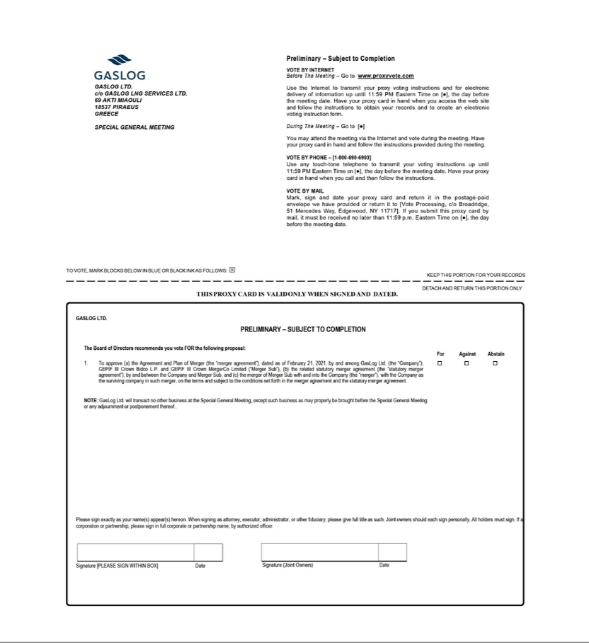

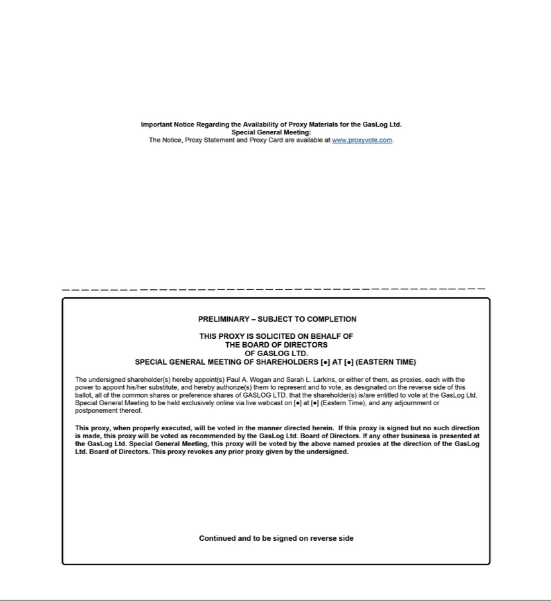

Exhibit (c)(2)
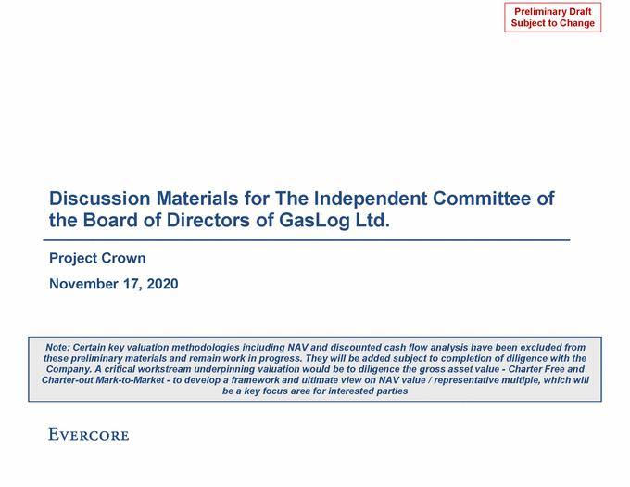

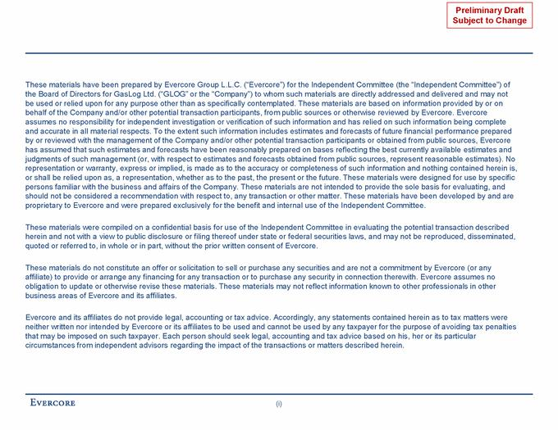

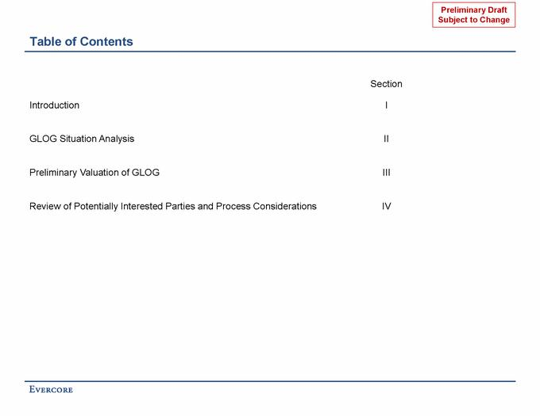

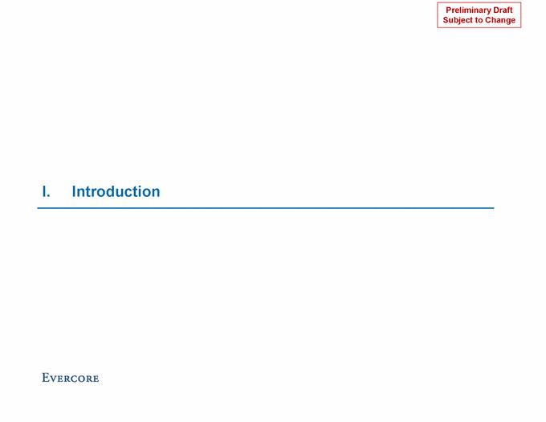

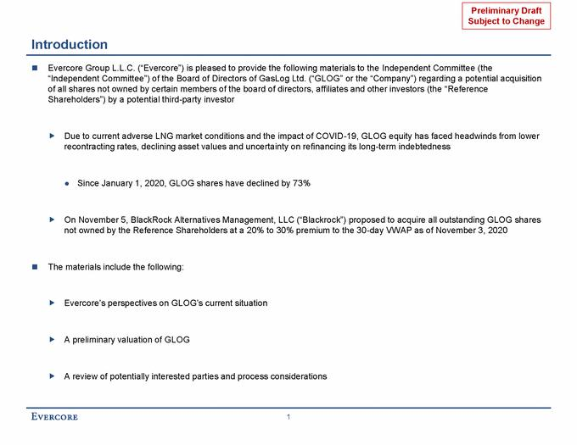

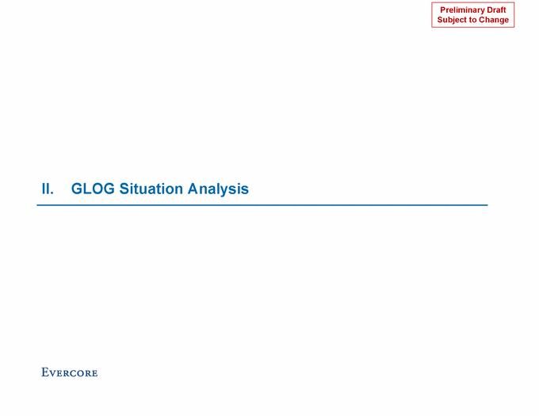

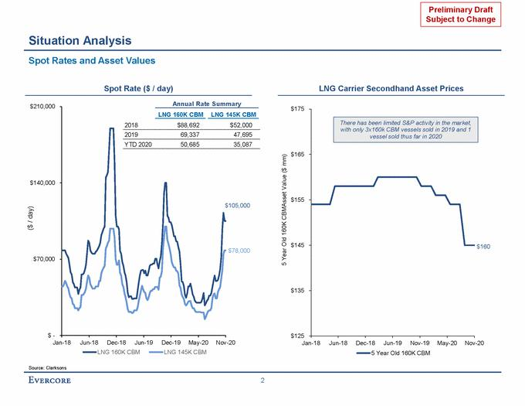

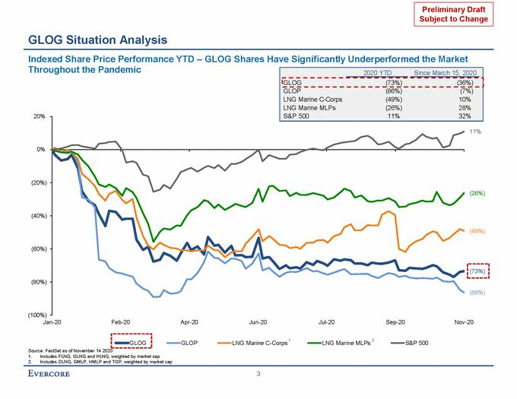

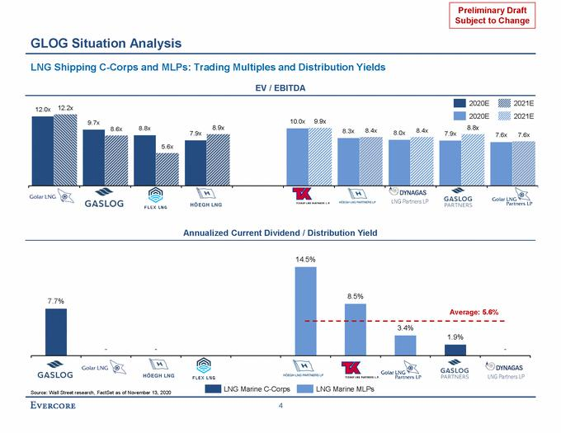

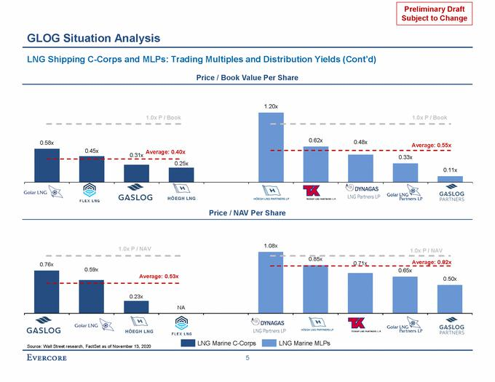

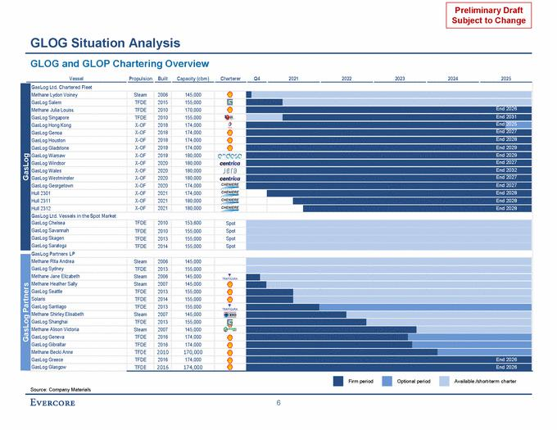

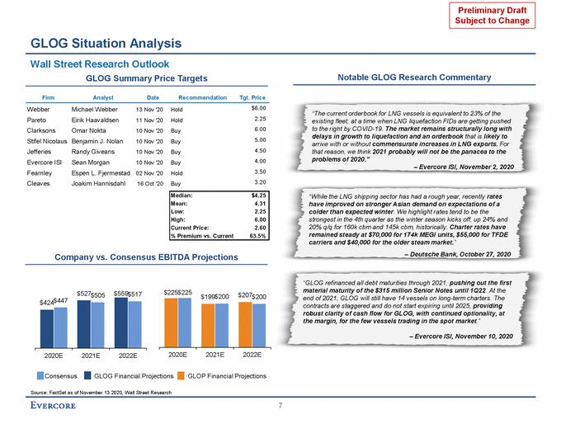

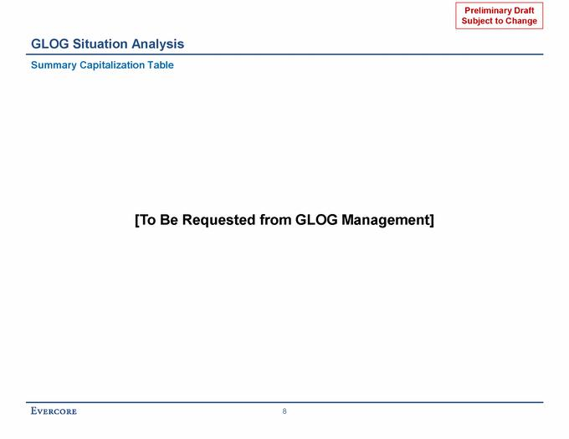

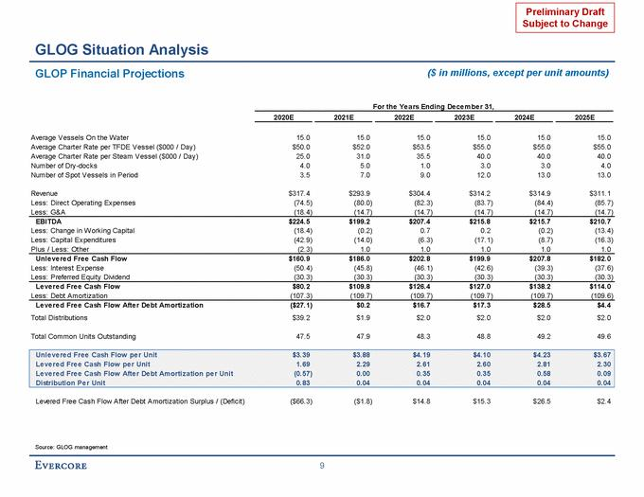

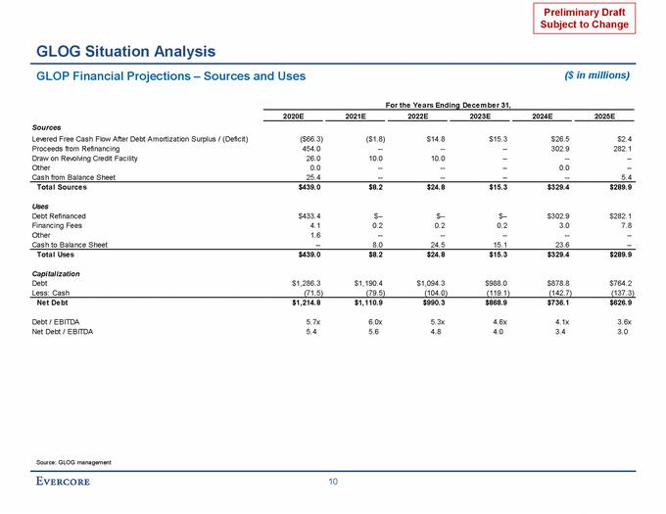

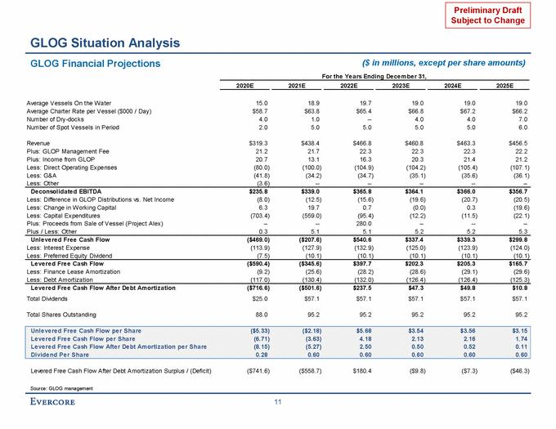

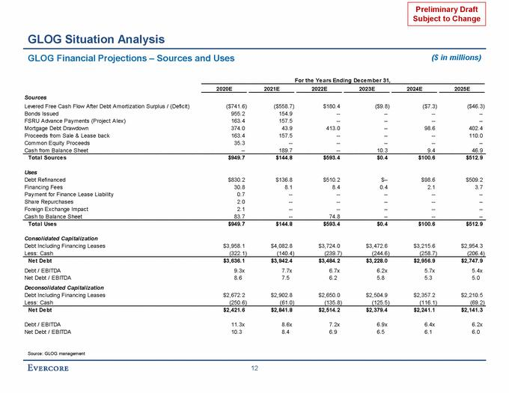

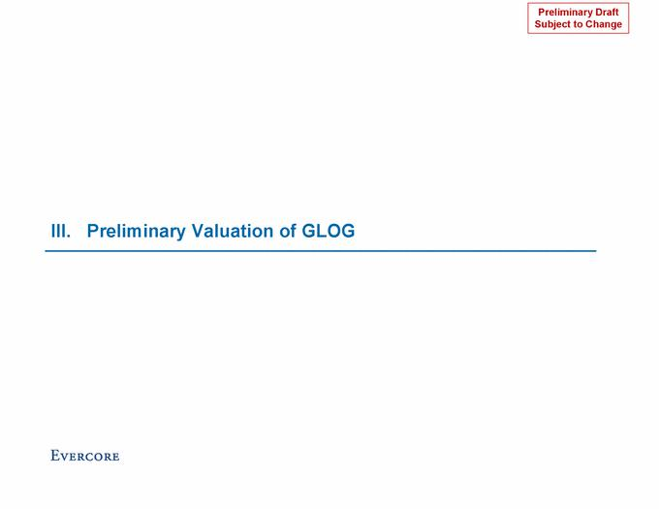

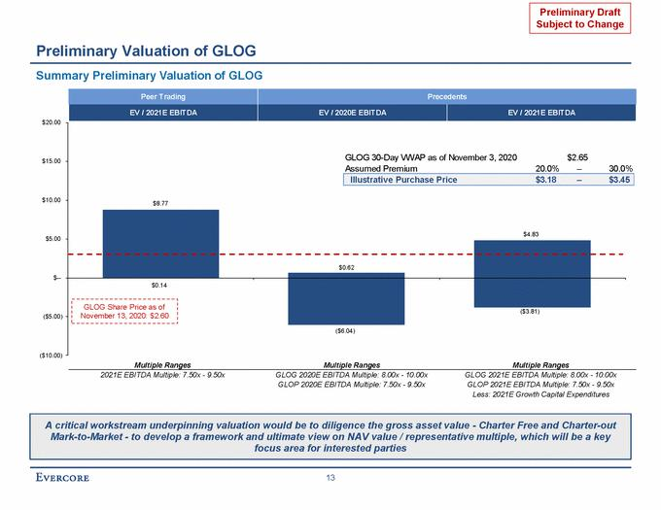

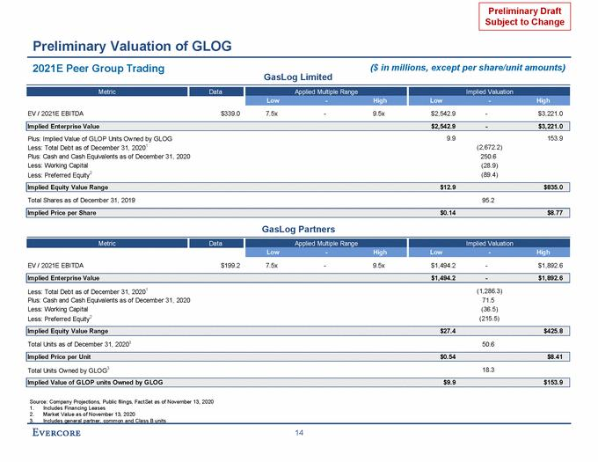

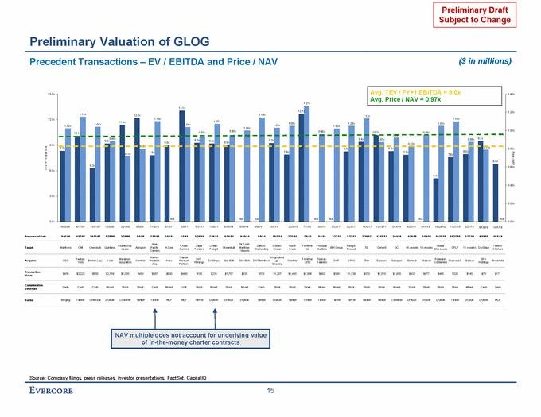

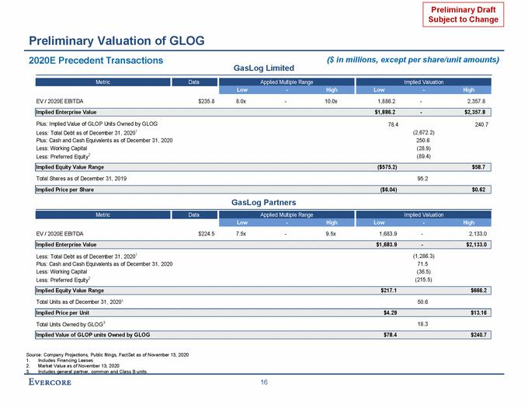

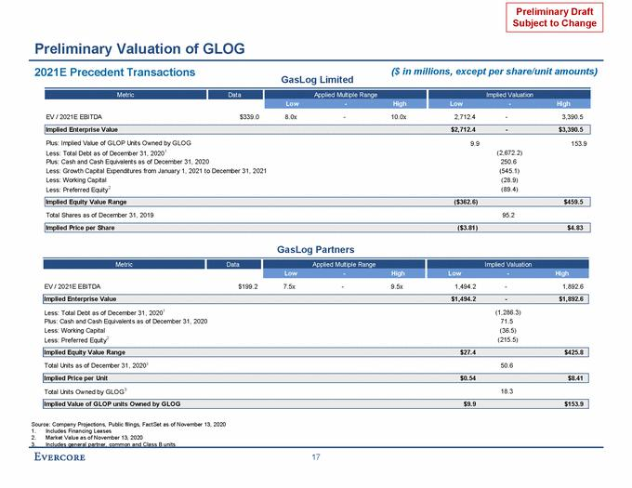

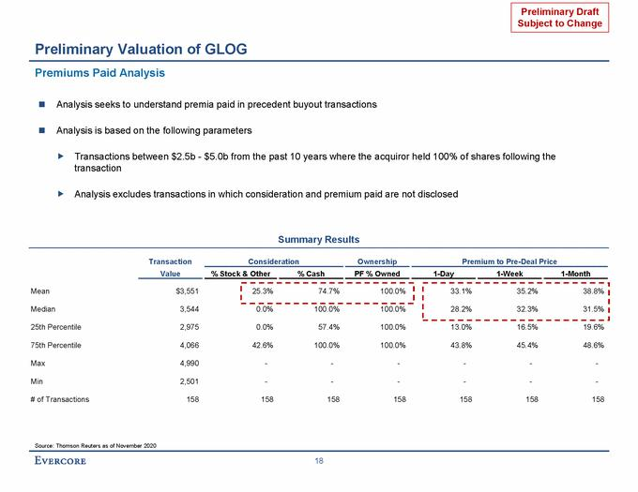

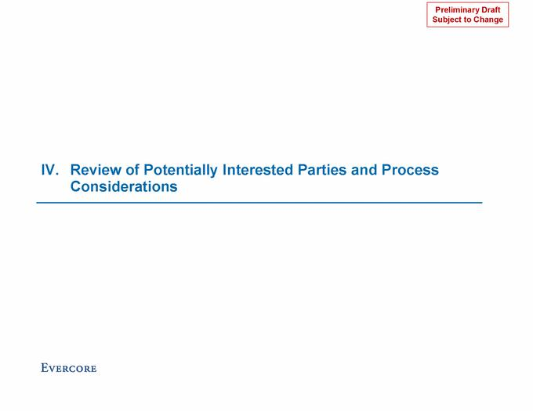

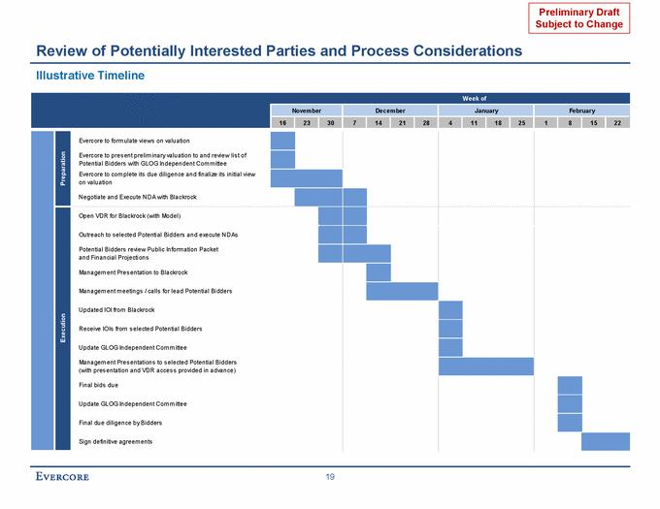

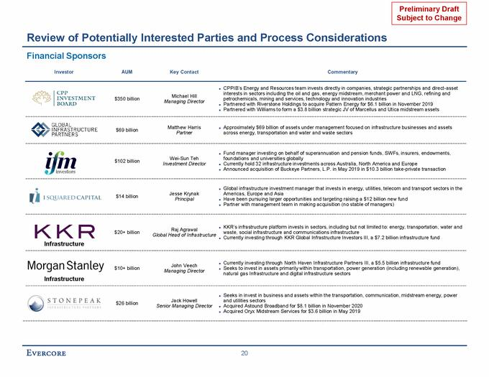

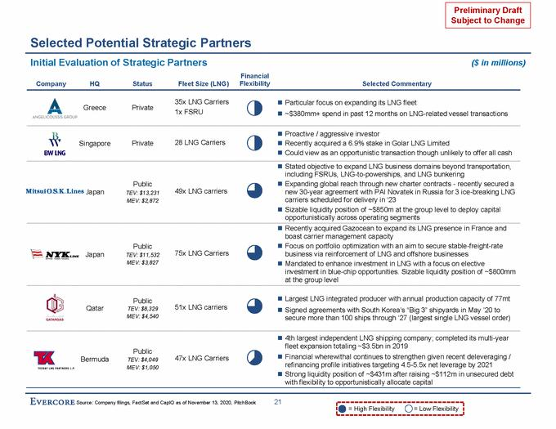

Exhibit (c)(3)
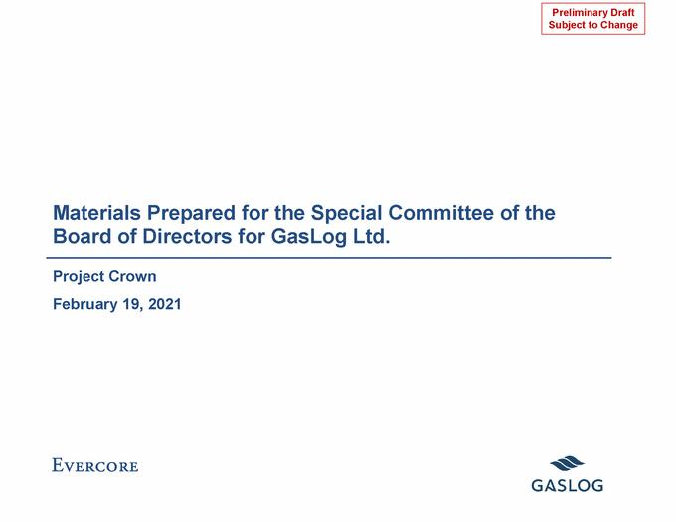

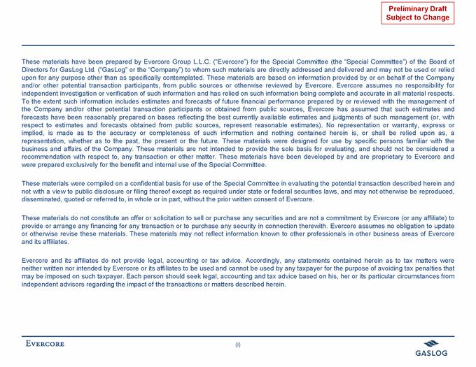

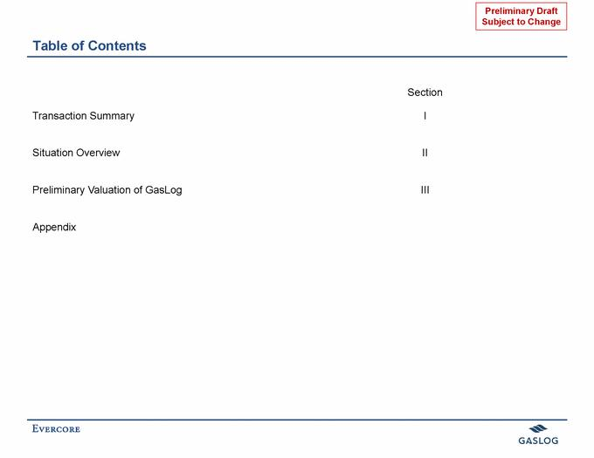

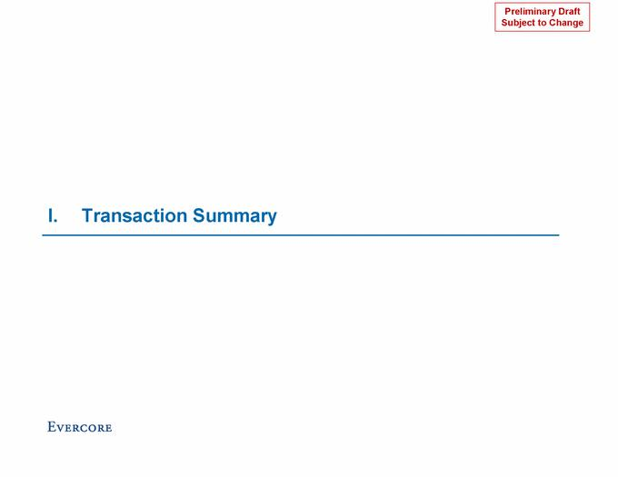

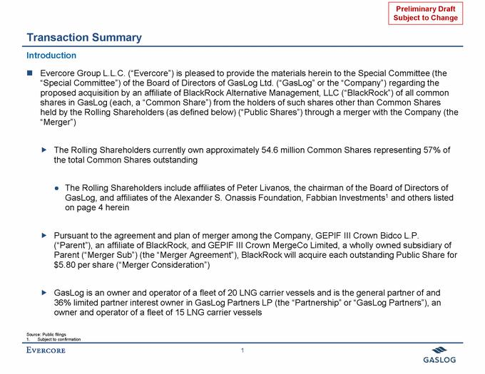

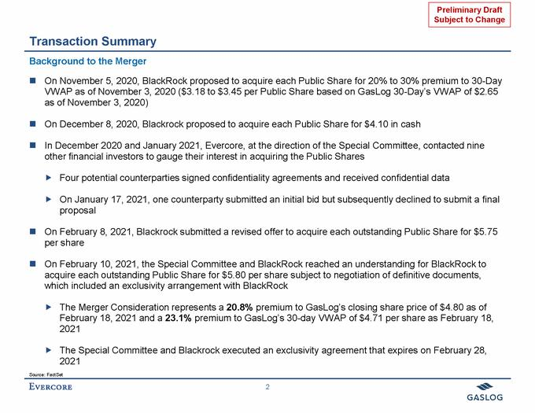

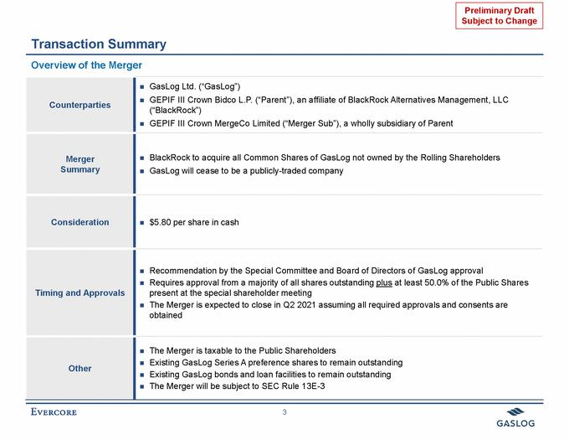

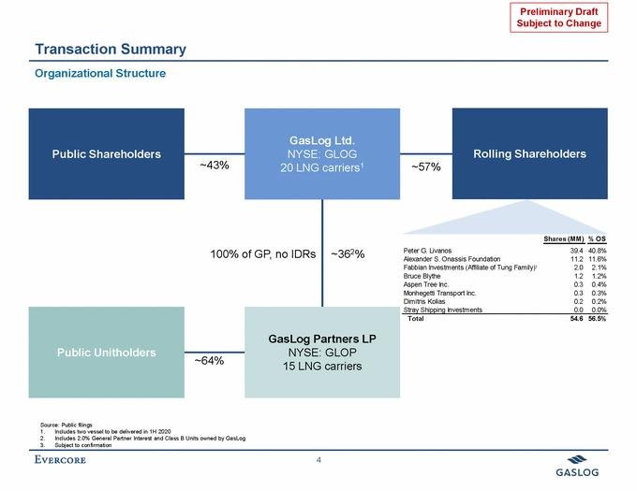

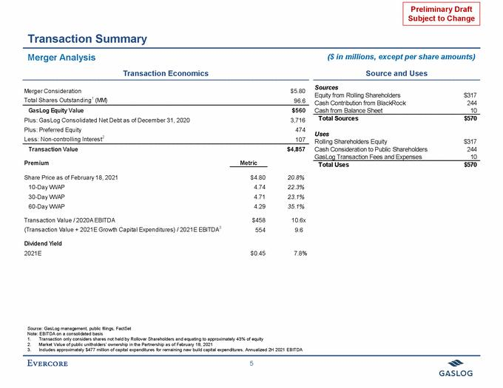

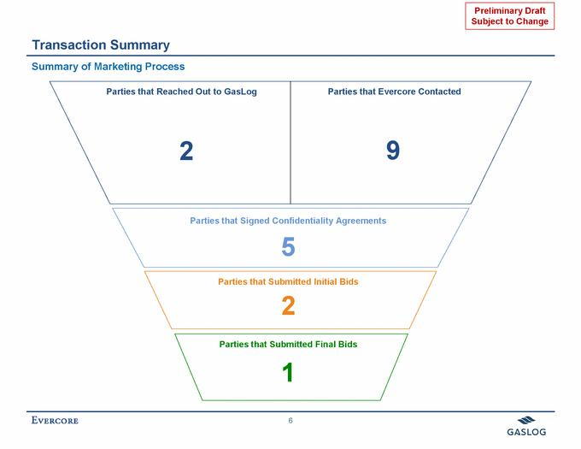

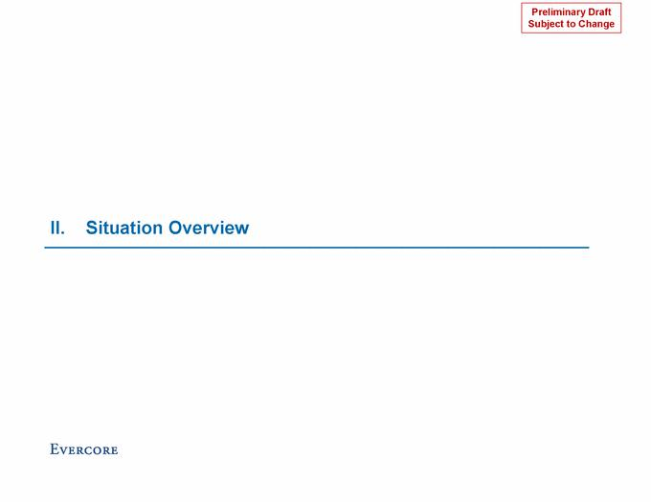

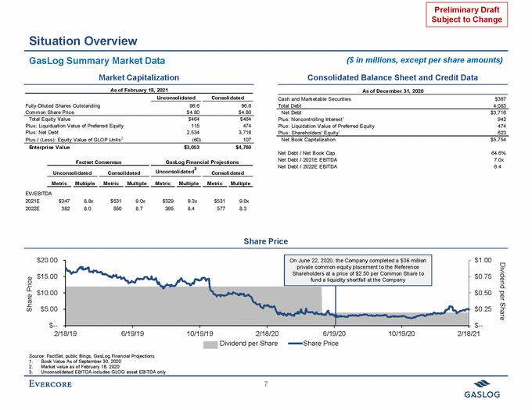

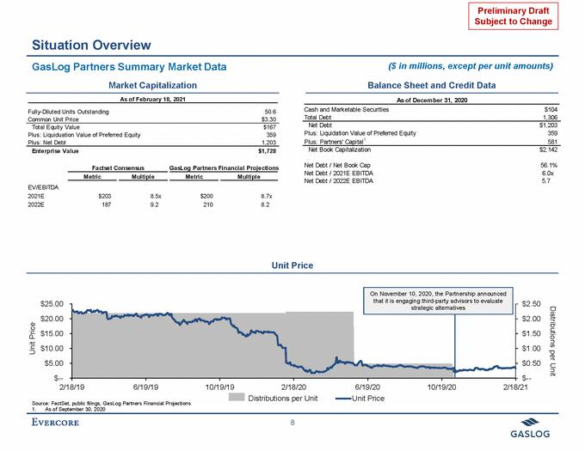

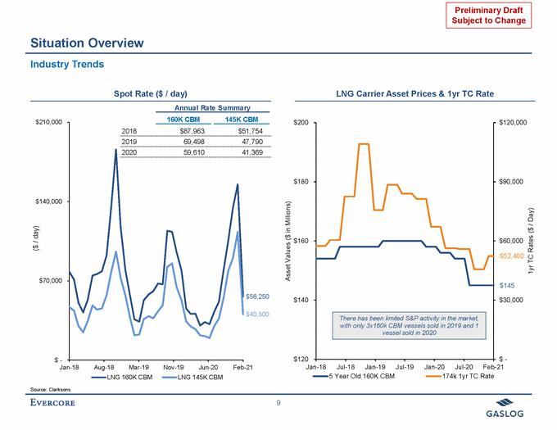

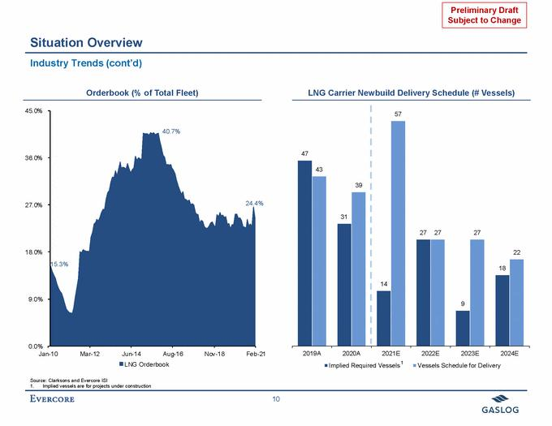

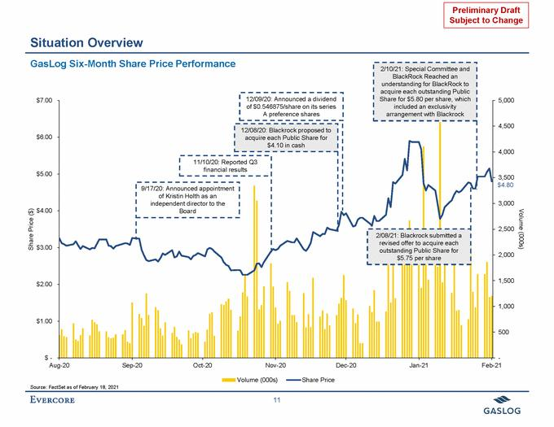

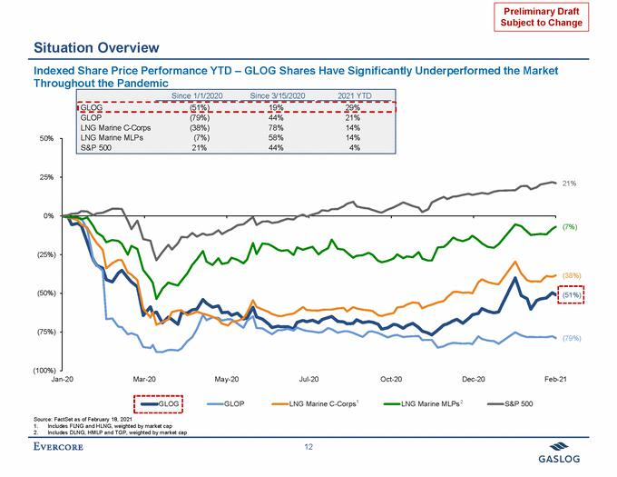

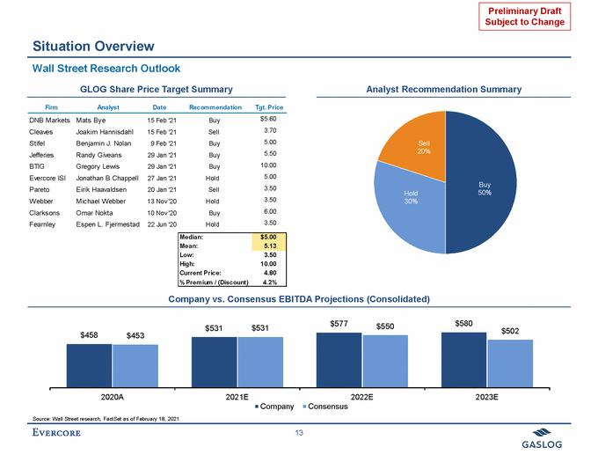

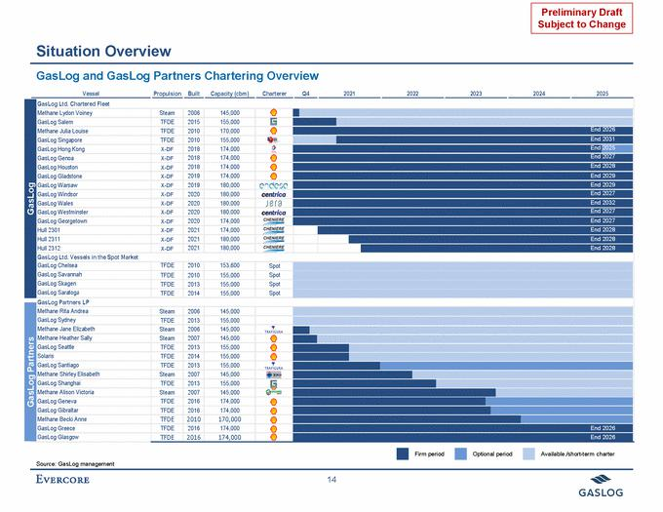

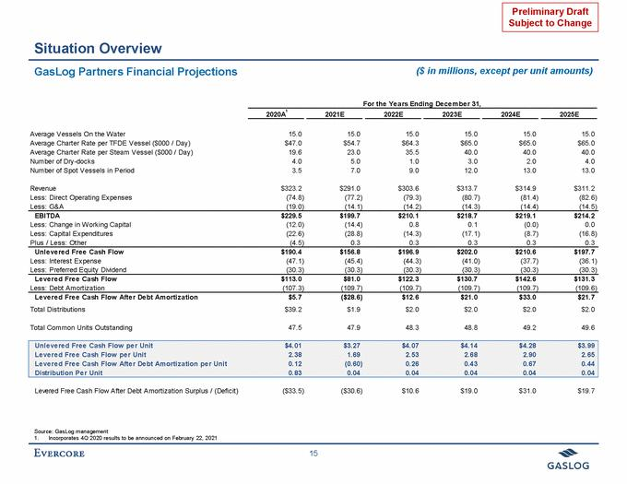

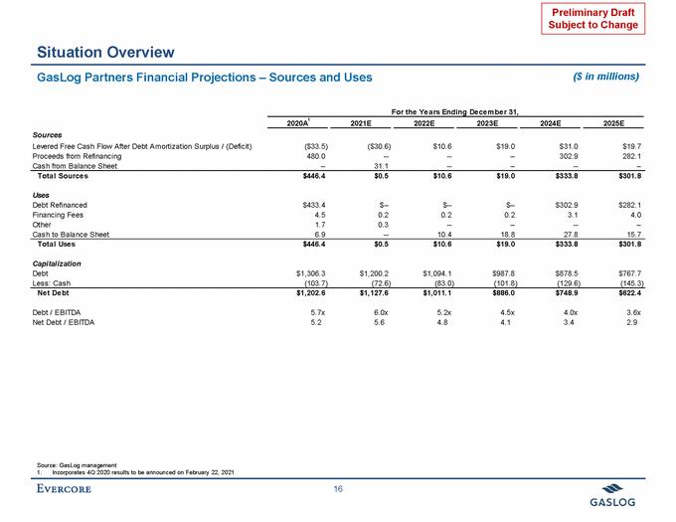

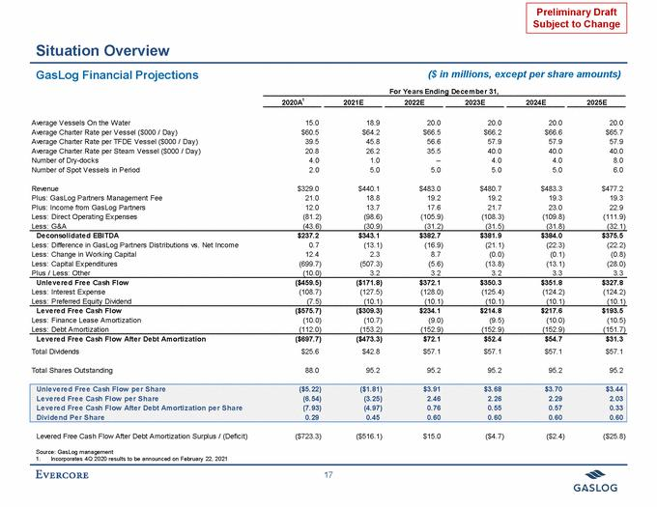

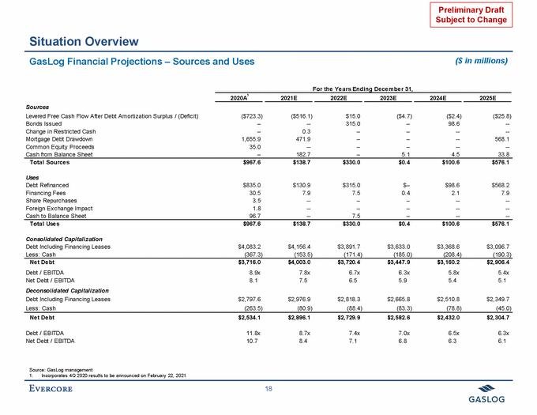

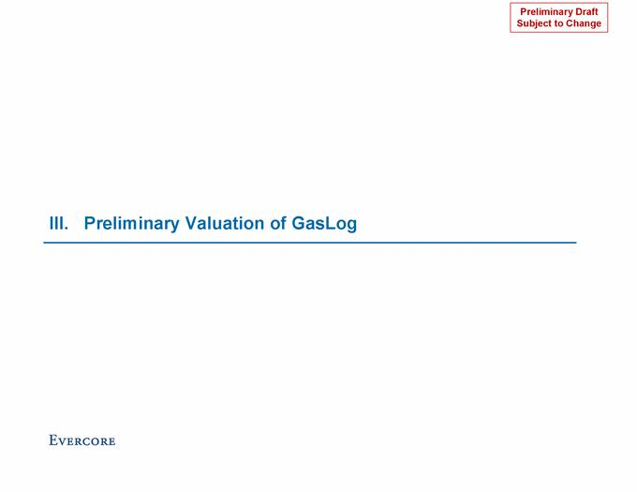

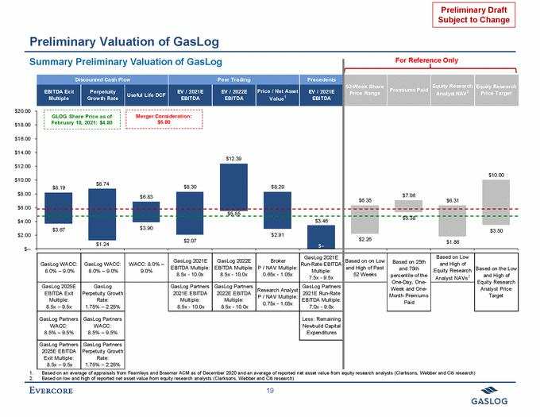

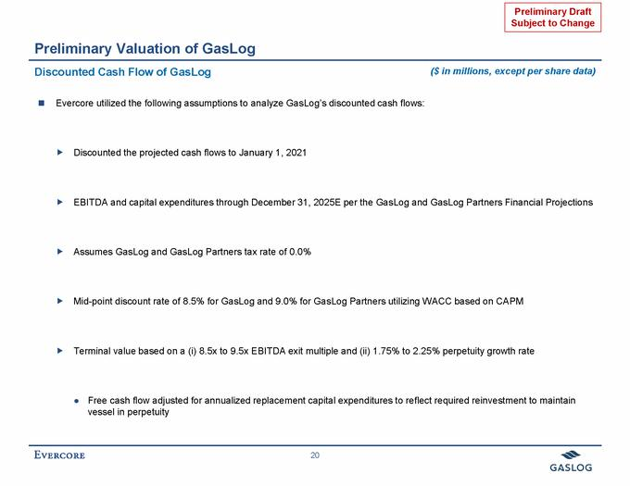

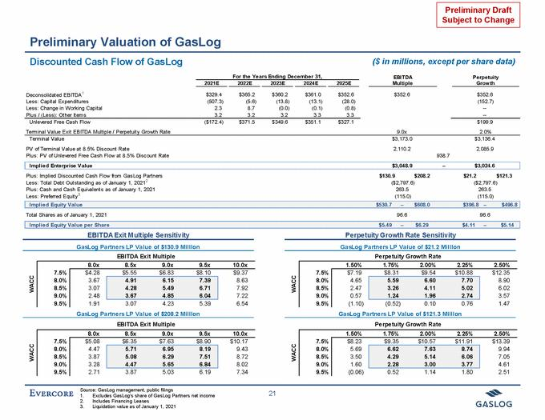

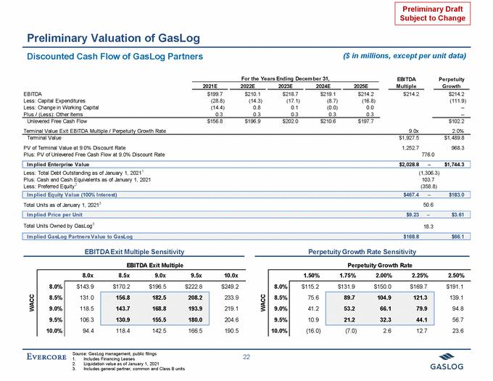

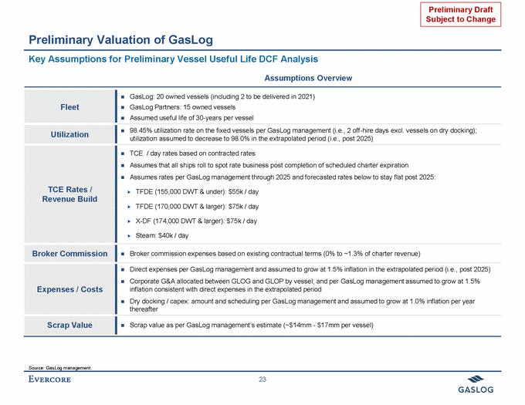

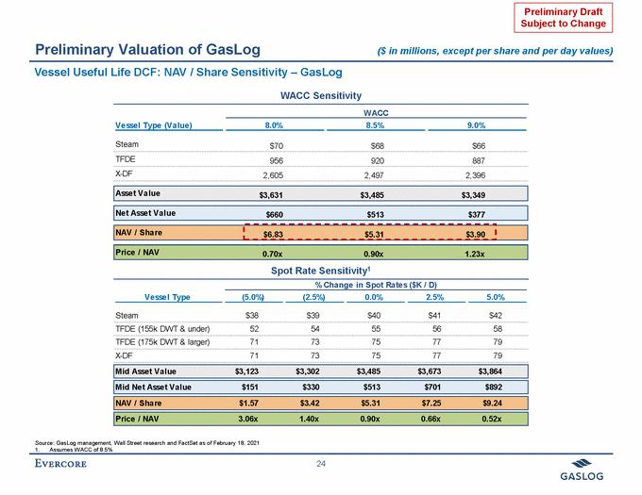

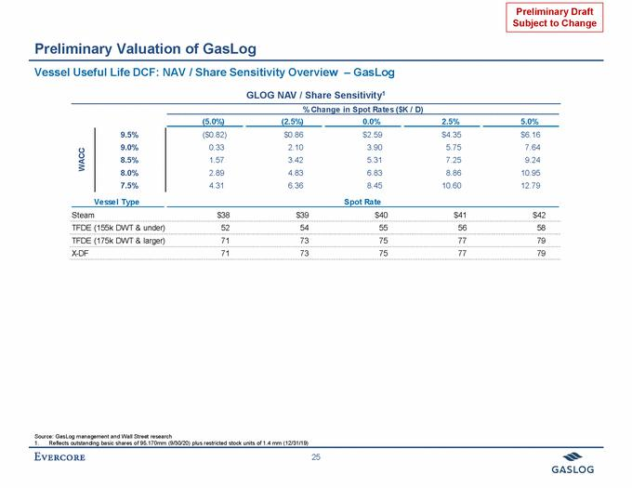

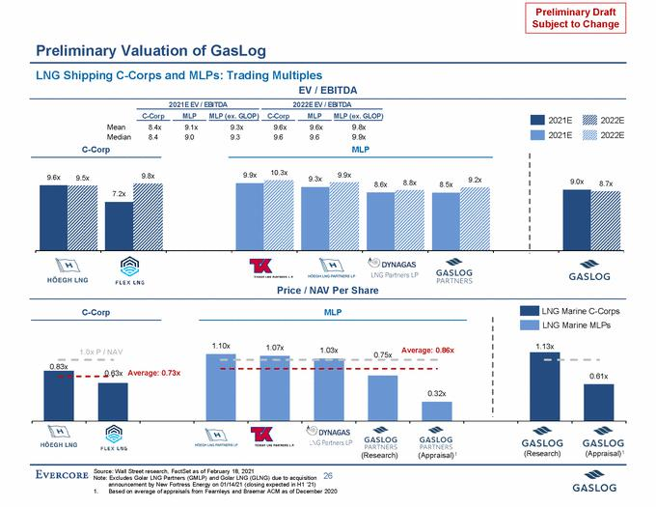

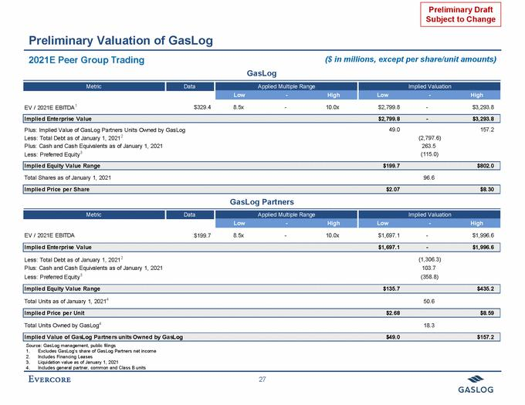

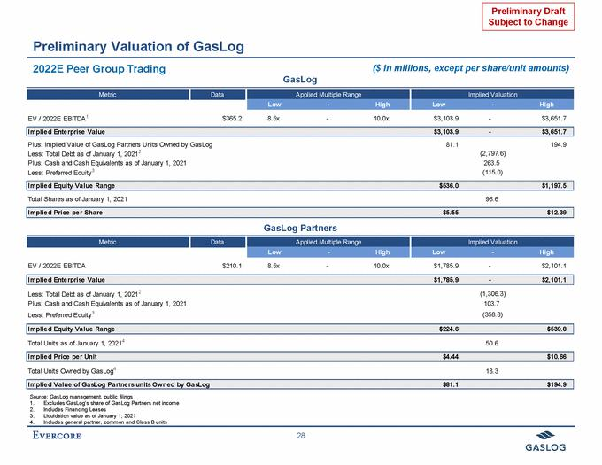

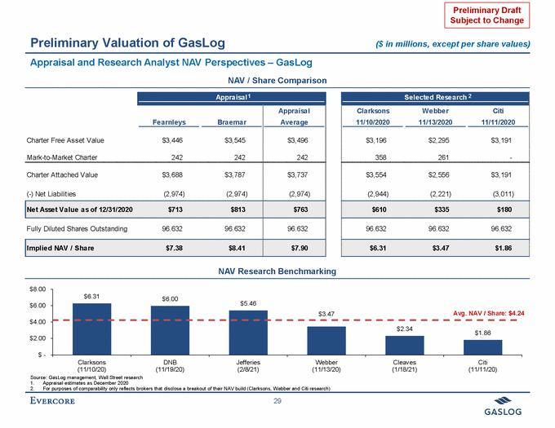

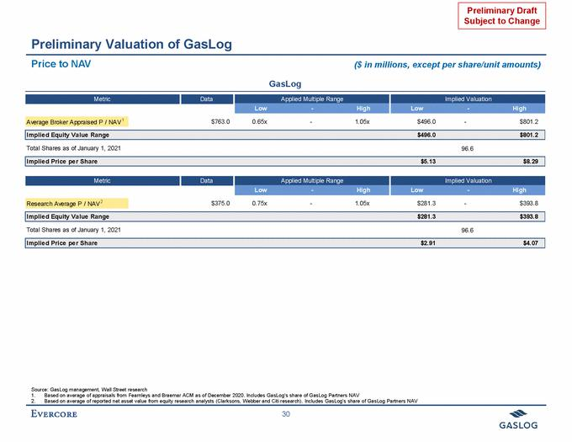

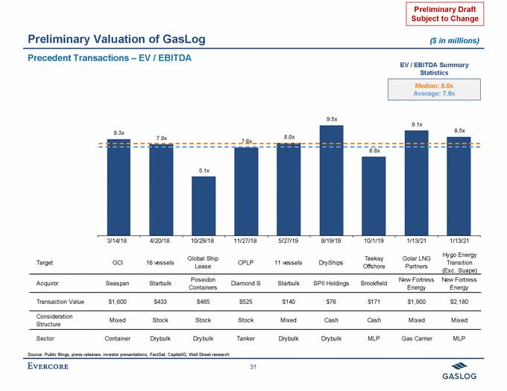

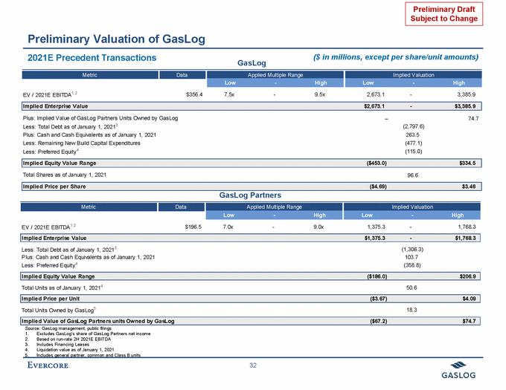

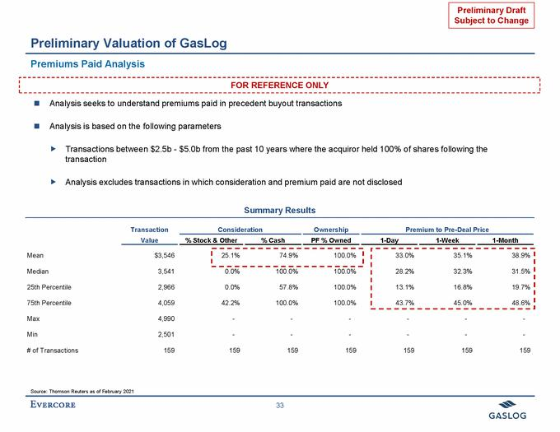

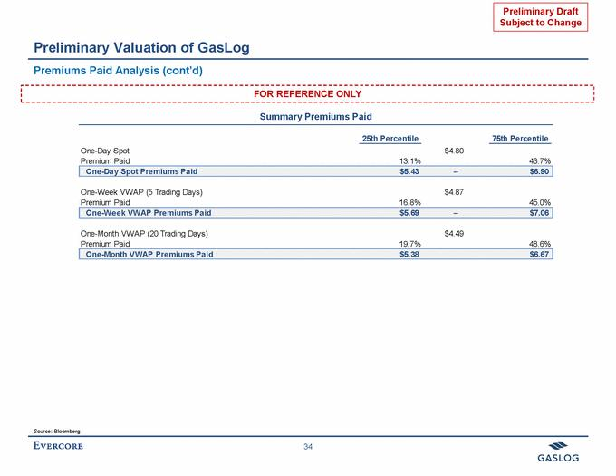

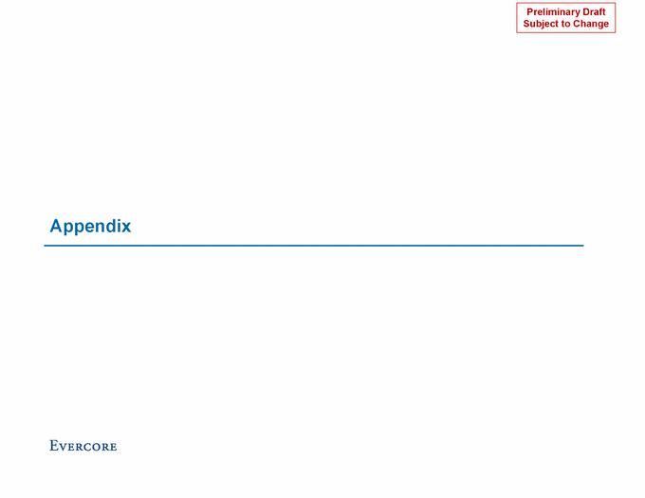

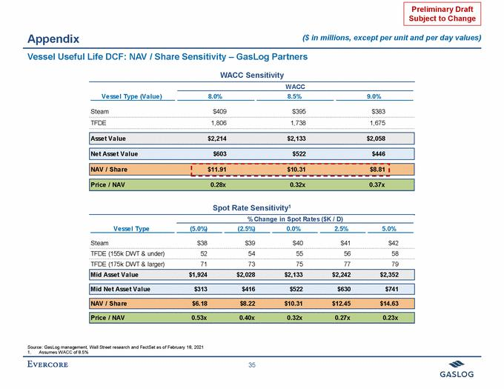

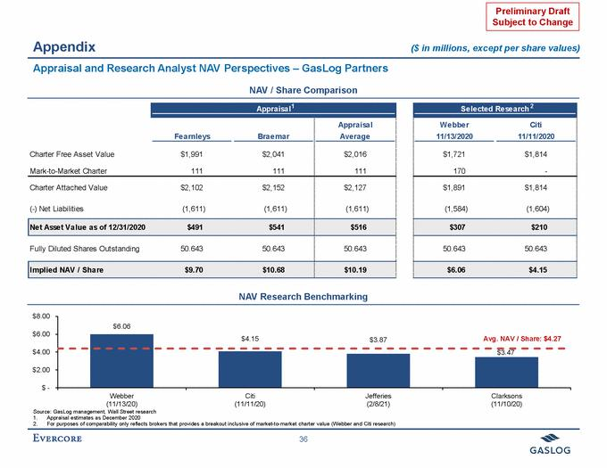

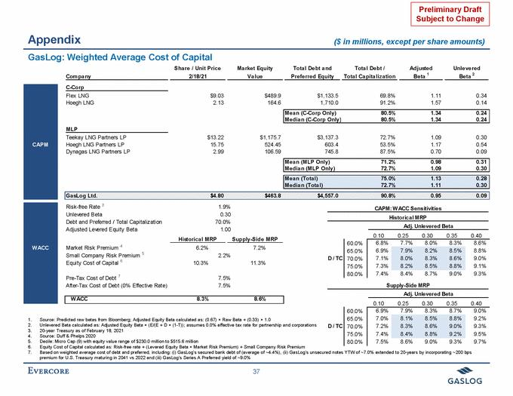

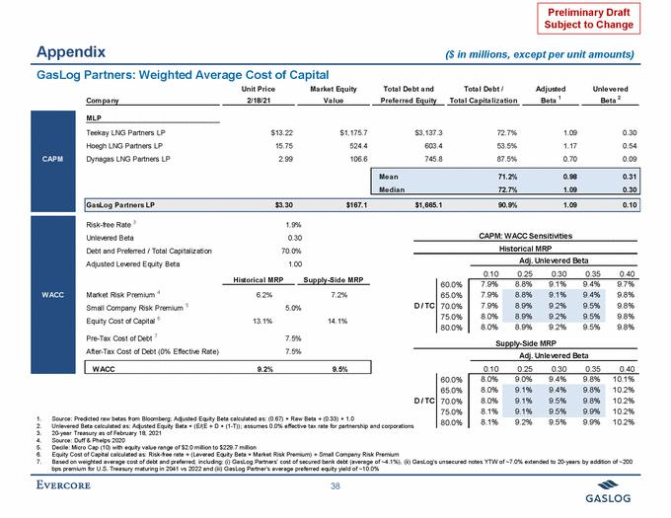

Exhibit (c)(4)
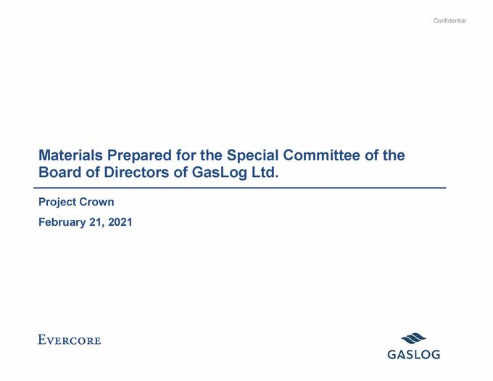

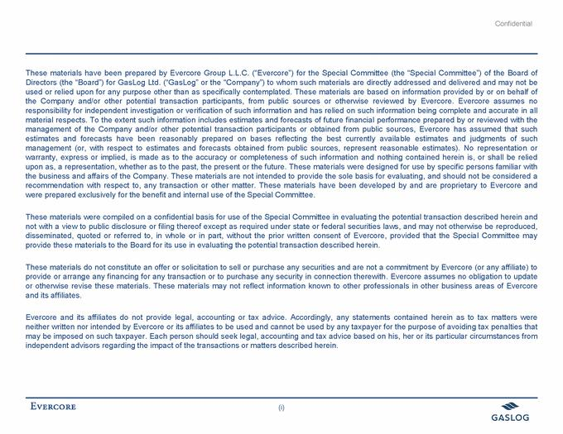

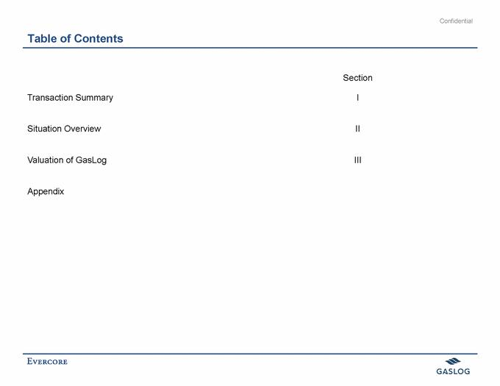

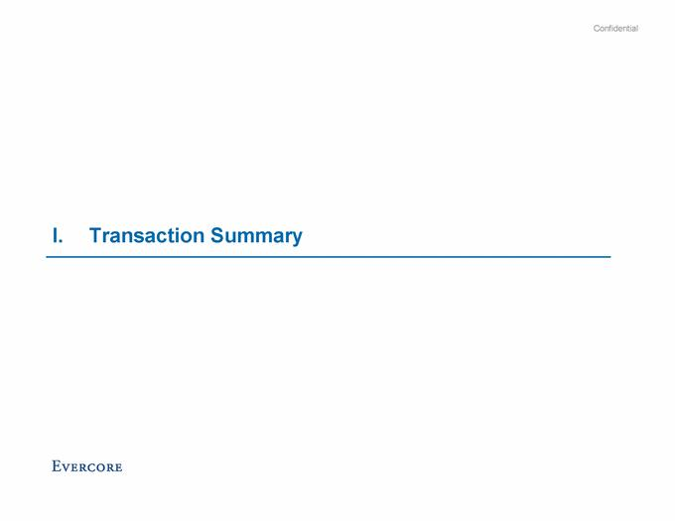

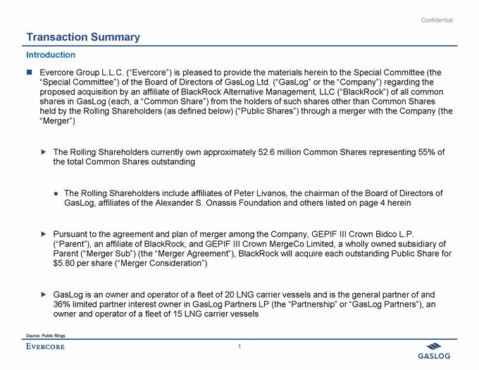

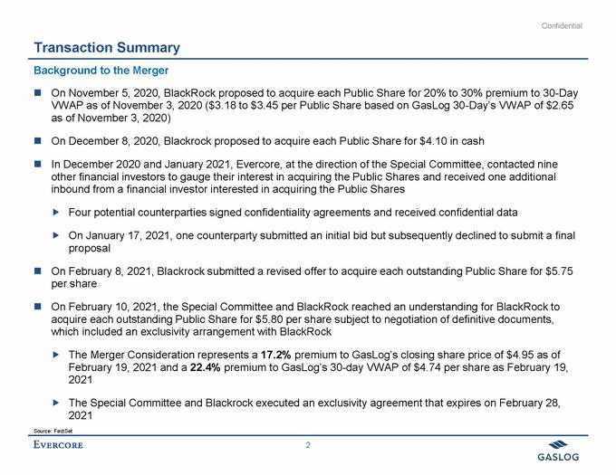

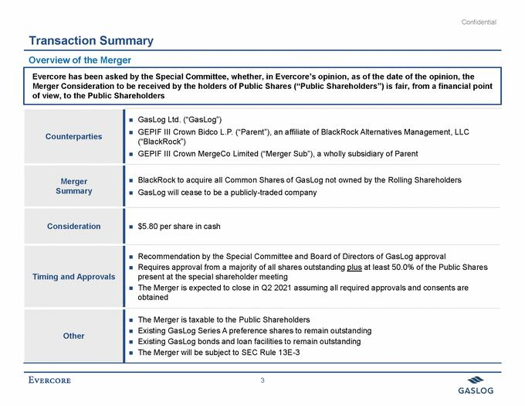

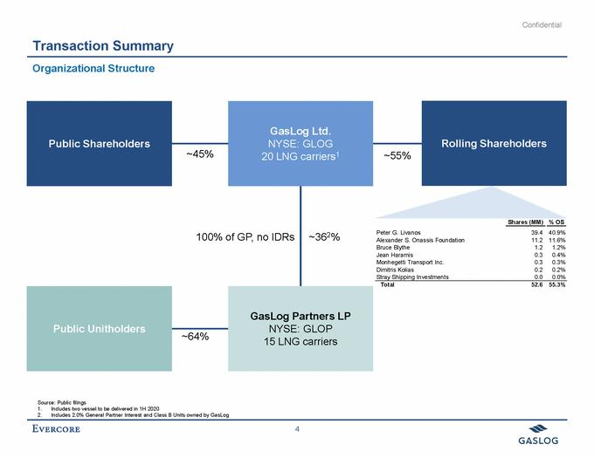

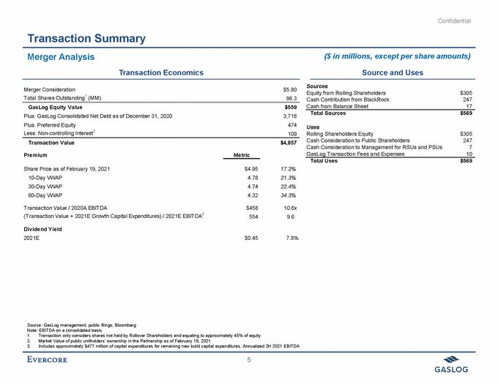

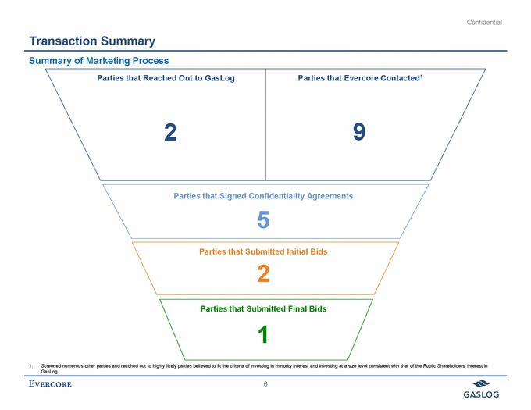

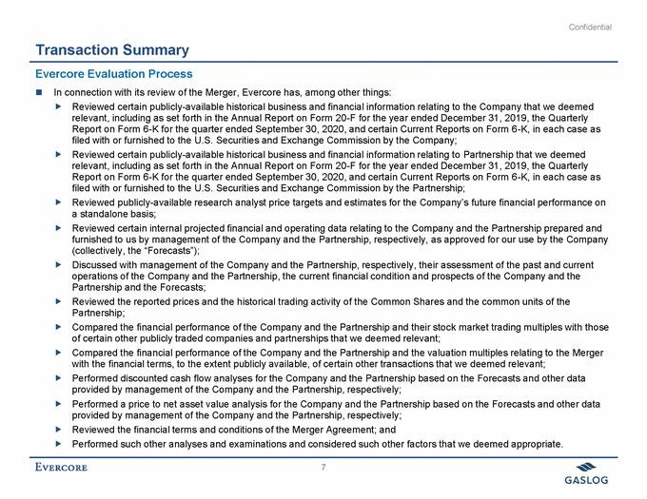

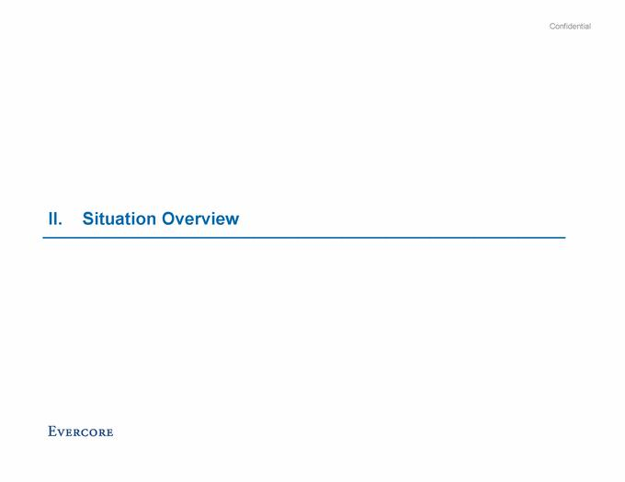

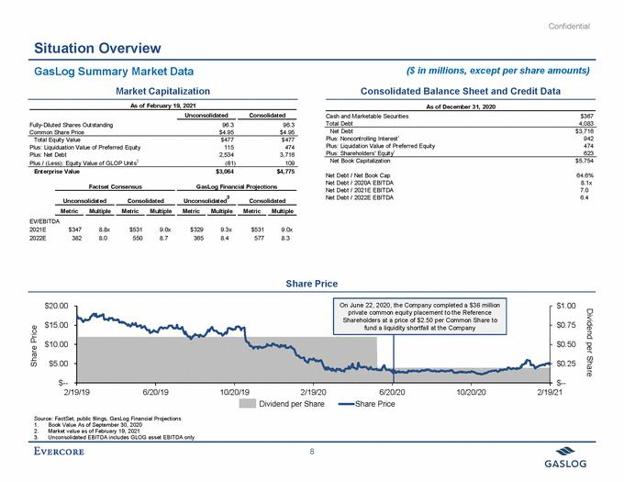

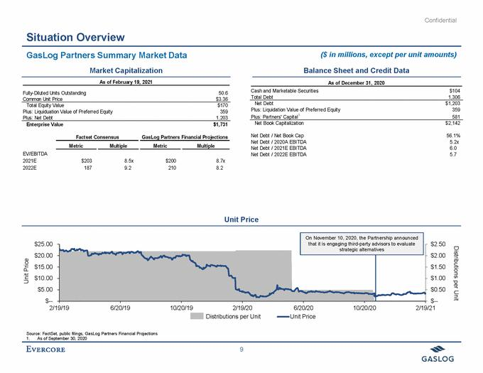

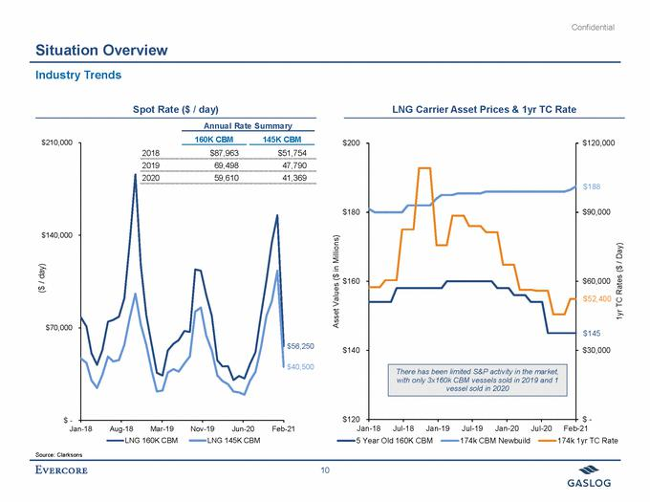

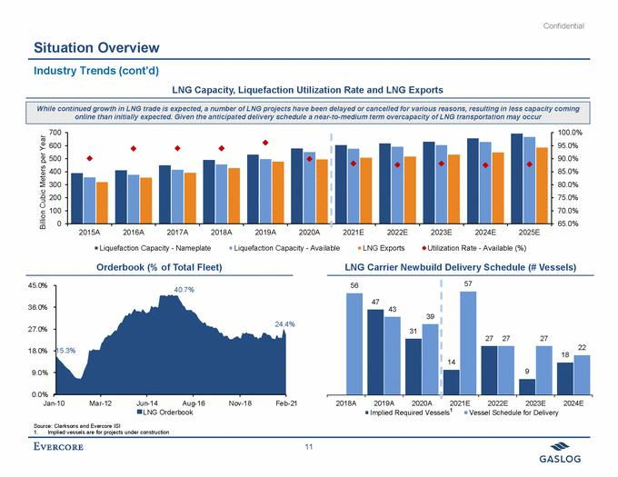

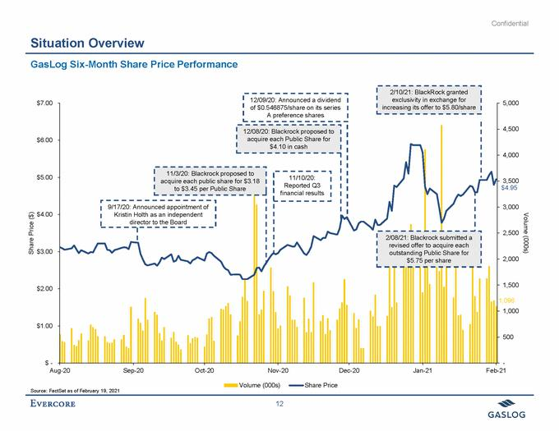

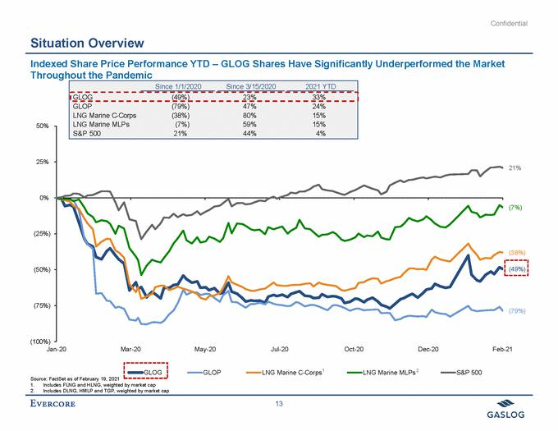

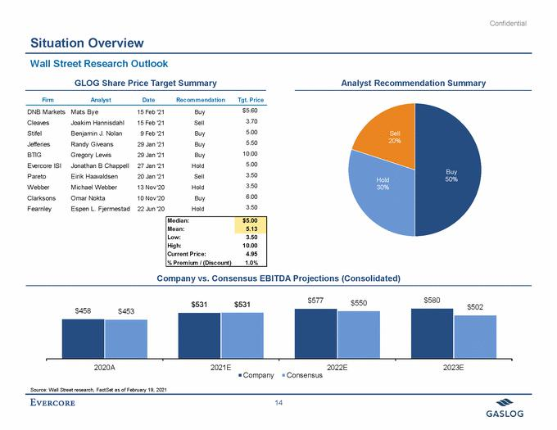

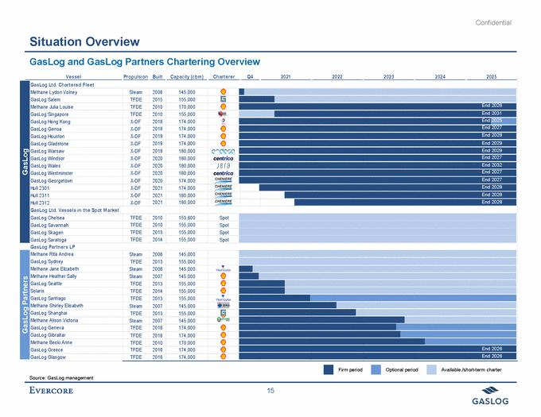

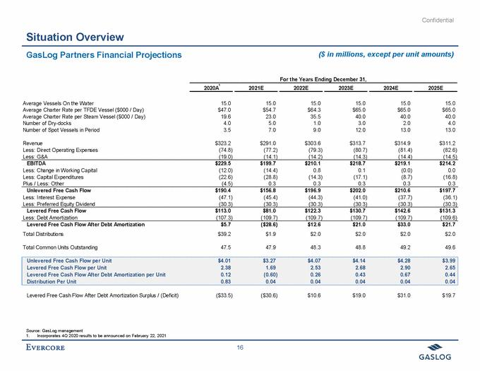

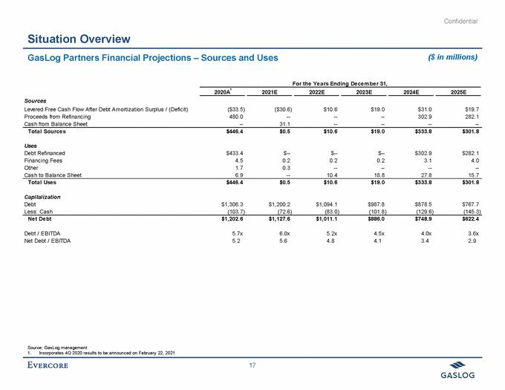

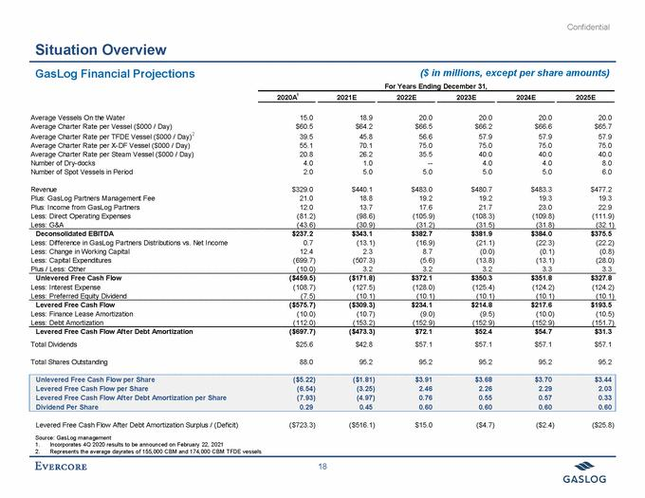

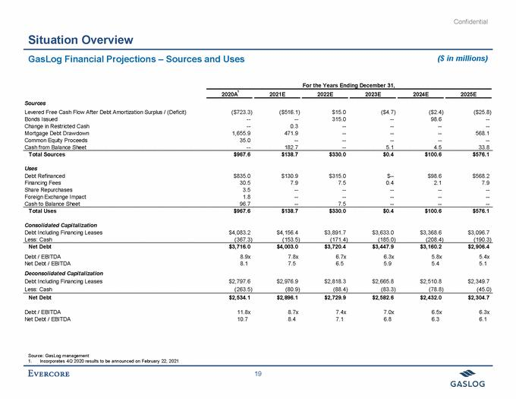

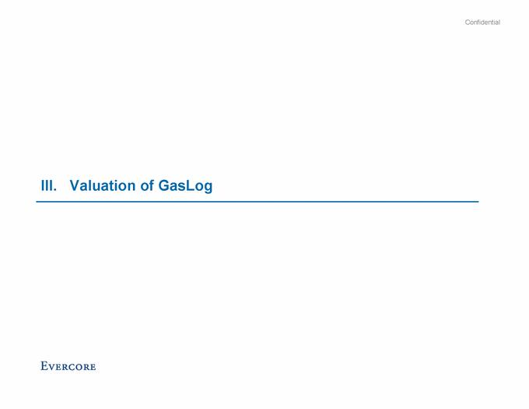

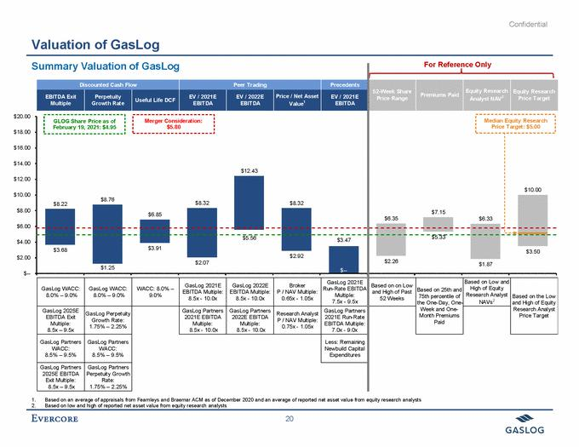

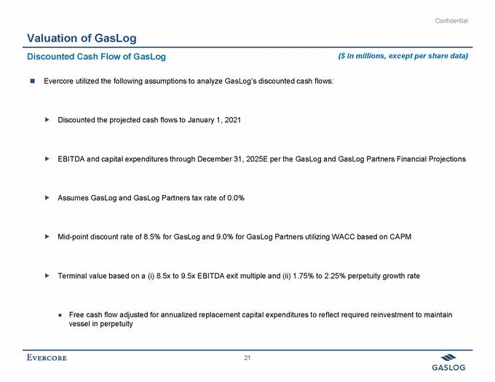

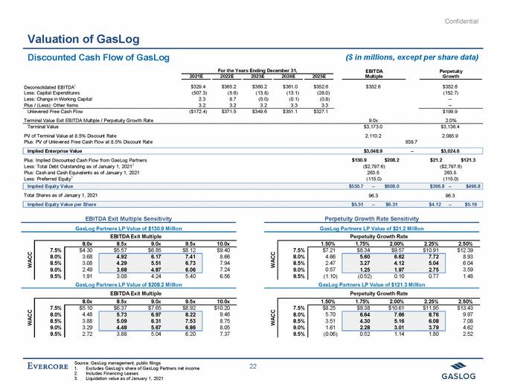

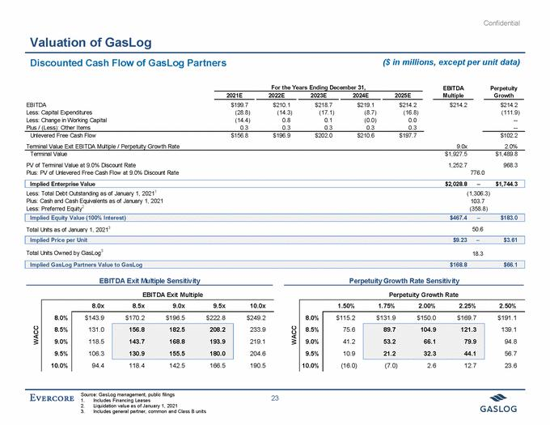

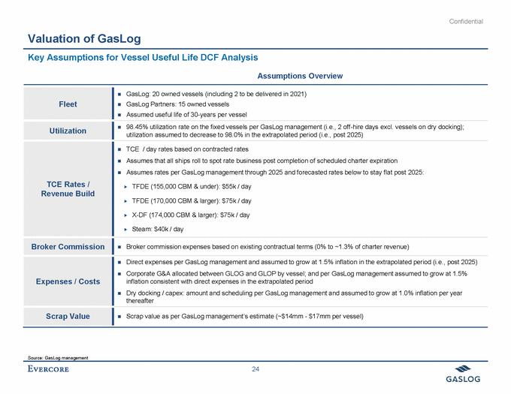

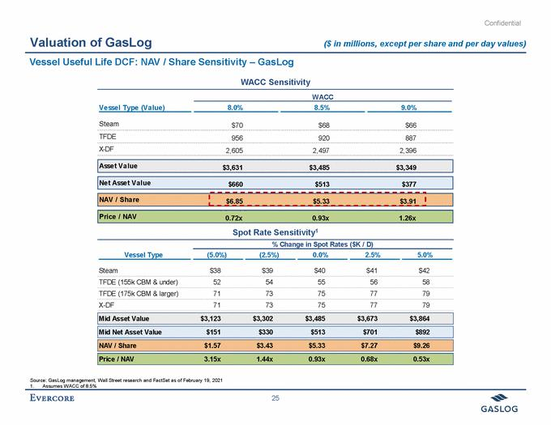

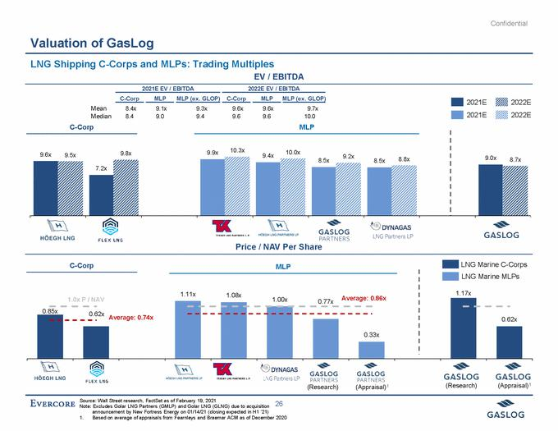

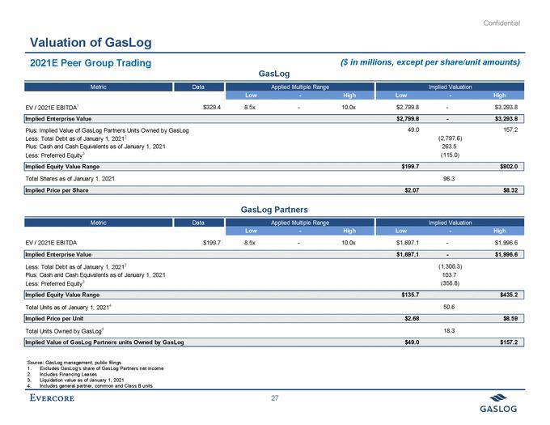

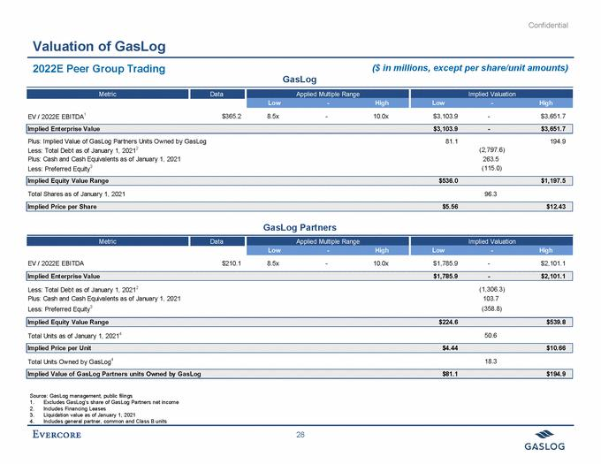

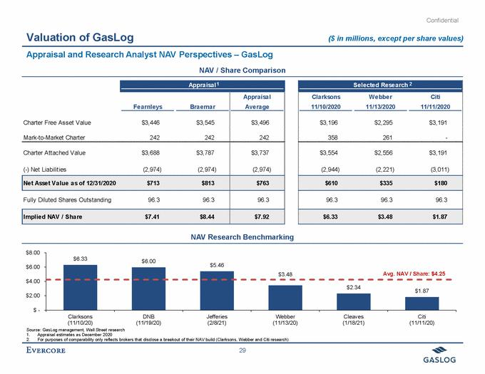

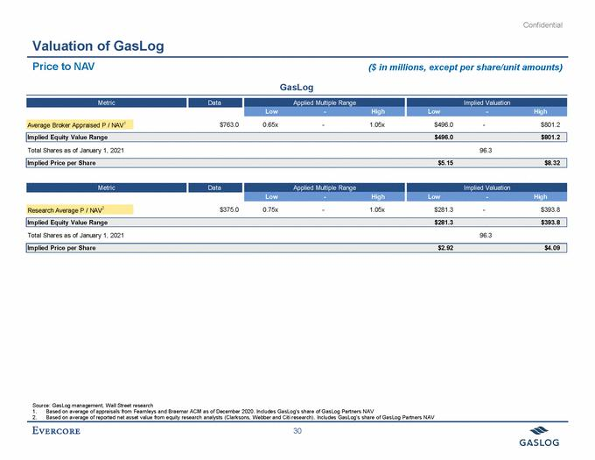

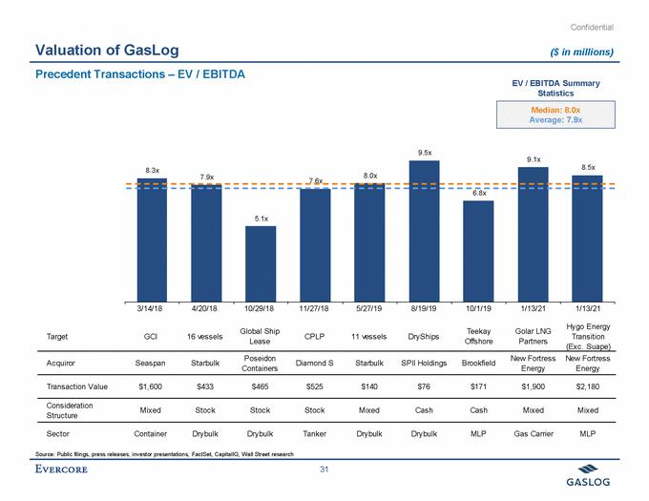

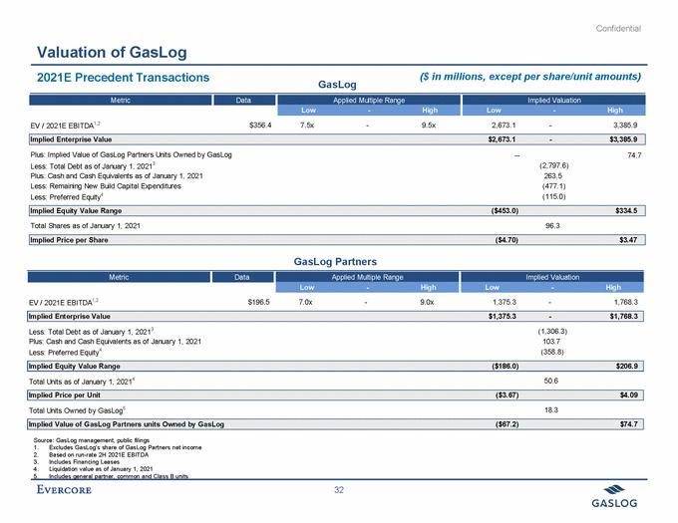

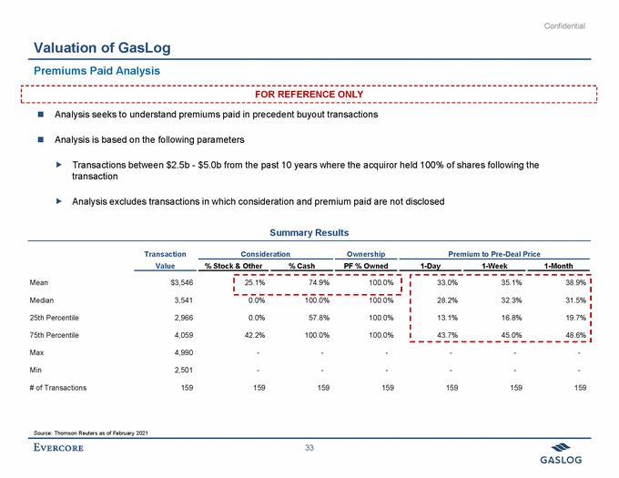

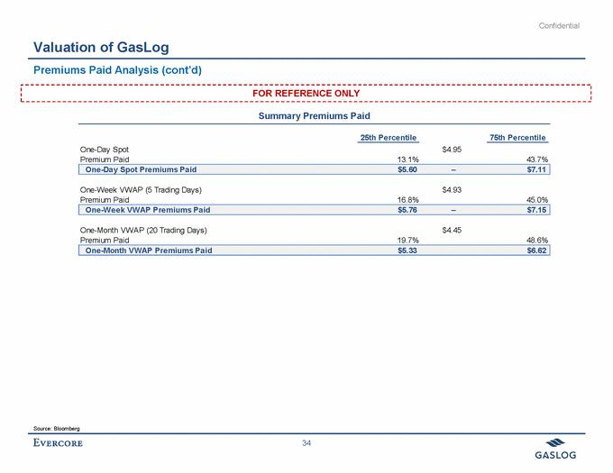



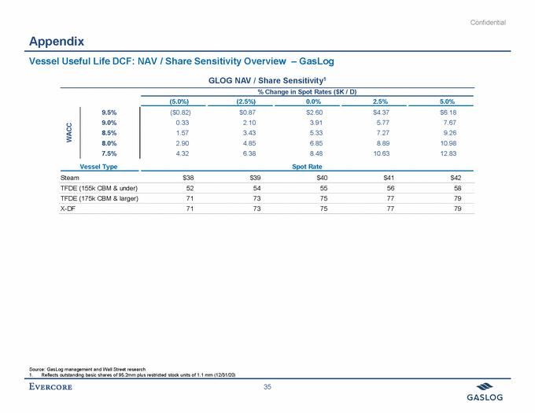

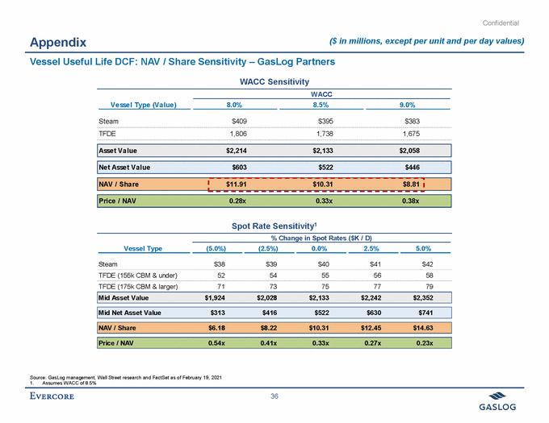

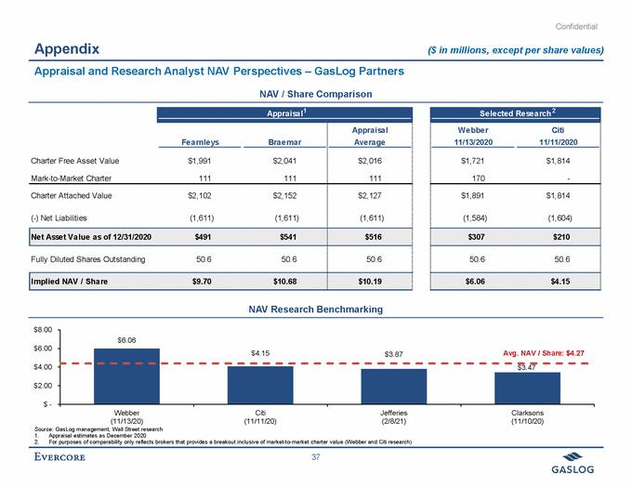

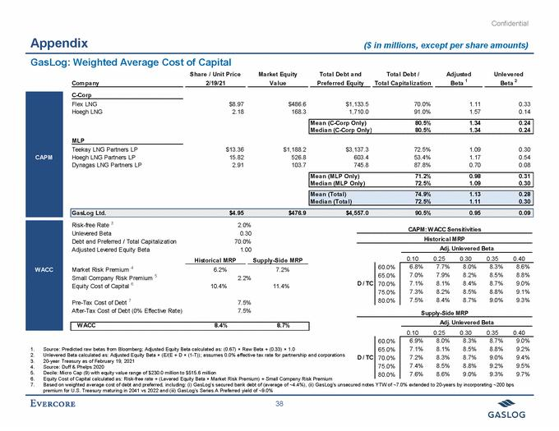

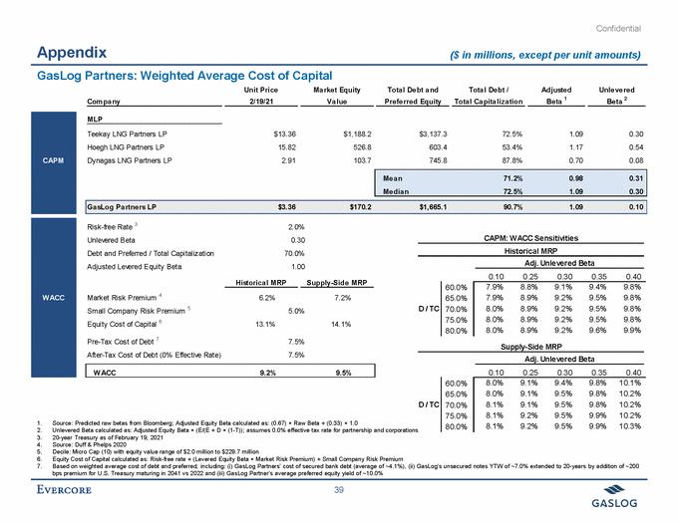

Exhibit (d)(4)

Execution Version

LIMITED GUARANTEE

This LIMITED GUARANTEE is dated as of February 21, 2021 (this “Limited Guarantee”) and is by Global Energy & Power Infrastructure Fund III, L.P., a Cayman Islands exempted limited partnership (the “Guarantor”), in favor of GasLog Ltd., a Bermuda exempted company (the “Company” or the “Guaranteed Party”). Each capitalized term used and not defined herein shall have the meaning ascribed to it in the Merger Agreement (as defined below).

- Limited Guarantee. To induce the Guaranteed Party to enter into the Agreement and Plan of Merger, dated as of February 21, 2021 (as it may be amended, restated, supplemented or otherwise modified in accordance with its terms from time to time, the “Merger Agreement”) by and among the Guaranteed Party, GEPIF III Crown Bidco L.P., a Cayman Islands exempted limited partnership (“Parent”), and GEPIF III Crown MergerCo Limited, a Bermuda exempted company and a wholly owned Subsidiary of Parent (“Merger Sub”), pursuant to which, subject to the terms and conditions set forth in the Merger Agreement, Merger Sub will merge with and into the Company, with the Company surviving such merger, the Guarantor, intending to be legally bound, hereby expressly, absolutely, irrevocably and unconditionally guarantees to the Guaranteed Party, as primary guarantor and not merely as surety, on the terms and subject to the conditions set forth herein, the due and punctual payment of the Parent Termination Fee as and when due and payable under Section 7.03(c) of the Merger Agreement and any amounts due under Section 7.03(e) of the Merger Agreement, pursuant to, and subject to the terms of, the Merger Agreement (the “Obligations”), it being understood that in no event shall the Guarantor’s aggregate liability under this Limited Guarantee exceed $40,000,000, plus any amounts owed under Section 7.03(e) of the Merger Agreement up to an aggregate amount of $10,000,000 (the “Cap”). The Guarantor undertakes to make all payments hereunder free and clear of any deduction, offset, defense, claim or counterclaim of any kind. The Guaranteed Party hereby agrees that in no event shall the Guarantor be required to pay to the Guaranteed Party under, in respect of, or in connection with this Limited Guarantee or the Merger Agreement any amounts other than as expressly set forth herein. All payments hereunder shall be made in lawful money of the United States, in immediately available funds.

- Nature of Guaranty. Guarantor’s liability hereunder is absolute, unconditional, irrevocable and continuing irrespective of any modification, amendment or waiver of or any consent to departure from the Merger Agreement or any agreement or instrument related thereto that may be agreed to by Parent and Merger Sub. Without limiting the foregoing, the Guaranteed Party shall not be obligated to file any claim relating to the Obligations in the event that Parent becomes subject to a bankruptcy, reorganization or similar proceeding, and the failure of the Guaranteed Party to so file shall not affect the Guarantor’s obligations hereunder. In the event that any payment hereunder, or any other payment of the Obligations (including payment by Parent), is rescinded or must otherwise be returned for any reason whatsoever, Guarantor shall remain liable hereunder as if such payment had not been made. This Limited Guarantee is an unconditional and continuing guarantee of payment and not of collection, and the Guaranteed Party shall not be required to proceed against Parent first before proceeding against Guarantor hereunder.

- Changes in Obligations, Certain Waivers. The Guarantor agrees that, to the fullest extent permitted by Law, its obligations hereunder shall not be released or discharged, in whole or in part, or otherwise affected by (a) the failure or delay on the part of the Guaranteed Party to assert any claim or demand or to enforce any right or remedy against Parent or any other Person

1

(including the Guarantor); (b) any change in the time, place or manner of payment of the Obligations or any rescission, waiver, compromise, consolidation or other amendment to or modification of any of the terms or provisions of the Merger Agreement or the Equity Commitment Letter (as defined below) made in accordance with the terms thereof; (c) the addition, substitution or release of any Person now or hereafter liable with respect to the Obligations or otherwise interested in the transactions contemplated by the Merger Agreement, the Equity Commitment Letter, this Limited Guarantee or any related agreement or document; (d) any change in the legal existence, structure or ownership of Parent or any other Person (including the Guarantor) now or hereafter liable with respect to the Obligations or otherwise interested in the transactions contemplated by the Merger Agreement, the Equity Commitment Letter, this Limited Guarantee or any related agreement or document; (e) any insolvency, bankruptcy, reorganization or other similar proceeding affecting Parent or any other Person (including the Guarantor) now or hereafter liable with respect to the Obligations or otherwise interested in the transactions contemplated by the Merger Agreement, the Equity Commitment Letter, this Limited Guarantee or any related agreement or document; (f) the existence of any claim, set-off or other right which the Guarantor may have at any time against Parent or any other Person (including the Guaranteed Party), whether in connection with the Obligations or otherwise; (g) the adequacy of any other means the Guaranteed Party may have of obtaining payment related to the Obligations; (h) the value, genuineness, validity, regularity, illegality or enforceability of the Merger Agreement, the Equity Commitment Letter or any agreement or instrument related thereto, in each case in accordance with its terms; (i) any default by Parent under the Merger Agreement; (j) any change in Law (it being understood that the foregoing shall not be construed to permit the Company to make any claim hereunder in excess of the Cap); or (k) any other occurrence, circumstance, act or omission that might operate as a legal or equitable discharge of a guarantor or surety (other than defenses to the payment of the Obligations that are available to Parent under the Merger Agreement, each of the foregoing defenses being retained by the Guarantor); provided, however, that notwithstanding the foregoing, but subject to the penultimate sentence of Section 2, the Guarantor shall be fully released and discharged hereunder if the Obligations are fully satisfied.

To the fullest extent permitted by law, the Guarantor hereby expressly waives any and all rights or defenses arising by reason of any law which would otherwise require any election of remedies by the Guaranteed Party. The Guarantor waives promptness, diligence, notice of the acceptance of this Limited Guarantee and of the Obligations, presentment, demand for payment, notice of non-performance, default, dishonor and protest, notice of any Obligations incurred and all other notices of any kind (other than notices required to be made by the Company to Parent pursuant to the Merger Agreement, provided that nothing herein requires any such notice to be given to the Guarantor), all defenses which may be available by virtue of any valuation, stay, moratorium law or similar law now or hereafter in effect or any right to require the marshaling of assets of Parent or any other Person now or hereafter liable with respect to the Obligations or otherwise interested in the transactions contemplated by the Merger Agreement, this Limited Guarantee or any related agreement or document (other than defenses to the payment of the Obligations that are available to Parent under the Merger Agreement, each of the foregoing defenses being retained by the Guarantor). The Guarantor acknowledges that it will receive substantial direct and indirect benefits from the Transactions and that this Limited Guarantee, including specifically the waivers set forth in this Limited Guarantee, are knowingly made in contemplation of such benefits.

2

The Guarantor hereby agrees not to assert any rights that it may now have or hereafter acquire against Parent or any other Person that arise from the existence, payment, performance or enforcement of the Guarantor’s obligations under or in respect of this Limited Guarantee or any other agreement in connection therewith, including, without limitation, any right of subrogation, reimbursement, exoneration, contribution or indemnification and any right to participate in any claim or remedy of the Guaranteed Party against Parent or any other Person, whether or not such claim, remedy, or right arises in equity or under contract, statute or common law, including, without limitation, the right to take or receive from Parent or such other Person, directly or indirectly, in cash or other property or by setoff or in any other manner, payment or security on account of such claim, remedy or right, unless and until all amounts payable by Guarantor under this Limited Guarantee shall have been paid in full in immediately available funds. If any amount shall be paid to Guarantor in violation of the immediately preceding sentence at any time prior to the payment in full in immediately available funds of all amounts payable under this Limited Guarantee, such amount shall be received and held in trust for the benefit of the Guaranteed Party, shall be segregated from other property and funds of the Guarantor and shall forthwith be promptly paid or delivered to the Guaranteed Party in the same form as so received (with any necessary endorsement or assignment) to be credited and applied to all amounts payable by the Guarantor under this Limited Guarantee.

The Guaranteed Party hereby covenants and agrees that it shall not institute, directly or indirectly, and shall cause its controlled Affiliates not to institute, any proceeding or bring any other claim arising under, or in connection with, the Merger Agreement, the transactions contemplated thereby or the equity commitment letter between the Guarantor and Parent (the “Equity Commitment Letter”), against the Guarantor or any Non-Recourse Party (as defined in Section 9 herein), except for claims (a) against the Guarantor under this Limited Guarantee (subject to the limitations described herein),

- against Parent under the Merger Agreement (subject to the terms thereof), (c) for specific performance in, but only in, circumstances where it is permitted by Section 8.08 of the Merger Agreement or Section 8 of the Equity Commitment Letter (subject to the terms thereof) or (d) against BlackRock Alternatives Management LLC under the Confidentiality Agreement (the claims described in clauses (a) through (d) collectively, the “Retained Claims”).

  - No Waiver; Cumulative Rights. No failure on the part of the Guaranteed Party to exercise, and no delay in exercising, any right, remedy or power hereunder shall operate as a waiver thereof; nor shall any single or partial exercise by the Guaranteed Party of any right, remedy or power hereunder preclude any other or future exercise of any right, remedy or power hereunder. Each and every right, remedy and power hereby granted to the Guaranteed Party shall be cumulative and not exclusive of any other right, remedy or power, and may be exercised by the Guaranteed Party at any time or from time to time. For the avoidance of doubt, and notwithstanding anything to the contrary, the Guaranteed Party hereby expressly acknowledges that the only manner in which the Guaranteed Party or any of its Affiliates can obtain any form of money damages or other remedy against the Guarantor or its Affiliates (including, without limitation, the Non-Recourse Parties) is pursuant to the express provisions of this Limited Guarantee (it being understood that the foregoing is not intended to limit the specific performance rights in circumstances where it is permitted by Section 8.08 of the Merger Agreement or Section 8 of the Equity Commitment Letter).

3

- Representations and Warranties. The Guarantor hereby represents and warrants that:

- it is a limited partnership duly formed, validly existing and in good standing under the laws of the Cayman Islands, and has all requisite limited partnership or other power and authority to execute, deliver and perform this Limited Guarantee;

- the execution, delivery and performance of this Limited Guarantee have been duly and validly authorized by all necessary limited partnership or other action, and do not violate or contravene any provision of the Guarantor’s charter, partnership agreement, operating agreement or similar organizational documents, any material contract to which Guarantor is a party or any applicable Law, regulation, rule, decree, order, judgment or contractual restriction binding on the Guarantor or its assets;

- all consents, approvals, authorizations, permits of, filings with and notifications to, any governmental authority necessary for the due execution, delivery and performance of this Limited Guarantee by the Guarantor have been obtained or made and all conditions thereof have been duly complied with, and no other action by, and no notice to or filing with, any governmental authority or regulatory body is required in connection with the execution, delivery or performance of this Limited Guarantee;

- this Limited Guarantee constitutes a legal, valid and binding obligation of the Guarantor enforceable against the Guarantor in accordance with its terms, subject to, as to enforcement, the Bankruptcy and Equity Exception; and

- the Guarantor has the financial capacity to pay and perform its obligations under this Limited Guarantee, and all funds necessary for the Guarantor to fulfill its obligations under this Limited Guarantee are available, and shall continue to be available, to the Guarantor (or its permitted assignees pursuant to Section 6 hereof) for so long as this Limited Guarantee shall remain in effect in accordance with Section 8 hereof.

- No Assignment. This Limited Guarantee may not be assigned by any party without the prior written consent of the other party, except that, without the prior written consent of the Guaranteed Party, the Guarantor may assign its obligations hereunder to any affiliated fund, alternative investment vehicle or other Affiliate of the Guarantor; provided that no such assignment shall relieve the Guarantor of any of its obligations hereunder to the extent such obligations are not satisfied by the assignee. Any attempted assignment in violation of this section shall be null and void.

- Notices. All notices, requests, claims, demands and other communications hereunder shall be given by the means specified in the Merger Agreement (and shall be deemed given as specified therein), as follows:

if to the Guarantor:

c/o Global Energy & Power Infrastructure Funds

One Lafayette Place,

Greenwich, CT 06830

Attention: Matt Raben

4

Email: matthew.raben@blackrock.com

with a copy to (which alone shall not constitute notice):

BlackRock, Inc.

Office of the General Counsel
40 East 52nd Street, 19th floor

New York, NY 10022

Attention: Jelena Napolitano

Email: legaltransactions@blackrock.com

Simpson Thacher & Bartlett LLP

600 Travis Street, Suite 5400

Houston, Texas 77002

Attention: Christopher R. May

Facsimile: 713-821-5602

Email: cmay@stblaw.com

If to the Guaranteed Party, as provided in the Merger Agreement.

  - Continuing Guaranty. This Limited Guarantee may not be revoked or terminated and shall remain in full force and effect and shall be binding on the Guarantor, its successors and permitted assigns until all the Obligations payable under this Limited Guarantee have been paid in full. Notwithstanding the foregoing, this Limited Guarantee shall terminate and the Guarantor shall have no further obligations under this Limited Guarantee as of the earliest to occur of: (a) full funding of the aggregate Merger Consideration (as defined in the Merger Agreement); (b) a consummation of the Closing in accordance with the terms of the Merger Agreement; (c) the full payment and performance of the Obligations; and (d) the 60th day after any valid termination of the Merger Agreement in accordance with its terms unless prior thereto the Guaranteed Party shall have in good faith delivered a written notice to the Guarantor that the Parent Termination Fee is due, in which case the Guarantor shall have no further obligations under this Limited Guarantee from and after the earliest to occur of (i) any events described in clauses (a)-(c) above, (ii) a final, non-appealable order of a court of competent jurisdiction in accordance with Section 10 hereof determining that the Guarantor does not owe any amount under this Limited Guarantee and (iii) a written agreement among the Guarantor and the Guaranteed Party terminating the obligations of the Guarantor under this Limited Guarantee; provided, that, the Guarantor shall not be required to pay any claim not submitted on or before the termination of this Limited Guarantee. Notwithstanding the foregoing, in the event that the Guaranteed Party or any of its controlled or controlling Affiliates or its respective successors and assigns asserts in any litigation or other proceeding that the provisions of Section 1 hereof limiting the Guarantor’s liability to the Cap or that any other provisions of this Limited Guarantee are illegal, invalid or unenforceable in whole or in part, or asserting any theory of liability against the Guarantor or any Affiliates of the Guarantor other than the Retained Claims then (i) the obligations of the Guarantor under this Limited Guarantee shall terminate ab initio and shall thereupon be null and void,

- if the Guarantor has previously made any payments under this Limited Guarantee, it shall be entitled to recover such payments from the Guaranteed Party, and (iii) neither the Guarantor nor any Non-Recourse Parties (as defined below) shall have any liability to the Guaranteed Party or any of its Affiliates with respect to the Merger Agreement, the

5

Equity Commitment Letter, any other documents executed in connection with the Merger Agreement, the transactions contemplated by the Merger Agreement or under this Limited Guarantee.

- No Recourse. Notwithstanding anything that may be expressed or implied in this Limited Guarantee or any document or instrument delivered in connection herewith, by its acceptance of the benefits of this Limited Guarantee, the Guaranteed Party covenants, agrees and acknowledges that, except with respect to the Retained Claims made against the parties thereto, no Person other than the Guarantor, and any assignee permitted in accordance with Section 6, has any obligations hereunder and that, notwithstanding that the Guarantor or its general partner (or any assignee permitted in accordance with Section 6) is a limited partnership or a limited liability company, no recourse hereunder or under any documents or instruments delivered in connection herewith may be had against any director, officer, agent or employee of the Guarantor or Parent, or any of its successors or assigns or any partner, member, manager or stockholder of the Guarantor or Parent, or any of its successors or assigns or any director, officer, employee, partner, affiliate, assignee or representative of the foregoing, in each case whether current, former or future (collectively, but not including Guarantor or Parent or any of their respective successors or assigns, each a “Non-Recourse Party”), whether by the enforcement of any judgment or assessment or by any legal or equitable proceeding, or by virtue of any statute, regulation or other applicable Law, or otherwise, and the Guaranteed Party further covenants, agrees and acknowledges that the only monetary remedies that the Guaranteed Party have in respect of the Merger Agreement or the transactions contemplated thereby are its rights to recover from Parent under and to the extent expressly provided in the Merger Agreement and its right to recover from Guarantor (but not any Non-Recourse Party) under and to the extent expressly provided in this Limited Guarantee, subject to the Cap and the other limitations described herein, other than with respect to any Retained Claims. The Guaranteed Party acknowledges and agrees that Parent has no assets other than certain contract rights and that no additional funds are expected to be contributed to Parent unless and until the Closing occurs. Other than with respect to any Retained Claims made against the parties thereto, recourse against the Guarantor under and pursuant to the terms of this Limited Guarantee shall be the sole and exclusive monetary remedy of the Guaranteed Party and all of its Affiliates against the Guarantor and the Non-Recourse Parties in respect of any liabilities or obligations arising under, or in connection with, the Merger Agreement, the Equity Commitment Letter or the transactions contemplated thereby, including by piercing of the corporate veil or by a claim by or on behalf of Parent. The Guaranteed Party hereby covenants and agrees that it shall not institute, and it shall cause its controlled Affiliates not to institute, any proceeding or bring any other claim arising under, or in connection with, the Merger Agreement, the Equity Commitment Letter or the transactions contemplated thereby, against the Guarantor or any Non-Recourse Party except for claims against the Guarantor under this Limited Guarantee or claims against the applicable party with respect to any Retained Claims. Nothing set forth in this Limited Guarantee shall confer or give or shall be construed to confer or give to any Person other than the Guaranteed Party (including any Person acting in a representative capacity) any rights or remedies against any Person including the Guarantor, except as expressly set forth herein. For the purposes of clarity and notwithstanding anything to the contrary, the parties hereto agree that the terms of this Section 9 are not intended to, and shall not be construed to, limit or otherwise modify the obligations of the Guarantor otherwise contemplated herein.

6

- Governing Law; Jurisdiction. This Limited Guarantee shall be governed by, and construed in accordance with, the laws of the State of Delaware applicable to contracts executed in and to be performed entirely within that state, regardless of the laws that might otherwise govern under any applicable conflict of laws principles. All Actions arising out of or relating to the interpretation and enforcement of the provisions of this Limited Guarantee shall be heard and determined in the Delaware Court of Chancery or, if the Delaware Court of Chancery declines to accept jurisdiction over a particular matter, any federal court within the State of Delaware or, if both the Delaware Court of Chancery and the federal courts within the State of Delaware decline to accept jurisdiction over a particular matter, any other state court within the State of Delaware, and, in each case, any appellate court therefrom. The parties hereto hereby irrevocably (i) submit to the jurisdiction and venue of such courts in any Actions arising out of or relating to this Limited Guarantee, (ii) irrevocably waive the defense of an inconvenient forum or lack of jurisdiction to the maintenance of any such Action and (iii) agree to not attempt to deny or defeat such jurisdiction by motion or otherwise request for leave from any such court. The consents to jurisdiction set forth in this Section 10 shall not constitute general consents to service of process in the State of Delaware and shall have no effect for any purpose except as provided in this Section 10 and shall not be deemed to confer rights on any Person other than the parties hereto. Each party hereto agrees that service of process upon such party in any Action arising out of or relating to this Limited Guarantee shall be effective if notice is given by overnight courier at the address set forth in Section 7 of this Agreement. The parties hereto agree that a final judgment in any such Action shall be conclusive and may be enforced in other jurisdictions by suit on the judgment or in any other manner provided by applicable Law.

- WAIVER OF JURY TRIAL. EACH PARTY ACKNOWLEDGES AND AGREES THAT ANY CONTROVERSY WHICH MAY ARISE UNDER THIS LIMITED GUARANTEE IS LIKELY TO INVOLVE COMPLICATED AND DIFFICULT ISSUES, AND THEREFORE IT HEREBY IRREVOCABLY AND UNCONDITIONALLY WAIVES, TO THE FULLEST EXTENT PERMITTED BY APPLICABLE LAW, ANY RIGHT IT MAY HAVE TO A TRIAL BY JURY IN RESPECT OF ANY ACTION DIRECTLY OR INDIRECTLY ARISING OUT OF OR RELATING TO THIS LIMITED GUARANTEE. EACH PARTY CERTIFIES AND ACKNOWLEDGES THAT (A) NO REPRESENTATIVE, AGENT OR ATTORNEY OF ANY OTHER PARTY HAS REPRESENTED, EXPRESSLY OR OTHERWISE, THAT SUCH OTHER PARTY WOULD NOT, IN THE EVENT OF LITIGATION, SEEK TO ENFORCE THE FOREGOING WAIVER, (B) IT UNDERSTANDS AND HAS CONSIDERED THE IMPLICATIONS OF SUCH WAIVER, (C) IT MAKES SUCH WAIVER VOLUNTARILY AND (D) IT HAS BEEN INDUCED TO ENTER INTO THIS LIMITED GUARANTEE BY, AMONG OTHER THINGS, THE MUTUAL WAIVER AND CERTIFICATIONS IN THIS SECTION 11.

- Counterparts. This Limited Guarantee may be executed in any number of counterparts (including by facsimile, PDF, electronic mail or electronic signature), each such counterpart being deemed to be an original instrument, and all such counterparts shall together constitute the same agreement.

- No Third Party Beneficiaries. Except for the Non-Recourse Parties who are express third-party beneficiaries hereof and entitled to enforce the provisions of Section 9, the parties hereby agree that their respective representations, warranties and covenants set forth herein are solely for the benefit of the other party hereto and its successors and permitted assigns, in

7

accordance with and subject to the terms of this Limited Guarantee, and this Limited Guarantee is not intended to, and does not, confer upon any Person other than the parties hereto and their respective successors and permitted assigns any rights or remedies hereunder, including, the right to rely upon the representations and warranties set forth herein.

- Confidentiality. The existence of this Limited Guarantee and its terms shall be treated as confidential and this letter is being provided to the Guaranteed Party solely in connection with the Merger Agreement. This Limited Guarantee may not be used, circulated, quoted, referred to in any document (other than the Merger Agreement and the Equity Commitment Letter) or otherwise disclosed, except with the written consent of the Guarantor and the Guaranteed Party; provided, that no such written consent is required for any disclosure of the existence or terms of this Limited Guarantee (a) to the extent required by applicable law or the rules or regulations of any national securities exchange or in connection with any action or proceeding to enforce this Limited Guarantee, (b) in connection with the enforcement of this Limited Guarantee or (c) by the Guaranteed Party to its Affiliates and its and their respective officers, directors, employees, advisors, consultants and other representatives to the extent such Persons in turn agree to abide by the confidentiality provisions of this Section 14.

- Miscellaneous.

- This Limited Guarantee contains the entire agreement between the parties relative to the subject matter hereof and supersedes all prior agreements and undertakings between the parties with respect to the subject matter hereof. No amendment, modification or waiver of any provision hereof shall be enforceable unless approved by the Guaranteed Party and the Guarantor in writing.

- Any term or provision hereof that is prohibited, invalid or unenforceable in any situation in any jurisdiction shall be, as to such jurisdiction, ineffective solely to the extent of such prohibition, invalidity or unenforceability without invalidating the remaining provisions hereof, and any such prohibition or unenforceability in any situation in any jurisdiction shall not invalidate or render unenforceable such provision in any other jurisdiction; provided, however, that this Limited Guarantee may not be enforced without giving effect to the limitation of the amount payable hereunder to the Cap provided in Section 1 hereof and the provisions of Section 8, Section 9 and this Section 15(b).

- The descriptive headings herein are inserted for convenience of reference only and are not intended to be part of or to affect the meaning or interpretation of this Limited Guarantee.

- All parties acknowledge that each party and its counsel have reviewed this Limited Guarantee and that any rule of construction to the effect that any ambiguities are to be resolved against the drafting party shall not be employed in the interpretation of this Limited Guarantee.

[Remainder of page intentionally left blank]

8

IN WITNESS WHEREOF, the Guarantor has caused this Limited Guarantee to be executed and delivered as of the date first written above by its officer thereunto duly authorized.

GUARANTOR:

GLOBAL ENERGY & POWER INFRASTRUCTURE FUND III, L.P.

By: Global Energy & Power Infrastructure GP III, L.P., its general partner

By: GEPIF III (GenPar), LLC, its general partner

By: | /s/ James Berner
Name: | James Berner
Title: | Managing Director

[Signature Page to Limited Guarantee]

GUARANTEED PARTY:

GASLOG LTD.

By: Paul A. Wogan

Name: Paul A. Wogan

Title: Director & CEO

[Signature Page to Limited Guarantee]

